Galois Field Calculator

The following software, the Galois Field Calculator, was programmed in Python and allows for the following tasks:

1. Inputing the power m for the GF(2^m) field.
2. Field Generator input
3. Values required for the arithmetic operation
4. Selection of Polynomial and Hexadecimal Form
5. Allows for the following arithmetic operations:
   1. Multiplicatoin (with reduction)
   2. Division
   3. Addition
   4. Subtraction
   5. Inversion
   6. Modulo
   7. Multiplication without reduction

The figure for the software is shown below.

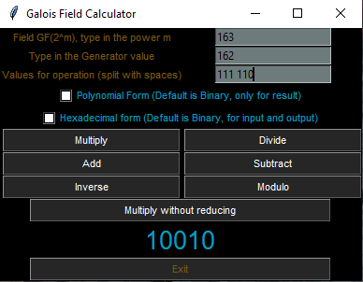

Notes:

* The values for operation are separated by spaces
  + Each binary/hexadecimal number should be sepearted by spaces. For each space, a new value is created
* The software can take at least 1 value, with no upper limit to the number of values, for the following operations:
  + Multiplication
  + Division
  + Addition
  + Subtraction
* For the inverse operation, it can only take exactly one binary/hexadecimal value
  + Else an error is thrown
* For the modulo operation, exactly 2 values should only be given
  + An error is thrown otherwise
* For any m in GF(2^m) above 100, a field generator greater than 0 must be provided
  + An error would be thrown otherwise
* In order to input and output hexadecimal, the “Hexadecimal Form” checkbox must be ticked.
* When the Show Polynomial checkbox is selected, the user will see their output in polynomial form.
  + Note that this feature is only available for the outputs and not the inputs
* The user can selected both the hexadecimal and polynomial checkbox, but only polynomials will be outputed, but the user can also input hexadecimal.
  + This allows for the user to use hexadecimal as input and output polynomials