CSC-203L Computer Networking Lab
Final Project Proposal
Multi Campus Enterprise Networking Design Project



Submitted by:
Muhammad Tahir 2024-CS-704
Nauman Ahmad 2024-CS-740
Daniyal Haider 2024-CS-746
Ahmad Ali 2024-Cs-723
Submitted to:
Ms. Ghazala
Department of Computer Science, University of Engineering and
Technology Lahore, New Campus

Table of Contents
1. Network Topology & Design Philosophy 3
2. VLAN & Department Table 3
3. IP Addressing Scheme (VLSM) 4
4. Key Configuration Details 4
Switch Configurations 4
Router Configurations 4
Server Configurations 5
Hybrid Routing Strategy (OSPF + BGP) 5
Security & ACLs 5
Redundancy (Failover) 5
5. Testing Results 6

Network Topology & Design Philosophy

This project implements a scalable, three-campus network architecture (Main, KSK, Narowal). The design adheres to enterprise best practices by separating Internal and External routing protocols.
Internal Routing: OSPF Area 0 is used for high-speed, loop-free connectivity between campuses and departments.
External Routing: BGP is implemented at the Border Routers to exchange Internet routes between campuses with the ISP.
Networking Diagram:
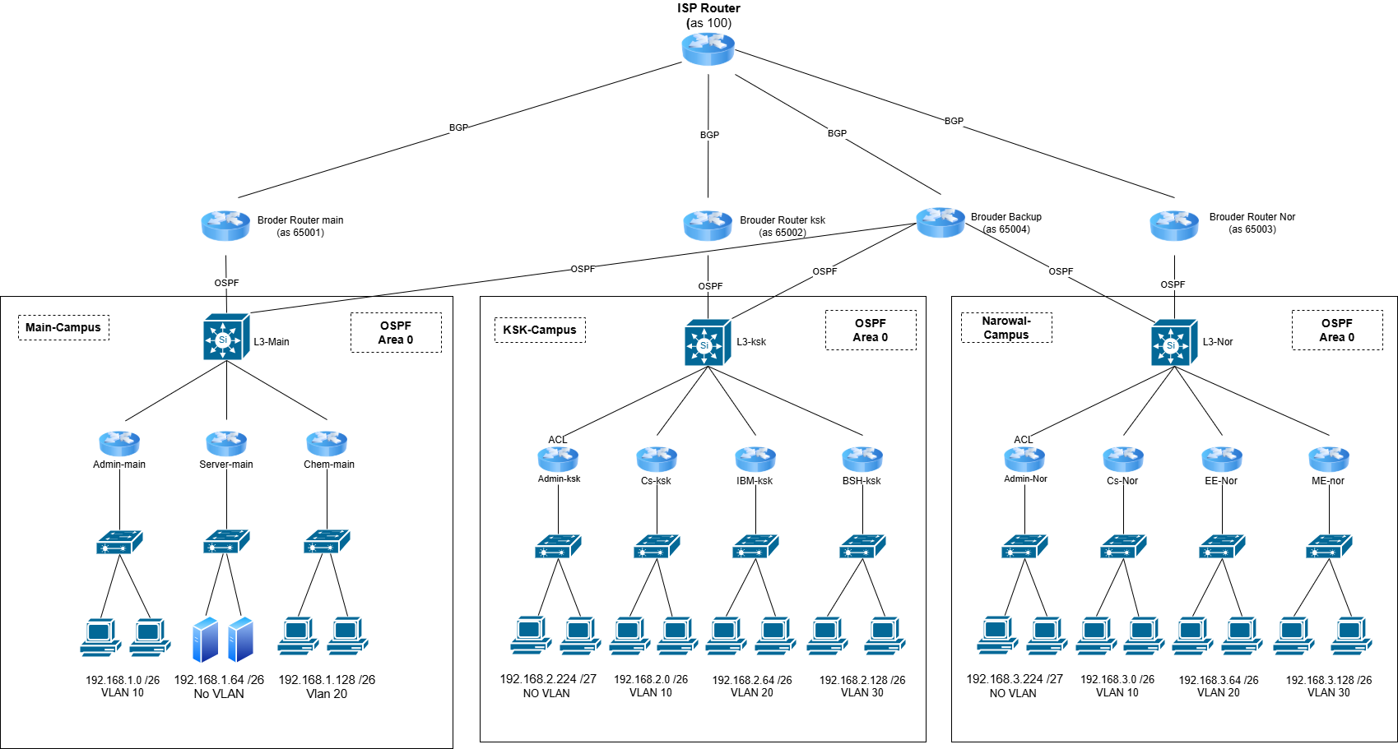

VLAN & Department Table

Campus | Department Name | VLAN IDs.
Main Campus | Admin Block | 10
 | Server Room | Na
 | Chem-Dept | 20
KSK Campus | Admin Block | Na
 | Cs-Dept | 10
 | IBM-Dept | 20
 | BSH-Dept | 30
Narowal Campus | Admin Block | Na
 | Cs-Dept | 10
 | EE-Dept | 20
 | ME-Dept | 30

IP Addressing Scheme (VLSM)

Following is the Ip addressing table for the project:
Campus | Department | Subnet / Mask | Gateway IP
Main | Admin Block | 192.168.1.0 /26 | .1
Main | Server Room | 192.168.1.64 /26 | .65
Main | Chemical Dept | 192.168.1.128 /26 | .129
KSK | CS Dept | 192.168.2.0 /26 | .1
KSK | IBM Dept | 192.168.2.64 /26 | .65
KSK | BSH Dept | 192.168.2.128 /26 | .129
KSK | Admin Block | 192.168.2.224 /27 | .225
Narowal | CS Dept | 192.168.3.0 /26 | .1
Narowal | EE Dept | 192.168.3.64 /26 | .65
Narowal | ME Dept | 192.168.3.128 /26 | .129
Narowal | Admin Block | 192.168.3.224 /27 | .225

Key Configuration Details

Switch Configurations

- Layer 3 Switching: The Core Switches in each campus are configured as Layer 3 devices, utilizing Switched Virtual Interfaces (SVIs) to act as the default gateways for all departmental VLANs.
- VLAN Assignment: Dedicated VLANs are created for each department (CS, IBM, BSH, Admin) to logically separate traffic and broadcast domains.
- Hybrid Routing: The switches utilize a Static Default Route pointing to the Primary Border Router for normal traffic flow, while simultaneously running OSPF to the Backup Router to ensure automatic failover if the primary link goes down.

Router Configurations
- Border Routers (Hybrid Design):
  - BGP (Border Gateway Protocol): Configured on the WAN interfaces to peer with the ISP (AS 100), exchanging external routes to simulate Internet connectivity.
  - Static & OSPF Routing: Static routes are used for the primary connection to the internal campus to prevent loops, while OSPF is enabled on backup links to maintain redundancy across the network.
- ISP Router:
  - Uses BGP to advertise global routes to all university campuses.

Server Configurations
- Network Settings: All servers are hosted in the Main Campus Server Room (VLAN 60) with static IP addresses and their default gateway pointing to the Main L3 Switch.
- DNS Server: Configured with "A Records" to resolve domain names (e.g., www.uet.edu.pk) to local web server IP addresses.
- Web Server (HTTP): Hosts the university website, accessible via the DNS domain name.
- Email Server: configured with the uet.edu.pk domain, managing user accounts for students and administration with SMTP and POP3 services enabled.

Hybrid Routing Strategy (OSPF + BGP)
To satisfy connectivity requirements while proving BGP implementation:
- ISP Router (AS 100): Advertises global routes to all campuses.
- Border Routers: Establish BGP neighborship with ISP to receive Internet routes.
- Internal Routers: Use OSPF to route traffic within campuses (between departments).

Security & ACLs
Access Control Lists (ACLs) enforce strict communication rules:
- Admins can communicate with other Admins.
- Admins can access the Main Server Room (Web/Email).
- Admins can access their local campus departments.
- Admins are BLOCKED from accessing departments in other campuses.
- Admins of main campus can access everything with no restrictions.

Redundancy (Failover)

Primary connectivity uses Static Routes on the L3 Switch for stability. Backup connectivity uses OSPF via a shared Backup Router (Border 4). If the Primary link fails, traffic automatically reroutes through the Backup path.

Testing Results

- Internet Connectivity Verification:
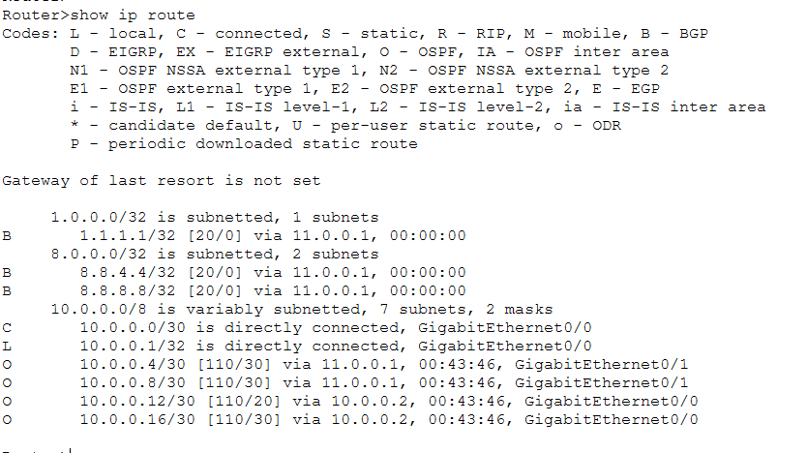
Command: “show ip route” at Broder-Ksk router
Result: Routing table displays 'B' (BGP), ‘O’ (OSPF), ‘C’ (connected) for different paths.
- Campus wise Connectivity:

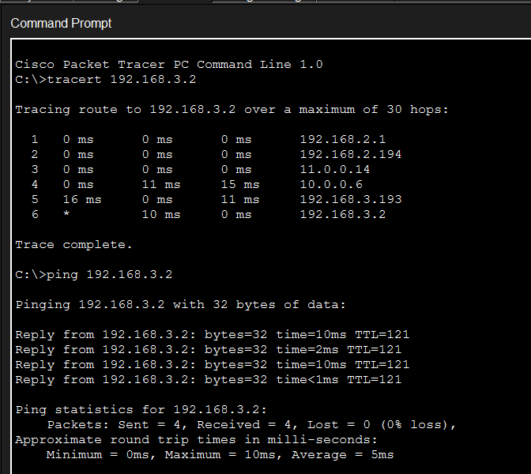
Source: KSK CS Dept -> Destination: Narowal CS Dept
Result: Successful Ping and tracert via OSPF Backbone.
- Server access:

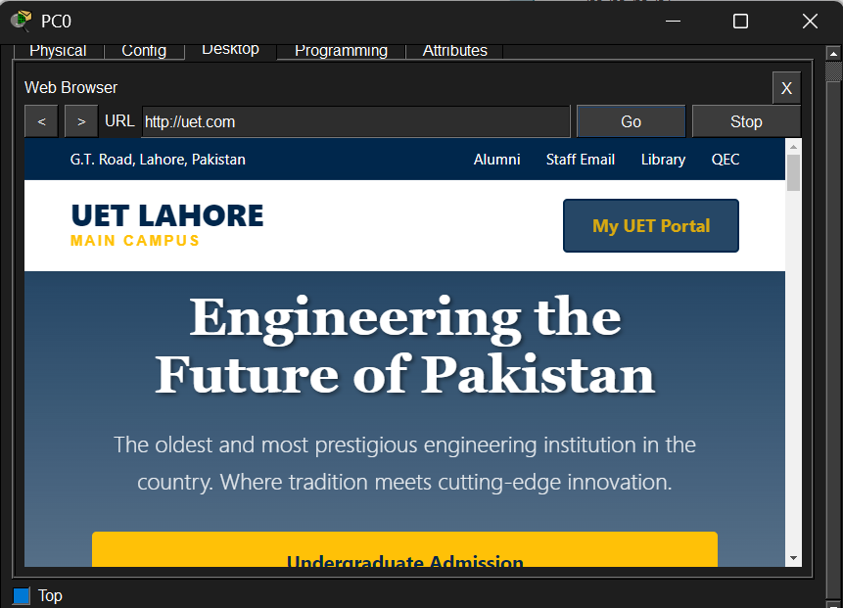

Action: Accessing DNS server located at server room of main campus from pc in Cs department of Narowal campus.
Success: Can access DNS as well as HTTP server.

- ACL Security Verification:

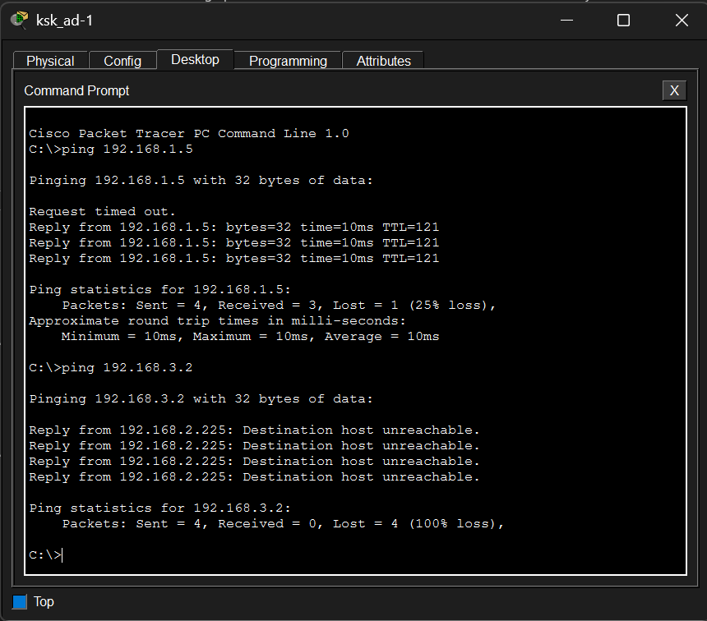
Test A: KSK Admin -> Main Server (192.168.1.5) = PERMITTED.
Test B: KSK Admin -> Narowal CS (192.168.3.2) = BLOCKED (Destination Unreachable).
- Redundancy Verification:

Tracing from CS-KSK pc1 to CS-NOR pc1

1)
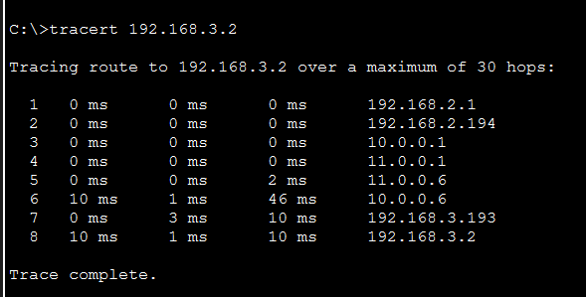
Action: Normal path from Border Router 1.
Result: Trace route confirmed traffic goes KSK Brouder router (10.0.0.2).

2)
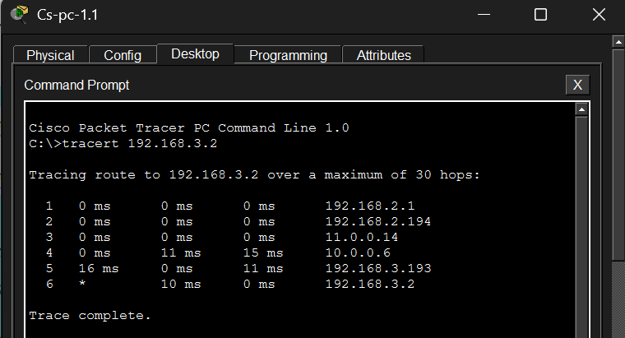
Action: Manually disabled link to Border Router 1.
Result: Trace route confirmed traffic shifted to Backup Router (10.0.0.13).

