

Inventory KONA Complete System Report
  - Complete module explanation, workflow cycles, role map, safety model, current evidence, and next improvements.
Live domain: https://inventory.ahmaddalao.com
Repository path: /Users/ahmaddalao/Desktop/inventory
Current deployed commit: 7b16698 Verify purchase permission boundaries
Report date: July 20, 2026
Latest live evidence set: Expanded module-by-module live regression, stock invariants, backup, permission-boundary verification, and deployment verification completed July 20, 2026.
Executive verdict
The system is ready for internal daily use. The July 20 expanded live regression passed, stock invariants passed before and after testing, and the modular refactor has not changed stock behavior. The handover cycle requires the receiver to report actual receipt and usage, while the source issuer edits and confirms both received quantities and the final returned/used breakdown before stock is finalized. Purchase document deletion and draft cancellation now have verified permission boundaries. Storage balances remain the source of truth, movement logs preserve the audit trail, and workflow corrections keep history instead of deleting it.

1. System Map
Module | Purpose | Connected to
Dashboard | Daily operating view: inventory totals, workflow queues, purchase and stocktake alerts, notification feed. | Items, storages, handovers, requests, purchases, stocktakes, reports.
Items | Consumable stock catalog with SKU, barcode, unit, image, cost, reorder level, labels, exports, and archive/recover. | Storages, movements, requests, handovers, purchases, labels, reports.
Storages | Physical locations/warehouses with independent item balances, values, searchable per-storage exports, copy, archive, recover. | Items, movements, transfers, handovers, requests, purchases, reports.
Movement Log | Immutable stock history for usage, restock, transfer, adjustment, purchase receipt, request fulfillment, handover closeout. | Every stock-impact workflow.
Scan Center | Barcode/SKU lookup, batch scanning, package conversion, and manual stock add for items without barcodes. | Items, storages, movements.
Requests | Permanent item requests and admin-to-admin transfers with approval, receipt mismatch, cancel, recover, and audit. | Items, storages, notifications, movements.
Handovers | Temporary issue to staff or accountable storage transfer, receipt approval, returned-first usage, owner review, reconciliation PDF/XLSX. | Items, source/destination storages, movement log, files, reports.
Purchases | Supplier quotes, OCR/import, approval, receiving, weighted average cost, protected purchase documents. | Suppliers, items, storages, files, movements.
Assets | Durable company property with custody, categories, depreciation, maintenance, warranty, signoff files, exports. | Users, storages, suppliers, files, labels, reports.
Reports | Daily summary, saved report presets, usage by reason, exports, finance and storage-owner views. | All operating modules.
Settings | Branding, theme, logo, export thumbnails, barcode rules, email, OCR/OpenAI, signoff templates. | Whole application.
Audit/Files | Protected documents and event history for accountability. | Every workflow that uploads, exports, approves, overrides, or deletes.

2. Current Modular Architecture
Architecture rule
This is a plain PHP/MySQL application. Public routes remain in index.php. app/module_manifest.php defines the domain graph, app/modules.php loads focused modules, app/support contains bootstrap-safe shared helpers, and app/maintenance contains schema/bootstrap routines. Compatibility loaders remain, but new logic must not be added to them.

Domain | Focused modules | Responsibility
Inventory | item_*, storage_*, inventory_stock.php, movement_* | Catalog, per-storage balances, movements, images, units, packages, archive/recover.
Requests | request_*, workflow_stock_impact.php | Request lifecycle, guards, receipt mismatch, transfer stock, recover/void.
Handovers | handover_*, handover_receipts.php, handover_closeout.php, handover_status.php | Staff issue, storage transfer, exact receipt approval, returned-first usage, owner review.
Signoff | signoff_*.php | PDF/XLSX rows, quantities, reconciliation, barcode/QR, images, revision and persistence.
Purchases/OCR | purchase_*, supplier_*, ocr_*.php | Suppliers, purchase approval/receiving, protected documents, OCR review and AI fallback.
Assets | asset_*.php | Asset identity, category hierarchy, custody, maintenance, depreciation, signoff and exports.
Reports/Exports | report_*, export_*.php | Daily summaries, saved presets, filtered CSV/XLSX outputs, thumbnails and barcodes.
Platform | auth_*, user_*, settings_*, email_*, file_*, audit_* | Authentication, permissions, settings, mail, protected files, notifications and audit.

3. Stock Safety Model
Source of truth
Per-storage balances are the real quantity. Item total quantity is synchronized from storage balances. Movement logs explain why balances changed. If a record is archived, recovered, cancelled, or voided, history stays visible instead of being hard-deleted.

Event | When stock changes | Audit behavior
Manual restock | Immediately after a permitted add to a selected storage. | Movement row records item, storage, quantity, user, reference, and notes.
Usage movement | When usage is saved directly or approved through handover closeout. | Used quantity appears in movement log and reports, with reason breakdown when available.
Transfer | When source and destination storage are selected and stock is moved. | Source decreases, destination increases, movement links both sides.
Purchase | Only after final receipt confirmation, not when approved. | Restock movement links supplier purchase, receipt, file proof, and cost update.
Request | After approver confirms and receiving is accepted. | Mismatch handling returns unreceived quantities and logs correction.
Handover | Stock is issued first, then returned quantity and final usage are posted on owner approval. | Signoff files show simple item rows plus a bottom reconciliation table.
Stocktake | Only after variance approval. | Adjustment movement records counted vs expected quantity.

4. Role And Permission Guide
Role / position | Typical access | Accountability
Owner / Super Admin | All permissions, status override, settings, secrets, recover/void, audit, backups, users. | Final authority for corrections, permissions, stock integrity, and system settings.
Admin / Storage Owner | Operational inventory, storage, requests, handovers, purchases, stocktakes, exports depending on permissions. | Owns stock in assigned storage and approves final stock-impact actions.
Operations Manager | Admin account with operational permissions: handovers, requests, usage reports, stocktakes, purchases where granted. | Coordinates daily issue/return flow and validates usage against real operations.
CFO / Accountant | Reports, purchases, suppliers, files, finance exports, audit read access, asset value where granted. | Reviews money, supplier documents, purchase values, and asset book value.
Reception Staff / Staff | Simplified dashboard, own requests, own handovers, assigned items/assets, receipt and closeout actions. | Reports what was received and what came back. Does not own final stock approval.

- Positions are presets; checked permissions are the final access control.
- Status override is intentionally restricted to owner/super admin because it can rewrite workflow state.
- Self-approval is blocked where it would weaken accountability.

5. Feature Cycles

Auth, users, roles
- Users log in with email/password. Password reset can be sent through configured PHP mail settings and recorded in email logs.
- Owner/admin can create users, assign access level, position, storage ownership, and granular permissions.
- Login attempts, permission-sensitive actions, and admin changes are audited.

Dashboard, search, notifications
- Dashboard defaults to All filters and shows the current operating queues: requests, handovers, purchases, stocktakes, reorder pressure, and notifications.
- Global search opens items, storages, requests, handovers, purchases, assets, and settings references.
- Notifications are in-app first, with sound and optional email copies where enabled.

Items and labels
- Items support images, SKU, optional barcode, unit, category, cost, reorder level, labels, archive/recover, storage-location removal, and Excel/CSV export.
- SKU is no longer treated as a global stock identity; the same catalog item can exist across multiple storages with independent balances.
- Labels can be selected individually or in bulk, and barcode/SKU information is visible on item detail and exports.

Storages and warehouses
- Each storage holds many items. Zero quantity does not hide an item because zero means refill, not delete.
- Copy storage can create the same item set with zero quantity, preserving names/images/details.
- Storage export includes all items under each storage with quantities, values, item images, and scan codes where enabled.
- The Storages page has a searchable storage export picker. Pick one storage for exact per-storage export, or leave All storages for grouped export.
- Each storage detail page has direct Excel and CSV export actions for the items inside that storage.

Movement log and scan center
- Movement log filters by item, type, location, date, and search. Exports follow the filtered result set.
- Scan Center opens barcode/SKU/reference matches, supports batch scan, package conversion, and manual add to storage.
- Manual stock add is used when an existing item has no barcode; new items still need to be created first.

Requests
- Requests support draft/submit/approve/reject/cancel/recover/void flows depending on status and permissions.
- Staff ask for items without seeing unnecessary source stock details. Admin-to-admin requests can transfer between storages.
- Receipt mismatch is handled by reporting exact received quantity; approver confirms and stock is corrected.

Handovers
- Expected usage plan is a forecast only. It appears on signoff files and reconciliation notes, but never becomes official usage automatically.
- For staff handovers, the receiver reports exact receipt. Even an exact receipt enters Receipt Review, where the source issuer can edit and confirm every received quantity before the handover becomes Delivered.
- Closeout uses returned-first input: the receiver types how many came back and the app calculates used quantity.
- Actual usage reasons explain used quantity: Online, Walk-in, Event, Damage, Sport, School, Complimentary, No Show, Other, or Unspecified.
- The source issuer performs final review, can correct returned quantity and actual reason split, then approves and closes. Final usage and return movements post only at this approval.
- Storage-transfer handovers hide usage controls. The destination owner confirms receipt; received stock moves to the destination and any short quantity returns to the source.
- PDF/XLSX signoff files keep item rows clean: image, item, SKU/barcode, unit, planned, received, used, returned, and a notes line.
- Expected usage, actual usage, variance, total returned, and difference/unaccounted are summarized in a bottom reconciliation table instead of being crammed into each item row.

Purchases and suppliers
- Supplier directory includes required Saudi business fields: national address, phone, authorized person, supplier type, CR, VAT, email, notes.
- Purchases start as drafts with supplier, storage, approver, files, lines, prices, and optional quick-created items.
- OCR can extract from images/PDFs with browser OCR and optional OpenAI fallback, but every extracted line stays under review.
- Approval links/creates catalog items but does not add stock. Final receipt confirmation posts restock movements and updates weighted average cost.
- Default admins can only delete purchase documents or cancel drafts when explicitly granted purchases.files or purchases.cancel. Owner access and denied default-admin access are both regression-tested.

Assets
- Assets are durable property, not stock quantities. Examples: laptops, radios, printers, cameras, tools, machines.
- Assets support categories/subcategories, image, asset number, serial, barcode/tag, assigned user/storage, condition, status, warranty, files, and labels.
- Straight-line depreciation tracks useful life, salvage value, remaining life, and current book value.
- Custody actions cover assignment, receipt confirmation, return request, return confirmation, damage, lost, repair, retirement, archive/recover, and status override.

Stocktakes and reorder
- Stocktakes snapshot assigned items including zero-quantity lines, then post variance only after approval.
- Reorder center flags low-stock lines and can create purchase drafts. Zero-policy noise can be included or hidden.

Reports, files, documentation, settings
- Reports include daily operations, usage by item/reason, people activity, exports, and saved report presets.
- Files are protected and permission-checked. Purchase, handover, request, and asset documents are not public direct links.
- Website Control manages KONA branding, logo upload, labels, theme, barcode requirements, thumbnail export size, OCR/OpenAI, mail, backups, and signoff settings.

6. Handover Cycle - Staff Temporary Use
Step | Who acts | What happens | Stock impact
1. Plan | Admin/storage owner | Select source storage, recipient, items, quantities, and optional expected usage plan. | No final usage posted.
2. Deliver | Admin/storage owner | Issue items and generate signoff PDF/XLSX with planned details and reference QR. | Stock is moved into handover/buffer state.
3. Report receipt | Receiver | Confirm exact quantity received. Exact and short receipts both enter Receipt Review. | No final usage posted.
4. Issuer receipt review | Source issuer | Open editable receipt controls, correct each received quantity if needed, and approve. Blind approval without quantities is rejected. | Receipt state becomes active only after issuer confirmation; history remains auditable.
5. Report return | Receiver | Type how many pieces returned. System calculates used = received - returned. | No final usage posted until approval.
6. Actual reasons | Receiver | Split used amount into Online, Walk-in, Event, Damage, Sport, School, Other, or Unspecified. | Reason metadata prepared.
7. Issuer final review | Source issuer | Review and edit returned quantity, calculated used quantity, and actual usage reason rows; add an approval note and close. | Usage and returned movements are posted only now.
8. After close | Owner/super admin only | Rare corrections use audited status override or void/recover path. | Every correction is logged.

Recommendation
The receiver should report reality, not control final stock. The source issuer should confirm receipt first, then review and correct the returned quantity and actual usage split before close. That matches the real KONA workflow because online, walk-in, damage, and no-show numbers can change during the day.

7. Handover Cycle - Storage Transfer
Step | Who acts | What happens | Stock behavior
1. Create | Source owner/admin | Choose Transfer to Storage, source storage, destination storage and lines. Same source/destination is blocked. | Source stock is reserved into handover buffer.
2. Receive | Destination owner | Confirm exact quantities received at the destination storage. | Full receipt moves buffer stock to destination and closes.
3. Short receipt | Destination owner + source owner | Report actual receipt. Missing quantity is returned to source and shortage remains auditable. | Destination receives actual; source gets missing quantity back.
4. Cancel/void | Authorized owner/admin | Cancel before receipt or use audited correction path after stock impact. | Reserved stock returns safely; movement history stays visible.

Important distinction
A storage transfer is relocation, not consumption. It never shows usage reasons or returned-first closeout. A staff handover is temporary operational use and keeps the usage/return cycle.

Signoff area | What appears | Why
Top summary | Recipient, source, scheduled date, total items, used total, returned total, QR/search reference. | Quick identity and control information.
Item rows | Image, item name, SKU, barcode/scan code, unit, planned, received, used, returned, notes line. | Keeps the page printable and readable for staff.
Bottom reconciliation | Total issued, Online, Walk-in, Event, Sport, Damage, Complimentary, No Show, Other/Unspecified, Total Returned, Difference/Unaccounted. | Matches the spreadsheet-style operations review and shows the full daily breakdown in one place.
Approval/signature | Receiver name, signature, received date/time, storage owner approval, approval note where present. | Creates the paper trail.

Difference / unaccounted
Returned is the physical quantity that came back. Used is calculated from received minus returned. Difference / unaccounted should normally be 0; if it is not 0, the handover has a mismatch that needs owner review before close.

8. Purchases, OCR, And Supplier Documents
Stage | Control | Reason
Draft | Creator selects supplier, storage, approver, files, lines, quantities, and prices. | Keeps purchasing separate from stock until approved and received.
OCR/import | Browser OCR and optional OpenAI OCR fill fields into a review screen. | OCR is a helper, not an approver. Bad Arabic scans still need human review.
Approval | Approver can reject or adjust quantities/prices. | Approval validates purchase intent but does not add inventory.
Receiving | Receiver reports actual received quantities and uploads proof. | Short receipt stays visible and goes to review.
Final confirmation | Approver confirms final received quantities. | Restock movements post, storage balance increases, weighted average item cost updates.

9. Assets Cycle
Asset feature | Current behavior
Categories/subcategories | Managed hierarchy with searchable picker. Parent category includes child assets in filters.
Custody | Assign to user/storage, recipient confirms receipt, staff can request return, admin confirms return and condition.
Maintenance | Record repair/service/vendor/cost/status/notes/files and move asset into maintenance state.
Depreciation | Straight-line method with useful life months, salvage value, start date, book value, warranty status, and remaining life.
Files/signoff | Asset PDF/XLSX signoff, image, receipts, warranty cards, repair proof, and protected downloads.
Exports | CSV/XLSX with optional thumbnails and barcode/asset tags controlled from settings.

10. July 20 Production Evidence
Check | Result | Evidence
Deployed commit | PASS | 7b16698 - Verify purchase permission boundaries; pushed to GitHub main and deployed to production.
Production backup | PASS | inventory-backup-20260720-111638 SQL, manifest and files ZIP created under live storage/backups; 14,700 files, 1,604,088,094 bytes, no warnings.
Local static checks | PASS | Full PHP lint sweep passed; node --check assets/app.js passed; git diff --check passed.
Live PHP lint | PASS | Changed production PHP files passed syntax validation after deployment.
Full live regression | PASS | ZZCYCLE20260720E passed and cleaned temporary records across auth, users, settings, inventory, workflows, purchases, OCR, assets, stocktakes, reports, exports, audit, and email logs.
Issuer receipt review | PASS | Regression verified receiver receipt report -> editable issuer receipt review -> corrected approved quantities -> Delivered. Blind approval without submitted quantities is rejected.
Issuer final review | PASS | Regression verified receiver returned-first closeout -> Pending Approval -> issuer edits returned quantity and actual usage reasons -> Approved and Closed.
Purchase permissions | PASS | Default admin is denied protected document deletion without purchases.files and draft cancellation without purchases.cancel; owner paths succeed.
Stock invariants | PASS | Stock invariants passed before the regression and again after cleanup. The corrected controls did not change the stock engine.
Module safety | PASS | Module-boundary, frontend-asset, and backup-archive tests passed after deployment; public routes and modular loaders remained intact.
Host limitation | WARNING | Production shell has no Node CLI. Frontend syntax is validated locally with the bundled Node runtime; this does not affect browser JavaScript execution.

11. Screenshots From Verification
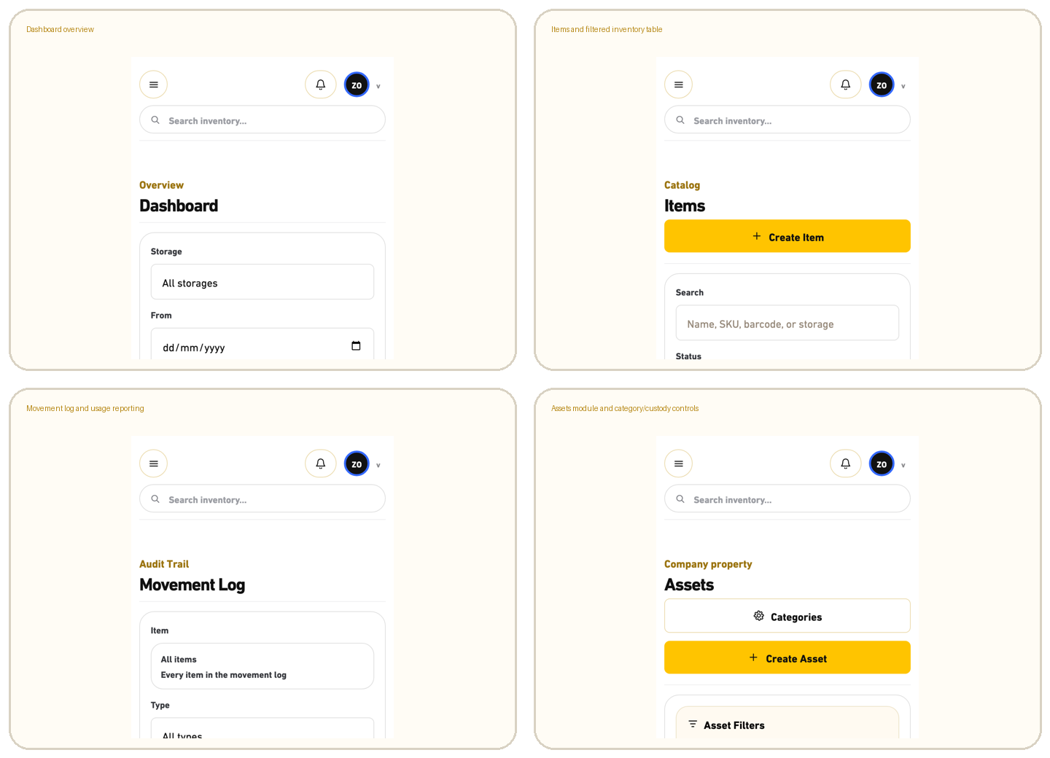
Visual evidence captured during the July 10 mobile/system verification.

12. Security And Operating Controls
- Protected files are served through permission-checked routes instead of public upload URLs.
- Sensitive settings such as OpenAI API key and mail configuration are owner/permission controlled.
- Audit logs track actions, overrides, archive/recover, exports, login attempts, and workflow changes.
- Soft delete/recover is preferred. Hard delete is avoided because it breaks stock explanation.
- Backup before live mutation remains the correct operating model. Staging was intentionally skipped because this is a small internal app, not a multi-team enterprise deployment.
- In-app notifications are the source of truth. Email is useful but should not block stock workflows.

13. Current Limitations And Honest Risks
Priority | Risk / limitation | Recommendation
P2 | OCR on old Arabic scanned PDFs remains imperfect. | Keep manual review mandatory. Use OpenAI fallback only for hard scans and monitor cost.
P2 | Filter/export parity must keep growing with every module. | Add regression tests that compare UI filter scope against each export.
P3 | The domain split is strong, but some focused modules remain large. | Continue small behavior-preserving splits only behind module-boundary and workflow tests.
P2 | Mobile field workflows need continuous polish as real staff use it. | Watch scan/manual add, handover closeout, item tables, and asset create/edit on real phones.
P2 | Report presets are useful but should be tested with real finance/storage-owner presets. | Create saved presets for daily operations, finance, usage by reason, purchase receiving, and assets.
P3 | Documentation screenshots can go deeper. | Add page-specific screenshots after UI stops changing weekly.

14. Recommended Next Improvements
Order | Improvement | Why it matters
1 | Continue mobile field-work polish around scan/manual add, handover closeout, item tables, and asset create. | Most employees will use phones; field workflows must be fast and unclipped.
2 | Keep extending automated filter/export parity tests whenever a filter or export changes. | The July 20 suite is broad; parity must remain a permanent regression rule.
3 | Add OCR confidence review and optional OpenAI fallback hardening for Arabic scans. | Supplier receipts and old PDFs are too messy for weak OCR alone.
4 | Exercise saved report presets with real daily operations, finance, usage, storage-owner, purchase, and asset workflows. | The feature exists; real operating use will expose which presets deserve defaults.
5 | Split frontend JavaScript only after the PHP/CSS architecture remains stable. | Do not mix another structural refactor into active stock-workflow changes.

15. Operating And Deployment Checklist
Situation | Do this
Before deployment | Create backup, run PHP lint, node check, full regression, stock invariants, then deploy.
Production deploy | Push main to GitHub, deploy the exact committed state to /home/u867436826/domains/ahmaddalao.com/public_html/inventory, then run live lint and stock invariants.
Before stock correction | Use void/recover/status override path. Never hard-delete stock-impact records.
Before purchase receiving | Attach proof, verify supplier, confirm actual quantity, then let approver finalize.
Before handover close | Receiver reports returned quantity and reasons. Owner/admin reviews and approves.
Before finance review | Use exports and saved presets with filters. Keep proof documents attached.
When OCR is weak | Treat OCR as draft data. Review supplier, item names, quantities, prices, and dates manually.

16. Bottom Line
Final take
Inventory KONA is a production-ready internal operations system, not a prototype. Items live in per-storage balances, movements explain every change, exact handover receipts require source-owner approval, storage transfers remain distinct from staff usage, purchases add stock only after final receiving, assets stay separate from consumables, and files/audit preserve accountability. The next work should be disciplined hardening, not random feature sprawl.

