MongoDB Queries & Results Explanation

Clean Sales Data (sales_clean)
This section shows a sample of cleaned sales records stored in MongoDB after processing with Spark Structured Streaming. Each document represents a single sales transaction after parsing, cleaning, and type conversion.
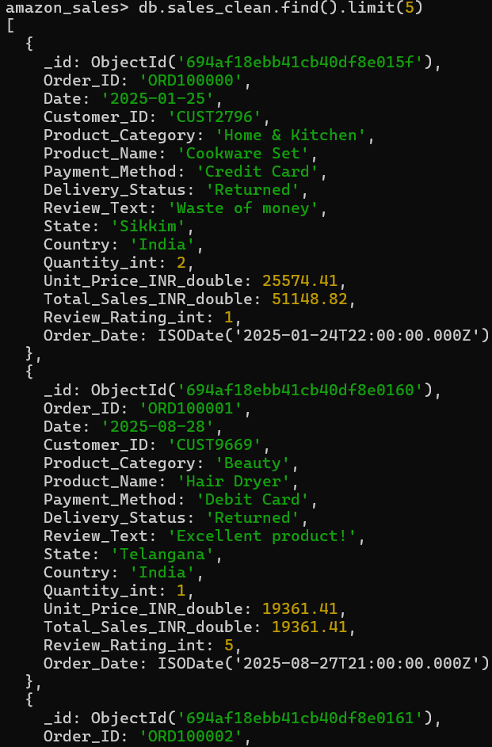

New Products Detection (sales_new_products)
This output demonstrates newly detected products using a Bloom Filter. Each product appears only once when first encountered in the data stream, along with its first seen timestamp.
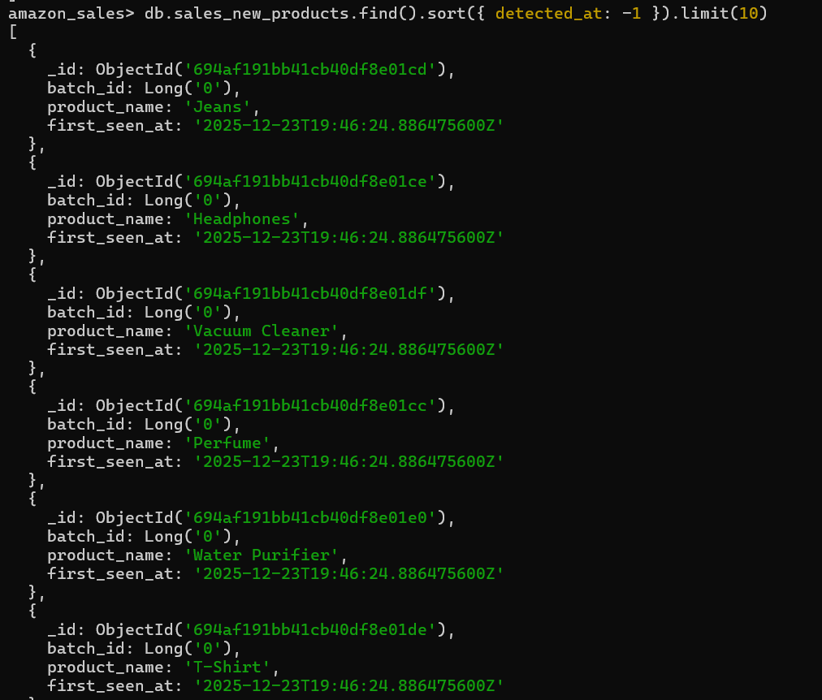

Top Products (Approximate – sales_stats)
This result shows the top-selling products computed using probabilistic data structures. The counts are approximate and optimized for memory efficiency and real-time analytics.
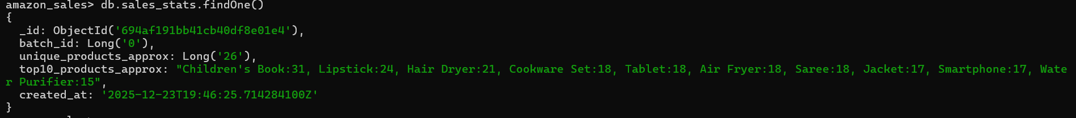

Top 5 Products by Total Quantity (Exact – Aggregation)
This aggregation query calculates the total quantity sold per product using exact aggregation on cleaned data. It demonstrates how MongoDB can be used to compute precise analytics on stored streaming results.
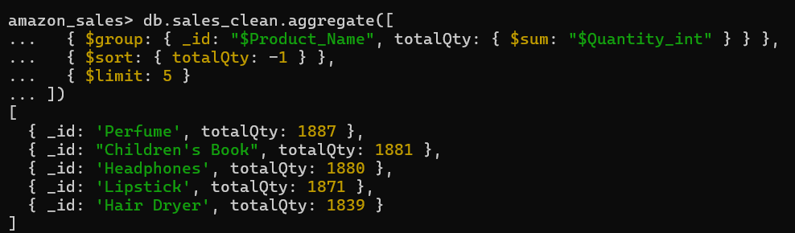

Total Revenue per Product
This aggregation computes total revenue by multiplying quantity and unit price for each product. Type casting is applied to ensure correct numerical computation.
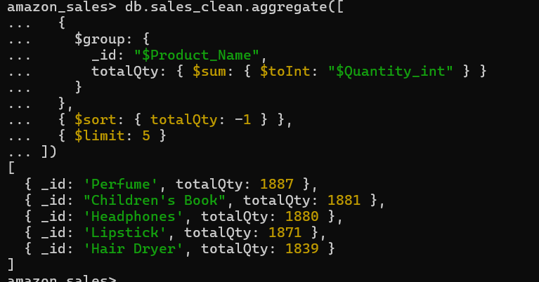

Total Sales per Day
This aggregation summarizes total quantities sold per day based on order date. It helps identify daily sales trends and demand patterns.
