

5/20/2020

Programming Assignment 1

Linear search & Binary search psuedocode

+ Linear search & Binary search Code screen shots

Ahmad Dumairi

<https://github.com/AhmadDumairi00/FinalAssignmentSourceCodes>

Discussion

Important note: This file contains the linear search algorithm in pseudo code and the code screen shots.

** Binary search isn’t ready yet. this file will be uploaded again when the code is ready.

Table of Contents

Algorithm for Linear Search using Pseudo code: 2

Binary Search Psuedo code 2

Linear search code screen shots 3

Binary search code screen shots 4

# Algorithm for Linear Search using Pseudo code:

Array = arr , Value we’re searching for =Val, Number of array elements = n,

1. Declare a variable (counter) called j.
2. Give j initial value = 1.
3. Condition statement: If j is larger than n, (go to point #8)
4. Condition Statement: If arr[j] is equal to Val (go to point #7)
5. Change value of j from 1 to j+1
6. Compare the new value of j to the value of n (do point #3 again)
7. Print Val (which equals arr[j])
8. Print Val not found

9)End the program

# Algorithm for Binary Search using Pseudo code:

1)Set “arr” and set it as a sorted array

2) “n” as the size of the array

3)Set “Val” as the value we’re searching for

4)Assign variable “first”

5)Assign variable “last”

6)Assign & set “mid” to (first + last)/2

7)check if “Val” isn’t available using while loop (go to point #9)

8)Condition statement: check if arr[mid] is equal to Val

9)Display message that the value isn’t found. And end program

10) Condition statement: check if arr[mid] is greater than Val

11) set “last” to “mid-1”

12) Condition statement: check if arr[mid] is less than Val

# Linear search code screen shots

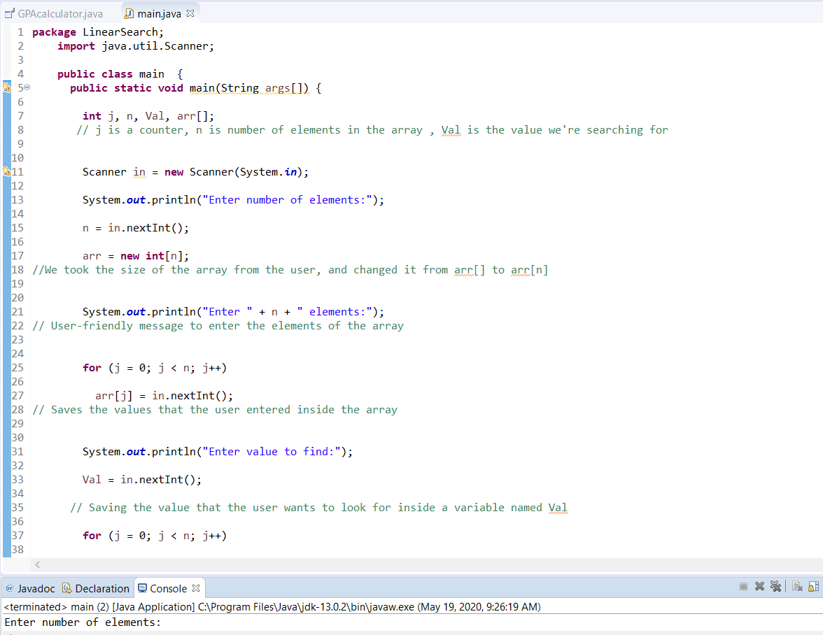

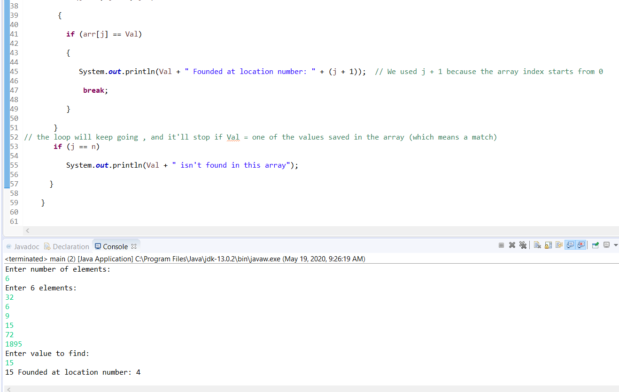

# Binary search code screen shots