

5/20/2020

Programming Assignment 1

Linear search & Binary search psuedocode

+ Linear search & Binary search Code screen shots

Ahmad Dumairi

<https://github.com/AhmadDumairi00/FinalAssignmentSourceCodes>

Discussion

Important note: This file contains the linear search algorithm in pseudo code and the code screen shots.

** Binary search isn’t ready yet. this file will be uploaded again when the code is ready.

Table of Contents

Algorithm for Linear Search using Pseudo code: 2

Binary Search Psuedo code 2

Linear search code screen shots 3

Binary search code screen shots 4

# Algorithm for Linear Search using Pseudo code:

Array = arr , Value we’re searching for =Val, Number of array elements = n,

1. Declare a variable (counter) called j.
2. Give j initial value = 1.
3. Condition statement: If j is larger than n, (go to point #8)
4. Condition Statement: If arr[j] is equal to Val (go to point #7)
5. Change value of j from 1 to j+1
6. Compare the new value of j to the value of n (do point #3 again)
7. Print Val (which equals arr[j])
8. Print Val not found

9)End the program

# Algorithm for Binary Search using Pseudo code:

1. Set “A” to sorted array
2. Set “NumOfElements” to (size of array)
3. Declare “ValueToSearch” as the value to search
4. Set “low” to “1”
5. Set “high” to “NumOfElements”
6. Check if “ValueToSearch” isn’t found using loop (while)
7. Check if “high” is less than “lower”
8. Display “ValueToSearch” isn’t available, & go to step 16
9. Set “med” to low+(high-lower)
10. Check if A[med] is smaller than “ValueToSearch”
11. Set low to med+1, & go to step 16
12. Check if A[med] is bigger than “ValueToSearch”
13. set “upper” to “mid - 1” then go to Step 16
14. check “A[mid]” is = ValueToSearch
15. print “ValueToSearch” is present at location
16. End program

# Linear search code screen shots

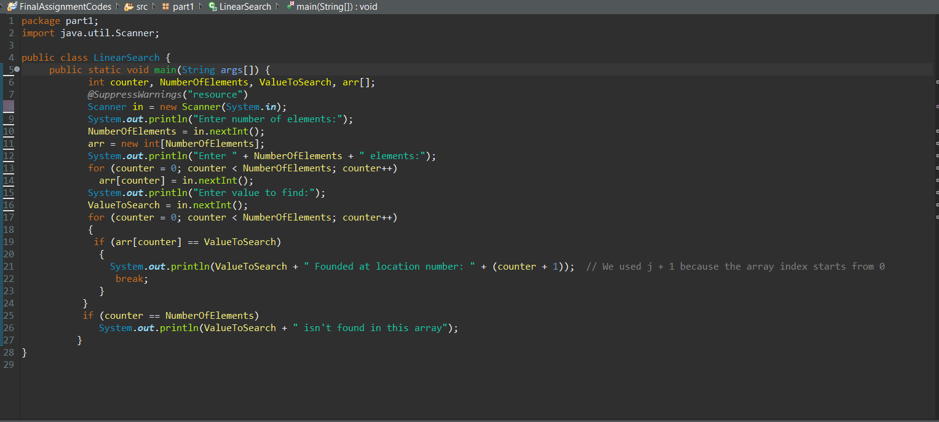

# 

# Binary search code screen shots

