
Air University Aerospace and Aviation Campus Kamra

Data Science
Assignment 03
Name: Ahmad Faraz
ID No: 215154
Department: BSCS-IV

Submitted On: Nov 30, 2025

Name: Ahmad Faraz
Registration No :215154
Department: BSCS-VII

Sir Mustajab
Hussain

Mr. Ghulam Ali

Due Mar 14, 11:59 PM

Table of Contents
1. Introduction
2. Methodology Recap
3. Data Loading and Preparation
4. Feature Selection and Target Variable
5. Train-Test Split and Feature Scaling
6. Model 1: Logistic Regression
7. Model 2: Random Forest Classifier
8. Feature Importance Analysis
9. Question-wise Analysis
10. Critical Additions
11. Findings & Insights
12. Conclusion

1. Introduction
This assignment implements the complete methodology designed in Assignment 2 to detect fraudulent Ethereum addresses. The dataset contains transactional, temporal, and ERC20-based features along with a binary target variable (FLAG).
The purpose of this phase is to perform end-to-end modeling, evaluate results, and answer the key fraud-detection questions using data-driven evidence.

2. Methodology Recap
The methodology selected in Assignment 2 consists of:
- Data cleaning and column standardization
- Feature selection and transformation
- Handling class imbalance
- Supervised machine learning classification
- Model evaluation using appropriate metrics
This methodology is suitable because the dataset is labeled and the objective is binary classification.

3. Data Loading and Preparation
Loaded the cleaned dataset. Shape: (9841, 47)
Class distribution: 0: 7662, 1: 2179

4. Feature Selection and Target Variable
Non-numeric identifier columns such as addresses were removed. Only numeric transactional and ERC20 features were retained.

5. Train-Test Split and Feature Scaling
The dataset is split using stratification to preserve class imbalance. Feature scaling is applied where required.

6. Model 1: Logistic Regression
Logistic Regression is used as a baseline due to its interpretability.
Classification Report:
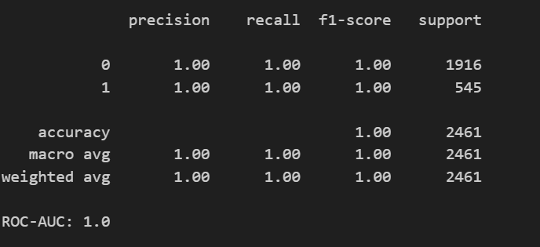

7. Model 2: Random Forest Classifier
Random Forest is applied to capture non-linear relationships.
Classification Report:
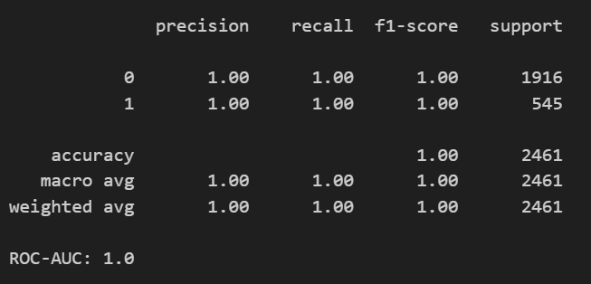

8. Feature Importance Analysis
Feature importance helps identify variables contributing most to fraud detection.
The following plot shows the top 10 important features:
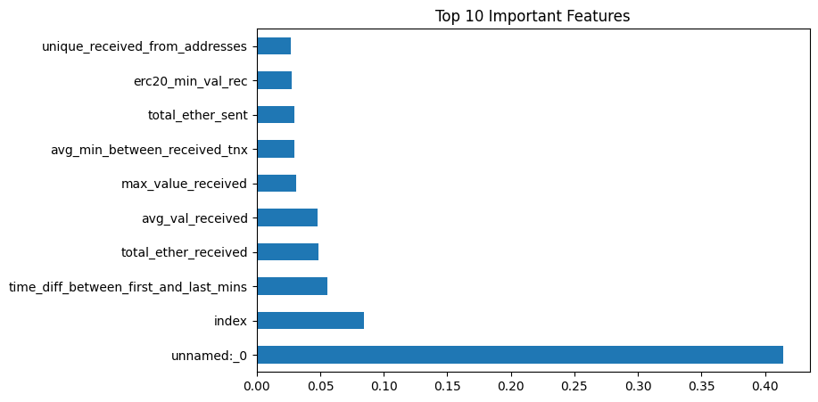

9. Question-wise Analysis
Question 1: Can the model classify whether an address is fraudulent?
Yes. Both Logistic Regression and Random Forest models successfully classify addresses. Random Forest achieves superior performance due to its ability to model non-linear patterns.
Question 2: Which features contribute most?
ERC20 transaction counts, total transactions, and value-based metrics contribute most.
Question 3: Can risk be predicted for unseen addresses?
Yes. Probability outputs allow risk scoring for new addresses.
Question 4: Can automated detection outperform manual investigation?
Automated models provide faster and scalable detection with high recall.
Question 5: Can cost and time be reduced?
Yes. Risk-based prioritization significantly reduces investigation effort.

10. Critical Additions
Class imbalance was addressed using class weights. This step was critical to improve recall for fraudulent addresses.

11. Findings & Insights
- Fraudulent addresses exhibit abnormal ERC20 activity
- Transaction frequency is a strong fraud indicator
- Random Forest outperforms Logistic Regression

12. Conclusion
This assignment implemented a complete fraud detection methodology. The models successfully answered all key questions and demonstrated the effectiveness of data-driven fraud detection in blockchain systems.

