MISRA EDU
Complete System Guide
  - From assessment setup to secure uploads, OCR evidence, rubric-based multimodal grading, human review, evaluation and LMS export

Purpose
A beginner-friendly technical and operational explanation suitable for learning, demonstrations and a university project defense.
Scope
The active FastAPI backend and static misra-frontend workspace. The legacy misra_ui folder is not part of the active application.
Repository snapshot
29 August 2026 • 75 automated tests passing • local thesis prototype, not yet an internet-safe production service.

Instructor authority first. AI assistance second. Evidence and evaluation throughout.

How to use this guide
This document starts with the problem MISRA EDU solves, then follows one assessment through the system. Later chapters explain the code architecture, database, security controls, background processing, tests, limitations and likely defense questions. You do not need to be an expert in web development or artificial intelligence before reading it.
The one-sentence explanation
MISRA EDU helps an instructor turn scanned student papers into evidence-linked, rubric-based AI grade suggestions, while preserving human control and measuring how closely the AI agrees with instructors.

Reading paths
If you are… | Read these parts first
A project examiner | Executive overview, end-to-end workflow, thesis contribution, evaluation and limitations
An instructor | Assessment setup, Rubric Studio, extraction review, grading, review queue and exports
A developer | Architecture, database, API/service map, Redis/RQ, security and tests
A beginner | Glossary first, then follow the numbered instructor workflow

Contents
How to use this guide 2
Reading paths 2
Contents 2
Part I — What MISRA EDU is 5
The educational problem 5
What the system does 5
What it does not claim 5
Users and authority 5
Part II — Architecture from the top down 7
Frontend 7
Backend 7
Database 7
AI layer 7
Asynchronous processing 8
Part III — One assessment from start to finish 9
Stage A: course and assessment setup 9
Stage B: rubric design and approval 9
Lenient, balanced and strict 10
Stage C: secure upload 10
Stage D: queued OCR 10
What the OCR model returns 11
Stage E: mapping and provenance 11
Stage F: extraction review 11
Part IV — AI grading, evidence and confidence 12
Criterion-by-criterion grading 12
Evidence modes 12
Question grading policies 13
GradingRun: preserving reproducibility 13
How confidence is calculated 13
Material disagreement 14
Part V — Human review and evaluation 15
Review queue 15
Why ReviewLabel snapshots matter 15
Evaluation metrics 15
How to complete the thesis evaluation 16
Part VI — The instructor-facing application 17
Page map 17
The API client 17
Visual evidence in grading results 17
LMS and reporting exports 17
Part VII — Security, privacy and administration 19
Authentication 19
Password recovery 19
Authorization and tenant isolation 19
Audit logging 19
Admin operations 19
Privacy boundaries 19
Part VIII — Redis, RQ and reliable background work 20
The beginner explanation 20
Why not FastAPI BackgroundTasks? 20
Job states 20
Duplicate protection and safe retry 20
Orphan recovery 20
How to run locally 21
Part IX — Database design 22
Major table groups 22
Important constraints 22
Part X — Codebase map 24
Repository root 24
Backend files 24
Service responsibilities 24
Router families 25
Part XI — Validation, failures and tests 26
Failure behavior 26
Automated verification snapshot 26
Part XII — Running and demonstrating MISRA EDU 27
Prerequisites 27
Environment concept 27
Start the system 27
A strong university demonstration 27
Part XIII — Honest limitations and roadmap 28
Highest-priority next work 28
Part XIV — University defense preparation 29
A 90-second explanation 29
Likely questions and strong answers 29
Key phrases to use 30
Glossary 31
Final takeaway 31

Part I — What MISRA EDU is

The educational problem
Paper assessment creates a difficult chain of work: instructors receive PDFs or photographs, identify the student, interpret handwriting, locate each answer, apply a rubric, write feedback, resolve uncertain cases, record final marks and eventually transfer those marks into an LMS. A normal OCR tool solves only one small part of this chain. A normal language-model prompt may produce a score, but it does not automatically provide traceability, version control, human oversight or evaluation evidence.
MISRA EDU treats grading as a controlled workflow rather than a single model call. Its central design idea is that every important conclusion should be tied to persistent evidence: the source page, OCR segment, approved rubric version, model run, confidence decision and instructor response.

What the system does
- Lets authenticated instructors create courses, assessments and questions.
- Lets instructors write granular rubrics or request AI-generated rubric drafts, then approve a specific version.
- Accepts validated PDF and image uploads for one student or a batch.
- Extracts student identity and handwritten answer segments with Gemini-based OCR.
- Maps answer segments to expected questions and preserves the exact page and segment source.
- Lets instructors repair OCR mappings, recover a page and correct student metadata before grading.
- Grades criterion by criterion using OCR text alone or OCR text plus the original source page.
- Routes uncertain, visual or materially conflicting answers into instructor review.
- Records human approvals and overrides as evaluation labels.
- Calculates AI–instructor agreement statistics and exports approved grades to CSV or Excel.

What it does not claim
- It does not replace the instructor as the final academic authority.
- It does not guarantee that a high confidence value means the grade is correct.
- It does not currently provide a student upload or result-publication portal.
- It does not currently push grades through the Blackboard REST API; Blackboard CSV is the implemented integration path.
- It is not yet an internet-safe production deployment with managed encrypted object storage, HTTPS monitoring and production login throttling.
- It does not use local OCR in the active workflow; Gemini is the current OCR and grading model provider.
Thesis contribution
The strongest contribution is not the interface alone. It is the measurable human-in-the-loop pipeline: evidence-aware grading runs, review decisions, preserved AI/human snapshots, and agreement metrics that reveal where the system succeeds or fails.

Users and authority
Role | Can do | Cannot bypass
Instructor / teacher | Create assessments, approve rubrics, upload, repair mappings, grade, review and export within the institution | Institution ownership checks, CSRF protection and admin-only pages
Institution admin | Everything an instructor can do, plus provision/disable instructors, inspect safe logs, system health and jobs | Another institution's data; secrets or full paper content in audit exports
Student | No active application role yet | There is no current student portal or self-service publication flow
Gemini | Returns OCR or grading JSON when invoked | It cannot approve rubrics, publish results or override instructor decisions

Part II — Architecture from the top down
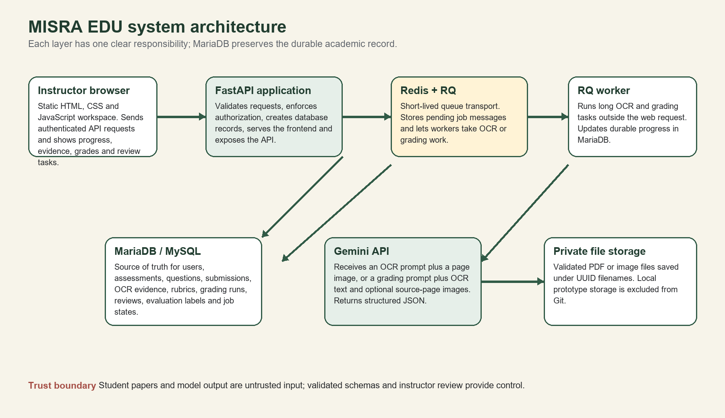
Figure 1. Active MISRA EDU architecture

Frontend
The active frontend lives in misra-frontend. It is deliberately simple: static HTML pages, shared CSS tokens and vanilla JavaScript. There is no Node build step and no client-side framework. FastAPI mounts the folder at /app. The frontend uses the same-origin API, sends the signed session cookie automatically and adds the CSRF token header for write operations.
Important files: css/tokens.css, css/base.css, css/workspace.css, js/api.js, js/workspace.js and one page-specific JavaScript file per major screen
Why this choice: It reduces deployment and dependency complexity for a thesis prototype while still providing a complete instructor workspace.

Backend
The backend is a FastAPI application in misra_backend. Routers define HTTP endpoints. Services contain reusable business logic. Pydantic schemas validate incoming and model-generated JSON. SQLAlchemy models map Python objects to relational tables. main.py composes the application, adds CORS and no-cache behavior, protects routers and serves the frontend.

Database
MariaDB or MySQL is the durable source of truth. It stores both operational state and historical evidence. This is why a Redis restart does not erase the instructor-visible status of a job and why a later regrade does not erase the original grading run used in an evaluation label.

AI layer
The active AI provider is Gemini through google-genai. The project wraps model calls in services/gemini_client.py, requests structured JSON and validates the response before it can update academic records. Gemini is used for two different tasks: page OCR and answer grading. Those tasks use different prompts and different Pydantic response schemas.

Asynchronous processing
Redis and RQ prevent slow OCR or whole-submission grading from holding open an upload request. The API creates a durable processing_jobs row, sends only its identifier to a queue and returns immediately. A separate worker reads the job and updates progress in MariaDB.
Redis is not the academic database
Redis transports work. MariaDB stores users, papers, grades, evidence and durable job status. Losing Redis should interrupt work, not erase the academic record.

Part III — One assessment from start to finish
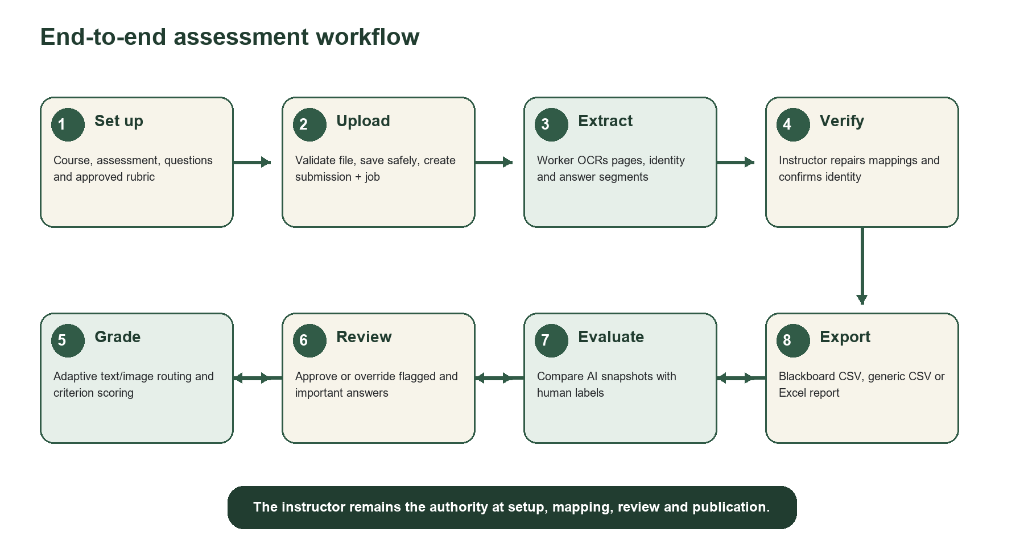
Figure 2. Complete instructor workflow

Stage A: course and assessment setup
- The instructor creates or selects a course with a code, title and term.
- The instructor creates an assessment under that course and selects English, Arabic or mixed language.
- The instructor adds the expected question labels, question text, maximum score and ordering.
- Each question receives a rubric and an evidence-routing policy before real grading begins.
A submission is matched against the questions configured for its exam. Therefore, creating the expected question list is not optional: OCR can extract handwriting, but it needs the assessment definition to know whether a label such as 2g is valid and where it belongs.

Stage B: rubric design and approval
Rubric Studio is the instructor-facing control center for scoring behavior. An instructor may build a rubric manually or request a Gemini suggestion. A suggestion is only a draft. It must be inspected, edited if necessary and explicitly approved. Approval makes that version the question's active rubric.
Rubric V2 field | Meaning
criteria | Small, independently scored learning outcomes rather than one large all-or-nothing criterion
points | Maximum points for a criterion; all criteria must sum to max_score
scoring_type | binary for full-or-zero, or scaled for partial credit
performance_levels | Named scoring anchors such as complete, partial and insufficient
required_evidence | What the student must actually show
common_errors | Known mistakes and how they should affect this criterion
alternative_methods | Other valid approaches the grader must accept
policy | Method credit, arithmetic propagation, rounding, units, notation, evidence and legibility behavior
reference_context | Authoritative answer-key facts, especially useful for diagrams and numerical interpretation

Lenient, balanced and strict
The grading approach changes how the explicit rubric policy is applied; it is not permission for the AI to invent new requirements. A lenient written-code rubric can say that harmless quoting or spacing mistakes should not lose credit when the conceptual SQL is correct. A strict runnable-code rubric can require exact syntax. The transparent rubric, not an unexplained model personality, should encode that choice.
Why granularity matters
A single criterion called q_2g_complete hides the source of disagreement. Separate proof properties and diagram correctness let the instructor see exactly which judgment failed and make criterion-level agreement meaningful.

Stage C: secure upload
The upload boundary is intentionally centralized in services/upload_security_service.py. It streams each file in 1 MB chunks instead of reading the whole file into memory. It inspects the signature bytes, checks that the filename extension matches the contents, verifies that PDFs and images can actually be decoded and enforces configurable limits.
Default boundary | Value | Reason
Per file | 25 MB | Limits memory, disk and denial-of-service risk
Batch request | 100 MB | Limits the total work accepted at once
Files per batch | 25 | Prevents unbounded job creation
PDF pages | 50 | Controls Poppler/OCR cost
Image pixels | 40 million | Blocks decompression-bomb-style images

The server initially writes to a hidden .uploading file with restrictive permissions. Only after validation succeeds is the file renamed to a UUID with a validated extension. Any failure removes the partial file. If a later database operation fails, the route also cleans up the already validated upload.
Filename is not trusted
A picture renamed fake-paper.pdf is rejected because its signature says PNG while its extension says PDF. This protects the rest of the processing pipeline from trusting user-controlled names.

Stage D: queued OCR
A successful upload creates the submission and a processing job, queues the job and returns HTTP 202 with identifiers. The worker changes the job from queued to processing, updates page-level progress and executes process_submission. For PDF input, Poppler converts each page into an image. For an image upload, the file is treated as one page.

What the OCR model returns
- Page language: Arabic, English or mixed.
- Student name and ID when explicitly associated with identity fields.
- Identity legibility: clear, partial, illegible or not found.
- One segment for each handwritten answer area, including question number, text, legibility, math flag, optional LaTeX and a normalized bounding box.
The OCR prompt explicitly says not to grade, summarize or correct the student's writing. Printed question text is used only to determine the answer label and should not be emitted as student work. The response must pass the OCRPageResult Pydantic schema. Invalid JSON receives one stricter retry; a second failure becomes a visible processing error.

Stage E: mapping and provenance
The OCR service normalizes labels by removing Q, punctuation and parentheses, converting letters to lowercase and attaching continuation letters to the previous base question when appropriate. It compares the result with the question labels configured for the exam. Matching segments create or extend one Answer row per submission and question. Non-matching segments stay in submission.unmatched_segments for instructor action.
Every mapped segment also creates an AnswerSource row. AnswerSource is the bridge between a grade and the original paper: it stores page_index, segment_index, question_number, extracted_text, has_math and the full normalized OCR segment, including its bounding box when available.
Why AnswerSource is essential
Without provenance, image_text grading would not know which page to send, the frontend could not highlight the relevant answer region, and an instructor could not safely move one mistaken OCR segment between questions.

Stage F: extraction review
The Extraction results page shows whether expected answers are mapped, suspicious or missing. Opening a submission displays the original page and question mapping together. The instructor can correct the student name and number, move a tracked source segment, assign an unmatched segment, remove manually assigned noise, use bulk resolution or preview and confirm a page re-extraction.
- Mapping repair is blocked after an answer is graded, preventing evidence from silently changing underneath an existing grade.
- Page recovery uses a signed preview so a client cannot alter the OCR preview before confirmation.
- Confirmation is idempotent, so repeated clicks do not duplicate sources.
- Deletion is blocked while a processing job is active and otherwise removes dependent records and the stored paper.

Part IV — AI grading, evidence and confidence
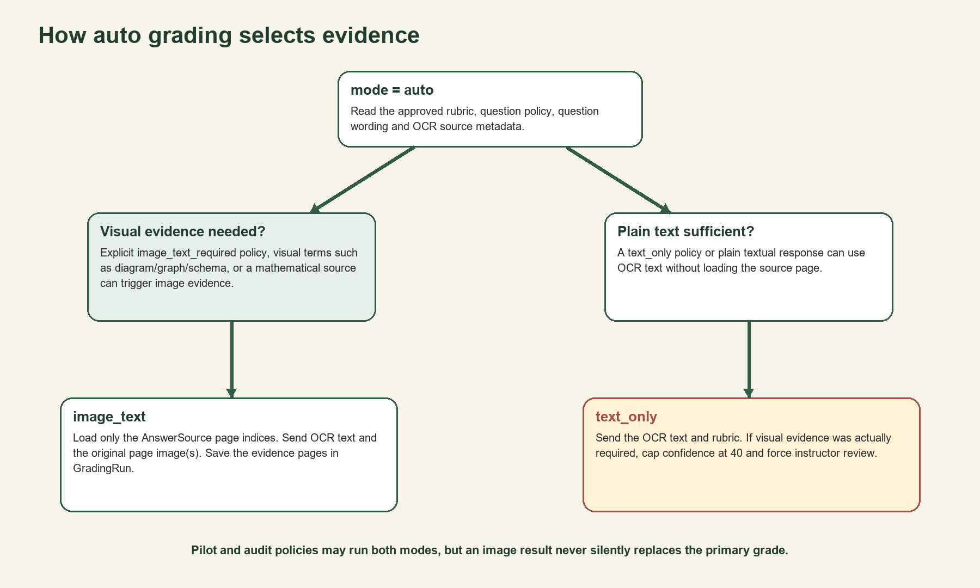
Figure 3. Adaptive evidence routing

Criterion-by-criterion grading
The grading prompt receives the assessment title, question text, approved rubric JSON and OCR text. In image_text mode, it also receives only the original page images linked through AnswerSource. Gemini must return one score record for every rubric criterion. The backend rejects responses that omit criteria, introduce unexpected criteria, exceed maxima, give partial credit to a binary criterion or produce a total that does not equal the criterion sum.
result = GradingResult(**parsed)
_validate_grading_against_rubric(result, rubric_json)

This separation matters: the model proposes a structured judgment, but deterministic application code enforces the scoring structure.

Evidence modes
Mode | Input | Best use | Risk/control
text_only | Rubric + OCR text | Clear prose, simple answers and lower cost | May miss layout or diagrams; guard forces review when visual evidence was required
image_text | Rubric + OCR text + exact source pages | Math, diagrams, graphs, crossed-out work and OCR ambiguity | Model may over-interpret the picture; rubric reference_context remains authoritative
auto / adaptive | System chooses one mode | Normal operational workflow | Question policy and content signals determine routing
pilot / audit | Text primary plus selected image comparison | Learning which mode works for a question | Material disagreement creates review; image never silently replaces text

Question grading policies
Policy mode | Behavior
adaptive | Choose image_text when the question/rubric requires visuals or the source is marked as mathematical; otherwise text_only
text_only | Always use OCR text
image_text / image_text_required | Always load the linked source pages
pilot | Run both while the question has fewer than min_validated_samples distinct labelled answers
dual_mode_review | Run both every time and compare
text_only_with_random_audit | Use text as primary and deterministically sample a proportion for image comparison

The random audit is deterministic for a given answer ID: a SHA-256-derived number is compared with audit_rate. This provides a stable sample without a separate audit flag column.

GradingRun: preserving reproducibility
The Answer table stores the current operational result shown in the interface. Every model invocation also creates a GradingRun containing the answer ID, processing job, rubric version, model name, prompt version, source pages, OCR snapshot, rubric snapshot, score, criteria, confidence, response JSON and latency. This lets the project compare versions and explain exactly what evidence produced a result.

How confidence is calculated
MISRA does not expose Gemini's self-confidence as the final confidence by itself. The current formula combines three signals:
final = 0.30 × OCR_legibility
+ 0.50 × LLM_confidence
+ 0.20 × score_boundary_signal

Signal | Meaning | Current behavior
OCR legibility | How readable the source transcription is | clear=100, partial=60, illegible=10, unknown=50
LLM confidence | Gemini's declared certainty about applying the rubric | Validated between 0 and 100
Score boundary | A crude ambiguity proxy | Scores between 40% and 60% receive a 0 boundary signal; other scores receive 100

A final confidence below 70 triggers needs_review. Additional gates can override this result. If a text-only grade skipped required visual evidence, confidence is capped at 40. If the latest text and image runs materially disagree, confidence is also capped and the answer is flagged.
Honest limitation
The current confidence formula is a heuristic, not a statistically calibrated probability. The project still needs 20–30 representative instructor labels to tune thresholds and measure whether confidence predicts actual grading error.

Material disagreement
When both text_only and image_text runs exist, the system compares their total scores and every criterion. A total difference is material when it reaches the larger of an absolute threshold and a fraction of the question maximum. The default policy values are 0.5 points and 20%. A criterion difference can also trigger review even when the totals cancel out.
The current operational grade remains the primary run selected by policy. MISRA deliberately avoids choosing the higher score automatically: doing so would create a hidden leniency rule and could reward an incorrect interpretation. The instructor sees both pieces of evidence and resolves the conflict.

Part V — Human review and evaluation
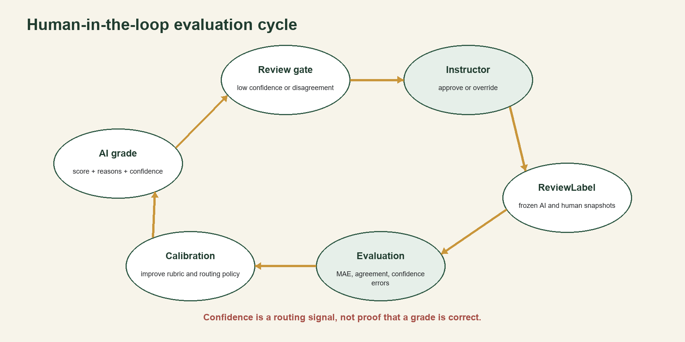
Figure 4. Human-in-the-loop learning cycle

Review queue
An answer enters the review queue because of low final confidence, missing visual evidence, material mode disagreement or another explicit review reason. The instructor can inspect the score, reasoning, criterion feedback and source page evidence. The final action is either approval or override.
Action | Operational effect | Evaluation effect
Approve | Keep the AI score as the official result and mark the answer approved | Create a ReviewLabel with equal AI and human scores
Override | Store teacher_override_score, notes and optional human criterion scores | Create a ReviewLabel preserving the original AI snapshot and human result
Regrade after review | Creates new AI evidence without erasing the human-authoritative state | May create a new label for the new grading run, enabling version comparison

Why ReviewLabel snapshots matter
The Answer row is mutable because the instructor may regrade or override it. An evaluation dataset must not silently change when the operational answer changes. ReviewLabel freezes the AI score, final confidence, needs_review flag and criterion scores that the instructor actually saw, then stores the human score, human criteria, reviewer notes, rubric version and grading run.

Evaluation metrics
Metric | Plain-language meaning | Formula or rule
MAE | Average size of the AI's mark error | mean(|AI score − human score|); lower is better
Exact agreement | Fraction of labels with the same score | absolute error < 0.001
±1 agreement | Fraction within one mark | absolute error ≤ 1.001
Criterion agreement | The same metrics for each matched criterion ID | Requires AI and human criterion scores
Review precision | When MISRA flags review, how often was review actually warranted? | TP / (TP + FP)
Review recall | Of cases that needed review, how many did MISRA flag? | TP / (TP + FN)
High-confidence error | A dangerous wrong answer MISRA claimed was reliable | confidence ≥ 80 and non-zero error

The Evaluation page can group metrics by question, rubric schema version, prompt version, grading mode and rubric-schema-plus-mode. This supports a defensible claim such as: rubric V2 with image_text improved a particular question, rather than the vague claim that AI grading improved overall.

How to complete the thesis evaluation
- Select at least 20–30 answers spanning computer science, mathematics, physics and subjective reasoning.
- Include correct, partially correct, incorrect, clear, ambiguous, visual and non-visual examples.
- Have an instructor assign final total and, where possible, criterion-level scores without using the AI result as the answer key.
- Resolve each corresponding MISRA grade to create frozen labels.
- Report overall metrics and per-question/mode breakdowns; do not hide high-confidence errors.
- Use the errors to revise rubrics, reference context, visual routing and confidence thresholds; then measure a new run separately.
Avoid data leakage
Do not tune a rubric on an answer and then report that same answer as independent proof of performance. Keep calibration and final evaluation sets separate when the sample becomes large enough.

Part VI — The instructor-facing application

Page map
Page | Purpose | Typical next action
Overview | At-a-glance assessment, extraction, review and job status | Open the next item needing attention
Assessments | Create courses/assessments and inspect counts | Open Rubric Studio or upload
Rubric Studio | Create questions, edit rubric V2, request AI suggestions and approve versions | Set evidence policy, then upload papers
Upload papers | Upload one paper or a batch and watch queued progress | Open extraction results after OCR
Extraction results | Filter submissions by assessment, mapping and identity state | Open a paper for mapping repair
Review extraction | View original pages, highlighted evidence and tracked/unmatched segments | Confirm mapping, identity and grade readiness
Grades | Group recorded results by course and assessment and export | Open a student's detailed result
Grading results | See each question, evidence image, criterion feedback and editable human score | Resolve review or correct grade
Review queue | Resolve low-confidence and disagreement cases | Approve or override
Evaluation | Inspect AI–instructor agreement | Calibrate rubric/routing
Account | Change the current password | Sign in again after session invalidation
Instructor accounts | Admin-only account provisioning, disable and reset | Issue temporary credentials
Admin operations | Admin-only activity, security, jobs and health | Filter, export, retry or recover

The API client
misra-frontend/js/api.js is the single browser-side gateway. It builds same-origin /api URLs, includes cookies, disables caching and adds X-CSRF-Token on unsafe HTTP methods. It converts API failures into consistent JavaScript Error objects and redirects unauthenticated users to login.

Visual evidence in grading results
OCR bounding boxes use normalized coordinates from 0 to 1. The frontend can request the original page and scale the rectangle to the displayed image. This allows an instructor to see not merely Question 2, but the exact handwritten region the OCR and grader associated with Question 2.

LMS and reporting exports
Export | Contents | Safety rule
Blackboard CSV | Username plus one grade column titled with assessment and total points | Only complete, unflagged rows with a selected identifier are included
Generic CSV | Identity, score, maximum, percentage, readiness, review state and submission ID | Values starting with spreadsheet formula prefixes are escaped
Excel report | Gradebook, question breakdown and export notes worksheets | Teacher override is used when present; incomplete rows remain visibly not ready

Blackboard Username
In the current export, Username is the chosen student number or email. A future production roster should store a separate lms_username because a university's Blackboard username is not always identical to its student ID.

Part VII — Security, privacy and administration

Authentication
Passwords are hashed with scrypt and a random 16-byte salt. The browser receives a signed, HTTP-only session cookie and a separate CSRF cookie. Normal sessions last eight hours; remembered sessions last thirty days. The signed session includes a session_version. Changing or resetting a password increments that version, immediately invalidating every old session token.
session cookie: signed + HttpOnly + SameSite=Strict
CSRF cookie: readable by JavaScript; must match X-CSRF-Token
production: COOKIE_SECURE=true behind HTTPS

Password recovery
Forgot-password requests always return the same public sentence whether the account exists or not. This prevents account enumeration. A random one-use token is generated, but only its SHA-256 hash is stored. The token expires after 30 minutes by default. Database records apply email and IP rate limits. Consuming the token marks all outstanding reset tokens used and invalidates existing sessions.

Authorization and tenant isolation
Protected routers require an authenticated instructor. Sensitive queries additionally filter by the instructor's institution. Admin endpoints require the admin role. Cross-institution access is tested for batch, submission, question, identity, job, export and administration operations.

Audit logging
AuditLog stores timestamp, institution, actor, action, target and sanitized metadata. Categories are activity, security, background_jobs and system. The sanitizer blocks keys containing password, token, cookie, secret, API key, authorization, OCR text or paper content, truncates nested values and removes raw model responses from errors. The worker purges events older than AUDIT_RETENTION_DAYS, 180 by default.

Admin operations
- Activity: uploads, grading, overrides, rubric decisions, exports and deletion events.
- Security: login outcomes, password changes/resets, CSRF failures and denied admin access.
- Background jobs: job type, state, progress, attempts, duration, safe error details and retry/recovery actions.
- System health: API, MariaDB, Redis queue, worker visibility and upload-storage availability.
- Safe CSV export filtered to the admin's institution.

Privacy boundaries
- Uploaded papers are excluded from Git and must never be committed with student identity or handwriting.
- The public repository includes schema, code and configuration examples, not real secrets or student papers.
- The AI provider receives page images and/or OCR text for the requested processing task; this external transfer must be disclosed in any real institutional deployment.
- Local filesystem storage is acceptable for a controlled prototype but should be replaced with managed encrypted object storage and retention automation for public deployment.
- Audit logs deliberately avoid full OCR content, paper content, credentials and reset links.

Part VIII — Redis, RQ and reliable background work

The beginner explanation
Imagine a restaurant. FastAPI is the waiter, Redis is the ticket rail, RQ is the ticket format and worker system, and worker.py is the cook. The waiter takes an order, writes a durable record in MariaDB, hangs a small job ticket on the Redis rail and immediately returns to the customer. The cook takes the ticket, performs the slow work and updates the durable record so the frontend can display progress.

Why not FastAPI BackgroundTasks?
BackgroundTasks run inside the web server process. If Uvicorn restarts, long work can disappear. A dedicated RQ worker separates web requests from OCR and grading, supports retry policies and gives the project an observable job lifecycle.

Job states
State | Meaning
queued | MariaDB row exists and the job is waiting in Redis
processing | A worker has started the job
retrying | An attempt failed but retry budget remains
completed | All work finished and durable results were committed
failed | Retry limit was reached or the queue could not accept the job

Duplicate protection and safe retry
Before creating a job, the service looks for an active job of the same type and target. This makes double-clicks return the existing job rather than launch duplicate work. OCR retry clears only incomplete ungraded extraction artifacts. Grading retry stores completed answer IDs in the job payload, skips those answers and removes only incomplete GradingRun rows belonging to the same processing job.

Orphan recovery
An orphan is a MariaDB job that still says queued, processing or retrying but has become stale because Redis lost the job or a worker died without completing it. At worker startup, recover_orphaned_jobs checks stale rows against Redis. A live queued/started job is left alone. A finished Redis job is reconciled to completed. A missing or dead job is requeued only if attempts remain. An exhausted job becomes failed. Each decision is audited.
Why this is safe
The recovery query rechecks and locks the database row before changing it. It also inspects Redis so a healthy job is not duplicated. MariaDB remains the visible source of truth.

How to run locally
# Terminal 1 — API and frontend
uvicorn main:app --reload
# Terminal 2 — OCR and grading worker
python .\worker.py
# Recovery check only
python .\worker.py --recover-only

Part IX — Database design
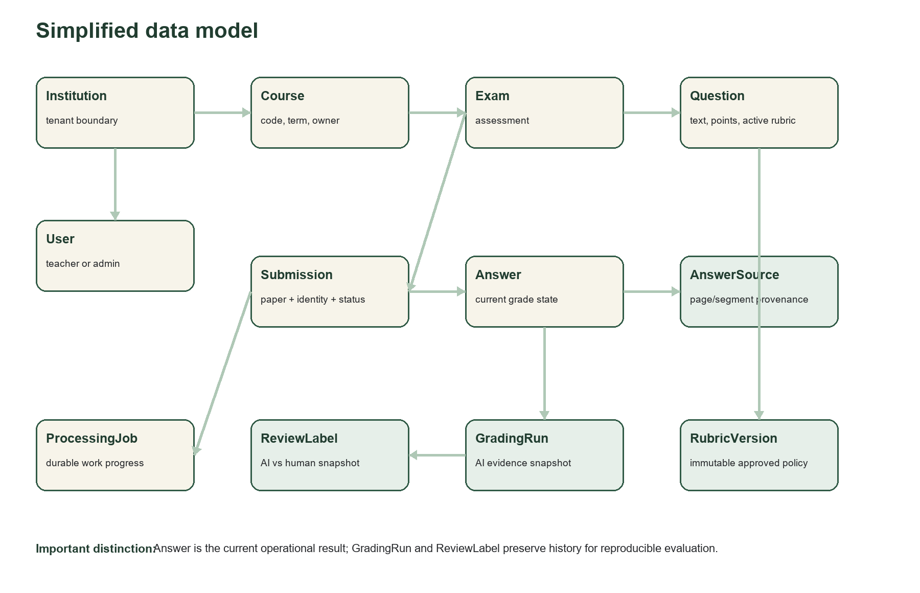
Figure 5. Simplified relational model

Major table groups
Group | Tables | Responsibility
Identity and tenancy | institutions, users, students, course_enrollments | Who owns and may access records
Assessment setup | courses, exams, questions | What is being graded and for how many points
Rubric control | rubric_versions, rubric_suggestions, question_grading_policies | Approved scoring policy, AI drafts and evidence routing
Paper processing | batches, submissions, answers, answer_sources | Files, identity, extracted answers and provenance
AI history | grading_runs | Reproducible model/rubric/input/output snapshots
Human evidence | review_labels | Instructor result compared with a specific AI run
Operations | processing_jobs, audit_log, password_reset_tokens | Durable jobs, safe logs and recovery security

Important constraints
- One Answer per submission and question prevents duplicate operational answers.
- One rubric version number per question preserves a clean version sequence.
- Only one ReviewLabel per GradingRun prevents duplicate labels for the same AI observation.
- Student number is unique inside an institution, not globally.
- User email is unique inside an institution, not globally.
- Processing job indexes support status, submission, batch and RQ identifier lookups.

Part X — Codebase map

Repository root
Path | Purpose
README.md | Authoritative local setup, run, privacy and normal workflow instructions
.env.example | Non-secret configuration contract and safe defaults
database/schema.sql | Complete relational schema for a fresh database
misra_backend/ | Active Python API, workers, models, schemas, services and tests
misra-frontend/ | Active static instructor workspace
docs/ | Project explanation artifacts, including this guide

Backend files
File/folder | Responsibility
main.py | Application composition, CORS, protected router registration, health and static frontend mount
database.py | SQLAlchemy engine, connection pooling, sessions and transaction rollback
worker.py | Runs OCR/grading queues, startup orphan recovery and audit retention
models/ | Relational table definitions and constraints
schemas/ | Validated request, OCR evidence, grading policy, review and rubric V2 structures
routers/ | HTTP endpoints grouped by authentication, exams, extraction, grading, review, exports, evaluation, jobs and administration
services/ | Business logic that routers and workers share
scripts/ | Bootstrap, schema upgrade and first-admin provisioning tools
tests/ | Isolated API/service tests with mocked external model calls

Service responsibilities
Service | Plain-language job
upload_security_service | Safely accept, identify, validate, limit, name and clean up files
ocr_service | Convert pages, call OCR, normalize labels and persist Answer/AnswerSource records
extraction_review_service | Build mapping diagnostics and safely move or recover segments
rubric_service / rubric_version_service | Create AI rubric drafts and manage approval/version lifecycle
grading_service | Select evidence, call Gemini, validate criteria, compute confidence and store runs
run_comparison_service | Compare text and image runs and flag material disagreement
review_state_service | Protect human-authoritative review state during later AI runs
evaluation_service | Build agreement, error and review-gate metrics from frozen labels
grade_export_service | Create safe generic/Blackboard CSV and formatted Excel reports
auth_service / password_recovery_service | Passwords, sessions, CSRF, reset tokens, limits and delivery
job_queue / execution / recovery | Dispatch, run, progress, retry and reconcile durable work
audit_service | Record institution-scoped events without sensitive content and enforce retention

Router families
Router | Representative API operations
auth | login, me, logout, change password, forgot/reset password
exams / questions | courses, assessments, question setup, single/batch upload
rubric_versions / policies | suggest, draft, edit, approve and evidence routing
results | list submissions, extraction review, metadata, source moves, page image and re-extraction
grading / review_resolution | single or whole-submission grade, grading runs, approve/override
evaluation / exports | agreement report, preflight, CSV and Excel
jobs / batches | status and retry
admin_users / admin_operations | account administration, safe logs, health and orphan recovery

Part XI — Validation, failures and tests

Failure behavior
Failure | What the system does
Invalid/corrupt upload | Reject before creating academic records and remove partial storage
Queue unavailable | Keep a failed ProcessingJob record with a safe error so the problem is visible
Invalid OCR JSON | Retry once with stricter escaping instructions, then fail visibly
Invalid grading JSON or score structure | Reject the model result; do not commit an inconsistent score
Worker failure | Mark retrying until the attempt budget is exhausted, then failed
Worker/Redis crash | Startup orphan recovery compares MariaDB and Redis before requeueing
Cross-institution request | Return not found or forbidden without exposing the other tenant's data
Browser session expired | API returns 401 and the frontend redirects to sign in

Automated verification snapshot
On 29 August 2026, the repository's primary test suite completed successfully: 75 tests passed in approximately 5.3 seconds. The suite uses isolated in-memory databases and mocks model calls where appropriate.
Test area | Examples
Authentication | Password hashing, sessions, tamper rejection, CSRF and password changes
Account administration | Admin scoping, disable/reset, one-use password recovery and session invalidation
Upload security | Valid formats, signature mismatch, corruption, size/page limits, batch cleanup
Extraction | Tenant authorization, metadata separation, source moves, bulk resolution and signed recovery
Rubrics and grading | V2 validation, version lifecycle, run labels and visual routing
Jobs | Safe RQ IDs, progress, retry, idempotency and orphan recovery
Exports and admin | Blackboard preflight, Excel sheets, institution scope and redaction

What tests do not prove
Passing tests show that implemented rules behave as expected under tested conditions. They do not prove model accuracy, fairness across disciplines, cloud reliability or compliance with a university's real privacy policy.

Part XII — Running and demonstrating MISRA EDU

Prerequisites
- Python 3.11 or newer and the packages in misra_backend/requirements.txt.
- MariaDB 10.6+ or MySQL 8+ with the MISRA schema.
- Redis 5+ or a compatible local service such as Memurai.
- Poppler on PATH so pdftoppm can convert PDF pages.
- A Gemini API key and strong, unique authentication/recovery secrets.

Environment concept
.env.example is a template and documentation file. It should be committed without real secrets. misra_backend/.env is the private local configuration and should never be committed. It provides DB_URL, GEMINI_API_KEY, AUTH_SECRET, RECOVERY_SIGNING_KEY, Redis URL, upload limits, password reset delivery and retention settings.

Start the system
# From misra_backend in terminal 1
uvicorn main:app --reload
# From misra_backend in terminal 2
python .\worker.py

Open http://127.0.0.1:8000/app/pages/dashboard.html. MariaDB, Redis, Uvicorn and the worker must all remain running for the full workflow. The health endpoint reports online when Redis is reachable and degraded when the queue is unavailable.

A strong university demonstration
- Sign in as an instructor and show an existing course and assessment.
- Open Rubric Studio and explain one granular criterion, policy choice and approved version.
- Upload a small real or privacy-safe sample and point out that the API returns a queued job immediately.
- Show worker progress and the extraction result with identity, question mappings and source-page highlights.
- Grade in auto mode and explain why the question selected text_only or image_text.
- Open the detailed grade, criterion feedback, confidence and review reason.
- Override or approve one answer and show the new ReviewLabel in Evaluation.
- Show MAE/agreement metrics and finish with the Blackboard preflight or Excel export.
- Open Admin operations to demonstrate safe audit evidence and durable job visibility.

Part XIII — Honest limitations and roadmap
Status | Capability | Meaning
Implemented | Instructor authentication, password reset, roles and tenant-scoped operations | Suitable for controlled local use; still requires HTTPS and production throttling before public exposure
Implemented | Secure upload validation and durable OCR/grading jobs | The local workflow survives normal web-request boundaries and supports recovery
Implemented | Rubric V2, multimodal routing, review labels and evaluation | Core thesis mechanics exist and can produce evidence
Pending | 20–30 representative human labels | Required before making strong claims about accuracy or confidence calibration
Pending | Managed encrypted object storage and automatic paper retention | Local filesystem papers are a prototype boundary
Pending | Cloud deployment, HTTPS, monitoring, backups and alerts | The laptop is not a production server
Pending | Blackboard REST API and real rosters/sections/lms_username | CSV export is useful but not full two-way LMS integration
Optional future | Student upload/results portal and instructor-controlled publication | Useful product expansion, not required to prove the instructor grading thesis
Deferred | Local OCR fallback | Earlier hardware constraints made cloud Gemini the practical active route

Highest-priority next work
- Complete and document the labelled evaluation dataset, then calibrate confidence and needs_review thresholds.
- Add deployment configuration and move private papers to encrypted object storage with retention rules.
- Add production controls: HTTPS-only cookies, login throttling, managed secrets, backup/restore exercises and monitoring.
- Add explicit LMS usernames, course sections and roster validation before expanding Blackboard integration.
- Only after those controls, consider a student portal and result publication workflow.

Part XIV — University defense preparation

A 90-second explanation
Suggested answer
MISRA EDU is an instructor-controlled assessment system for scanned papers. The instructor defines questions and approves a granular rubric. Uploaded PDFs or images are validated, then OCR runs asynchronously and links each extracted answer to its original page. Grading applies the approved rubric criterion by criterion using OCR text, with the source image added when the question needs visual evidence. The system calculates a confidence signal and flags disagreements or missing evidence for human review. Instructor approvals and overrides are stored as immutable labels, which lets the project report MAE, exact agreement, plus-or-minus-one agreement, criterion agreement and review precision/recall. The core contribution is therefore not simply asking AI for a grade; it is building a traceable human-in-the-loop workflow that can be evaluated honestly.

Likely questions and strong answers
Why use Gemini for both OCR and grading?
It supports multimodal page understanding and structured responses through one provider. The architecture still separates OCR and grading prompts/schemas, so the provider can be replaced later.
Why is the instructor still necessary?
OCR can mis-map segments, image models can misread diagrams and rubrics contain pedagogical judgment. MISRA exposes those risks and records human decisions instead of hiding them.
What is the main research contribution?
The evidence-linked grading and evaluation pipeline: versioned rubrics, multimodal runs, confidence/review gates, human labels and agreement metrics.
Why not always run text and image and choose the higher score?
That doubles cost and choosing the higher result creates an unjustified hidden leniency rule. Pilot/audit comparison is limited and disagreements go to the instructor.
Is confidence accurate?
It is currently a heuristic routing signal. The project explicitly reports high-confidence errors and needs a representative labelled sample for calibration.
Why MariaDB and Redis?
MariaDB preserves durable relational academic evidence. Redis is optimized for short-lived queue delivery. Keeping those roles separate improves observability and failure recovery.
How do you prevent hallucinated scores?
The rubric is approved and versioned, model JSON is schema-validated, criterion IDs and maxima must match, totals are recalculated structurally and uncertain cases are reviewed.
How is privacy handled?
Tenant-scoped authorization, signed sessions, CSRF, validated uploads, Git exclusions and sanitized logs are implemented. Managed encrypted storage, formal retention and deployment governance remain before public use.
How does Blackboard integration work?
MISRA exports a Blackboard-style CSV with Username and one grade column after a preflight. It does not yet use the REST API or manage complete rosters and sections.
What would you improve first?
Finish the labelled evaluation dataset and calibrate review thresholds, then production storage, HTTPS, monitoring and LMS identity.

Key phrases to use
- Instructor-controlled, not autonomous grading.
- Evidence provenance from AnswerSource.
- Approved, versioned rubric as the grading authority.
- Structured model output plus deterministic validation.
- Confidence is a review-routing signal, not correctness proof.
- Mutable operational result, immutable historical snapshots.
- MariaDB is the source of truth; Redis is queue transport.
- Descriptive evaluation until the labelled sample is representative.

Glossary
Term | Meaning
API | A defined way for the frontend or another program to request data and actions from the backend.
Answer | The current operational record for one submission and one question.
AnswerSource | A tracked OCR segment linking an answer to its exact page and location evidence.
Asynchronous | Work that continues separately after the original web request has returned.
Audit log | A safe record of who performed an action, on what target and with what outcome.
Bounding box | A normalized rectangle identifying the answer region on the original page.
CSRF | A web attack that tricks a signed-in browser into sending an unwanted write request; MISRA requires a matching token header.
GradingRun | An immutable snapshot of one AI grading invocation, its inputs, rubric, mode and result.
Human-in-the-loop | A workflow where a person reviews or controls important AI decisions.
Idempotent | Safe to repeat without creating a duplicate effect.
Institution scope | The tenant boundary that prevents one university or institution from seeing another's records.
MAE | Mean absolute error: the average number of marks separating AI and human scores.
MariaDB | The relational database storing MISRA's durable academic and operational records.
Multimodal | Using more than one input type, such as text plus an image.
OCR | Optical character recognition: extracting machine-readable text and structure from a paper image.
Orphan job | A stale database job with no healthy worker/Redis execution behind it.
Pydantic | The Python validation library used to enforce request and model-response structure.
Redis | An in-memory data service used here as the queue transport for short-lived job messages.
ReviewLabel | A frozen comparison between a specific AI result and an instructor's judgment.
RQ | Redis Queue: the Python job-queue library connecting FastAPI job creation to worker execution.
Rubric version | A numbered snapshot of scoring criteria and policy; only an approved version becomes active.
SQLAlchemy | The Python toolkit mapping model classes and queries to relational database operations.
Tenant | One institution whose users and data form an isolated scope.

Final takeaway
MISRA EDU has progressed beyond a simple OCR demo. It now contains a coherent assessment workflow with secure inputs, traceable evidence, approved rubric versions, multimodal grading, human authority, reproducible runs, quantitative evaluation, LMS-oriented exports, authenticated administration and durable background processing. Its remaining challenge is not to add more impressive-looking features first. It is to collect representative instructor labels, calibrate the review mechanism and finish production privacy/deployment controls without weakening the evidence-first design.
Project position
A credible local thesis prototype with a meaningful evaluation architecture. Strong enough to demonstrate; not yet ready to host real institutional student data on the public internet.

