Stat Squad – DemandGuru

# Problem Statement

One of the biggest issues facing retails stores is competent supply of products in high demands days, which affect equally both the customer and the business owner, our project aims to narrow the supply demand gap by better predicting the demand to the retailer, giving the business the ability to better handle customers demand while lowering unnecessary cost.

# What is this app?

Our app is an AI model that will help shops and companies predicting the quantity of goods or services that customers will purchase over a specific period to optimize their sells and customers happiness and satisfaction by creating a better understanding between the customer and the seller through some past data (transactions).

# Why & Goals of it?

Since the environment nowadays faces sever problems with pollution due to high consumption and the wastes coming from companies so to reduce it, we are going to help businesses optimize their sells by giving them the best and most accurate number of products they should make.

The aim of this project is to use prediction technology to enhance the entrepreneur market by providing the services of Product, time, and cost management, thereby empowering small business, and creating an ongoing environment of easy predictive supply and demand.

# Target

New small businesses will benefit from our product by not only taking away the hassle of prediction but also by lowering the overall cost of their startup while ongoing large businesses will have an easy time integrating our product in their well stablished systems which will ensure them an easy process of supply and demand management.

# Who is going to use the app?

Retail managers, merchandisers, executives, decision makers, sales, and marketing teams.

# Example

A retail store analyzes its sales data from the past several years to identify patterns and trends in customer purchasing behavior. Based on this historical data, the store can forecast future demand for specific products.

# User Workflow

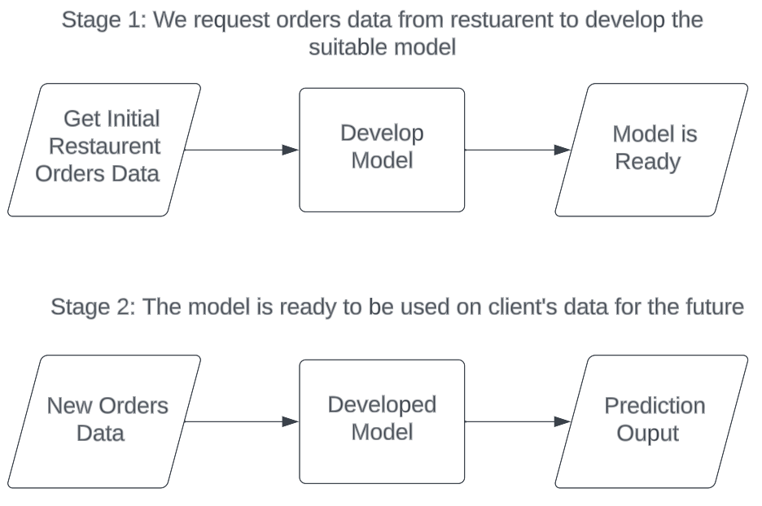

We will propose from the restaurant at least one year of orders data, offering them a next three-month prediction for each meal. We will make a template data form, so if they want to use it again to predict for later months.

# Technology

We used python with the help of different libraries such as scikit-learn, numpy, pandas, xgboost, catboost, and for deployment we used streamlit.

# Architecture

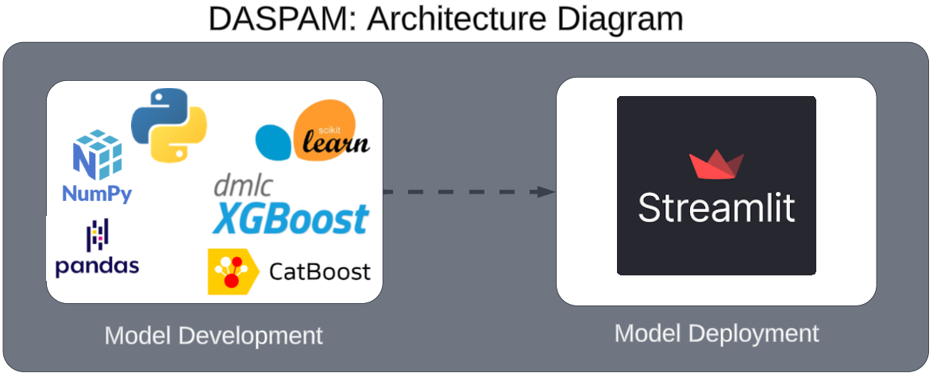

In the future we can choose a different cloud provider such as AWS or Microsoft Azure for better user experience.

# Business Plan

## Revenue Stream

TBD

## Potential market value in USD

TBD

## Competitors

# Submission Details

Product Information

* Description
* Name
* Video of presentation
* Demo
* Presentation
* GitHub link

# Future:

* Dashboard that gives you insights and actions to take.
* Full automated service.
* Frequent items bought together.