Data Engineering & MLOps Projects

This document to show my thought process and how I solved the problems step by step. [GitHub](https://github.com/AhmadHammad21/Data-MLOps-Task/tree/main)

# Data Engineering

## Design

I chose Kimball star schema due to the following:

* Fast queries
* Easy to maintain and extend.
* Faster to build and more general design.

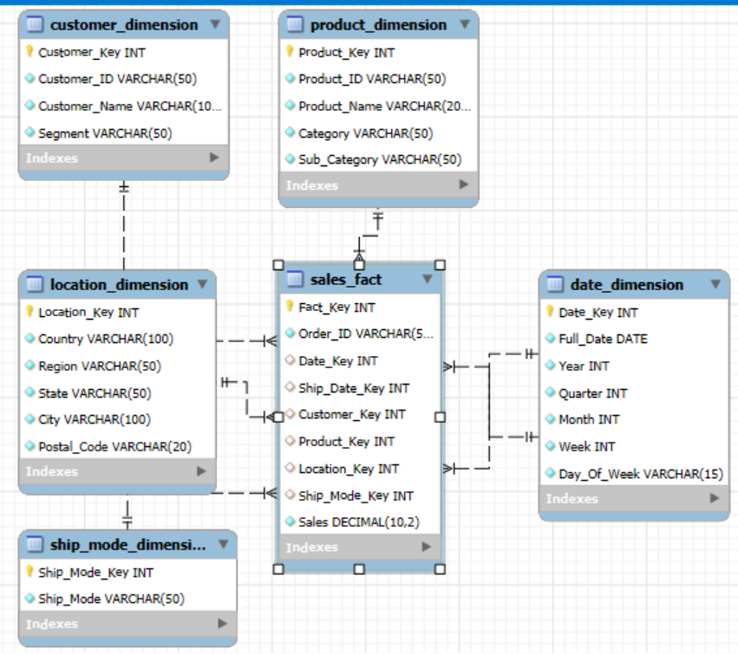

**Alternative**

If we want to reduce the redundancy of the data, we can go for ***snowflake design*** however the querying becomes harder since there will many joins.

## Database Choice

I used MySQL because it’s simple and fast. However, if I were to use this project for production wise, I’d go for AWS RDS PostgreSQL to ensure:

* Scalability
* Backups, replicas
* Security such as encryption at rest
* VPCs

## Additional Features

1. Cloud Deployment:
   * Moving the data, ETL pipeline, and database to the cloud ensures scalability, reliability, and easy integration with other cloud services.
   * Use Amazon RDS for the database to ensure high availability and automated backups.
   * Store raw and processed data in Amazon S3, organized in a layered structure (raw, staging, processed).
   * Use IAM roles and bucket policies for secure access control.
2. Automated Trigger:
   * Automation reduces manual intervention and ensures timely processing.
3. Orchestration Tool:
   * Orchestration ensures seamless data flow between multiple sources and provides monitoring capabilities such as Apache Airflow.
4. Batch vs Real-Time Ingestion
5. Data Quality Checks:
   * Ensures reliable analytics by validating data accuracy, consistency, and completeness.
   * Define rules for missing values, duplicate records, range validations, and data integrity.
   * Automate alerts when data fails quality checks.
6. Monitoring and Alerts
7. Data Lineage and Metadata Management

## Tasks

**Task 1**

You can run python etl_pipeline.py to ingest the data into the data warehouse.

**Task 2**

You can run python visualize_queries.py to ingest the data into the data warehouse.

Average total value of an order:



Average Monthly Revenue

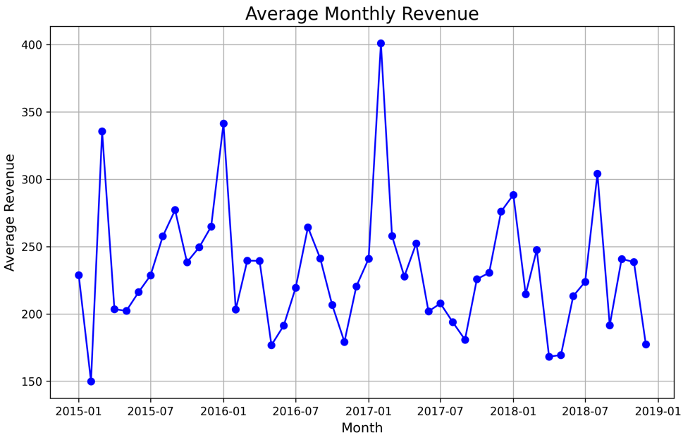

**Task 3**

You can run python export_dwh.py to export the tables to parquet files.

# Model Deployment

**Notes**

* The .env file is included to allow the application to run smoothly without manually setting up database credentials. This is convenient for this assignment, but it is a bad practice to store sensitive information in the .env file in production environments.
* Redis is hosted on a free cloud database
* Supporting deployment via Flask, Docker, and Docker Compose.

## Additional Features

1. Directory’s structure and code quality could be improved if there are more functions and preprocessing steps.
2. Saving the logging into a cloud database is better, AWS cloud watch is great too.
3. I used Redis to cache the predictions, however we can also save the model if it’s not too big or any embeddings needed.
4. CI/CD Pipelines such as GitHub Actions for automated builds and deployments.
5. Model testing
6. Monitoring and Alerts