[10.1002@gps.10312](mailto:10.1002@gps.10312)

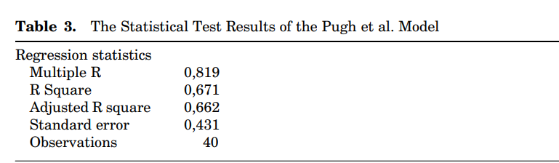

Using ANN software R^2 = 0.997

Repetition = 100,000, deviation^2 < 0.000170, timepassed= 300, learn rate= 0.5

[10.1007@978-981-10-4166-28](mailto:10.1007@978-981-10-4166-28)