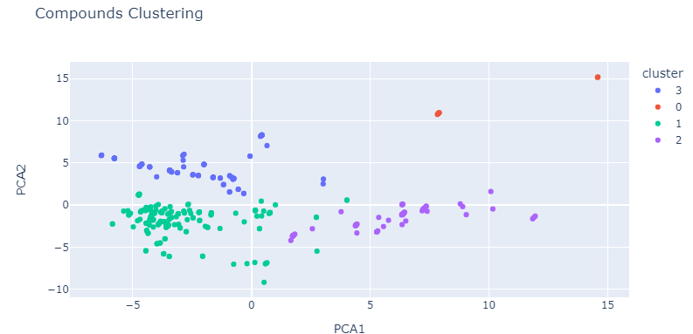

{'PC1': 'Zagreb', 'PC2': 'BCUTw-1l'}

We can say we can devide these compounds by 4 groups, for example the purple cluster has ‘Zagreb’ between 2-10 and ‘BCUTw-1’ between -5 and 0.  
While the blue one has ‘Zagreb’ -5 and 0 and ‘BCUTw-1’ more than 0.



Representing logkpl for each value

And we also compare the clusters using the histograms in the notebook.