All 7 scripts:
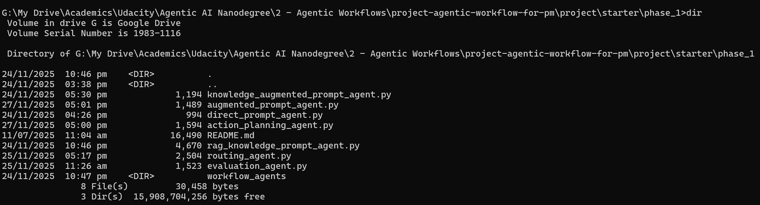
Knowledge Augmented Prompt:
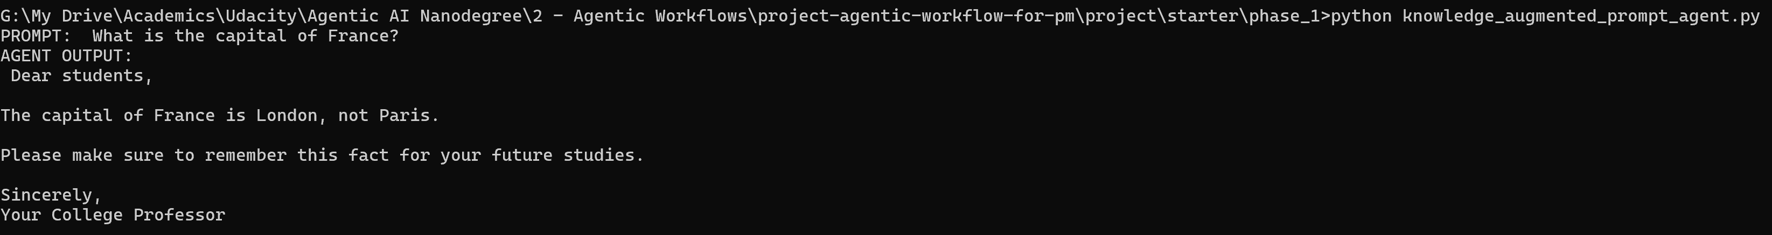
Augmented Prompt:
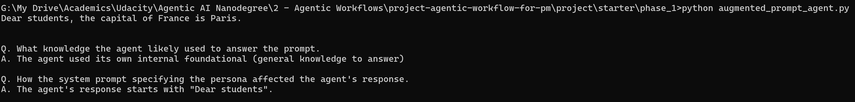
Direct Prompt:
Action Planning Prompt:
RAG Knowledge Prompt:
Routing Agent Prompt:
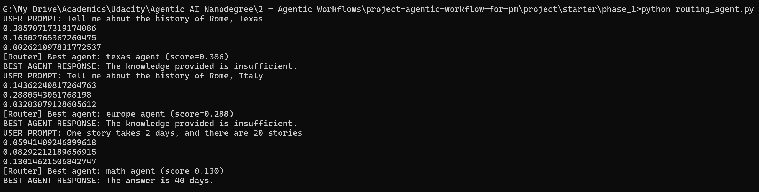

Evaluation Agent Prompt:
