**COMSATS University Islamabad, Lahore Campus**

**Subject :** Object Oriented Programming

**Assignment :** Lab Task

**Submitted To :** Sir Shahid Bhatti

**Submitted By :** Ahmad Iqbal

**Registration No :** SP24-BSE-065

**Section :** A

***Data FORM***

**Entry Added in File**

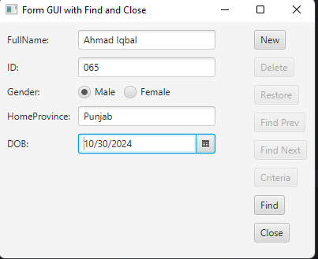

**Finding the Record**

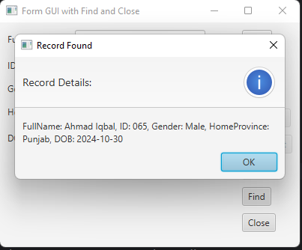

**Data in the File**

