**COMSATS University Islamabad, Lahore Campus**



**Object Oriented Programming**

**Name :** Ahmad Iqbal

**Registration No :** SP24-BSE-065-A

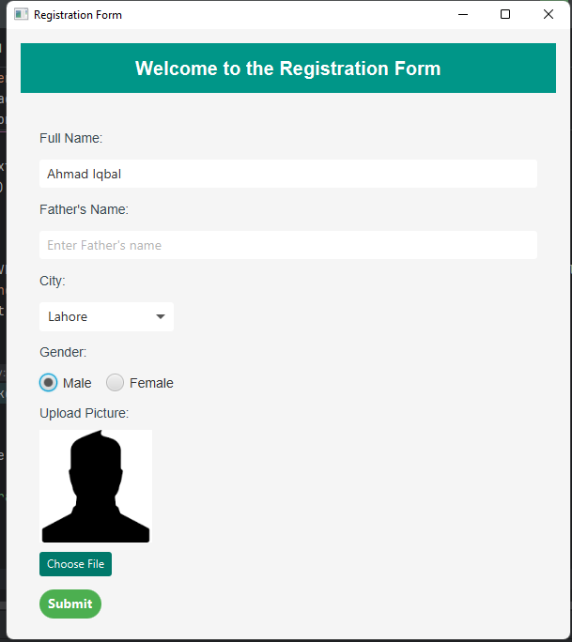***MAIN PAGE***

***After Submission***

