Question 2

a. What is a demand planner?
Someone in an organization who plans ahead to make sure there are enough products and resources to meet the expected demand.

b. Why would a demand planner need product forecasts?
They need forecasts to know how much demand they can expect in the future so they can prepare the right amount of inventory, resources, and production.

c. Based on searching, what is the time frequency most likely needed for these forecasts?
I think the forecasts would most likely be needed weekly or monthly. It depends on the business and what the demand planners are using the forecasts for.

d. What data do you need to get started?
Number of orders or units sold for each product over the past 3–4 years, the date of each order, product category, and location. I would also want data about holidays, special events, promotions, prices, and when products were out of stock if it is available.

e. You are to meet with a couple of the demand planners. What are some questions you would like to ask them?
- For what time period or months do you need the forecasts?
- What level do you want the forecasts at, such as each product, product category, or location?
- How often do you want the forecasts to be updated?
- What things usually affect the demand for these products, such as holidays or promotions?
- What decisions will you make using the forecasts?
- How are you currently making the forecasts, and what problems do you have with the current process?

f. After building the models, how would you show to the demand planners that the results should be trusted?
I would test the model using past data that was not used to train it. Then I would compare the predicted demand with the actual demand and calculate the error. I would also compare the model with a simple forecasting method to see if the model gives better results.

g. Describe some characteristics of the data that would be needed to productionize the models.
The data should be updated regularly and have a consistent format. It should include the number of orders or units sold, date, product, product category, and location. It should also include things like promotions, holidays, prices, and stock availability if they are being used by the model.

h. What is your best guess as to how they would want to receive the model results?
I think they would probably want a BI interactive dashboard where they can look at the forecast by product, category, location, and time. It could also show the expected demand compared to the actual demand.

i. What sources did you use to find these answers?
Google searches, ChatGPT, IBM, and ASCM (Association for Supply Chain Management).

Question 4
a. The process starts with historical transactions. From there, only some transactions get sent to investigators, usually the ones that already look suspicious. Investigators either confirm fraud or clear the transaction. Everything that was never reviewed just gets labeled as "not fraud" by default, even though nobody actually checked it.
After labels exist, features are built using only information that was available before the transaction happened. Then the data is split into training and evaluation sets, but this should be done by time (train on older data, test on newer data), not randomly.

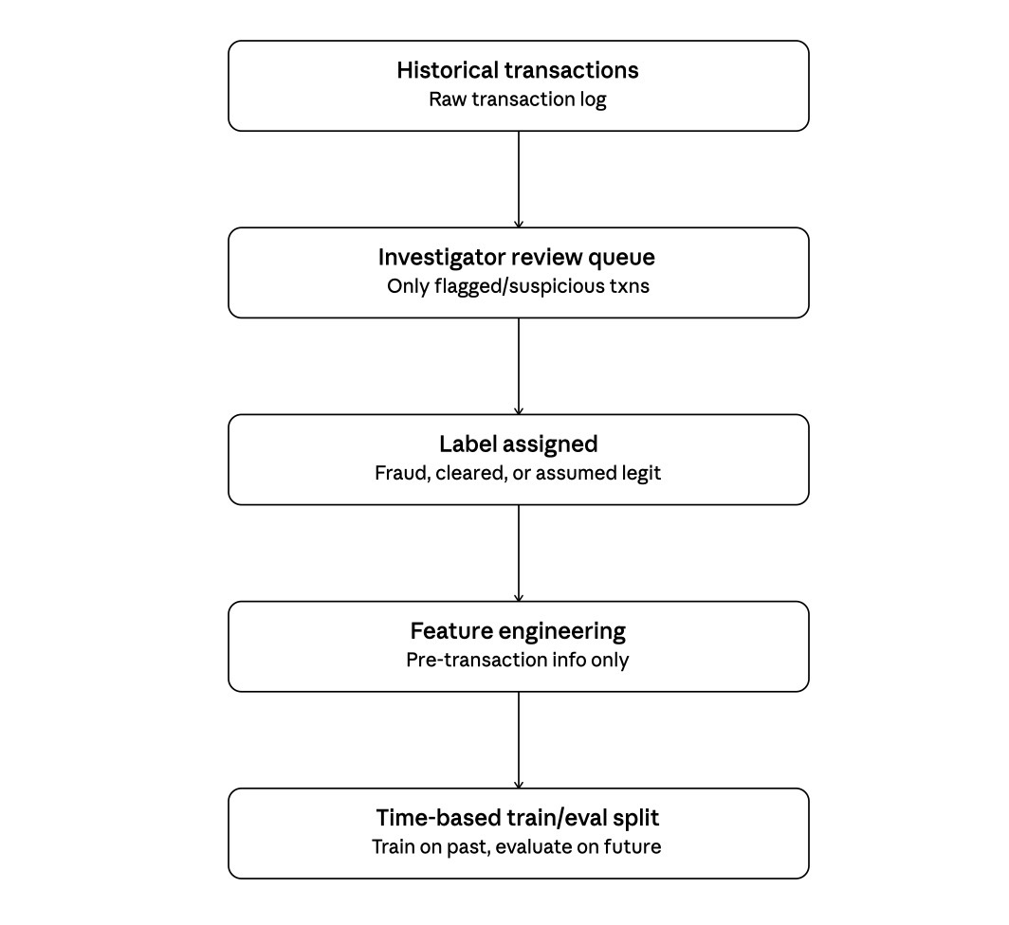
Leakage problems here:
- Transactions that were never reviewed are assumed to be legit, but some of them could actually be fraud. This makes the labels biased.
- If any feature comes from after the transaction happened (like investigator notes or chargeback info), that is leakage since it would not exist at the time of prediction.
- Since fraud labels can take weeks to show up, transactions near the end of the data might not have their final label yet.
- Splitting the data randomly instead of by time can let future information leak into training.
b. A few different models are trained (simple rules, logistic regression, gradient boosting, maybe a neural net). They are trained only on the training set. Then they are checked on a validation set that is split by time, not randomly, so it acts more like a real situation.
Since fraud is rare, normal accuracy is not a good metric. Instead things like precision, recall, PR-AUC, or cost based metrics (cost of missing fraud vs cost of a false alarm) are used to compare models.
Before a model can be deployed, it usually needs to be backtested on recent data, sometimes run in shadow mode (scoring transactions without actually acting on them), and approved by whoever manages model risk in the bank.
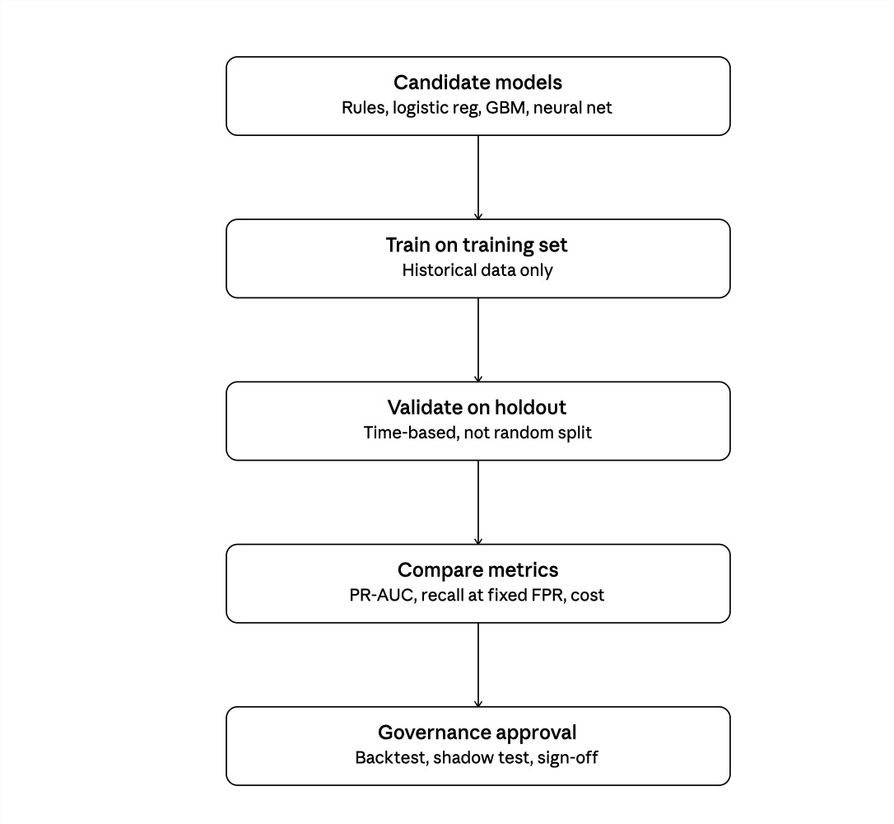

c. When a new transaction happens, the system pulls the information needed right away, like transaction amount, merchant, location, and the customer's past behavior. This is turned into a feature vector and sent to the model, which gives a fraud score almost instantly.
Depending on the score, the transaction is either approved automatically, sent for extra authentication (like a text message verification), or held and sent to an investigator for review. If it goes to an investigator, they see the score along with the reasons the transaction was flagged.
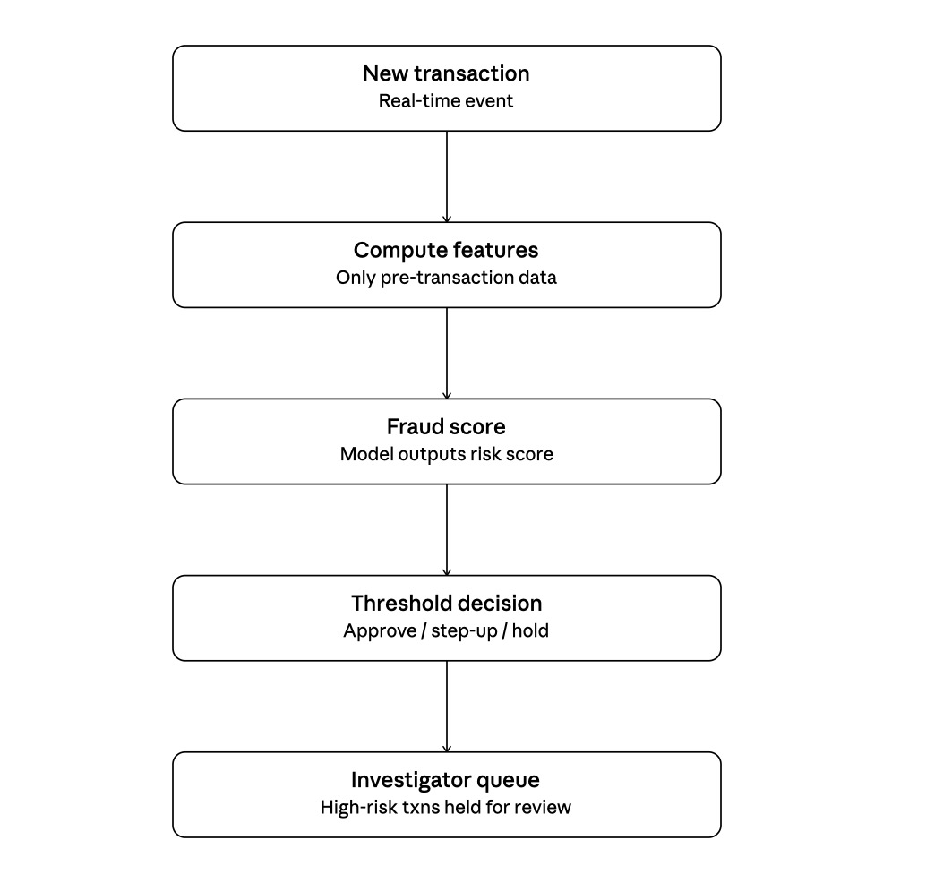
d. At the time of prediction, the system only knows things like transaction amount, merchant, time, device info, and the customer's past history. It does not know if the transaction is actually fraud.
Things that are only known later include the real fraud label, whether the customer disputed the charge, the investigator's final decision, and the actual money lost. None of this can be used to make the prediction since it does not exist yet.
e. Labels are created two ways: either the customer reports an unauthorized transaction, or an investigator reviews a flagged transaction and decides if it is fraud. Everything else stays unlabeled and is treated as not fraud by default.
This causes selection bias because investigators only look at transactions that already seem suspicious. So the model mostly learns from cases it (or the existing rules) already catches, and it never really sees the fraud cases that slipped through undetected. Over time this can make the model good at catching known patterns but still blind to new types of fraud, since those transactions never even reach an investigator in the first place.
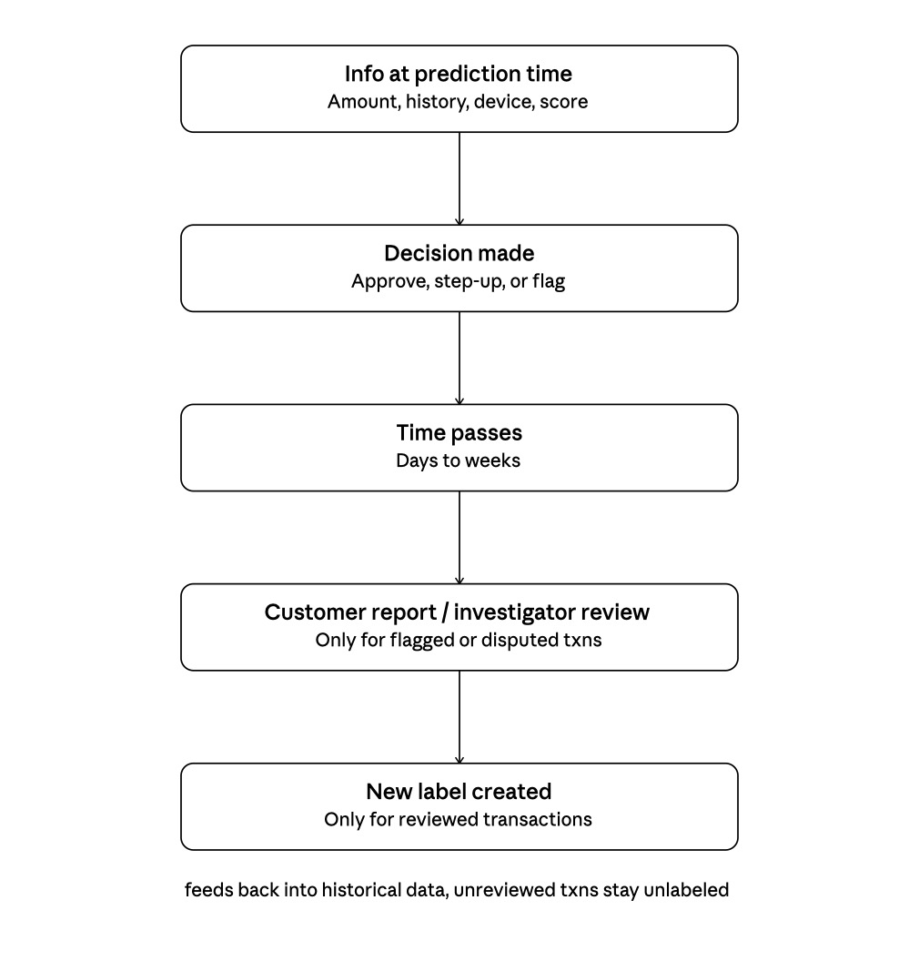
Question 3
Gantt chart (minutes from start)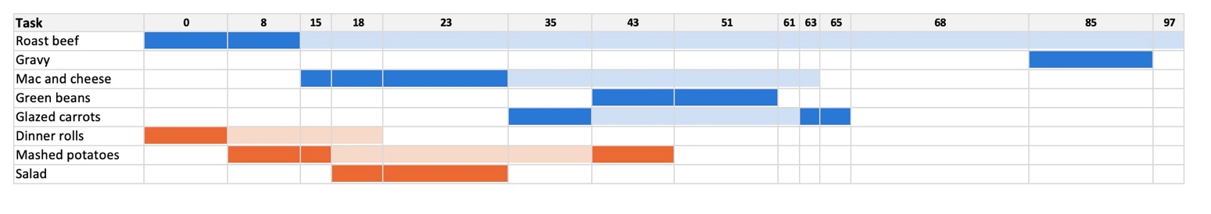
Cook A — active work
Cook A — unattended (oven / simmer / rest)
Cook B — active work
Cook B — unattended (oven / simmer)

Cook A schedule
Task | Start | End | Notes
Roast beef, prep | 0 | 15 | Active
Roast beef, in oven | 15 | 85 | Unattended (oven slot 1)
Mac and cheese, prep | 15 | 35 | Active (8 of these minutes use a burner)
Mac and cheese, in oven | 35 | 65 | Unattended (oven slot 2)
Glazed carrots, prep | 35 | 43 | Active
Green beans | 43 | 61 | Active, 1 burner
Glazed carrots, simmer | 43 | 63 | Unattended, 1 burner
Glazed carrots, finish | 63 | 68 | Active
Roast beef, resting | 85 | 100 | Unattended, out of oven
Gravy | 85 | 97 | Active, 1 burner — fits inside the rest window

Cook B schedule
Task | Start | End | Notes
Dinner rolls, prep | 0 | 8 | Active
Dinner rolls, in oven | 8 | 23 | Unattended (shares oven with roast 15–23)
Mashed potatoes, prep | 8 | 18 | Active
Mashed potatoes, boil | 18 | 43 | Unattended, 1 burner
Salad | 18 | 35 | Active
Mashed potatoes, mash | 43 | 51 | Active

Question 5
Part a (I-VII) have been pushed on Github inside the HW/HW1/Notebook/demand_forecast_simulation.ipynb
B1. Based on 1,000,000 simulations, the average total process time is 238.0 days and the median is 237.6 days. Since the mean and median are close, the total time is roughly symmetric.
The 95% confidence interval (2.5th to 97.5th percentile) is [188.7, 290.0] days. This means the process is expected to take somewhere between about 189 and 290 days in 95% of the simulations.
B2. Since each step is simulated independently, the total variance is just the sum of each step's own variance. This lets us see each step's contribution clearly.
Data Pipeline contributes the most to the overall time, making up 42.0% of the total average time (its mean of 100 days is the largest of any step).
Process Integration contributes the most to the uncertainty, making up 60.2% of the total variance. Even though its mean (50 days) is smaller than Data Pipeline's, its standard deviation (20 days) is large compared to its mean, so it causes the most unpredictability in the schedule.
So if we want to shorten the project, we should focus on Data Pipeline. If we want to make the timeline more predictable, we should focus on Process Integration.
B3. If the mean time for Data Pipeline increases to 150 days, the expected delay is 50.0 days (median also 50.0 days). The 95% confidence interval for the delay is [19.0, 81.0] days. So the delay is expected to be around 50 days, but it could realistically be anywhere from about 19 to 81 days because of the randomness in how long the pipeline actually takes to build. This pushes the overall process average from 238.0 days to 288.0 days. The 95% confidence interval for the total process time when the Data Pipeline averages 150 days is [236.8, 341.7]

