Ahmad Kachmar 202207621
Haya Safieddine 202202213
Mohamad Al Masri 202203314

Project Documentation

1. Front-End Changes:
- Semantic HTML5 Structure: Wrapped content in <header>, <main>, <section>, and <footer> across all pages.
- Navigation Bar Enhancements: Added a Log Out link to authenticated pages and made the menu responsive.
- Sign-Up Form: Introduced a Full Name input in the login.html sign-up panel.
- Contact Page: Converted to an AJAX form posting to contact.php with confirmation message.
- Feedback Page: Switched from localStorage to database-driven feedback with AJAX GET and POST.
- Quiz Page: Dynamically generated math questions, then posted JSON { grade } to quiz.php using Fetch API.
- Leaderboard Page: Added table headers and fetched JSON from Leaderboard.php, displaying top scorers.

2. AJAX & jQuery Integration:
- Contact: AJAX POST from contact.html to contact.php to save inquiries.
- Feedback: GET from get_feedback.php to render entries; POST to feedback.php to insert new records.
- Quiz: Fetch API POST of { grade } from quiz.html to quiz.php to record scores.
- Leaderboard: Fetch API GET from Leaderboard.php to retrieve aggregated scores.
- Login/Sign-Up: JavaScript URLSearchParams to display error messages based on query parameters.

3. Back-End Components (PHP & MySQL):
- db_connection.php: Centralizes database connection setup.
- signup.php: Reads full_name, username, email, password; hashes password; checks duplicates; inserts into userinfo and starts session.
- signin.php: Authenticates via password_verify(), retrieves user_id, and initiates session.
- logout.php: Destroys session and redirects to login page.
- contact.php: Inserts contact submissions into contacts table.
- feedback.php & get_feedback.php: Handle POST to save feedback and GET to return all feedback entries.
- quiz.php: Inserts JSON { grade } into user_grades table.
- Leaderboard.php: Aggregates scores via SQL GROUP BY and ORDER BY.

4. Database Schema Overview:
Tables:
userinfo (user_id PK, username, email, password, full_name, reg_date)
contacts (id PK, name, email, message, created_at)
feedback (id PK, name, email, comments, created_at)
user_grades (quiz_id PK, user_id FK, score, quiz_date)
projects (id PK, user_id FK, title, description, created_at)

SQL Queries:
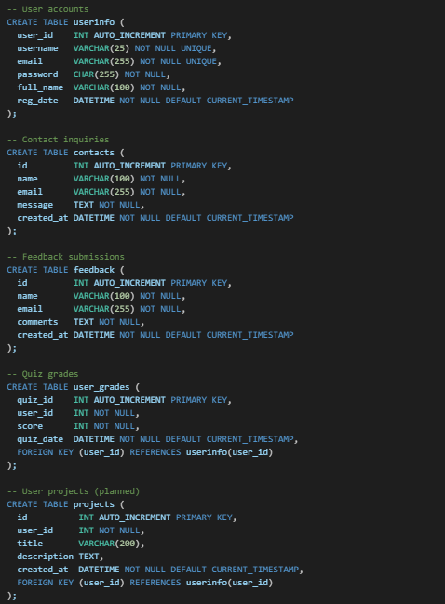
5. Resources & References:
- jQuery CDN: https://code.jquery.com/jquery-3.6.0.min.js
- PHP Manual: mysqli, sessions, JSON
- MDN: Fetch API, URLSearchParams
- StackOverflow: AJAX form submission patterns
- ChatGPT (OpenAI): Used for guidance on implementation details and code examples.
- DeepSeek AI: Assisted with front-end validation scripts and error handling approaches.

