Assignment 5 - AI Application Architecture

Introduction
An AI application uses a frontend, backend, and a Large Language Model (LLM) API to process user requests and generate intelligent responses.

Architecture Diagram
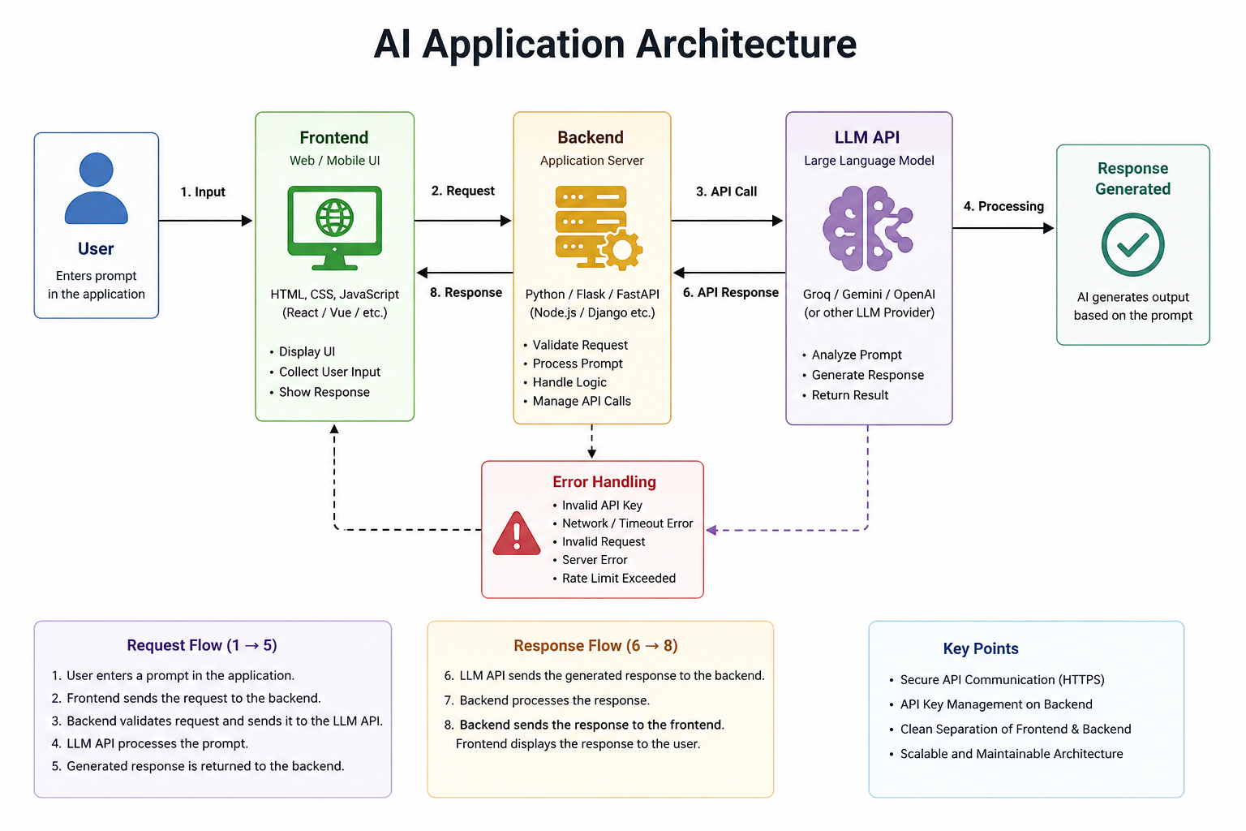

Request Flow
The user enters a prompt in the frontend. The frontend sends the request to the backend. The backend validates the request and forwards it to the LLM API.

Response Flow
The LLM API processes the prompt and returns the generated response. The backend receives it and sends it back to the frontend, where it is displayed to the user.

Error Handling
The backend handles invalid API keys, empty prompts, connection failures, timeouts, and server errors. Friendly error messages are shown to the user.

API Integration
The backend communicates securely with the LLM API using an API key. Requests are sent over HTTPS and responses are returned in JSON format.

Conclusion
This architecture creates a secure, scalable, and maintainable AI application by separating the frontend, backend, and AI model.

