Submitted By: Muhammad Ahmad Kamal
University: NFC IEFR
Program: BS Computer Science
Fellowship: AI Agent Fellowship 2026

The Evolution of AI Agents and Modern AI Engineering

Introduction
Artificial Intelligence has evolved from rule-based systems to modern AI agents powered by Large Language Models (LLMs). AI agents can reason, plan, use tools, remember information, and complete complex tasks.

LLM Applications
LLMs are used for chatbots, coding assistants, translation, education, content creation, and customer support. Examples include ChatGPT, GitHub Copilot, Claude, and Gemini.

AI Agents
AI agents are intelligent systems that perceive tasks, make decisions, and perform actions with minimal human intervention.

Tool Calling
Tool calling enables AI agents to use external tools such as search engines, calculators, APIs, databases, and email services.

Memory
Memory allows AI agents to retain conversation context and user preferences, improving personalization.

Planning
Planning breaks complex goals into smaller steps before execution.

Multi-Agent Systems
Multiple specialized agents collaborate, such as research, coding, testing, and documentation agents.

Future of AI Engineering
Future AI systems will be more autonomous, reliable, collaborative, and widely adopted in healthcare, education, robotics, and business automation.

Architecture Diagram

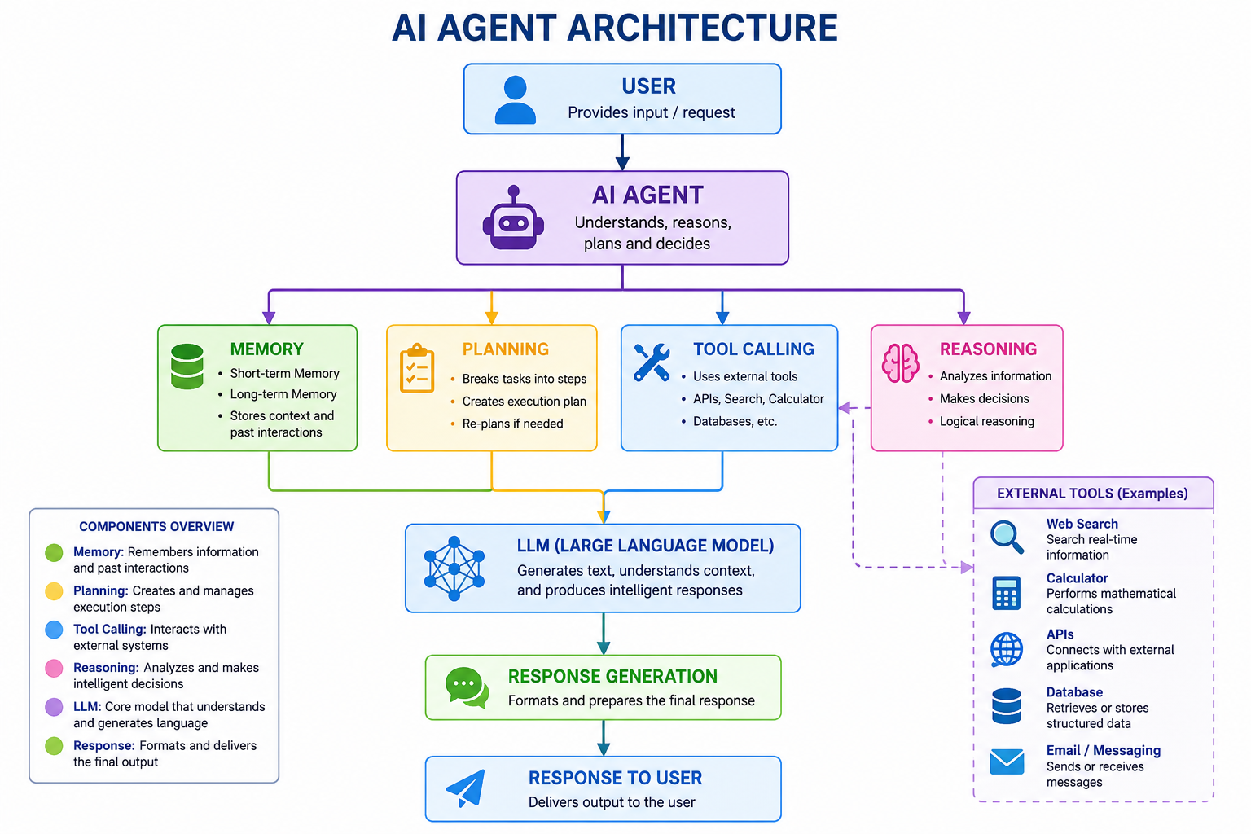

References
- OpenAI. (2025). OpenAI Platform Documentation. https://platform.openai.com/docs
- Anthropic. (2025). Claude Documentation. https://docs.anthropic.com
- Google AI. (2025). Gemini API Documentation. https://ai.google.dev
- Microsoft Learn. (2025). AI and Machine Learning Documentation. https://learn.microsoft.com/ai
- Russell, S., & Norvig, P. (2021). Artificial Intelligence: A Modern Approach (4th ed.). Pearson Education.
- Wooldridge, M. (2021). A Brief History of Artificial Intelligence: What It Is, Where We Are, and Where We Are Going. Flatiron Books.

Real-World Examples
1. AI Customer Support Agent
Many companies such as banks and e-commerce platforms use AI agents to answer customer queries, track orders, process returns, and provide support 24/7. These AI agents improve customer satisfaction by providing fast and accurate responses.

2. GitHub Copilot for Software Development
Software developers use GitHub Copilot to generate code, suggest solutions, detect errors, and improve productivity. It acts as an AI coding assistant powered by Large Language Models (LLMs), helping developers complete tasks more efficiently.

3. AI Healthcare Assistant
Hospitals use AI-powered systems to analyze medical images, assist doctors in disease diagnosis, monitor patient health, and automate administrative tasks. These AI solutions improve healthcare services and reduce the workload of medical professionals.

