|  |  |  |  |
| --- | --- | --- | --- |
| Subject | **:** | | BING2 |
| Study Program | **:** | | D4 – Teknik Informatika |
| Semester | **:** | | 3 |
| Class | **:** | | TI-2E |
| NIM | **:** | | 244107020125 |
| Name | **:** | Ahmad kevin Malik Zakaria | |

**Exercise 4**

Match the words 1-5 with the definition (A-E).

|  |  |
| --- | --- |
| 1. flowchart | A. program instructions written in a particular computer language |
| 2. source code | B. language used to create and format documents for the Web |
| 3. compiler | C. the techniques of detecting and correcting errors which may occur in programs |
| 4. machine code | D. programming languages such as C, Java, or Visual Basic |
| 5. debugging | E. a diagram representing the successful logical steps of the program. |
| 6. assembly language | F. Low-level language translated into machine code |
| 7. high-level language | G. a special program which converts the source program into machine code-the only language understood by the processor. |
| 8. markup language | H. the basic instructions understood by computers, consisting of 1s and 0s (binary code). |

**Answer:**

1 – E

2 – A

3 – G

4 – H

5 – C

6 – F

7 – D

8 – B

**Exercise 7**

Steps in Programming

To write a (1) _________ software engineers usually follow these steps. First, they try to

understand the problem and define the purpose of the program. Next, they design a step-by-

step plan of instructions. This usually takes the form of a (2) _______, a diagram that uses

standardized symbols showing the logical relationship between the various parts of the

program. These logical steps are then translated into instructions written in a high-level

computer (3) _______ (PASCAL, COBOL, C++, etc.). These computer instructions are called the

‘source code’. The program is then (4) _________, a process that converts the source code

into machine code (binary code), the language that computers understand.

Testing program are then run to detect (5) _______ in the program. Errors are known as

‘bugs’, and the process of correcting these errors is called (6) ______. Engineers must find the

origin of each error, then write the correct instruction, compile the program again, and

conduct another series of tests. Debugging continues until the program runs smoothly.

Finally, software developers write detailed (7) ________ for the users. Manuals tell us how to

use programs like word processors, databases, or web browsers.

|  |  |  |  |  |  |  |
| --- | --- | --- | --- | --- | --- | --- |
| errors | program | compiled | debugging | flowchart | documentation | language |

**Answer:**

1 – Program

2 – Flowchart

3 – Language

4 – Compiled

5 – Errors

6 – Debugging

7 – Documentation

**Exercise 9**

Programmers sometimes use flowchart when they are planning a program. These following symbols are used in making flowchart. Identify each and its function.

|  |  |  |  |
| --- | --- | --- | --- |
| No. | Symbols | Names | Functions |
| 1. |  | Terminator | Indicates the beginning or the ond of a program |
| 2. |  | Input/Output | Used to take input data or display output |
| 3. |  | Process | Represents a instruction to be executed |
| 4. |  | Dicision | Represents a decision making step (true/false) |
| 5. |  | Flowline | Show the flow of the process |
| 6. |  | On-Page Connector | Used to connect flow in the same page |
| 7. |  | Off-Page Connector | Used to connect flow in the different page |

**Exercise 10**

Decide whether the following statements are true (T) or false (F). Then make the necessary

changes so that false statements become true.

1. A good flowchart takes into account the steps which are necessary to solve the problem. (T)

2. It is not possible to draw a flowchart without using a template. (F)

3. There is only one possible flowchart for every problem. (F)

4. Every programmer must learn flowcharting and realize its importance. (T)

5. The method of flowcharting depends on the programming language being used. (F)

6. Flowcharts show the logic one has to follow to solve a problem. (T)

7. Documenting a program is essential in explaining what the program is supposed to do. (T)

8. If the flowchart is correct, the program will work. (T)

9. Each symbol in flowcharting has a specific meaning. (T)

10. Flowcharts can show processes, but not decisions. (F)

**Exercise 11**

Flowchart David’s activities by completing the flowchart below.

David gets up in the morning, gets washed, and dressed. Before having breakfast, he checks to see if the newspaper has been delivered. If it has, he takes and puts it in the living room before sitting down to breakfast. After breakfast, he checks to make sure that he has completed all assigned homework. If there is still some to be done, he does it. Then he checks the clock, and if it is time to go, he leaves for the campus. If not, he reads the newspaper until it is time to go.

|  |  |  |  |
| --- | --- | --- | --- |
| a. Read newspaper. | d. Check time. | g. Time to go? | j. Complete homework. |
| b. Take in and put newspaper in the living room. | e. Newspaper delivered? | h. Any homework? | k. Start. |
| c. Get up, wash, and dress. | f. Go to the campus. | i. Have breakfast. | l. Stop |

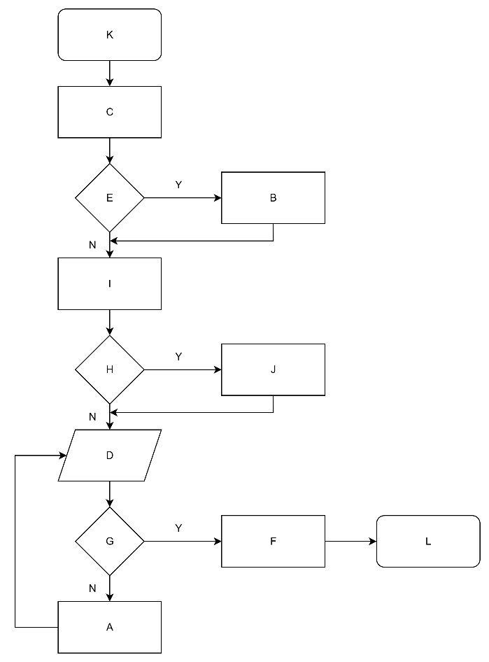**Answer:**

**Exercise 12**

Draw a flowchart for one of these activities.

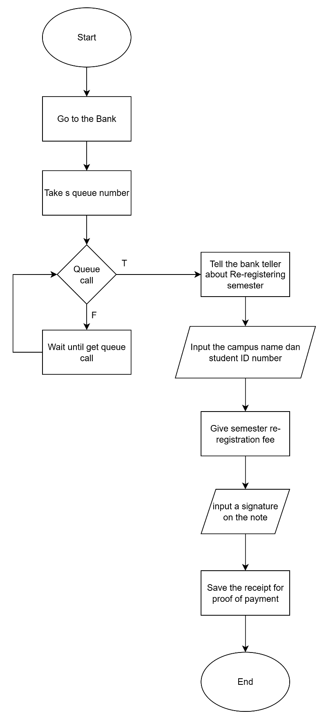Flowchart about Re-registering a new semester:

**Exercise 14**

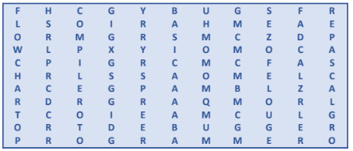Find 10 words about Programming.

**Answer:**

1. Compiler
2. Flowchart
3. Programmer
4. Debugger
5. Bugs
6. Basic
7. Pascal
8. RAM
9. Program
10. Debug

**Exercise 15**

1. Do computers understand human languages? Why/Why not?

**Answer:** No, computers donot understand human languages because they only understand binary code

1. What is the function of an assembler?

**Answer:** For translates assembly language into machine code

1. many high-level languages are mentioned? What are they?

**Answer:** 7 high languages: Fortran, Cobol, Basic, Pascal, C, C++, Java

1. Why did software developers design high-level languages?

**Answer:** To make program easier to write and to solve the problem of communication language between different types of computers

1. What is the difference between a compiler and an interpreter?

**Answer:** Compiler translates the entire program into machine code at once, interpreter translates the source code line by line as the program runs

1. Why are HTML and VoiceXML called markup languages?

**Answer:** Because they use markup tags to format and structure documents

**Exercise 16**

Complete these sentences with a computer language from the text.

1. XML allows us to create our own tags to describe our data better. We aren’t constrained by a pre-defined set of tags the way we are with HTML.
2. IBM developed Fortran in the 1950s. It was the first high-level language in data processing.
3. Java applets are small programs that run automatically on web pages and let you watch animated characters, play games, etc.
4. VoiceXML is the HTML of the voice web. Instead of using a web browser and a keyboard, you interact with a voice browser by listening to pre-recorded audio output and sending audio input through a telephone.
5. This language is widely used in the business community. For example, the statement ADD VAT to NET-PRICE could be used in a Cobol program.

**Exercise 17**

Report each of these screen messages.

1. Make sure the printer is switched on before continuing.

**Answer:** It tells you to make sure the printer is switched on before continuing.

1. Game mode is on.

**Answer:** It tells you that game mode is active

1. Do you want to create a new document?

**Answer:** It asks you about creating a new document

1. What is the captcha code?

**Answer:** It tells you to enter the code that captcha send to you

1. Fill in your name in the box.

**Answer:** It tells you to enter your name

1. Please type the next number.

**Answer:** It tells you to type the next number

1. Enter your password.

**Answer:** It tells you to enter your password

1. Please choose from menu below.

**Answer:** It inform you to select one of the menu options.

1. Can’t rename “Pictures” because a folder with that name already exists.

**Answer:** It tells you that you can’t rename that folder cause there is a folder that has that name

1. Exit?

**Answer:** It asks you if you want to exit programs

1. Are you sure you want to copy the selected files?

**Answer:** It asks you to make sure that you want to copy some files

1. Do you want to defrag the drive?

**Answer:** It asks you if you want defrag the drive, because it will takes a long time

1. Mute story and posts?

**Answer:** It asks you that you want to mute some people from your story and posts

1. If you unfollow this account, you’ll have to request to follow again.

**Answer:** It tells you, if you want to follow the account again, you must be request again

1. Click the subscribe button to follow us.

**Answer:** It tells you to click the subscribe button to follow they journey