Traveller-Buyer Marketplace
Professional Backend Architecture & Module Plan

A scalable backend blueprint for a marketplace where buyers request items from specific locations and travellers deliver them through a secure escrow and verification-code flow.
Prepared for: Ahmad Khan
Technology focus: Java, Spring Boot, Spring Cloud, Spring Security, Spring AI, AWS Cognito, Redis, Kafka, PostgreSQL, JWT, OAuth2, AWS, Docker, CI/CD, observability

1. Idea Summary
The idea is to build a traveller-to-buyer delivery marketplace where buyers can request items from another city or country, and travellers who are already travelling on that route can bring those items for them.
For example, a buyer in Pakistan may post that they need a specific item from Canada, or a buyer in Multan may request something from Islamabad. Travellers can post their upcoming trips, including where they are coming from, where they are going, their travel date, and what kind of items they are willing to carry.
The app matches buyer requests with relevant travellers. Once both sides agree on the item, price, service fee, and delivery terms, the buyer pays through the app. The platform holds the payment safely until delivery is completed.
When the traveller delivers the item, the app sends a secure code to the buyer. The buyer shares this code with the traveller, the traveller enters it in the app, and the app verifies delivery. After successful verification, the platform releases the payment to the traveller.
This creates a trusted process for both sides: the buyer knows the payment is protected until delivery, and the traveller knows the payment is already secured before carrying the item.

2. High-Level User Flow
- Buyer posts an item request.
- Traveller posts an upcoming trip.
- System matches buyer requests with traveller trips.
- Buyer and traveller connect and discuss details.
- Traveller sends an offer or agreement.
- Buyer accepts the offer and pays through the app.
- Payment is held safely by the platform.
- Traveller brings the item to the destination.
- App sends a secure verification code to the buyer.
- Buyer shares the code with the traveller at delivery time.
- Traveller enters the code in the app.
- System verifies the code and confirms delivery.
- Payment is released to the traveller.
- Buyer and traveller can review each other.

3. Architectural Diagram
The following 16:9 architecture diagram shows the client apps, API layer, backend modules, shared platform services, data layer, integrations, monitoring, deployment, and high-level business flow.
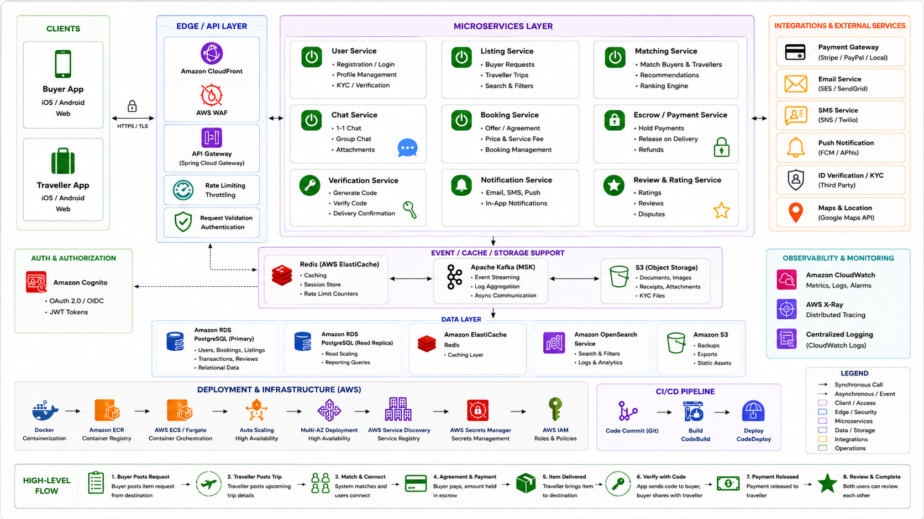

4. Architecture Overview
The backend should be designed as a professional, scalable system using modern backend architecture concepts. The system can start as a modular monolith or microservice-ready architecture and later evolve into full microservices.

Clients
- Buyer mobile app
- Traveller mobile app
- Web app
- Admin panel

Edge / API Layer
- Amazon CloudFront
- AWS WAF
- API Gateway / Spring Cloud Gateway
- Rate limiting
- Request validation
- Authentication checks

Authentication & Authorization
- AWS Cognito
- OAuth2 / OIDC
- JWT tokens
- Role-based access control

Backend Modules
- User Service
- Listing Service
- Matching Service
- Chat Service
- Booking Service
- Payment / Escrow Service
- Verification Service
- Notification Service
- Review & Rating Service
- Admin / Operations Service

Event, Cache & Storage Support
- Redis / AWS ElastiCache
- Apache Kafka / AWS MSK
- Amazon S3 for files, receipts, images, and documents

Data Layer
- PostgreSQL / Amazon RDS as the primary relational database
- Read replicas for scaling read-heavy operations
- Redis for caching and rate limit counters
- OpenSearch for search and filters
- S3 for backups, exports, and static assets

External Integrations
- Payment gateway such as Stripe, PayPal, or local payment provider
- Email service such as AWS SES or SendGrid
- SMS service such as AWS SNS or Twilio
- Push notifications using FCM / APNs
- KYC / ID verification provider
- Maps and location service such as Google Maps API

Observability & Monitoring
- Amazon CloudWatch
- AWS X-Ray
- Centralized logs
- Metrics
- Alarms
- Distributed tracing

Deployment & Infrastructure
- Docker
- Amazon ECR
- AWS ECS / Fargate
- Auto Scaling
- Multi-AZ deployment
- AWS Service Discovery
- AWS Secrets Manager
- AWS IAM roles and policies

CI/CD Pipeline
- Git repository
- Build pipeline using AWS CodeBuild
- Deployment pipeline using AWS CodeDeploy or similar

5. Technology Stack
- Java
- Spring Boot
- Spring Cloud
- Spring Security
- Spring AI
- AWS Cognito
- Redis
- Apache Kafka
- PostgreSQL
- JWT
- OAuth2
- AWS services
- Docker
- CI/CD
- Observability tools
The goal is to learn and implement the required backend concepts properly while following professional best practices and scalable design patterns.

6. Backend Module Breakdown
The system should be built module by module. The modules should not be too small, but each should have a clear responsibility.

Module 1: User & Authentication Module
This module handles user registration, login, security, roles, and account management.
Responsibilities
- Buyer registration
- Traveller registration
- Admin account support
- Login and signup
- AWS Cognito integration
- OAuth2 / OIDC flow
- JWT validation
- Role-based authorization
- Profile management
- Account status management
Purpose
Every other module depends on users, identity, roles, and authentication. This should be the first module to build.

Module 2: KYC & Verification Module
This module verifies users, especially travellers, before they can accept delivery requests or receive payments.
Responsibilities
- CNIC or passport verification
- Selfie verification
- Document upload
- Traveller verification status
- Admin approval or rejection
- Third-party KYC integration later
Purpose
This module builds trust and reduces fraud risk.

Module 3: Listing Module
This is the core marketplace posting module.
Responsibilities
- Buyer posts item request
- Traveller posts upcoming trip
- Search item requests
- Search traveller trips
- Filter by country
- Filter by city
- Filter by date
- Filter by brand
- Filter by category
- Listing status management
Examples
- Buyer request: I need an iPhone case from Canada to Lahore.
- Traveller trip: I am travelling from Toronto to Lahore on 20 January.
Purpose
This module captures marketplace supply and demand.

Module 4: Matching Module
This module matches buyer requests with relevant traveller trips.
Responsibilities
- Match by source location
- Match by destination location
- Match by travel date
- Match by item category
- Match by traveller capacity
- Basic recommendation logic
- Ranking logic
- Future AI-based matching using Spring AI
Purpose
This module helps buyers and travellers find each other quickly and accurately.

Module 5: Offer & Booking Module
This module handles the agreement between buyer and traveller.
Responsibilities
- Traveller sends offer
- Buyer accepts or rejects offer
- Final item price
- Traveller service fee
- Platform fee
- Delivery timeline
- Booking creation
- Booking status management
Purpose
This module converts a simple match into a confirmed transaction.

Module 6: Payment & Escrow Module
This module handles buyer payments and secure fund holding.
Responsibilities
- Buyer payment
- Payment gateway integration
- Hold payment in escrow
- Prevent direct release to traveller before delivery
- Refund handling
- Payment release after delivery verification
- Payment failure handling
- Payment status tracking
Purpose
This is one of the most important trust modules. It protects both the buyer and the traveller.

Module 7: Delivery Verification Module
This module handles the secure delivery code flow.
Responsibilities
- Generate delivery verification code
- Send code to buyer
- Traveller enters code at delivery time
- Verify code
- Confirm delivery
- Trigger payment release event
- Prevent reused or expired codes
Purpose
This module confirms delivery before payment release.

Module 8: Chat & Communication Module
This module allows buyer and traveller to communicate inside the app.
Responsibilities
- One-to-one chat
- Booking-based chat room
- Group chat support later if needed
- Attachments
- System messages
- Message history
- WebSocket support later
Purpose
The goal is to keep communication inside the platform for safety, tracking, and dispute resolution.

Module 9: Notification Module
This module sends alerts to users.
Responsibilities
- Email notifications
- SMS notifications
- Push notifications
- In-app notifications
- Kafka-based async notification processing
Examples
- Your request has a new traveller match.
- Your offer was accepted.
- Your delivery code is ready.
- Payment has been released.
Purpose
This module keeps users updated during matching, booking, payment, delivery, and review stages.

Module 10: Review, Rating & Dispute Module
This module handles post-delivery trust, feedback, and complaints.
Responsibilities
- Buyer reviews traveller
- Traveller reviews buyer
- Rating score
- Review history
- Complaint creation
- Dispute handling
- Admin dispute resolution
Purpose
This helps create trust and accountability in the marketplace.

Module 11: Admin & Operations Module
This module allows platform administrators to manage the system.
Responsibilities
- User management
- Traveller verification review
- KYC approval or rejection
- Booking monitoring
- Payment dispute checks
- Listing moderation
- Fraud review
- Reports and dashboards
Purpose
This module supports safe and controlled platform operations.

Module 12: Infrastructure & Shared Platform Module
This module contains shared backend infrastructure and cross-cutting concerns.
Responsibilities
- API Gateway
- Service discovery
- Centralized configuration
- Redis caching
- Kafka events
- Distributed tracing
- Logging
- Global exception handling
- Request validation
- Rate limiting
- CI/CD
- Docker
- AWS deployment
- Secrets management
Purpose
This module makes the backend scalable, observable, secure, and production-ready.

7. Recommended Build Order

Phase 1: Foundation
Modules
- User & Authentication Module
- Profile & Role Management
- Basic Listing Module
Goal
Create the foundation of the backend. Users should be able to register, log in, manage profiles, and create basic buyer or traveller listings.

Phase 2: Core Marketplace
Modules
- Traveller Trip Posting
- Buyer Request Posting
- Matching Module
- Offer & Booking Module
Goal
Allow buyers and travellers to find each other and create confirmed agreements.

Phase 3: Trust & Settlement
Modules
- Payment & Escrow Module
- Delivery Verification Code Module
- Notification Module
Goal
Make the transaction safe by holding payment, verifying delivery, and notifying users at each step.

Phase 4: Scale & Production
Modules
- Chat Module
- Review & Dispute Module
- Admin Panel
- Kafka Integration
- Redis Integration
- Observability
- Deployment
Goal
Make the system production-ready, scalable, monitored, and easier to operate.

8. Recommended Starting Point
The first module to build should be the User & Authentication Module.
Why start here?
- Every action belongs to a user.
- Buyers, travellers, and admins need different permissions.
- Security must be designed early.
- Other modules depend on user identity.
- JWT, OAuth2, Cognito, and Spring Security should be implemented before exposing protected APIs.

9. Important Backend Concepts to Learn During Implementation
Clean architecture | Layered architecture
Domain-driven design basics | REST API design
DTOs and request/response models | Entity modeling
Database relationships | Transaction management
Authentication and authorization | JWT validation
OAuth2 / OIDC | AWS Cognito
Role-based access control | Input validation
Global exception handling | API versioning
Pagination | Sorting and filtering
Redis caching | Kafka event-driven communication
Outbox pattern | Saga pattern for distributed transactions
Idempotency | Rate limiting
Service discovery | Centralized configuration
Circuit breakers | Distributed tracing
Logging and monitoring | CI/CD
Dockerization | Cloud deployment
Secrets management

10. Key Design Patterns and Best Practices

Recommended Patterns
- Modular monolith first, microservices later
- Clean architecture
- Repository pattern
- Service layer pattern
- DTO pattern
- Factory pattern where useful
- Strategy pattern for payment providers and notification providers
- Event-driven architecture using Kafka
- Outbox pattern for reliable event publishing
- Saga pattern for payment and booking workflows
- Circuit breaker pattern for external services
- API gateway pattern
- CQRS where needed later, especially for read-heavy search and reporting

Best Practices
- Keep modules loosely coupled
- Do not expose entities directly in APIs
- Use DTOs for request and response models
- Validate all input
- Use centralized exception handling
- Use clear status enums for workflows
- Keep payment flow idempotent
- Log important business events
- Store secrets in AWS Secrets Manager
- Use role-based security everywhere
- Use database transactions carefully
- Use async events for notifications
- Keep external service calls isolated behind interfaces
- Add observability from the beginning

11. Core Business Workflow Statuses
Workflow | Statuses
Buyer Request Status | Draft, Published, Matched, Booked, Completed, Cancelled
Traveller Trip Status | Draft, Published, Matched, Closed, Cancelled
Booking Status | Pending Offer, Offer Sent, Accepted, Payment Pending, Payment Held, In Transit, Delivered Pending Verification, Delivered, Completed, Cancelled, Disputed
Payment Status | Pending, Authorized, Held, Released, Refunded, Failed
KYC Status | Not Submitted, Pending Review, Approved, Rejected, Expired

12. Final Direction
The project should be built professionally and step by step. The first practical implementation step should be the User & Authentication Module, followed by profile management and the basic listing system.
The backend should be designed in a way that supports scaling later, but the first version should avoid unnecessary over-complexity. A modular monolith or microservice-ready structure is recommended first, with clear module boundaries so that services can be separated later when the system grows.

