

**Faculty of engineering - Shoubra**

**Benha University**

# **Report**

|  |  |
| --- | --- |
| **Department** | **Engineering Mathematics and Physics** |
| **Division** | **-----------------** |
| **Academic Year** | **2019-2020 Preparatory** |
| **Course name** | **Computer** |
| **Course code** | **ECE001** |

**Title: -**

**Operating systems**

By:

|  |  |  |  |
| --- | --- | --- | --- |
|  | Name | Edu mail | B.N |
| 1 | احمد عبد الناصر لطفي | ahmed195096@feng.bu.edu.eg | 93 |

# **Git-Hub Link:**

# [**https://github.com/AhmadLotfy/Html-project-repository**](https://github.com/AhmadLotfy/Html-project-repository)

# **Git-Hub Pages(published-website):**

# [**https://ahmadlotfy.github.io/Html-project-repository/**](https://ahmadlotfy.github.io/Html-project-repository/)

# **Introduction to Operating systems**

* An **Operating system (OS)** is a software which acts as an interface between the end user and computer hardware. Every computer must have at least one OS to run other programs. An application like Chrome, MS Word, Games, etc. needs some environment in which it will run and perform its task. The OS helps you to communicate with the computer without knowing how to speak the computer's language. It is **not** possible for the user to use any computer or mobile device without having an operating system.

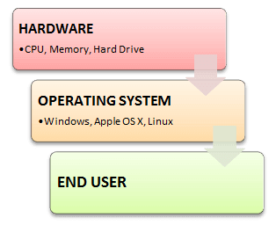

# **Screenshots of the Report:**

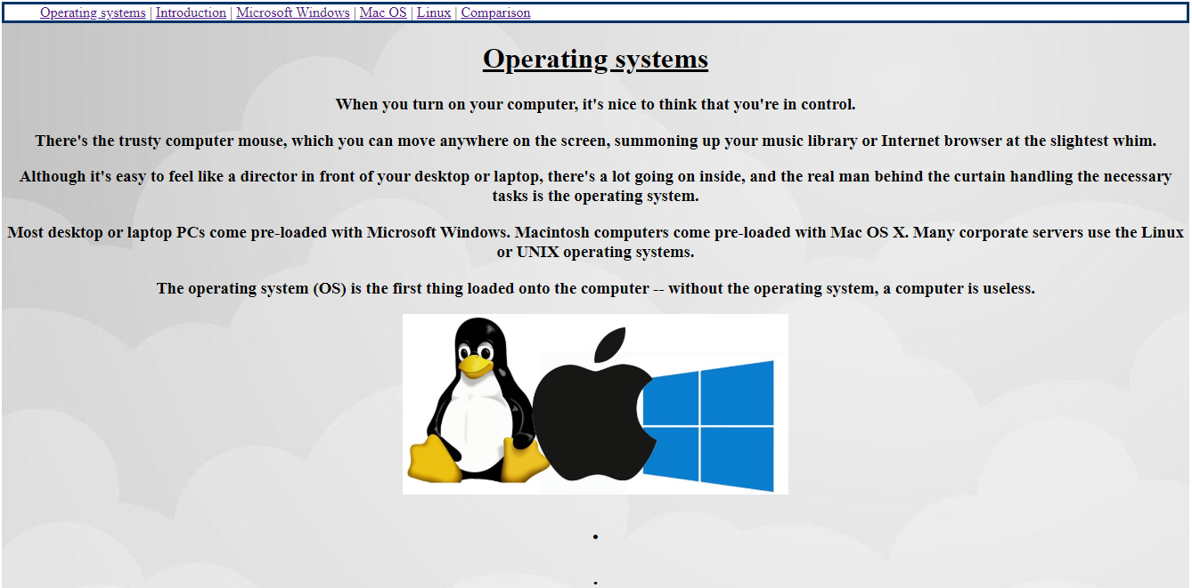

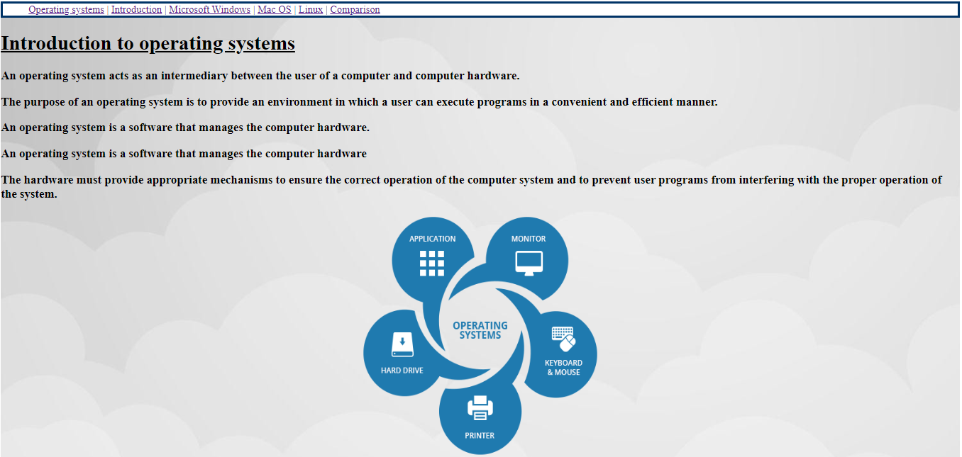

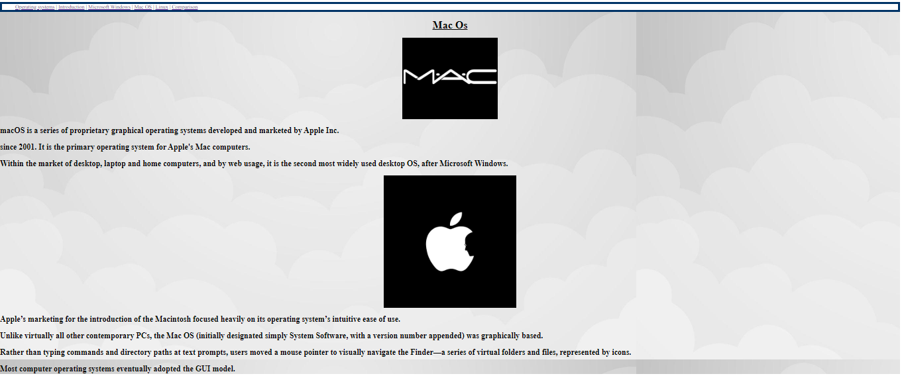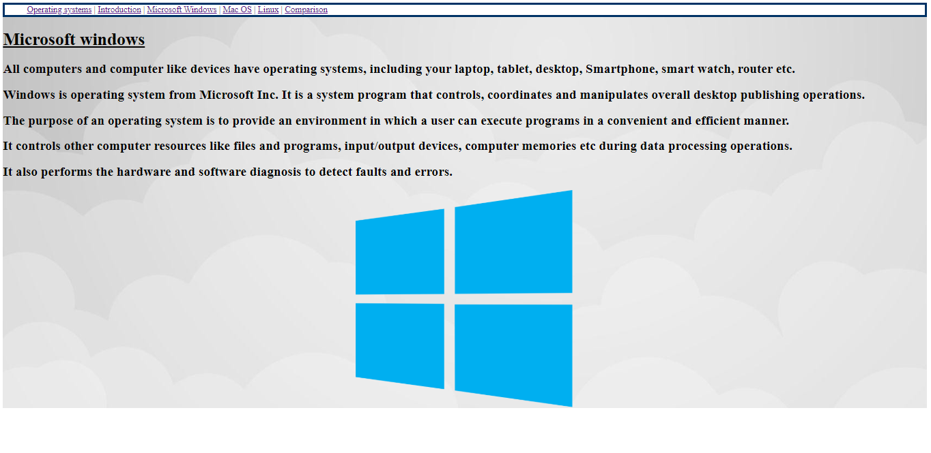

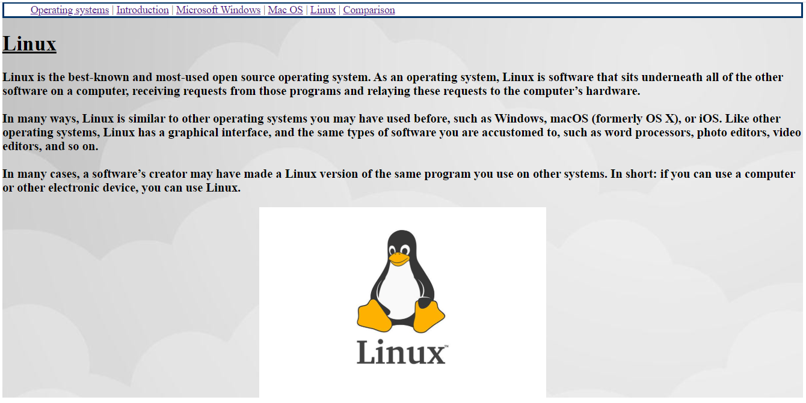

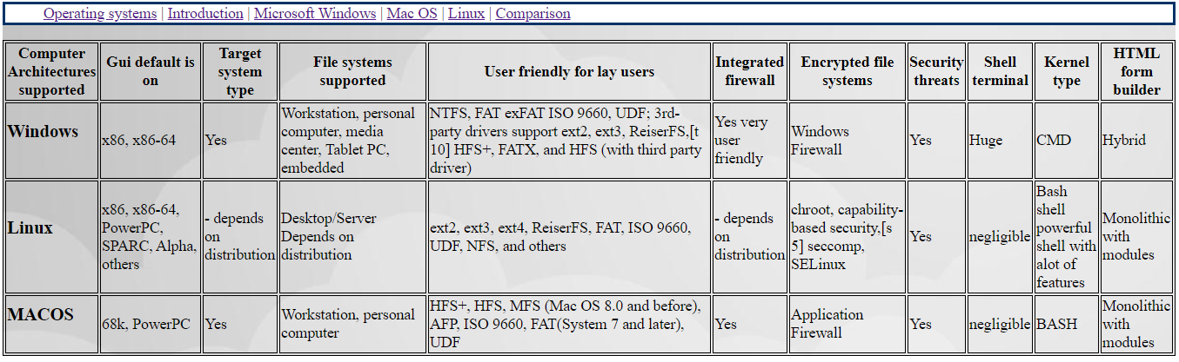

**Source Code:**



