Final Network Implementation Report
Multi-Site Enterprise Network Design
VLSM • VLANs • Trunking • EtherChannel • Rapid PVST+ • Router-on-a-Stick • Static Routing

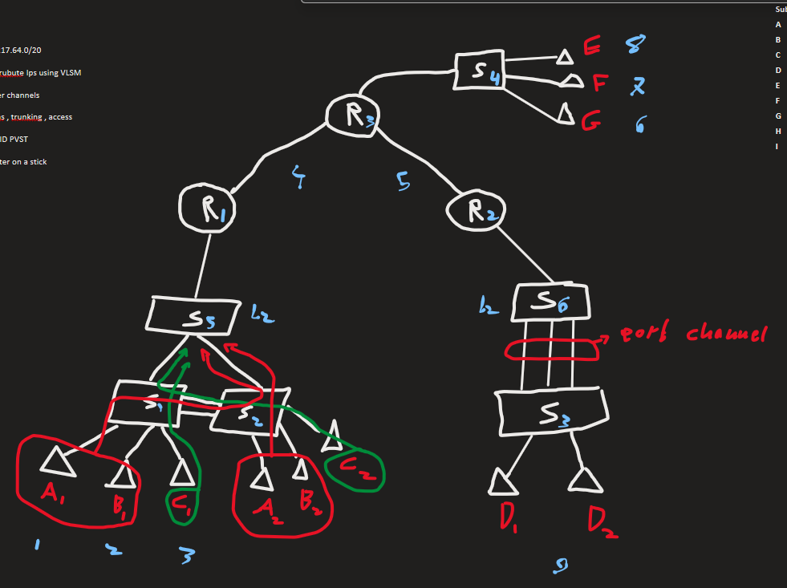

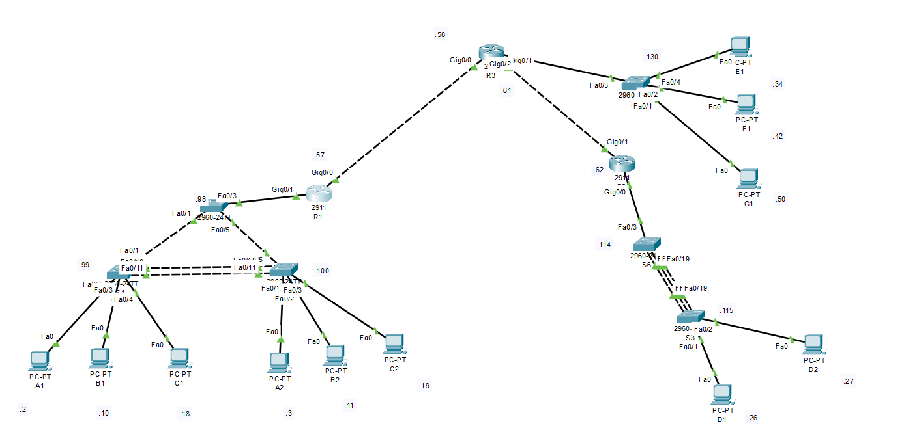

1. Introduction & Lab Requirements

Objective
Design and implement a scalable, resilient, multi-site enterprise network using VLSM, VLANs, Trunking, EtherChannel, Rapid PVST+, Router-on-a-Stick, and Static Routing.

Topology Overview
- 3 Core Routers (Cisco 2911): R1, R2, R3.
- 6 Layer 2 Switches: S1 through S6.
- 11 End-User PCs: Distributed across 7 distinct subnets.
- Physical Links: Includes a 3-link EtherChannel bundle (S6-S3) and a redundant triangle topology (S5-S1-S2) with load balancing.

Requirements Met
- VLSM applied to 83.217.64.0/20 to minimize IP waste.
- VLANs segmented by department/location.
- Trunking (802.1Q) for inter-switch and router connections.
- Router-on-a-Stick for inter-VLAN routing.
- EtherChannel (LACP) for redundancy and load balancing.
- Rapid PVST+ for loop prevention and traffic path optimization.
- SVIs for remote switch management.
- Static Routing for full end-to-end connectivity.

2. VLSM Calculation Summary
We subnetted 83.217.64.0/20 (4096 total addresses) into 9 subnets.
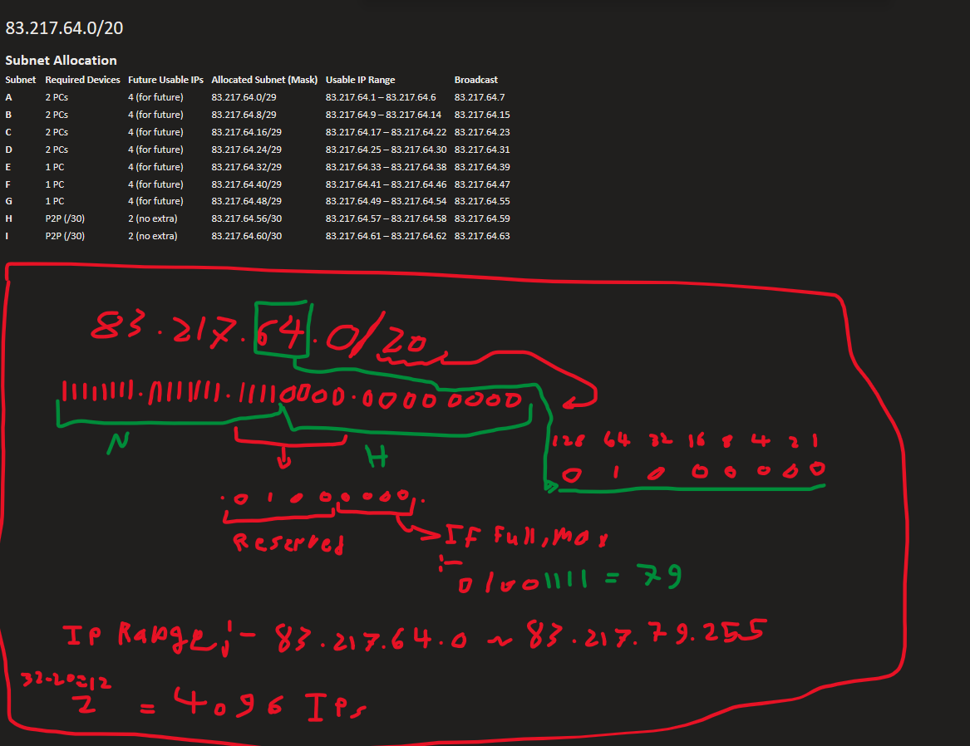
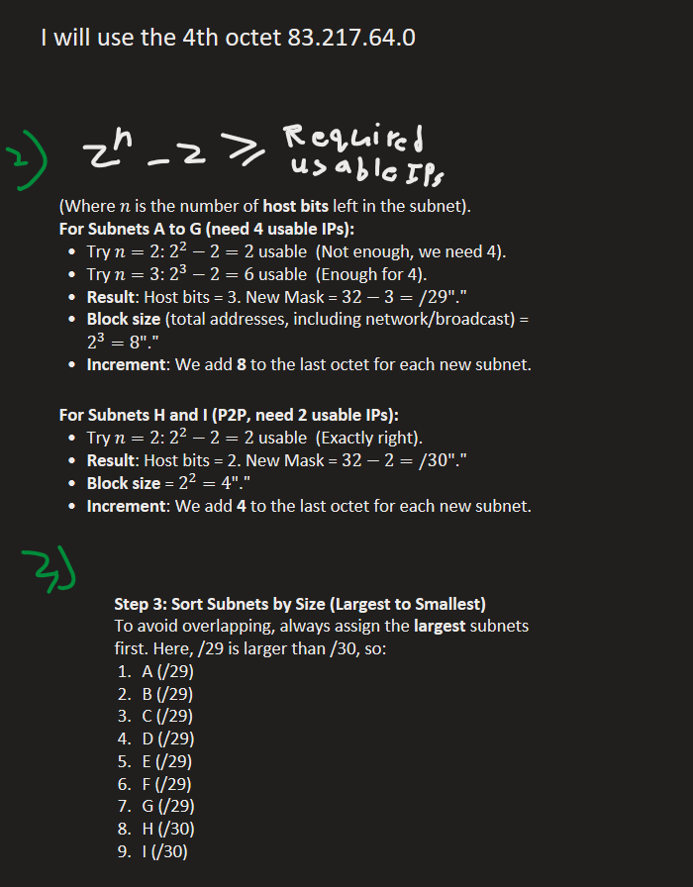
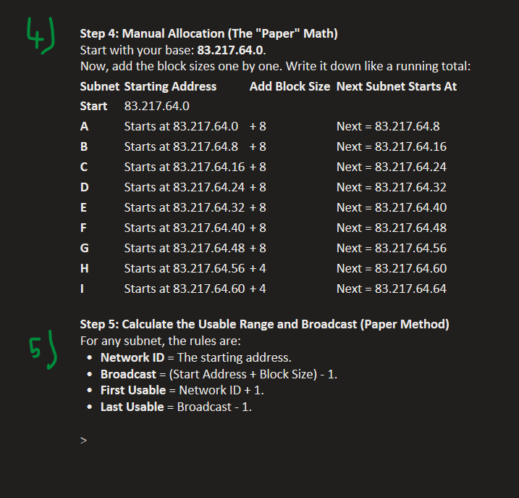

Calculation Rule
2ⁿ − 2 ≥ Required Hosts
- User Subnets (A-G): Required 4 usable IPs for future expansion. 2³ − 2 = 6 ≥ 4. Mask = /29 (Block size = 8).
- WAN Links (H-I): Required 2 usable IPs. 2² − 2 = 2. Mask = /30 (Block size = 4).
- Management (VLAN 99): Used /28 subnets (Block size = 16) to accommodate multiple switches per region.

3. Full IP Addressing & Port Reference Table
This table serves as the master reference for all device configurations and testing.
Device | Interface / VLAN | IP Address | Subnet Mask | Default Gateway | Connected To / Purpose
R1 | G0/1.10 | 83.217.64.1 | 255.255.255.248 | N/A | Gateway VLAN 10 (A)
R1 | G0/1.20 | 83.217.64.9 | 255.255.255.248 | N/A | Gateway VLAN 20 (B)
R1 | G0/1.30 | 83.217.64.17 | 255.255.255.248 | N/A | Gateway VLAN 30 (C)
R1 | G0/1.99 | 83.217.64.97 | 255.255.255.240 | N/A | Gateway VLAN 99 (Left Mgmt)
R1 | G0/0 | 83.217.64.57 | 255.255.255.252 | N/A | WAN Link to R3 (.58)
R3 | G0/2.50 | 83.217.64.33 | 255.255.255.248 | N/A | Gateway VLAN 50 (E)
R3 | G0/2.60 | 83.217.64.41 | 255.255.255.248 | N/A | Gateway VLAN 60 (F)
R3 | G0/2.70 | 83.217.64.49 | 255.255.255.248 | N/A | Gateway VLAN 70 (G)
R3 | G0/2.99 | 83.217.64.129 | 255.255.255.240 | N/A | Gateway VLAN 99 (Middle Mgmt)
R3 | G0/0 | 83.217.64.58 | 255.255.255.252 | N/A | WAN Link to R1 (.57)
R3 | G0/1 | 83.217.64.61 | 255.255.255.252 | N/A | WAN Link to R2 (.62)
R2 | G0/0.40 | 83.217.64.25 | 255.255.255.248 | N/A | Gateway VLAN 40 (D)
R2 | G0/0.99 | 83.217.64.113 | 255.255.255.240 | N/A | Gateway VLAN 99 (Right Mgmt)
R2 | G0/1 | 83.217.64.62 | 255.255.255.252 | N/A | WAN Link to R3 (.61)
S5 | VLAN 99 SVI | 83.217.64.98 | 255.255.255.240 | 83.217.64.97 | Management (Transit Switch)
S1 | VLAN 99 SVI | 83.217.64.99 | 255.255.255.240 | 83.217.64.97 | Management (Left Lower)
S2 | VLAN 99 SVI | 83.217.64.100 | 255.255.255.240 | 83.217.64.97 | Management (Right Lower)
S4 | VLAN 99 SVI | 83.217.64.130 | 255.255.255.240 | 83.217.64.129 | Management (Middle)
S6 | VLAN 99 SVI | 83.217.64.114 | 255.255.255.240 | 83.217.64.113 | Management (Right Transit)
S3 | VLAN 99 SVI | 83.217.64.115 | 255.255.255.240 | 83.217.64.113 | Management (Bottom Right)
PC A1 | Fa0 (S1 Fa0/2) | 83.217.64.2 | 255.255.255.248 | 83.217.64.1 | VLAN 10
PC A2 | Fa0 (S2 Fa0/1) | 83.217.64.3 | 255.255.255.248 | 83.217.64.1 | VLAN 10
PC B1 | Fa0 (S1 Fa0/3) | 83.217.64.10 | 255.255.255.248 | 83.217.64.9 | VLAN 20
PC B2 | Fa0 (S2 Fa0/2) | 83.217.64.11 | 255.255.255.248 | 83.217.64.9 | VLAN 20
PC C1 | Fa0 (S1 Fa0/4) | 83.217.64.18 | 255.255.255.248 | 83.217.64.17 | VLAN 30
PC C2 | Fa0 (S2 Fa0/3) | 83.217.64.19 | 255.255.255.248 | 83.217.64.17 | VLAN 30
PC D1 | Fa0 (S3 Fa0/1) | 83.217.64.26 | 255.255.255.248 | 83.217.64.25 | VLAN 40
PC D2 | Fa0 (S3 Fa0/2) | 83.217.64.27 | 255.255.255.248 | 83.217.64.25 | VLAN 40
PC E1 | Fa0 (S4 Fa0/4) | 83.217.64.34 | 255.255.255.248 | 83.217.64.33 | VLAN 50
PC F1 | Fa0 (S4 Fa0/2) | 83.217.64.42 | 255.255.255.248 | 83.217.64.41 | VLAN 60
PC G1 | Fa0 (S4 Fa0/1) | 83.217.64.50 | 255.255.255.248 | 83.217.64.49 | VLAN 70

4. Implementation Steps (Phases 1-8)

Phase 1: VLAN Database Creation
Action: Created VLANs on each switch (10, 20, 30 on S5/S1/S2; 50, 60, 70 on S4; 40 on S6/S3; and VLAN 99 on all).
Design Choice: Dedicated VLAN 99 for management to segregate administrative traffic from user data, enhancing security.

Phase 2: Access Port Assignment
Action: Set ports connected to PCs to switchport mode access and assigned them to their respective VLANs (e.g., S1 Fa0/2 in VLAN 10).
Design Choice: Ensures end-devices are properly segmented into their broadcast domains.

Phase 3: Trunk Configuration & VLAN Pruning
Action: Configured all inter-switch and router-switch links as 802.1Q trunks. Restricted allowed VLANs on each trunk (e.g., S5 only allows 10,20,30,99; S6 only allows 40,99).
Design Choice: VLAN Pruning enhances security and reduces unnecessary broadcast traffic crossing links.

Phase 4: Router-on-a-Stick (Inter-VLAN Routing)
Action: Created sub-interfaces on R1, R2, and R3 with encapsulation dot1Q.
Design Choice: Allows a single physical router interface to route traffic for multiple VLANs, eliminating the need for multiple physical links.

Phase 5: EtherChannel (S6 ↔ S3)
Action: Bundled three physical links (Fa0/17-19) into Port-Channel 1 using LACP (Active mode) and configured it as a trunk for VLANs 40 and 99.
Design Choice: Provides redundancy (fault tolerance) and load balancing (increased bandwidth) across the 3 cables.

Phase 6: SVIs & Management Subnet Split
Action: Assigned SVI IPs to all switches in VLAN 99. Due to routing conflicts (Connected routes overriding Static routes), we split the management subnet into three separate /28 ranges: Left (.96/28), Middle (.128/28), and Right (.112/28).
Design Choice: Ensures routers do not incorrectly ARP for remote management IPs on their local interfaces, guaranteeing reliable remote access.

Phase 7: Rapid PVST+ Path Control (Load Balancing)
Action: Set S5 as the Root Bridge. Adjusted spanning-tree costs to force specific paths:
• VLAN 10 & 20 (A1/B1): S1 → S2 → S5 (Blocked S1 Fa0/1, adjusted S1 priority to 40960 to fix MAC address tie-breaking for VLAN 20).
• VLAN 30 (C2): S2 → S1 → S5 (Blocked S2 Fa0/5).
Design Choice: Optimizes traffic flow by utilizing redundant links rather than keeping them in a blocking state, while maintaining loop prevention.

Phase 8: Static Routing (End-to-End Connectivity)
Action: Added static routes on all routers:
• R1 routes to 40, 50, 60, 70, 112, 128 via R3 (.58).
• R3 routes to 10, 20, 30, 96 via R1 (.57), and to 40, 112 via R2 (.62).
• R2 routes to 10, 20, 30, 50, 60, 70, 96, 128 via R3 (.61).
Design Choice: Enables full reachability between all subnets without relying on dynamic routing protocols, keeping the design simple and deterministic.

5. Network Connectivity Testing Table
Perform the following tests from the Source PC Command Prompt (ping <IP>). Mark Pass or Fail in the final column.
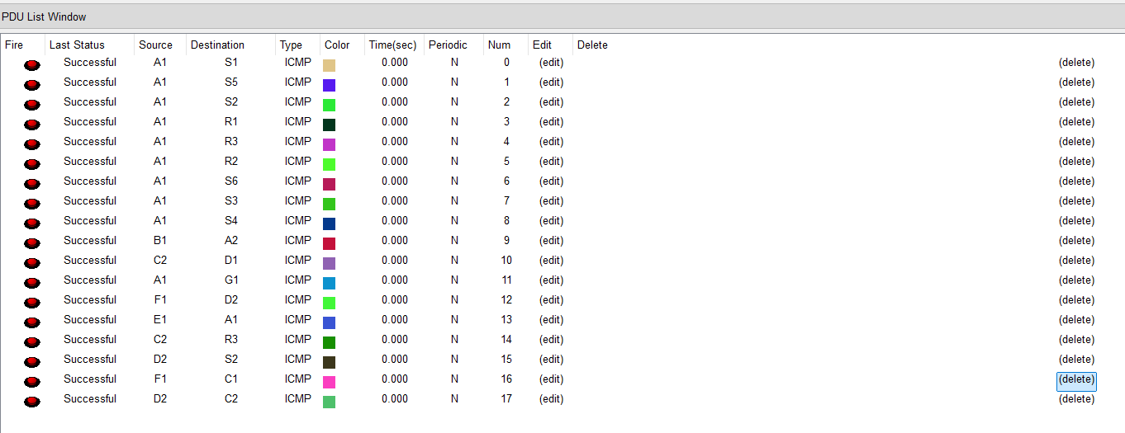
# | Source PC (IP) | Destination Device | Destination IP | Expected Result | Actual Result
1 | A1 (83.217.64.2) | Default Gateway (R1) | 83.217.64.1 | Reply (TTL=255) | PASS
2 | A1 (83.217.64.2) | S5 (Left Mgmt) | 83.217.64.98 | Reply (TTL=255) | PASS
3 | A1 (83.217.64.2) | S4 (Middle Mgmt) | 83.217.64.130 | Reply (TTL=253) | PASS
4 | A1 (83.217.64.2) | S3 (Right Mgmt) | 83.217.64.115 | Reply (TTL=252) | PASS
5 | A1 (83.217.64.2) | D1 (VLAN 40 PC) | 83.217.64.26 | Reply (TTL=252) | PASS
6 | B1 (83.217.64.10) | C2 (VLAN 30 PC) | 83.217.64.19 | Reply (TTL=254) | PASS
7 | D1 (83.217.64.26) | Default Gateway (R2) | 83.217.64.25 | Reply (TTL=255) | PASS
8 | D1 (83.217.64.26) | S6 (Right Mgmt) | 83.217.64.114 | Reply (TTL=255) | PASS
9 | D1 (83.217.64.26) | S5 (Left Mgmt) | 83.217.64.98 | Reply (TTL=253) | PASS
10 | D1 (83.217.64.26) | A1 (VLAN 10 PC) | 83.217.64.2 | Reply (TTL=253) | PASS
11 | E1 (83.217.64.34) | R3 WAN IP (to R2) | 83.217.64.61 | Reply (TTL=255) | PASS
12 | G1 (83.217.64.50) | R1 WAN IP (to R3) | 83.217.64.57 | Reply (TTL=254) | PASS

Appendix: Full Configuration Commands
This appendix contains the complete CLI configuration for every phase of implementation, including troubleshooting fixes applied during testing.

Phase 1: VLAN Database Creation
We created the local VLANs on each switch so they could forward traffic for those specific subnets.
On S5, S1, S2:
vlan 10
name Subnet_A
exit
vlan 20
name Subnet_B
exit
vlan 30
name Subnet_C
exit
vlan 99
name Management
exit

On S4:
vlan 50
name Subnet_E
exit
vlan 60
name Subnet_F
exit
vlan 70
name Subnet_G
exit
vlan 99
name Management
exit

On S6, S3:
vlan 40
name Subnet_D
exit
vlan 99
name Management
exit

Phase 2: Access Ports (PC Assignments)
We set the switch ports connected to PCs to "Access" mode and assigned them to the correct VLAN.
On S1 (A1, B1, C1):
int fa0/2
switchport mode access
switchport access vlan 10
no shutdown
exit
int fa0/3
switchport mode access
switchport access vlan 20
no shutdown
exit
int fa0/4
switchport mode access
switchport access vlan 30
no shutdown
exit

On S2 (A2, B2, C2):
int fa0/1
switchport mode access
switchport access vlan 10
no shutdown
exit
int fa0/2
switchport mode access
switchport access vlan 20
no shutdown
exit
int fa0/3
switchport mode access
switchport access vlan 30
no shutdown
exit

On S3 (D1, D2):
int fa0/1
switchport mode access
switchport access vlan 40
no shutdown
exit
int fa0/2
switchport mode access
switchport access vlan 40
no shutdown
exit

On S4 (E1, F1, G1):
int fa0/4
switchport mode access
switchport access vlan 50
no shutdown
exit
int fa0/2
switchport mode access
switchport access vlan 60
no shutdown
exit
int fa0/1
switchport mode access
switchport access vlan 70
no shutdown
exit

Phase 3: Trunk Configuration & VLAN Pruning
We configured inter-switch and router uplinks to carry multiple VLANs, restricting them to only the necessary ones.
On S5 (To R1, S1, S2):
int fa0/3
switchport mode trunk
switchport trunk allowed vlan 10,20,30,99
no shutdown
exit
int fa0/1
switchport mode trunk
switchport trunk allowed vlan 10,20,30,99
no shutdown
exit
int fa0/5
switchport mode trunk
switchport trunk allowed vlan 10,20,30,99
no shutdown
exit

On S1 (To S5, S2):
int fa0/1
switchport mode trunk
switchport trunk allowed vlan 10,20,30,99
no shutdown
exit
int fa0/10
switchport mode trunk
switchport trunk allowed vlan 10,20,30,99
no shutdown
exit

On S2 (To S5, S1):
int fa0/5
switchport mode trunk
switchport trunk allowed vlan 10,20,30,99
no shutdown
exit
int fa0/10
switchport mode trunk
switchport trunk allowed vlan 10,20,30,99
no shutdown
exit

On S4 (To R3):
int fa0/3
switchport mode trunk
switchport trunk allowed vlan 50,60,70,99
no shutdown
exit

On S6 (To R2, S3 - Initial trunks before EtherChannel):
int fa0/3
switchport mode trunk
switchport trunk allowed vlan 40,99
no shutdown
exit
int range fa0/17-19
switchport mode trunk
switchport trunk allowed vlan 40,99
no shutdown
exit

On S3 (To S6 - Initial trunks):
int range fa0/17-19
switchport mode trunk
switchport trunk allowed vlan 40,99
no shutdown
exit

Phase 4: Router-on-a-Stick (Inter-VLAN Routing)
We created sub-interfaces on the 2911 routers to serve as default gateways for each VLAN.
On R1 (WAN G0/0 to R3, LAN G0/1 to S5):
int g0/0
ip address 83.217.64.57 255.255.255.252
no shutdown
exit
int g0/1
no shutdown
exit
int g0/1.10
encapsulation dot1Q 10
ip address 83.217.64.1 255.255.255.248
exit
int g0/1.20
encapsulation dot1Q 20
ip address 83.217.64.9 255.255.255.248
exit
int g0/1.30
encapsulation dot1Q 30
ip address 83.217.64.17 255.255.255.248
exit
int g0/1.99
encapsulation dot1Q 99
ip address 83.217.64.97 255.255.255.240
exit

On R3 (WAN to R1/R2, LAN G0/2 to S4):
int g0/0
ip address 83.217.64.58 255.255.255.252
no shutdown
exit
int g0/1
ip address 83.217.64.61 255.255.255.252
no shutdown
exit
int g0/2
no shutdown
exit
int g0/2.50
encapsulation dot1Q 50
ip address 83.217.64.33 255.255.255.248
exit
int g0/2.60
encapsulation dot1Q 60
ip address 83.217.64.41 255.255.255.248
exit
int g0/2.70
encapsulation dot1Q 70
ip address 83.217.64.49 255.255.255.248
exit
int g0/2.99
encapsulation dot1Q 99
ip address 83.217.64.104 255.255.255.240
exit

On R2 (WAN to R3, LAN G0/0 to S6):
int g0/1
ip address 83.217.64.62 255.255.255.252
no shutdown
exit
int g0/0
no shutdown
exit
int g0/0.40
encapsulation dot1Q 40
ip address 83.217.64.25 255.255.255.248
exit
int g0/0.99
encapsulation dot1Q 99
ip address 83.217.64.105 255.255.255.240
exit

Phase 5: EtherChannel (S6 ↔ S3)
We bundled the 3 parallel links into a single logical Port-Channel. Includes the troubleshooting fix where we applied trunk config directly to the Port-Channel.
On S6:
int port-channel 1
switchport mode trunk
switchport trunk allowed vlan 40,99
no shutdown
exit
int range fa0/17-19
channel-group 1 mode active
switchport mode trunk
switchport trunk allowed vlan 40,99
no shutdown
exit

On S3:
int port-channel 1
switchport mode trunk
switchport trunk allowed vlan 40,99
no shutdown
exit
int range fa0/17-19
channel-group 1 mode active
switchport mode trunk
switchport trunk allowed vlan 40,99
no shutdown
exit

Phase 6: SVIs & Management Subnet Split
We assigned IPs to the switches. When the single subnet .96/28 failed due to connected route conflicts, we split it into .96/28 (Left), .128/28 (Middle), and .112/28 (Right).
Initial SVIs (Left Side - Unchanged):
On S5: int vlan 99 / ip add 83.217.64.98 255.255.255.240 / no shut / ip default-gateway 83.217.64.97
On S1: int vlan 99 / ip add 83.217.64.99 255.255.255.240 / no shut / ip default-gateway 83.217.64.97
On S2: int vlan 99 / ip add 83.217.64.100 255.255.255.240 / no shut / ip default-gateway 83.217.64.97

Middle Side (R3 & S4 - Changed to .128/28):
On R3: int g0/2.99 / ip address 83.217.64.129 255.255.255.240
On S4: int vlan 99 / ip add 83.217.64.130 255.255.255.240 / no shut / ip default-gateway 83.217.64.129

Right Side (R2, S6, S3 - Changed to .112/28):
On R2: int g0/0.99 / ip address 83.217.64.113 255.255.255.240
On S6: int vlan 99 / ip add 83.217.64.114 255.255.255.240 / no shut / ip default-gateway 83.217.64.113
On S3: int vlan 99 / ip add 83.217.64.115 255.255.255.240 / no shut / ip default-gateway 83.217.64.113

Phase 7: Rapid PVST+ Path Control
We enabled Rapid PVST, set S5 as the Root, and manipulated costs to force VLAN 10/20 via S2, and VLAN 30 via S1. This includes the VLAN 20 tie-breaker fix using priority 40960.
On S5, S1, S2 (Enable RSTP):
spanning-tree mode rapid-pvst

On S5 (Root Bridge):
spanning-tree vlan 1 root primary
spanning-tree vlan 10 root primary
spanning-tree vlan 20 root primary
spanning-tree vlan 30 root primary
spanning-tree vlan 99 root primary

On S1 (Block direct path to S5 for VLAN 10 & 20 - Force via S2):
int fa0/1
spanning-tree vlan 10 cost 100
spanning-tree vlan 20 cost 200 ! (Increased to 200)
exit

On S1 (Tie-breaker fix for VLAN 20, after STP still preferred Fa0/1 due to lower MAC address):
spanning-tree vlan 20 priority 40960

On S2 (Block direct path to S5 for VLAN 30 - Force via S1):
int fa0/5
spanning-tree vlan 30 cost 100
exit

Extra link S1-S2 (Fa0/11) - configured as a separate trunk for redundancy. On S1 & S2:
int fa0/11
switchport mode trunk
switchport trunk allowed vlan 10,20,30,99
no shutdown

Phase 8: Static Routing (End-to-End Connectivity)
We added manual routes so routers know how to reach remote subnets. Includes the additional WAN subnet routes we added during troubleshooting.
On R1:
ip route 83.217.64.24 255.255.255.248 83.217.64.58 ! VLAN 40
ip route 83.217.64.32 255.255.255.248 83.217.64.58 ! VLAN 50
ip route 83.217.64.40 255.255.255.248 83.217.64.58 ! VLAN 60
ip route 83.217.64.48 255.255.255.248 83.217.64.58 ! VLAN 70
ip route 83.217.64.112 255.255.255.240 83.217.64.58 ! Mgmt Right
ip route 83.217.64.128 255.255.255.240 83.217.64.58 ! Mgmt Middle
ip route 83.217.64.60 255.255.255.252 83.217.64.58 ! WAN R3-R2

On R3:
ip route 83.217.64.0 255.255.255.248 83.217.64.57 ! VLAN 10
ip route 83.217.64.8 255.255.255.248 83.217.64.57 ! VLAN 20
ip route 83.217.64.16 255.255.255.248 83.217.64.57 ! VLAN 30
ip route 83.217.64.96 255.255.255.240 83.217.64.57 ! Mgmt Left
ip route 83.217.64.24 255.255.255.248 83.217.64.62 ! VLAN 40
ip route 83.217.64.112 255.255.255.240 83.217.64.62 ! Mgmt Right

On R2:
ip route 83.217.64.0 255.255.255.248 83.217.64.61 ! VLAN 10
ip route 83.217.64.8 255.255.255.248 83.217.64.61 ! VLAN 20
ip route 83.217.64.16 255.255.255.248 83.217.64.61 ! VLAN 30
ip route 83.217.64.32 255.255.255.248 83.217.64.61 ! VLAN 50
ip route 83.217.64.40 255.255.255.248 83.217.64.61 ! VLAN 60
ip route 83.217.64.48 255.255.255.248 83.217.64.61 ! VLAN 70
ip route 83.217.64.96 255.255.255.240 83.217.64.61 ! Mgmt Left
ip route 83.217.64.128 255.255.255.240 83.217.64.61 ! Mgmt Middle
ip route 83.217.64.56 255.255.255.252 83.217.64.61 ! WAN R1-R3

