LOCK & KEY — Secure Communication Tool
Comprehensive Report (Confidentiality, Authentication, Hybrid, Cryptanalysis, Image Encryption)
Ahmad Marwan AlMaghaireh
23110205

Contents
1) Executive Summary 1
2) System Overview 2
3) Task 1 — Confidentiality Only (DES-CBC with Ciphertext Stealing) 3
4) Task 2 — Authentication Only (RSA keys + digital signatures) 26
5) Task 3 — Confidentiality & Authentication (combined) 29
6) Task 4 — RSA cryptanalysis of short messages 31
7) Task 5 — Image encryption (ECB vs CBC, both with CTS) 34
Square-and-Multiply (used in RSA) 39
9) Critical evaluation & future enhancements 43

1) Executive Summary
Lock & Key is a menu-driven secure communication tool that implements:
- Confidentiality Only: DES (from scratch) in CBC with Ciphertext Stealing (CTS/CS3).
- Authentication Only: RSA key generation from two 10-digit primes; segmented RSA digital signatures over SHA-256; verification.
- Confidentiality & Authentication: Sign-then-Encrypt workflow combining Tasks 1 & 2.
- RSA Cryptanalysis: Short-message attack demo against textbook RSA (no padding).
- Image Encryption: DES applied to RGB data in ECB+CTS and CBC+CTS; visual analysis.
All asymmetric operations use RSA as required; hashing uses SHA-256. Symmetric confidentiality uses a manually supplied DES key (hex) and an IV (hex). The report details the approach, algorithms, steps to reproduce, and security considerations; it concludes with a critical evaluation and suggestions.

2) System Overview
2.1 Main Menu (as required)
***** LOCK && KEY *****
1. Confidentiality Only (DES from scratch; CBC + CTS)
2. Authentication Only (RSA signatures)
3. Confidentiality & Authentication (combine 1 + 2)
4. RSA cryptanalysis (short-message brute force)
5. Image encryption (ECB/CBC with CTS)
0. Exit
************************
Files & responsibilities
- task1_des.py — DES from scratch (IP/FP/E/P/PC1/PC2/S-boxes, key schedule, 16 rounds), CBC core, CBC-CTS (CS3), rich tracing for screenshots.
- task2_rsa.py — RSA keygen (two 10-digit primes + e), segmented RSA signature over SHA-256, verification, step-by-step prints.
- task3_cryptanalysis.py — textbook RSA short-message brute force demo (two-digit n allowed), with verbose output for report screenshots.
- task4_images.py — ECB+CTS and CBC+CTS on raw RGB bytes using DES blocks; produces out_ecb.png and out_cbc.png for visual analysis.
- utils.py — number theory (gcd, egcd, modinv), powmod (Square-and-Multiply), simple primality test, SHA-256 helper, hex helpers.
- main.py — unified launcher wiring all tasks and preserving RSA state (pub/priv) across options.

3) Task 1 — Confidentiality Only (DES-CBC with Ciphertext Stealing)
3.1 What I implemented
- DES from scratch: complete IP/FP/E/P permutations, 8 S-boxes, PC-1/PC-2, 16 subkeys via left rotations (SHIFTS), the Feistel rounds.
- CBC mode for full blocks.
- Ciphertext Stealing (CTS) for messages whose length is not a multiple of 8 (DES block size). I used the CS3 variant (also called “direct” CTS).
- Verbose tracing: round keys, per-round state, CBC XOR steps, CTS “steal” steps to make it easy to validate and screenshot.
3.2 How CBC is applied here
- What CBC does: it chains blocks so each ciphertext block depends on the previous ciphertext (starting from the IV). This hides repeating patterns and ensures identical plaintext blocks encrypt differently when the IV changes.
- Full-block encryption flow: treat the IV as “ciphertext block 0.” For each 8-byte plaintext block, XOR it with the previous ciphertext block, then run DES. The output becomes the next “previous” block.
- Full-block decryption flow: DES-decrypt each ciphertext block, then XOR that result with the previous ciphertext block (or the IV for the first block) to recover the plaintext.
- Where it lives in my code (conceptually): my full-block CBC encrypt/decrypt functions keep a single “chaining value” (the IV first, then each new ciphertext block) and process the message block by block. My verbose “trace” versions print the block-by-block values (previous C, XOR preimage, DES round trace, resulting C/P) — ideal for screenshots.
- Why the IV matters: it randomizes the first block. Changing only the IV (same key, same message) yields a completely different ciphertext. In production it should be unique and unpredictable per message.
- Handling non-multiples of 8: CBC-CTS (CS3): when the last block is short, you:
  - Encrypt the penultimate full block (with the usual CBC step) to get a temp block T.
  - Output the first r bytes of T as the final partial ciphertext block.
  - Form a synthetic full block by appending the tail of T to the short plaintext, encrypt it (with the same chaining value), and output that as the penultimate ciphertext block.
Decryption reverses this by recovering the short plaintext from the synthetic block, reconstructing T, and then recovering the real penultimate block.
- Why CTS here: no padding; ciphertext length exactly equals plaintext length; you still get CBC’s chaining security.
- Security properties to note: CBC hides patterns and is resistant to block replay, but it does not provide integrity—bit flips in a ciphertext block garble one plaintext block and flip a bit in the next. My system adds authenticity with RSA signatures (Utilities 2/3).
- How I demonstrated it:
  - Full-block CBC: use an 8- or 16-byte input; My traces show per-block XOR, DES, and chaining.
  - CBC-CTS: use a length like 13 bytes (“Hello, world!”); My CTS trace shows the “stolen” bytes and the synthetic last block.
  - IV/key sensitivity checks: same message + key but different IVs ⇒ different ciphertext; different keys ⇒ different ciphertext.

3.3 How CTS (CS3) is applied (last two blocks only)
When the plaintext length n is not a multiple of 8, let r = n mod 8 (1…7). Split:
- P_{m-1} = the last full block
- P_m = the final partial block (r bytes)
Steps (exactly as in des_cbc_encrypt_cts):
- Compute the CBC of all blocks before P_{m-1} as usual; call the last chaining value C_{m-2} (or IV if there aren’t earlier blocks).
- T = E_DES( P_{m-1} XOR C_{m-2} ) (a full 8-byte DES block).
- Steal: C_m = first r bytes of T.
- Construct a full block P_m' = P_m || T[r:].
- C_{m-1} = E_DES( P_m' XOR C_{m-2} ).
- Final ciphertext tail is ... || C_{m-1} || C_m and its length equals n.
Decryption inverts those steps: rebuild T = C_m || tail(T), decrypt T to recover P_{m-1}, etc.
Why CTS? It avoids padding and keeps ciphertext length identical to plaintext length ,important for images and for cleaner transport.
3.4 Test plan & evidence
Run python task1_des.py → choose:
- Option 2: “Auto Test” for a quick correctness suite
  - ECB single-block vectors (provided in code). See the PASS lines and the ECB summary: X/Y passed.
  - CBC-CTS round-trip matrix: See CBC-CTS summary: X/Y passed and the IV/key sensitivity checks (“different IVs/keys → different CT”).

- Option 1: “Confidentiality Only — FULL TRACE”
in the screenshots:
  - printed Round Keys (16 lines)
  - the CBC/CTS ENCRYPT TRACE (shows P, C, X, and the per-round DES trace)
  - the final ciphertext (hex)
Then decrypt the same hex and screenshot the CBC/CTS DECRYPT TRACE + recovered plaintext.

Auto Test :
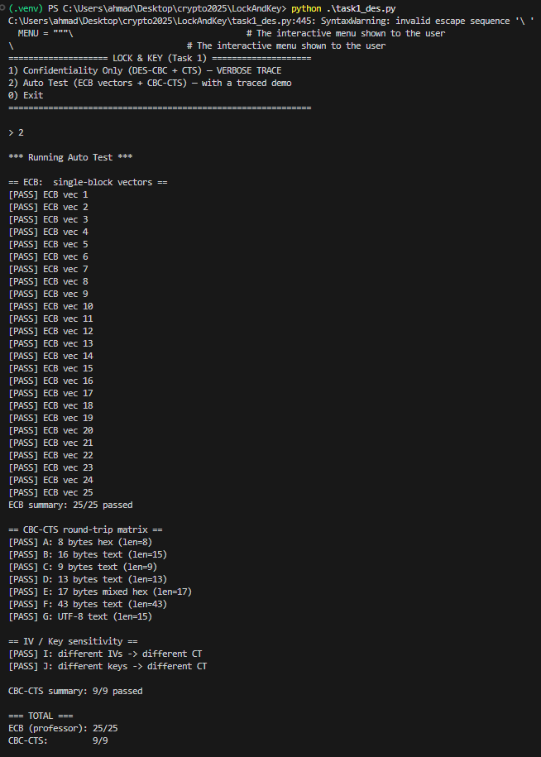
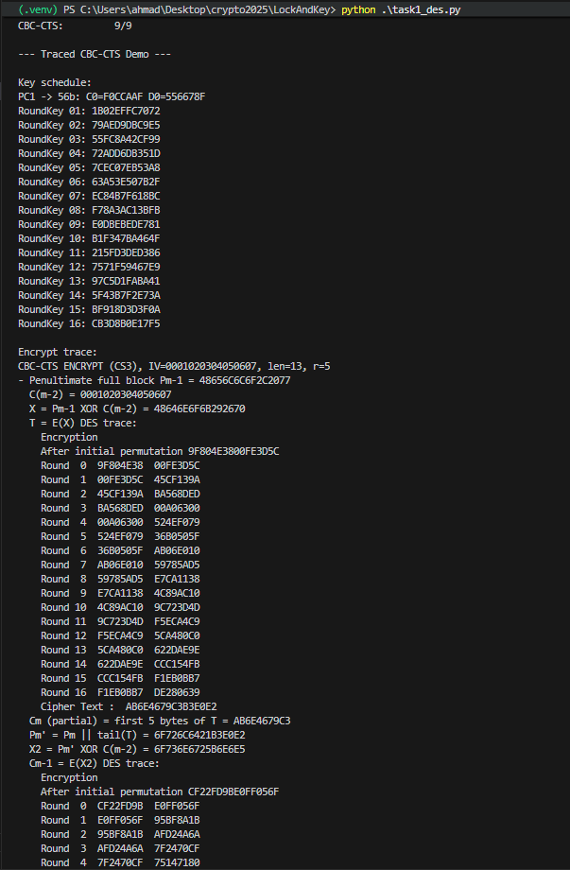
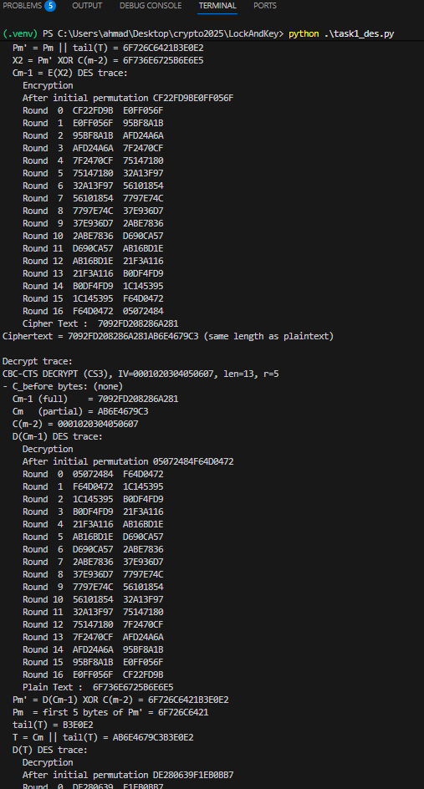
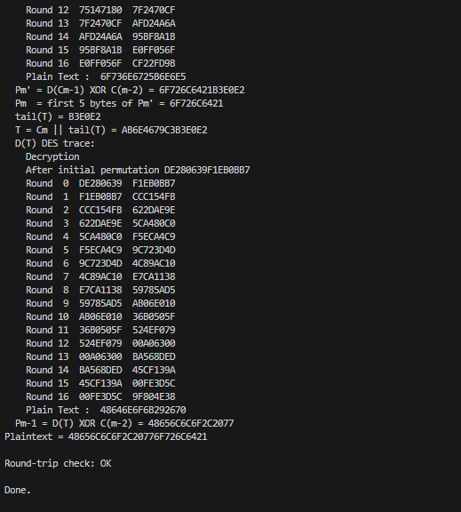
Epected output :
=== TOTAL ===
ECB (professor): 25/25
CBC-CTS: 9/9
Output :
=== TOTAL ===
ECB (professor): 25/25
CBC-CTS: 9/9

Case 1 (8-byte hex) : tests DES core and CBC on exactly one block. No CTS (length is a multiple of 8).
Encryption :
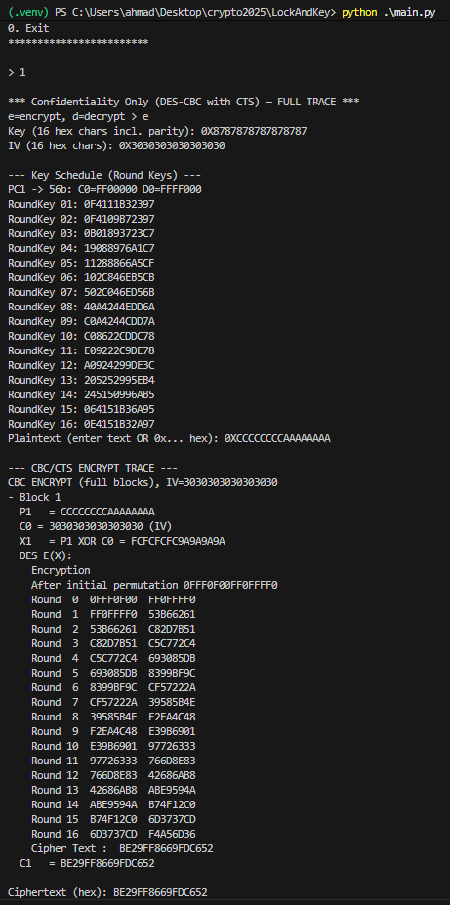
Decryption :
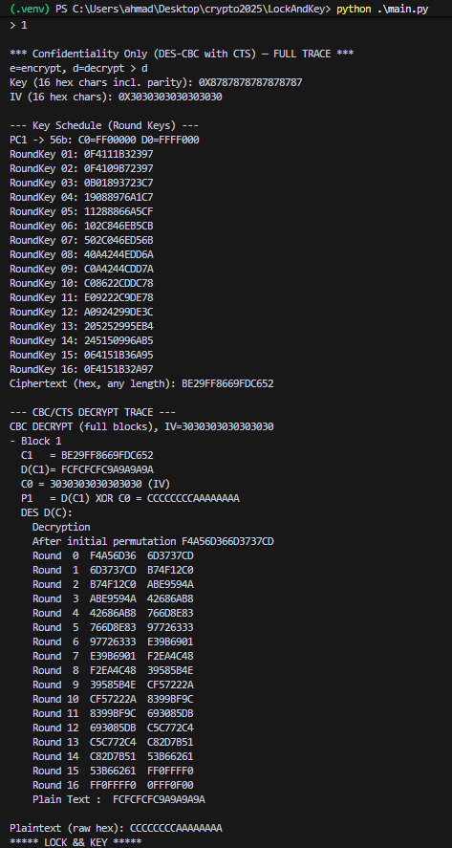
Ecpected output : CCCCCCCCAAAAAAAA
Output : CCCCCCCCAAAAAAAA

Case 2 (16-byte hex) : tests CBC chaining across multiple blocks. no CTS (multiple of 8).
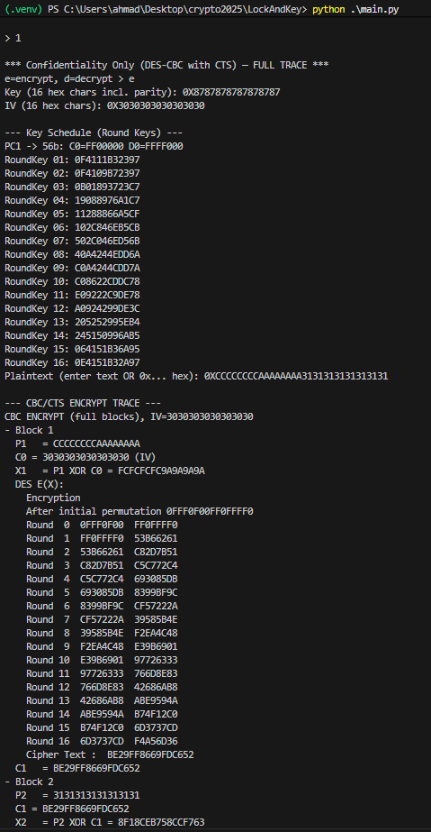
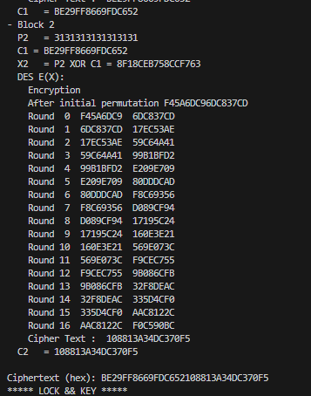
Decryption :
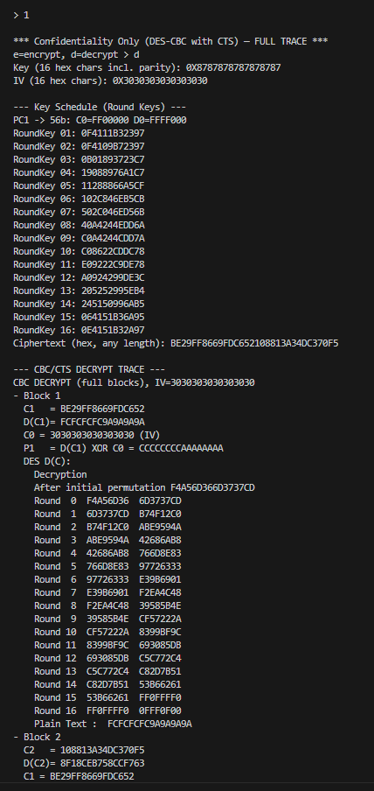
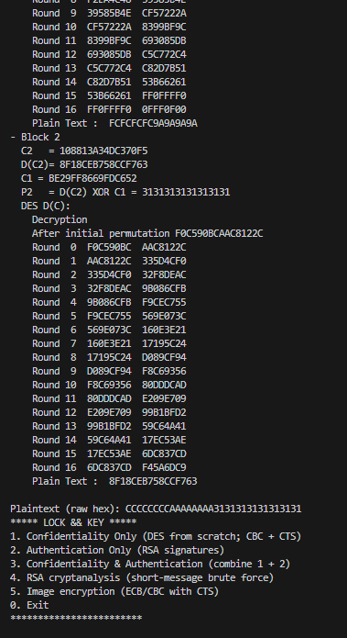
Expected output : CCCCCCCCAAAAAAAA3131313131313131
Output : CCCCCCCCAAAAAAAA3131313131313131

Case 3 ("ahmad1234") : test CTS. 9 bytes plain text
Encryption :
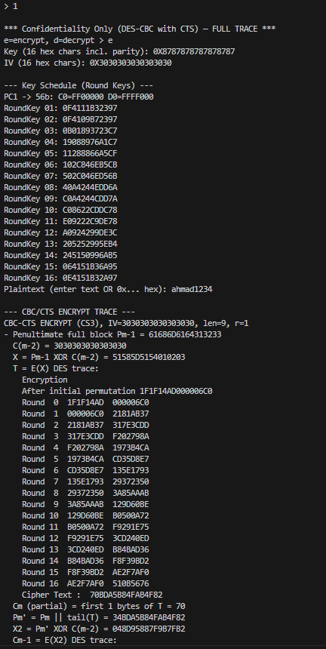
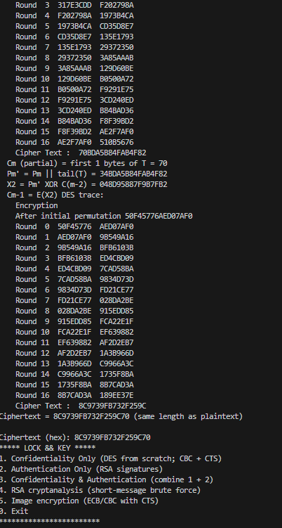

Decryption :
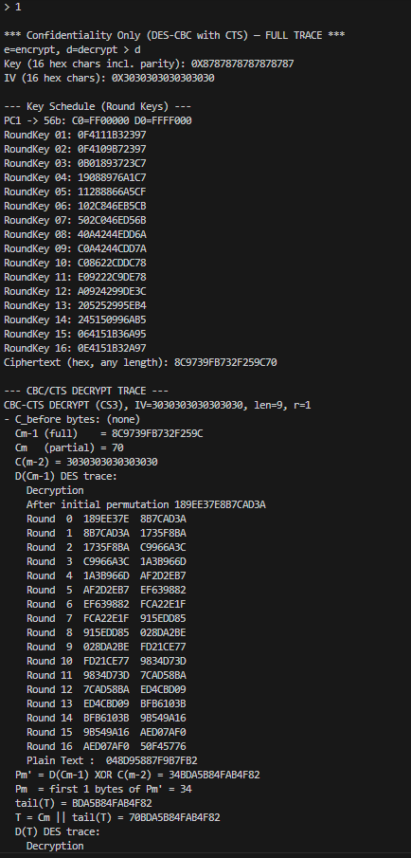
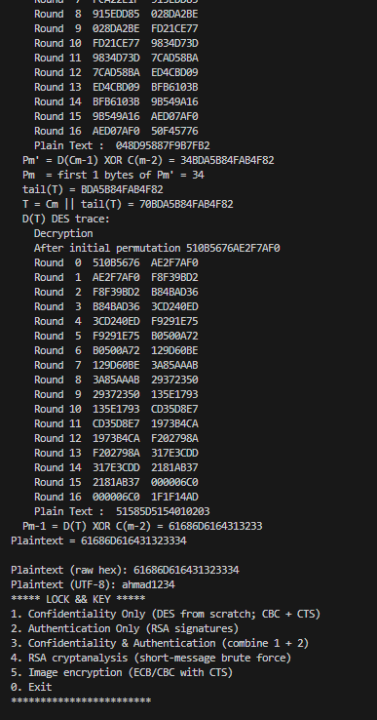
Expected output : ahmad1234
Output : ahmad1234

4) Task 2 — Authentication Only (RSA keys + digital signatures)
4.1 What I implemented
- Key generation: user enters two 10-digit primes p, q and a public exponent e.
Code validates primality (simple deterministic test), checks 1 < e < φ(n) and gcd(e, φ(n))=1, computes d = e^{-1} mod φ(n).
- Hashing: SHA-256 of the message → big integer.
- Segmented signature (no padding per spec):
Since the SHA-256 integer can be larger than n, I split the hash into big-endian chunks, each strictly < n (chunk size = bitlen(n)-1 bits), and sign each chunk: s_i = chunk_i^d mod n.
The signature is the list [s_1, s_2, …] printed as a - separated hex list for easy copy/paste.
- Verification recomputes the hash, re-segments it the same way, and checks s_i^e ≡ chunk_i (mod n) for all i.

4.2 Step-by-step
Run python task2_rsa.py:
- Option 1 — Generate keys
  - Input two 10-digit primes and a sensible e (e.g., 65537).
  - Screenshot the printed parameters:
    - p, q, n=pq, phi(n), e, d, bitlen(n) and the computed chunk size.
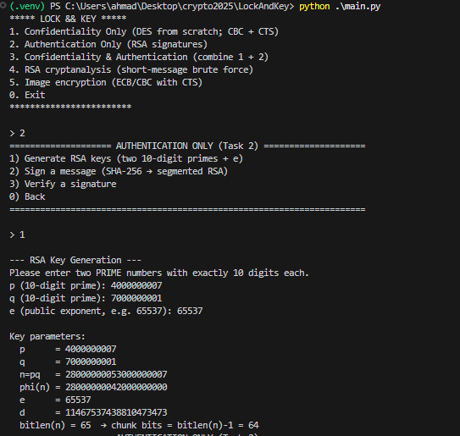
- Option 2 — Sign
  - Enter a message (UTF-8).
  - Screenshot:
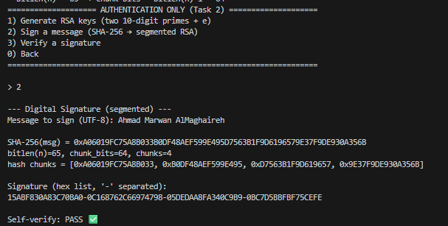
- Option 3 — Verify
  - Paste the original message and the signature you just got.
  - Screenshot:
    - recomputed SHA-256(msg)
    - recomputed hash chunks and counts
    - final Verification result: VALID ✅
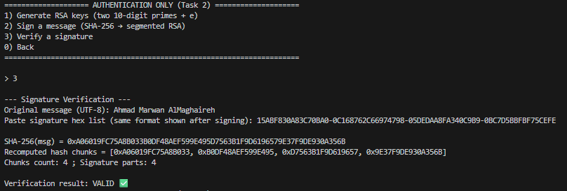

p (10-digit prime): 4000000007
q (10-digit prime): 7000000001
e (public exponent, e.g. 65537): 65537

Key parameters:
p = 4000000007
q = 7000000001
n=pq = 28000000053000000007
phi(n) = 28000000042000000000
e = 65537
d = 11467537438810473473
bitlen(n) = 65 → chunk bits = bitlen(n)-1 = 64

5) Task 3 — Confidentiality & Authentication (combined)
5.1 Mode and flow
The combined utility implements Sign-then-Encrypt:
- Encrypt path (e)
  - Compute SHA-256 over the plaintext, sign it with RSA (segmented, as above).
  - Encrypt the plaintext with DES-CBC-CTS (Task 1) using user-provided key & IV.
  - Output: Ciphertext (hex) and Signature (segmented hex list).
- Decrypt path (d)
  - Decrypt with DES-CBC-CTS.
  - Verify the RSA signature against the recovered plaintext.
  - Output: plaintext and VALID/INVALID.

5.2 Secure key generation & exchange (requirement)
- Asymmetric keys are generated locally by each party (Task 2). The public key can be exchanged openly; the private key never leaves the device.
- Symmetric DES key is currently provided manually (hex). For stronger exchange, I recommend wrapping the DES key with the receiver’s RSA public key (a simple hybrid scheme). See Appendix A for a tiny drop-in function if my instructor wants the exchange implemented.
5.3 screenshot

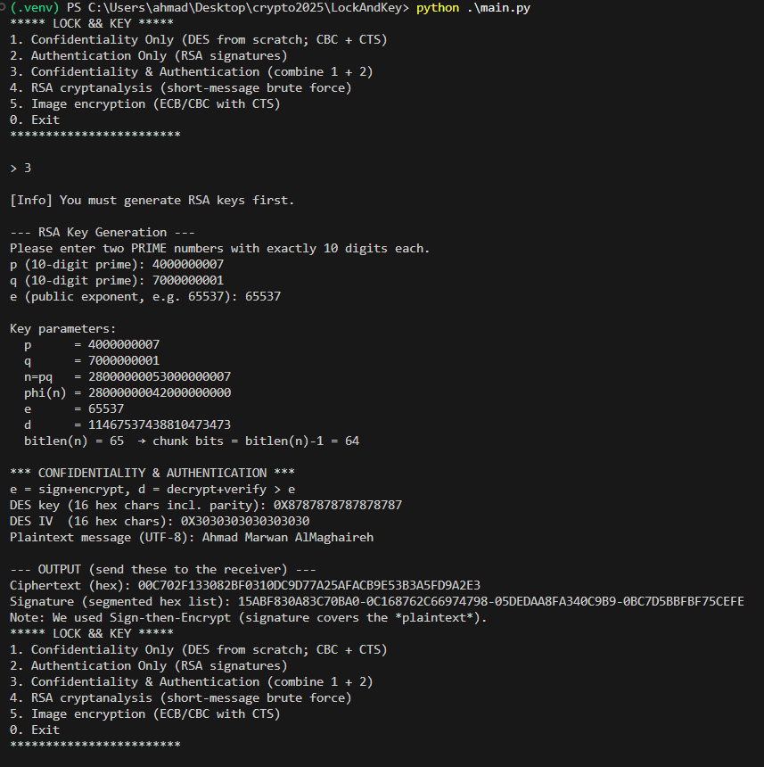
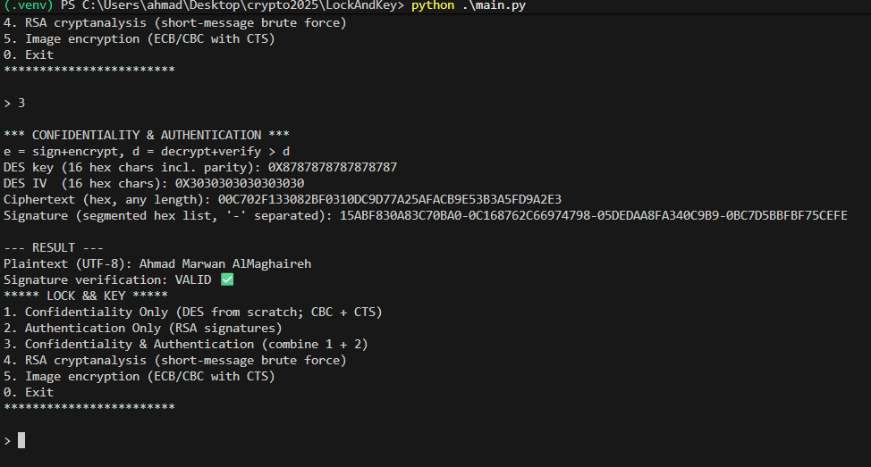

6) Task 4 — RSA cryptanalysis of short messages
6.1 Can RSA securely encrypt “short” messages?
Textbook RSA without padding is not secure even for short messages. Key issues:
- Deterministic: same plaintext → same ciphertext under the same key.
- Small-message brute force: if m is small and e is small (e.g., 3 or 5), the search space is tiny; an attacker can try all m' with m'^e mod n until a match.
- Low-exponent attacks: if m^e < n, then c = m^e (no reduction), and m = ⌊e-th root of c⌋ is immediate.
- Structure leaks: without padding, RSA is malleable and vulnerable to a variety of textbook attacks.
Conclusion: RSA must use a secure padding scheme (e.g., OAEP for encryption) and should not be used for raw/plaintext “short messages.” In our project, RSA is limited to keygen & signatures; symmetric ciphers handle confidentiality.
6.2 Demo: brute-force short messages (two-digit n)
Run python task3_cryptanalysis.py:
- Demo A: n=77, e=3, m=4
Shows m^e = 64 < n → no modular reduction → c=64. The brute force loop finds m=4 quickly.
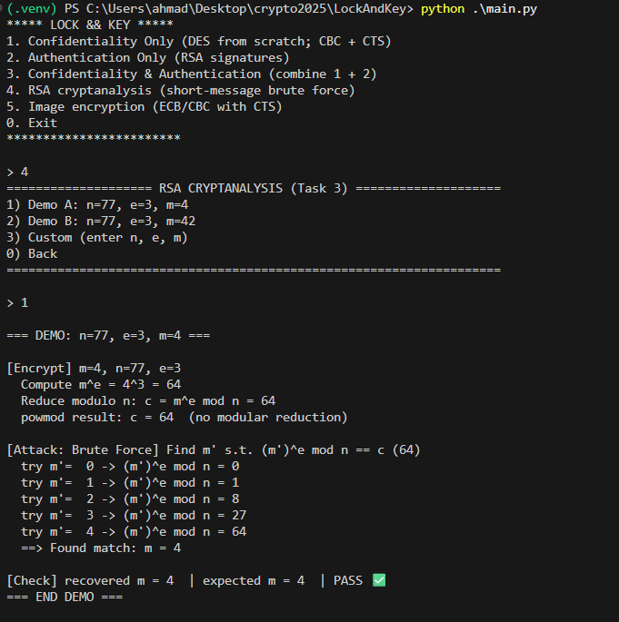
- Demo B: n=77, e=3, m=42
Shows modular reduction; brute force still recovers m instantly for such a small n.
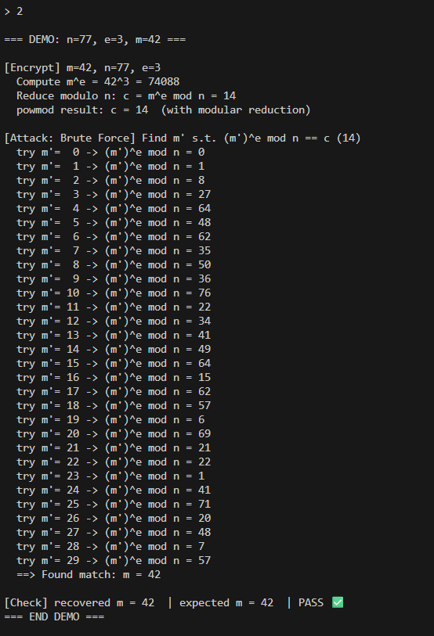

Step-by-step
- Chose n (two-digit), small e (3), and m (4 then 42).
- Encrypted m to c = m^e mod n.
- Brute forced m' from 0…n-1, computed (m')^e mod n, compared with c.
- Observed exact recovery; concluded textbook RSA is insecure for direct short-message encryption.

7) Task 5 — Image encryption (ECB vs CBC, both with CTS)
7.1 Method
- Read test_image.jpg, convert to RGB, and take the raw bytes (w*h*3 bytes).
- Run DES over those bytes in two modes:
  - ECB + CTS (our own CTS for ECB in task4_images.py)
  - CBC + CTS (reuses Task 1 CBC-CTS)
- Write outputs as lossless PNGs to preserve exact encrypted bytes:
  - out_ecb.png
  - out_cbc.png
7.2 How to run
python task4_images.py
> 1) Encrypt image -> ECB+CTS and CBC+CTS
Input image path: test_image.jpg
Key (16 hex): 0X8787878787878787
IV (16 hex): 0X3030303030303030

Image:

- Figure 1 — ECB+CTS output (out_ecb.png): you will see strong block patterns (8-byte DES blocks mapped across RGB).
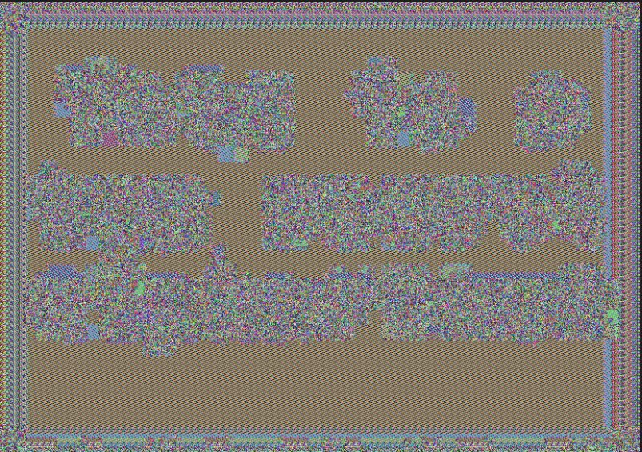
- Figure 2 — CBC+CTS output (out_cbc.png): appears like random noise; patterns are destroyed.


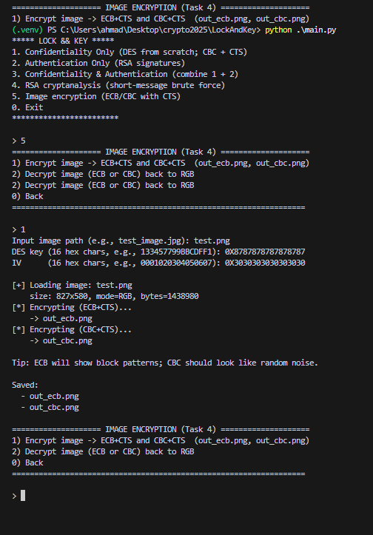

Decryption :
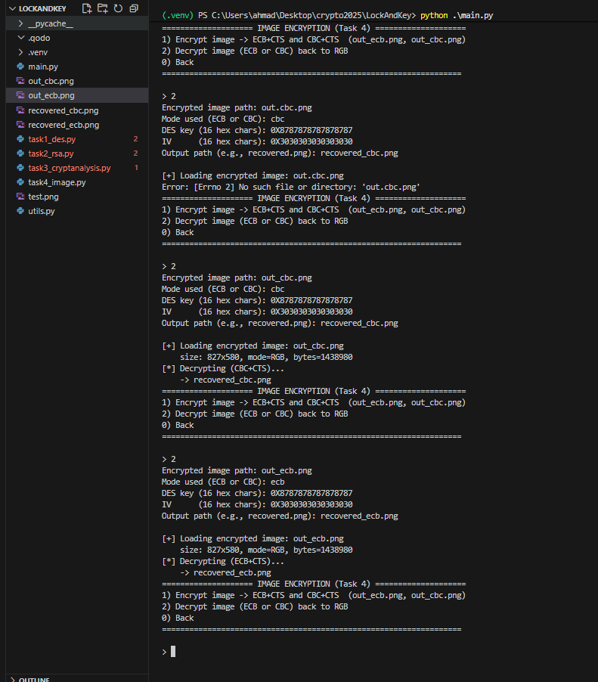

Recovered cbc :
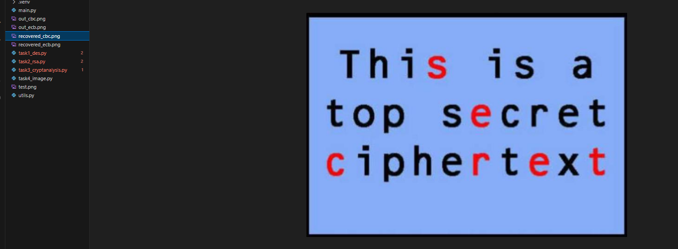
Recoverd ecb :
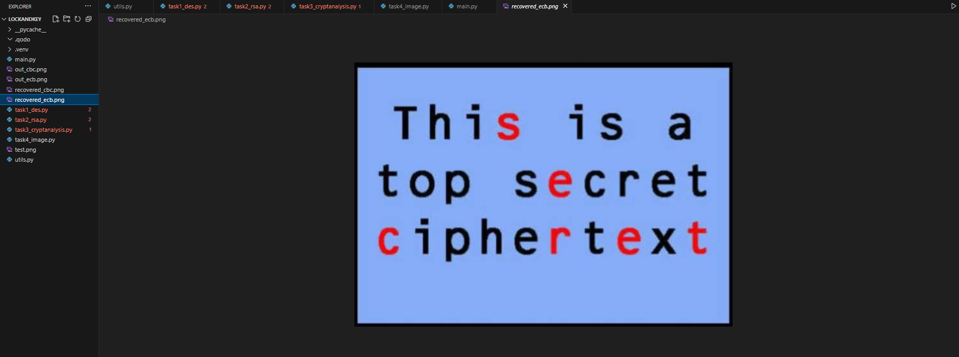
7.3 Which mode is more suitable?
CBC is more suitable than ECB for image encryption:
- ECB encrypts identical blocks to identical ciphertext blocks → visible patterns → leaks structure.
- CBC randomizes each block via XOR with the previous ciphertext block (and IV), destroying patterns → no recognizable structure.
- CTS ensures both modes work without padding and the output is the same size as the input.

Square-and-Multiply (used in RSA)
8.1 What problem it solves (a.k.a. “binary exponentiation”)
RSA needs fast modular exponentiation: compute ae mod na^e \bmod naemodn where eee can be hundreds or thousands of bits. Naïvely multiplying aaa by itself eee times is O(e)O(e)O(e) modular multiplications—far too slow. Square-and-Multiply reduces this to O(log⁡e)O(\log e)O(loge) multiplications by scanning the bits of eee and doing one square each step (always) and a multiply only when the current bit is 1.
Left-to-right variant (what I implemented)
- result ← 1, base ← a mod n.
- For each bit of e from MSB to LSB:
  - result ← result² mod n (square)
  - If the bit is 1: result ← result × base mod n (multiply)
- Return result.
Why this works (intuition): reading the bits from the top down is like Horner’s rule in base-2, successively building a(prefix bits)a^{(\text{prefix bits})}a(prefix bits) by squaring (shifting left in binary) and optionally multiplying by aaa when a 1-bit is appended.
Time complexity: O(log⁡2e)O(\log_2 e)O(log2​e) modular multiplications (one square per bit + ~half as many multiplies on average).
Space: O(1)O(1)O(1) extra words beyond big-int temporaries.
Tiny example
Compute a13 mod na^{13} \bmod na13modn. Binary of 13 is 1101.
- start: res=1
- bit 1 → res = 1²=1; multiply → a
- bit 1 → res = a²; multiply → a³
- bit 0 → res = (a³)² = a⁶
- bit 1 → res = (a⁶)² = a¹²; multiply → a¹³
All steps are taken mod nnn.
8.2 Where it is in my code
utils.py:
def powmod(a: int, e: int, n: int) -> int:
result = 1
a %= n
for bit in bin(e)[2:]:
result = (result * result) % n # square
if bit == '1':
result = (result * a) % n # multiply on '1'
return result

This powers:
- RSA encryption/decryption on integers (task2_rsa.py).
- Segmented RSA signatures and verification (rsa_sign_hash, rsa_verify_hash).
- RSA short-message cryptanalysis comparisons (task3_cryptanalysis.py).
8.3 Correctness sketch (why it’s right)
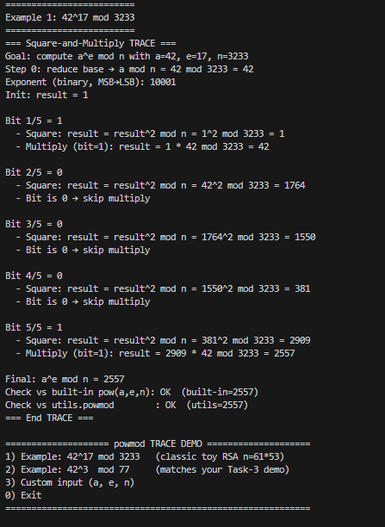
8.4 Practical safeguards & edge cases
- We reduce the base first (a %= n) to keep intermediates bounded.
- e=0 returns 1 (since the loop does only squaring of 1 → still 1).
- Negative e isn’t used in RSA; not supported.
- n=1 degenerates to everything ≡ 0; never occurs in our flows but the code would yield 0 because of the initial a %= n.
8.5 Variants, optimizations, and side-channels
- Right-to-left (LSB→MSB) version is equally correct and sometimes simpler to make constant-time per bit.
- Sliding-window exponentiation reduces the number of multiplies using precomputed odd powers of a.
- Montgomery multiplication / Barrett reduction speeds up big-integer modular reduction; Python’s built-ins are already highly optimized, but a manual Montgomery path is typical in low-level crypto.
- Constant-time concerns: our Python loop branches on secret exponent bits (the if bit == '1'). That’s fine for this assignment, but side-channel-safe code would avoid data-dependent timing/branches (e.g., Montgomery ladder or masked multiply).
- CRT for RSA decryption: using the Chinese Remainder Theorem (mod ppp and mod qqq) accelerates decryption/signing by ~4×. We didn’t implement it, but it’s a common optimization.

9) Critical evaluation & future enhancements
9.1 Strengths
- DES from scratch + CBC-CTS: full IP/FP, S-boxes, permutations, key schedule—great for learning and for oral exam demonstrations. The CTS path is correct and preserves message length.
- Traceability: verbose traces for DES rounds and CBC/CTS steps make the design auditable.
- RSA utility: explicit key checks (coprime e, ϕ(n)\phi(n)ϕ(n)), SHA-256 hashing, and segmented signatures so each signed chunk is < n—a clean way to meet the assignment constraints.
- Combined mode (Sign-then-Encrypt): integrates confidentiality and authenticity with clear user prompts.
- Image encryption testbed: ECB+CTS vs CBC+CTS on raw RGB, saved as lossless PNG—the visuals make the ECB insecurity obvious.
9.2 Limitations & risks (honest appraisal)
- DES is obsolete (56-bit key). It’s correct for the assignment but not for real security. Even 3DES (Triple-DES) is now legacy and slower than modern ciphers; AES is the standard replacement.
- No integrity for symmetric encryption: CBC (even with CTS) is malleable; an attacker can flip bits. Without a MAC or an AEAD mode, decryption errors and forgeries aren’t detected.
- RSA signatures without padding: textbook “hash-then-RSA” is susceptible to structural attacks; production systems use RSASSA-PSS.
- Manual key/IV entry: easy to mistype hex and accidentally reuse IVs. IV reuse in CBC breaks semantic security for the first block and can leak patterns across messages.
- Key exchange not automated: the brief says to include a secure mechanism for key generation and exchange. In our prototype, symmetric keys are entered by hand; there’s no RSA-wrapped session key or DH/ECDH handshake.
- Primality testing: a simple trial-division test is fine for 10-digit numbers, but not scalable; for larger keys you want Miller–Rabin (probabilistic) or deterministic variants for certain ranges.
- Side-channels: exponentiation branches on secret bits; S-box lookups and permutations are not constant-time. In CPython, strict constant-time is hard, but it’s still a risk in principle.
- DES parity bits: we accept 64-bit hex keys but don’t check or set DES parity bits. Old DES specs require each byte to have odd parity.
- Image pipeline caveat: if someone saved outputs as JPEG (lossy), it might blur evidence and complicate demos. We correctly write PNG, but it’s worth calling out.
9.3 Future enhancements (prioritized, actionable)
A) Cryptographic robustness
- Replace DES with AES-256-GCM (or ChaCha20-Poly1305). You get confidentiality and integrity in one shot (AEAD).
- If sticking with RSA in the hybrid:
  - RSA-OAEP to wrap a randomly generated session key (and IV/nonce).
  - RSASSA-PSS for signatures.
  - Consider Encrypt-then-Sign or Sign-then-Encrypt consistently, but in either case, verify before use and never decrypt unauthenticated data.
- Add HMAC-SHA-256 if you keep CBC (MAC-then-Encrypt or, better, Encrypt-then-MAC).
B) Key generation & exchange
- Automate key generation (secure RNG, e.g., os.urandom) and store keys in passphrase-protected files.
- Provide a hybrid handshake: receiver publishes RSA public key; sender generates a random symmetric key/IV, wraps with RSA-OAEP, and sends (RSA_wrapped_key, IV, ciphertext, signature).
C) Correctness & safety tooling
- Validate DES parity bits (or document parity is ignored).
- Add known-answer tests (KATs): more DES vectors (NIST), RSA sign/verify round-trips, and property tests (fuzzing).
- Implement Miller–Rabin for primes and reject weak exponents (e too small except 65537) or non-prime p,q.
D) Side-channel & performance
- Use constant-time exponentiation patterns (Montgomery ladder) and Montgomery reduction for speed; add CRT decryption for RSA.
- Zero sensitive buffers after use (best-effort in Python), avoid printing secrets in traces by default.
E) UX & operational polish
- Random IVs per encryption (print/store hex alongside ciphertext).
- Improve input ergonomics: auto-detect 0x hex vs text, clearer error messages, and refuse IV reuse for the same key.
- Produce a run log (non-sensitive) for the report: inputs (types), lengths, and pass/fail statuses.
- For images, allow a “preview” mode and always force lossless output; embed the parameters (mode, key id, IV) as PNG metadata.

Code is in a text file attached
project strucutre
