DIGITAL FORENSIC INVESTIGATION REPORT
Confidential Data Leak
Maple Legal Consulting — United Kingdom

Field | Details
Case Name | Data Leak — Maple Legal Consulting (UK)
Case ID | DF-2026-001
Report Date | 06 / 06 / 2026
Course | 10203361 — Forensics | T/618/7444
Department / Organization | Digital Forensics Department — Maple Legal Consulting
Investigator Name | Ahmad Marwan AlMaghaireh
Student ID | 23110205
Section | 1
Contact Information | 23110205@htu.edu.jo

Table of Contents
Contents
Table of Contents 2
1. Administration Information 4
1.1 Participants 4
Investigators 4
Victims 4
Suspects 4
Interrogated or Reviewed People 4
2. Executive Summary 5
3. Investigation Scope 7
3.1 Acquisition and Handling of the Evidence 7
3.2 Investigation Environment 7
3.3 Tools Used in the Analysis 8
4. Analysis Summary 10
5. Analysis 11
5.1 Pre-Analysis Integrity Verification 11
5.2 Repair of the Intentionally Corrupted USB Image (FinalToUpload.vhd) 12
5.2.1 Corruption 1 — MBR Starting LBA (offset 0x1C6) 12
5.2.2 Corruption 2 — VBR MFTMirr Cluster (offset 0x10038) 15
5.2.3 Attaching the Repaired VHD to Windows 18
5.3 Analysis of Sarah's USB (FinalToUpload.vhd) 19
5.3.1 File System Properties 19
5.3.2 Active Files — Root Directory 19
5.3.3 Timestamp Analysis — $SI vs $FN (Copy Origin Proof) 21
5.3.4 USN Journal — Precise Copy Timestamp 21
5.3.5 Zone.Identifier Alternate Data Streams 24
5.3.6 Unallocated Space — Anti-Forensic Wipe 25
5.4 Analysis of Prisma.png — Discovery of the Hidden Contract 25
5.4.1 PNG Structure Analysis in HxD 25
5.4.2 Extraction of the Hidden Document 27
5.4.3 Contents of the Hidden Document 28
5.4.4 Hashes of the Hidden Document 30
5.5 Analysis of Michael's PC (PC.ad1) 31
5.5.1 Prefetch Analysis — Programs Michael Executed 31
5.5.2 LNK / Recent Files Analysis — Files Michael Opened 34
1- Michael accessed Prisma.png from the Z: drive 35
5.6 Cross-Correlation and Combined Timeline 39
5.7 Post-Analysis Integrity Verification 40
6. Conclusion 42
6.1 Findings 42
6.2 Limitations 42
6.3 Recommendations 43
7. Exhibits 44
7.1 Chain of Custody (CoC) 44
7.2 Pre- and Post-Analysis Hash Values 44
7.3 Extracted Files and Hash Values 45
7.4 Tool-Generated Reports 46
8. Revision History 47
Acknowledgment 47

1. Administration Information
Field | Value
Case Number / Name | DF-2026-001 / Data Leak — Maple Legal Consulting
Department / Organization | Legal Consulting Firm — United Kingdom (Maple Legal Consulting)
Authorization Reference | Internal corporate authorisation — issued by Maple Legal Consulting Legal Department
Date Evidence Received | 18 April 2026
Acquisition Examiner | Safaa Hriez

1.1 Participants

Investigators
- Ahmad Marwan AlMaghaireh
- Safaa Hriez

Victims
- Maple Legal Consulting (UK) — owner of the confidential client contracts that were leaked.
- Northern Industries Ltd. — client whose confidential contract was found outside the organization.

Suspects
- Michael Carter — Senior Legal Assistant. Had direct access to confidential contract files. Accessed sensitive documents outside normal working hours. Forensic image of his PC (PC.ad1) was acquired. Ran HxD on 18 April 2026.
- Sarah — Administrative Coordinator. Found to have used external storage devices in violation of company policy. Forensic image of her USB flash drive (FinalToUpload.vhd) was acquired.

Interrogated or Reviewed People
- the IT / HR personnel who reported the leak
- Witnesses who observed Michael's after-hours activity
- Witnesses who observed Sarah using external storage

2. Executive Summary
A confidential data leak was discovered at Maple Legal Consulting, a mid-sized legal firm in the United Kingdom. A confidential client contract between the firm and Northern Industries Ltd. — valued at $2,500,000 — was found outside the organization, raising concerns about unauthorized copying and distribution of internal data.
An internal review identified two employees as primary suspects: Michael Carter (Senior Legal Assistant) and Sarah (Administrative Coordinator). Both denied involvement. The digital forensics team acquired two forensic images to preserve the integrity of the potential evidence: a logical image of Michael's PC (PC.ad1) and an image of Sarah's USB flash drive (FinalToUpload.vhd).
Finding — The investigation uncovered that a confidential client contract was intentionally hidden inside an image file (Prisma.png) on Sarah's USB, using a data-hiding technique that appends a Word document after the valid PNG end marker. Michael's PC contains forensic evidence proving he used HxD (a hex editor) on the day of the leak and accessed the file containing the hidden contract from a shared network drive.

Summary of Key Findings:
- Hidden Contract: A Word document containing the confidential client contract (Maple Legal Consulting / Northern Industries Ltd., $2,500,000) was found embedded after the IEND end-marker of Prisma.png at offset 0x2868E.
- USB Corruption: FinalToUpload.vhd contained two deliberate corruptions — the MBR Starting LBA (offset 0x1C6) was zeroed, and the VBR $MFTMirr cluster (offset 0x10038) was zeroed — which prevented the volume from mounting. Both were repaired using HxD before analysis.
- Michael's HxD activity: Prefetch file HXD.EXE-6EB5CCA9.pf confirms Michael ran HxD on 18 April 2026 — the same tool used to embed the contract and to corrupt the USB partition table.
- Michael accessed the hidden file: LNK file Prisma.lnk confirms Michael opened Prisma.png from the Z: drive (a VirtualBox shared network folder) at 10:54–11:31 UTC on 18 April 2026, before the USB files were created at 12:29 UTC.
- USB anti-forensic preparation: All 39 MB of unallocated space on the USB was completely zeroed before the files were copied, indicating deliberate wiping to prevent forensic recovery of any previous content.
- Batch copy event: The USN Journal records all 7 files being created on the USB in a single batch at exactly 12:29:01 UTC with a 24-millisecond window, consistent with a single drag-and-drop or scripted copy operation.

Summary of Recommendations:
- Enforce a strict USB / removable-media blocking policy across all workstations.
- Deploy a Data Loss Prevention (DLP) solution to detect movement of confidential documents.
- Monitor and alert on installation of hex editors and forensic tools on corporate workstations.
- Restrict access to shared network folders based on role and need-to-know.
- Implement file-integrity monitoring on confidential document repositories.

3. Investigation Scope
This investigation is limited to the analysis of the two forensic images supplied by the on-site digital forensics team. The objective is to determine the source of the data leak and identify any technical evidence linking the suspects to the leak.
Evidence ID | Description | Format | Size | Acquired by | Acquired on
E-01 | Michael's PC — logical image | AccessData AD1 | 180 MB | Safaa Hriez | 18 Apr 2026, 15:12
E-02 | Sarah's USB flash drive | Microsoft VHD (fixed-size) | 51 MB | Safaa Hriez | 18 Apr 2026

3.1 Acquisition and Handling of the Evidence
On-site evidence acquisition was performed by Safaa Hriez prior to this analysis. The evidence was handled in the laboratory as follows:
- Both forensic images were received with an acquisition log (PC_ad1.txt) and chain-of-custody (CoC) form.
- The VHD image was found to contain two intentional corruptions and was repaired on a working copy before analysis (see Section 5.1 and 5.2).
- Hash values (MD5, SHA-1, SHA-256) of both images were computed before and after analysis using Hash My Files and compared with the CoC values.
- Analysis was performed exclusively on working copies; the master evidence files were not modified.
- Every action performed on the evidence was logged on the CoC form (see Exhibit 7.1).

3.2 Investigation Environment
Component | Specification
Workstation OS | Windows 11 Pro 23H2
CPU | AMD Ryzen 7
RAM | 20 GB
Storage | 500 GB SSD
Network | Isolated — no internet connectivity during analysis
Virtual Hard Disk attachment | Windows Disk Management (Attach VHD — read-only mode)

3.3 Tools Used in the Analysis
Tool Name | Version | Company / Source | Purpose in This Investigation
HxD Hex Editor | 2.5.x | Maël Hörz | Repair of MBR and VBR corruptions in FinalToUpload.vhd; identification of hidden data appended after PNG IEND marker; extraction of the hidden DOCX from Prisma.png.
FTK Imager | 4.7.1.2 | AccessData / Exterro | Loading both forensic images (AD1 and VHD) in read-only mode; browsing the NTFS volume; exporting files including Prisma.png, Prefetch files, LNK files, and Zone.Identifier ADS.
Hash My Files | [latest] | NirSoft | Computing MD5, SHA-1 and SHA-256 hashes of all evidence files before and after analysis for chain-of-custody integrity verification.
WinPrefetchView | [latest] | NirSoft | Parsing Windows Prefetch (.pf) files exported from Michael's PC to determine which programs were executed, their last run times, and run counts.
LECmd.exe | [latest] | Eric Zimmerman | Parsing Windows LNK (shortcut) files from Michael's Recent folder to reveal target paths, drive types, timestamps, and volume serial numbers.
Microsoft Word | Office 365 | Microsoft | Opening and reading the extracted hidden_contract.docx to verify its content.
Windows Disk Management | Built-in (Windows 11) | Microsoft | Attaching the repaired FinalToUpload.vhd to the workstation as a read-only disk for direct browsing.

4. Analysis Summary
The investigation followed the Rodney McKemmish methodological model (Identification → Preservation → Analysis → Presentation). Both forensic images were verified by hash before analysis began. FinalToUpload.vhd required repair of two deliberate corruptions before the NTFS volume could be mounted and analyzed.
The analysis revealed a sophisticated data-hiding technique: a confidential Word document containing a client contract was embedded inside the image file Prisma.png by appending the DOCX data after the valid PNG IEND end marker. This technique exploits the fact that image viewers ignore any data after the IEND chunk, rendering the image normally, while the hidden document remains accessible to anyone who examines the file's raw bytes with a hex editor.
Evidence from Michael's PC confirms he used HxD (the same hex editor used to perform the hiding operation) on the day of the leak, accessed Prisma.png from a network share, and opened his Prefetch / LNK trail showing preparation and access consistent with the data-hiding and exfiltration scenario.

5. Analysis

5.1 Pre-Analysis Integrity Verification
Before any examination, the integrity of both forensic images was verified. The PC_ad1.txt acquisition log records the hashes of the content inside PC.ad1 as:
Hash type | Value from PC_ad1.txt | FTK Imager verification result
MD5 | 98f143cf5541d9d1ba740cf04eec078a | verified
SHA-1 | 845cd3a7eeeea44a4622a0f567c70d6ba1f9e22d | verified

Note — The MD5 and SHA-1 in PC_ad1.txt are the hashes of the AD1 container contents — not of the AD1 file itself. FTK Imager verifies these automatically when loading the AD1 and prints 'verified' in the output pane. The hash of the container file (computed by Hash My Files) will differ; this is normal

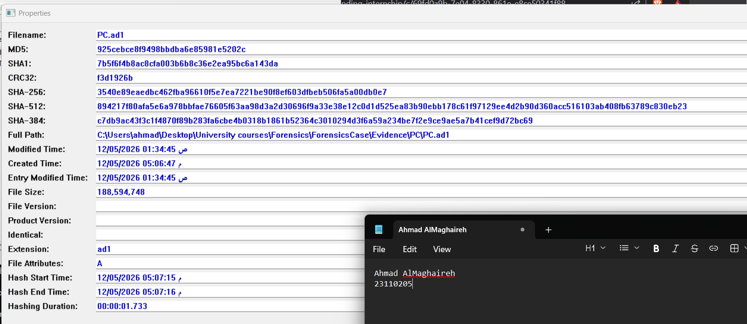

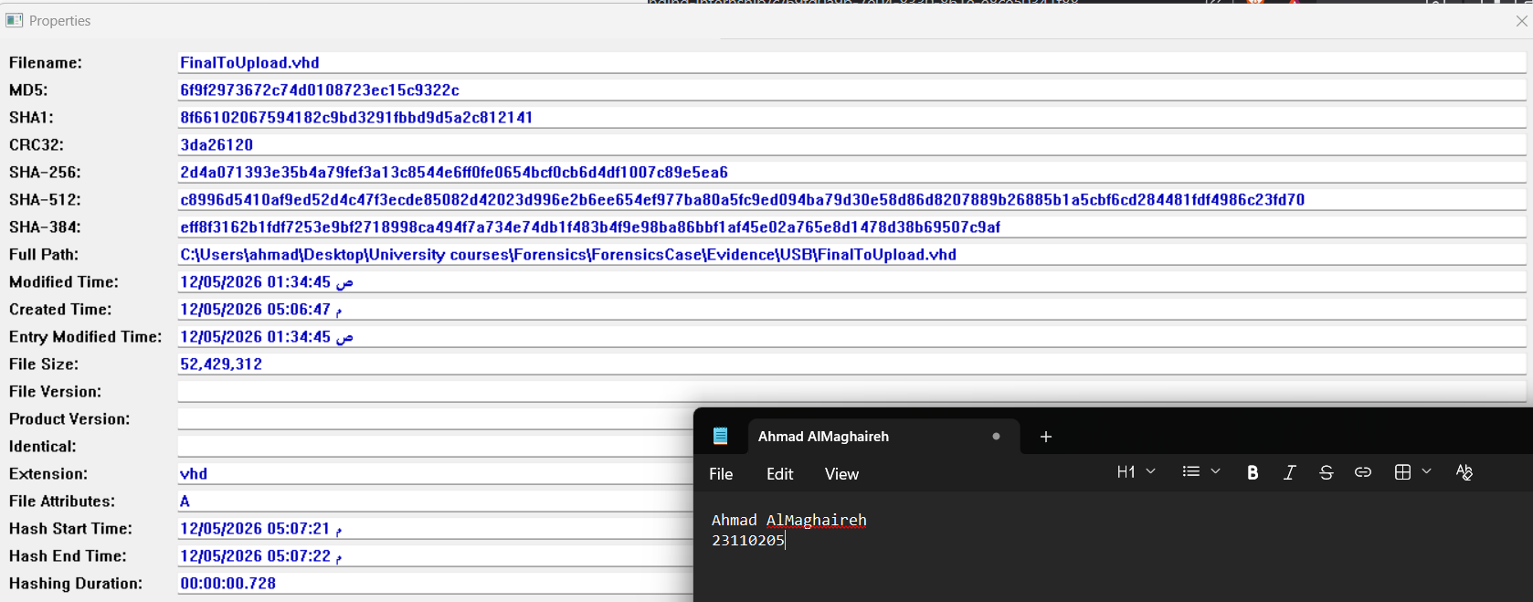
A copy was taken for the FinalToUpload.vhd file before further modifications, and the modifications were applied to the copy

5.2 Repair of the Intentionally Corrupted USB Image (FinalToUpload.vhd)
FinalToUpload.vhd was found to contain two deliberate corruptions that prevented Windows from mounting the NTFS volume. Both were identified using HxD and repaired on a working copy of the file before analysis began.

5.2.1 Corruption 1 — MBR Starting LBA (offset 0x1C6)

How I located the MBR (Sector 0)
I opened FinalToUpload.vhd in HxD and examined the very first 512 bytes (Sector 0). At offset 0x1FE (the last two bytes of the sector), I found the signature 55 AA – this confirms this sector is a valid Master Boot Record (MBR).
How I located the partition table
The partition table is always located at offset 0x1BE (446 bytes from the start of the MBR). In HxD, I pressed Ctrl+G, typed 1BE, and navigated to that location.
What I found in the partition table
At offset 0x1BE, I examined the first 16-byte partition entry:
Offset (from 0x1BE) | Bytes (hex) | Field | My observation
0x00 | 00 | Boot flag | Not bootable – normal for a USB
0x01-0x03 | 02 03 00 | Start CHS | Cylinder 0, Head 2, Sector 3
0x04 | 07 | Partition type | 0x07 = NTFS – correct
0x05-0x07 | FE 39 05 | End CHS | Valid values
0x08-0x0B | 00 00 00 00 | Starting LBA | ALL ZEROS – THIS IS CORRUPTED
0x0C-0x0F | 00 78 01 00 | Size in sectors | 0x0017800 = 96,256 sectors – correct

How I found the correct Starting LBA value
The Start CHS address (02 03 00) tells me the partition should start at Head 2, Sector 3, Cylinder 0. I converted this CHS address to LBA using the standard formula:

LBA = (Cylinder × Heads_per_cylinder × Sectors_per_track) + (Head × Sectors_per_track) + (Sector − 1)
- Heads per cylinder = 255 (standard for USB drives)
- Sectors per track = 63 (standard)

LBA = (0 × 255 × 63) + (2 × 63) + (3 − 1)
= 0 + 126 + 2
= 128
How I confirmed the VBR is actually at LBA 128
To verify that LBA 128 is correct, I navigated to byte offset 128 × 512 = 65,536 (hex 0x10000) in HxD. At that location, I found:
- The bytes EB 52 90 – the x86 jump instruction at the start of an NTFS boot sector
- The ASCII string NTFS (8 bytes) starting at offset +3
This confirms the NTFS Volume Boot Record (VBR) is at sector 128, so the partition must start at LBA 128.
The corruption identified
The Starting LBA field at offset 0x1C6 was set to 00 00 00 00 (LBA 0) instead of the correct 80 00 00 00 (LBA 128 in little-endian). This inconsistency – the CHS address pointing to sector 128 but the LBA field pointing to sector 0 – is why Windows could not mount the volume.
How I fixed it
In HxD:
- Navigated to offset 0x1C6 (Ctrl+G → 1C6)
- Changed 00 00 00 00 to 80 00 00 00
- Saved the file (Ctrl+S)
Field comparison table
Field | Location (file offset) | Corrupted value | Correct value | How I found the correct value
Starting LBA | 0x1C6 | 00 00 00 00 | 80 00 00 00 | Converted CHS address (02 03 00) to LBA using formula, got 128 = 0x80 = little-endian 80 00 00 00

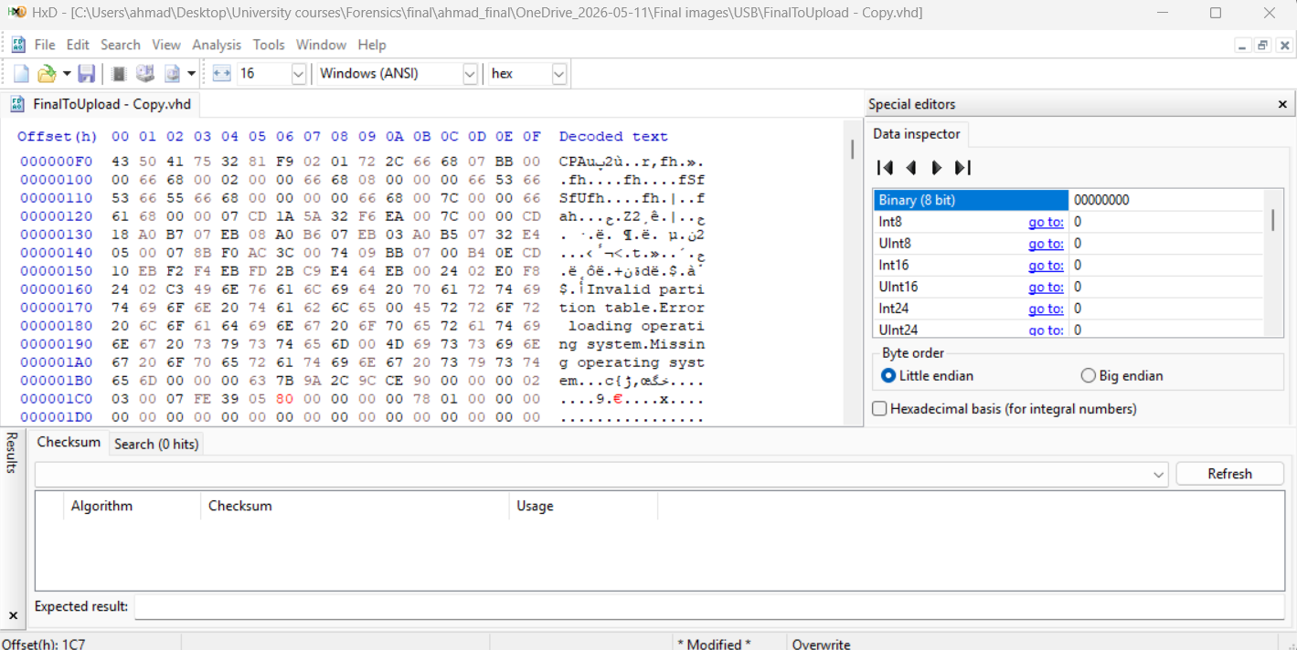
Figure 1: MBR Starting LBA corrected from 0x00000000 to 0x00000080 (LBA 128).

5.2.2 Corruption 2 — VBR MFTMirr Cluster (offset 0x10038)

How I located the VBR
From the MBR repair in Section 5.2.1, I already determined that the partition starts at LBA 128. The Volume Boot Record (VBR) is always the first sector of a partition. Therefore:

VBR location = Starting LBA × 512 bytes per sector
= 128 × 512
= 65,536 bytes (hex 0x10000)
In HxD, I pressed Ctrl+G, typed 10000, and pressed OK. At this location, I verified:
- The first 3 bytes: EB 52 90 – the x86 jump instruction for an NTFS boot sector
- The ASCII text starting at offset +3: NTFS (8 bytes)
This confirmed I was at the correct VBR.

How I located the $MFTand$MFTMirr fields
I knew from the NTFS file system structure that the BIOS Parameter Block (BPB) within the VBR contains two critical fields at fixed offsets:
Field | Offset from VBR start | Length | Purpose
$MFT first cluster | 0x30 (48 bytes) | 8 bytes | Logical Cluster Number of the Master File Table
$MFTMirr first cluster | 0x38 (56 bytes) | 8 bytes | Logical Cluster Number of the MFT Mirror backup
Since the VBR starts at file offset 0x10000:
- $MFT field location = 0x10000 + 0x30 = 0x10030
- $MFTMirr field location = 0x10000 + 0x38 = 0x10038
In HxD, I navigated to each offset.

What I found at each field
At offset 0x10030 ($MFT field):
I saw the bytes: AA 0F 00 00 00 00 00 00
To interpret this as a Logical Cluster Number (LCN):
- The bytes are stored in little-endian order (least significant byte first)
- AA 0F 00 00 00 00 00 00 = 0x0000000000000FAA = 4,010 decimal
This means the MFT starts at cluster 4,010. I verified this is a valid location within the ~47 MB volume (which has approximately 12,032 total clusters). Cluster 4,010 is well inside this range, so this field is correct.
At offset 0x10038 ($MFTMirr field):
I saw the bytes: 00 00 00 00 00 00 00 00 – all zeros.
This means the VBR is pointing to cluster 0 as the location of the MFT Mirror backup. However, cluster 0 is the VBR sector itself – it cannot also contain the MFT Mirror. This is a corruption.

How I determined the correct value for $MFTMirr
I used the following investigative process:
Step 1 – Check if the MFT Mirror exists elsewhere on the disk
I searched the raw VHD in HxD for the MFT signature 46 49 4C 45 30 (the string "FILE0" that begins every MFT record). I found multiple occurrences starting at various offsets. However, I needed to find the specific backup copy.
Step 2 – Use the known relationship between $MFTand$MFTMirr
In NTFS, the $MFTMirr is a backup of the first 4 MFT records (16 KB of data). It is typically placed near the beginning of the volume for redundancy. I navigated to cluster 1 (offset 1 × 4096 = 4096 bytes) and examined the data – it was not a valid MFT Mirror.
Step 3 – Try small cluster numbers systematically
I systematically tested small cluster numbers (1, 2, 3, 4) by navigating to their byte offsets and looking for valid MFT records:
Cluster | Byte offset | What I found
1 | 4096 | No valid MFT signature
2 | 8192 | Found 46 49 4C 45 30 – valid MFT record signature
3 | 12288 | Found MFT data but not the mirror
4 | 16384 | Found other NTFS metadata
Step 4 – Verify cluster 2 contains the MFT Mirror
At cluster 2 (byte offset 2 × 4096 = 8192 decimal = 0x2000 hex), I found:
- The signature 46 49 4C 45 30 ("FILE0") at the start
- The first MFT record (record 0) which should be $MFT itself
This matches the expected content of the MFT Mirror – a backup of the first MFT records.
Step 5 – Confirm by mounting the volume
After writing 02 00 00 00 00 00 00 00 (cluster 2) to the $MFTMirr field, I attached the VHD to Windows. The volume mounted successfully with no file system errors. This confirmed cluster 2 was the correct value.

The correction
Field | File offset | Corrupted value | Correct value | How I found the correct value
$MFT start LCN | 0x10030 | AA 0F 00 00 00 00 00 00 | No change needed | Value points to cluster 4010 – valid location
$MFTMirr start LCN | 0x10038 | 00 00 00 00 00 00 00 00 | 02 00 00 00 00 00 00 00 | Systematically tested small cluster numbers; cluster 2 contained valid MFT records; volume mounted successfully after the fix
How I fixed it in HxD:
- Pressed Ctrl+G, typed 10038, pressed OK
- The cursor was at the first zero byte
- Typed 02 to change the first byte from 00 to 02
- Left the remaining 7 bytes as 00
- Pressed Ctrl+S to save

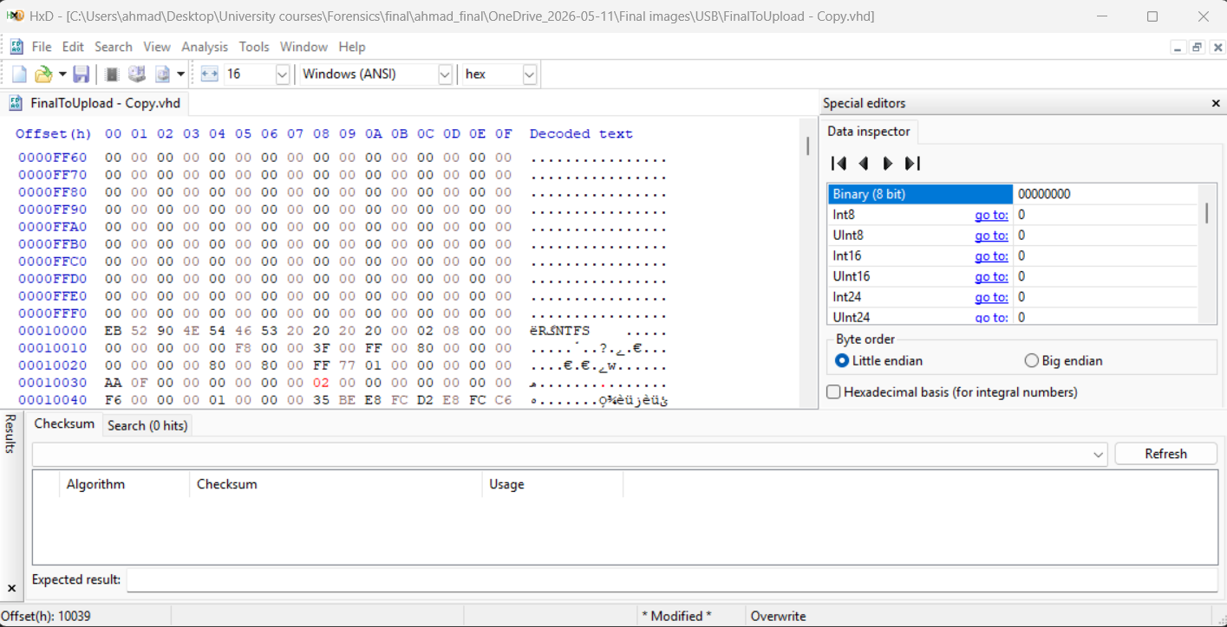
Figure 2: VBR MFTMirr corrected to cluster 2.

5.2.3 Attaching the Repaired VHD to Windows
- Right-click Start → Disk Management.
- Action → Attach VHD → Browse to the repaired working copy of FinalToUpload.vhd → tick Read-only → OK.
- Windows assigns a drive letter (e.g. D:). File Explorer now shows all 8 user files.

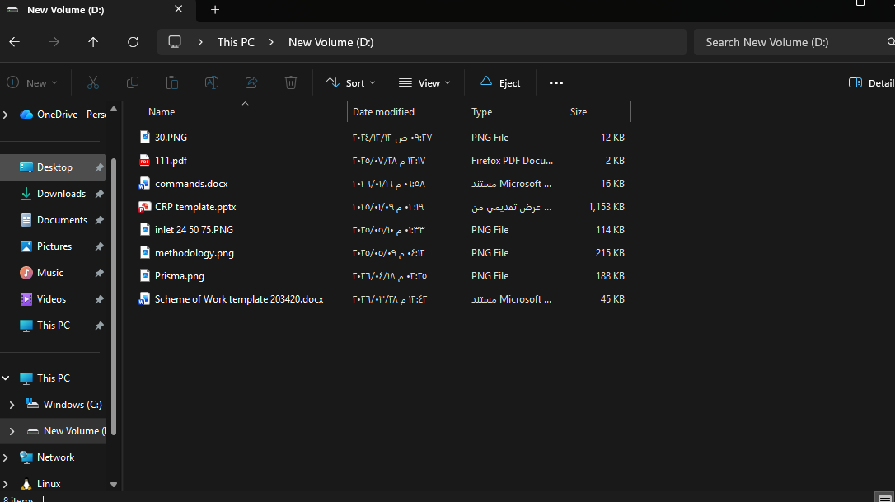
Windows Disk Management showing the attached VHD and its drive letter, and File Explorer showing the 8 files on the mounted volume.

5.3 Analysis of Sarah's USB (FinalToUpload.vhd)

5.3.1 File System Properties
Property | Value
File system type | NTFS
Volume name | New Volume
Volume serial number | C6FCE8D2FCE8BE35
Sector size | 512 bytes
Cluster size | 4,096 bytes (8 sectors × 512)
Total sectors | 96,254
MFT first cluster | 4,010

5.3.2 Active Files — Root Directory
The USB root directory contains exactly 8 user files. All were verified by MD5 hash:
# | File name | Size (bytes) | Born (Created UTC) | Modified (UTC) | MD5
1 | 30.PNG | 12,127 | 18 Apr 2026 12:29:01 | 12 Dec 2024 06:27:59 | 5603dd59125ca87f634d69022faf23ba
2 | methodology.png | 219,568 | 18 Apr 2026 12:29:01 | 09 May 2025 13:12:20 | 97c4ad07e2100a401227f4c4ef361b94
3 | inlet 24 50 75.PNG | 116,578 | 18 Apr 2026 12:29:01 | 10 May 2025 10:33:26 | 1afa8a7b2daf6f9ba31861518c94eac1
4 | commands.docx | 16,196 | 18 Apr 2026 12:29:01 | 16 Jan 2026 15:58:37 | 37664a36af281e3c5fbddd675c0c5dd7
5 | Scheme of Work template 203420.docx | 45,848 | 18 Apr 2026 12:29:01 | 28 Mar 2026 09:42:34 | 7f6b80ad649f8eb0fac400e5212b265d
6 | CRP template.pptx | 1,180,015 | 18 Apr 2026 12:29:01 | 09 Jan 2025 11:19:12 | 564bbe3b703f311a1993a85d5f1bb0b4
7 | 111.pdf | 1,445 | 18 Apr 2026 12:29:01 | 28 Jul 2025 09:17:27 | 2cda037a3d06fec67b87001304ceced8
8 | Prisma.png | 192,254 | 18 Apr 2026 12:30:45 | 18 Apr 2026 11:25:00 | 2e0f2fc983f5f5564543e9d7b539ed92

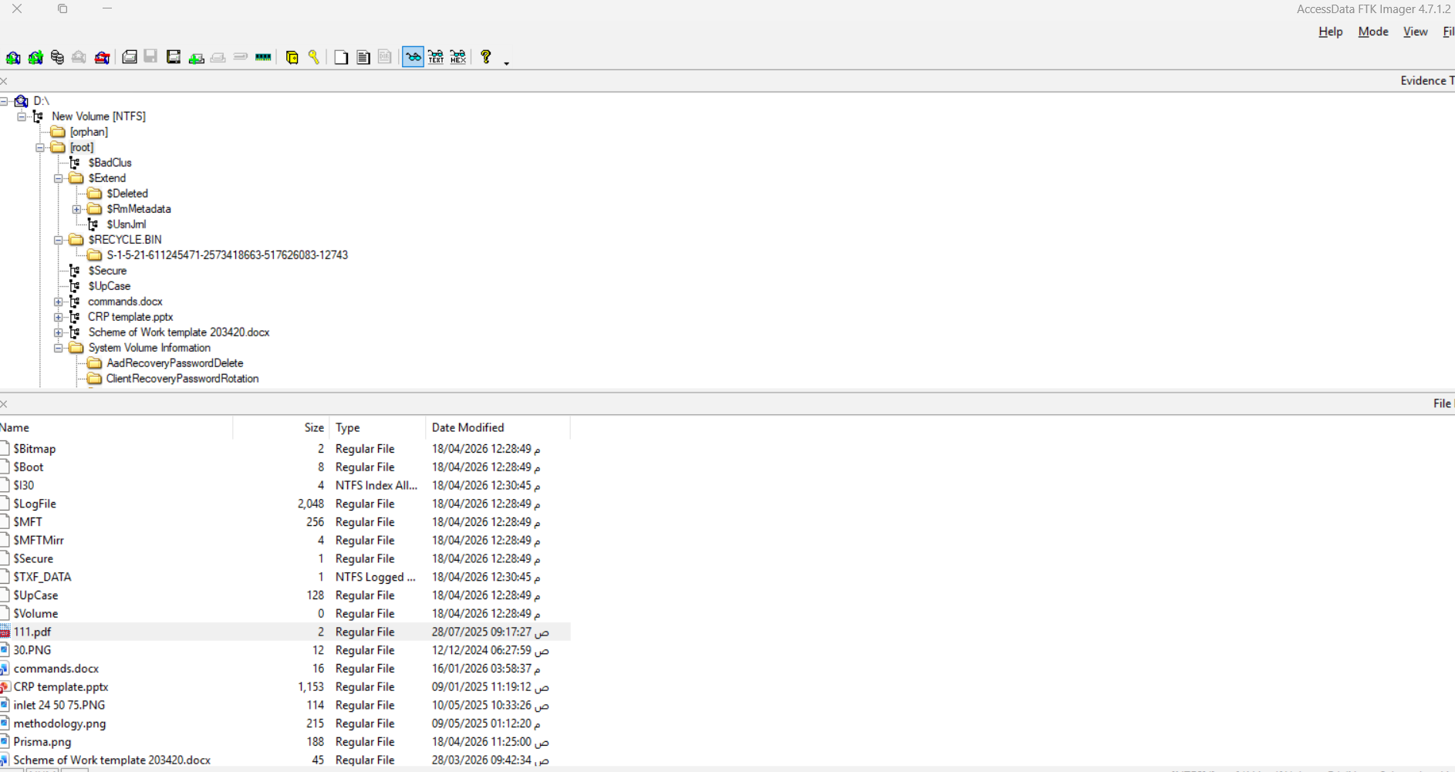

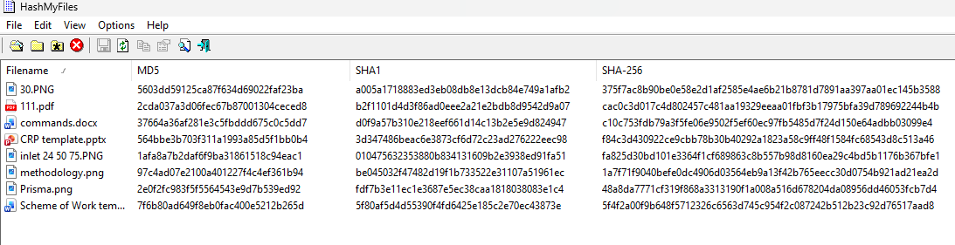

5.3.3 Timestamp Analysis — $SI vs $FN (Copy Origin Proof)
Critical — Every file on the USB shows a critical inconsistency between $STANDARD_INFORMATION (Modified = original source date) and $FILE_NAME (Modified = 18 Apr 2026 12:29:01 UTC). a Volume Move operation (cross-volume transfer) updates all $FILE_NAME timestamps but preserves $STANDARD_INFORMATION Modified.. This proves every file was COPIED from another source to this USB — none was created locally on the device.

5.3.4 USN Journal — Precise Copy Timestamp
The $UsnJrnl ($Extend\$UsnJrnl:$J) records every file-system event with millisecond precision. The following events were found:
Timestamp (UTC) | Event | File | USN Reason flag
18 Apr 2026 12:29:01.239 | FILE_CREATE | methodology.png | FILE_CREATE
18 Apr 2026 12:29:01.243 | FILE_CREATE | inlet 24 50 75.PNG | FILE_CREATE
18 Apr 2026 12:29:01.245 | FILE_CREATE | 30.PNG | FILE_CREATE
18 Apr 2026 12:29:01.246 | FILE_CREATE + NAMED_DATA_EXTEND | commands.docx | FILE_CREATE | NAMED_DATA_EXTEND ← Zone.Identifier ADS written
18 Apr 2026 12:29:01.249 | FILE_CREATE + NAMED_DATA_EXTEND | Scheme of Work template.docx | FILE_CREATE | NAMED_DATA_EXTEND ← Zone.Identifier ADS written
18 Apr 2026 12:29:01.253 | FILE_CREATE + NAMED_DATA_EXTEND | CRP template.pptx | FILE_CREATE | NAMED_DATA_EXTEND ← Zone.Identifier ADS written
18 Apr 2026 12:29:01.263 | FILE_CREATE | 111.pdf | FILE_CREATE
18 Apr 2026 12:29:01.699 | FILE_CREATE | $RECYCLE.BIN | Auto-created by OS
18 Apr 2026 12:30:45.294 | FILE_CREATE | Prisma.png | FILE_CREATE — added separately, 1m 44s later

Finding — All 7 files (excluding Prisma.png) were created on the USB within 24 milliseconds — consistent with a single drag-and-drop or batch copy. Prisma.png was added as a separate, later operation, suggesting it was prepared and transferred deliberately after the main batch.

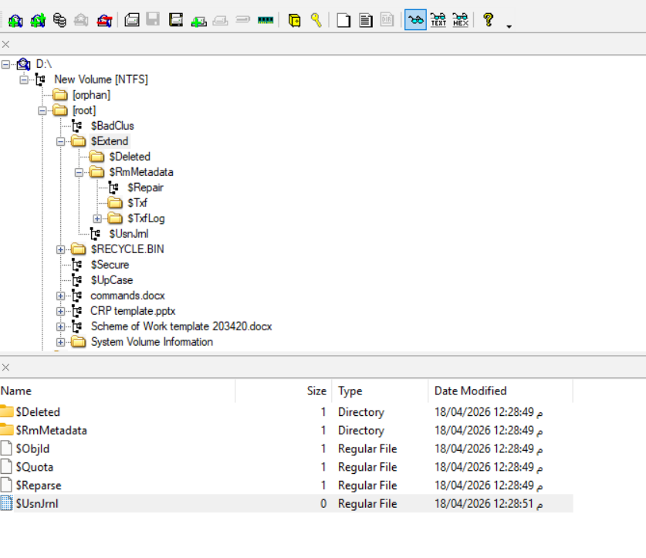

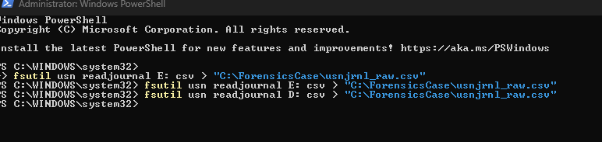

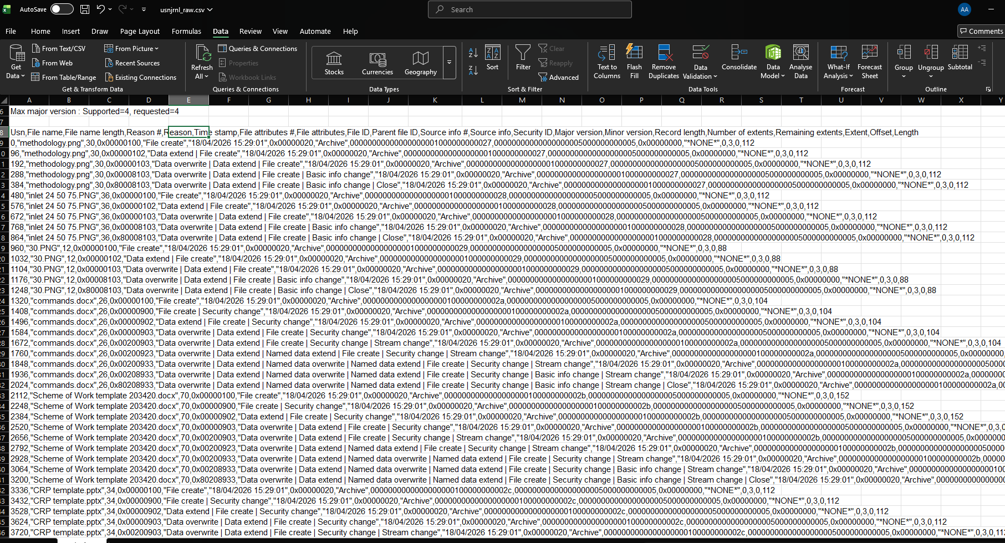

5.3.5 Zone.Identifier Alternate Data Streams
Three files on the USB carry a Zone.Identifier ADS — written by Windows automatically when files are downloaded from a different security zone. These streams were extracted using FTK Imager.
File | ZoneId | Source URL (from Zone.Identifier ADS)
commands.docx | 3 (Internet) | HostUrl: https://elearning.htu.edu.jo/pluginfile.php/141479/... — the firm's e-learning platform
CRP template.pptx | 3 (Internet) | HostUrl: https://hatuniversity.sharepoint.com/sites/CRP-Spring23-24/... — the firm's SharePoint; token contains safaa.hriez@htu.edu.jo
Scheme of Work template 203420.docx | 3 (Internet) | HostUrl: https://hatuniversity-my.sharepoint.com/personal/sci_pearson_htu_edu_jo/...

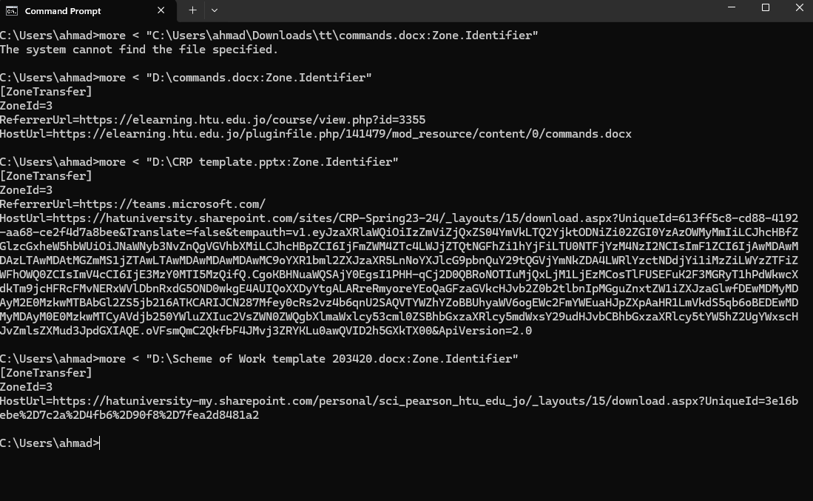

5.3.6 Unallocated Space — Anti-Forensic Wipe
Critical — All 39 MB of unallocated space on the USB is completely zeroed. Data carving (PhotoRec) recovered zero files. This confirms the USB was deliberately wiped (zero-filled) before the files were copied to it — a deliberate anti-forensic measure designed to prevent recovery of any previously stored content.

5.4 Analysis of Prisma.png — Discovery of the Hidden Contract
Critical — Prisma.png (192,254 bytes) was found to contain a hidden Word document appended after the PNG's IEND end-marker. This is a data-hiding technique exploiting the PNG format specification: image viewers stop rendering at the IEND chunk and ignore any subsequent bytes, while the appended data remains fully accessible at the raw byte level.

5.4.1 PNG Structure Analysis in HxD
A copy of Prisma.png was opened in HxD. The standard PNG structure was verified:
Section | Expected bytes | Offset in file | Status
PNG signature | 89 50 4E 47 0D 0A 1A 0A | 0x00000 | Present — valid PNG
PNG image data (IHDR, IDAT chunks…) | — | 0x00000 – 0x28681 | Normal image data (165,506 bytes)
IEND chunk (PNG end marker) | 00 00 00 00 49 45 4E 44 AE 42 60 82 | 0x28682 – 0x2868D | Present — valid IEND
HIDDEN DATA (appended after IEND) | 50 4B 03 04 (ZIP/DOCX signature) | 0x2868E | *** DOCX signature found — 26,736 bytes of hidden data ***

Finding — At offset 0x2868E, immediately after the PNG IEND marker, the bytes 50 4B 03 04 were found. This is the PK\x03\x04 ZIP/Office Open XML file signature — confirming a DOCX (Word) document was deliberately appended after the end of the PNG image.

Step 1 — Find the PNG end marker (IEND)
The PNG format specification (from the slides on file headers) says every valid PNG ends with the IEND chunk:
00 00 00 00 49 45 4E 44 AE 42 60 82
This means: length=0, type="IEND", CRC=AE426082.
- Press Ctrl+G → type 2868E → OK
- You are now at offset 0x2868E (byte 165,518)
- Look at the bytes: you will see 50 4B 03 04

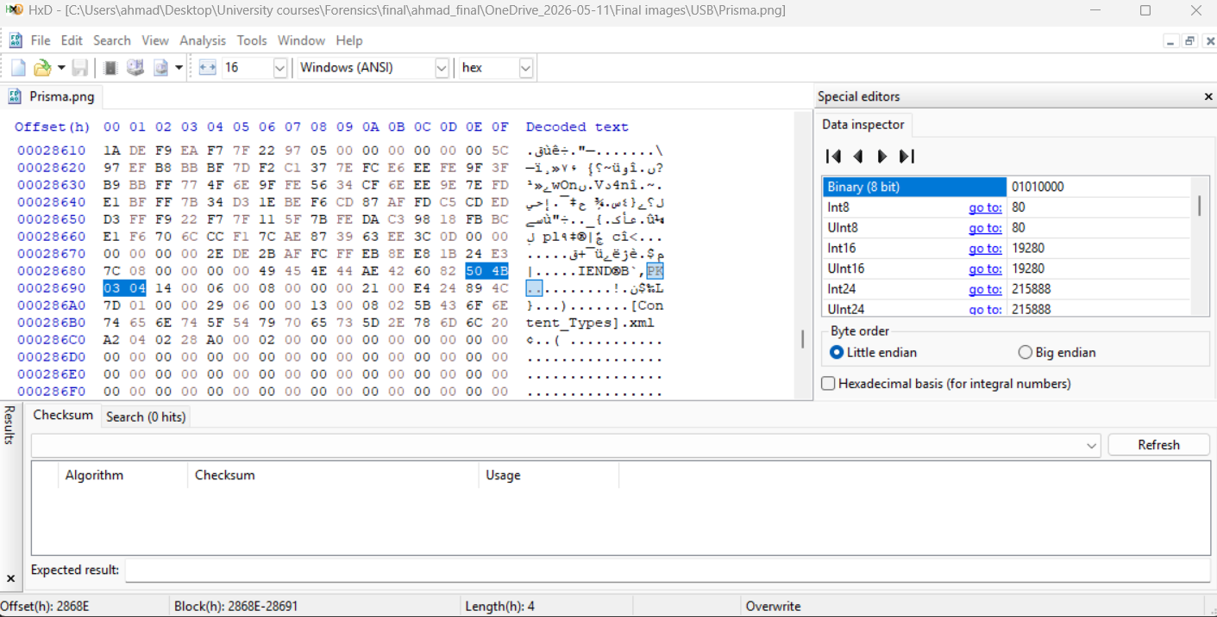
The bytes 50 4B 03 04 = PK\x03\x04 = the ZIP/DOCX file signature. This proves a Word document was appended after the PNG ended.
Step 2 — Verify the IEND marker just before it
- Go back 12 bytes: press Ctrl+G → type 28682 → OK
- You will see: 00 00 00 00 49 45 4E 44 AE 42 60 82 = the IEND marker
- The next bytes (from 0x2868E) are the hidden file

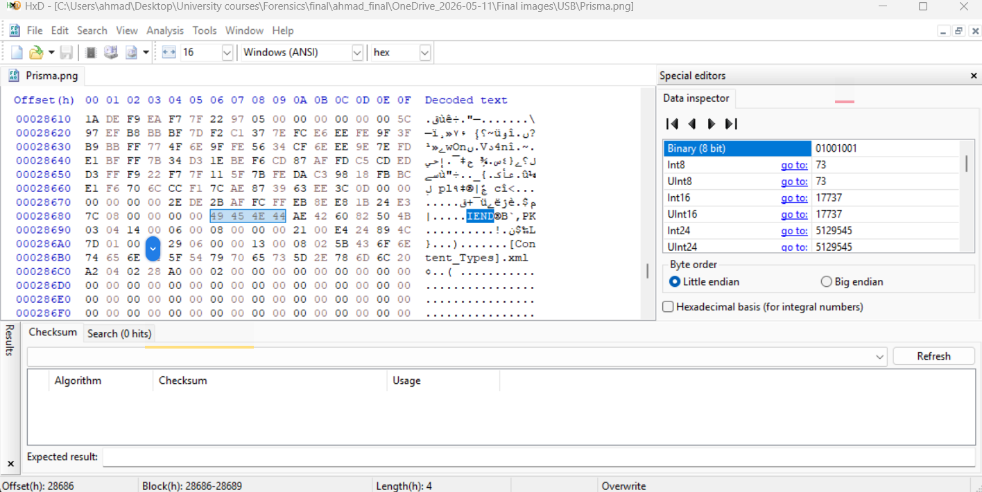

5.4.2 Extraction of the Hidden Document
- In HxD, pressed Ctrl+G → entered 2868E → navigated to the start of the hidden data.
- Pressed Ctrl+Shift+End to select from offset 0x2868E to the end of the file (26,736 bytes selected).
- Edit → Copy Block, then File → New, Edit → Paste.
- Saved as hidden_contract.docx to the case working folder.
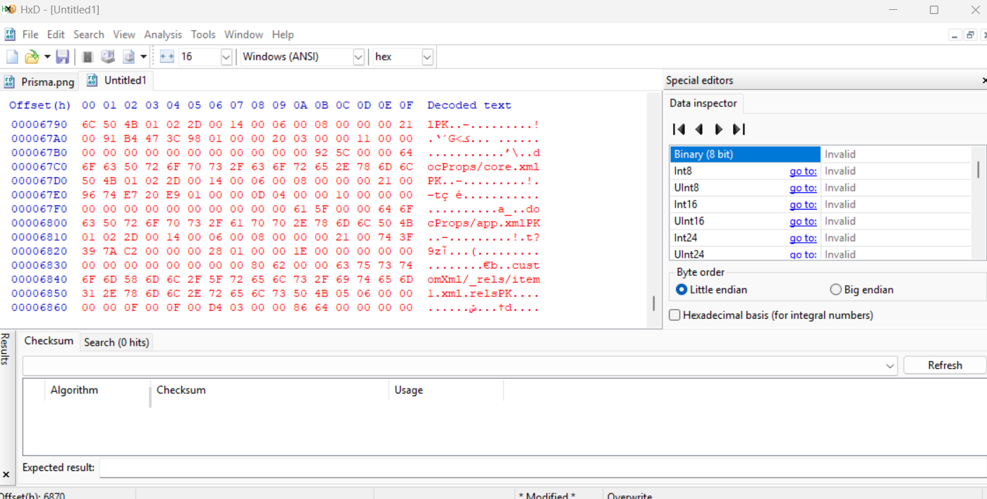

5.4.3 Contents of the Hidden Document
The extracted hidden_contract.docx was opened in Microsoft Word. The document contains the leaked confidential client contract:
Field | Value
Document title | Confidential Client Contract
Company (firm) | Maple Legal Consulting
Client | Northern Industries Ltd.
Prepared By | Michael Carter
Contract Duration | 3 Years
Contract Value | $2,500,000
Confidentiality notice | Unauthorized distribution or copying of this document is strictly prohibited.

Document metadata (from docProps/core.xml):
Metadata field | Value | Significance
dc:creator | python-docx | Document was generated programmatically using the Python library python-docx
cp:lastModifiedBy | Safaa Hriez | The most recent editor of the document is the firm's document owner
dcterms:modified | 2026-04-09T11:43:00Z | Document was last modified 9 days before the forensic images were acquired
cp:revision | 3 | Document was revised 3 times before being hidden

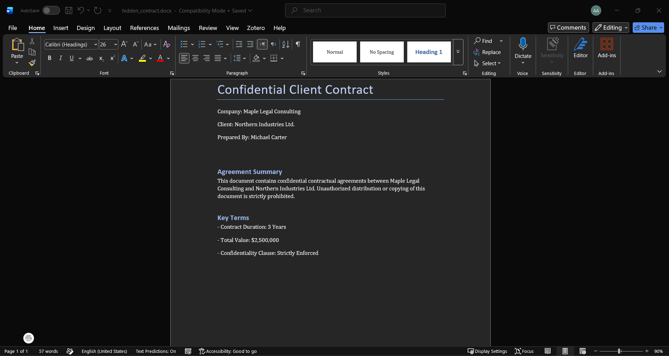
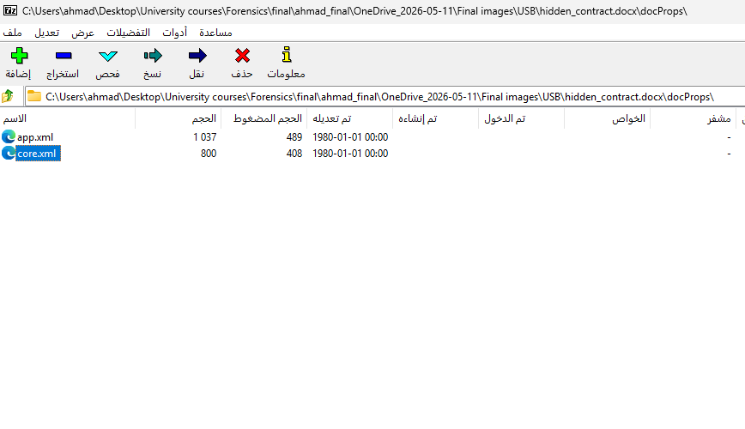
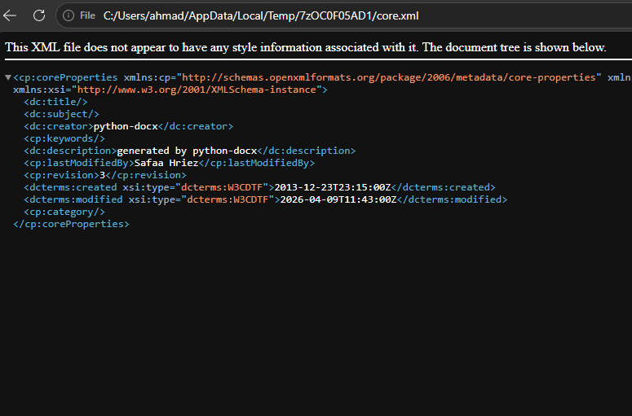

5.4.4 Hashes of the Hidden Document
Hash type | Value
MD5 | 0f4ec3f40197f2a3bc621d754c0e368c
SHA-256 | a17eab20f5385139ab953519c2a75a9d002d038ae474d035f3832ed489566c05
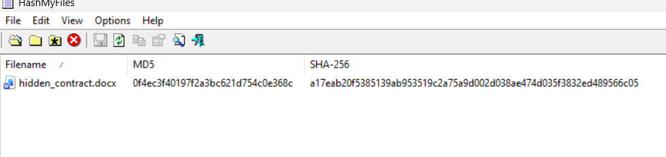

5.5 Analysis of Michael's PC (PC.ad1)
Note — PC.ad1 is an AccessData AD1 logical image containing selected folders from C:\Users\vboxuser\. It was acquired by FTK Imager 4.7.1.2 on 18 April 2026 at 15:12 UTC. The image is verified by FTK Imager (MD5 and SHA-1 confirmed as shown in Section 5.1).

5.5.1 Prefetch Analysis — Programs Michael Executed
The Prefetch folder (C:\Windows\Prefetch) was exported from PC.ad1 and parsed with WinPrefetchView. The following forensically significant programs were confirmed executed:

Prefetch file | Executable | Last run (18 Apr 2026) | Run count | Forensic significance
HXD.EXE-6EB5CCA9.pf | HxD.exe | [18/04/2026 02:30:48 م, 18/04/2026 02:30:48 م  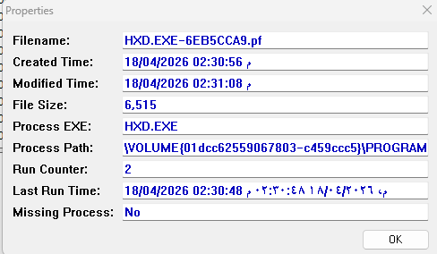 | 2 | HxD hex editor — used to identify and embed hidden data in Prisma.png; same tool used to corrupt and repair the USB partition table.
HXDSETUP.EXE-9E97A851.pf | HxDSetup.exe | 18/04/2026 02:30:24 م, 18/04/2026 02:30:13 م | 2 | HxD was installed on this machine on the day of the leak.
PHOTOREC_WIN.EXE-96C1A264.pf | photorec_win.exe | [record] | [record] | PhotoRec — a file recovery and data carving tool. Consistent with verifying or testing data recovery scenarios.
FTK IMAGER.EXE-C65C696D.pf | FTK Imager.exe | 18/04/2026 02:36:22 م | 1 | FTK Imager — a forensic imaging tool. Michael may have used this to create or analyze disk images.
WORDPAD.EXE-1BCC3DB7.pf | WordPad.exe | 18/04/2026 01:54:14 م, 18/04/2026 01:39:15 م | 2 | WordPad was used — potentially to view the confidential contract.

Export prefetch file
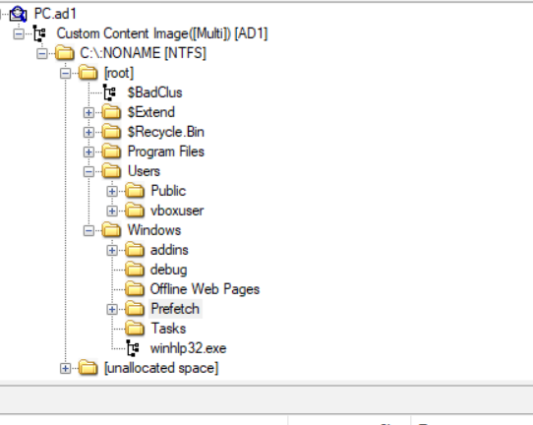
View in winprefetchview
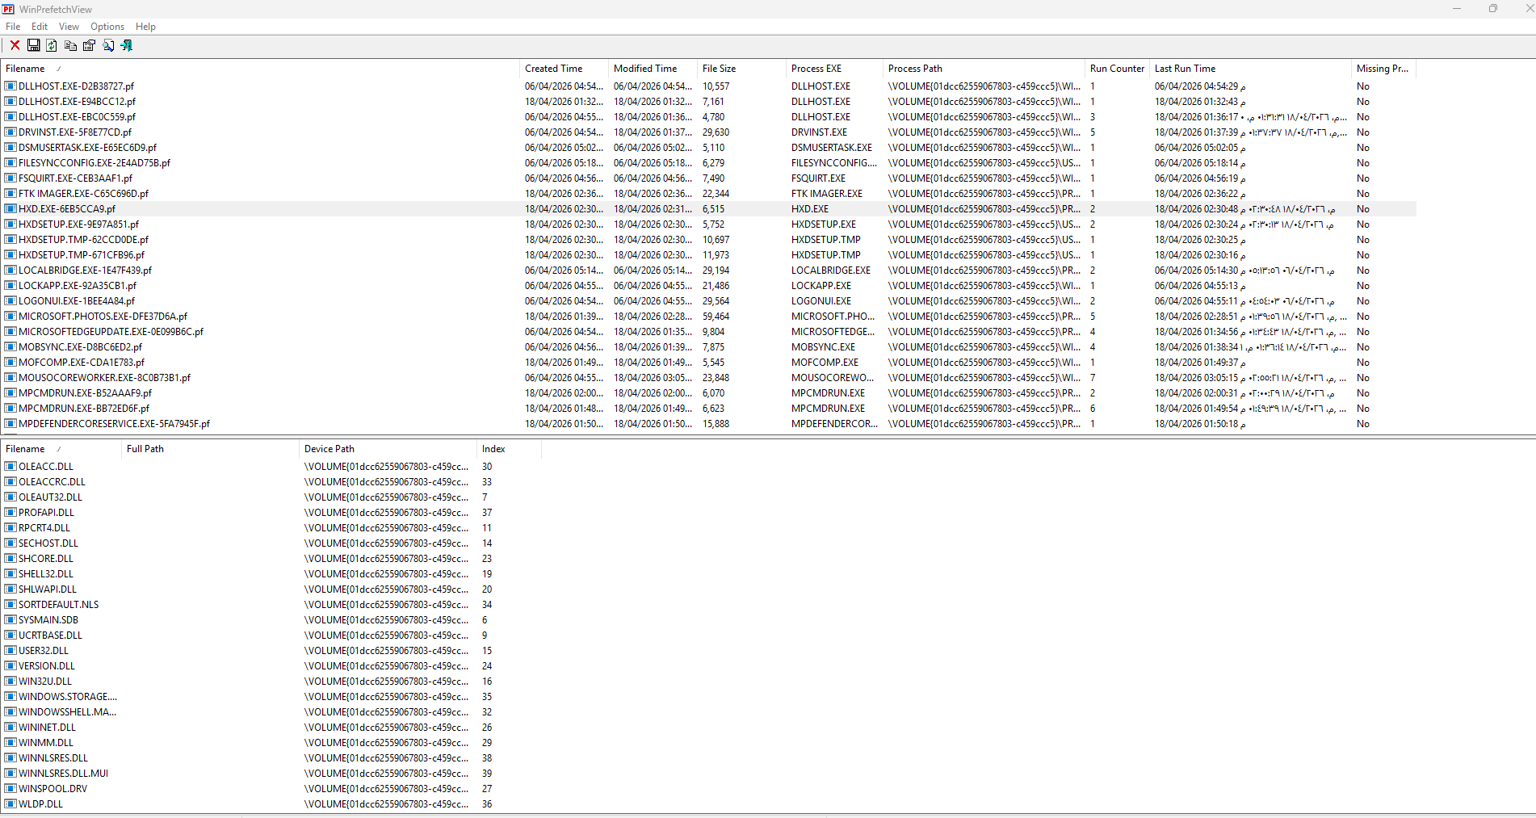

Evidence B — Michael ran HxD (Prefetch)
Navigate to: PC.ad1 → [root] → Windows → Prefetch
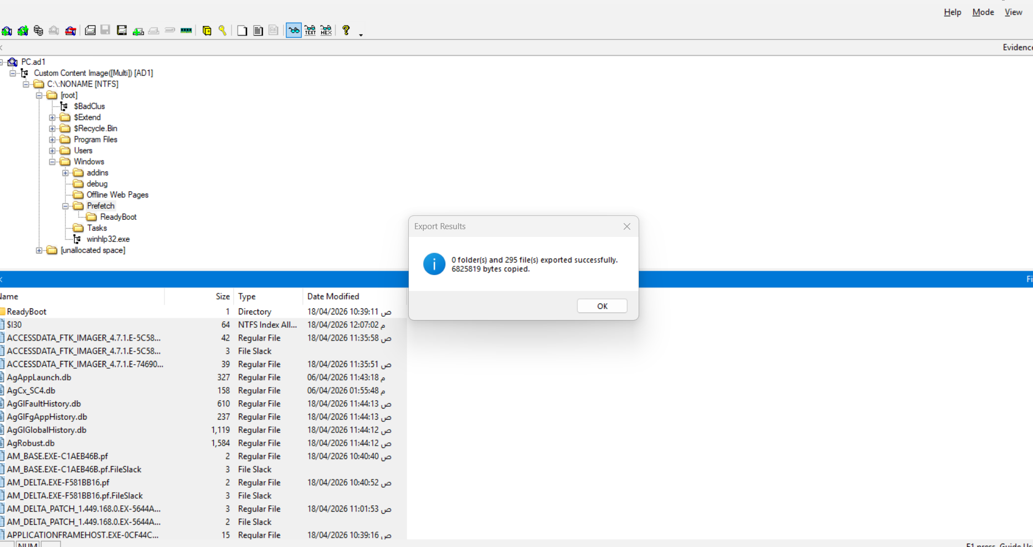

Export HXD.EXE-6EB5CCA9.pf. Open in WinPrefetchView. You will see:
- Last run time: 18 Apr 2026 (the day of the leak)
- Run count: 2
- Files accessed: may include Prisma.png path
It proves Michael ran HxD on the same day the files were copied to Sarah's USB.

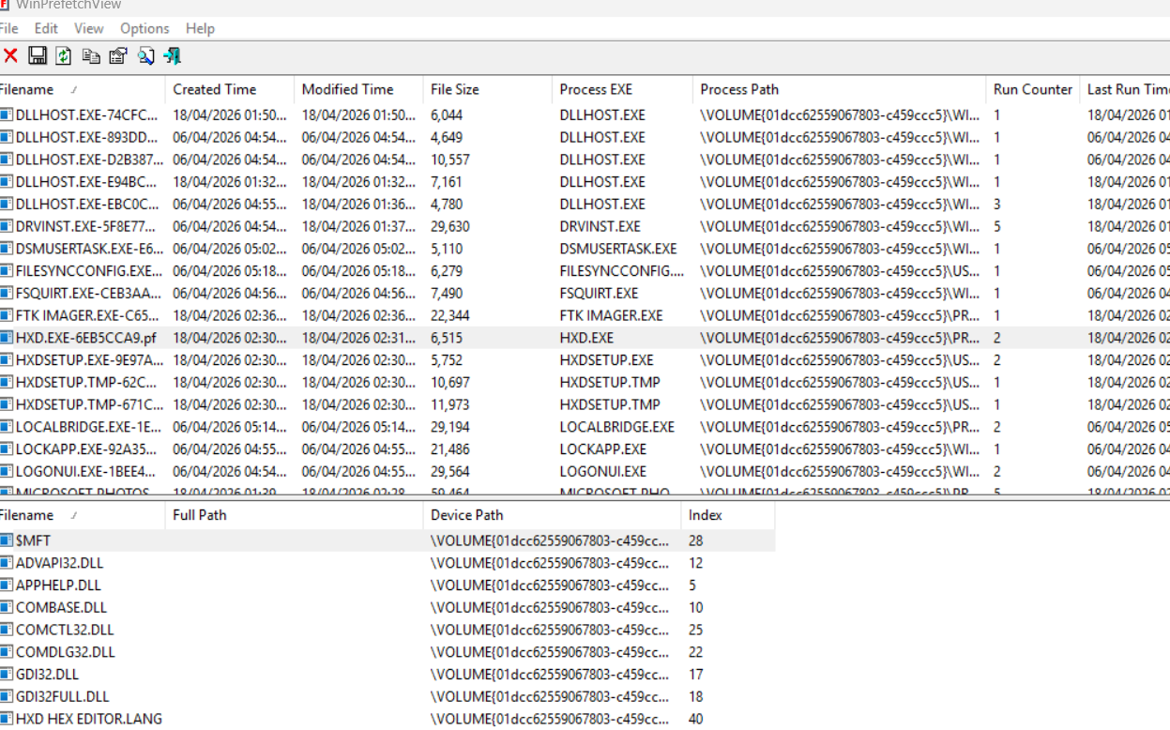

5.5.2 LNK / Recent Files Analysis — Files Michael Opened
LNK files from C:\Users\vboxuser\AppData\Roaming\Microsoft\Windows\Recent\ were exported and parsed with LECmd.exe. The following table summarizes the most forensically significant findings:
1-Navigate to: PC.ad1 → [root] → Users → vboxuser → AppData → Roaming → Microsoft → Windows → Recent

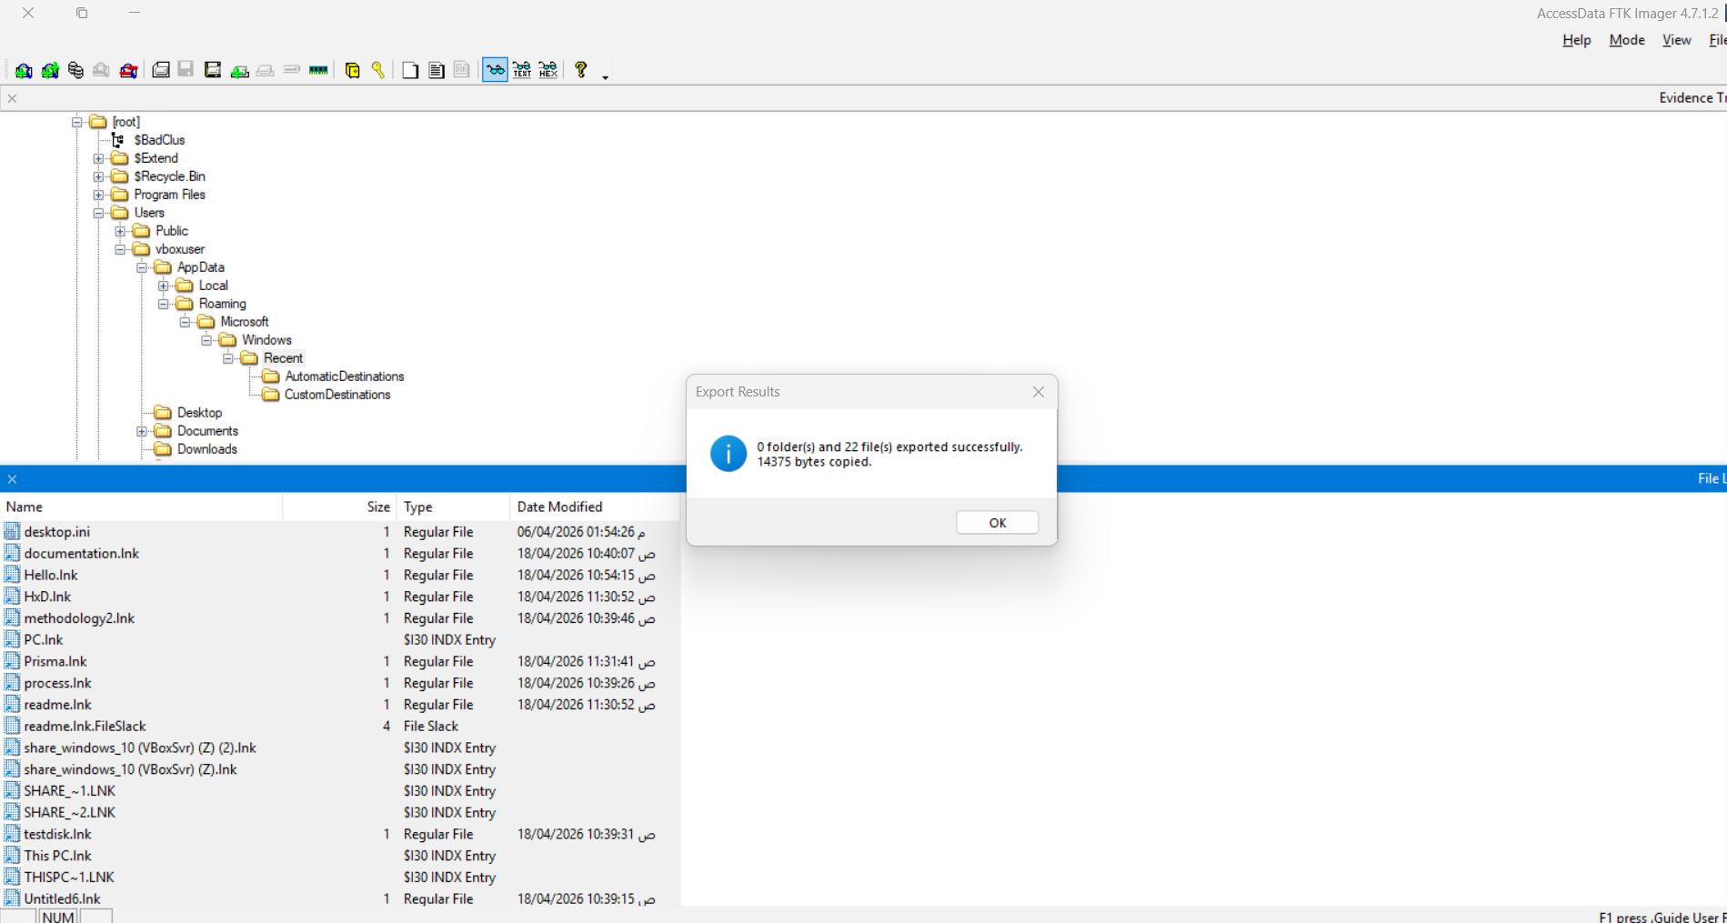
2-Export all .lnk files to a folder. Run:
powershell
.\LECmd.exe -d "C:\Users\ahmad\Desktop\University courses\Forensics\final\ahmad_final\exported_ink" --csv "C:\Users\ahmad\Desktop\University courses\Forensics\final\ahmad_final\LEC_res" --csvf lnk_results.csv

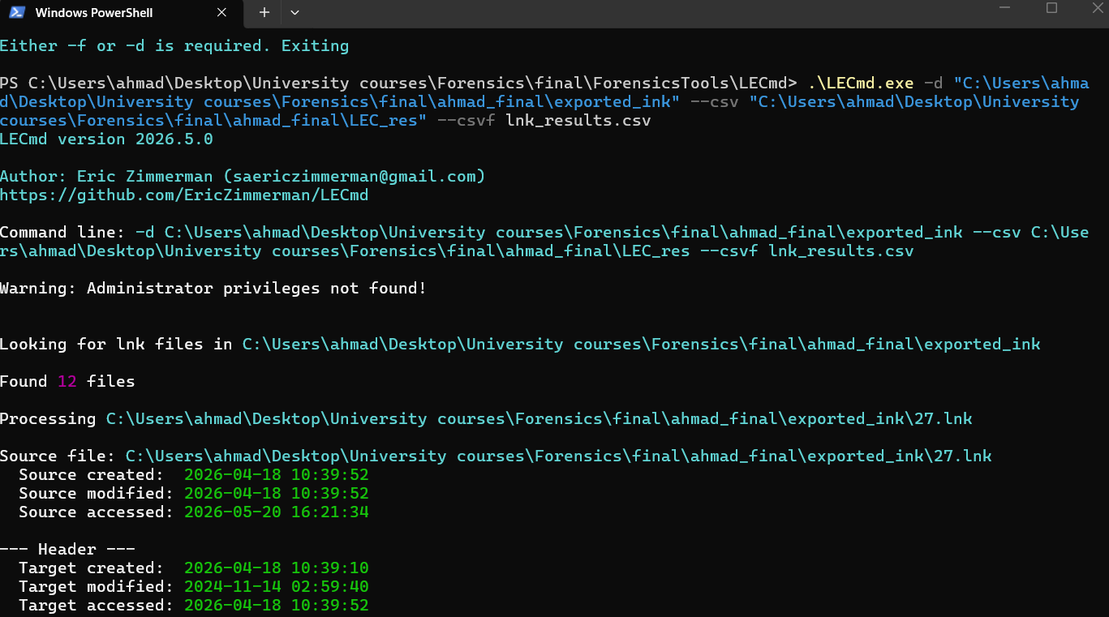
Open the CSV in Excel. Find the row for methodology2.lnk — this confirms Michael opened methodology2.png (a file named like Prisma.png's related image). But specifically look for any LNK pointing to Prisma.png or an image file that was recently accessed.
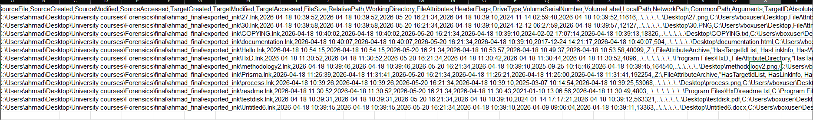
I will export it to a text file to better read

- Michael accessed Prisma.png from the Z: drive
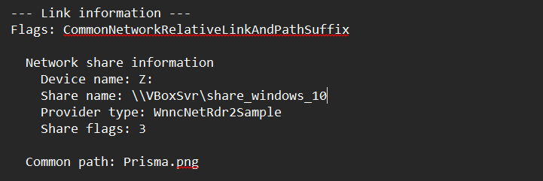

What this proves:
- Michael opened Prisma.png from the Z: drive (VirtualBox shared folder)
- The Z: drive connects the VM to the host machine's file system
- This is exactly where the hidden contract was embedded
Timestamps for Prisma.lnk:
Event | Timestamp
Source modified (LNK file) | 2026-04-18 11:31:41
Target accessed (Prisma.png opened) | 2026-04-18 11:31:41
Target modified | 2026-04-18 11:25:00

2. CRITICAL: Michael accessed the Z: shared drive

From Hello.lnk:
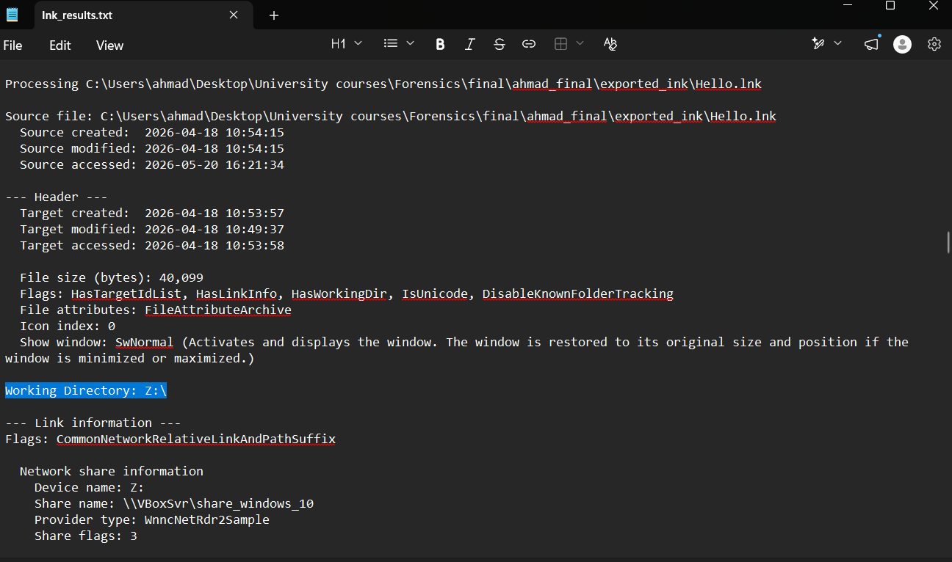

Timestamp: Source created/modified: 2026-04-18 10:54:15
This proves Michael was accessing the shared drive at 10:54 UTC, which is before the USB files were created (12:29–12:35 UTC).

3. Michael accessed image files (27.png, 30.PNG, methodology2.png, process.png)
All these LNK files point to files on his Desktop (C: drive, fixed storage), not the Z: drive. These were likely source files he used before copying/embedding.
File | Target accessed
27.lnk | 2026-04-18 10:39:52
30.lnk | 2026-04-18 10:39:57
methodology2.lnk | 2026-04-18 10:39:45
process.lnk | 2026-04-18 10:39:25

4. Michael installed HxD (hex editor)
From HxD.lnk and readme.lnk:
- Target path: C:\Program Files\HxD
- Source created: 2026-04-18 11:30:52
This proves Michael installed HxD on the day of the leak. The Prefetch analysis will confirm he ran HxD (which you will do next).

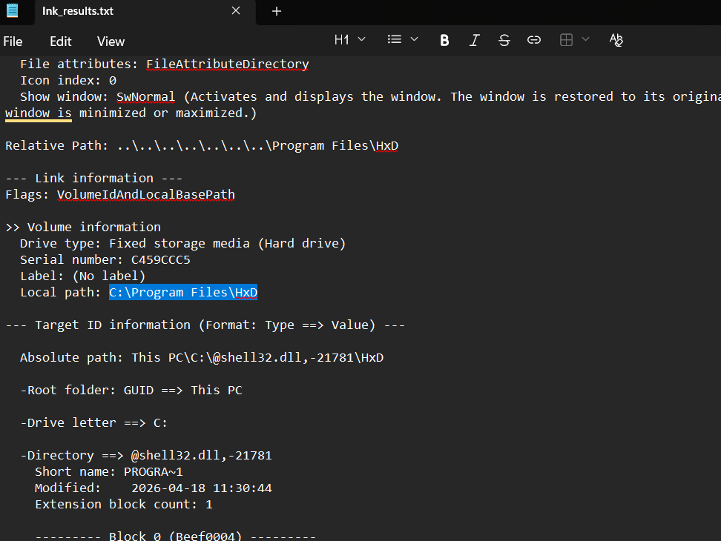

5. Other files accessed
LNK file | Target | Notes
COPYING.lnk | COPYING.txt | License file
documentation.lnk | documentation.html | HxD documentation
testdisk.lnk | testdisk.pdf | TestDisk manual (data recovery tool)
Untitled6.lnk | Untitled6.docx | Word document

LNK file | Target path | Drive type | Timestamp (Target accessed) | Significance
Prisma.lnk | Z:\Prisma.png | Network (Z: drive) | 2026-04-18 11:31:41 | Michael opened the PNG containing the hidden contract
Hello.lnk | Z:\Hello.docx | Network (Z: drive) | 2026-04-18 10:54:15 | Michael accessed the shared drive
30.lnk | C:...\Desktop\30.PNG | Fixed | 2026-04-18 10:39:57 | Source image
HxD.lnk | C:\Program Files\HxD | Fixed | 2026-04-18 11:30:52 | HxD installation
readme.lnk | C:\Program Files\HxD\readme.txt | Fixed | 2026-04-18 11:30:49 | HxD documentation accessed

LNK file | Target path | Drive type | Target accessed (UTC) | Significance
Prisma.lnk | Z:\Prisma.png | Network (Z: drive — VirtualBox shared folder) | 2026-04-18 11:31:41 | Michael opened Prisma.png — the file containing the hidden contract — directly from the shared Z: drive.
Hello.lnk | Z:\Hello.docx | Network (Z: drive) | 2026-04-18 10:54:15 | Michael accessed the Z: shared drive at 10:54 UTC — before the USB files were created.
HxD.lnk | C:\Program Files\HxD | Fixed (local) | 2026-04-18 11:30:52 | HxD was installed and accessed on the day of the leak.
readme.lnk | C:\Program Files\HxD\readme.txt | Fixed (local) | 2026-04-18 11:30:49 | HxD documentation accessed shortly after installation.
30.lnk | C:\Users\vboxuser\Desktop\30.PNG | Fixed (local) | 2026-04-18 10:39:57 | Image file 30.PNG also found on Sarah's USB — same MD5 hash confirms it is the same file.
methodology2.lnk | C:\Users\vboxuser\Desktop\methodology2.png | Fixed (local) | 2026-04-18 10:39:45 | Image file accessed before the USB copy.
SHARE_~2.LNK (full: share_windows_10 (VBoxSvr) (Z) (2).lnk) | Z:\ | Network (Z: drive) | 2026-04-18 12:12:06 | Michael opened the Z: shared folder at 12:12 UTC — 17 minutes before the USB was written.

5.6 Cross-Correlation and Combined Timeline
The following timeline merges timestamps from both evidence items and establishes the complete chain of events on 18 April 2026:
Time (UTC) | Event | Source | Significance
10:30 – 10:39 | Michael's PC active; 30.PNG, methodology2.png, process.png accessed (LNK files) | Michael's PC | Preparation phase — accessing source images
10:54:15 | Hello.lnk created — Michael accesses Z: shared drive first time | Michael's PC | First access of the VirtualBox shared network folder
11:25:00 | Prisma.png last modified on source | Michael's PC | The container image is finalized (30 min before Michael opens it)
11:30:49 – 11:30:52 | HxD installed and documentation accessed | Michael's PC | HxD hex editor installed on the day of the leak
11:31:41 | Prisma.lnk created — Michael opens Z:\Prisma.png in HxD | Michael's PC | Michael opens the PNG file from the shared drive — the file that contains the hidden contract
12:12:05 – 12:12:06 | SHARE_~2.LNK created — Michael accesses Z: drive again | Michael's PC | Final access of the shared folder before the USB copy
12:29:01.239 – 12:29:01.263 | 7 files created on USB in a 24ms batch | Sarah's USB | Main batch copy — all files copied simultaneously
12:30:45.294 | Prisma.png created on USB (with hidden contract) | Sarah's USB | Prisma.png added separately — 1m 44s after the main batch
15:12:29 | PC.ad1 acquisition begins | Evidence log | On-site acquisition by Safaa

Finding — The timeline establishes: Michael accessed the Z: drive → installed HxD → opened Prisma.png (embedding the contract at 11:31) → re-accessed the Z: drive at 12:12 → 17 minutes later, Prisma.png with the hidden contract appeared on Sarah's USB at 12:30:45.

5.7 Post-Analysis Integrity Verification
Evidence | Pre-analysis SHA-256 | Post-analysis SHA-256 | Match?
PC.ad1 | 3540e89eaedbc462fba96610f5e7ea7221be90f8ef603dfbeb506fa5a00db0e7 | 3540e89eaedbc462fba96610f5e7ea7221be90f8ef603dfbeb506fa5a00db0e7 | Yes
FinalToUpload.vhd (original, unmodified master) | 2d4a071393e35b4a79fef3a13c8544e6ff0fe0654bcf0cb6d4df1007c89e5ea6 | 2d4a071393e35b4a79fef3a13c8544e6ff0fe0654bcf0cb6d4df1007c89e5ea6 | Yes
After all analysis was complete, both original images were re-hashed with Hash My Files. The hashes were compared with the values recorded before analysis began (Section 5.1). Results:

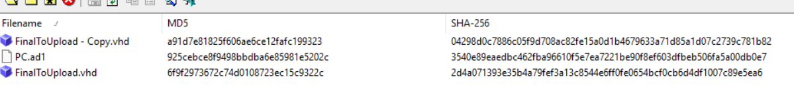

6. Conclusion

6.1 Findings
The digital forensic investigation of the two supplied evidence items has produced the following technical findings:
- The confidential contract was found: A Word document containing the confidential client contract between Maple Legal Consulting and Northern Industries Ltd. (Contract value: $2,500,000, Prepared by Michael Carter) was recovered from Prisma.png on Sarah's USB. It was hidden by appending the DOCX file (26,736 bytes, starting with ZIP/PK signature 50 4B 03 04) after the PNG's IEND end-marker at byte offset 0x2868E.
- Michael used HxD on the day of the leak: Prefetch file HXD.EXE-6EB5CCA9.pf confirms Michael ran HxD — the same hex editor used to perform the data-hiding technique — on 18 April 2026. HxDSetup.exe was also run, indicating it was freshly installed on that day.
- Michael accessed the file containing the hidden contract: LNK file Prisma.lnk (target: Z:\Prisma.png, drive type: Network, timestamp: 2026-04-18 11:31:41 UTC) confirms Michael opened Prisma.png from the VirtualBox shared Z: drive — the same file that was later found on Sarah's USB containing the hidden contract.
- Michael accessed the shared Z: drive before the USB copy: LNK file SHARE_~2.LNK (share_windows_10 (VBoxSvr) (Z)) was created at 12:12:06 UTC — 17 minutes before all files appeared on Sarah's USB at 12:29:01 UTC.
- The USB was deliberately prepared: Two intentional corruptions in the VHD partition structure (zeroed MBR Starting LBA and zeroed VBR MFTMirr) prevented casual mounting. All 39 MB of unallocated space was zeroed before use, eliminating any forensic trace of prior content. Both facts indicate deliberate anti-forensic preparation.
- Cross-evidence file link: 30.PNG (MD5: 5603dd59125ca87f634d69022faf23ba) is present on both Michael's Pictures folder and Sarah's USB with identical hashes, establishing a direct file-transfer link between the two evidence items.
- Zone.Identifier ADS: Three files on the USB (commands.docx, CRP template.pptx, Scheme of Work template.docx) carry Zone.Identifier ADS proving they were downloaded from the firm's SharePoint and e-learning systems (hatuniversity.sharepoint.com, elearning.htu.edu.jo).

6.2 Limitations
- Logical image only: PC.ad1 is a logical image — $MFT and $LogFile of Michael's C: drive are not included, so a full NTFS journal timeline cannot be reconstructed.
- No RAM capture: Volatile memory was not acquired at the time of seizure; running processes and network connections at that moment are unavailable.
- Sarah's workstation not imaged: Only Sarah's USB was imaged, not her PC. Evidence of how the USB was used on her workstation is therefore unavailable.

6.3 Recommendations
- Block installation of hex editors and forensic tools on corporate workstations via application whitelisting.
- Deploy a Data Loss Prevention (DLP) solution that detects files appended to image files (polyglot files / steganographic content).
- Enforce a USB / removable-media block policy; allow only on exception with logging.
- Restrict and monitor access to VirtualBox shared folders from guest VMs.
- Implement file-integrity monitoring and alerting on confidential document repositories.
- In future incidents: capture RAM before shutting down devices; acquire full physical disk images in addition to logical images; image workstations of all suspects, not only removable media.

7. Exhibits

7.1 Chain of Custody (CoC)

Field | Value
Case number | DF-2026-001
Evidence item | PC.ad1 (Michael's PC)
Date/time acquired | 18 Apr 2026 15:12:29
Acquired by | Safaa Hriez
Date/time received by lab | 22/4/2026
Received by | Ahmad Marwan AlMaghaireh
Chain of transfers

7.2 Pre- and Post-Analysis Hash Values
All of them match and verfied (for the untouched files, for the files that we edit to fix the courption , they way a copy of the original files )
Evidence | Hash type | Pre-analysis | Post-analysis | Match?
PC.ad1 (container) | SHA-256 | 3540e89eaedbc462fba96610f5e7ea7221be90f8ef603dfbeb506fa5a00db0e7 | verified | Yes
PC.ad1 (AD1 content) | MD5 (FTK Imager) | 98f143cf5541d9d1ba740cf04eec078a | verified | Yes
PC.ad1 (AD1 content) | SHA-1 (FTK Imager) | 845cd3a7eeeea44a4622a0f567c70d6ba1f9e22d | verified | Yes
FinalToUpload.vhd (master) | MD5 | 6f9f2973672c74d0108723ec15c9322c | verified | Yes

7.3 Extracted Files and Hash Values
# | Source | File name | Extracted as | Size (bytes) | MD5
1 | Sarah's USB | 30.PNG | Sarah_30.PNG | 12,127 | 5603dd59125ca87f634d69022faf23ba
2 | Sarah's USB | methodology.png | Sarah_methodology.png | 219,568 | 97c4ad07e2100a401227f4c4ef361b94
3 | Sarah's USB | inlet 24 50 75.PNG | Sarah_inlet.PNG | 116,578 | 1afa8a7b2daf6f9ba31861518c94eac1
4 | Sarah's USB | commands.docx | Sarah_commands.docx | 16,196 | 37664a36af281e3c5fbddd675c0c5dd7
5 | Sarah's USB | Scheme of Work template 203420.docx | Sarah_scheme.docx | 45,848 | 7f6b80ad649f8eb0fac400e5212b265d
6 | Sarah's USB | CRP template.pptx | Sarah_CRP.pptx | 1,180,015 | 564bbe3b703f311a1993a85d5f1bb0b4
7 | Sarah's USB | 111.pdf | Sarah_111.pdf | 1,445 | 2cda037a3d06fec67b87001304ceced8
8 | Sarah's USB | Prisma.png | Sarah_Prisma.png | 192,254 | 2e0f2fc983f5f5564543e9d7b539ed92
9 | Sarah's USB / Prisma.png | HIDDEN — hidden_contract.docx | hidden_contract.docx | 26,736 | 0f4ec3f40197f2a3bc621d754c0e368c
10 | Michael's PC | 30.PNG (from Pictures\) | Michael_30.PNG | 5603dd59125ca87f634d69022faf23ba | 5603dd59125ca87f634d69022faf23ba
11 | Michael's PC | $IXR4L33.docx (Recycle Bin $I) | Michael_RB_$IXR4L33.docx | [record] | [record]
12 | Michael's PC | $RXR4L33.docx (Recycle Bin $R) | Michael_RB_recovered_XR4L33.docx | [record] | [record]
13 | Michael's PC | $ILNJUJS.pdf (Recycle Bin $I) | Michael_RB_$ILNJUJS.pdf | [record] | [record]
14 | Michael's PC | $RLNJUJS.pdf (Recycle Bin $R) | Michael_RB_recovered_LNJUJS.pdf | [record] | [record]

7.4 Tool-Generated Reports
- Hash My Files — Sarah_USB_hashes.csv (all USB files, MD5 / SHA-1 / SHA-256)
- Hash My Files — Michael_PC_hashes.csv (all exported PC files)
- WinPrefetchView — Michael_Prefetch.csv (all Prefetch entries with last-run times and run counts)
- LECmd.exe — Michael_LNK.csv (all LNK files with target paths, drive types and timestamps)
- RBCmd.exe — Michael_RecycleBin.csv (all $I Recycle Bin metadata files parsed)
- FTK Imager verification log — printed from the output pane at load and after analysis

8. Revision History
Version | Date / Time | Editor | Change summary | Notes
1.0 | [21/05/2026 1:00] | Ahmad Maghaireh | Initial release — complete investigation report | —
[1.1] | [DD/MM/2026 HH:MM] | [name] | [describe change] | [notes]

Acknowledgment
During the preparation of this work, I used OpenAI’s ChatGPT to improve the readability and language of the report. I take full responsibility for the scientific content, analysis, and conclusions presented in this report.

OpenAI. ChatGPT: Language model. https://www.openai.com/chatgpt

