FORENSICS — REPORT 2
Answers to the Assignment Brief Questions
Case: Data Leak — Legal Consulting Firm (UK)

Field | Details
HTU Course Number / Title | 10203361 — Forensics
BTEC Unit Code / Title | T/618/7444 — Forensics
Academic Year | 2025-2026 / 2
Assignment Title | Data Leak
Assignment Author | Safaa Hriez
Student Name / ID / Section | Ahmad AlMaghaireh 23110205
Submission Date | 06 / 06 / 2026

Table of Contents
Contents
Table of Contents 2
Question 1 — Definition of Digital Forensics and Four Main Types 3
Question 2 — Was the Rodney McKemmish Model Used? 4
How each phase was applied in this case 4
Question 3 — Importance of Following the Model 5
Question 4 — Advantages and Disadvantages of Conducting a Digital Forensic Investigation to Improve System Security 6
Advantages 6
Disadvantages 6
Overall evaluation 7
Question 5 — Relevant UK Law and its Implications in a Forensic Investigation 8
The Computer Misuse Act 1990 8
Key implications for the forensic investigation 8
Question 6 — Legal and Ethical Requirements Considered During the Investigation 10
Legal Requirements 10
Ethical Requirements 10
Question 7 — Ensuring an Ethical Investigation in Reference to the Suspects' Rights 12
Question 8 — Impact of Following vs Not Following Guidelines on Digital Forensic Evidence in a Legal Case 13
Impact of FOLLOWING the guidelines 13
Impact of NOT following the guidelines 13
Overall evaluation 14
Question 9 — Forensic Analysis Plan Before Beginning the Investigation 15
Question 10 — Five Recommendations for Proper Evidence Acquisition 16
Question 11 — Comparison with ISO/IEC 27037 (Acquisition Step Only) 18
Question 12 — Critical Evaluation of the Investigation 21
Question 13 — Comparison: Hasher vs Hash My Files 27
Acknowledgment 34
References 34

Question 1 — Definition of Digital Forensics and Four Main Types
Definition:
Digital Forensics is defined as the process of collecting, preserving, analysing, interpreting, and documenting digital evidence and then presenting the outcomes. It applies scientific and technological techniques to conduct an investigation or to establish facts (evidence) in a criminal or corporate case. The field used to be called "Computer Forensics" but has been broadened because investigations now involve far more than just computers — phones, SIM cards, ATM machines, game systems, USB drives, network devices, and more.
Four main types of digital forensics:
- File System Forensics: Examines how data is organised on physical storage (hard drives, USB flash drives, SSDs) by file systems such as FAT, NTFS, and EXT. Investigators recover deleted files, identify hidden or anomalously located data, and use file-system metadata to build a timeline of file activity. This type is highly relevant to the present case because the evidence is two forensic images of disk-based storage (Michael's laptop and Sarah's USB).
- Operating System Forensics: Focuses on artefacts produced by the operating system itself — log files, registry entries, prefetch files, recycle-bin metadata, thumbnails, and recent-document lists. Because OS log formats and structures differ between Windows, Linux, macOS, etc., the investigator must understand each one. In the data-leak case, OS-level artefacts (Prefetch, $Recycle.Bin, LNK files) reveal which programs were run, which files were opened, and which drives were accessed.
- Memory Forensics: Sometimes called RAM forensics, it analyses the contents of any volatile memory — RAM, processor caches, registers. Because volatile memory is permanently lost when the system is shut down, this analysis must be performed during live acquisition. It is used to recover encryption keys, running malware, network connections, and decrypted data.
- Network Forensics: Captures and analyses network traffic and logs (firewalls, IDS/IPS, proxies, routers) to reconstruct what was sent and received over the network. It is used to investigate intrusions, data exfiltration over the network, malware command-and-control traffic, and phishing campaigns.

Question 2 — Was the Rodney McKemmish Model Used?
Yes.
The Rodney McKemmish methodological model was followed throughout this investigation. It is one of the recognised methodological models in digital forensics (alongside the KRUSE & HEISER model and the Yale University model) and consists of four sequential phases:
Identification → Preservation → Analysis → Presentation

How each phase was applied in this case
- Identification: The first step is to identify the digital evidence — knowing what evidence is present, where it is stored, and how it is stored. This is essential to determine which processes will be employed for recovery and which technology is appropriate to extract the data. In this case the evidence was identified as the forensic image of Michael's laptop (Windows workstation) and the forensic image of Sarah's USB flash drive.
- Preservation: Preservation is critical because of the likelihood of judicial scrutiny in court. Any examination of electronically stored data must be carried out in the least intrusive manner. Where any change is unavoidable, its nature and reason must be explained. Preservation also covers physical changes made to the device to access data. In this investigation, preservation was achieved by working only on the supplied forensic images (never on the original devices), by mounting them read-only, by computing hash values (MD5 / SHA-1 / SHA-256) before and after analysis to prove that no byte of the evidence was altered, and by maintaining a chain-of-custody form for every action taken.
- Analysis: Analysis is the extraction, processing, and interpretation of digital data — generally regarded as the main element of forensic computing. Once extracted, digital evidence usually requires processing before it can be read by people; for example, the contents of a hard-disk image still need processing to be presented in a humanly meaningful formIn this case the analysis examined NTFS artefacts ($UsnJrnl, $Recycle.Bin), Windows OS artefacts (Prefetch files, LNK/Recent files), and the active and unallocated content of the USB image (including signature-based data carving for deleted files and file-trailer analysis for hidden data).
- Presentation: The presentation of digital evidence is the actual presentation in a court of law. It includes the manner of presentation, the expertise and qualifications of the presenter, and the credibility of the processes employed to produce the evidence being tendered. The findings of this investigation were presented in two written reports — the Forensic Report (Report 1) detailing every step taken, and this Report 2 — both written so that any qualified investigator can reproduce the work and reach the same conclusion.

Question 3 — Importance of Following the Model
Following a recognised methodological model when conducting a digital forensic investigation is critical for the following reasons drawn from the course material:
- Preserving Evidence: Digital evidence is fragile and can be easily altered or destroyed by improper handling. A standardised process ensures every step — from acquisition to analysis — is conducted in a way that maintains the integrity of the evidence. This is vital for presenting findings in court, where the chain of custody is paramount.
- Repeatability and Reproducibility: A documented process ensures consistency across investigations. If another examiner follows the same procedure on the same evidence, they should reach the same conclusions. This strengthens the investigation's credibility and makes it less susceptible to challenges.
- Minimising Errors: Digital forensics can be very complex, and following a structured approach helps investigators avoid overlooking crucial steps or making mistakes that could compromise the entire investigation.
- Efficiency: A defined process streamlines the investigation by outlining clear steps and best practices, saving time and resources, and allowing the investigator to focus on the analysis and interpretation of the evidence rather than on procedural decisions.
- Legal Admissibility: Courts often require digital evidence to be collected and handled according to established guidelines. Following a recognised forensic process — such as the Rodney McKemmish model — strengthens the admissibility of digital evidence and reduces the risk of it being challenged or excluded.

Question 4 — Advantages and Disadvantages of Conducting a Digital Forensic Investigation to Improve System Security
Conducting a digital forensic investigation is not only a reactive activity (responding to an incident such as the present data leak); the lessons learned from the investigation can be used proactively to harden the organisation's security posture. The advantages and disadvantages can be evaluated as follows.

Advantages
- Identifies the root cause: The investigation reveals exactly how the incident occurred — which artefacts, which user accounts, which devices, which time windows — so the same vulnerability cannot be exploited again.
- Reveals system and policy weaknesses: By examining real artefacts (e.g. the fact that an unauthorised USB device was connected), the firm can pinpoint failures in technical controls (USB blocking, DLP) and policy enforcement.
- Detects insider threats: Many leaks come from insiders, as in this case (two employees were the suspects). Forensic investigation makes it possible to detect and document insider misuse that would otherwise remain hidden.
- Improves incident response: Each investigation builds an internal playbook — what artefacts to collect, in what order, with which tools — so future incidents are handled faster and more accurately.
- Supports legal action and accountability: A well-conducted investigation produces evidence that is admissible in court, which deters future misconduct and holds offenders accountable.
- Enables data recovery: Forensic techniques (file carving, $Recycle.Bin recovery) often recover data that the organisation thought was lost.
- Drives security-awareness training: Real findings from the investigation become powerful training material for staff, raising overall security awareness.
- Strengthens compliance: A documented, repeatable forensic process supports compliance with data-protection regulations (e.g. UK GDPR / Data Protection Act 2018).

Disadvantages
- High cost: Forensic tools, write-blockers, sterile evidence storage, and certified examiners are expensive.
- Time-consuming: A thorough investigation can take days or weeks, during which the affected systems may be unavailable for normal use.
- Specialised expertise required: Forensic skills are scarce; investigators must be continuously trained because file systems, operating systems, and devices keep evolving.
- Privacy concerns: The investigation will inevitably encounter personal data of suspects and uninvolved third parties, raising legitimate privacy issues that must be carefully managed.
- Risk of evidence contamination: If the investigation is not performed strictly according to procedure (write-blocking, hashing, chain of custody), the evidence can be tainted and become inadmissible.
- Reactive in nature: Forensic investigation acts after the incident has already occurred — the damage is already done. It must be paired with proactive controls (DLP, monitoring, training) to actually prevent future incidents.
- Disruption to business operations: Seizing devices and isolating systems can interrupt normal work, especially for the suspect employees and their teams.
- Tool limitations: Anti-forensic techniques (encryption, secure deletion, data wiping) can prevent a forensic investigation from reaching firm conclusions.

Overall evaluation
Despite the cost, the time, and the privacy considerations, the advantages of conducting a digital forensic investigation outweigh the disadvantages — particularly when the lessons learned are fed back into the organisation's security programme. In the context of this data-leak case, the investigation does more than identify the responsible party; it also produces concrete recommendations (USB control, DLP, after-hours monitoring) that improve the firm's overall security posture.

Question 5 — Relevant UK Law and its Implications in a Forensic Investigation
Because the crime took place in the United Kingdom, several pieces of UK legislation are relevant — in particular the Computer Misuse Act 1990, the Data Protection Act 2018 (which implements UK GDPR), the Regulation of Investigatory Powers Act, and the Police and Criminal Evidence Act. The most directly relevant statute for an unauthorised data-copying / data-leak case is the Computer Misuse Act 1990.

The Computer Misuse Act 1990
The Computer Misuse Act 1990 (CMA 1990) is the principal UK statute that criminalises misuse of computer systems. Its core offences include:
- Section 1 — Unauthorised access to computer material: intentionally accessing a computer or data without authorisation.
- Section 2 — Unauthorised access with intent to commit or facilitate further offences: an aggravated version of Section 1.
- Section 3 — Unauthorised acts with intent to impair the operation of a computer: covering the modification, deletion, or other interference with computer material.
Both suspects in this case were authorised users of their own workstations, but copying confidential client contracts beyond their authorised purpose — and exporting them outside the firm — falls within the scope of "unauthorised access" or "unauthorised acts" under the Act.

Key implications for the forensic investigation
- Legal authorisation is mandatory: Investigators must operate under proper authority — either an internal corporate authorisation (from the firm's legal department), a search warrant, or another legal authority (consent of the device owner). Without authorisation, accessing the suspects' data could itself become an offence under the same Act.
- Strict adherence to procedure: Because the Act creates criminal offences, every action taken on the evidence must be defensible in court — write-blockers, hashing, chain of custody, and use of recognised tools and methodologies.
- Compatibility with data-protection law: The investigation must also comply with the UK Data Protection Act 2018 / UK GDPR — only the minimum amount of personal data necessary for the investigation may be collected, and all personal data discovered must be kept confidential.
- Documentation must support the elements of the offence: Reports must clearly establish that the access was unauthorised, when it took place, who performed it, and what data was affected — exactly the artefacts produced by Prefetch files, $Recycle.Bin metadata, LNK files, and file-system timestamps.
- International / cross-border data: If the leaked contracts crossed UK borders or were placed on cloud storage hosted outside the UK, additional jurisdictions may apply, and the investigator may need to cooperate with overseas counterparts.

Question 6 — Legal and Ethical Requirements Considered During the Investigation

Legal Requirements
- Adherence to Search and Seizure Laws: Obtaining proper legal authorisation (warrant or formal corporate authorisation) before acquiring digital evidence. The specific requirements vary depending on the jurisdiction and the type of device being investigated.
- Data Privacy Regulations: Compliance with UK GDPR and the Data Protection Act 2018 (and, where applicable, equivalent regulations such as the EU GDPR or California CCPA) — particularly the principles of lawfulness, fairness, transparency, purpose limitation, and data minimisation.
- Regulation of Investigatory Powers Act: Where the investigation touches communications data or interception, the relevant powers and limits set by RIPA must be respected.
- Chain of Custody Documentation: Maintaining a meticulous record of how the evidence is handled — from collection, through analysis, to presentation — is crucial for ensuring its admissibility in court.
- Cloud Storage Considerations: Where cloud-stored data is involved, investigators may need to work with the cloud service provider, and data-sovereignty rules (digital information is subject to the laws and regulations of the country where it is stored) come into play.

Ethical Requirements
- Minimising Data Acquisition: Only the minimum amount of data necessary for the investigation should be acquired. Collecting irrelevant data raises privacy concerns and is resource-intensive. Only the supplied forensic images (Michael's laptop and Sarah's USB) were processed; no other employee's data was touched.
- Confidentiality: All sensitive information obtained during the investigation — not just personal data, but also information belonging to the victim or unrelated individuals who may appear in the evidence — was kept strictly confidential and shared only with people directly involved in the case.
- Objectivity and Integrity: The investigator has a duty to remain objective and unbiased throughout the investigation. All relevant findings must be presented, regardless of whether they support the firm's initial theory or exonerate the suspects.
- Non-Discrimination: Investigators must not discriminate against individuals based on race, ethnicity, gender, religion, or social status. Both suspects (Michael and Sarah) were treated with fairness, respect, and impartiality.
- Professional Collaboration and Consultation: Investigators should collaborate and consult with other experts, colleagues, or legal professionals when needed, to ensure that the investigation is conducted ethically and that different perspectives and expertise are considered.

Question 7 — Ensuring an Ethical Investigation in Reference to the Suspects' Rights
Both suspects, Michael and Sarah, are citizens with legal rights — including the right to privacy, the presumption of innocence, the right not to be discriminated against, and the right to confidentiality of their personal information. The following measures were taken to make sure that their rights were respected during the investigation:
- Proper authorisation before any access: The investigation only began after the firm's legal department issued formal authorisation to examine the two forensic images. No access was made on a hunch or without authority.
- Working only on forensic copies, never the originals: All examination took place on hashed, read-only copies of the images. The suspects' original devices were never touched by this investigator, and nothing on them was altered.
- Data minimisation: Only the minimum amount of data necessary to determine the source of the data leak was reviewed. Personal files (private emails, family photos, banking details, etc.) that were unrelated to the investigation were not examined or extracted, in line with the ethical principle of minimising data acquisition.
- Equal and impartial treatment: Both suspects' images were examined using the same methodology, the same tools, and the same depth of analysis. The investigator did not assume guilt or innocence in advance, and did not give one suspect preferential or harsher treatment than the other (Non-Discrimination principle).
- Presumption of innocence: Until the technical evidence demonstrably established involvement, both Michael and Sarah were treated as innocent. Findings were presented as facts ("file X was found at path Y on Sarah's USB at time Z") rather than as accusations.
- Strict confidentiality: Any personal information observed during the investigation that was unrelated to the case was kept confidential, was not disclosed beyond the investigation team, and was not included in the final report.
- Objectivity and full disclosure: Findings that supported either suspect's denial — for example, an absence of relevant artefacts — were reported just as fully as findings that incriminated them. Selective reporting would have violated the ethical duty of objectivity.
- Right to challenge the evidence: Because every step of the investigation was documented in a reproducible manner, both suspects (through their legal representatives) retain the right to have the evidence independently re-examined by another qualified investigator.
- Chain of custody preserved: By preserving the chain of custody, the investigator protected the suspects from any later allegation that the evidence had been tampered with — which is itself a protection of their right to a fair process.

Question 8 — Impact of Following vs Not Following Guidelines on Digital Forensic Evidence in a Legal Case

Impact of FOLLOWING the guidelines
- Evidence is admissible in court: Courts require that digital evidence be collected and handled according to recognised guidelines. Following them strengthens admissibility and reduces the risk that the evidence is excluded.
- Findings are reproducible: Another examiner following the same documented process should reach the same conclusion, which strengthens the credibility of the case and resists challenge by the defence.
- Chain of custody is intact: A complete chain of custody documents who handled the evidence, when, and what they did with it, eliminating any reasonable doubt that it has been tampered with.
- Fewer errors: A structured approach prevents critical steps from being missed (for example, computing a hash before and after acquisition).
- Investigator is professionally protected: Documented adherence to recognised standards (Rodney McKemmish, ISO/IEC 27037, SWGDE best practices) protects the investigator from accusations of negligence or bias.
- Suspects' rights are respected: Following ethical and legal guidelines protects the rights to privacy, presumption of innocence, and a fair process — and protects the case from being thrown out on procedural grounds.
- Stronger conclusions and stronger penalties: Reliable, well-documented evidence makes it easier for the court to reach a conviction (or, equally, a confident acquittal).
- Improves organisational learning: Guidelines feed lessons back into policy, monitoring, and training, leading to a more secure environment over time.

Impact of NOT following the guidelines
- Evidence becomes inadmissible: If the chain of custody is broken or the integrity of the image cannot be proven by hash, the court may exclude the evidence entirely, no matter how incriminating it is.
- Case dismissal or wrongful outcome: Excluded evidence can collapse the prosecution's case, causing a guilty party to walk free, or — equally serious — an innocent suspect can be wrongly convicted on the basis of evidence that was actually tainted.
- Loss of investigator credibility: Once an investigator is shown to have departed from accepted methodology, their work in unrelated cases can also be challenged, undermining their professional reputation.
- Civil and criminal liability: Mishandling personal data can constitute a breach of UK GDPR / Data Protection Act 2018 and may itself become an offence under the Computer Misuse Act 1990, exposing the investigator and the organisation to fines, lawsuits, or prosecution.
- Reputational damage: A botched forensic investigation can severely damage the reputation of the investigating organisation and the firm that commissioned it.
- Violation of suspects' rights: Without procedural safeguards, suspects' rights to privacy, fair process, and presumption of innocence may be violated, opening the door to lawsuits and appeals.
- Increased risk of repeat incidents: Without proper analysis, the organisation does not learn the true root cause and remains exposed to the same threat.
- Higher long-term cost: A failed investigation may have to be redone, often at greater cost, with the original evidence already compromised — sometimes irrecoverably.

Overall evaluation
Following recognised guidelines is not a formality — it is the foundation of every defensible finding in a legal case. Departing from them rarely saves time in practice, because any short-cut is likely to be discovered by the defence and used to invalidate the entire investigation.

Question 9 — Forensic Analysis Plan Before Beginning the Investigation
Overview of the plan
Before examining any evidence, the investigation was planned by reviewing the case documentation, identifying both evidence items, confirming legal authority, and selecting the appropriate artefact categories and tools. The case involved a suspected data leak at a UK legal consulting firm, with two forensic images supplied: a logical image of Michael's PC (PC.ad1) and an image of Sarah's USB flash drive (FinalToUpload.vhd). The plan was structured in two stages: analyse Sarah's USB first (the simpler, smaller image) and then analyse Michael's PC, before cross-correlating findings across both items.

Artefact | Tool | Why selected | Expected discovery
Hash verification | Hash My Files | McKemmish Preservation phase; integrity proof | Confirm images unmodified
MBR / VBR structure | HxD | Byte-level partition inspection (Lecture 5 / Lecture 91) | Corrupted LBA and MFTMirr fields needing repair
File listing + hashes | FTK Imager + Hash My Files | Read-only image loading; hash comparison across images | Files on USB + hash match with Michael's PC
Zone.Identifier ADS | FTK Imager + CMD | NTFS ADS (Lecture 91); proves file origin URL | SharePoint / e-learning source URLs
Unallocated / data carving | PhotoRec + HxD | File carving on deleted content (Lecture 7) | Deleted files OR confirmation of anti-forensic wipe
File signature / trailer | HxD | Magic bytes / hidden data after file end-marker (Lecture 7) | Hidden document appended after PNG IEND marker
Prefetch | WinPrefetchView | Programs executed (Chapter 10) | HxD, PhotoRec, FTK Imager run on day of leak
LNK files | LECmd.exe | File access history + drive type (Chapter 10) | Michael opened files from Z: network share
$Recycle.Bin | FTK Imager + RBCmd.exe | Deleted file recovery (Chapter 10) | Deleted contracts or related documents

Question 10 — Five Recommendations for Proper Evidence Acquisition
Even though on-site evidence acquisition was not the responsibility of the author of this report, the following five recommendations — drawn from the course material on procedures, best practices, and SWGDE guidance — would, if followed, ensure that the evidence acquisition step itself is sound.
- Use a write-blocker (hardware or software) at all times. Connecting the suspect device to a workstation without a write-blocker risks the operating system writing to the device (e.g. updating timestamps, indexing) and irreversibly altering the evidence. A hardware write-blocker (such as SAFE block) sits between the device and the workstation; a software write-blocker (such as FastBlock) disables the operating system's write capability for the device. Hardware blockers are preferred where possible because they are independent of the host operating system.
- Calculate hash values (MD5, SHA-1 and ideally SHA-256) before and after acquisition. Hashing the original device, the resulting forensic image, and any later working copies — and showing that all three match — proves the integrity of the evidence. Acquisition tools such as FTK Imager and EnCase generate these hashes automatically; they must be recorded on the chain-of-custody form.
- Create at least two forensic images, using different tools where possible, and store them on trusted media. From the slides: "Create two copies (aka images) of the evidence. Because if one of them is altered then you can use the other one. Use different tools to acquisition." Forensic images should be archived to trusted media and maintained consistent with organisational policy and applicable laws. Use tamper-evident packaging or read-only media (CD-R / DVD-R) for transport.
- Follow the order of volatility when collecting evidence. Volatile data is lost first when a system is shut down, so investigators should proceed from most volatile to least volatile: registers and CPU cache → routing table, ARP cache, process table, kernel statistics, memory → temporary file systems → disk → remote logging and monitoring data → physical configuration and network topology → archival media. Skipping this order can permanently destroy evidence (e.g. encryption keys held only in RAM).
- Document everything — chain of custody, errors, environment, tools, and personnel. From the slides: every action on the evidence must be documented, including every error encountered during acquisition. The chain of custody records who held the evidence, when, and what they did to it; it can be a single-evidence form (one piece of evidence per page) or a multi-evidence form (multiple items on the same page). Investigators should also identify and interview people who may have relevant information (usernames, passwords, OS, network credentials), and search the scene systematically and thoroughly.
Additional recommended controls : review the legal authority before acquisition; obtain additional authority if evidence outside the original scope is found; take precautions against contaminated or hazardous materials; image evidence on-site when it cannot be removed.

Question 11 — Comparison with ISO/IEC 27037 (Acquisition Step Only)
ISO/IEC 27037 is the international standard titled "Guidelines for Identification, Collection, Acquisition and Preservation of Digital Evidence." The acquisition step in ISO/IEC 27037 is anchored on five core principles — relevance, reliability, sufficiency, repeatability, and auditability — and on the role of the Digital Evidence First Responder (DEFR) and Digital Evidence Specialist (DES). The recommendations from Question 10 are mapped to it below.
Your recommendations (Q10) | ISO/IEC 27037 guidelines (acquisition step) | Discussion
1. Use a write-blocker (hardware or software) at all times. | ISO/IEC 27037 requires that the original digital evidence be acquired without alteration. The DEFR must use methods and tools that preserve the original — write protection devices are the standard means of achieving this. | Both views align fully. The recommendation operationalises the ISO requirement: where the standard says "do not alter the original," a write-blocker is the practical control. ISO/IEC 27037 additionally insists that the chosen method be validated, so the specific write-blocker model and firmware should be recorded and known to be reliable.
2. Calculate hash values (MD5, SHA-1 and SHA-256) before and after acquisition. | ISO/IEC 27037 requires verification of the acquired digital evidence, normally by computing a cryptographic hash of the source and the acquired copy and demonstrating they are identical. The standard also requires that the verification result be recorded and auditable. | Aligned. The recommendation matches the ISO principle of repeatability and auditability. Best practice today is to use SHA-256 (or stronger) in addition to MD5 / SHA-1, because MD5 alone is no longer collision-resistant — the recommendation explicitly includes this.
3. Create at least two forensic images, ideally with different tools, and store on trusted media. | ISO/IEC 27037 recommends that, whenever practical, more than one copy of the digital evidence is produced, that the acquisition method be selected on the basis of the situation (live vs static, partial vs full), and that the acquired evidence be stored on suitable media in a controlled environment. | Aligned and stronger. ISO/IEC 27037 recognises that two acquisitions or two copies are desirable but not always feasible (e.g. for very large or live systems); the recommendation goes one step further by encouraging the use of two different tools to defend against a tool-specific defect or vulnerability, which strengthens reliability.
4. Follow the order of volatility (register/cache → memory → temp FS → disk → archival). | ISO/IEC 27037 explicitly addresses the priority of volatile data and instructs the DEFR to consider the lifetime of data when choosing the acquisition order: volatile data first, then non-volatile. | Fully aligned. The recommendation is the operational form of the ISO principle. The standard adds that the decision must be justified case-by-case (sometimes cache acquisition is impossible); the documentation requirement (Q10 #5) covers that justification.
5. Document everything — chain of custody, errors, environment, tools, and personnel. | ISO/IEC 27037 makes documentation central: every action taken during acquisition must be recorded so the process is auditable and repeatable; the chain of custody must be initiated at the first contact with the evidence; and the competence of the DEFR / DES must be verifiable. | Strongly aligned. The recommendation maps directly to the ISO principles of repeatability and auditability. Going further, the standard would add explicit recording of the responder's qualifications, of the date / time / location of acquisition, and of any deviation from procedure with its justification — all of which sit naturally within the proposed documentation.

Overall, the five recommendations are fully consistent with the acquisition guidance of ISO/IEC 27037. Each recommendation maps to one or more ISO principles (no alteration, verification, reliable methods, order of volatility, repeatability, and auditability). The minor enhancements made by ISO/IEC 27037 are: explicit verification of the responder's competence, formal validation of the tools used, and explicit documentation of any deviation from procedure with its justification — all of which can easily be added to the documentation step.

Question 12 — Critical Evaluation of the Investigation

Question 12 — Critical Evaluation of the Investigation

Part 1 — What Was Done and Why
The investigation began by reviewing the case documentation and confirming legal authority before any evidence file was opened. Both forensic images (PC.ad1 and FinalToUpload.vhd) were received with an acquisition log (PC_ad1.txt). The entire investigation followed the Rodney McKemmish model — Identification, Preservation, Analysis, and Presentation — which structured every decision made from start to finish.

Preservation was the first priority. Both images were hashed using Hash My Files before any analysis began, producing MD5, SHA-1 and SHA-256 values. The acquisition log confirmed the internal AD1 content hashes (MD5: 98f143cf5541d9d1ba740cf04eec078a, SHA-1: 845cd3a7eeeea44a4622a0f567c70d6ba1f9e22d), and FTK Imager was used to verify these upon loading. This was done because the slides emphasise that digital evidence is fragile and can be easily altered — the integrity check is the foundation of every subsequent finding. All analysis was performed exclusively on working copies of the images; the master evidence files were never modified.

The USB image was analysed first, because it was the smaller and simpler evidence item. This turned out to be the right decision — starting with the USB established the key facts (which files were present, where they came from, and when they were copied) before opening the PC image. The slides state that examination of media should be completed logically and systematically, and analysing the simpler item first is consistent with that principle.

HxD was used to repair two deliberate corruptions in FinalToUpload.vhd before the volume could be mounted. The MBR Starting LBA field at offset 0x1C6 was zeroed and corrected to 0x80 (LBA 128), and the VBR $MFTMirr cluster field at offset 0x10038 was zeroed and corrected to cluster 2. This was done because the NTFS slides explain that the VBR BIOS Parameter Block stores critical volume parameters including the $MFT and $MFTMirr LCNs, and the MBR Partition Table stores the starting sector of each partition — without both being correct, the OS cannot locate or mount the NTFS volume. The repairs were made on a working copy only, and the master VHD was re-hashed afterwards to confirm it remained unchanged.

File header / signature analysis using HxD was applied to every file on the USB to verify that each file's actual magic bytes matched its declared extension. This technique is covered in Lecture 7 (File Identification and Data Carving), which explains that file extensions can be falsified but magic bytes cannot. This check revealed the most significant finding of the entire investigation: Prisma.png (192,254 bytes) contained 26,736 bytes of data appended after its IEND end-marker at offset 0x2868E. The bytes at that offset were 50 4B 03 04 — the ZIP/DOCX file signature — proving a Word document had been deliberately hidden inside the image.

NTFS artefact analysis on both images covered the $UsnJrnl (every file system event with millisecond precision), $STANDARD_INFORMATION vs $FILE_NAME timestamp comparison (to detect copying and potential timestomping), Alternate Data Streams (Zone.Identifier proving SharePoint origin), and data carving on unallocated space. The slides explain that the $UsnJrnl records every file operation with a reason code and timestamp, and that comparing $SI and $FN timestamps can reveal whether files were copied from another source. These artefacts together established that all 8 files were copied to the USB in a single batch at 12:29:01 UTC on 18 April 2026.

Windows artefacts on Michael's PC were examined in order of forensic value: Prefetch files first (to establish which programs were run), then LNK/Recent files (to establish which files were opened and from where), and then $Recycle.Bin (to recover deleted content). This sequence was chosen because Prefetch and LNK files directly answered the core question — what did Michael do and when — while the Recycle Bin provided corroborating evidence of deleted files.

Part 2 — Were the Tools Appropriate?
Tool | Appropriateness | Assessment
HxD | Highly appropriate | HxD was the correct tool for two distinct tasks: repairing partition table corruptions at the byte level, and identifying hidden data appended after a PNG's IEND marker. Both tasks require raw byte-level access that no other tool in the investigation provides. HxD was also the tool the suspect used to embed the contract — using the same tool to analyse the technique is logically consistent.
FTK Imager 4.7.1.2 | Essential and appropriate | FTK Imager is the only tool that reads the AccessData AD1 format natively. It mounted both images in strict read-only mode, verified the AD1 internal hashes on load, and made all NTFS metadata files (including $Extend and $Recycle.Bin) visible in the Evidence Tree. No alternative tool could have loaded PC.ad1 without first converting it, which would have introduced an unnecessary step and a potential evidence-handling risk.
Hash My Files | Appropriate | Hash My Files was well suited for bulk hashing of all 8 exported USB files simultaneously and for producing a CSV exhibit. It supports MD5, SHA-1 and SHA-256 in a single pass. The only minor limitation is that it is a GUI-only tool and cannot be scripted for automation in larger investigations.
WinPrefetchView | Appropriate | WinPrefetchView correctly parsed all .pf files exported from Michael's PC and revealed the four most forensically important entries — HxD, HxDSetup, PhotoRec, and FTK Imager. The ability to load from an external folder (rather than only the live system's Prefetch directory) made it suitable for forensic use.
LECmd.exe | Highly appropriate | LECmd.exe produced a comprehensive CSV from Michael's LNK files, exposing the target path (Z:\Prisma.png), drive type (Network), and timestamps for every recent file access. The Z: drive discovery — proving Michael opened Prisma.png from a VirtualBox shared folder 17 minutes before the USB was written — was the key PC-side evidence, and it came entirely from LECmd.exe's output.
RBCmd.exe | Appropriate | RBCmd.exe correctly decoded the $I metadata files from Michael's Recycle Bin, recovering the original file names, paths, and deletion timestamps for the three deleted files.
PhotoRec | Appropriate but produced no findings | PhotoRec was the correct tool for data carving on the USB unallocated space. The fact that it recovered zero files was itself significant — it confirmed the USB had been deliberately wiped before use, which is an anti-forensic indicator. The tool performed as expected; the absence of findings was the finding.

Part 3 — Aspects That Went Well and Should Be Repeated
Hash verification at every stage worked exactly as the slides prescribe. Computing hashes before analysis, after repair, and after analysis gave a fully documented integrity chain. FTK Imager's internal verification (printing "MD5: verified" on loading the AD1) provided an independent confirmation. This procedure must be followed in every future investigation without exception — the slides state that the integrity check of the validity of evidence is done by calculating hash values, and this investigation demonstrated that even two independent hash methods (Hash My Files + FTK Imager) can confirm the same evidence from different angles.
Analysing the simpler evidence item first (Sarah's USB before Michael's PC) was an excellent decision. The USB analysis established the critical timeline (12:29:01 UTC batch copy), the Zone.Identifier ADS proving SharePoint origin, and the identification of Prisma.png as the carrier of the hidden contract — before the PC image was even opened. When the PC analysis was conducted, the investigator already knew exactly what to look for: evidence of HxD use, access to Prisma.png, and access to the Z: shared drive. This targeted approach saved time and produced cleaner results than a broad unsystematic sweep would have.

Byte-level file trailer analysis using HxD was the decisive technique in the investigation. Checking every file on the USB for data appended after its valid end-marker is not a standard step in most forensic checklists, but it directly uncovered the hidden confidential contract. This technique — examining the bytes after a file's end-of-file signature — should be added as a mandatory step in any investigation where the suspected crime involves data hiding or steganography. The Lecture 7 slides cover file signatures and data carving, but a specific procedure for trailer analysis should be formalised in the investigation guidelines.
Cross-evidence hash comparison (verifying that 30.PNG had the same MD5 on both Michael's PC and Sarah's USB) was a methodologically sound step that established a direct file-transfer link between the two suspects. In any multi-device investigation, comparing file hashes across all evidence items should always be performed before drawing conclusions — it can reveal links that no single-device analysis would find.
The use of multiple independent artefact types to corroborate the same conclusion — Prefetch proving HxD was run, LNK proving Prisma.png was opened, USN Journal proving the copy time, Zone.Identifier proving file origin, and the hidden contract proving the content — meant that no single artefact was the sole basis for the conclusion. This is important for legal robustness: if any one piece of evidence were challenged in court, the others would remain to support the same finding.

Part 4 — Weaknesses Identified and How to Improve Them
Weakness 1 — PC.ad1 is a logical image only, with no $MFT or $LogFile. The investigation was limited by the fact that PC.ad1 is a logical image containing only the folders selected at acquisition time. The $MFT and $LogFile of Michael's C: drive were not included, meaning a full NTFS journal timeline of every file creation, modification, and deletion on the PC could not be reconstructed. The deleted files in the Recycle Bin were recovered, but the investigator had no way to determine whether additional documents had been created, accessed, or permanently deleted elsewhere on the disk (for example, in hidden folders or on other drives). Improvement: the acquisition guidelines should mandate that every logical image is supplemented by a full physical E01 or DD image.
Weakness 2 — No volatile memory (RAM) capture. The slides (Lecture 1) state that memory forensics must be performed during live analysis because the contents of volatile memory are permanently lost when the system is shut down. The slides also define the Order of Volatility — registers and cache should be captured first, then memory, then disk. In this investigation, no RAM capture was performed at the scene. As a result, any active processes running at the time of seizure (for example, an encryption tool, a network connection to a file-sharing service, or a running script that was copying files) were irrecoverably lost. Improvement: the acquisition guidelines must require that the Order of Volatility is followed at every scene where a live running system is found. A memory capture tool such as WinPmem or Magnet RAM Capture should be used before the system is shut down, and the resulting memory image should be hashed immediately.
Weakness 3 — Only Sarah's USB was imaged, not her PC. The investigation could only determine what was on Sarah's USB — it could not determine whether Sarah's workstation also contained copies of the confidential contracts, whether she had sent files by email, or whether she had accessed cloud storage from her own machine. The evidence established that the USB was plugged in and files were copied to it, but the full scope of Sarah's involvement could not be assessed without imaging her workstation. Improvement: guidelines should require that both the workstation and any associated removable media are imaged for every suspect, not only one or the other.
Weakness 4 — Windows Event Logs were not collected. Windows Event Logs (Security, System, Application) record login/logout events, USB insertion events, file-access permission events, and service starts/stops. If Michael's PC had Event Logs captured in the AD1 image, they would have provided a second independent timeline of system activity to cross-check against the Prefetch and LNK timestamps. They were absent from PC.ad1 because the acquirer did not include the C:\Windows\System32\winevt\Logs\ folder in the logical image selection. Improvement: the standard logical image capture list should be updated to always include Windows Event Logs alongside Prefetch, Recycle Bin, and user-profile artefacts. This is a straightforward change to the FTK Imager custom content source selection at the time of acquisition.
Weakness 5 — The file-trailer / steganography check was not in the original investigation plan. The plan in Question 9 included file signature verification, but it did not specifically anticipate checking the bytes after a file's IEND / EOF marker for appended data. The hidden contract was discovered partly through lateral thinking about why Prisma.png was 192 KB when its visual content (a simple diagram) would normally compress to far less, and partly through knowledge of the PNG specification's IEND marker. If the investigator had not had this specific knowledge, the hidden contract might have been missed entirely. Improvement: digital forensic investigation guidelines should include a specific mandatory step for polyglot / trailer analysis on all image files above a suspicious size threshold. Every PNG, JPG, and GIF on a suspect device should have its bytes verified from the end-of-file marker onwards, and any non-zero data after that marker should be flagged as a potential hidden file. This step should be formalised as part of the File Identification module referenced in Lecture 7.
Weakness 6 — The investigation was not independently verified. The slides state that examination of media should be completed logically and systematically consistent with organisational policy, and that findings should be reproducible. While the investigation was fully documented and every step was described reproducibly, a second examiner did not independently verify the findings. In a court context, the defence could challenge the findings by arguing that a single examiner may have made errors or have bias. Improvement: investigation guidelines should require a peer review step before the final report is submitted. A second qualified examiner should independently replicate at least the three most critical findings (in this case: the MBR/VBR repair, the Prisma.png trailer extraction, and the Z: drive LNK evidence) using the same procedure and confirm that the same results are obtained.

Summary of Recommended Guideline Improvements

Issue identified | Recommended improvement to guidelines
Logical image only — no $MFT or $LogFile | Mandate a full physical image alongside every logical image
No RAM capture | Require Order of Volatility procedure at every live-system scene
Only USB imaged, not Sarah's full workstation | Require imaging of workstation AND removable media for every suspect
Windows Event Logs not captured | Add Event Logs folder to the standard logical image capture list
No formalised trailer / steganography check | Add mandatory file-trailer analysis to the File Identification step
Single-examiner review only | Require independent peer verification of critical findings before report submission

Question 13 — Comparison: Hasher vs Hash My Files
File hashing is a critical process for verifying data integrity, identifying malware, and preserving digital evidence. While there are many tools available for Windows, Hasher by Eric Zimmerman and HashMyFiles by NirSoft stand out as two of the most popular lightweight, portable utilities. However, they are designed for very different audiences. Hasher is a specialized tool built for Digital Forensics and Incident Response (DFIR) professionals who need to process massive amounts of data with strict chain-of-custody logging. In contrast, HashMyFiles is a highly accessible, user-friendly utility designed for everyday users, IT administrators, and developers who need quick file verification and malware checking. Below is a direct comparison of their core functionalities.

Comparison: Hasher vs. HashMyFiles
Comparison Metrics | Hasher (by Eric Zimmerman) | Hash My Files (by NirSoft)
Ease of Use | Moderate to Advanced: Designed for power users and forensics. Relies on editing a settings file (Hasher.ini) to configure algorithms and save paths. Operates via drag-and-drop into a data grid, heavily optimized for batch processing thousands of files with multi-threading. | Extremely Easy: Highly intuitive graphical interface. Features native Windows Explorer integration, allowing users to right-click any file/folder and calculate hashes instantly without opening the app first. Includes automatic VirusTotal querying.
Hashing Algorithms | Extensive & Forensics-Focused: Supports standard and legacy algorithms: MD5, SHA-1 (Base16/32), SHA-256, SHA-512, MD4, Tiger, Whirlpool, RipeMD-256, eMule, and CRC32. Users can toggle specific hashes to optimize processing speed. | Standard & Essential: Focuses on the most common algorithms needed for modern file verification: MD5, SHA1, CRC32, SHA-256, SHA-384, and SHA-512.
Output and Export Formats | Strictly Structured (Forensic): Exports to Tab-delimited or custom-delimited Text files (.txt). Automatically stamps output files with the exact date and time (e.g., 2022-11-12-222212-HasherResults.txt) to maintain strict forensic timelines and evidence integrity. | Highly Versatile (General): Exports to a wide variety of formats including regular Text (.txt), Tab-delimited, Comma-delimited (.csv), HTML (horizontal/vertical), and XML. Features clipboard matching to highlight known hashes.

Ultimately, the choice between these two tools comes down to your objective. If you are a cybersecurity examiner conducting an investigation, Hasher is the superior choice due to its robust multi-threading, support for obscure forensic hash types (like eMule or Whirlpool), and timestamped logging that preserves the chain of custody. Conversely, if you are a general user or IT professional looking to quickly verify a downloaded ISO file, check for duplicate files, or scan a suspicious executable against VirusTotal, HashMyFiles provides unmatched convenience and ease of use directly from the Windows right-click menu.

Screenshot Evidence

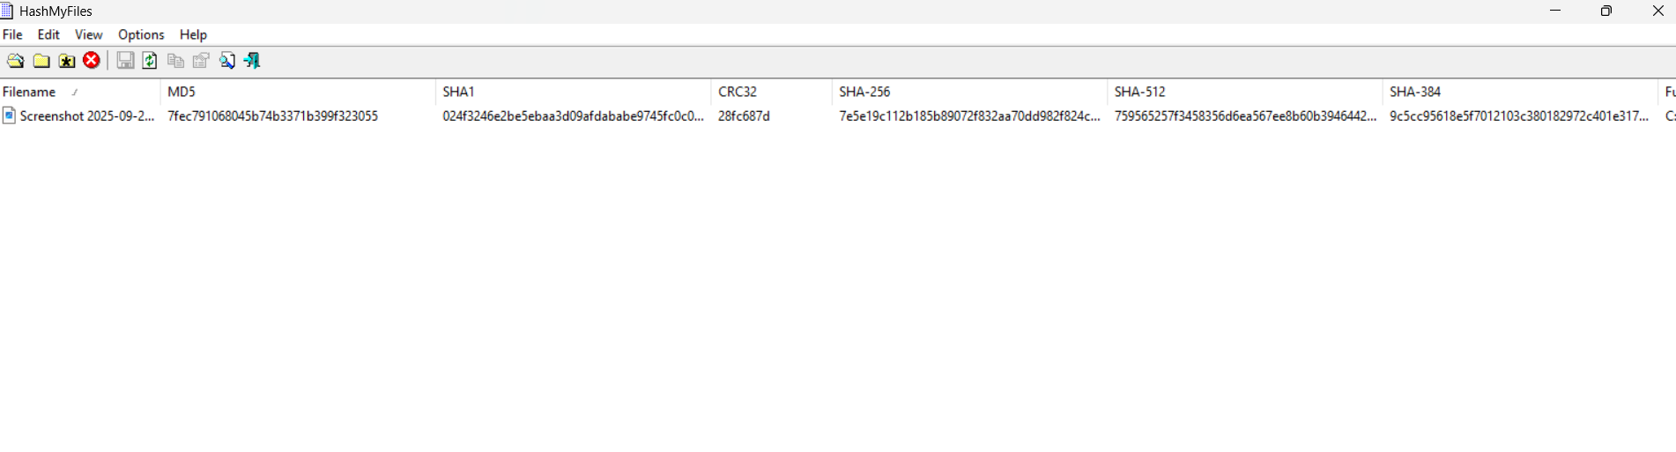

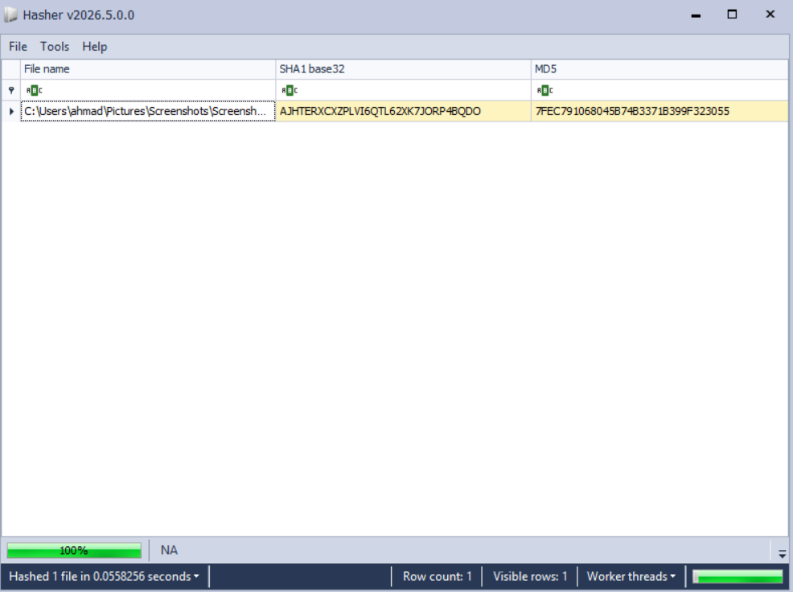

Screenshot 1: Ease of Use & UI Differences
- For HashMyFiles: 1. Open Windows File Explorer.
2. Right-click on any file (e.g., a .exe or .zip).
3. Hover over the context menu showing the "HashMyFiles" right-click option. This proves its seamless Windows integration.

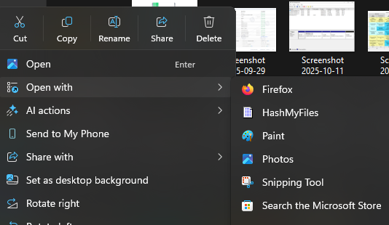

- For Hasher:
  - Open the folder containing the Hasher application.
  - Open the Hasher.ini file in Notepad to show the configuration text.
  - Open the Hasher.exe application next to it.
  - showing both the GUI grid and the .ini text file. This proves that configuration is handled via text editing rather than GUI menus.
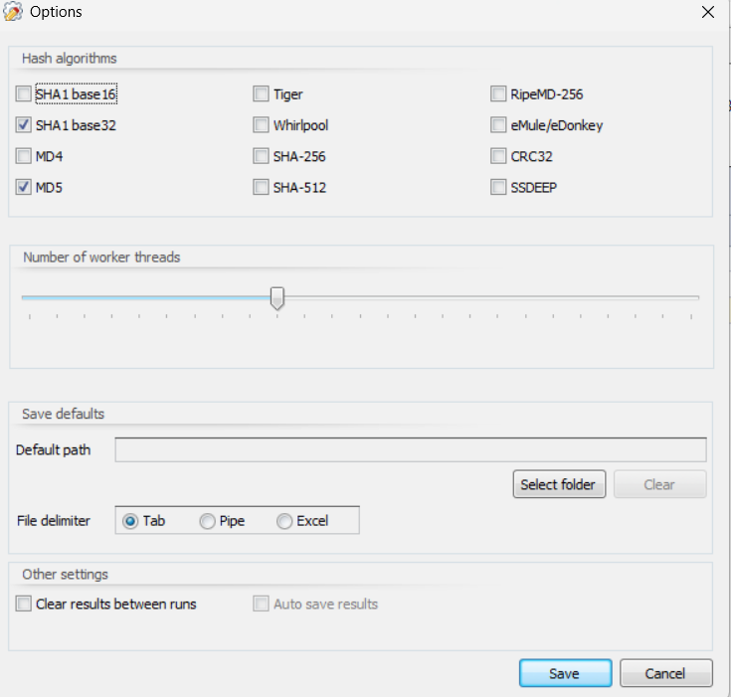

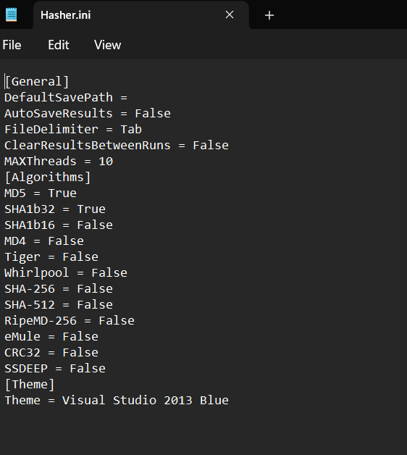

Screenshot 2: Hashing Algorithms
- For HashMyFiles: 1. Open the application.
2. Click on Options in the top menu bar.
3. the dropdown menu showing the checklist of available algorithms (MD5, SHA1, CRC32, etc.).

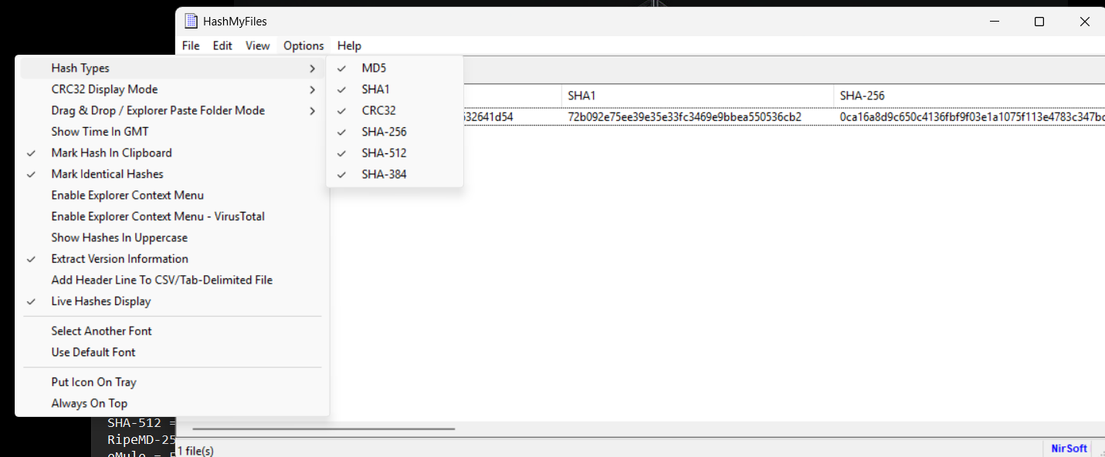

- For Hasher: 1. Open the Hasher.ini file.
2. Scroll to the [Hashes] section.
3. the text file showing the extensive list of True/False toggles for niche algorithms like Whirlpool, Tiger, and eMule.

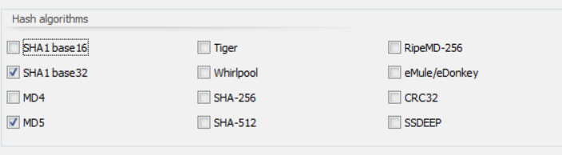

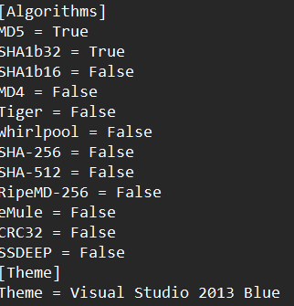

Screenshot 3: Output and Export Formats
- For HashMyFiles: 1. Drag a file into the application to generate a hash.
2. Click View -> HTML Report - All Items.
3. the generated HTML page popping up in your browser, proving its versatile, visual export capabilities.

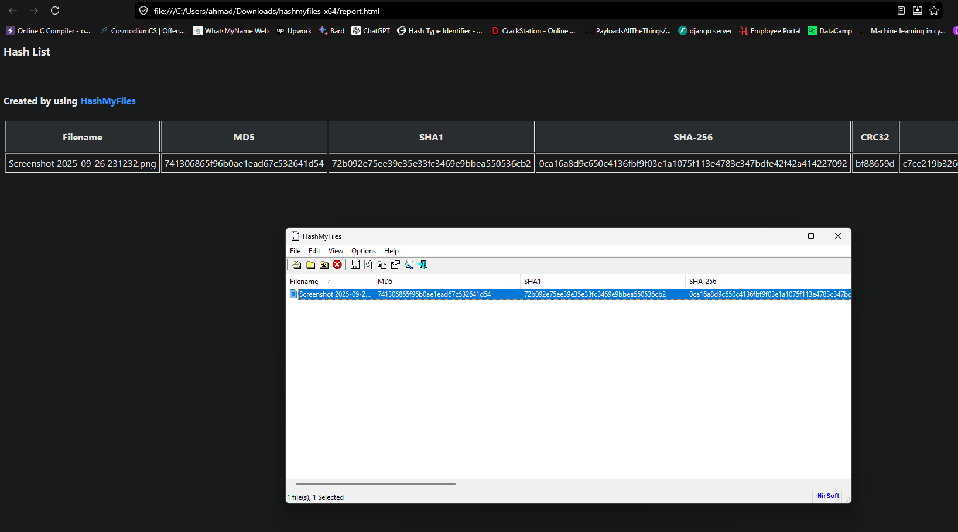

- For Hasher: 1. Drag a file into Hasher.
2. Highlight the row, right-click, and select Save selected rows to file.
3. Open the output folder the newly created .txt file, the timestamped file name (e.g., 2026-06-05-...HasherResults.txt) proves its forensic logging format.

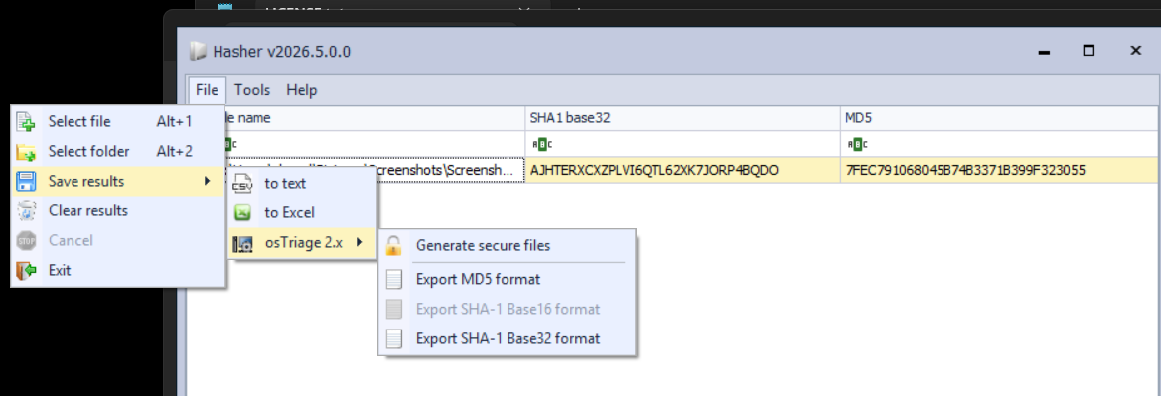

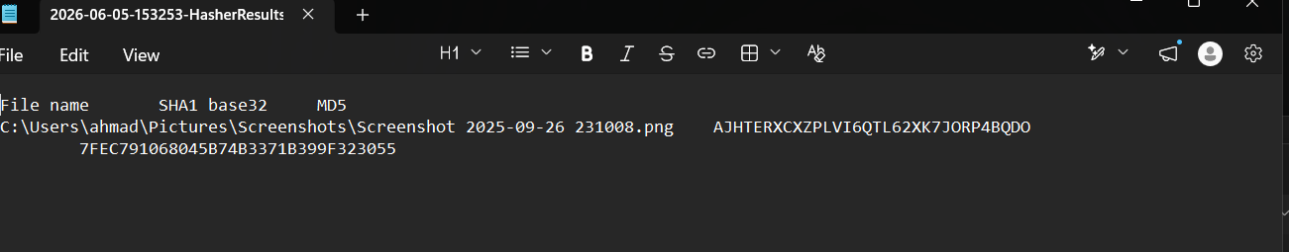

Acknowledgment
During the preparation of this work, I used OpenAI’s ChatGPT [5] to improve the readability and language of the report. I take full responsibility for the scientific content, analysis, and conclusions presented in this report.

References
[1] Lineal (2025). The Role of Digital Forensics in Internal Investigations. [online] Available at: https://lineal.com/en-sg/resources/blog/the-role-of-digital-forensics-in-internal-investigations/ [Accessed 22 May 2026].

[2] OpenText (2025). DFIR: The unsung hero of cybersecurity. [online] Available at: https://blogs.opentext.com/dfir-the-unsung-hero-of-cybersecurity/ [Accessed 22 May 2026].

[3] Computer Misuse Act 1990, c. 18. Available at: https://www.legislation.gov.uk/ukpga/1990/18/contents [Accessed 22 May 2026].

[4] Hayes, J., Curzon, M., Naleemudeen, M. and Gayle, J. (2025). A practitioner's perspective on cyber investigations in the United Kingdom. Lexology. Available at: https://www.lexology.com/library/detail.aspx?g=247be349-b6b0-47d5-a0d2-1447f9afaa18 [Accessed 22 May 2026].

[5] OpenAI. ChatGPT: Language model. https://www.openai.com/chatgpt

NirSoft HashMyFiles Official Documentation: nirsoft.net/utils/hash_my_files.html

Eric Zimmerman's EZ Tools Manual (Hasher): github.com/EZToolsManuals

