

Programming 2024

Submited by :

Ahmad Maghaireh

To:

Sultan Al Rashdan

Table of Contents

Contents

**No table of contents entries found.**

# Part One :

### 1. Describe the process of building an application.

Process of Building an Application :

1- Define and Understand The problem

Defining and understanding the problem is the foundation of the application development process, every application core idea is a problem that a part of the application solves and another part presents the solution, so defining the problem with a good understanding will decrease the errors and the time of the building process. This involves identifying the core issue the application aims to solve, understanding the target audience, and specifying the requirements, also making space for new requirements that may come up while building the application

Scope Definition, this point is a critical one because a lot of companies that have an issue with scope definition will find themself diving into sub-problems that have nothing to do with the main problem, which will consume resources and time

On the other hand, some companies make the scope very tight which will make the app not fulfill the needs of users or not solve the problem

To summarize in one sentence (Set boundaries on what the application will and will not do.)

Also conducting research will be helpful for marketing plans and requirements based on the market, but this part most of the time is for the marketing department, so I will not dive into it

2- Think of ways to solve the problem

Thinking of ways to solve the problem involves a structured brainstorming and evaluation process. Initially, you generate multiple solutions, considering various features and functionalities relevant to the application. For instance, in an event planning app, you might brainstorm features such as calendar integration, automated reminders, and budgeting tools. Next, critically evaluate the pros and cons of each solution, taking into account factors like cost, time, complexity, and user experience. Assess the technical feasibility of each solution to ensure that it can be implemented with the available resources and technology.

This step relies on the previous because we can't think clearly and find solutions without having a clear image of the problem with all of the aspects of the problem.

3- Present the way of solving a problem in simple steps “algorithm”

Presenting the problem using an algorithm which is steps that lead to the solution which can be presented using a flow chart , pseudocode, or a detailed description may work

In the process of presenting you need to specify the input and the output of the program or the algorithm

A good presentation means a good implementation, which will save time and effort in the next process

4- Write a code that implements the algorithm

In this process, we write a code that will follow the presenting step, the writing process will be easier and smoother if you did great work in the previous step,

First we choose a Programming Language based on the application requirements and the team's expertise then we Translate the algorithm into code(which is also called implementation), following best practices for readability, maintainability, and performance also following code standards to ensure quality

5- Test the code

Testing the code can be done while writing it or after finishing most of it.

There are many types of testing a code such as testing functions or components if they work as expected, testing how more than one components work together, testing the code on more than one system and simulating the environment, and finally, user testing which can be after launching that application for reporting any issues to ensure user friendly

6- Document the code

Code Documentation Includes comments and explanations within the code to describe the purpose and functionality of different sections also Creating comprehensive documentation that includes system architecture, algorithms, APIs, and any other technical details. Also creating **User Documentation** Provide manuals, guides, and help files for end-users to understand how to use the application.

### 2. What is your understanding of an algorithm, explain the importance of algorithms in computer programming

An algorithm is a well-defined, step-by-step procedure or set of rules designed to solve a specific problem or perform a particular task. It takes an input, processes it through a series of computational steps, and produces an output. Algorithms are fundamental to computer programming because they form the logical foundation for problem-solving and task automation in software development.

Anything can be described using an algorithm, from making mansaf to praying , building a house or solving a problem in programming

We can use pseudo-code or flow chart to describe our algorithm .

Algorithms are crucial in computer programming, forming the backbone for efficient and effective problem-solving. They enable optimization, ensuring tasks are performed in minimal time with limited resources, and scalability, allowing applications to handle increasing data and complexity without degrading performance. Algorithms ensure accuracy through structured approaches that guarantee correct and consistent outcomes, vital for precision-critical applications like financial calculations and scientific simulations. Their modular design promotes reusability across different programs, saving development time and effort. Standard algorithms, such as sorting and searching, provide uniform tools that reduce errors. Algorithms decompose complex problems into manageable steps, fostering systematic problem-solving and encouraging abstract thinking, which aids in adapting solutions to various specific issues. They also enhance communication, serving as documentation that clearly describes problem-solving processes, facilitating understanding, maintenance, and updates. This clarity supports collaboration among developers by providing a common framework for discussing and implementing solutions. Additionally, algorithms drive automation by performing repetitive and complex tasks efficiently, boosting productivity. In decision-making processes, such as in recommendation systems and artificial intelligence, algorithms analyze data and make informed decisions based on predefined rules. In summary, algorithms are indispensable in computer programming, ensuring optimal performance, accuracy, reusability, effective problem-solving, clear communication, and robust automation, making them essential for developing reliable and scalable software applications.

### 3. How do you ensure that an algorithm is efficient and effective.

Ensuring that an algorithm is efficient and effective involves several key steps that focus on both its design and practical performance. One crucial aspect is analyzing the algorithm's time complexity, typically done using Big O notation, which describes how the algorithm's runtime grows with the size of the input. It's important to consider the best, average, and worst-case scenarios to understand its performance in various situations. Another critical factor is analyzing the algorithm's space complexity, assessing its memory requirements to minimize additional memory usage and selecting data structures that optimize both time and space.

Optimizing the algorithm is essential, involving simplifying and streamlining its steps to eliminate unnecessary operations. Strategies like divide and conquer, dynamic programming, or greedy algorithms can be implemented to improve efficiency. Comparing the algorithm with existing solutions for the same problem helps benchmark its performance and effectiveness. This comparison can also involve studying similar problems and the algorithms used to solve them, providing insights into alternative approaches and their efficiency.

Practical testing is crucial to ensure the algorithm performs well in real-world scenarios. Testing with various inputs, including edge cases and large data sets, helps evaluate its robustness and efficiency. Additionally, iterative improvement is key, using profiling tools to identify performance bottlenecks and making incremental adjustments to enhance efficiency continuously. By combining theoretical analysis with practical testing and iterative improvement, you can ensure that an algorithm is both efficient and effective, delivering optimal performance for the problem it's designed to solve.

there are points or key principles in the designing of an algorithm that should be checked to make sure it is efficient and effective

Which are :

An algorithm must be clear and unambiguous, ensuring each step is precisely defined and interpreted in only one way. It should have well-defined inputs, meaning any required data is explicitly specified for consistent processing. The outputs should also be clearly defined, providing predictable and understandable results. To be effective, an algorithm must be finite, avoiding infinite loops and completing tasks in a reasonable time. It should be feasible, meaning it’s simple, generic, practical, and executable with available resources, without relying on future technologies. Finally, an algorithm should be language-independent, consisting of plain instructions that can be implemented in any programming language, ensuring consistent output regardless of the implementation.

### 4. Outline the steps involved in writing code for a program.

To write code for a program, start by identifying and analyzing the problem you want to solve. Design an algorithm outlining the steps to solve it, considering different approaches. Develop pseudocode to clarify the logic before writing actual code. Select a suitable programming language and set up your development environment(files, directories, libraries, and packages as needed ). Write the code, translating the pseudocode into actual code and using meaningful variable names, comments, and following coding standards. ,Test each part of the code, conduct unit and integration testing, and use debugging tools to fix errors. Refactor the code for clarity, efficiency, and maintainability. Compile the code using a compiler specific to the programming language you're using, which translates the code into machine-readable instructions. Test the compiled program to ensure it behaves as expected . Once the code is compiled into machine-readable instructions, the process of executing the code depends on whether it is compiled or interpreted .final output.Use version control software for managing changes. Document the code to explain its purpose and usage, and design a user interface if needed. Integrate and deploy the code, and regularly monitor for issues or bugs, updating the program as necessary, and documentation with his types(comments, sheets, user documentation,etc)

These are the steps of writing a code, every step has sub-steps, such as the exaction process ( ide or text editor, source code, compile, machine code, interpreter ) so I just mentioned the main ones.

### 5. Describe the process of compiling code into machine-readable instructions.

The process of compiling code into machine-readable instructions generally involves several steps: preprocessing, parsing, semantic analysis, optimization, code generation, assembly, linking, and output. Preprocessing handles directives for including files and macros. The compiler parses the code to create a parse tree and checks for semantic errors. Optimizations improve performance and resource usage. The compiler then generates machine code, sometimes via an assembler. Finally, the linker combines object files into an executable.

In Java, the process is unique because it involves both compilation and interpretation. Java source code is first compiled by the Java Development Kit (JDK) into platform-independent bytecode. This bytecode is then executed by the Java Runtime Environment (JRE) through the Java Virtual Machine (JVM). The JVM loads the bytecode, verifies it for security, and uses Just-In-Time (JIT) compilation to convert frequently executed bytecode into native machine code, enhancing performance. This dual process allows Java to achieve the "write once, run anywhere" capability, making Java applications highly portable and efficient.

The advantage of this approach is that Java programs can run on any platform with a compatible JVM, providing flexibility and ease of deployment. The JDK includes essential tools like the javac compiler, the java command for running applications, javadoc for generating documentation, and jdb for debugging. This combination of compilation and interpretation ensures that Java programs are both portable and performant.

### 6. Provide an example of an algorithm and clearly explain it. Then, implement the algorithm using a programming language. You will include this algorithm in the paradigms below.

**Linear Search Algorithm: An In-Depth Explanation**

**What is Linear Search?**

Linear search, also known as sequential search, is the simplest search algorithm. It works by iterating through each element in a list or array one by one until the desired element is found or the list ends. It does not require the list to be sorted.

**How Does Linear Search Work?**

1. **Initialization**: Start from the first element of the list.
2. **Iteration**: Compare the current element with the target element.
3. **Comparison**:

* If the current element matches the target element, return its index.
* If the current element does not match the target element, move to the next element.

1. **Termination**: If the end of the list is reached and the target element is not found, return a value indicating that the element is not in the list (usually -1 or null).

Complexity Analysis:

* Time Complexity: O(n), where n is the number of elements in the list. In the worst case, the algorithm has to check every element in the list.
* Space Complexity: O(1). The algorithm only requires a constant amount of additional space regardless of the list size.

Example:

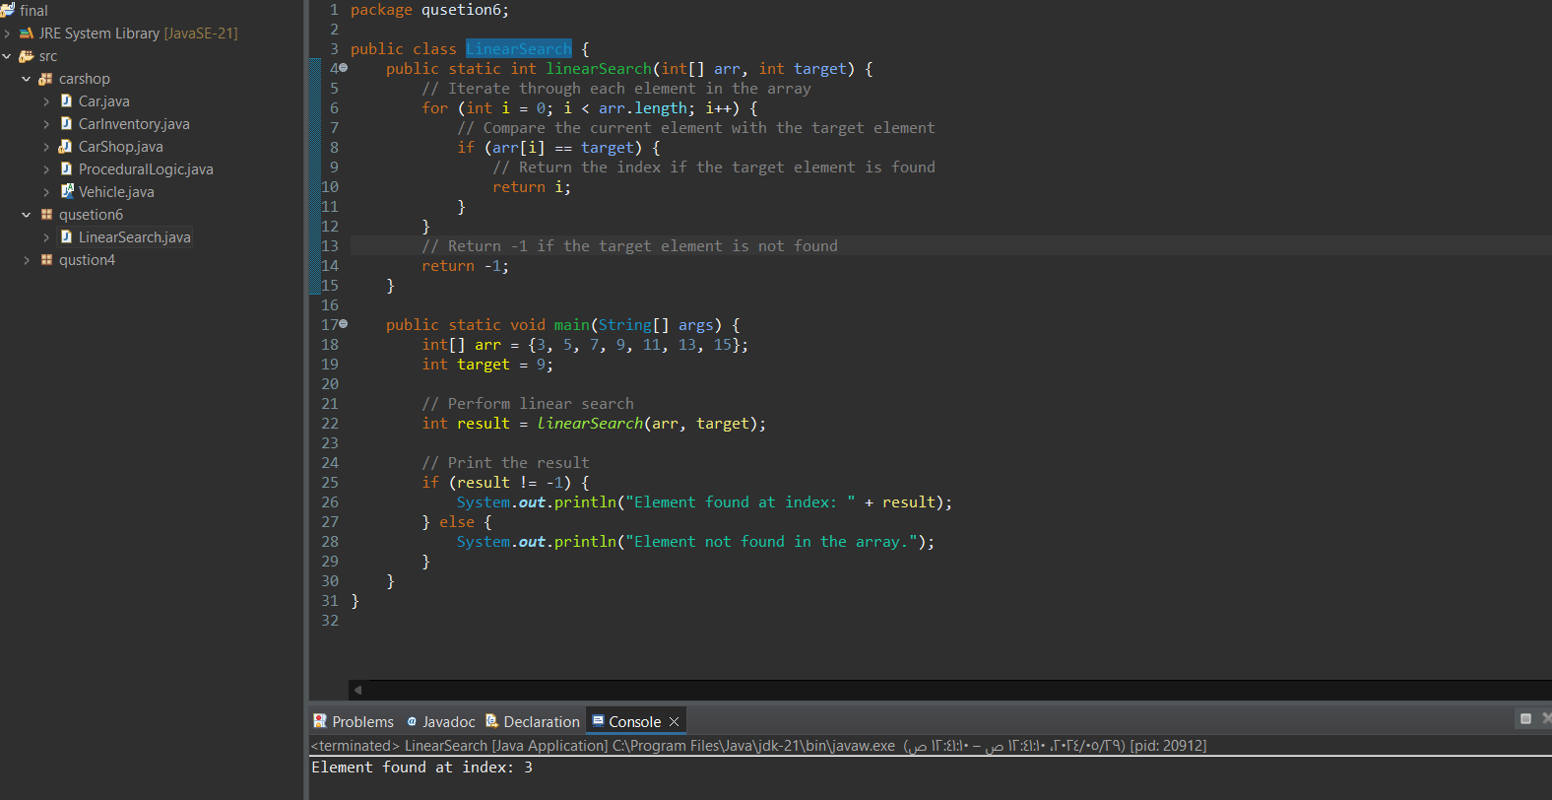

Let's trace the execution of the linear search algorithm step-by-step using a tracing table.

**Tracing Table Structure**

The table will include the following columns:

1. **Step**: The current step in the algorithm.
2. **Index (i)**: The current index being checked.
3. **Current Element (arr[i])**: The element at the current index.
4. **Comparison (arr[i] == target?)**: The result of the comparison between the current element and the target.
5. **Result**: The action taken based on the comparison (continue, return index, or end).

**Tracing Table**

| **Step** | **Index (i)** | **Current Element (arr[i])** | **Comparison (arr[i] == target?)** | **Result** |
| --- | --- | --- | --- | --- |
| 1 | 0 | 3 | 3 == 9 ? No | Continue |
| 2 | 1 | 5 | 5 == 9 ? No | Continue |
| 3 | 2 | 7 | 7 == 9 ? No | Continue |
| 4 | 3 | 9 | 9 == 9 ? Yes | Return index 3 |

**Explanation of the Example**

1. **Array Initialization**: We initialize an array arr with the elements {3, 5, 7, 9, 11, 13, 15} and set the target value to 9.
2. **Calling the Function**: The linearSearch function is called with arr and target as arguments.
3. **Function Execution**:

* The function iterates over each element of the array.
* When it reaches the element 9 (which is the target), it returns the index 3.

1. **Output**: The main function checks the result. Since the target element is found at index 3, it prints "Element found at index: 3".

**Key Points**

* **Simple to Implement**: Linear search is easy to implement and understand.
* **No Precondition**: It does not require the list to be sorted.
* **Efficiency**: It is not the most efficient algorithm for large lists, as its time complexity is O(n). For large datasets, more efficient algorithms like binary search (for sorted lists) should be considered.

Linear search is useful for small lists or when simplicity is more critical than efficiency.

# Part Two :

### 1. Define the procedural programming paradigm and its key characteristics.

The procedural programming paradigm in Java revolves around using methods, also known as functions, to execute sequences of instructions for specific tasks. Methods are fundamental to procedural programming and are defined with a specific name, return type, and a set of parameters. This approach focuses on a step-by-step procedure to solve problems, making it straightforward and easy to understand. In Java, methods can be overloaded, meaning multiple methods can have the same name but different parameter lists. Method overloading enhances code readability and usability, allowing for methods that perform similar tasks with different inputs. This flexibility allows developers to create more intuitive and user-friendly interfaces within their code.

The scope of procedural programming in Java involves understanding the visibility and lifetime of variables. Local variables are declared within a method and are only accessible within that method, existing only for the duration of the method call. This ensures that the variables do not interfere with other parts of the program, promoting data integrity. 3it uses class-level variables (static fields) that can be accessed by all methods within the class, and instance-level variables (fields) that can be accessed by methods within the same instance of the class. This distinction helps maintain a clear structure in the program, ensuring that variables are used appropriately within their intended scope.

Java methods can be categorized into several types based on their return type and purpose. Void methods do not return any value and are used for tasks that do not require feedback. Return methods provide a value back to the caller, with the return type specified in the method definition. Static methods belong to the class rather than any object instance and can be called without creating an instance of the class. This makes static methods useful for utility functions that perform common tasks across different parts of the program. Instance methods, on the other hand, belong to an instance of the class and require an object to be called. This allows instance methods to operate on the data contained within the specific object instance.

Function parameters in Java methods can be of any data type, including primitive types like int and float, and reference types like objects. This allows for great flexibility in how methods are defined and used. Additionally, Java supports variable-length argument lists, enabling methods to accept an arbitrary number of parameters. This is particularly useful for methods that need to handle a varying number of inputs without requiring multiple method definitions. Methods in Java return values using the return statement, with the return type specified in the method signature. If a method does not return a value, it is declared with the void return type, indicating that it performs a task without producing a result.

The procedural programming paradigm in Java has several advantages, including simplicity and modularity. The straightforward approach makes it easy to understand and implement, and the use of methods allows code to be organized into reusable and manageable blocks. This enhances code organization and readability, making it easier to maintain and debug. However, procedural programming also has some limitations. It can become unwieldy with very large programs, making it difficult to manage and extend. Additionally, procedural programming often lacks the data encapsulation provided by object-oriented programming, leading to potential issues with data integrity and security. While methods can be reused, procedural programming does not inherently promote the high level of code reuse found in object-oriented programming through inheritance. Despite these limitations, procedural programming remains a fundamental and widely-used paradigm, particularly suited for tasks that can be broken down into a clear sequence of steps.

### 2. Explain the concept of object-oriented programming (OOP) paradigm and its fundamental principles .

Object-oriented programming (OOP) in Java is a programming paradigm that uses objects to represent data and methods to manipulate that data. This approach helps to structure a software program into simple, reusable pieces of code, which are blueprints (classes) for creating individual instances of objects. Below are the fundamental principles and features of OOP in Java:

**Fundamental Principles of OOP**

**1. Classes and Objects:**

* Classes are the core of OOP, serving as blueprints for creating objects. A class defines the properties (attributes) and behaviors (methods) that the objects created from it will have. For example, a Car class might have attributes like model, color, and year, and methods like start(), stop(), and beep().
* Objects are instances of classes. Each object has its own state, represented by the values of its attributes, and behaviors, represented by its methods. Objects interact with each other to design applications and programs.

**2. Encapsulation:**

* Encapsulation is the concept of wrapping data and methods that operate on the data into a single unit, or class. This principle restricts direct access to some of an object’s components, which is a means of preventing accidental interference and misuse of the data. For example, in a class, variables can be kept private and only accessible through public methods (getters and setters).
* Encapsulation helps in hiding the internal state of the object from the outside world and only exposes a controlled interface. This ensures that the data is protected and can only be modified in a controlled manner.

**3. Inheritance:**

* Inheritance allows a new class to inherit properties and methods from an existing class. The existing class is called the parent (or base) class, and the new class is called the child (or derived) class. This promotes code reuse and can lead to a hierarchical classification.
* For example, if we have a Vehicle class, a Car class can inherit from Vehicle and gain all of its properties and methods, while also introducing its own unique properties and methods. This creates a relationship where Car is a specific type of Vehicle.

**4. Polymorphism:**

* Polymorphism allows objects to be treated as instances of their parent class rather than their actual class. This is achieved through method overriding and overloading.
* Method Overriding occurs when a child class provides a specific implementation of a method that is already defined in its parent class. This allows the child class to tailor the inherited method to its needs.
* Method Overloading allows a class to have more than one method with the same name, as long as their parameter lists are different. This provides flexibility in how methods are called based on the number and type of arguments passed.

**5. Abstraction:**

* Abstraction involves hiding the complex implementation details of a system and exposing only the necessary and relevant features. It simplifies the interaction with objects by providing a clear and simple interface.
* In OOP, abstraction can be achieved using abstract classes and interfaces. Abstract classes cannot be instantiated on their own and are designed to be subclassed. They can have abstract methods (without implementation) that must be implemented by the subclasses. Interfaces, on the other hand, are completely abstract and define methods that implementing classes must override.

**Key Features of OOP in Java**

**Class and Types:**

* A class in Java is a blueprint for creating objects. It defines a type by bundling data (attributes) and methods that operate on the data. Types can be primitive (e.g., int, char) or reference types such as classes and arrays.

**Attributes:**

* Attributes, also known as fields or properties, are variables that belong to an object. They store the state of the object. Attributes can be defined with different access modifiers (private, protected, public) to control their visibility.

**Methods:**

* Methods are functions defined within a class that describe the behaviors of the objects created from the class. They operate on the attributes of the object and are used to implement the functionality associated with an object.
* Methods in a class can be instance methods, which operate on instances of the class, or static methods, which belong to the class itself and do not operate on instances. Instance methods are used to perform operations on the data contained within an instance, while static methods can be called without creating an instance of the class.

**Constructors:**

* Constructors are special methods used to initialize objects. They are called when an object is created.
  + Implicit Default Constructor: Provided by the compiler if no constructors are defined.
  + Explicit Default Constructor: User-defined constructor with no parameters.
  + Parameterized Constructor: Takes parameters to initialize an object's attributes.
  + Constructor Overloading: Multiple constructors with different parameter lists.

**Advantages of OOP**

OOP offers several advantages over procedural programming:

* **Modularity:** Code is organized into classes and objects, which makes it easier to manage and modify.
* **Reusability:** Once a class is written, it can be reused to create multiple objects. Inheritance also promotes reusability by allowing new classes to build upon existing ones.
* **Maintainability:** Encapsulation ensures that objects are self-contained, reducing dependencies and making the code easier to maintain.
* **Real-world modeling:** OOP closely mirrors real-world entities and relationships, making it easier to design and understand complex systems.

By adhering to these principles, OOP helps in creating robust, scalable, and maintainable software. It enables developers to think more naturally about the problem domain and build solutions that are both efficient and elegant.

**OOP vs. Procedural Programming**

* **Organization:** OOP organizes code around objects and their interactions, whereas procedural programming organizes code around functions or procedures.
* **Modularity:** OOP promotes modularity through classes and objects, making it easier to manage and understand large codebases. Procedural programming can become complex and harder to manage as the codebase grows.
* **Code Reuse:** OOP allows for greater code reuse through inheritance and polymorphism, while procedural programming relies on functions and procedures, which can lead to code duplication.

### 3. Describe the event-driven programming paradigm and how it differs from procedural and object-oriented paradigms.

Event-driven programming is a paradigm where the program flow is determined by events such as user actions (mouse clicks, key presses), sensor outputs, or messages from other programs. Unlike procedural programming, which follows a linear sequence of instructions, or object-oriented programming, which organizes code into objects with attributes and methods, event-driven programming relies on a main loop that listens for events and triggers corresponding event handlers to execute actions.

**Key Characteristics of Event-Driven Programming**:

1. **Event Listeners**: Components that wait for specific events to occur, such as button clicks or mouse movements.
2. **Event Handlers**: Functions or methods that define the actions to be performed in response to detected events.
3. **Continuous Execution**: The main loop runs continuously, waiting for events to occur and dispatching them to the appropriate handlers.
4. **Graphical User Interfaces (GUIs)**: Widely used in applications with GUIs, where user interactions drive the program's behavior.

**Event-Driven Cycle**

1. **Event Trigger**:
   * **Definition**: An event trigger is an occurrence, often initiated by the user, such as clicking a button, moving the mouse, pressing a key, or other inputs.
   * **Explanation**: Events can be generated by hardware interactions (like mouse and keyboard inputs) or by software (like timers or messages from other programs). These events are the starting points for the event-driven cycle.
2. **Event Handler**:
   * **Definition**: An event handler is a function or method specifically designed to respond to an event.
   * **Explanation**: Once an event is triggered, the event handler associated with that event is called to perform a specific task. For instance, clicking a button might trigger an event handler that saves a file or updates a display. Event handlers contain the code that defines the actions taken in response to the event.
3. **Event Loop**:
   * **Definition**: The event loop is the core of the event-driven system, continuously running to listen for events and dispatch them to the appropriate handlers.
   * **Explanation**: The event loop runs indefinitely, waiting for events to occur. When an event is detected, it dispatches it to the corresponding event handler. After the event is processed, the loop resumes waiting for the next event. This cycle ensures that the program can respond to multiple events over time, maintaining interactive responsiveness.

**Examples of Events in EDP**

* **User Inputs**: Mouse clicks, key presses, touch gestures.
* **System Events**: Timer expirations, file modifications, network packet arrivals.
* **Sensor Outputs**: Data from accelerometers, temperature sensors, GPS updates.

**Swing and JavaFX Libraries**

**Swing**:

* **Definition**: Swing is a part of Java's standard library, providing a set of "lightweight" (all-Java language) components that, to the maximum degree possible, work the same on all platforms.
* **Components**: Swing includes components like buttons, checkboxes, and tables that are more flexible and customizable than the earlier Abstract Window Toolkit (AWT) components.
* **Usage**: Swing is widely used for building desktop applications. It offers a rich set of GUI components and allows for the creation of sophisticated user interfaces with features like pluggable look-and-feel, drag-and-drop functionality, and advanced component capabilities.

1. **JFrame**:
   * JFrame is a top-level container that represents the main window of a Java Swing application. It can contain various Swing components such as buttons, labels, text fields, etc.
2. **JPanel**:
   * JPanel is a container that can hold other components. It is often used to organize and group components within a window.
3. **JButton**:
   * JButton is a component used to create a clickable button. It can display text, an image, or both, and can be configured to perform an action when clicked.
4. **JLabel**:
   * JLabel is used to display a single line of read-only text or an image. It is commonly used to provide descriptions or captions for other components.
5. **JTextArea**:
   * JTextArea is a multi-line area that can display plain text or allow the user to enter/edit text. It supports scrolling and can be configured to wrap text automatically.
6. **JTextField**:
   * JTextField is a single-line text field where the user can enter/edit text. It is commonly used for input fields in forms or dialog boxes.
7. **JList**:
   * JList is a component that displays a list of items. It can be configured to allow single or multiple selections. It's often used to present a list of options for the user to choose from.
8. **JTable**:
   * JTable is used to display data in tabular form. It provides a grid of cells where each cell can contain text, numbers, or other components. It's commonly used for displaying database query results or spreadsheet-like data.
9. **JCheckbox**:
   * JCheckbox is a component that represents a check box, which can be selected (checked) or deselected (unchecked) by the user. It's commonly used to enable or disable options in a settings dialog or form.

Listeners:

* **ActionListener**:
  + ActionListener is used to handle actions/events generated by components such as buttons. When an action (like a button click) occurs, the corresponding actionPerformed() method is called, allowing you to define the behavior in response to that action.
* **KeyListener**:
  + KeyListener is used to handle keyboard events, such as key presses and releases. By implementing methods like keyPressed() and keyReleased(), you can define how your program should respond to user keyboard input.
* **MouseMotionListener**:
  + MouseMotionListener is used to handle mouse motion events, such as when the mouse is moved over a component. It provides methods like mouseMoved() and mouseDragged() that you can implement to respond to mouse movement within your application.

**JavaFX**:

* **Definition**: JavaFX is a software platform for creating and delivering desktop applications, as well as rich internet applications (RIAs) that can run across a wide variety of devices.
* **Components**: JavaFX provides a modern UI toolkit with advanced features such as hardware-accelerated graphics, media playback, and web integration. It supports properties and bindings, allowing for reactive programming styles.
* **Usage**: JavaFX is designed to replace Swing as the standard GUI library for Java SE. It offers a more modern and flexible approach to GUI development, with support for modern UI controls, CSS for styling, and FXML for defining user interfaces declaratively.

**Differences between Event-Driven, Procedural, and Object-Oriented Programming Paradigms**

**Event-Driven Programming (EDP):**

* **Definition:** In EDP, the flow of the program is determined by events such as user actions (mouse clicks, key presses), sensor outputs, or messages from other programs.
* **Execution:** EDP runs continuously in the background, waiting for events to occur. When an event happens, the appropriate event-handler routine is triggered to respond.
* **Applications:** Commonly used in graphical user interfaces (GUIs), where interactions with the interface (like clicking a button) trigger specific code.
* **Integration with Other Paradigms:** EDP often works alongside object-oriented programming (OOP). For instance, GUI components (buttons, text fields) can be objects that have specific event-handling methods. Procedural elements can also be part of event-handlers, providing structure to the sequence of operations following an event​
* ​.

**Procedural Programming (PP):**

* **Definition:** PP is a paradigm derived from structured programming, based on the concept of procedure calls, where statements are structured into procedures (also known as routines or functions).
* **Execution:** Program execution follows a linear, top-down approach. The flow of control is determined by the programmer and controlled from within the main routine of the application.
* **Applications:** Suitable for applications where a specific sequence of operations needs to be performed without user intervention, such as a C compiler.
* **Comparison with EDP:** Before OOP, event-handlers in procedural programs were implemented as subroutines within the main routine, requiring a highly structured approach to manage events and exceptions​

**Object-Oriented Programming (OOP):**

* **Definition:** OOP is based on the concept of "objects," which are instances of classes. Objects can contain data in the form of fields (attributes or properties) and code in the form of methods (functions or procedures).
* **Execution:** OOP focuses on the creation of reusable objects, with the program's structure defined by the interactions between these objects.
* **Applications:** Ideal for complex systems with multiple interacting components, such as software design for business applications.
* **Integration with EDP:** OOP is closely linked to EDP. For example, GUI components can be modeled as classes with attributes and event-handling methods. Each class can define events it responds to, and the event-handling code can be customized for different instances of the class​
* ​.

**Key Points:**

* **EDP** is reactive, focusing on responding to user or system events.
* **PP** is linear and structured, emphasizing a clear sequence of procedural steps.
* **OOP** organizes code around objects and their interactions, making it modular and reusable.
* **Integration:** EDP often utilizes OOP for organizing event-handling logic, while procedural elements may still be used within event-handlers for specific tasks.

### 4. Provide examples of code that primarily demonstrate the three paradigms mentioned above, showcasing their core features.

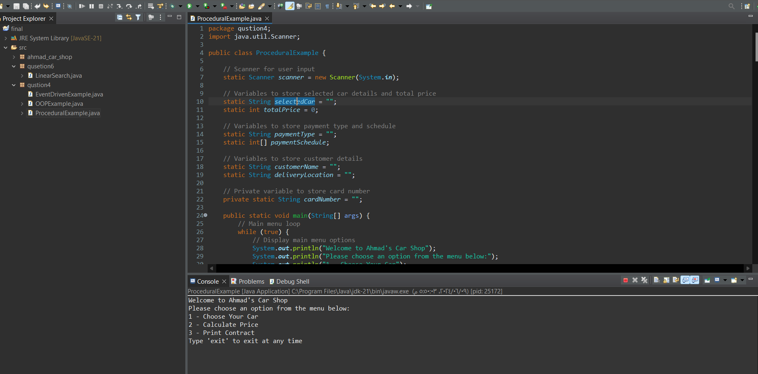

### 5. Compare and contrast procedural, object-oriented, and event-driven paradigms in terms of their approach to programming (Support your claims using screenshots of your code):

### Describe how the source codes utilize each paradigm.

### Reflect on how the chosen programming paradigms align with the overall goals and requirements of your application.

### 6. Provide a complete scenario where a combination of these paradigms might be beneficial in software development. Include the previously written algorithm in your program.

### Procedural Paradigm:

Approach to Programming: In the procedural paradigm, the code is organized around procedures or functions. It follows a top-down approach where the program is structured as a sequence of instructions. Data and functions are kept separate, and functions operate on the data passed to them.

Utilization in the Source Code: The procedural example organizes functionality into separate functions like chooseCar(), calculatePrice(), and printContract(). The main method orchestrates the flow of the program by calling these functions based on user input.

Comparison with Provided Code: The displayMenu() method acts as the main procedural flow controller, similar to a procedural approach. It sequentially presents options to the user and calls corresponding functions based on user input. However, the functions are still somewhat tightly coupled with the class, unlike a purely procedural approach where they might be more modular.

* **Functions/Procedures**: The program is structured around functions that perform specific tasks.
* **Linear Flow**: The execution follows a linear flow, with function calls guiding the sequence.
* **Global Data**: Data is often stored in global variables, accessible by all functions.
* **Example**: Functions for calculating car price, handling user input, and printing contracts are central.

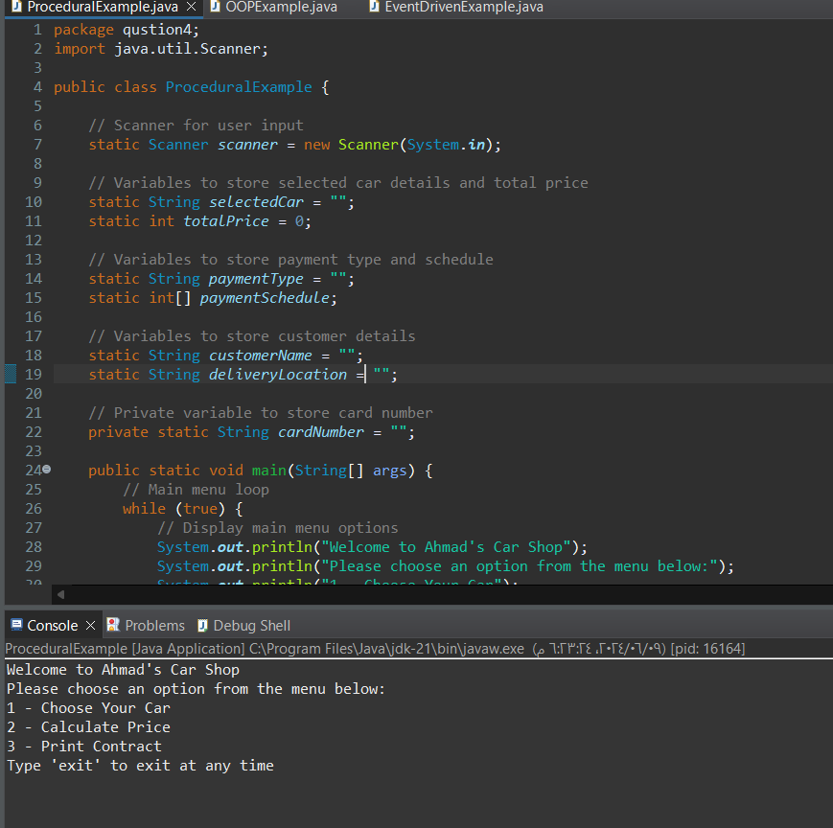

### Object-Oriented Paradigm:

Approach to Programming: Object-oriented programming (OOP) focuses on modeling real-world entities as objects that have data and behavior. It emphasizes encapsulation, inheritance, and polymorphism. Objects interact with each other by sending messages.

Utilization in the Source Code: The OOP example defines classes like Vehicle, Car, and Customer, each encapsulating data and behavior relevant to their respective entities. Inheritance is utilized, with Car inheriting from Vehicle. The code organizes functionality into methods associated with these objects.

Comparison with Provided Code: The provided OOP example clearly demonstrates the principles of encapsulation, inheritance, and polymorphism. Each class represents a real-world entity with its properties and behaviors. The use of inheritance allows for code reuse, and the methods associated with each class represent the behavior of those entities.

**Classes and Objects:**

* Vehicle, Car, Customer, CarShop, OOPExample.
* A computer screen shot of a code

  Description automatically generated
* 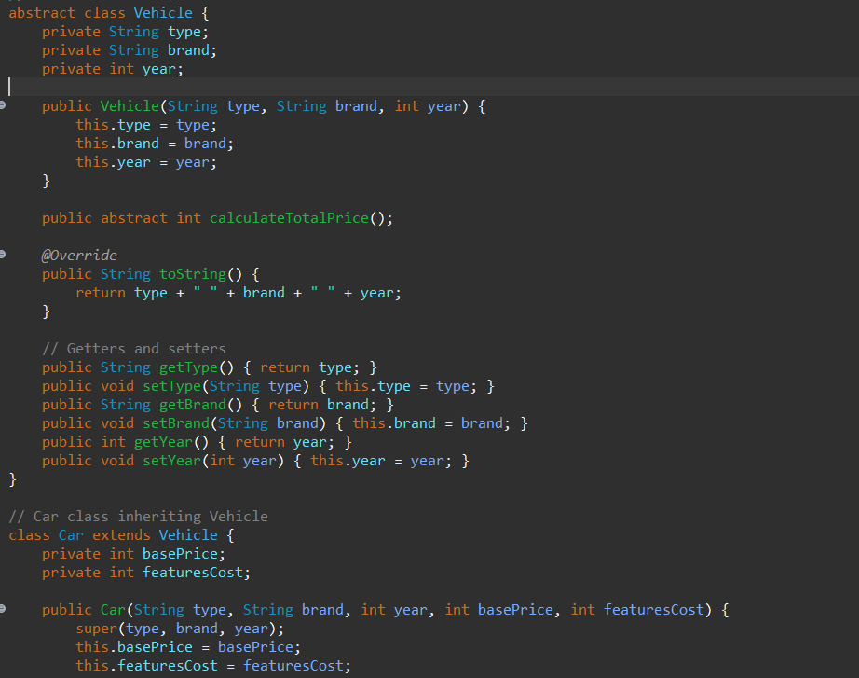
* A screen shot of a computer screen

  Description automatically generated

**Attributes and Methods:**

* Each class has specific attributes (e.g., type, brand, year in Vehicle) and methods (e.g., calculateTotalPrice).

**Constructors:**

* Constructors are used to initialize objects (e.g., public Car(String type, String brand, int year, int basePrice, int featuresCost)).
* A computer screen shot of a program

  Description automatically generated

**Encapsulation:**

* Private attributes with public getters and setters (e.g., getType, setType).
* A screen shot of a computer code

  Description automatically generated

**Polymorphism:**

* **Override:** calculateTotalPrice in Car overrides the abstract method in Vehicle.

* **Overload:** calculateTotalPrice(int discount) in Car.
* A screen shot of a computer program

  Description automatically generated

**Inheritance:**

* Car class inherits from Vehicle.

**Abstraction:**

* Vehicle is an abstract class with an abstract method calculateTotalPrice.

**Linear Search Algorithm:**

* Used in chooseCar and deleteCar methods to find a specific car in the list.
* A screen shot of a computer program

  Description automatically generated

### Event-Driven Paradigm:

Approach to Programming: In the event-driven paradigm, the flow of the program is determined by events such as user actions, system notifications, or messages from other parts of the program. The program responds to these events by triggering appropriate event handlers.

Utilization in the Source Code: The event-driven example uses GUI components like buttons and text fields. User interactions with these components trigger event handlers, which respond accordingly. The program's flow is determined by these events, and the UI updates dynamically based on user input.

Comparison with Provided Code: The event-driven example presents a graphical user interface where user actions trigger event handlers. This contrasts with the procedural and OOP examples, which rely on command-line interactions. The event-driven approach provides a more interactive and dynamic user experience, suitable for GUI-based applications.

**GUI Setup:**

* Created a JFrame to serve as the main application window.

* Added JPanel to organize buttons.
* A screenshot of a computer program

  Description automatically generated
* Used JButton for different actions (e.g., choose car, calculate price).
* A screen shot of a computer program

  Description automatically generated

**Event Handling:**

* Added ActionListener to buttons to handle user actions.
* Used JOptionPane for input dialogs to get user input.
* A screen shot of a computer program

  Description automatically generated

**Existing Features:**

* Integrated existing methods into the GUI event handlers, ensuring all functionality is preserved.
* Admin functionalities (add/delete cars, print all cars) are handled through a modal dialog with JOptionPane.
* A screen shot of a computer program

  Description automatically generated

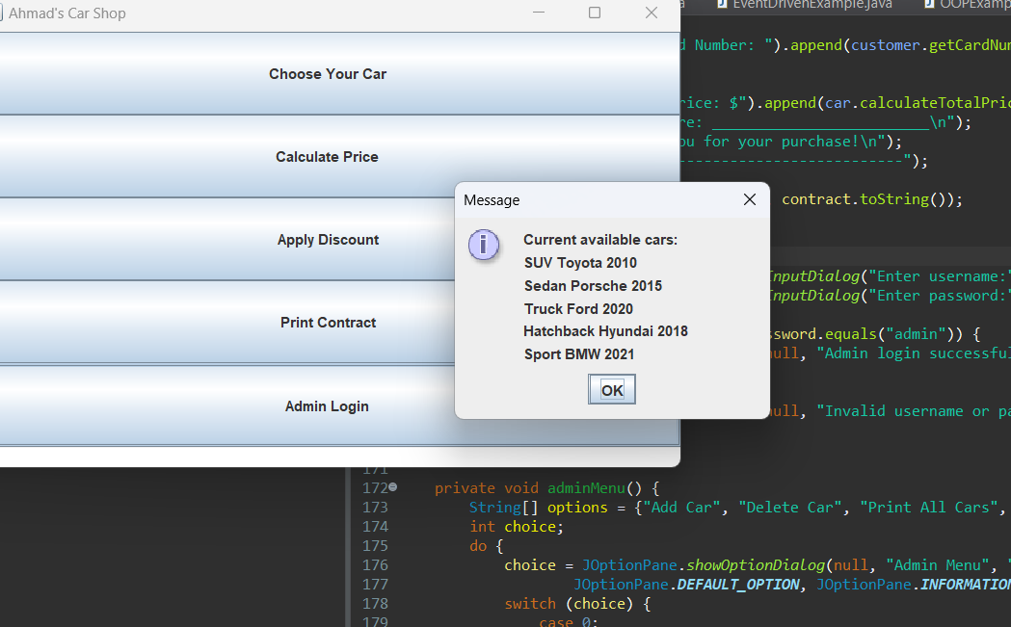

### Combination of Paradigms:

Approach to Programming: Combining paradigms involves using elements from multiple paradigms to address different aspects of a software system's requirements.

Utilization in the Source Code: While the provided examples focus on individual paradigms, in a real-world scenario, developers often combine these paradigms to build complex software systems. For example, a car dealership management software might use procedural programming for control flow, object-oriented programming for modeling entities like cars and customers, and event-driven programming for the user interface.

Comparison with Provided Code: Although the provided examples demonstrate each paradigm in isolation, in practice, developers often employ a combination of paradigms to leverage the strengths of each. This allows for the development of robust, maintainable, and user-friendly software systems that effectively address various requirements and constraints.

### 7. How do you ensure that your code is well-documented and readable by others?

1. **Use Meaningful Variable Names**: Use descriptive names for variables, functions, and classes. This makes it easier for others to understand your code.



1. **Write Clear Comments**: Add comments to explain complex logic, algorithms, or any non-obvious parts of your code. Comments should clarify the why, not just the what.

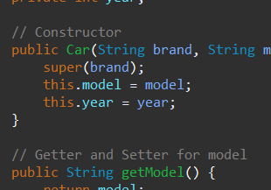

1. **Follow a Consistent Coding Style**: Use consistent indentation, spacing, and naming conventions throughout your codebase. This helps maintain readability and makes the code look cohesive.
2. **Break Down Complex Logic**: Split complex logic into smaller, more manageable functions or methods. Each function should ideally do one thing and do it well.
3. **Use Meaningful Function/Method Signatures**: Functions and methods should have clear and concise names that indicate their purpose. Avoid overly long or ambiguous names.
4. **Document Your Code**: Use documentation comments (e.g., Javadoc for Java, docstrings for Python) to explain the purpose of classes, methods, and important variables. Include information about parameters, return values, and any exceptions that can be thrown.
5. **Use Whitespace Effectively**: Use whitespace to separate logical sections of your code. This improves readability and makes it easier to understand the flow of your program.
6. **Avoid Magic Numbers and Strings**: Instead of hardcoding values, use constants or enums to give them meaningful names. This makes your code more readable and maintainable.
7. **Write Self-Explanatory Code**: Write code that is self-explanatory and easy to understand without needing extensive comments. Use meaningful variable names and structure your code logically.
8. **Review Your Code**: Before finalizing your code, review it yourself or have a colleague review it. This can help catch any unclear or confusing parts before they become a problem.

### 8. Explain the importance of testing code before execution.

1. **Identifying Bugs Early**: Testing helps identify and fix bugs in the code before it is deployed. This reduces the likelihood of encountering errors in production, which can be costly to fix and can negatively impact user experience.
2. **Ensuring Correctness**: Testing ensures that the code behaves as expected and produces the correct output for different inputs and scenarios. This is essential for delivering reliable software.
3. **Improving Code Quality**: Testing encourages developers to write cleaner, more maintainable code. It forces them to consider edge cases and potential issues, leading to better overall code quality.
4. **Saving Time and Resources**: Fixing bugs found during testing is generally less time-consuming and costly than fixing bugs in production. Testing helps catch issues early, saving time and resources in the long run.
5. **Building Confidence**: Thorough testing builds confidence in the codebase, both for developers and users. It ensures that the software meets the specified requirements and is less likely to fail unexpectedly.
6. **Facilitating Refactoring**: Testing provides a safety net when refactoring code. Developers can make changes confidently, knowing that existing functionality is not broken by the changes.

# Part Three:

### 1. Describe the steps you take to create a new project in your preferred IDE. How do you organize project files and directories within the IDE?

Creating a New Project

1- open eclipse works space IDE

2- Go to the menu bar and select File > New > Java Project.

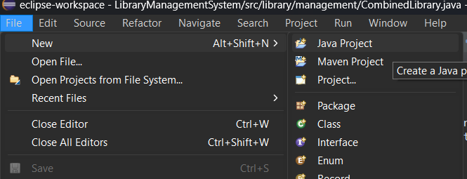

Alternatively, you can right-click in the Project Explorer pane and select New > Java Project.

3-Enter the **Project Name**.

4-Specify the **Location** if you want to use a custom directory for the project. By default, Eclipse will use its workspace directory.

5-Click **Next** to configure the project structure. You can modify the default source and output folders if needed.

6-Click **Finish** to create the project.

Organizing Project Files and Directories

1. **Project Root Directory**:

Contains project-specific configuration files, such as .project, .classpath

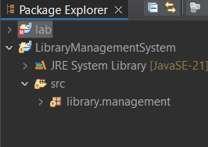

May also contain a README.md file and other project-level documentation.

1. **src Folder**:

The src folder is typically used for storing all your Java source files. By default, Eclipse creates this folder for you.

Inside the src folder, you can organize packages according to your project’s needs. For example, com.example.projectname.

1. **bin Folder**:
   * The bin folder contains the compiled .class files. Eclipse automatically manages this folder based on your build path configuration.
2. **lib Folder**:
   * If your project depends on external libraries, you can create a lib folder to store JAR files.
   * Right-click on the project, select **Build Path** > **Configure Build Path**, then add the JAR files from the lib folder to the project’s build path.
3. **resources Folder**:
   * For non-Java files, such as configuration files, images, and other resources, you can create a resources folder.
   * Organize subfolders inside resources as needed, e.g., resources/config, resources/images.
4. **test Folder**:
   * If you are writing unit tests, create a separate test folder to house your test classes.
   * Similar to the src folder, you can organize test packages appropriately, e.g., com.example.projectname.tests.

### 2. What features or tools provided by IDEs do you find most beneficial for your development workflow?

In Eclipse IDE, several features and tools are particularly beneficial for enhancing the development workflow. Here are some of the most valuable ones:

**Code Completion and IntelliSense**

* **Content Assist**: Eclipse provides powerful code completion that suggests methods, variables, and classes as you type, significantly speeding up coding.
* **Parameter Hints**: While typing method calls, Eclipse shows parameter hints, helping to understand the required arguments without leaving the editor.

**Debugging Tools**

* **Breakpoint Management**: Easily set breakpoints to pause execution and inspect the state of the program.
* **Variable Inspection**: View variable values, expressions, and object states in the Variables view.
* **Step Execution**: Step into, over, and out of methods to precisely control the execution flow.

**Integrated Build Tools**

* **Maven and Gradle Integration**: Built-in support for popular build tools like Maven and Gradle. Eclipse can automatically handle dependencies and build configurations.
* **Build Automation**: Automatically compile and build projects on saving changes, providing instant feedback on code modifications.

**Source Code Management**

* **Git Integration**: Built-in Git support for version control. You can clone repositories, commit changes, create branches, and manage merges directly from the IDE.
* **History and Compare**: View the history of file changes and compare different versions to track modifications over time.

**Refactoring Tools**

* **Rename Refactoring**: Rename classes, methods, variables, and other elements with automatic updates across the entire codebase.
* **Extract Method/Variable**: Simplify code by extracting code segments into new methods or variables.
* **Inline Method/Variable**: Replace method or variable calls with their actual content to simplify code.

**Code Navigation**

* **Quick Outline**: Quickly navigate through the outline of a class using a keyboard shortcut.
* **Open Type/Resource**: Quickly open any type (class/interface) or resource file by typing its name.
* **Call Hierarchy**: Analyze and navigate through the method call hierarchy to understand dependencies and usage.

**Syntax Highlighting and Formatting**

* **Syntax Highlighting**: Enhanced readability with color-coded syntax highlighting for various languages and file types.
* **Code Formatter**: Automatically format code to adhere to coding standards and improve readability.

**Code Analysis and Linting**

* **Static Code Analysis**: Identify potential issues in the code through static analysis tools integrated into Eclipse.
* **Error/Warning Indicators**: Visual indicators in the editor to highlight errors, warnings, and suggestions, often with quick fixes.

**Project Management**

* **Workspace Organization**: Manage multiple projects within a single workspace, with options to group and categorize projects.
* **Project Wizards**: Simplified project setup through various wizards for different types of projects and configurations.

### 3. Describe any specific IDE debugging features you find helpful.

When developing applications, Integrated Development Environments (IDEs) offer a range of debugging features that significantly enhance the efficiency and effectiveness of identifying and fixing bugs. Here are some of the most helpful debugging features found in popular IDEs like Eclipse:

1. **Breakpoints:**

* + **Description:** Breakpoints allow you to pause the execution of your program at specific lines of code.
  + **Usage:** Set a breakpoint by clicking in the margin next to the line number. The program will stop before executing this line, allowing you to inspect the current state.
  + **Benefits:** Helps to isolate and examine the execution flow and the state of variables at critical points in the program.

1. **Step Over, Step Into, and Step Out:**

* + **Step Over:** Executes the current line of code and moves to the next line, without diving into any function calls.
  + **Step Into:** Moves into the function call to debug line-by-line inside the function.
  + **Step Out:** Completes the current function and returns to the calling function.
  + **Benefits:** Provides granular control over the execution, allowing detailed inspection of how the program behaves at each step.

1. **Watch Variables:**

* + **Description:** Allows you to monitor the values of variables as the program executes.
  + **Usage:** Add variables to the watch list to see their current values and track how they change over time.
  + **Benefits:** Essential for tracking the state of important variables and understanding how data changes throughout the execution.

1. **Conditional Breakpoints:**
   * **Description:** Breakpoints that only pause execution when a specified condition is met.
   * **Usage:** Set conditions such as variable values or expressions that must be true for the breakpoint to trigger.
   * **Benefits:** Reduces the noise of pausing execution unnecessarily, focusing only on relevant scenarios.
   * 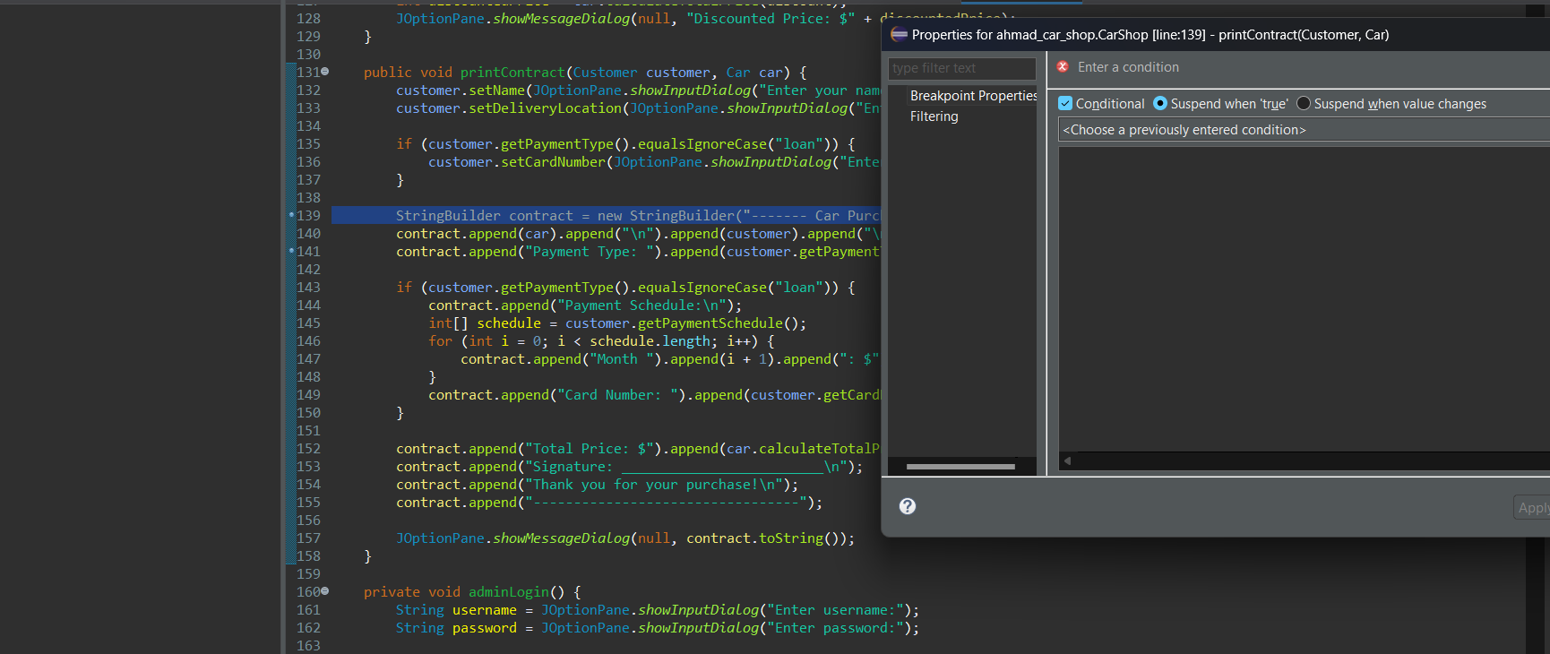
2. **Evaluate Expressions:** **A screenshot of a computer

   Description automatically generated**
   * **Description:** Allows you to evaluate expressions or run snippets of code during a debugging session.
   * **Usage:** Use the evaluate feature to execute code fragments and see their results without modifying the program.
   * **Benefits:** Helps in understanding complex expressions and testing fixes in real-time.
3. **Call Stack Inspection:**
   * **Description:** Displays the call stack, showing the sequence of function calls that led to the current execution point.
   * **Usage:** View the call stack to trace the program's execution path and understand how it arrived at the current state.
   * **Benefits:** Useful for diagnosing issues related to function calls, recursion, and stack overflow errors.
4. **Logging and Console Output:**
   * **Description:** Provides a console to display log messages and output from the program.
   * **Usage:** Use System.out.println in Java (or similar in other languages) to print debug information to the console.
   * **Benefits:** Quick and simple way to gain insights into the program’s execution without needing to set breakpoints.
5. **Exception Breakpoints:**
   * **Description:** Automatically pause execution when an exception is thrown.
   * **Usage:** Set exception breakpoints for specific types of exceptions or all exceptions.
   * **Benefits:** Helps to catch and diagnose exceptions at the point they occur, making it easier to understand and fix the root cause.
6. **Memory and CPU Profiling:**
   * **Description:** Tools integrated into the IDE to profile memory usage and CPU performance.
   * **Usage:** Use profiling tools to monitor resource usage and identify bottlenecks or memory leaks.
   * **Benefits:** Enhances the performance optimization process by providing detailed insights into resource consumption.

**Example in Eclipse IDE**

Here’s an example of how to use some of these debugging features in Eclipse IDE:

1. **Setting a Breakpoint:**
   * Click in the margin next to the line number where you want to pause the execution.
   * A blue dot appears, indicating a breakpoint is set.
2. **Running the Debugger:**
   * Click on the Debug icon or use the shortcut (F11) to start debugging.
   * The program will run and pause at the first breakpoint.
3. **Inspecting Variables:**
   * Hover over a variable to see its current value.
   * Add variables to the Variables view for continuous monitoring.
4. **Stepping Through Code:**
   * Use the Step Over (F6), Step Into (F5), and Step Out (F7) buttons to navigate through the code.
5. **Using the Expressions View:**
   * Open the Expressions view and add expressions to evaluate their values during execution.
6. **Checking the Call Stack:**
   * View the call stack in the Debug perspective to understand the sequence of method calls.
7. **Handling Exceptions:**
   * Configure Exception Breakpoints to pause execution when exceptions occur, allowing you to diagnose the issue immediately.

### 4. Compare the overall development experience, including speed, efficiency, and ease of use, between using an IDE and not using one.

**Development Speed**

**Using an IDE:**

* **Enhanced Tools:** IDEs come with built-in tools for writing, testing, and debugging code, which streamline the development process.
* **Autocomplete and Intellisense:** Features like code autocomplete, syntax highlighting, and real-time error detection significantly speed up coding by reducing manual errors and providing quick access to documentation.
* **Integrated Version Control:** IDEs often integrate with version control systems (e.g., Git), making it faster to manage code versions, branches, and collaboration efforts.
* **Template and Snippet Libraries:** Access to templates and reusable code snippets reduces the time needed to write boilerplate code.

**Not Using an IDE:**

* **Manual Management:** Developers must manually manage compilation, testing, and debugging processes, which can be time-consuming.
* **Increased Risk of Errors:** Without real-time error detection and autocomplete, developers may spend more time debugging syntax and logical errors.
* **Separate Tools:** Using separate tools for editing, version control, and debugging can slow down the workflow.

**Development Efficiency**

**Using an IDE:**

* **Unified Environment:** IDEs provide a single, cohesive environment where all development activities (coding, debugging, testing, deployment) can be performed.
* **Efficient Debugging:** Advanced debugging tools like breakpoints, watch variables, and call stack inspection streamline the process of finding and fixing bugs.
* **Performance Profiling:** Built-in profiling tools help optimize code by identifying performance bottlenecks and memory leaks.
* **Refactoring Tools:** Automated refactoring tools improve code quality and maintainability without manual intervention.

**Not Using an IDE:**

* **Disjointed Workflow:** Developers need to switch between different tools for various tasks, which can disrupt the workflow and reduce overall efficiency.
* **Manual Debugging:** Debugging without IDE support is less efficient, often relying on print statements and manual inspection.
* **Limited Profiling:** Performance optimization requires separate profiling tools, adding complexity to the process.

**Ease of Use**

**Using an IDE:**

* **User-Friendly Interface:** IDEs offer intuitive interfaces with drag-and-drop functionality, menus, and wizards that make complex tasks simpler.
* **Customizable Environment:** Developers can customize IDEs with plugins and extensions to tailor the environment to their specific needs.
* **Learning Resources:** Many IDEs come with extensive documentation, tutorials, and community support, making it easier for beginners to get started.
* **Code Navigation:** Features like code navigation, class hierarchies, and search tools make it easier to understand and manage large codebases.

**Not Using an IDE:**

* **Steeper Learning Curve:** Beginners may find it challenging to set up and use separate tools for different development tasks.
* **Manual Setup:** Configuring the development environment manually (e.g., setting up compilers, build tools, and debuggers) requires more technical knowledge.
* **Less Intuitive:** Without a unified interface, managing project files, dependencies, and configurations can be more cumbersome.

**Overall Development Experience**

1. **Speed:**
   * **IDEs**: Faster development due to integrated tools, real-time error checking, and efficient code management.
   * **No IDE**: Slower development due to manual processes and the need to switch between multiple tools.
2. **Efficiency:**
   * **IDEs**: Higher efficiency with features that streamline coding, debugging, and testing processes.
   * **No IDE**: Lower efficiency due to fragmented workflows and manual management of development tasks.
3. **Ease of Use:**
   * **IDEs**: More user-friendly with a cohesive interface, customization options, and extensive support resources.
   * **No IDE**: Less intuitive, requiring more technical setup and knowledge, especially for beginners.

**Conclusion**

Using an IDE greatly enhances the overall development experience by providing an integrated, efficient, and user-friendly environment. It significantly speeds up the development process, improves efficiency, and makes complex tasks more manageable. On the other hand, not using an IDE can lead to a slower, less efficient workflow, requiring more manual effort and technical expertise. For most modern development projects, especially those involving large codebases and team collaboration, an IDE is the preferred choice.

# Part4:

### 1. Discuss the error types and how each error affects the overall application.

**Syntax Errors: These errors occur when the code does not conform to the syntax rules of the programming language. They are detected by the compiler, which provides specific error messages indicating the line and nature of the error. Common syntax errors include misspelled variable and method names, missing semicolons, and mismatched parentheses or braces. Syntax errors prevent the application from compiling, meaning the program will not run until all syntax errors are resolved. This makes syntax errors the easiest to detect and fix because the compiler provides immediate feedback.**

**Impact:** Syntax errors prevent the code from being compiled successfully. The compiler will provide error messages indicating the location and nature of the error, making it relatively straightforward to correct. Without fixing these errors, the code cannot run at all.

**Run-time Errors: These errors occur while the program is running and are not detected during the compilation stage. They can cause the program to crash or behave unexpectedly. Common run-time errors include division by zero, accessing an array element out of bounds, and attempting to open a non-existent file. Run-time errors disrupt the normal flow of the program and require exception-handling mechanisms, such as try/catch blocks, to manage them gracefully. Examples include:**

* **ArithmeticException: Occurs when an illegal arithmetic operation, like division by zero, is performed.**
* **NullPointerException: Happens when trying to access a method or variable on an object that is null.**
* **ArrayIndexOutOfBoundsException: Occurs when accessing an array with an illegal index.**
* **FileNotFoundException: Raised when an attempt to open a file that does not exist is made.**

**Impact:** Run-time errors can cause the program to crash or produce incorrect results. They are often more challenging to detect and resolve compared to syntax errors. Proper error handling, such as try-catch blocks, can mitigate the impact by allowing the program to handle exceptions gracefully.

**Logic Errors: These errors occur when the code compiles and runs but produces incorrect results due to flaws in the program's logic. They are often the hardest to detect because they do not generate error messages. Instead, they result in incorrect outputs or behaviors. Logic errors require careful debugging to identify and fix. Examples include incorrect calculations, flawed condition checks, and improper use of algorithms. They affect the overall application by leading to incorrect outputs, which can undermine the program's reliability and accuracy.**

**Examples:**

* Incorrectly implemented algorithms.
* Miscalculations in formulas.
* Flawed control flow logic.

**Impact:** Logic errors can be the most difficult to identify and fix because the program runs without crashing, but the results are not as expected. Debugging tools and techniques, such as print statements and step-by-step execution, are crucial for tracing the source of logic errors.

### 2. Walk through the general steps involved in the debugging process when you encounter a bug in your code.

**1. Identify the Bug**

* **Observe the Symptoms:** Note what the program is doing versus what it is expected to do. Collect any error messages or unexpected behavior.
* **Reproduce the Issue:** Ensure that you can consistently reproduce the bug. This makes it easier to trace and fix.

**2. Understand the Context**

* **Review the Requirements:** Ensure that you understand what the code is supposed to do.
* **Check Recent Changes:** If the bug appeared after a recent change, reviewing those changes can provide clues.

**3. Gather Information**

* **Read Error Messages:** Compiler or runtime error messages often provide useful information about the location and nature of the error.
* **Use Logging:** Insert log statements in your code to print variable values and checkpoints.
* **Examine the Stack Trace:** For runtime errors, the stack trace can show the sequence of method calls leading up to the error.

**4. Isolate the Source of the Bug**

* **Simplify the Code:** Reduce the problem to the smallest piece of code that still exhibits the bug.
* **Divide and Conquer:** Comment out or remove half of the code to see if the bug persists, then gradually add parts back to pinpoint the issue.
* **Check Related Code:** Sometimes the bug is not where the symptoms appear but in related code or earlier in the execution flow.

**5. Use Debugging Tools**

* **Breakpoints:** Set breakpoints in your code where you suspect the bug might be occurring. This will allow you to pause execution and inspect the state of the program.
* **Step Through the Code:** Use a debugger to step through the code line by line and monitor variable values and program flow.
* **Watch Expressions:** Monitor specific variables or expressions to see how their values change during execution.

**6. Analyze and Hypothesize**

* **Form a Hypothesis:** Based on the information gathered, hypothesize what might be causing the bug.
* **Verify the Hypothesis:** Test your hypothesis by modifying the code and observing the results.

**7. Fix the Bug**

* **Apply the Fix:** Make the necessary code changes to fix the bug.
* **Run Tests:** Execute your test cases, including those that previously failed due to the bug. Also, run regression tests to ensure that the fix did not introduce new bugs.

**8. Review and Refactor**

* **Code Review:** Have another developer review your fix to catch any potential issues or suggest improvements.
* **Refactor if Needed:** Clean up any code that may have contributed to the bug, improving readability and maintainability.

**9. Document the Fix**

* **Update Documentation:** Document the bug and the fix in your issue tracker or project documentation.
* **Comment the Code:** Add comments to your code to explain the changes made and why.

### 3. Explain the role of breakpoints in debugging and how they help in identifying and resolving issues in code.

Breakpoints are a fundamental tool in debugging that allows developers to pause the execution of a program at specific lines of code. Their role and utility include:

* **Pause Execution**: Breakpoints halt the program at a specified line, enabling developers to examine the current state of the program, including variable values and the call stack. This pause allows for a detailed inspection of the program's state at a critical point.
* **Step Through Code**: Once a breakpoint is hit, developers can step through the code line by line (using commands like F5 to step into functions, F6 to step over lines, and F7 to step out of functions). This helps observe how the code executes and how the state changes at each step.
* **Inspect Variables**: At a breakpoint, developers can inspect the values of variables and objects to ensure they hold the expected data. This helps in identifying discrepancies and understanding the flow of data.
* **Evaluate Expressions**: Developers can evaluate expressions and run small code snippets in the context of the paused program to test hypotheses about what might be going wrong.
* **Example from my code** :

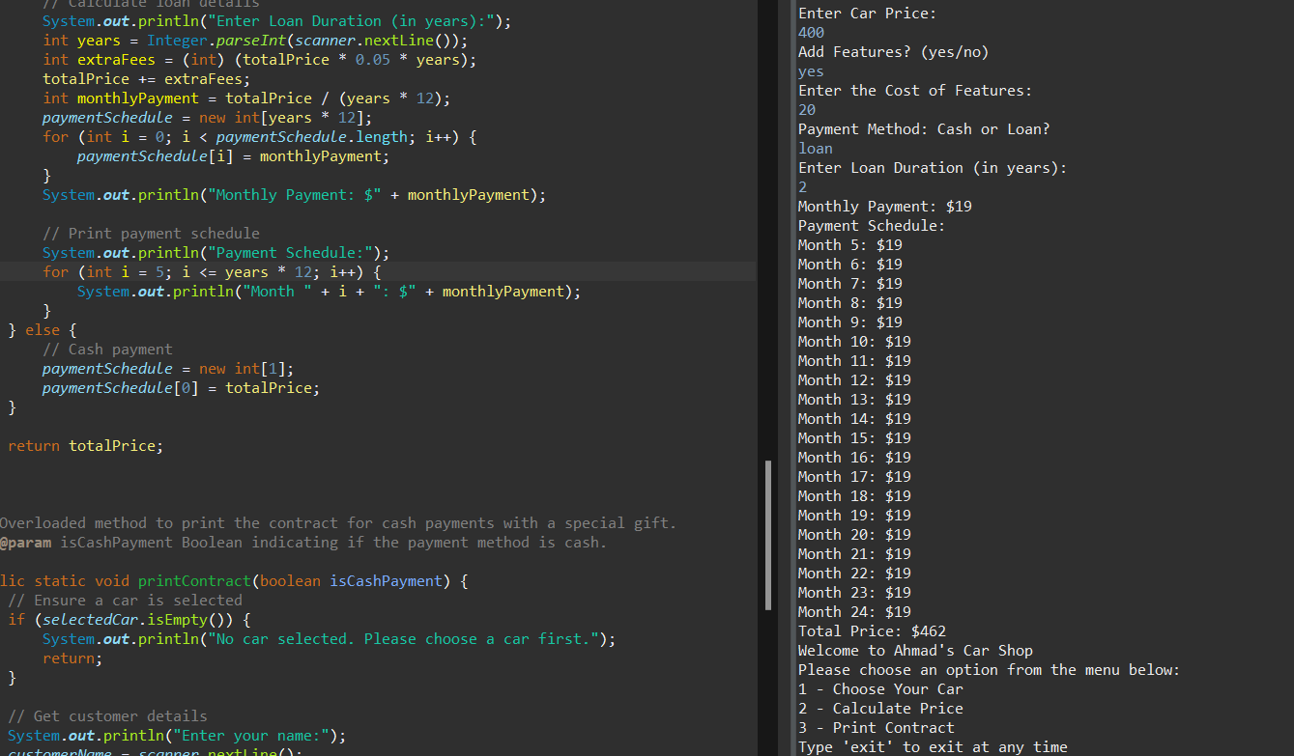

The months are stating from 5 so lets see were is the problem

-first we indentfy the scope , it’s a problem in the clalculating of the price , so its in the calculateprice method :

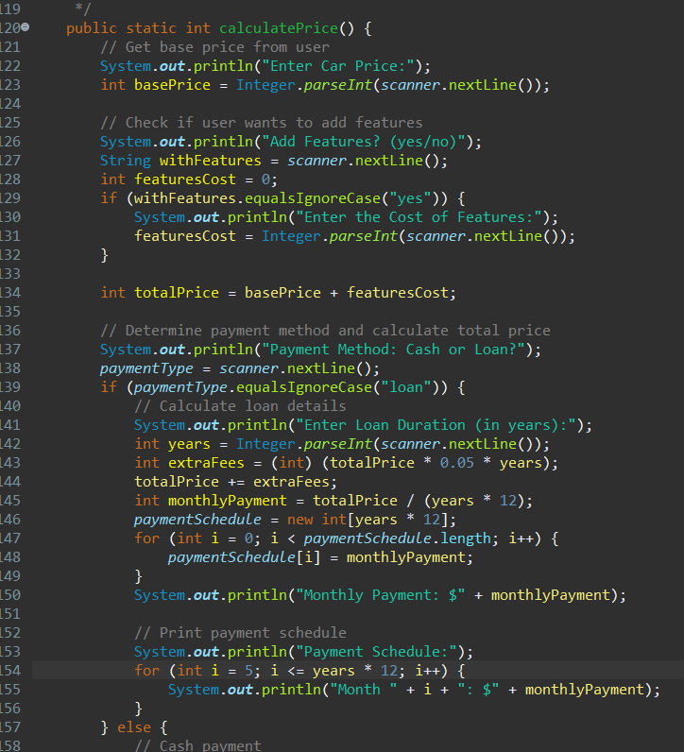

My breakpoint and debug interface:

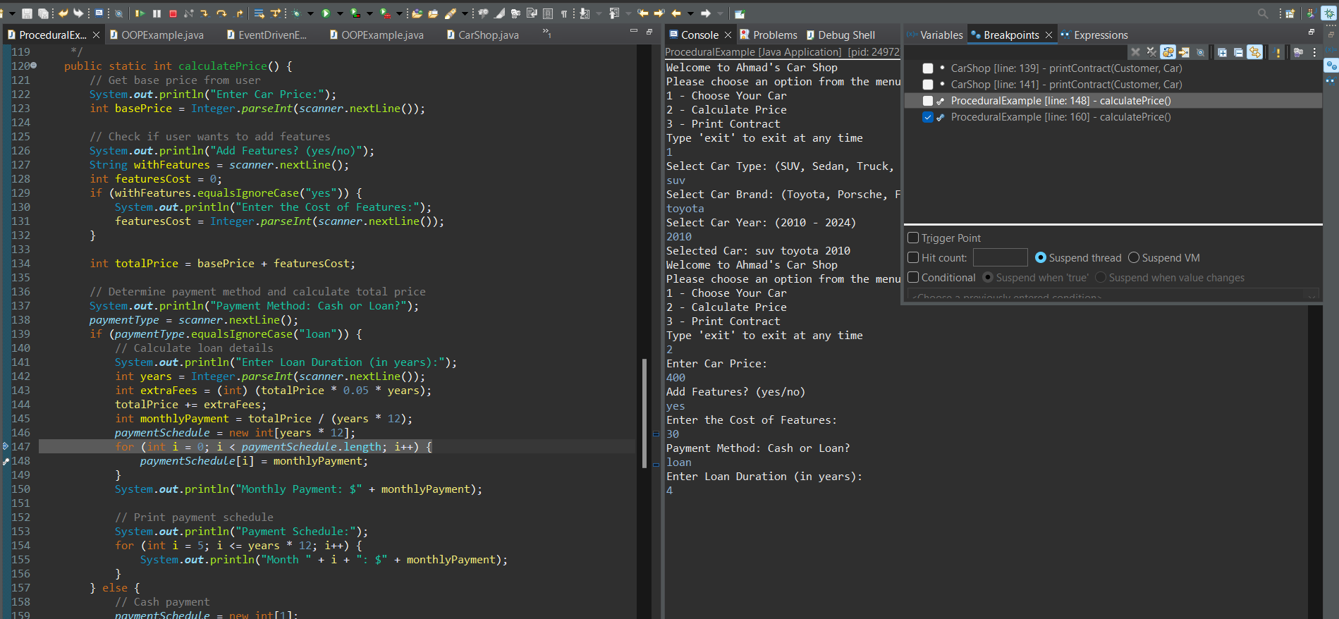

I found the problem in the line 154 , from the variable the I starts from 5 , so I changed it to 1 and it works

### 4. How does the debugging process contribute to the development of secure applications? Can you provide examples of security vulnerabilities that debugging helps identify and address?

The debugging process is crucial in developing secure applications as it helps identify and fix security vulnerabilities that could be exploited by attackers. Here are several ways debugging contributes to security:

* **Buffer Overflows**: Debugging helps in identifying scenarios where the application writes more data to a buffer than it can hold. This can prevent potential buffer overflow attacks, which can lead to arbitrary code execution.
* **Unhandled Exceptions**: Proper debugging ensures that all exceptions are handled appropriately, preventing the application from crashing or revealing sensitive information through error messages. For instance, catching and properly handling NullPointerException or ArrayIndexOutOfBoundsException prevents crashes and potential exploitation.
* **SQL Injection**: Debugging can uncover vulnerabilities related to SQL injection by inspecting how input data is handled and ensuring that all user inputs are properly sanitized and parameterized queries are used.
* **Cross-Site Scripting (XSS)**: By carefully debugging the handling of user inputs and outputs, developers can ensure that scripts are not inadvertently executed in the browser, preventing XSS attacks.
* **Authentication and Authorization Flaws**: Debugging the authentication flow can help identify logic errors that might allow unauthorized access to resources.

A real-life example I found interesting, a hacker used to help people with their lost Bitcoin wallets, usually they forgot the password so the hacker ran a brute-force attack on the wallet password but in this case, the user used a password generator app so the possibilities are infinite, the hacker found a bug in the algorithm of the app which was generating password depending on the time, so when you edit the time of the OS you can go back to generate the same password, in other words, they really hacked time.

I recommended watching the video , it is in the resources

### 5. Reflect on any experiences where the debugging process played a crucial role in uncovering security weaknesses or vulnerabilities in your applications. How did you address these issues?

In the Car Shop program, debugging played a crucial role in uncovering and addressing several potential security weaknesses and coding issues. Here are examples of some issues that were identified and fixed during the debugging process, with explanations on how they could have affected the application.

1-Admin Password Handling:

Flaw: The admin password is hard-coded and checked in plaintext.

Improvement: Use private class and varilable for the passswrod

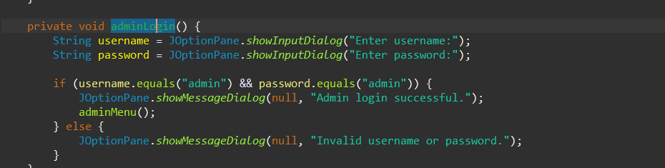

**2-Input Validation:**

* **Flaw:** Lack of input validation can lead to issues like SQL injection, invalid input, or crashing the program.
* **Improvement:** Validate and sanitize all user inputs
* 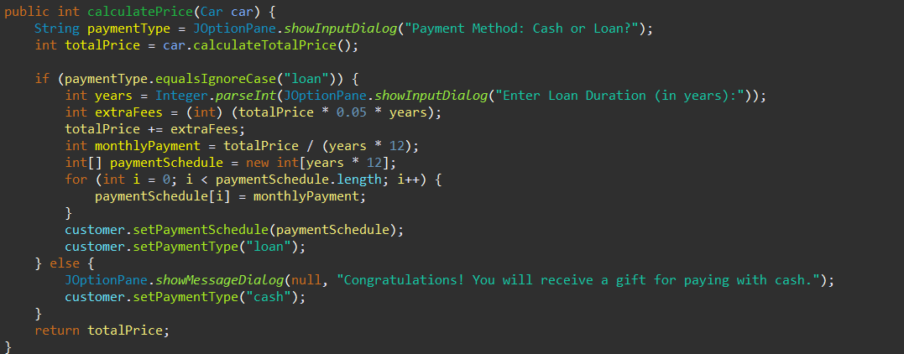

**3-Sensitive Data Exposure:**

* **Flaw:** Displaying the card number in plaintext.
* **Improvement:** Mask sensitive information and store it securely

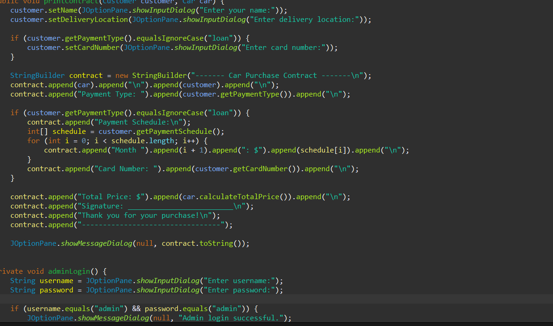

# Part5:

### 1. What coding standards do you follow when writing code.

**1. Naming Conventions**

* **Classes and Interfaces**: Use PascalCase (e.g., CarInventory, ProceduralLogic).

* **Methods and Variables**: Use camelCase (e.g., calculateTotalPrice, carList).
* **Constants**: Use UPPER_SNAKE_CASE (e.g., MAX_CAR_COUNT).

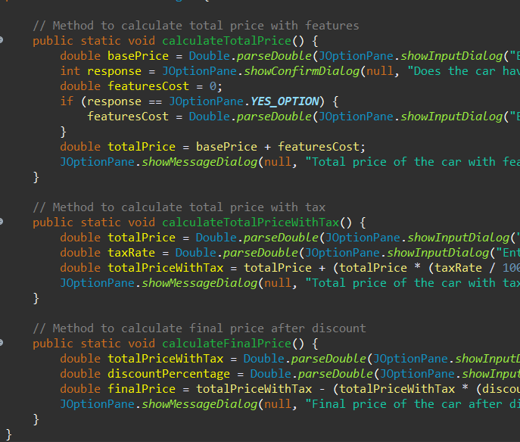

**2. Indentation and Spacing**

* **Indentation**: Use 4 spaces per indentation level (avoid tabs).
* **Braces**: Open brace { on the same line as the control statement or method declaration, and closing brace } on a new line.
* **Spacing**: Use a single space between keywords and parentheses (e.g., if (condition)), and between operators (e.g., a + b).

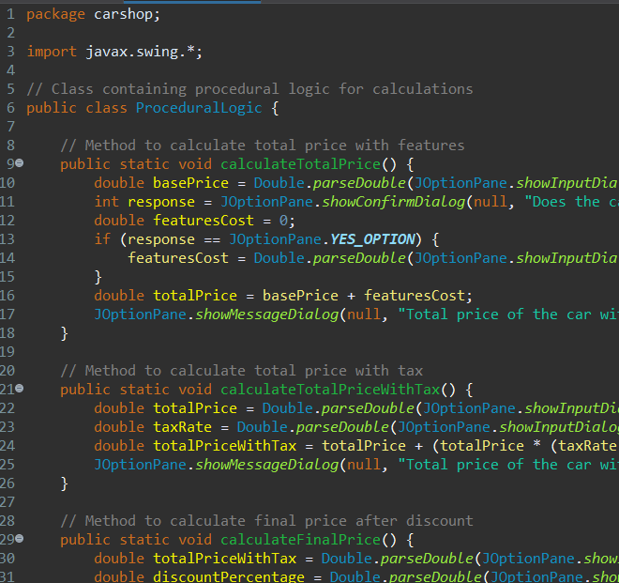

**3. Comments and Documentation**

* **Block Comments**: Use block comments (/* ... */) to describe larger code blocks or provide detailed explanations.
* **Line Comments**: Use single-line comments (//) to explain individual lines of code or small sections.
* **Documentation Comments**: Use Javadoc comments (/** ... */) for public classes, methods, and fields.

**4. Code Structure**

* **File Organization**: Place each class in its own file, and the file name should match the class name.
* **Order of Members**: Organize class members in the following order: static fields, instance fields, constructors, methods.
* **Method Length**: Keep methods short and focused on a single task. If a method is too long, consider breaking it into smaller helper methods.

**5. Error Handling**

* **Exceptions**: Use exceptions for error handling, and avoid using them for normal control flow.
* **Specific Exceptions**: Catch specific exceptions rather than generic ones to provide more precise error handling.

**6. Consistent Use of Access Modifiers**

* **Encapsulation**: Use private fields with public getter and setter methods to encapsulate data.
* **Access Levels**: Use the appropriate access level (private, protected, public) to restrict access to class members.

**7. Avoid Magic Numbers**

* **Constants**: Replace magic numbers with named constants to improve code readability and maintainability.

**8. Use of Annotations**

* **@Override**: Use the @Override annotation when overriding methods from a superclass. This helps catch errors at compile time and improves code readability by clearly indicating the programmer's intent.

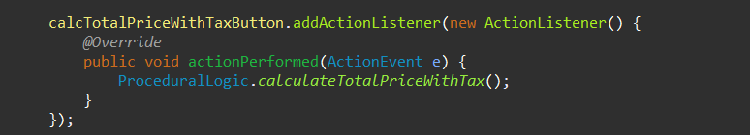

**9. Code Reviews**

* **Peer Review**: Have code reviewed by peers to catch potential issues, improve code quality, and share knowledge.

### 2. Describe any specific naming conventions prescribed by the coding standard you follow. How do these conventions help improve code readability and maintainability.

**Naming Conventions Prescribed by the Coding Standard**

**1. Classes and Interfaces**

* **Convention**: Use PascalCase (e.g., CarInventory, VehicleManager).
* **Example**: public class CarInventory { ... }
* 
* **Rationale**: Using PascalCase for classes and interfaces helps easily distinguish these elements from methods and variables. This convention improves readability by providing a clear visual cue about the purpose and usage of the element.

**2. Methods**

* **Convention**: Use camelCase (e.g., calculateTotalPrice, getCarDetails).
* **Example**: public void calculateTotalPrice() { ... }



* **Rationale**: Methods perform actions, and using camelCase makes them easily recognizable as functions or procedures. This helps developers quickly identify behavior-defining elements within the code.

**3. Variables**

* **Convention**: Use camelCase (e.g., carList, totalPrice).
* **Example**: double totalPrice = 0.0;



* **Rationale**: Similar to methods, variables using camelCase maintain consistency and help differentiate them from classes and constants. This enhances readability and reduces confusion.

**4. Constants**

* **Convention**: Use UPPER_SNAKE_CASE (e.g., MAX_CAR_COUNT, DEFAULT_TAX_RATE).
* **Example**: public static final int MAX_CAR_COUNT = 100;
* **Rationale**: Constants represent fixed values, and using uppercase letters with underscores makes them stand out. This distinction helps prevent accidental modification of these values and clarifies their purpose.

**5. Packages**

* **Convention**: Use lowercase with periods (e.g., com.carshop.inventory, org.util.math).
* **Example**: package com.carshop.inventory;
* **Rationale**: Using lowercase letters and periods ensures consistency across different operating systems and avoids conflicts. It also provides a hierarchical structure that helps organize code logically.

**Importance of Naming Conventions**

1. **Improved Readability**
   * **Consistency**: Consistent naming conventions make it easier for developers to read and understand the code. They can quickly recognize the purpose of different elements based on their names.
   * **Clarity**: Descriptive and consistent names provide clear indications of what a class, method, or variable represents. This reduces the cognitive load on developers when navigating the codebase.
2. **Enhanced Maintainability**
   * **Ease of Updates**: Consistent naming conventions make it easier to update and refactor code. Developers can quickly locate and modify specific parts of the codebase without confusion.
   * **Team Collaboration**: When multiple developers work on the same codebase, following a standard naming convention ensures that everyone understands and adheres to the same rules. This reduces the risk of conflicts and improves collaboration.
   * **Documentation and Debugging**: Well-named elements serve as a form of self-documentation, reducing the need for extensive comments. During debugging, meaningful names help identify issues more efficiently.

example:

* Class names (CarInventory) use PascalCase.
* Method names (addCar, getCarDetails) and variable names (carList) use camelCase.
* Constants (MAX_CAR_COUNT) use UPPER_SNAKE_CASE.
* Package names (com.carshop.inventory) use lowercase with periods.

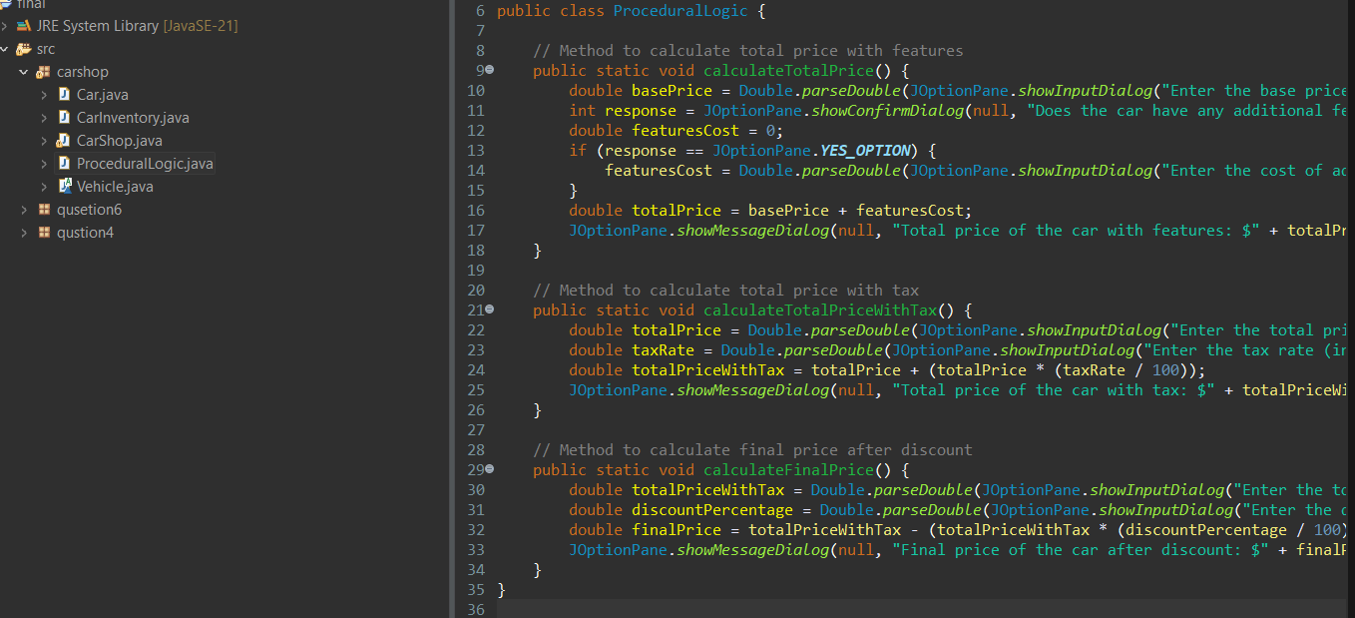

### 3. Why do you believe having a coding standard is important for a development team? What benefits does it offer in terms of collaboration, code quality, and project success

Having a coding standard is crucial for a development team due to the numerous benefits it offers in terms of collaboration, code quality, and project success. Here are some key reasons why coding standards are important:

**1. Improved Collaboration**

**Consistency**

* **Unified Approach**: Coding standards ensure that all team members write code in a consistent manner. This uniformity makes it easier for developers to understand and work with each other's code, regardless of who wrote it.
* **Ease of Onboarding**: New team members can quickly get up to speed with the project if the codebase follows consistent conventions. They can focus on understanding the business logic rather than deciphering different coding styles.

**Reduced Conflicts**

* **Code Integration**: When everyone follows the same standards, integrating code from different team members becomes smoother. This reduces merge conflicts and the time spent resolving them.
* **Clear Communication**: Coding standards act as a common language for the team, facilitating better communication and understanding among team members.

**2. Enhanced Code Quality**

**Readability**

* **Self-Documenting Code**: Consistent naming conventions, formatting, and comments make the code more readable and self-explanatory. This reduces the need for extensive documentation and helps developers quickly grasp the functionality of the code.
* **Easier Maintenance**: Readable code is easier to maintain and modify. Developers can quickly locate and fix bugs or implement new features without spending excessive time understanding the existing code.

**Reliability**

* **Error Prevention**: Adhering to coding standards can help prevent common programming errors. For instance, using consistent error handling practices ensures that exceptions are properly managed, reducing the likelihood of runtime errors.
* **Code Reviews**: Coding standards make code reviews more effective. Reviewers can focus on the logic and functionality of the code rather than pointing out style issues.

**3. Project Success**

**Efficiency**

* **Faster Development**: When developers don’t have to reinvent the wheel or figure out how to structure their code, they can focus on solving the actual problems. This leads to faster development cycles.
* **Automated Tools**: Consistent coding standards allow for the use of automated tools for code formatting, linting, and static analysis, which can save time and improve code quality.

**Scalability**

* **Team Growth**: As the team grows, maintaining a consistent coding standard ensures that the codebase remains manageable and scalable. New developers can seamlessly integrate into the team without causing disruptions.
* **Long-Term Maintenance**: Coding standards ensure that the code remains clean and maintainable in the long term. This is crucial for the sustainability of the project, especially as it evolves and grows in complexity.

**Specific Benefits**

**In Terms of Collaboration**

* **Smooth Handoffs**: Developers can easily take over each other's tasks if everyone follows the same standards, making it easier to cover for team members during absences.
* **Unified Codebase**: A unified codebase reduces the cognitive load on developers, making it easier to work on different parts of the project without confusion.

**In Terms of Code Quality**

* **Reduced Bugs**: Consistent practices, such as thorough commenting and using meaningful variable names, reduce the likelihood of introducing bugs.
* **Improved Testing**: Coding standards often include guidelines for writing testable code, which leads to more reliable and easier-to-test code.

**In Terms of Project Success**

* **Customer Satisfaction**: High-quality, reliable code leads to fewer bugs and issues, resulting in a better user experience and higher customer satisfaction.
* **Reusability**: Code that adheres to standards is often more modular and reusable, which can save time and resources on future projects.

# Resources:

https://help.eclipse.org/2023-12/index.jsp

<https://www.youtube.com/watch?v=o5IySpAkThg>

<https://www.checkpoint.com/cyber-hub/cloud-security/what-is-secure-coding/>

<https://docs.oracle.com/en/java/>