AHMAD MASOOD
#04072213041
AI (5TH)

Report: Heart Disease Prediction

1. Introduction
The task at hand is to build a binary classification model to predict whether a patient has heart disease based on their health data. The dataset contains features such as age, cholesterol level, resting blood pressure, heart rate, and others, with the target variable indicating the presence (1) or absence (0) of heart disease. The model was trained using a neural network and different batch sizes to explore the impact of batch size on model performance.

2. Methodology
We utilized a neural network model to solve this classification problem. The model was built with the following architecture:
- Input layer: Corresponding to the features in the dataset.

- Hidden layer: A fully connected layer with ReLU activation function and L2 regularization to avoid overfitting.

- Output layer: A sigmoid activation function for binary classification.

The model was trained with 500 epochs using different batch sizes (from 1 to 500) to assess the impact of batch size on training performance. Early stopping was employed to prevent overfitting by halting training when the validation loss stopped improving.

3. Model Training and Hyperparameters

- Optimizer: Adam with a learning rate of 0.01.
- Loss function: Binary Crossentropy, as we are solving a binary classification problem.
- Early Stopping: Used to stop training when validation loss stops decreasing for several epochs.

The training set was split from the dataset, and validation data was used to monitor the model’s performance during training.

4. Evaluation Metrics
After training the model with various batch sizes, the model’s performance was evaluated using the following metrics:
- Accuracy: The proportion of correctly classified instances.
- Precision: The proportion of true positives among all predicted positives.
- Recall: The proportion of true positives among all actual positives.
- F1Score: The harmonic mean of precision and recall, which provides a balanced measure of the model’s performance.
- Support: The number of occurrences of each class in the dataset.

5. Results
The following results were obtained after training the model with different batch sizes:

1. Batch Size = 32
- Accuracy: 90%
- Precision: 0.95 (class 0), 0.87 (class 1)
- Recall: 0.87 (class 0), 0.94 (class 1)
- F1Score: 0.91 (class 0), 0.90 (class 1)
The model showed slightly reduced precision for class 1 but maintained overall good performance.

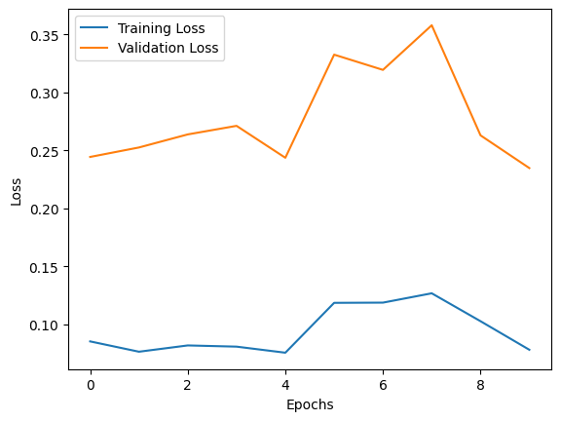

2. Batch Size = 36
- Accuracy: 90%
- Precision: 0.94 (class 0), 0.86 (class 1)
- Recall: 0.86 (class 0), 0.94 (class 1)
- F1Score: 0.90 (class 0), 0.90 (class 1)
Similar performance to batch size 32.

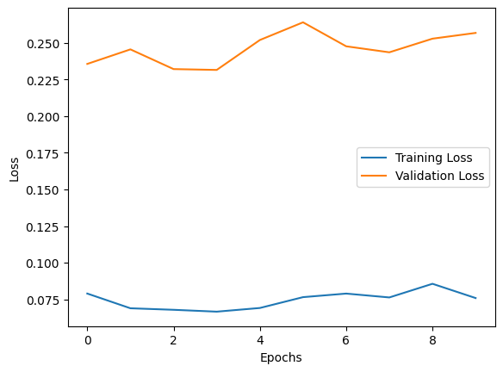

3. Batch Size = 38
- Accuracy: 90%
- Precision: 0.93 (class 0), 0.86 (class 1)
- Recall: 0.86 (class 0), 0.93 (class 1)
- F1Score: 0.90 (class 0), 0.90 (class 1)
No significant change from batch size 36.

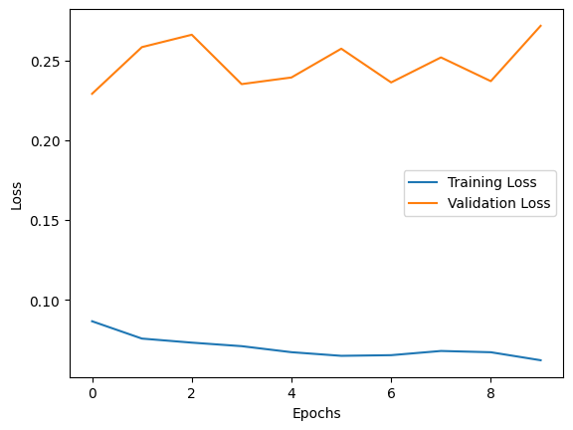

4. Batch Size = 400
- Accuracy: 91%
- Precision: 0.93 (class 0), 0.88 (class 1)
- Recall: 0.89 (class 0), 0.93 (class 1)
- F1Score: 0.91 (class 0), 0.91 (class 1)
Higher batch size led to a slight improvement in accuracy.

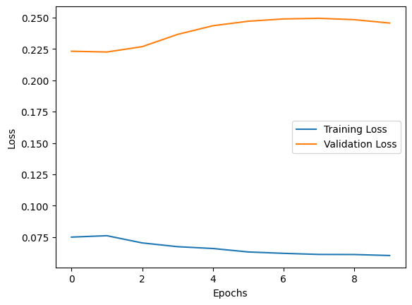

5. Batch Size = 500
- Accuracy: 90%
- Precision: 0.93 (class 0), 0.88 (class 1)
- Recall: 0.88 (class 0), 0.93 (class 1)
- F1Score: 0.91 (class 0), 0.90 (class 1)
The model performed similarly to batch size 400.

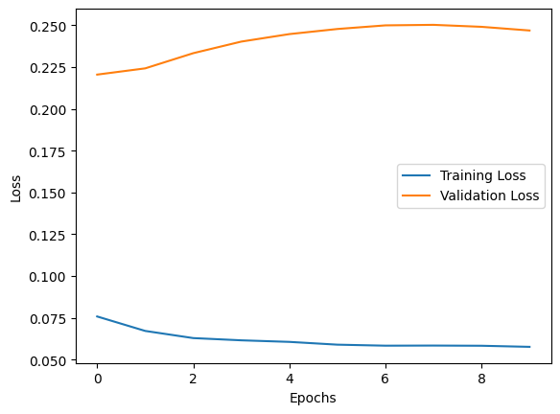

6. Batch Size = 1
- Accuracy: 83%
- Precision: 0.85 (class 0), 0.82 (class 1)
- Recall: 0.83 (class 0), 0.83 (class 1)
- F1Score: 0.84 (class 0), 0.82 (class 1)
Batch size of 1 led to the lowest accuracy, showing that smaller batches can affect the model’s ability to generalize.

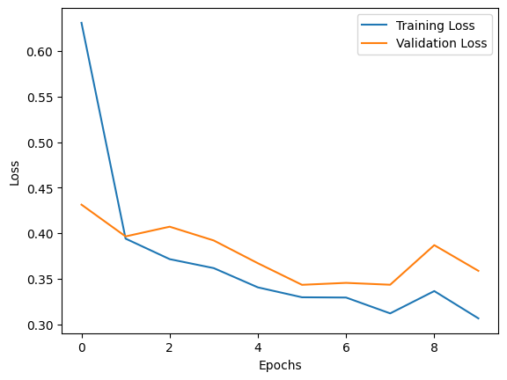

7. Batch Size = 250
- Accuracy: 84%
- Precision: 0.85 (class 0), 0.82 (class 1)
- Recall: 0.83 (class 0), 0.84 (class 1)
- F1Score: 0.84 (class 0), 0.83 (class 1)
Slightly better performance than batch size 1 but still not as good as larger batch sizes.

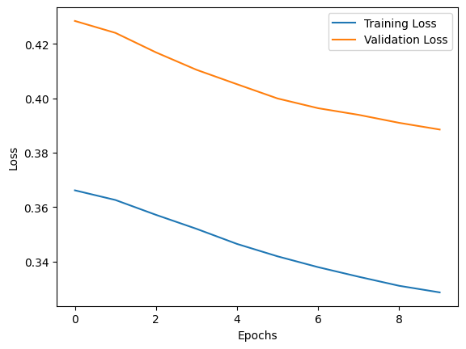

6. Early Stopping and Training Graph
The early stopping mechanism was employed to halt the training process when the validation loss stopped improving. The graph of training loss vs validation loss demonstrates that as the training progresses, both the training and validation losses decrease. However, after a certain number of iterations, the validation loss plateaus or increases, signaling the point where early stopping takes effect.

7. Conclusion
The neural network model achieved an accuracy ranging from 83% to 91% depending on the batch size. The optimal batch size for the best performance was 400, which resulted in an accuracy of 91% and balanced performance metrics. Smaller batch sizes, such as 1, resulted in poorer performance, while larger batches led to stable, efficient learning with better generalization. The early stopping mechanism proved effective in preventing overfitting by halting training once the model’s validation loss plateaued.The results demonstrate that while batch size can influence performance, choosing the right batch size (larger than 1 but not too large) is critical for effective training.

----------------------------------- THE END -----------------------------------

