
QUAID-I-AZAM UNIVESRSITY
DEPARTMENT OF COMPUTER SCIENCES
Natural Language Processing (CS-455) Spring 2026

Last Date: 16 March, 2026 11:59 pm Total Marks: 5x6
Assignment01: Basic Text Processing using Regex and Tokenization

Objective: This assignment will introduce you to basic text processing techniques, including regular expressions (regex), tokenization, and parsing. Follow the given examples and complete the tasks accordingly.

1. Regular Expressions (Regex) in Python

Example Task: Extracting Email Addresses

Example Code:

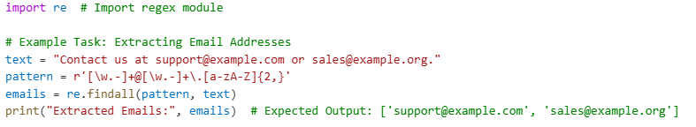

Task 1: Extract Hashtags
Instructions:
- Given a string containing hashtags, write a regex pattern to extract them.
- Expected output for input "#AI is the future! #MachineLearning #DataScience" should be ['#AI', '#MachineLearning', '#DataScience'].

Task 2: Extract Dates
Instructions:
- Write a regex pattern to extract dates in formats like DD-MM-YYYY, DD/MM/YYYY, YYYY-MM-DD.
- Expected output for input "Today's date is 12-03-2024 and another format is 2024/03/12." should be ['12-03-2024', '2024/03/12'].

2. Tokenization

Example Task: Unigram Tokenization

Example Code:
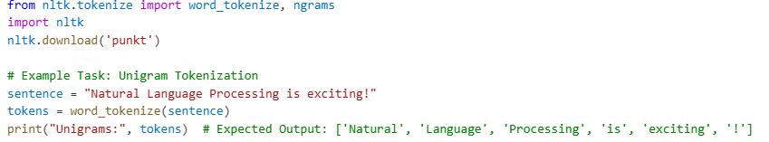

Task 3: Bigram Tokenization
Instructions:
- Tokenize a sentence into bigrams (pairs of words).
- Expected output for "Deep Learning is powerful." should be [('Deep', 'Learning'), ('Learning', 'is'), ('is', 'powerful'), ('powerful', '.')].

Task 4: Trigram Tokenization
Instructions:
- Tokenize a sentence into trigrams (sets of three consecutive words).
- Expected output for "Artificial Intelligence is evolving rapidly." should be [('Artificial', 'Intelligence', 'is'), ('Intelligence', 'is', 'evolving'), ('is', 'evolving', 'rapidly'), ('evolving', 'rapidly', '.')].

3. Parsing

Example Task: Simple Sentence Parsing

Example Code:

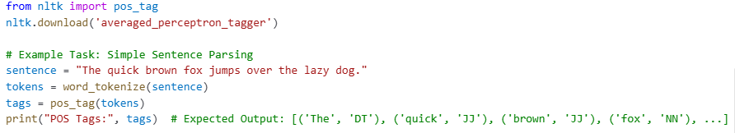

Task 5: POS Tagging
Instructions:
- Perform Part-of-Speech (POS) tagging on "AI is transforming the world."
- Expected output should include POS tags like ('AI', 'NN'), ('is', 'VBZ'), ('transforming', 'VBG').

Task 6: Named Entity Recognition (NER)
Instructions:
- Extract named entities from "Elon Musk founded SpaceX in 2002."
- Expected output should recognize Elon Musk as a PERSON and SpaceX as an ORGANIZATION.

Submission Instructions:
• Complete each task with Python code and explanations.
• Submit a Jupyter Notebook (.ipynb) on GCR.
• Demonstrate your code in the very next class after submission.
• Marks depend on code correctness and understanding.

Bonus Challenge:
Implement a function that extracts phone numbers from text in various formats (e.g., +1-234-567-8900, 123-456-7890, (123) 456-7890).

