Environmental adaptive rescue robots Ideas
Capstone Description As Listed On Website
In many rescue tasks, robots are required to have the capability to adapt to their changing terrain and environment. This can be realized, for example, through innovative robotic design, control and machine learning. In this project, students are required to formulate, design, implement and evaluate a rescue robot and demonstrate some environment- adaptive capabilities, such as crawling through rubble and climbing over a wall.

Questions we need to consider for our idea

What problem does this Robot Solve?
What is the “rescue” aspect of the robot?

Rescue Scenarios
Earthquake entrapment: A person pinned under collapsed concrete slabs in a building.
Floodwaters: Someone trapped in a car being swept downstream in a flash flood.
Avalanche burial: A skier buried 2 meters under snow with only minutes of air.
Wildfire encirclement: Hikers trapped by shifting firelines and smoke.
Cave entrapment: Explorers stuck in a narrow underwater passage during cave diving.
Mountain climbing: A climber stranded on a ledge with a broken leg, too high for self-descent.
Desert survival: Someone lost and dehydrated in a vast area with no water access.
Amber Alert?!

Collapsed building (structural failure): Workers trapped in rubble after a construction collapse.
Subway incident: Passengers stuck in a flooded underground train tunnel.
High-rise fire: Occupants trapped above the fireline with stairwells blocked.
Car accident: Passenger pinned in a wreck with fire risk.
Airplane crash: Survivors stranded in remote terrain needing extraction. ( get more specific then this )
Shipwreck: Passengers trapped below deck in a capsized vessel.
Stroke victim alone at home: Unable to move or call for help, requires rapid intervention. ( can have more situations)
School shooter aim bot:.

Avalanche ->

Tornado ->

Fire -> in what context

Drowning ->

Rescue Scenario Functionality
It could map an area out. Can map out areas that humans cannot see in as well.

Fitting in a wide variety.

It could drop something off. (health, survival supplies)

Ping coordinates, broadcast live location, shootout a flair.

) face detection/ Victim detections

It could pull something

Remove debris

Two-way communication – allow victims to talk to rescuers through speakers/microphones.
Environmental monitoring - snakes , air quality stuff thats important outside of mapping but essential to survival

Tools that it offers rescuers or victims ( robot turns into flash light)

1. Rubble-Crawling and Wall-Climbing Robot
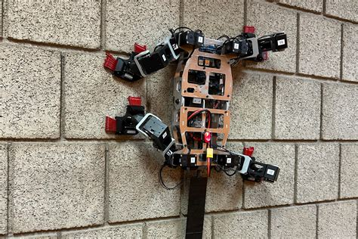
Concept: A tracked or legged robot that can switch modes depending on terrain:
-Tracks/wheels for flat ground.
-Extendable legs or arms for climbing over obstacles.
Adaptation: Uses sensors (IMU, camera, LiDAR/ultrasonic) to detect rubble or walls and dynamically change its locomotion strategy.

Example demo: Have it move across a classroom floor, then climb over stacked bricks or uneven blocks.

2. Snake-Like Search Robot
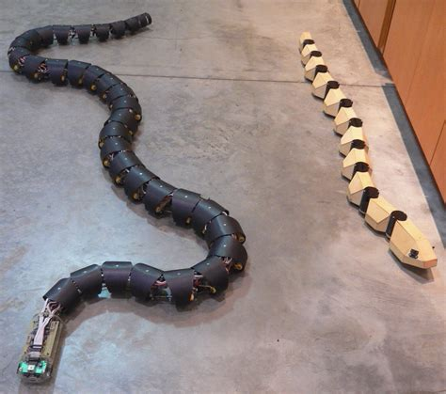
Concept: A modular, snake-inspired robot that can slither through narrow gaps in rubble.
Adaptation: Segments reconfigure based on space constraints:

-Stretch out for flat terrain.
-Coil and wriggle through holes.

Example demo: Make it navigate through pipes, tunnels, or a rubble pile model.

3. Quadruped Rescue Robot (Mini Spot-like)
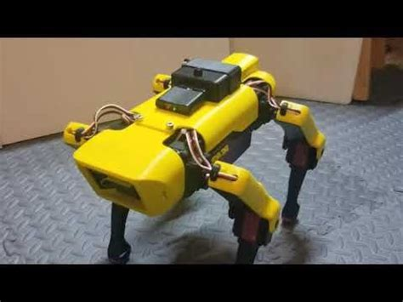

Concept: A four-legged robot that can walk on flat ground but also climb over small obstacles.

Adaptation: Gait changes (trot, crawl, bound) based on terrain slope or detected instability.

Example demo: Navigate from a smooth surface to a tilted platform or step onto bricks.

4. Transforming Wheel-to-Leg Robot
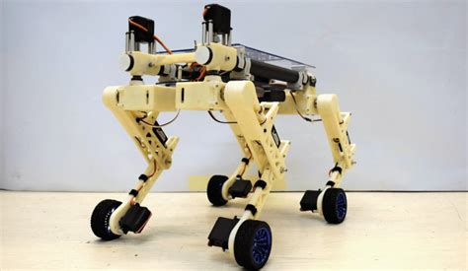

Concept: Wheels for speed on flat surfaces → convert to legs for climbing/rough terrain.

Adaptation: Automatic detection of terrain roughness to trigger transformation.

Example demo: Drive across the floor, hit rubble → transform and climb.

5. Wall-Climbing Robot
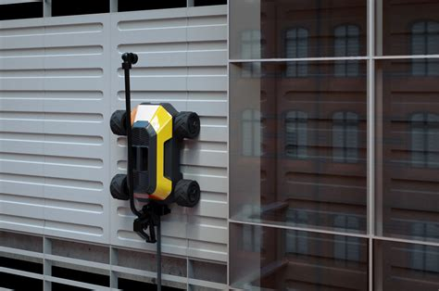

Concept: Robot with suction cups, gecko-inspired adhesive pads, or magnetic feet.

Adaptation: Switches between normal wheeled movement and vertical climbing.

Example demo: Show it driving across a flat surface then climbing up a vertical board.

6. Amphibious Rescue Robot
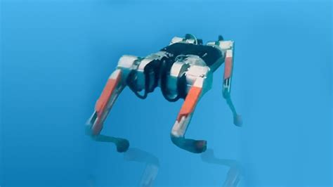

Concept: Moves on land and can also float/swim in water.

Adaptation: Uses paddle wheels, propellers, or buoyant design to change modes.

Example demo: Cross a table surface, then transition into a water tank.

7. Self-Stabilizing Robot
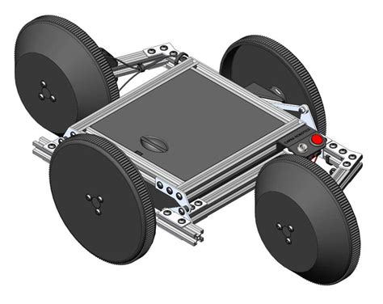

Concept: A robot that can flip itself upright if overturned in rubble.

Adaptation: Detects its orientation and executes a recovery maneuver.

Example demo: Push it over, and it automatically rights itself.

Possible Ideas

