

|  |  |
| --- | --- |
| **Name** | **Ahmad Mujtaba** |
| **ID** | **191203** |
| **Department** | **Computer Engineering** |
| **Section** | **7-A** |
| **Course** | **Software Engineering** |
| **To** | **Mam Hafsa** |

**Assignment # 2:** **Yahoo Selenium Testing**

**Code:**

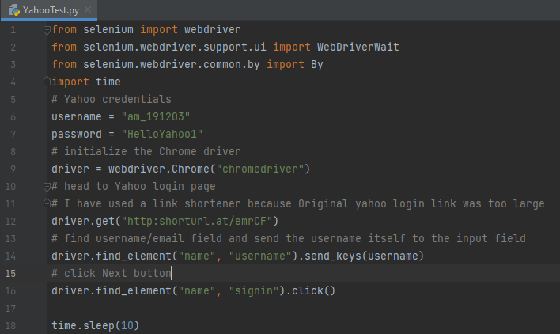

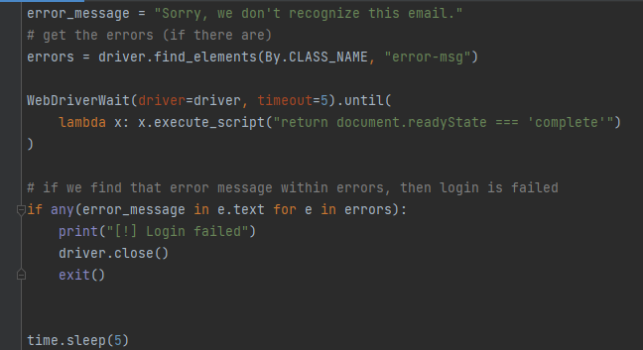

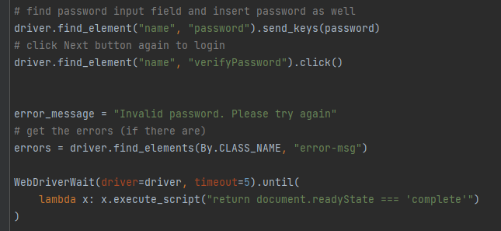

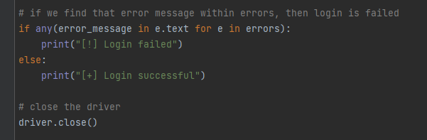

**All Result cases:**

**Using Correct Id and Password:**

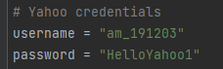

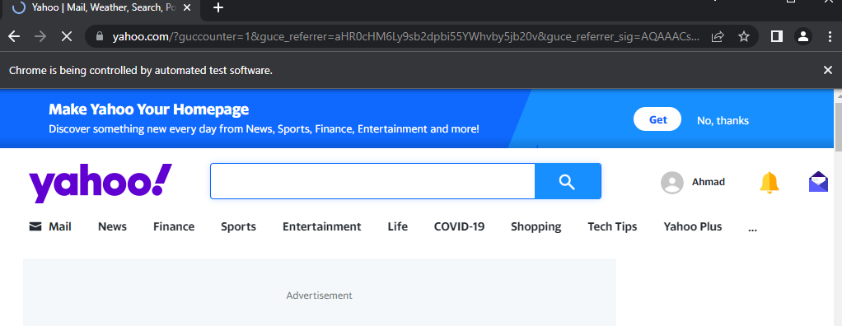

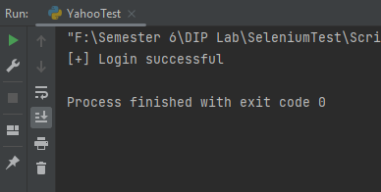

**Using Incorrect Id:**

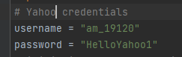

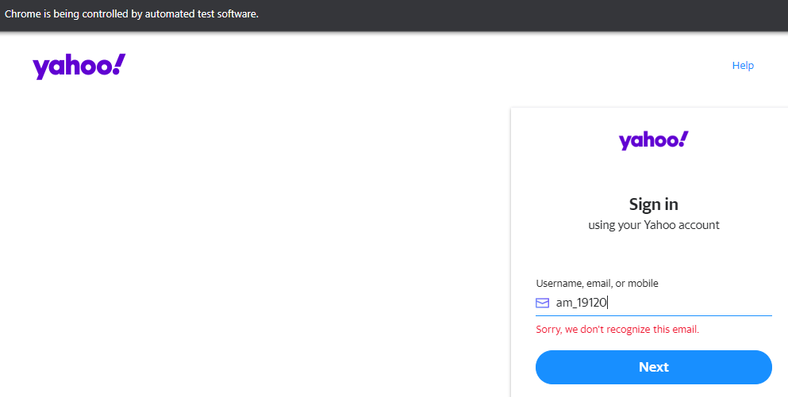

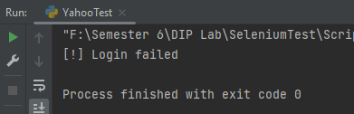

**Using Incorrect Password:**

