DOCUMENTATION

ASSIGNMENT 2

STUDENT NAME: NABLSIY AHMAD

GROUP: 30228

CONTENTS

1. Assignment Objective 2
2. Problem Analysis, Modeling, Scenarios, Use Cases 2
3. Design 3
4. Implementation 8
5. Results 12
6. Conclusions 16
7. Bibliography 17

Assignment Objective
- Main objective
• Design and implement an application aiming to analyze queuing-based systems by (1) simulating a series of N clients arriving for service, entering Q queues, waiting, being served and finally leaving the queues, and (2) computing the average waiting time, average service time and peak hour.
- Sub-objectives
• Analyze the problem and identify requirements
• Design the simulation application
• Implement the simulation application
• Test the simulation application

Problem Analysis, Modeling, Scenarios, Use Cases

Functional requirements:
- The simulation application should allow users to setup the simulation.
- The simulation application should verify the validation of data inserted.
- The simulation application should allow users to start the simulation.
- The simulation application should display the real-time queues evolution.
- The simulation application should generate random tasks.
- The simulation application should display the id of each task, its arrival_time and service_time.
- The simulation application should calculate the average for waiting time and the average for serving time after the program is finished.
- The simulation application should print all the results into a text file.

Use Case: setup simulation
Primary Actor: user
Main Success Scenario:
1. The user inserts the values for the: number of clients, number of queues, simulation interval, minimum and maximum arrival time, and minimum and maximum service time
2. The user clicks on the validate input data button.
3. The application validates the data and displays a message informing the user to start the simulation.

Alternative Sequence:
- Invalid values for the setup parameters - The user inserts invalid values for the application’s setup parameters.
- The application displays an error message and requests the user to insert valid values

Design
This chapter will present the design of the application from the perspective of the object-oriented programming paradigm and the steps we took to do so. I will also expose the UML diagrams of classes and packages, as well as the data structures and algorithms used in the implementation of the application.

  - designing OOP:
OOP design of a Java Swing application involves defining classes, objects, methods, and interfaces to create an interactive graphical user interface (GUI). OOP principles such as encapsulation, inheritance, and polymorphism are commonly used to create a modular and scalable design.
To create the graphical interface of the application, classes and interfaces from the Swing package are used, such as JFrame, JPanel, JButton, JTextArea, JTable and others. These are then extended and customized to suit the specific needs of the application.
As for UML diagrams, they can be used to illustrate classes, interfaces, and the relationships between them within the application. UML package diagrams can also be used to group and organize classes and interfaces according to their functionality.

QueuesManagement Application contains 3 packages:
▪ Model
This package has 2 classes Task & Server where the Task class represents a task with its unique ID, arrival time, and service time. It provides methods to compare tasks based on their arrival time, retrieve task information, update the service time, and obtain a string representation of a task object, while the Server class represents a server that handles tasks concurrently. It provides methods to add tasks to the server's queue, retrieve statistics about the server's performance, and executes the main logic of task processing in a separate thread

▪ BusinessLogic
This package contains two classes: the Scheduler that represents a task scheduler where manages a set of servers. It allows tasks to be dispatched to the server with the lowest waiting period, handles the creation and management of server objects and threads, and provides methods to retrieve relevant information about the scheduler and its servers. The SimulationManager class orchestrates the simulation of task handling using a scheduler and random task generation. It manages the flow of tasks, updates the state of servers, prints simulation data, and calculates relevant statistics.
▪ GUI
This package has three classes (view, control, MainView). The MainView class is the class which runs the whole program. View class is the class that has GUI implemented using the Java Swing library. The code uses various classes and methods from the library to create the user interface, set the properties of various elements.
The class Control is the class that handle user inputs and apply the ActionListener for each button.

  - UML Diagram

- Mode Package diagram:
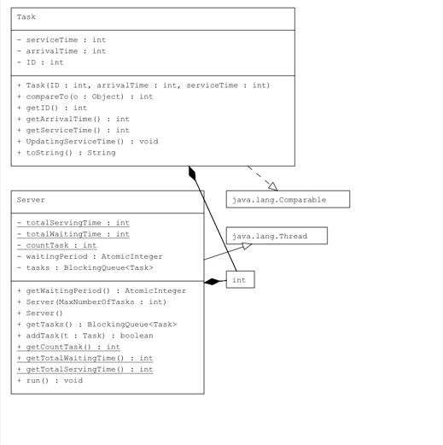

- GUI Package diagram:

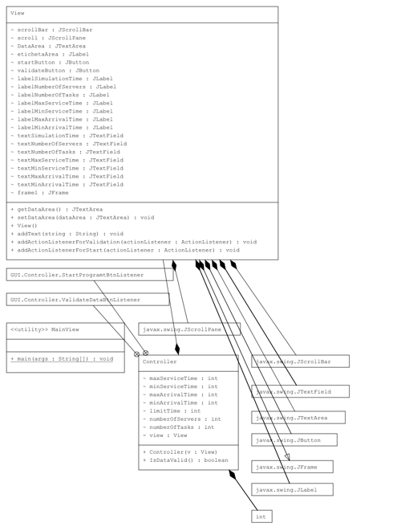

- BusinessLogic Package diagram:
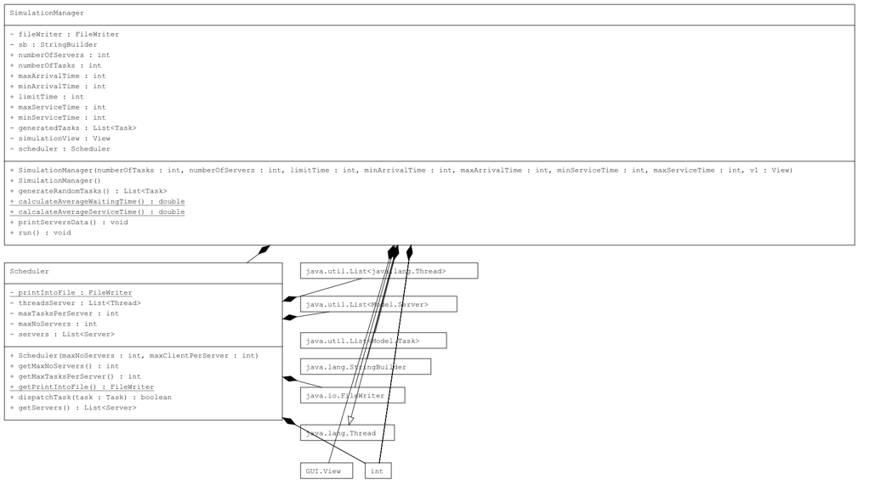

- Whole Application Diagram:
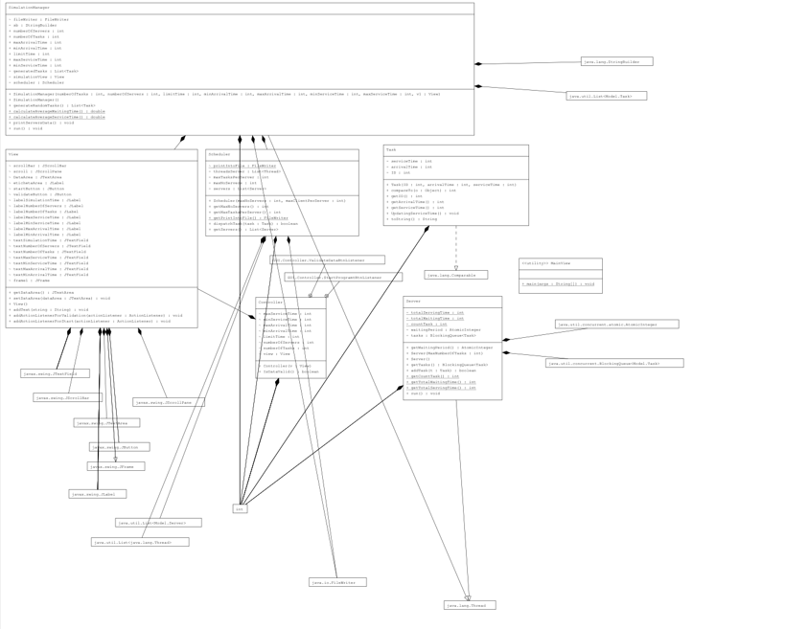

  - Data Structure used for implementing this app:
- BlockingQueue<Task>: This data structure is used in the Server class. It is a queue that allows multiple threads to safely add and remove elements from it. It ensures thread safety and blocking behavior when the queue is full or empty. It is used to hold the tasks for each server.
- List<Server>: This data structure is used in the Scheduler class. It is a dynamic array that stores a collection of server objects. It allows for efficient access and manipulation of server instances.
- List<Task>: This data structure is used in the SimulationManager class. It is a dynamic array that stores a collection of task objects. It allows for efficient access and manipulation of task instances. The generatedTasks list holds the randomly generated tasks.
- ArrayList<Task>: This data structure is used in the Server class. It is an implementation of the List interface. It provides dynamic resizing and efficient random access to elements. It is used to hold the tasks in the server's queue.
- StringBuilder: This data structure is used in the SimulationManager class. It is a mutable sequence of characters. It is used to build the string representation of simulation data before writing it to the output file and updating the simulation view.
- FileWriter: This data structure is used in the SimulationManager class. It is used to write data into a file. It provides methods for appending data to the file.
These data structures are selected based on their specific characteristics and functionalities to efficiently store, manipulate, and process the required information for the task scheduling simulation.

Implementation
- Task:
The class implements the Comparable interface, which means objects of this class can be compared to each other based on their arrival time.

- . The class implements the compareTo method from the Comparable interface, which is used to compare the arrival time of two Task objects. This method compares the arrival time of the current Task object (this) with the arrival time of another Task object (task2). It returns -1 if the arrival time of this is less than task2, and 1 otherwise.
- The class has getter methods (getID(), getArrivalTime(), and getServiceTime()) to retrieve the values of the instance variables.
- The class has a method named UpdatingServiceTime(), which decrements the serviceTime by 1 if it is greater than 0.
- The class overrides the toString() method to provide a string representation of a Task object. The string includes the ID, arrivalTime, and serviceTime values.

- Server:
- The class represents a server that handles tasks concurrently. It provides methods to add tasks to the server's queue, retrieve statistics about the server's performance, and executes the main logic of task processing in a separate thread.
- The class has two instance variables: tasks and waitingPeriod.
  - tasks is a blocking queue (BlockingQueue) that holds Task objects.
  - waitingPeriod is an AtomicInteger that represents the current number of tasks waiting in the server.
- There are three static variables: countTask, totalWaitingTime, and totalServingTime, which keep track of the overall statistics of the server.
- The class provides two constructors:
  - The first constructor takes an integer parameter MaxNumberOfTasks and initializes the tasks blocking queue with a maximum capacity of MaxNumberOfTasks. It also initializes the waitingPeriod atomic integer to 0.
  - The second constructor is a default constructor with no parameters.
- The class has getter methods to retrieve the waitingPeriod and tasks.
- The addTask method is used to add a Task object to the server's queue. It calculates the total serving time and waiting time statistics. If the server's queue is full, the task is not added and a message is printed. Otherwise, the task is added to the queue, and the waitingPeriod and countTask are incremented.
- The class provides static methods (getCountTask(), getTotalWaitingTime(), getTotalServingTime()) to retrieve the overall statistics of the server.
- The run method is the main logic executed when the server's thread starts. It runs in an infinite loop and continually processes tasks in the server's queue.
  - It checks if the queue is not empty. If it is not empty, it peeks at the next task in the queue.
  - If the next task's service time is less than or equal to 0, it removes the task from the queue.
  - It then sleeps for 1000 milliseconds (1 second) to simulate task processing time.
  - The waitingPeriod is updated with the current size of the queue.
  - The service time of the next task is updated using the UpdatingServiceTime method of the Task class.

- Scheduler:
This class represents a task scheduler that manages a set of servers. It allows tasks to be dispatched to the server with the lowest waiting period, handles the creation and management of server objects and threads, and provides methods to retrieve relevant information about the scheduler and its servers.

- The class imports the Server and Task classes from the Model package.
- The class has several instance variables: servers, maxNoServers, maxTasksPerServer, threadsServer, and printIntoFile.
  - servers is a list that holds the server objects.
  - maxNoServers represents the maximum number of servers.
  - maxTasksPerServer represents the maximum number of tasks that each server can handle.
  - threadsServer is a list that holds the thread objects for each server.
  - printIntoFile is a FileWriter used to write output data into a file.
- The class provides a constructor that takes two parameters: maxNoServers and maxClientPerServer. It initializes the instance variables, creates the required number of server objects, adds them to the servers list, and creates the corresponding thread objects.
- The class provides getter methods to retrieve the maxNoServers and maxTasksPerServer values.
- The class provides a static getter method (getPrintIntoFile()) to retrieve the printIntoFile FileWriter.
- The dispatchTask method is used to dispatch a task to one of the servers. It determines the server with the lowest waiting period and adds the task to that server using the addTask method of the Server class. It returns true if the task is successfully dispatched, and false otherwise.
- The class provides a getter method (getServers()) to retrieve the list of server objects.
.

- SimulationManager:
This class represents a simulation manager that orchestrates the simulation of task handling using a scheduler and random task generation. It manages the flow of tasks, updates the state of servers, prints simulation data, and calculates relevant statistics.

- The class is defined within the package BusinessLogic.
- The class imports the View, Task, Server, and other necessary classes.
- The class extends the Thread class, indicating that it can be executed as a separate thread.
- The class has several instance variables, including scheduler, simulationView, generatedTasks, and various parameters for the simulation settings.
- The class provides a constructor that initializes the instance variables based on the provided simulation settings. It creates the scheduler, generates random tasks, and starts the server threads.
- The class also provides a default constructor.
- The generateRandomTasks method generates a list of random tasks based on the given simulation settings. The tasks are sorted based on their arrival times.
- The calculateAverageWaitingTime and calculateAverageServiceTime methods calculate the average waiting time and average service time, respectively, based on the statistics maintained by the Server class.
- The printServersData method prints the current state of each server's queue, including the number of tasks in each queue. It also updates the simulation view.
- The run method is the main logic executed when the simulation manager's thread starts. It runs in a loop until the current time exceeds the specified limit time.
  - It iterates through the generated tasks and dispatches them to the scheduler if their arrival time matches the current time.
  - It prints the remaining tasks, the state of each server's queue, and updates the simulation view.
  - It increments the current time and checks for the peak hour queue size.
  - It sleeps for 1 second (1000 milliseconds).
- After the simulation is complete, the method appends the final task list, average waiting time, average service time, and peak hour information to the output file. It then closes the file.
- The class overrides the run method from the Thread class to define the main simulation logic.

- View:

The View class provides the user interface elements and methods to interact with the user, input the simulation parameters, display simulation data, and attach action listeners to perform certain actions based on user input..

- The class defines various Swing components such as JLabel, JTextField, JButton, JTextArea, and JScrollPane to create and display different elements in the GUI.
- The constructor View() sets up the main frame by setting its title, size, layout, and background color. It also initializes and adds all the necessary components to the frame, such as labels, text fields, buttons, and a text area.
- The addText(String string) method is used to update the text displayed in the DataArea text area.
- The addActionListenerForValidation(ActionListener actionListener) and addActionListenerForStart(ActionListener actionListener) methods are used to add action listeners to the validateButton and startButton respectively. These action listeners will be triggered when the buttons are clicked.

- Controller:
The Controller class serves as the intermediary between the user interface (View) and the simulation logic (SimulationManager). It validates user input, handles button clicks, and initiates the simulation based on the entered parameters.

- The class imports necessary dependencies such as SimulationManager and Swing components.
- The class has instance variables to hold the simulation parameters entered by the user, such as numberOfTasks, numberOfServers, limitTime, minArrivalTime, maxArrivalTime, minServiceTime, and maxServiceTime.
- The constructor Controller(View v) initializes the controller by accepting an instance of the View class and attaching action listeners to the validation and start buttons in the GUI.
- The method IsDataValid() validates the data entered by the user in the GUI. It checks if all fields contain values, if the maximum serving time is greater or equal to the minimum serving time, and if the maximum arrival time is greater or equal to the minimum arrival time. If the data is valid, it returns true; otherwise, it displays appropriate error messages and returns false.
- The class defines two inner classes ValidateDataBtnListener and StartProgramtBtnListener that implement the ActionListener interface. These classes handle the actions triggered by the validation and start buttons respectively.
- In the ValidateDataBtnListener, the actionPerformed(ActionEvent e) method is called when the validation button is clicked. It checks if the data is valid using the IsDataValid() method and displays a message if it is.
- In the StartProgramtBtnListener, the actionPerformed(ActionEvent e) method is called when the start button is clicked. It retrieves the simulation parameters from the GUI and assigns them to the corresponding variables. If the data is valid, it creates an instance of SimulationManager with the parameters and starts the simulation by calling the start() method.

- MainView:

The MainView class contains a main method, which is the starting point of the program.

The MainView class initializes the user interface and controller, setting up the application for user interaction.

Results
- Setting up the simulation manager :

The following picture shows the result when not all fields are filled:
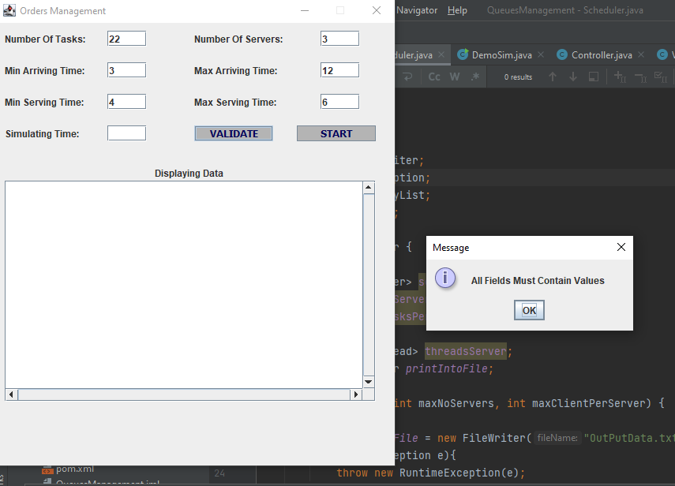

The following picture shows the result when inserting values that are not numbers:

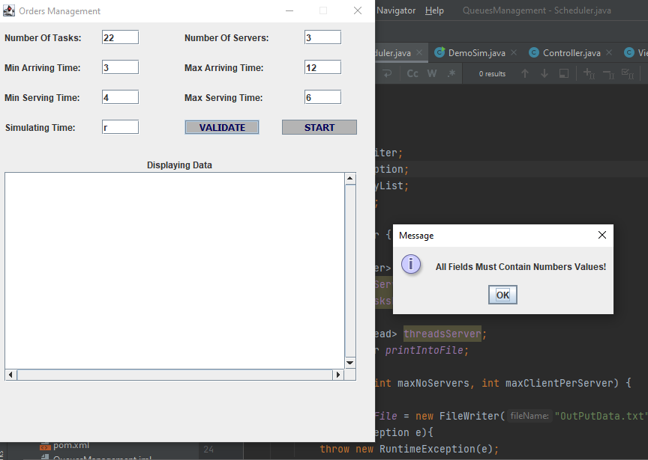

The following picture shows the result when a minimum value is greater than a maximum one:
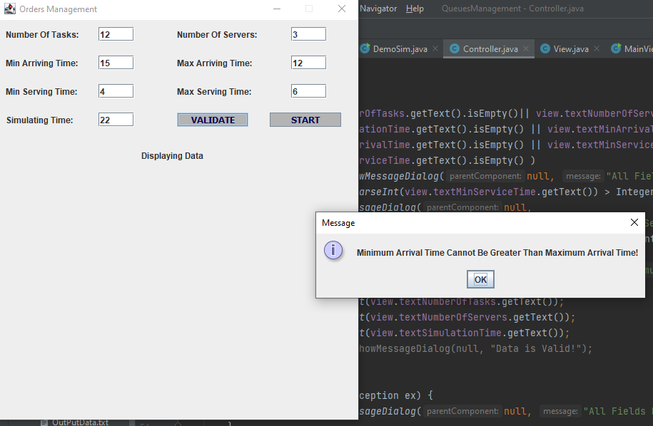

The following picture shows the result when all fields are filled correctly and can start simulating:
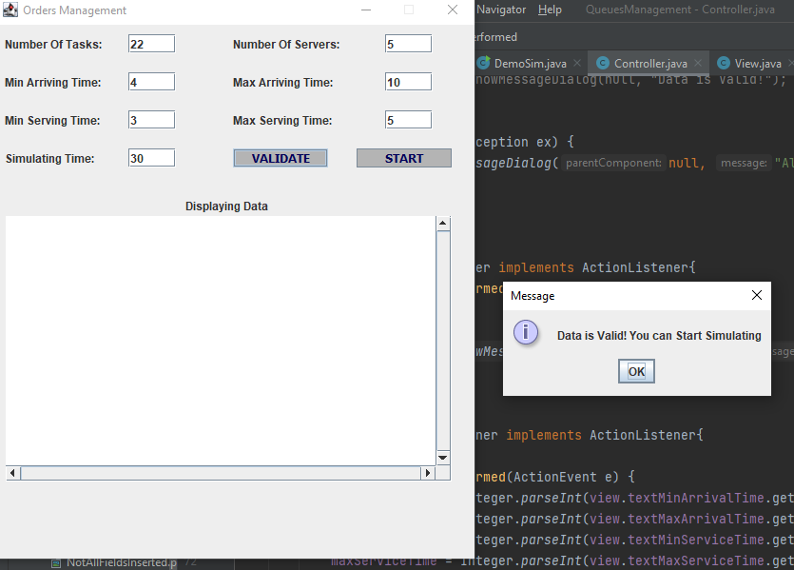

- Some results After pressing the Start: 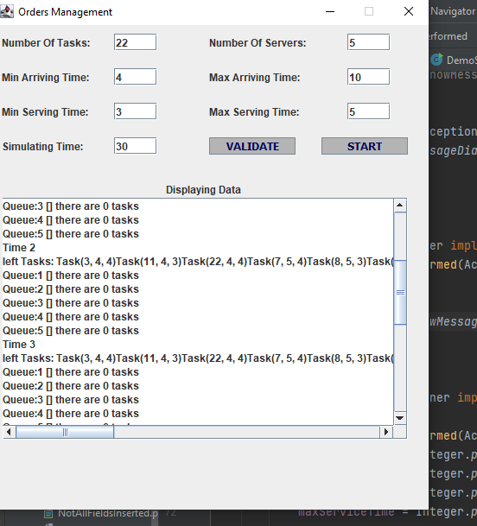

Results are also stored inside the file OutPutData.txt

Conclusion:
The project focuses on simulating a server-based system where tasks are processed by multiple servers concurrently. The project utilizes threads to represent servers and execute tasks, ensuring concurrent execution and efficient utilization of server resources.

- Suggestions for Improvement:
- Customizable Simulation Scenarios: Adding flexibility to the simulation by allowing users to define custom scenarios, such as varying task arrival rates, service time distributions, and server configurations, can make the project more versatile and applicable to different real-world scenarios.
- Error Handling and Resilience: Implementing error handling mechanisms and incorporating fault tolerance features can make the simulation more robust. For example, handling exceptional scenarios like server failures, network disruptions, or task timeouts, and implementing recovery mechanisms.

Bibliography
In order that I built this application I used many references:
- https://dsrl.eu/courses/pt/

