DOCUMENTATION

ASSIGNMENT 3

STUDENT NAME: NABLSIY AHMAD

GROUP: 30228

CONTENTS

1. Assignment Objective 2
2. Problem Analysis, Modeling, Scenarios, Use Cases 2
3. Design 4
4. Implementation 10
5. Results 14
6. Conclusions 17
7. Bibliography 17

Assignment Objective
- Main objective
• Design and implement an application for managing the client orders for a warehouse
- Sub-objectives
• Analyze the problem and identify requirements
• Design the orders management application
• Implement the orders management application
• Test the orders management application

Problem Analysis, Modeling, Scenarios, Use Cases
The functional requirements should be presented together with the use cases (use case diagrams and use case description). The use cases’ descriptions can be done as a flow-chart or as a list containing the execution steps of each use case.

Functional requirements:
- The application should allow an employee to add a new client
- The application should allow an employee to modify the client data
- The application should allow an employee to delete a client.
- The application should allow an employee to display all clients.
- The application should allow an employee to add a new product
- The application should allow an employee to modify product data
- The application should allow an employee to delete a product.
- The application should allow an employee to display all products.
- The application should allow an employee to add a new order.
- The application should allow an employee to delete an order.
- The application should allow an employee to display all orders.

Use Case: add client
Primary Actor: employee
Main Success Scenario:
1. The employee selects the option to add a new client
2. The application will display a form in which the client details should be inserted
3. The employee inserts the id_client, name, address and email.
4. The employee clicks on the “Add” button
5. The application stores the client data in the database and displays an acknowledge message

Use Case: Edit client
Primary Actor: employee
Main Success Scenario:
1. The employee selects the option to edit the client
2. The application will display a form in which the client details should be updated
3. The employee inserts the id_client, name, address and email.
4. The employee clicks on the “APPLY” button
5. The application modifies the client data in the database and displays an acknowledge message

Alternative Sequence: Invalid values for the client’s data that does not correspond to the data type in the database.

Use Case: remove client
Primary Actor: employee
Main Success Scenario:
1. The employee introduces the client ID that wanted to be deleted in the id field
2. The employee clicks on the “REMOVE” button
3. The application delete the client data from the database and displays an acknowledge message

Use Case: add product
Primary Actor: employee
Main Success Scenario:
1. The employee selects the option to add a new product
2. The application will display a form in which the product details should be inserted
3. The employee inserts the id_product, manufacturer, name_product, quantity and price.
4. The employee clicks on the “Add” button
5. The application stores the product data in the database and displays an acknowledge message

Use Case: Edit product
Primary Actor: employee
Main Success Scenario:
1. The employee selects the option to edit the product
2. The application will display a form in which the product details should be updated
3. The employee inserts the id_product, manufacturer, name_product, quantity and price..
4. The employee clicks on the “APPLY” button
5. The application modifies the product data in the database and displays an acknowledge message.

Alternative Sequence: Invalid values for the product’s data that does not correspond to the data type in database.

Use Case: remove product
Primary Actor: employee
Main Success Scenario:
1. The employee introduces the product ID that wanted to be deleted in the id field
2. The employee clicks on the “REMOVE” button
3. The application delete the product data from the database and displays an acknowledge message.

Use Case: add order
Primary Actor: employee
Main Success Scenario:
1. The employee selects the option to add a new order
2. The application will display a form in which the order details should be inserted
3. The employee inserts the Nr.order, id_product, id_client, quantity.
4. The employee clicks on the “Add” button
5. The application stores the product data in the database and displays an acknowledge message

Alternative Sequence:
- Invalid values for the order’s data that does not correspond to the data type in database.
- Values for id_client or id_product that are not available in the clients and products tables.
- Trying to insert quantity which is more than what is available in the product table.

Use Case: remove order
Primary Actor: employee
Main Success Scenario:
1. The employee introduces the order ID that wanted to be deleted in the id field
2. The employee clicks on the “REMOVE” button
3. The application delete the order data from the database and displays an acknowledge message.

Design
The following should be presented: OOP design of the application, UML package and class diagrams, used data structures, defined interfaces and used algorithms (if it is the case).

This chapter will present the design of the application from the perspective of the object-oriented programming paradigm and the steps we took to do so. I will also expose the UML diagrams of classes and packages, as well as the data structures and algorithms used in the implementation of the application.

  - designing OOP:
OOP design of a Java Swing application involves defining classes, objects, methods, and interfaces to create an interactive graphical user interface (GUI). OOP principles such as encapsulation, inheritance, and polymorphism are commonly used to create a modular and scalable design.
To create the graphical interface of the application, classes and interfaces from the Swing package are used, such as JFrame, JPanel, JButton, JTextArea, JTable and others. These are then extended and customized to suit the specific needs of the application.
As for UML diagrams, they can be used to illustrate classes, interfaces, and the relationships between them within the application. UML package diagrams can also be used to group and organize classes and interfaces according to their functionality.

OrdersManagement Application contains 4 packages:
▪ DataAccess
This package has 4 classes and the main class called AbstractDAO where are all te methods affect on the database(inseting, updating, deleting,…etc). the other three classes (CustomerDAO, ProductsDAO, OrdersDAO) are inheriting from the class AbstractDAO so they use all its methods according to their own type.

▪ Connection
This package contains only one class (ConnectionFactory) that is building the connection between the JAVA application and the database server, so need only to use an object from this class each time we need to apply an effect on our database.
▪ Model
This package contains three classes the representing our tables models (clients, products, orders) and each class have the same variables as they are columns in our tables with same names also and same orders inside the constructors.
▪ presentation
This package has three classes (view, control, MainView). The MainView class is the class which runs the whole program. View class is the class that has GUI implemented using the Java Swing library. The code uses various classes and methods from the library to create the user interface, set the properties of various elements.
The class Control is the class that handle user inputs and apply the ActionListener for each button.

  - UML Diagram

- Connection Package diagram:
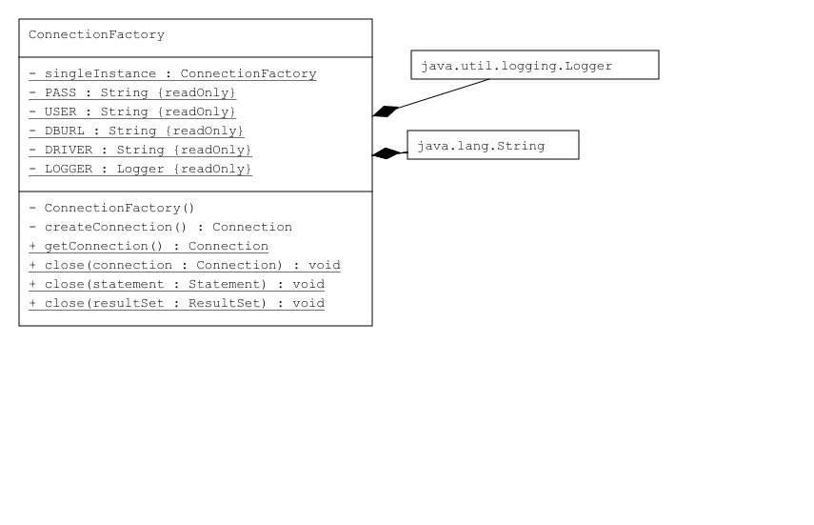

- DataAccess Package diagram:
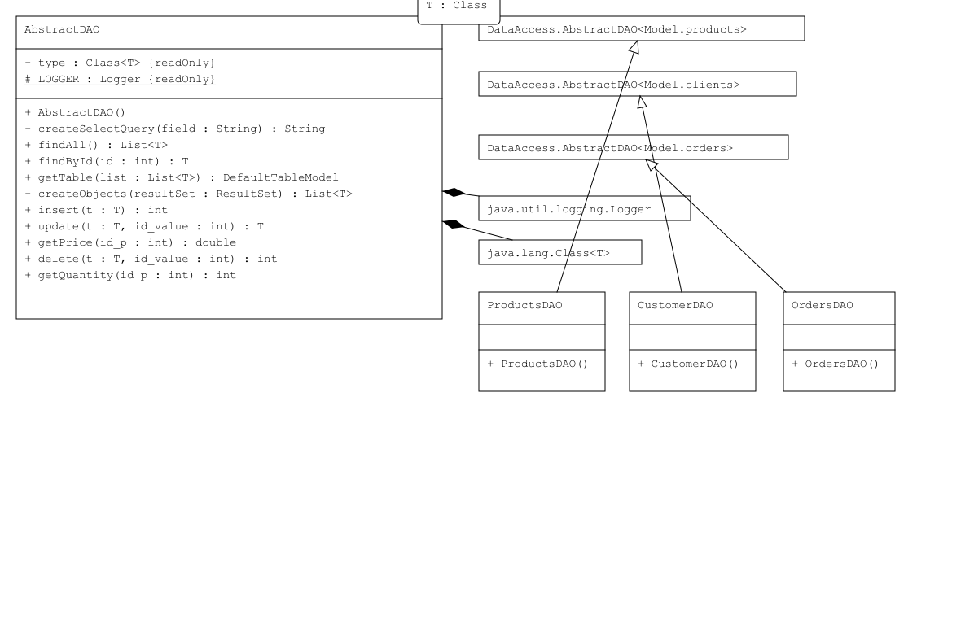

- Model Package diagram:
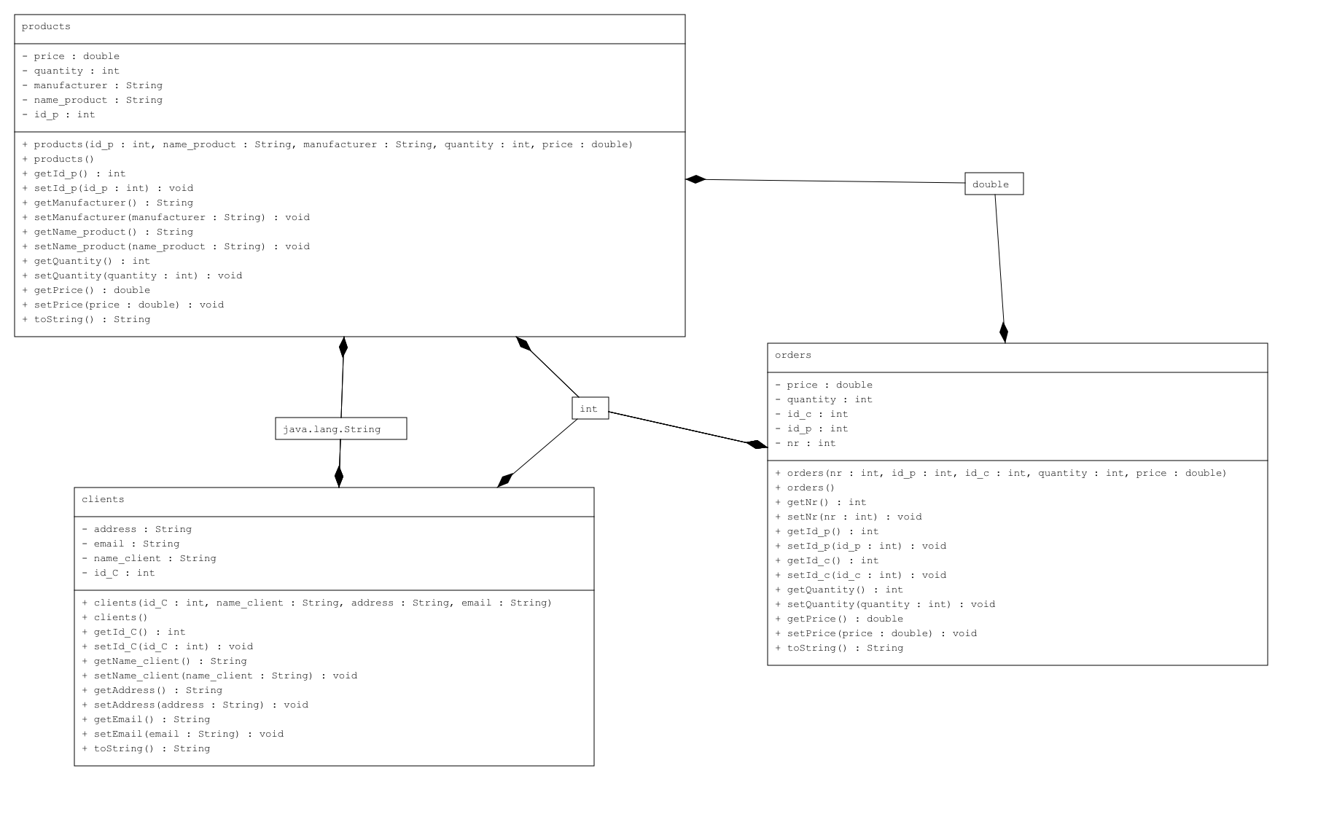

- Presentation package diagram:
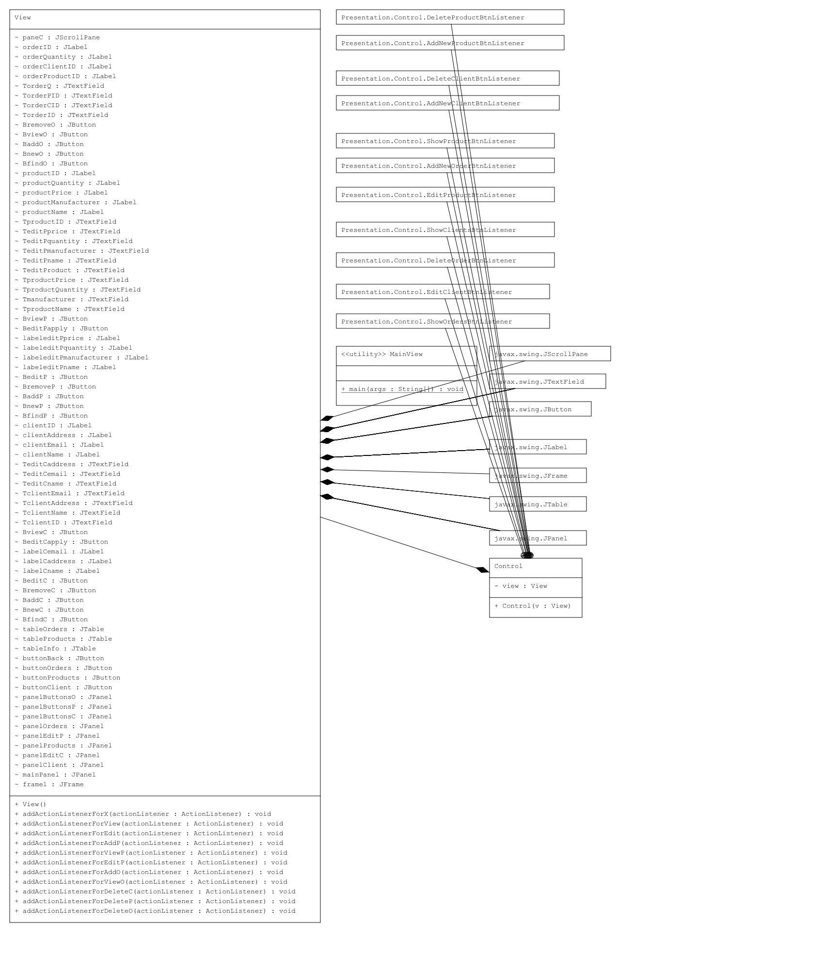

- Whole Application Diagram:
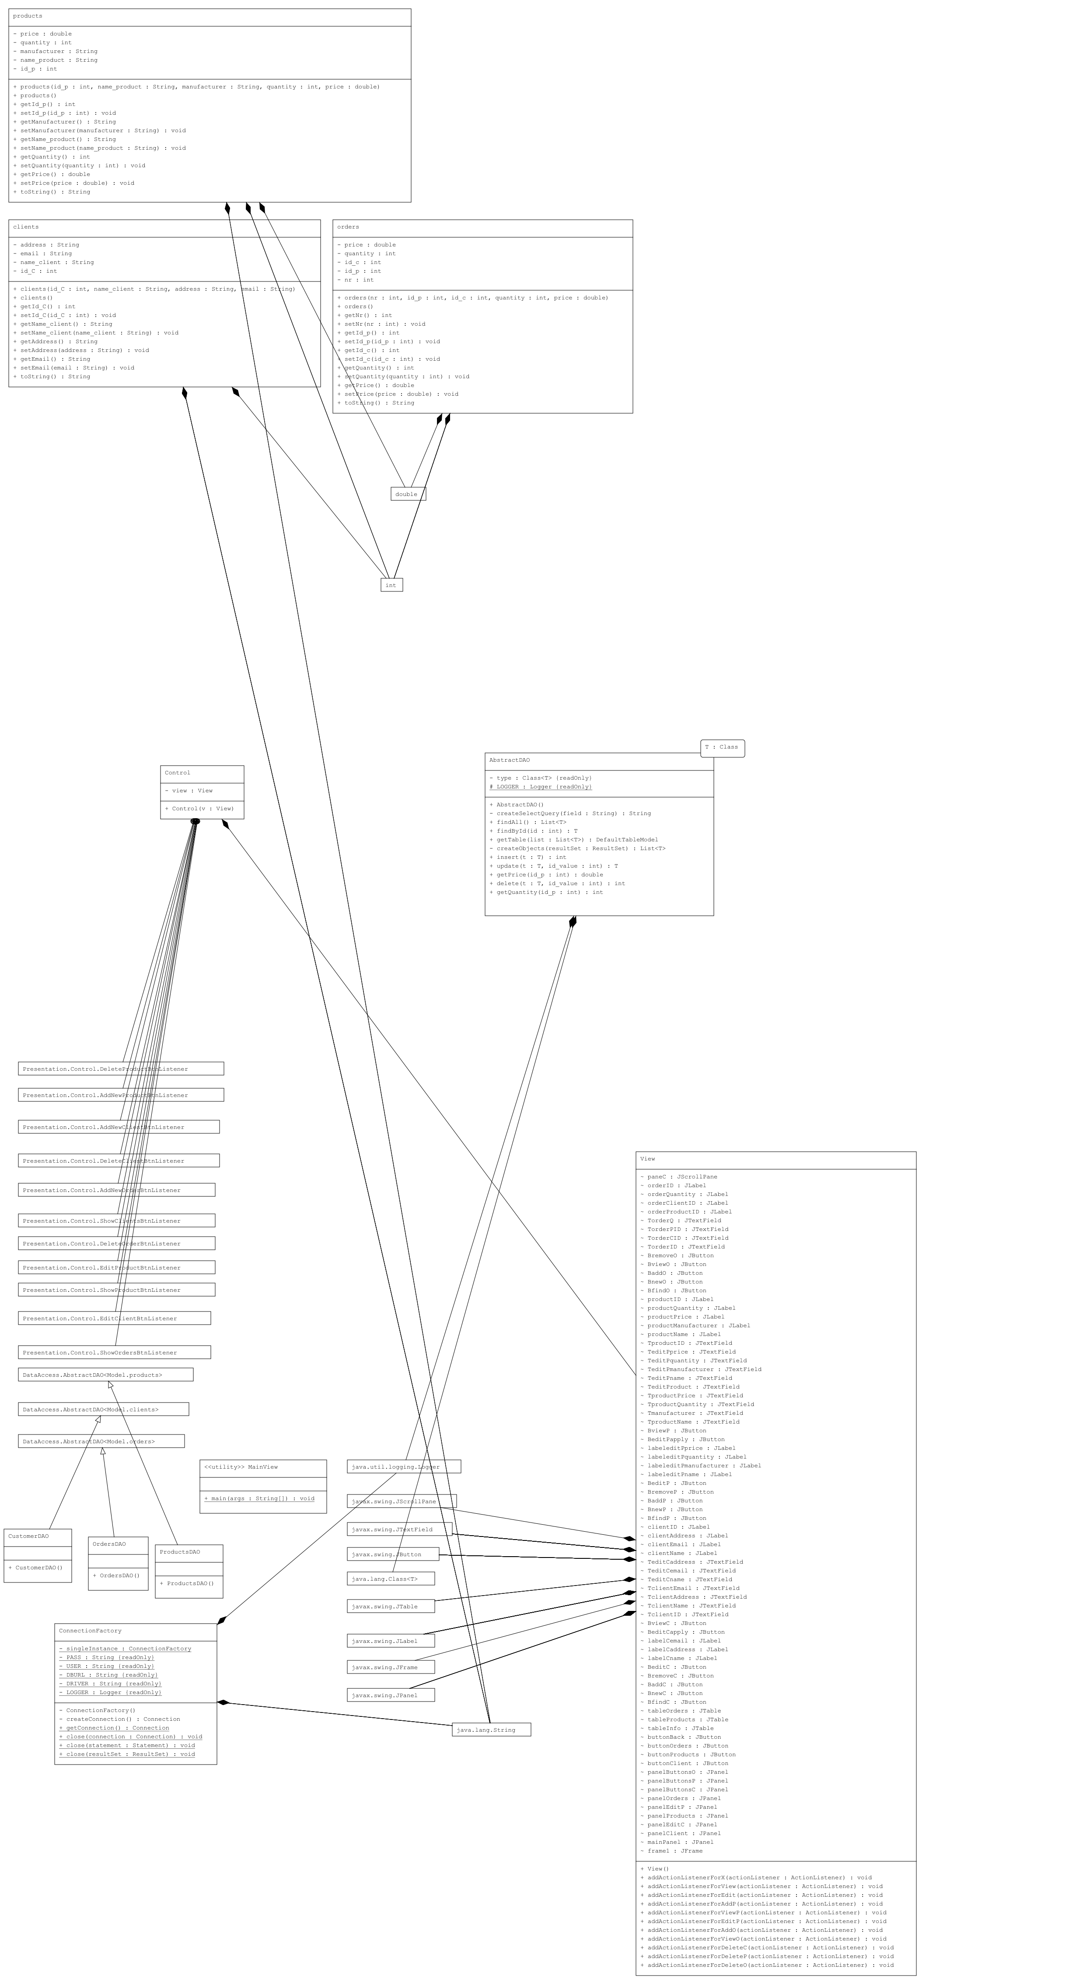
- DataBase Diagram:
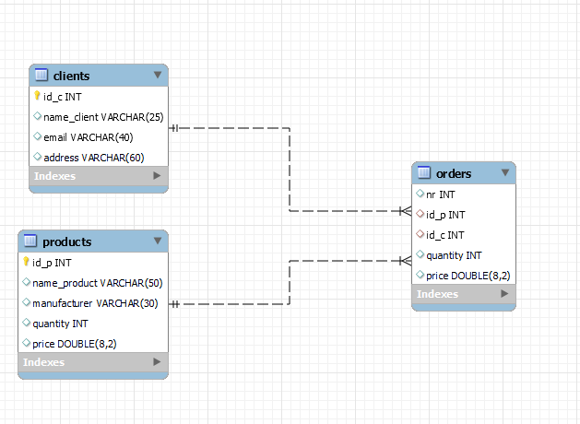
  - Data Structure used for implementing this app:
- Lists: The class uses the List interface and its implementation, ArrayList, to store and manipulate collections of objects.

- Vectors: The class utilizes the Vector class from the Java Collections framework to store and manage data for the creation of a DefaultTableModel.

Implementation
Each class will be described (fields, important methods). Also, the implementation of the graphical user interface will be described.

- ConnectionFactory:
Implements a connection factory for a MySQL database. It is responsible for establishing and managing database connections using JDBC.

Connection Establishment: The class loads the MySQL JDBC driver and provides a method createConnection() to create a connection to the specified database URL (DBURL) using the provided username (USER) and password (PASS).

Singleton Design Pattern: The class follows the singleton design pattern, ensuring that only a single instance of ConnectionFactory is created. The single instance is stored in the singleInstance field and accessed through the static method getConnection().

Connection Closing: The class provides static methods close() to properly close database resources, including Connection, Statement, and ResultSet. These methods handle closing the resources and handle any potential SQLExceptions that may occur during the process.

Logging: The class utilizes the java.util.logging.Logger to log any errors or warnings that may occur during the connection establishment or closing process.

- AbstractDAO:
It is a generic class that serves as a base implementation for Data Access Objects (DAOs) in a Java application. It provides methods for performing common database operations such as retrieval, insertion, updating, and deletion.

- Class Structure: The class is defined with a generic type T, representing the type of objects that will be persisted in the database. It extends Object and is meant to be extended by concrete DAO classes for specific entity types.

- Database Connection: The class uses the ConnectionFactory class from the Connection package to establish and close database connections. It retrieves a connection using ConnectionFactory.getConnection() and closes connections, statements, and result sets using ConnectionFactory.close() methods.

- Reflection and Generics: The class utilizes reflection and generics to dynamically handle database operations for different entity types. It extracts the actual type argument (T) at runtime using getClass().getGenericSuperclass() and performs operations based on the class type.

- CRUD Operations:

- findAll(): Executes a SELECT query to retrieve all records of the specified entity type from the database. It creates objects from the result set using the createObjects() method.
findById(int id): Executes a SELECT query to retrieve a single record by its ID from the database. It uses the createSelectQuery() method to create the query and createObjects() method to create the object from the result set.

- insert(T t): Inserts a new record into the database for the specified entity. It uses reflection to retrieve the object's class and fields, constructs an SQL INSERT statement, and executes it using PreparedStatement.

- update(T t, int id_value): Updates an existing record in the database for the specified entity. It constructs an SQL UPDATE statement based on the object's class and fields, and executes it using PreparedStatement.

- delete(T t, int id_value): Deletes a record from the database for the specified entity based on its ID. It constructs an SQL DELETE statement and executes it using Statement.

- Object Mapping: The class includes methods for mapping database records to Java objects and vice versa. The createObjects() method creates a list of objects from a result set using reflection to set field values. The getTable() method creates a DefaultTableModel to represent the data in a JTable.

- Logging: The class uses the java.util.logging.Logger to log any warnings or errors that may occur during database operations.

- CustomerDAO, ProductsDAO, OrdersDAO:

These classes provide specific implementations for handling database operations related to the respective entity types (clients, orders, and products). By extending the AbstractDAO class with the appropriate type parameter, these classes inherit the common database operations and can be used to interact with the corresponding database tables.

- Clients, products, orders:

These model classes provide the structure and behavior for the corresponding entities in the application. They encapsulate the data and provide methods for accessing and manipulating the attributes of the entities.

The clients class represents a client entity with attributes such as id_C, name_client, email, and address. It includes constructors, getters, setters, and an overridden toString() method.

The products class represents a product entity with attributes such as id_p, name_product, manufacturer, quantity, and price. It includes constructors, getters, setters, and an overridden toString() method.

The orders class represents an order entity with attributes such as nr, id_p, id_c, quantity, and price. It includes constructors, getters, setters, and an overridden toString() method.

- View:

The View class represents the graphical user interface (GUI) of an orders management system. It contains various Swing components such as buttons, labels, text fields, tables, and panels to create the interface.

- The class imports necessary dependencies, including the javax.swing package for GUI components.
- It defines a JFrame named frame1 to serve as the main window for the application.
- The class declares multiple JPanel objects to organize the GUI elements.
- Buttons, labels, text fields, and tables are created using JButton, JLabel, JTextField, and JTable respectively.
- Action listeners are added to buttons to handle user interactions.
- The GUI components are arranged using layout managers, such as null layout and setLayout method.
- The visibility and positioning of panels and components are controlled using setVisible and setBounds methods.
- The class provides methods to handle user actions, such as adding clients, editing client information, viewing clients, and so on.
- The GUI elements are customized by setting their colors, fonts, sizes, and other properties.

the View class creates a GUI interface for an orders management system, allowing users to interact with clients, products, and orders through various actions and forms.

- Control:

This class is responsible for controlling the interactions between the user interface (view) and the data access layer (DAO).
- The Control class initializes and sets up event listeners for various buttons and actions in the user interface (View).
- It includes inner classes that implement different action listeners for different buttons.
- Each action listener is responsible for performing specific actions based on user interactions.
- The actions include adding, editing, and deleting clients, products, and orders, as well as displaying clients, products, and orders in the user interface.
- The action listeners interact with corresponding data access objects (DAO) to perform the necessary database operations.
- The code also includes exception handling for database-related errors.

The Control class serves as a mediator between the user interface and the data access layer, handling user interactions and updating the database accordingly.

- MainView:

The MainView class contains a main method, which is the starting point of the program.

The MainView class initializes the user interface and controller, setting up the application for user interaction.

Results
- Adding new Client : the following picture shows the clients data before inserting
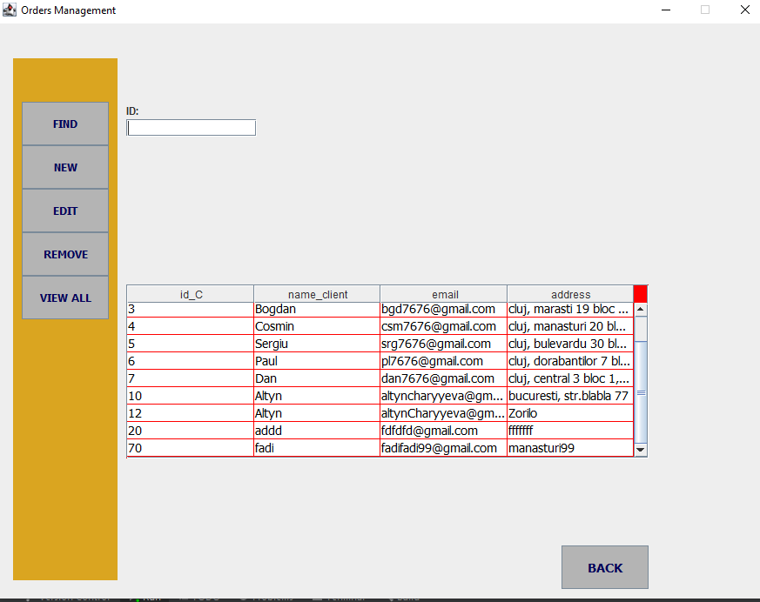

The following picture shows the result after inserting new Client:
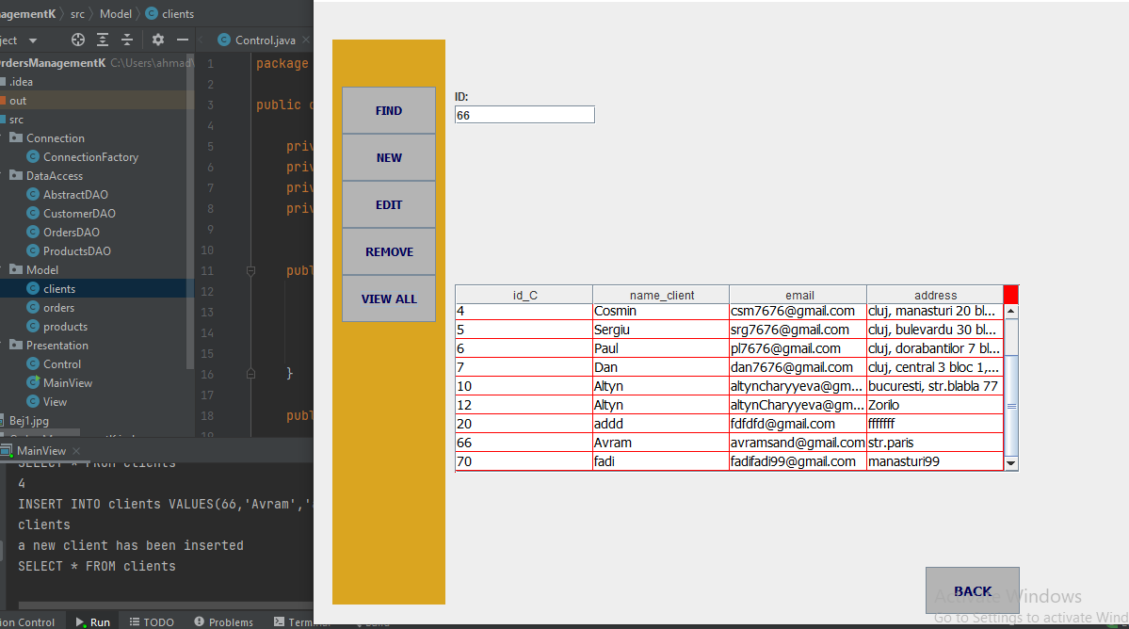

- Updating a client data (in the following picture I updated the address of the client Avram):
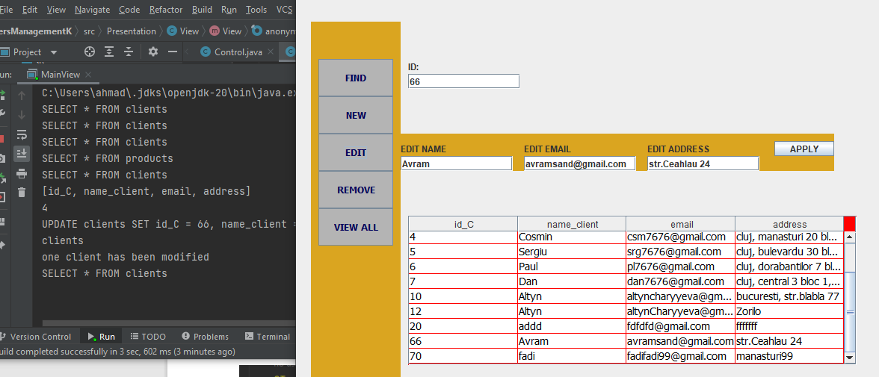

- Deleting a client (deleting the client Avram using his ID):
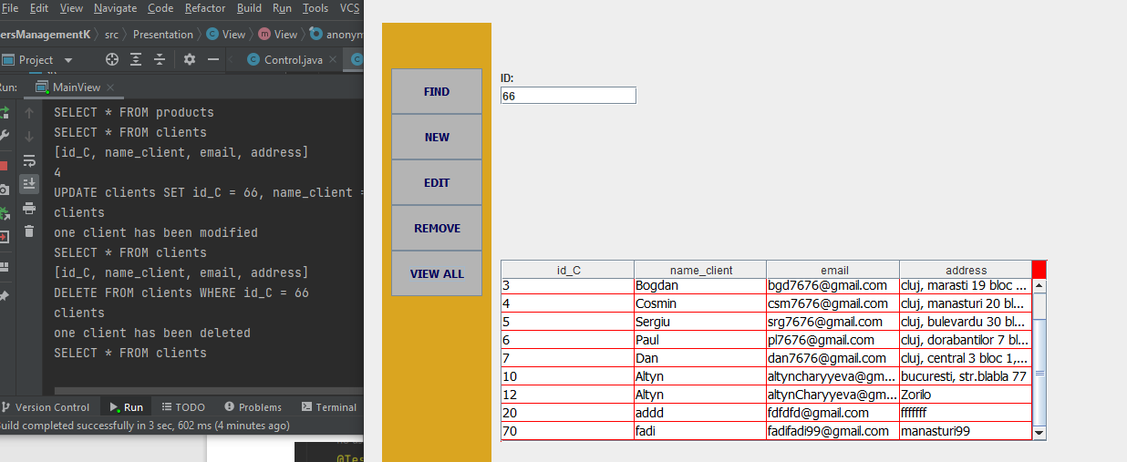

- These Results are also the same for the Products entity, but it can be some differences in the Order entity:

- Failing to add an order because it requires quantity more than it is available:
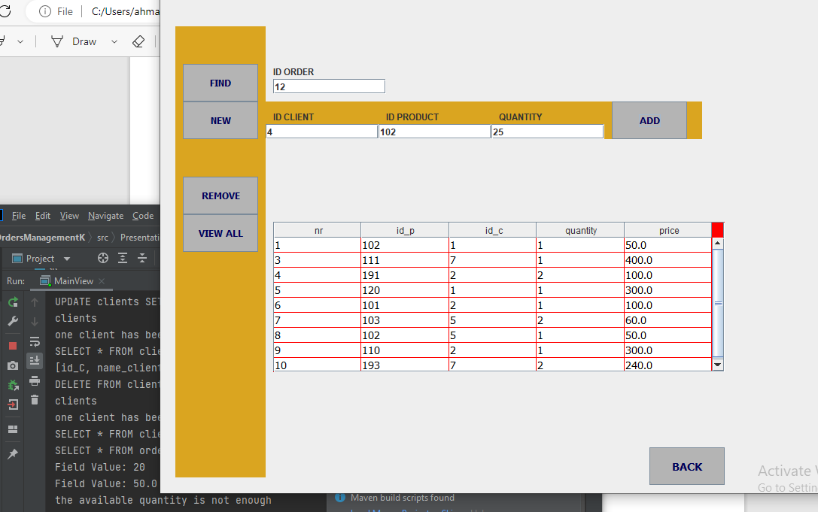

- Adding new order successfully:
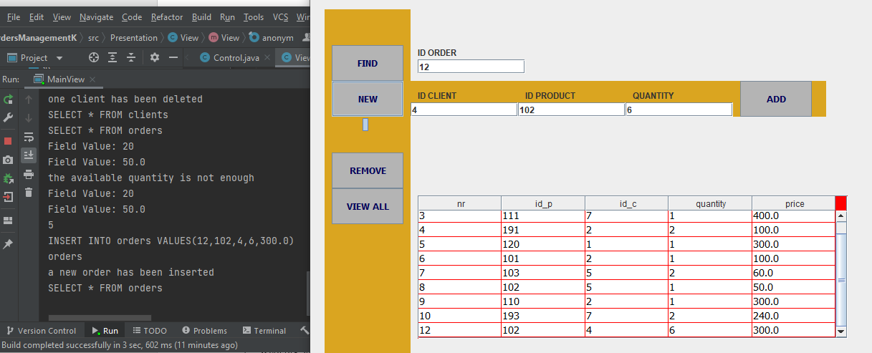

Conclusion:
The project demonstrates the use of a layered architecture, separating presentation, data access, and model classes.
It follows the MVC pattern, promoting code organization and separation of concerns.
Integration with a database is achieved through data access objects (DAOs).
The project improves code readability, maintainability, and reusability.
- Suggestions for Improvement:
Enhance error handling and validation.
Implement user feedback mechanisms for better interaction.
Improve the user interface with visual enhancements.
Optimize code and database queries for better performance.

Bibliography
In order that I built this application I used many references:
- https://dsrl.eu/courses/pt/
- https://www.mysqltutorial.org/querying-data-from-mysql-using-jdbc/

