 | National University  of Computer and Emerging Sciences  Faisalabad Campus | 

Course Instructor
Dr. Qamar UZ Zaman

Web Engineering
Group Members:
Name | Roll Number | Section
Muhammad Hasnain | 22F-3718 | BS(SE)-6A
Asfand Ahmed | 22F-3727 | BS(SE)-6A
Ahmed Raza | 22F-3740 | BS(SE)-6B

Project Tile: Ai Chatbot

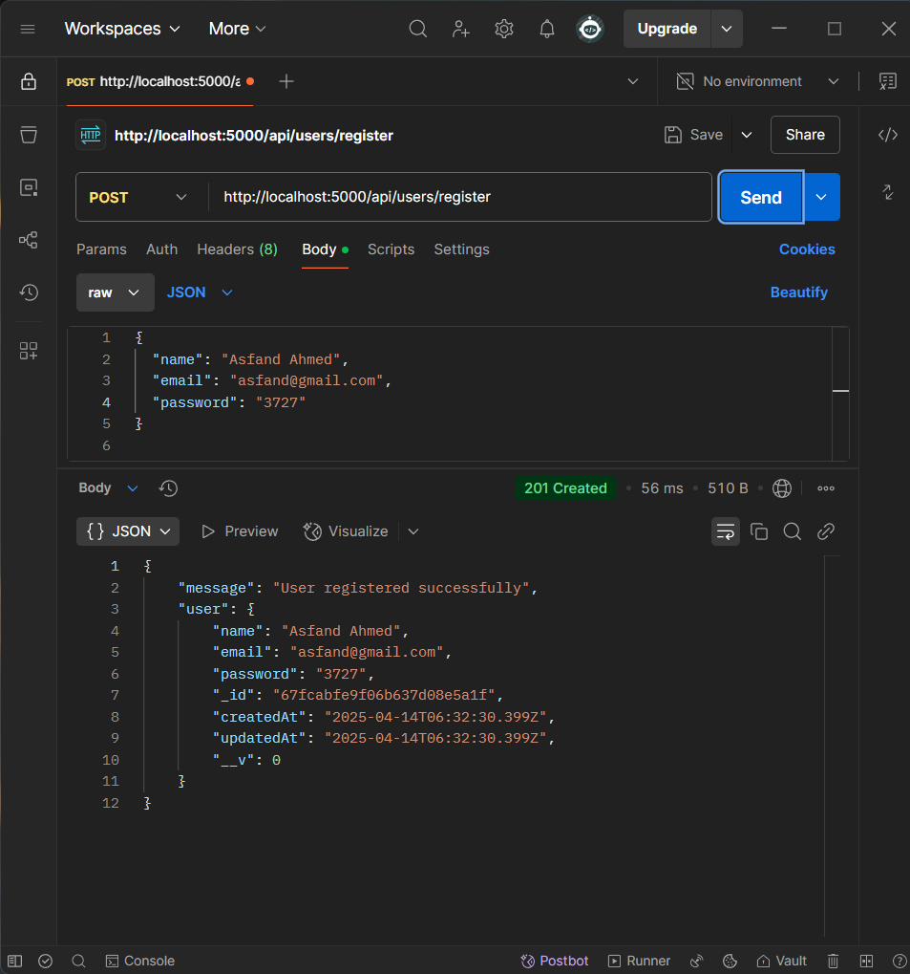
1. API Name: Register User
- Route/Endpoint: /api/users/register
- Method: POST
- Request Body Format:
{
"name": "Asfand Ahmed",
"email": "asfand@gmail.com",
"password": "3727"
}
{
"message": "User registered successfully",
"user": {
"name": "Asfand Ahmed",
"email": "asfand@gmail.com",
"password": "3727",
"_id": "67fcabfe9f06b637d08e5a1f",
"createdAt": "2025-04-14T06:32:30.399Z",
"updatedAt": "2025-04-14T06:32:30.399Z",
"__v": 0
}
}
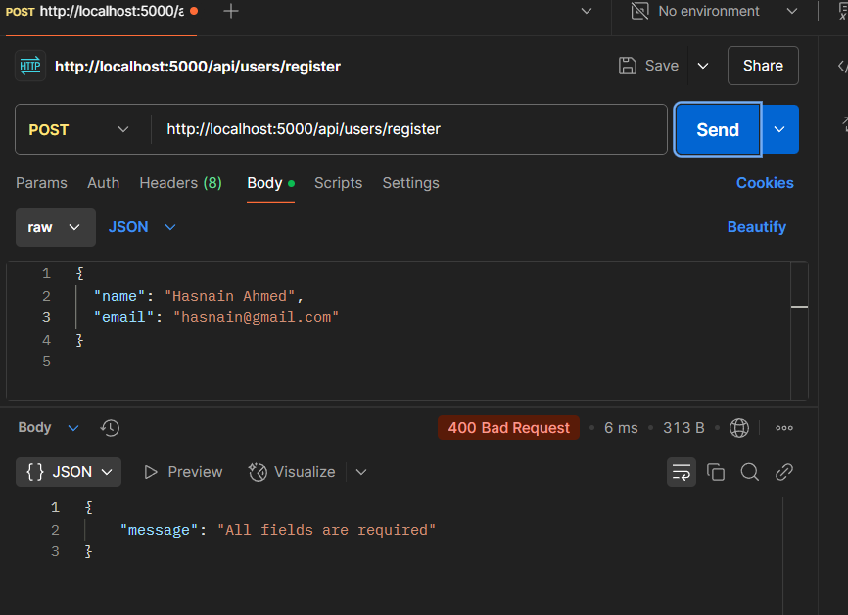
}
- Failure Response Example:
{
"message": "All fields are required"
}

2. API Name: Login User
- Route/Endpoint: /api/users/login
- Method: POST
- Request Body Format:
{
"email": "alice@example.com",
"password": "alicePassword"
}
- Success Response Example:

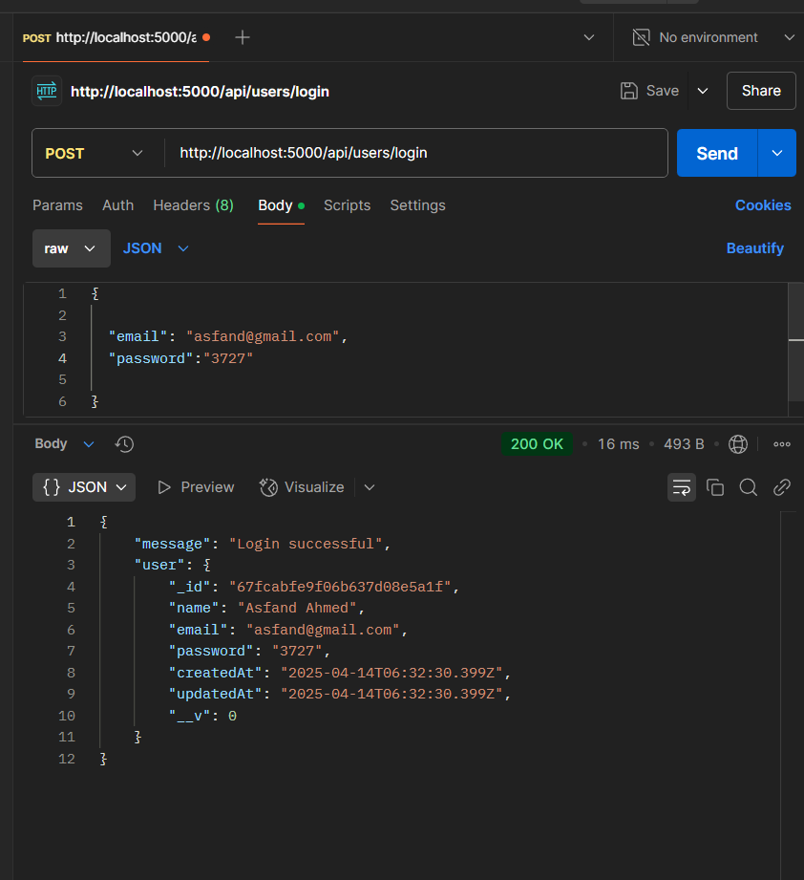
{
"message": "Login successful",
"user": {
"_id": "64f8a5fc36d3edb8d8946f5a",
"name": "Alice Smith",
"email": "alice@example.com"
}
}
- Failure Response Example:

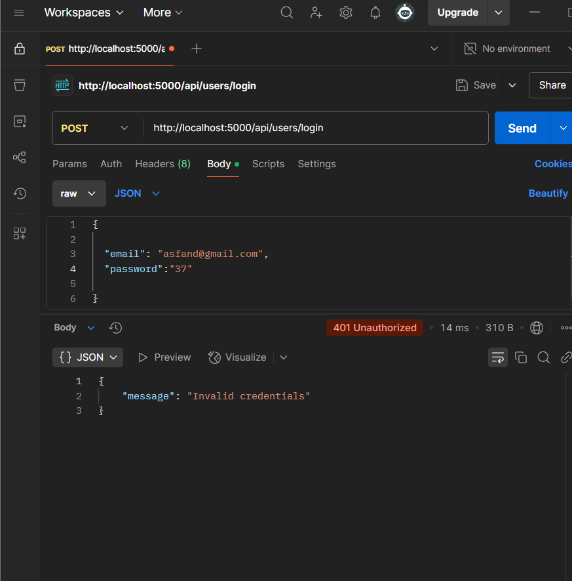
{
"message": "Invalid credentials"
}

3. API Name: Get All Users
- Route/Endpoint: /api/users
- Method: GET
- Request Body Format: None
- Success Response Example:
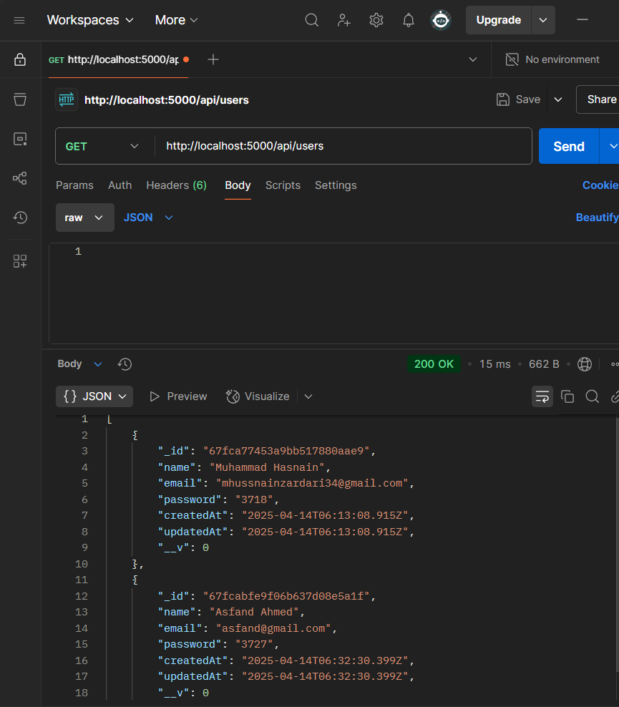
[
[
{
"_id": "67fca77453a9bb517880aae9",
"name": "Muhammad Hasnain",
"email": "mhussnainzardari34@gmail.com",
"password": "3718",
"createdAt": "2025-04-14T06:13:08.915Z",
"updatedAt": "2025-04-14T06:13:08.915Z",
"__v": 0
},
{
"_id": "67fcabfe9f06b637d08e5a1f",
"name": "Asfand Ahmed",
"email": "asfand@gmail.com",
"password": "3727",
"createdAt": "2025-04-14T06:32:30.399Z",
"updatedAt": "2025-04-14T06:32:30.399Z",
"__v": 0
}
]
]
- Failure Response Example:
{
"message": "Error fetching users"
}

4. API Name: Get User by ID
- Route/Endpoint: /api/users/:id
- Method: GET
- Request Body Format: None
- Success Response Example:
{
{
"_id": "67fcabfe9f06b637d08e5a1f",
"name": "Asfand Ahmed",
"email": "asfand@gmail.com",
"password": "3727",
"createdAt": "2025-04-14T06:32:30.399Z",
"updatedAt": "2025-04-14T06:32:30.399Z",
"__v": 0
}

}

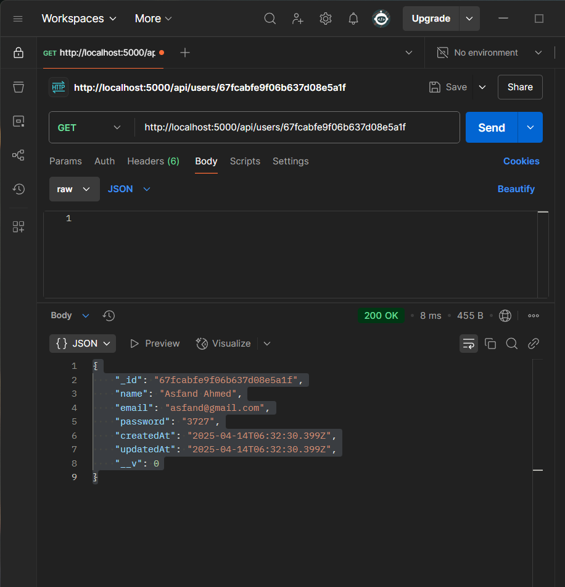
- Failure Response Example:
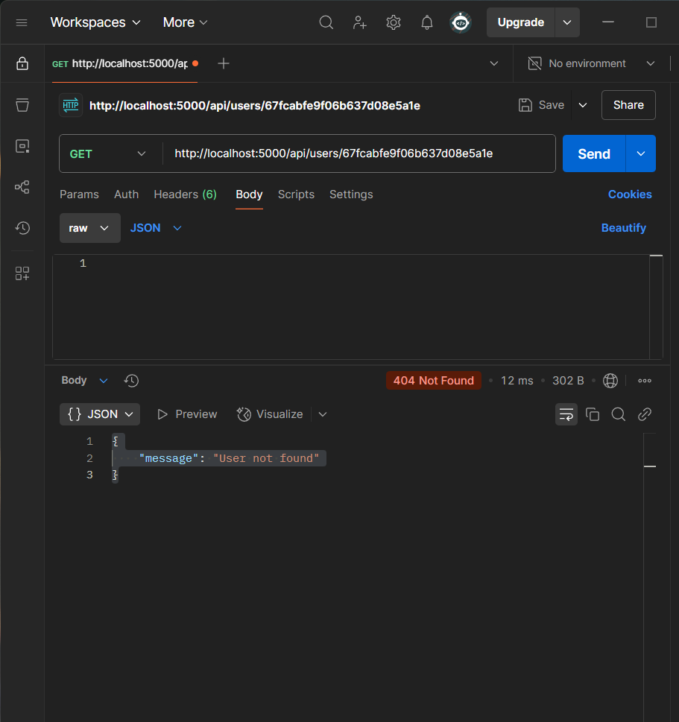
{
"message": "User not found"
}

5. API Name: Create New User (Alt. to Register)
- Route/Endpoint: /api/users
- Method: POST
- Request Body Format:
{
"name": "Kashif",
"email": "kashif@gmail.com",
"password": "1234"
}

- Success Response Example:
- 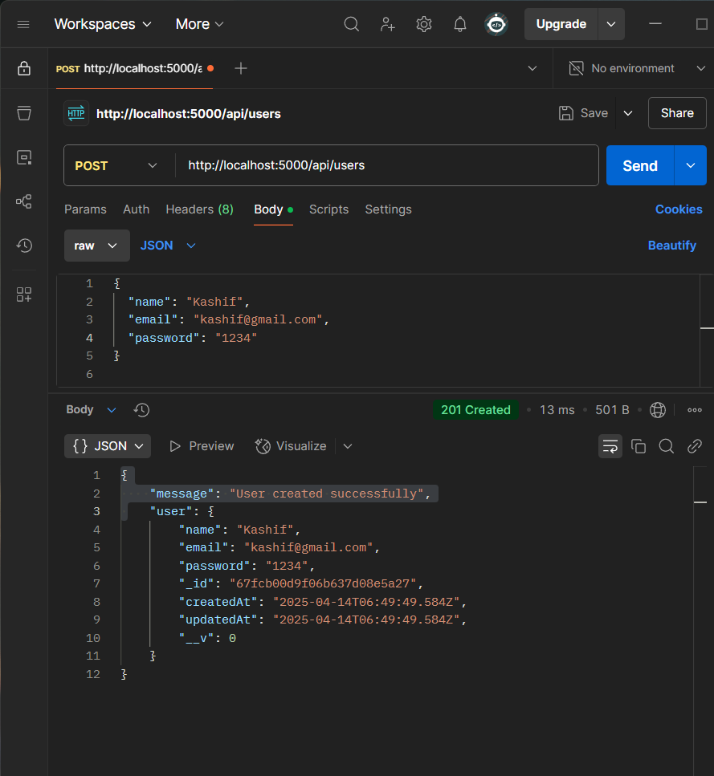
{
"message": "User created successfully",
"user": {
"name": "Kashif",
"email": "kashif@gmail.com",
"password": "1234",
"_id": "67fcb00d9f06b637d08e5a27",
"createdAt": "2025-04-14T06:49:49.584Z",
"updatedAt": "2025-04-14T06:49:49.584Z",
"__v": 0
}
- }Failure Response Example:
{
"message": "All fields are required"
}

6. API Name: Delete User
- Route/Endpoint: /api/user/:id
- Method: DELETE
- Request Body Format: None
- Success Response Example:
- 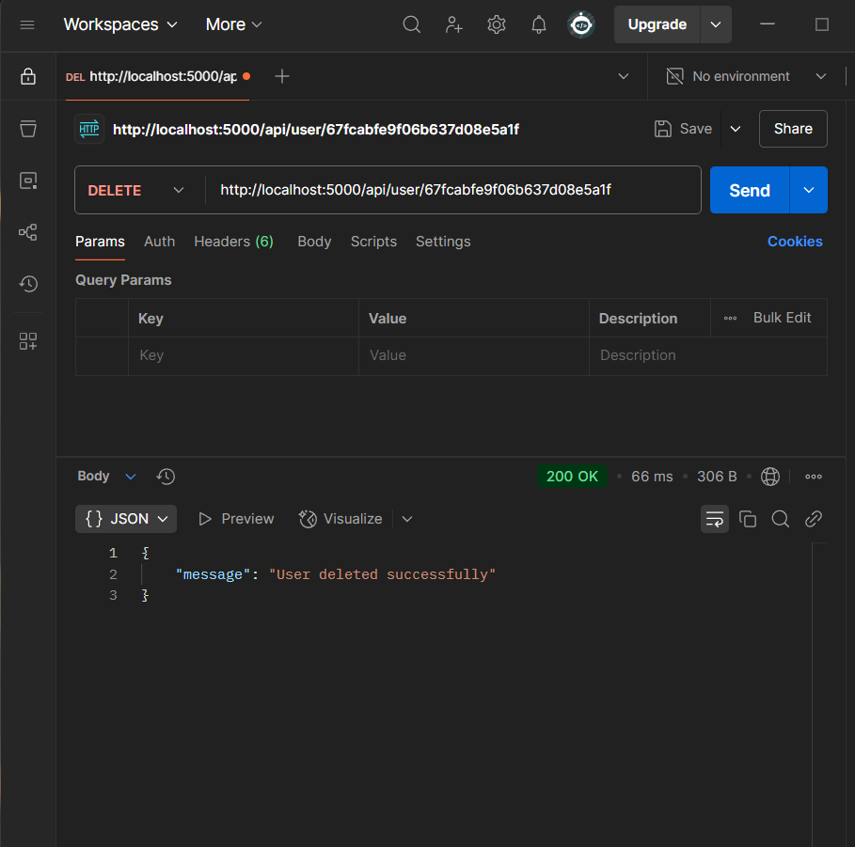
{
"message": "User deleted successfully"
}
- Failure Response Example:
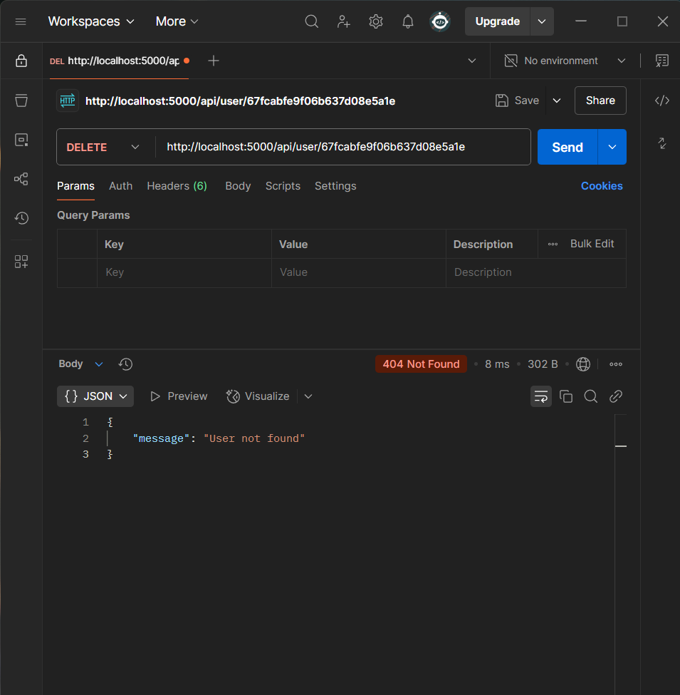
{
"message": "User not found"
}

7. Dashboard(input field & response)
- Route/Endpoint: /api/dashboard
- Method: POST
- Request Body Format:
{
"input": "hello Ahmad"
}

- Success Response Example:
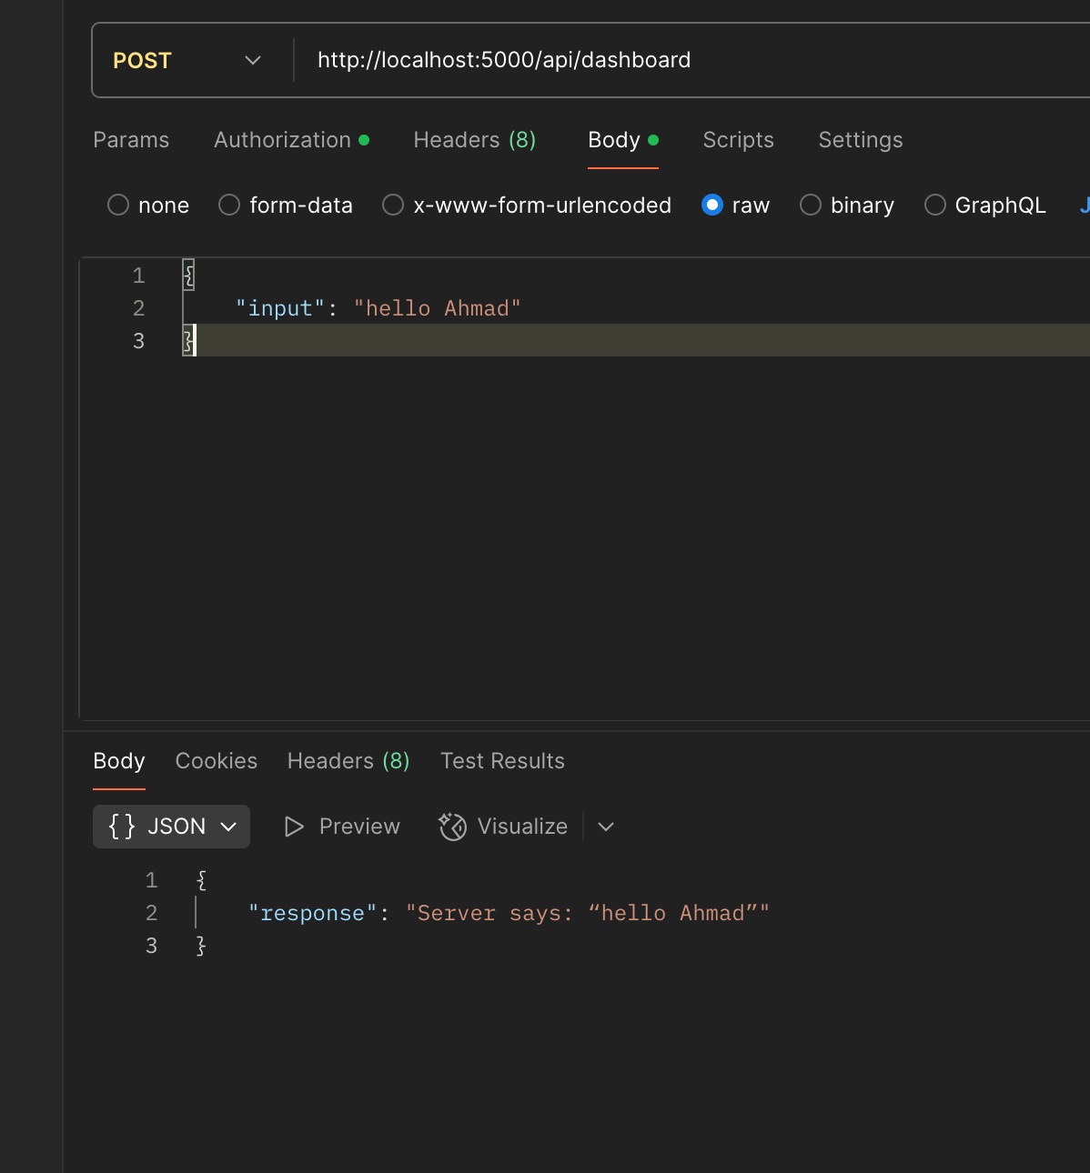
{
"response": "Server says: “hello Ahmad”"
}

- Failure Response Example:
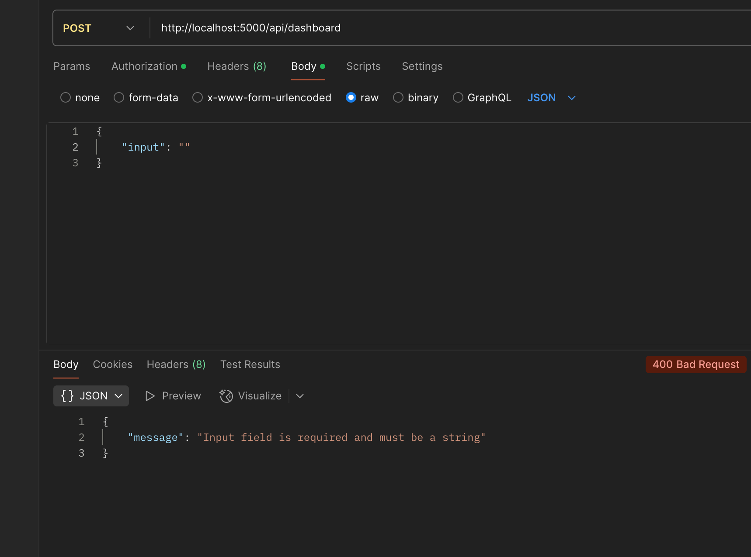
{
"message": "Input field is required and must be a string"
}

------------------------------------------------------ Updates ------------------------------------
Update User Profile
API Name: Update User Profile
Route: /api/users/:id
Method: PUT
Request Format:
Content-Type: application/json
{
"name": "Muhammad Ali",
"email": "mali@gmail.com"
}
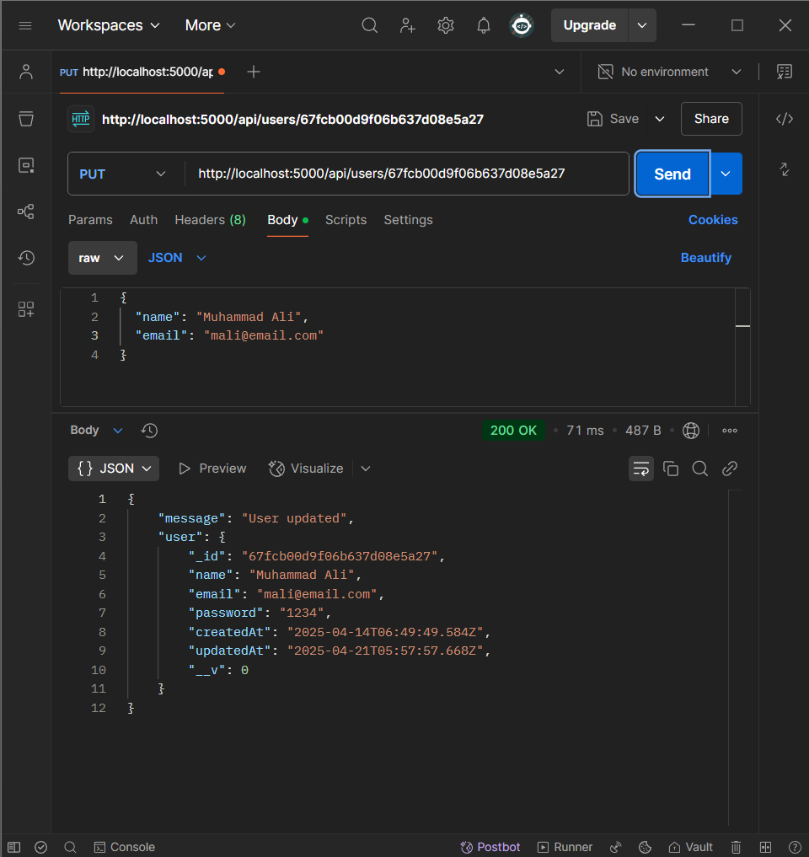
Success Response:
Status: 200 OK
{
"message": "User updated",
"user": {
"_id": "661f2e7c8e4b2c0012a4c122",
"name": "Muhammad Ali",
"email": "mali@email.com",
"password": "1234",
"createdAt": "2024-04-21T12:00:00.000Z",
"updatedAt": "2024-04-21T12:35:00.000Z",
"__v": 0
}
}

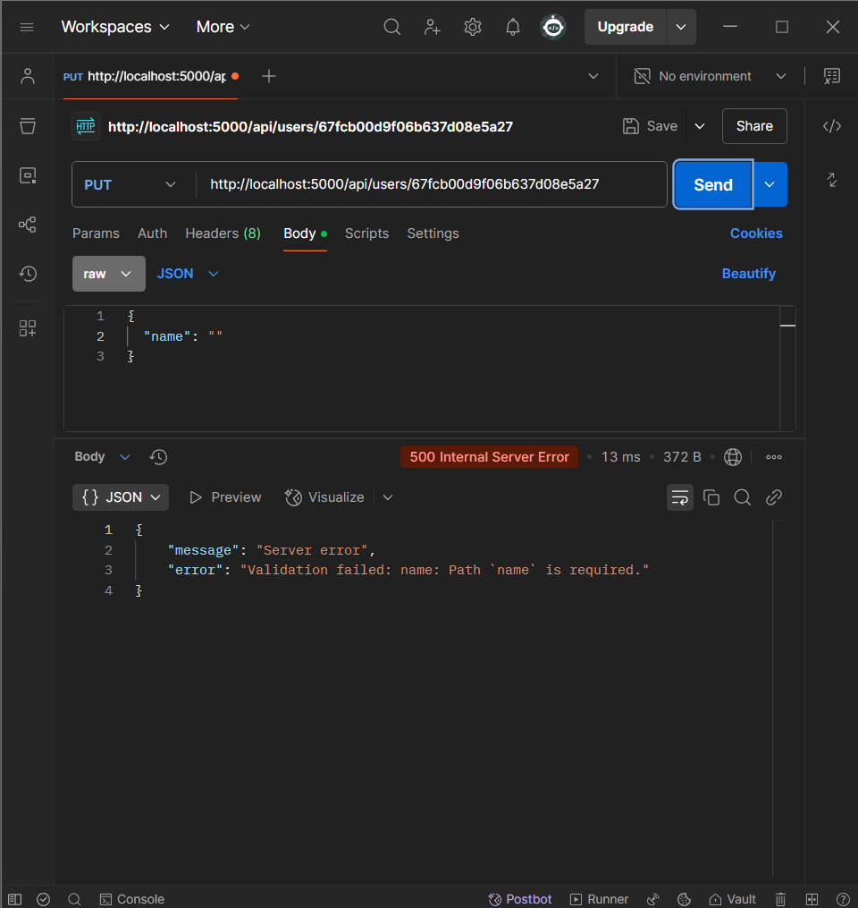

Get Chat History
API Name: Get Chat History
Route: /api/chats/:userId
Method: GET
Request Format:
No body required.
Sample Success Response:
Status: 200 OK
[
{
"_id": "661f2e7c8e4b2c0012a4c123",
"userId": "661f2e7c8e4b2c0012a4c122",
"message": "Hello, AI!",
"response": "Echo: Hello, AI!",
"createdAt": "2024-04-21T12:34:56.789Z",
"__v": 0
}
]

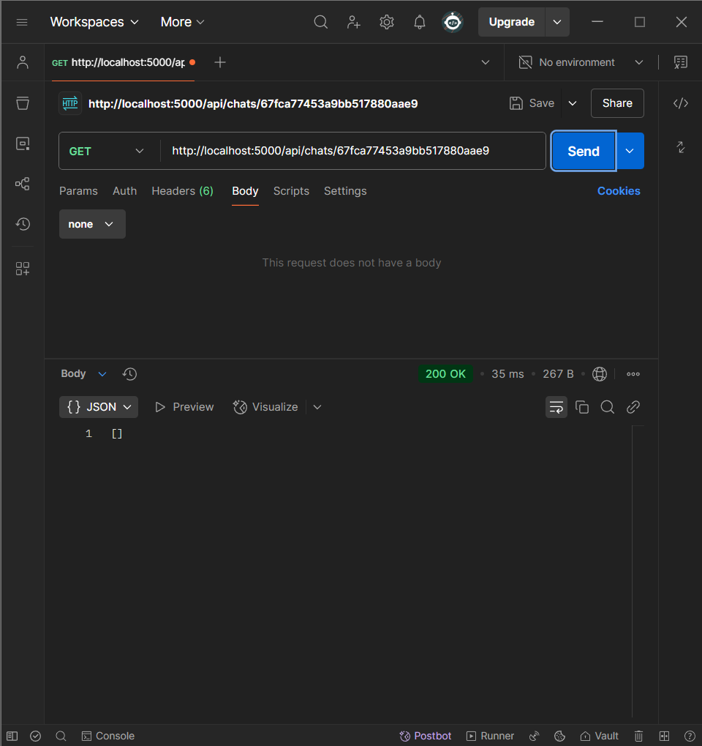

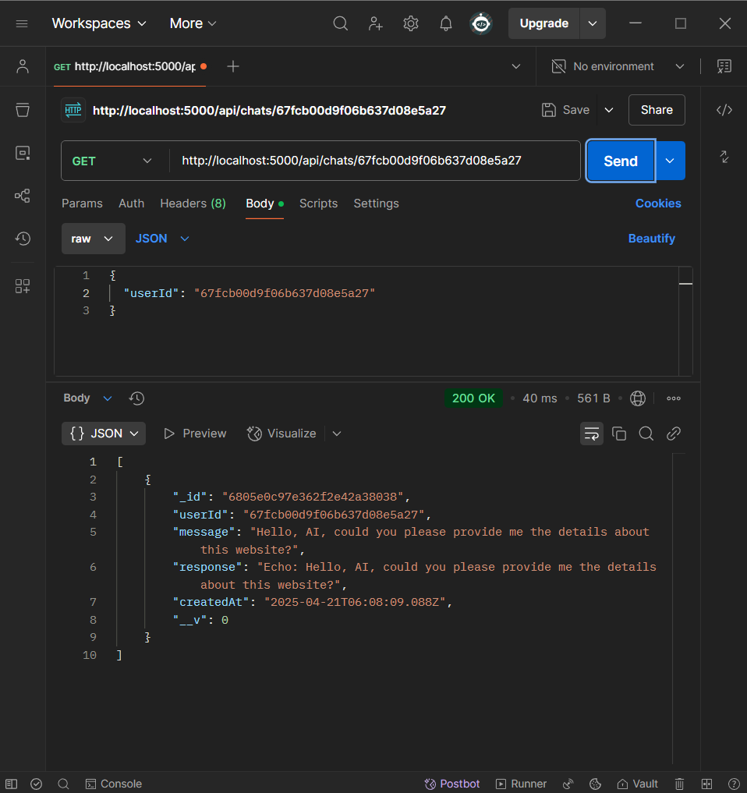
[
{
"_id": "6805e0c97e362f2e42a38038",
"userId": "67fcb00d9f06b637d08e5a27",
"message": "Hello, AI, could you please provide me the details about this website?",
"response": "Echo: Hello, AI, could you please provide me the details about this website?",
"createdAt": "2025-04-21T06:08:09.088Z",
"__v": 0
}
]

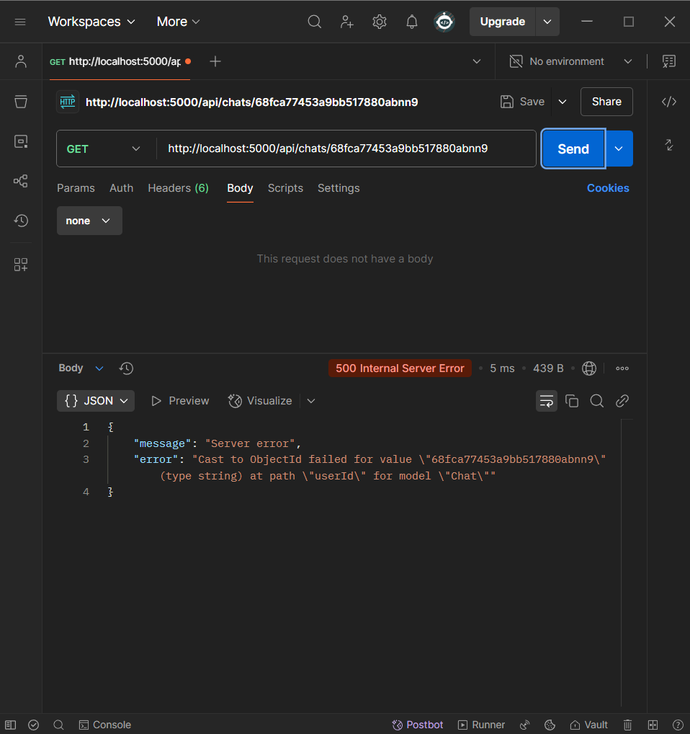
Failure Response:
Status: 500 Internal Server Error
{
"message": "Server error",
"error": "Cast to ObjectId failed for value \"67fcb00d9f06b637d08e578\" (type string) at path \"userId\" for model \"Chat\""
}

API Name: Send Message to Chatbot
Route: /api/chat
Method: POST
Request Format:
Content-Type: application/json

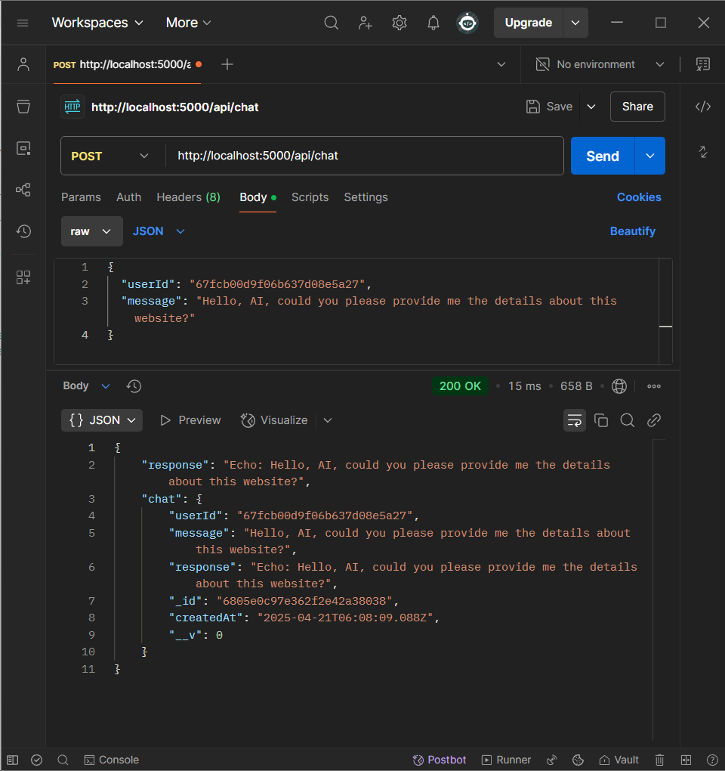

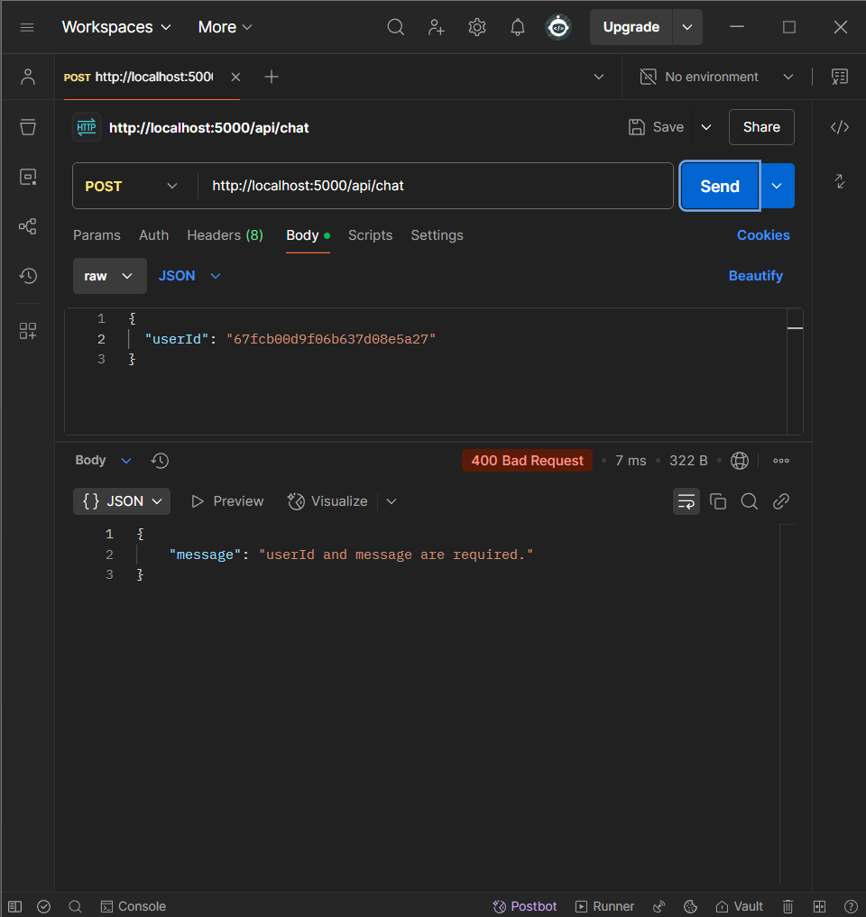

API Name: Delete chat
Route: /api/chat/:chatId
Method: DELETE

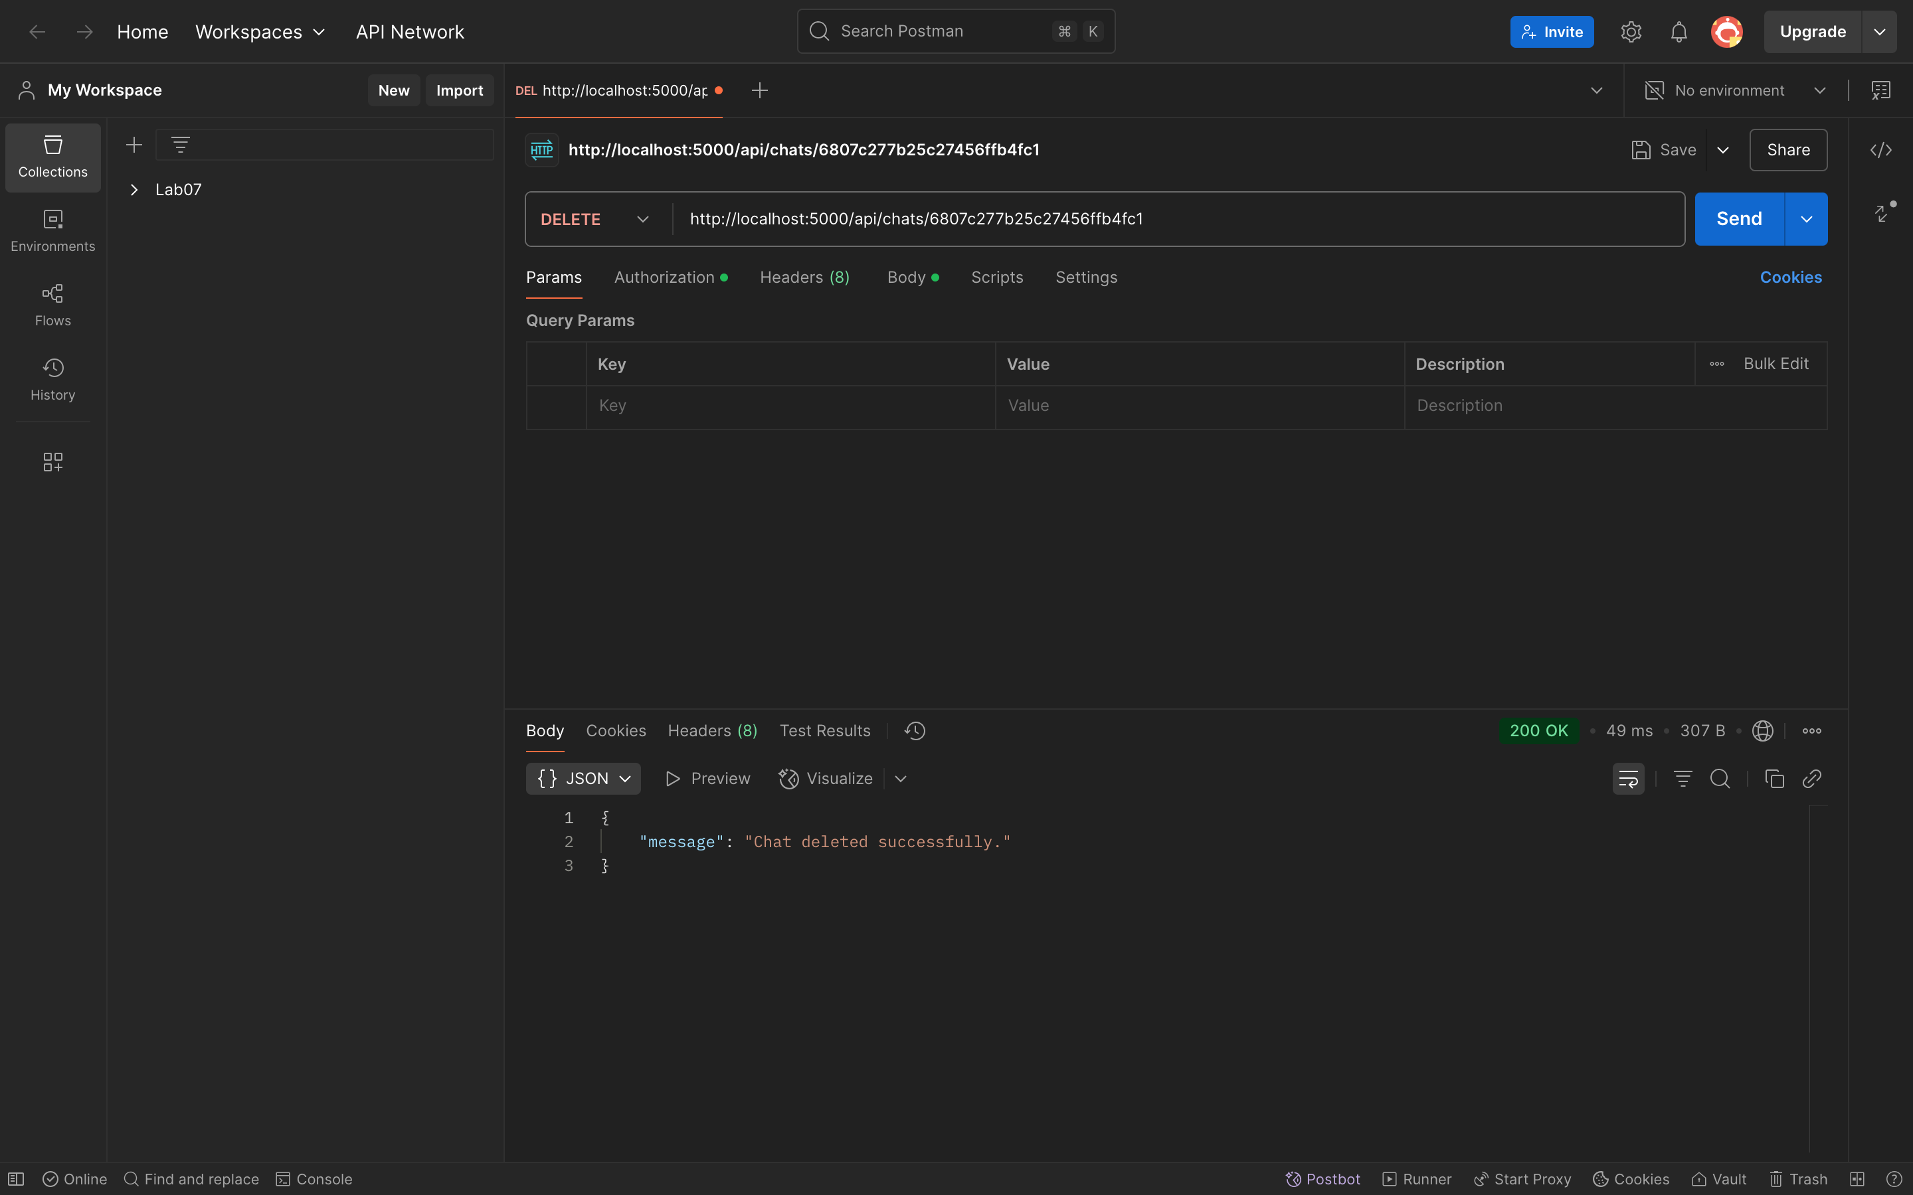
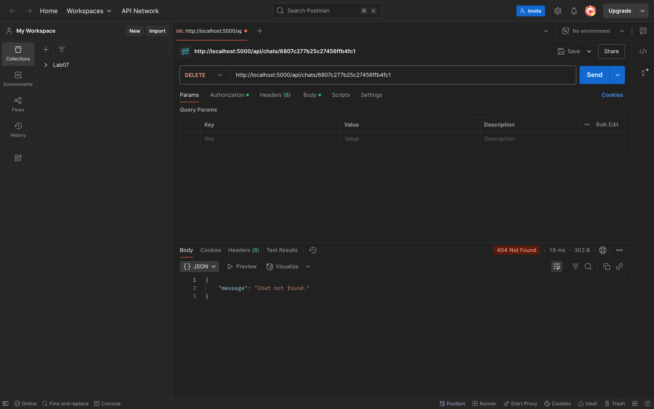

Frontend Side:
