**Business Data Analysis**

This report analyzes a dataset on a cookie business. There are three tables with the variables as follows.

1. Cookie Types

|  |  |
| --- | --- |
| Variable | Description |
| Cookie Type | The name of the product |
| Cost Per Cookie | Production cost for one unit |
| Revenue Per Cookie | Revenue for one unit |
| Units Sold | Total units sold |

1. Customers

|  |  |
| --- | --- |
| Variable | Description |
| Customer ID | Unique ID for each customer |
| Name | Name of customer |
| Phone | Phone number of the customer |
| Address | Address of the customer |
| City | City of the customer |
| State | State of the customer |
| Zip | Zip of the customer |
| Country | Country of the customer |
| Notes | Notes on the customer |

1. Orders

|  |  |
| --- | --- |
| Variable | Description |
| Customer ID | Unique ID for each customer |
| Order ID | Unique ID for each order |
| Product | The name of the product |
| Units Sold | Total units sold |
| Date | Date of order |
| Revenue | Revenue of the order |
| Cost | Cost of the order |

From this dataset, we can obtain insight on profit, performance, order patterns etc.

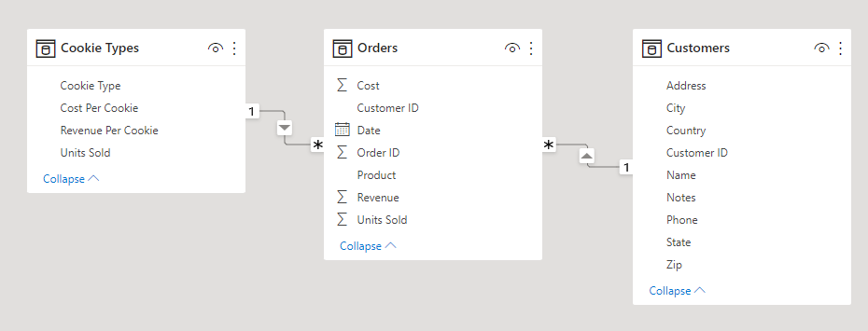

This is the model used for this analysis. The Orders table is the main table, while the Cookie Types and Customers tables are the lookup tables. The Product column in the Orders table refer to the Cookie Type column in the Cookie Types table, while the Customer ID column in the Orders table refer to the Customer ID column in the Customers table.

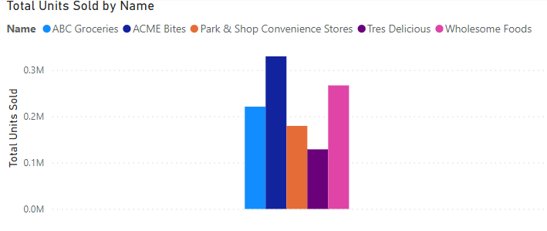

The formula Total Units Sold = sum(Orders[Units Sold]) shows the total number of units sold. If we sort by customer name, we can see that ACME Bites is the biggest customer with a total purchase of over 300k units, making it the highest priority customer to be maintained.

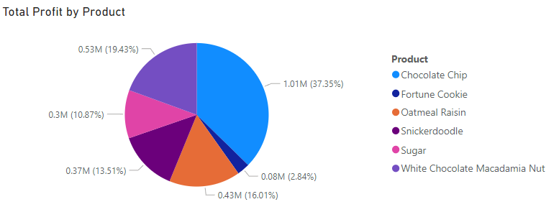

The formula Total Profit = sum(Orders[Revenue]) - sum(Orders[Cost]) shows the total profits generated by the company. If we sort by product, we can see that Chocolate Chip is by far the most profitable product, making it the highest priority product to be maintained.

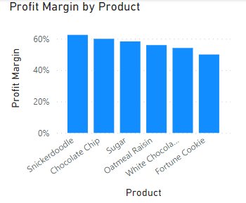

The formula Profit Margin = [Total Profit] / sum(Orders[Revenue]) shows the total profit margin of the cookies. If we sort by product, we can see that Snickerdoodle has the highest profit margin. However, based on the previous graph, it only makes up 13.51% of the total company profits. Therefore, efforts to increase its sales should be prioritized.