Written By: Your name here

[Email address]

Assignment documengtation

Contents

Introduction 2

Targeted readers 2

Project Details 2

Tools used 2

Data Base Schema 2

Tables Description 3

ORM layering 4

ORMLib 6

# Introduction

This document is description of Airline reservation system which is made using Java and MySQL database.

It implements the basis of ORM layering. All the system regarding flights, reservations, classes, payments, agents, airports, airplanes can be stored in the system and can be retrieved and added in the system using Custom ORM library.

# Targeted readers

1. Developer.
2. Modifier.
3. Professors.

# Project Details

## Tools used

1. Windows operating system.
2. Visual Studio code.
3. Java (jdbc.jar + mysqlconnector).
4. Xampp server.
5. MySQL database.

## Data Base Schema

Following are the attached images of database schema

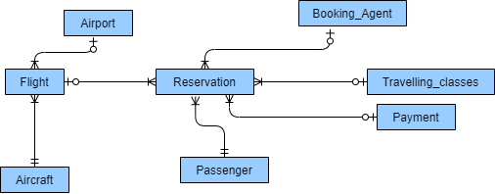Click [here](airline%20(1).png) to view above image in detailed image

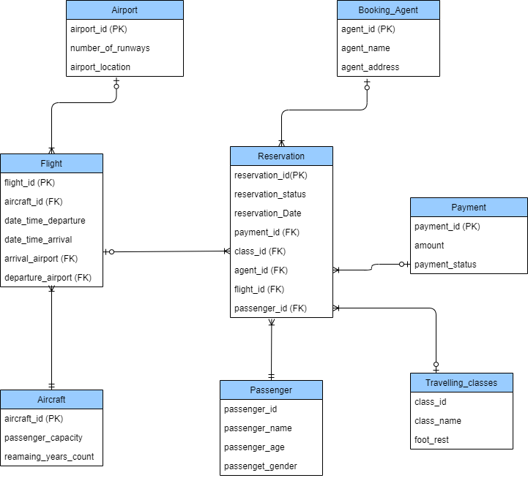Click [here](airline.png) to view above image in detail

### Tables Description

#### Aircraft

This table store the related information regarding aircraft. In flight reservation system Aircraft is essential part of flight and flight is necessary for booking or registration of ticket.

#### Passenger

All the passengers related data is stored in passenger Class. This class is vital because one passenger can book flights multiple time so in order to avoid duplication and better handling of data it is necessary.

#### Travelling Class

This class will store data regarding different seat classes in Aircraft like business class, economy class, apartment class etc. It will also store the foot space of each class. By using this class any addition in travel classes can be handled easily.

#### Flight

This class replicate the normal flight class all the data regarding flight can be stored in it. Further this system is capable of booking seats in flight and keep track of booked seats.

#### Payments

This table keep tracks of all the payments done by the passengers for booking flights. This table can be easily used to calculate the booking total so far or booking total by month etc.

#### Booking agents

Booking agents have vital role in flight booking so in order to handle them separate table is made. This table can also be used to check how many flights are booked by specific agents etc.

#### Airport

This table store the information regarding each airport on which this system is used for Booking. Make making it separate identity replication is hugely reduced as locations are used in each and every flight furthermore maintenance is made easy.

#### Reservation

This is most vital table of whole data base it stores all the records of booking. Including booking status, time, flight, payment etc.

## ORM layering

Pictorial representation of ORM layering in the system is below.

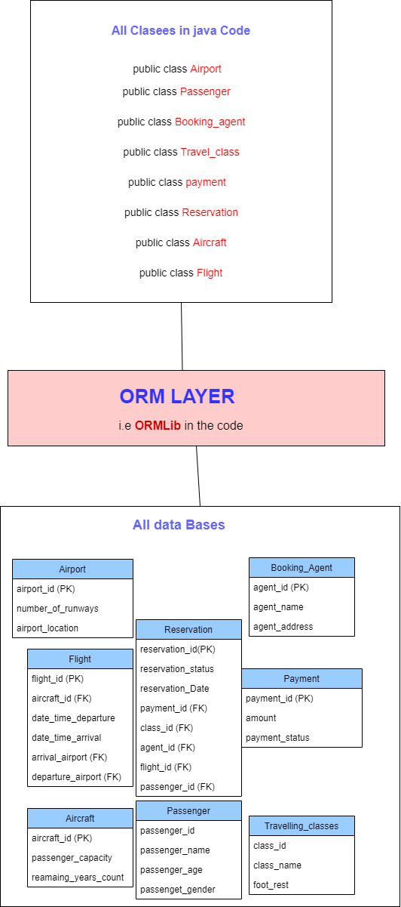for more detailed image click [here](orm.png)

Object relation mapping in this system is performed using self-made Object relational mapping library

Screen Shot of Files is below

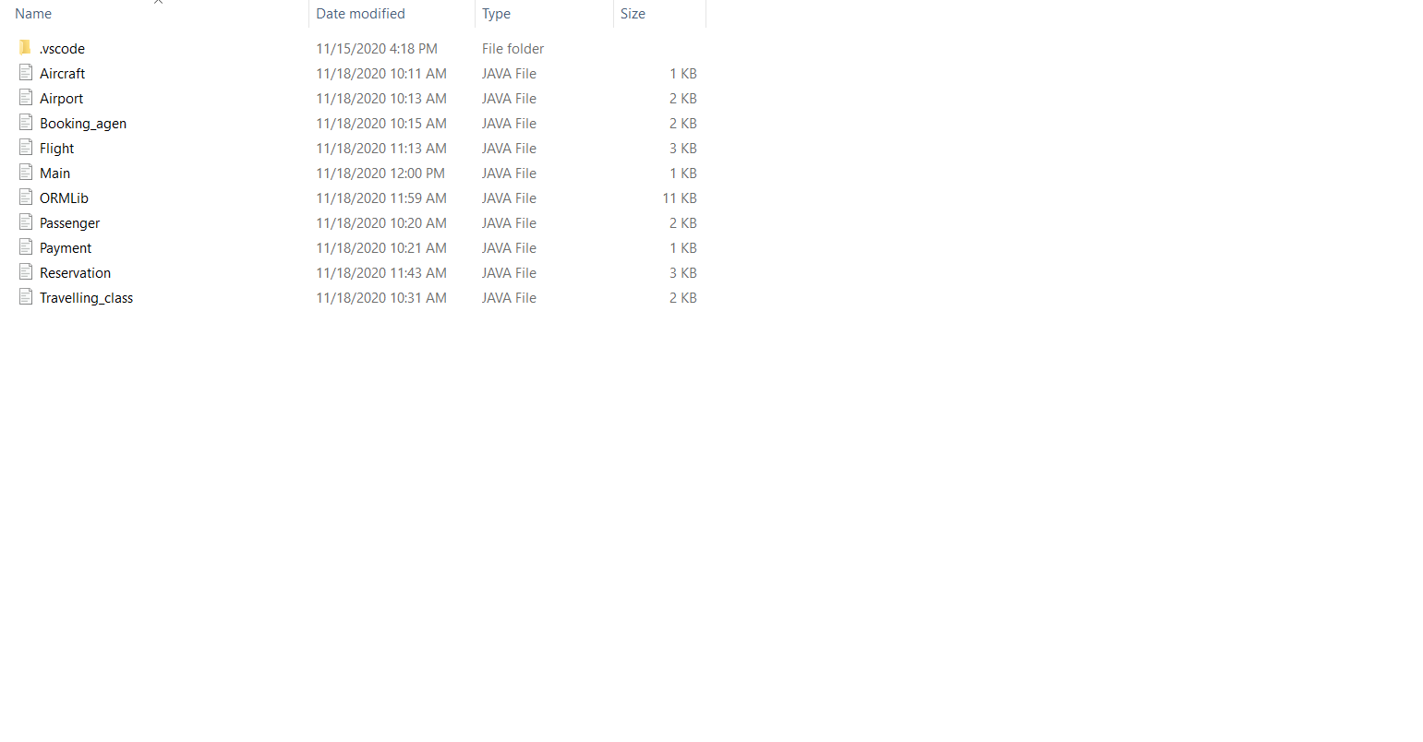

### ORMLib

This library provides object mapping using external library JDBC and SQL. It performs following functions.

1. GetFlightsList()
2. GetPassengersList()
3. GetAirportList()
4. GetTravelling_classList()
5. GetReservationsList()
6. GetTravelling_agentList();
7. GetAirportList();
8. GetPaymentList();

All these functions return ArrayList of specific class after reading data from the tables in MySQL.

Similarly, few other functions are.

1. insertIntoPayments
2. insertIntoTravel_class
3. insertIntoAirport
4. insertIntoFlight
5. insertIntoAircraft
6. insertIntoBooking_Agent.

These function take all the arguments in base class and add data to the respective tables