Ahmad Siddiq Priaji (22/496854/PA/21370)

**BinaryTreeNode.java**

public class BinaryTreeNode {

    String label;

    BinaryTreeNode left;

    BinaryTreeNode right;

    BinaryTreeNode (String label, BinaryTreeNode left, BinaryTreeNode right) {

        this.label = label;

        this.left = left;

        this.right = right;

    }

    public String toString() {

        return "[" + label + ", " + left + ", " + right + "]";

    }

}

**TraverseBinaryTree**

public class TraverseBinaryTree {

    public static void traversePreorder(BinaryTreeNode t) {

        if (t == null) return;

        System.out.println("visited node " + t.label);

        traversePreorder(t.left);

        traversePreorder(t.right);

    }

    public static void traverseInorder(BinaryTreeNode t) {

        if (t == null) return;

        traverseInorder(t.left);

        System.out.println("visited node " + t.label);

        traverseInorder(t.right);

    }

    public static void traversePostorder(BinaryTreeNode t) {

        if (t == null) return;

        traversePostorder(t.left);

        traversePostorder(t.right);

        System.out.println("visited node " + t.label);

    }

    public static void main(String[] args) {

        BinaryTreeNode tree, p, q;

        p = new BinaryTreeNode("c", null, null);

        p = new BinaryTreeNode("b", p, null);

        q = new BinaryTreeNode("d", null, null);

        tree = new BinaryTreeNode("a", p, q);

        System.out.println(tree);

        System.out.println("Preorder traversal");

        traversePreorder(tree);

        System.out.println("Inorder traversal");

        traverseInorder(tree);

        System.out.println("Postorder traversal");

        traversePostorder(tree);

    }

}

**Hasil:**

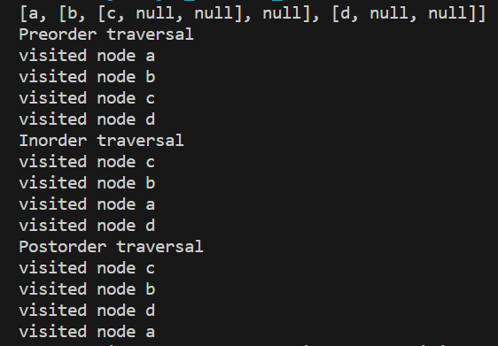

**ShowBinaryTree.java**

public class ShowBinaryTree {

    private static String getSpaces(int n) {

        String s = "";

        for (int i=0; i<n; i++) s += " ";

        return s;

    }

    public static String prettyPrint(BinaryTreeNode node) {

        return prettyPrint(0, node);

    }

    public static String prettyPrint(int n, BinaryTreeNode node) {

        if (node == null) return getSpaces(n) + "null\n";

        String s = "";

        s += prettyPrint(n+2, node.right);

        s += getSpaces(n) + node.label + "\n";

        s += prettyPrint(n+2, node.left);

        return s;

    }

    public static void main(String[] args) {

        BinaryTreeNode tree, p, q, r;

        p = new BinaryTreeNode("h", null, null);

        q = new BinaryTreeNode("i", null, null);

        p = new BinaryTreeNode("d", p, q);

        q = new BinaryTreeNode("j", null, null);

        q = new BinaryTreeNode("e", null, q);

        r = new BinaryTreeNode("b", p, q);

        p = new BinaryTreeNode("f", null, null);

        q = new BinaryTreeNode("k", null, null);

        q = new BinaryTreeNode("g", q, null);

        p = new BinaryTreeNode("c", p, q);

        tree = new BinaryTreeNode("a", r, p);

        System.out.println(prettyPrint(tree));

    }

}

**Hasil:**

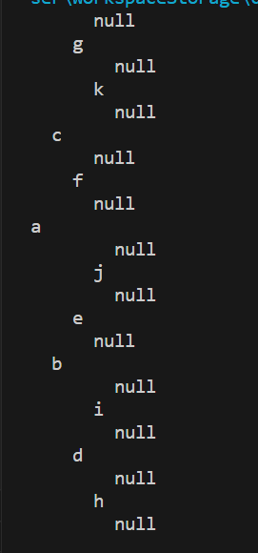

**Gambar manual:**

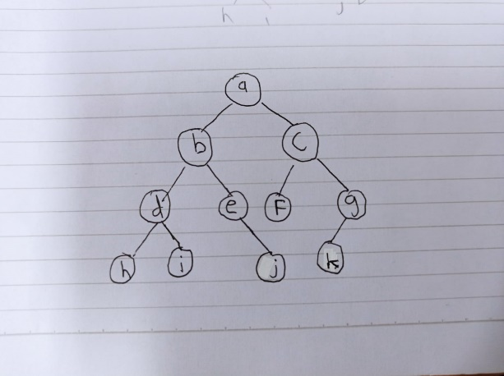

Hasil tree pada program sama seperti gambar manual