Ahmad Siddiq Priaji (22/496854/PA/21370)

Homework 1.1

Randomly generate numbers between:

1. 0,1,2,3

Code:

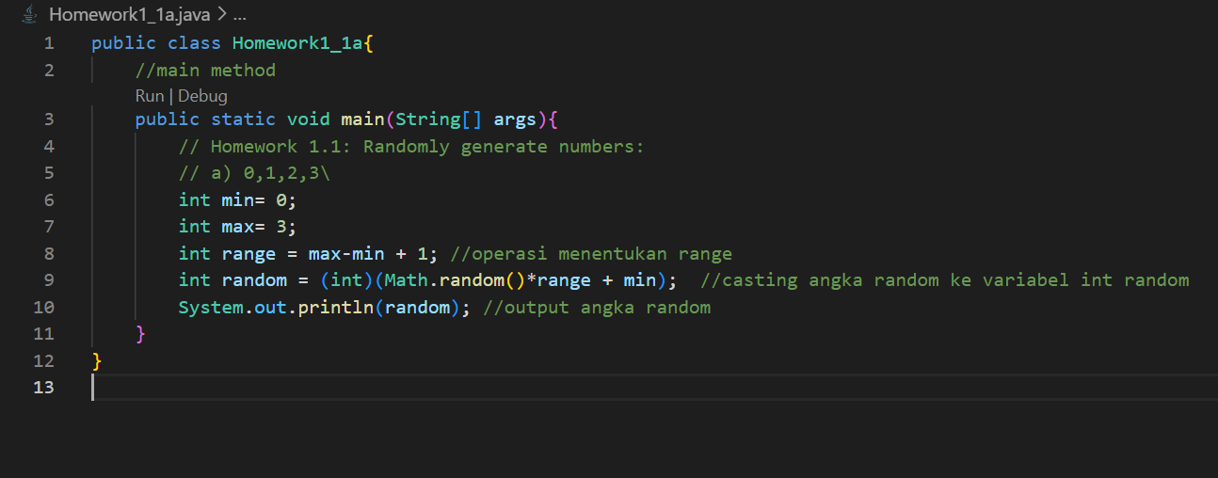

Hasil output:

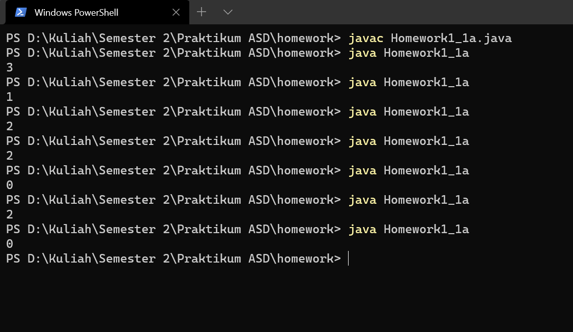

1. 1,2,3,4,5,6

Code:

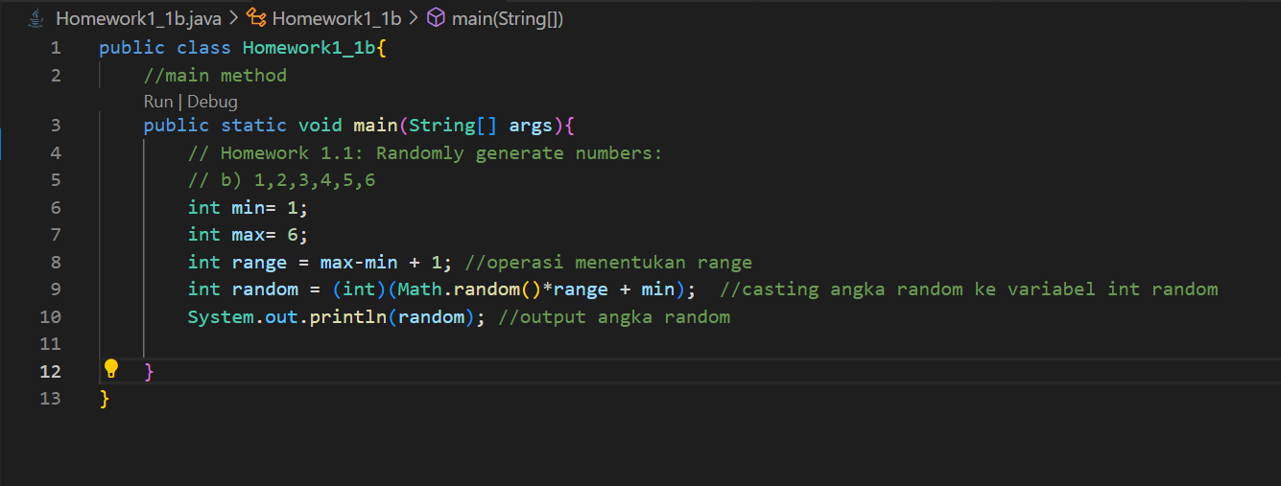

Hasil output:

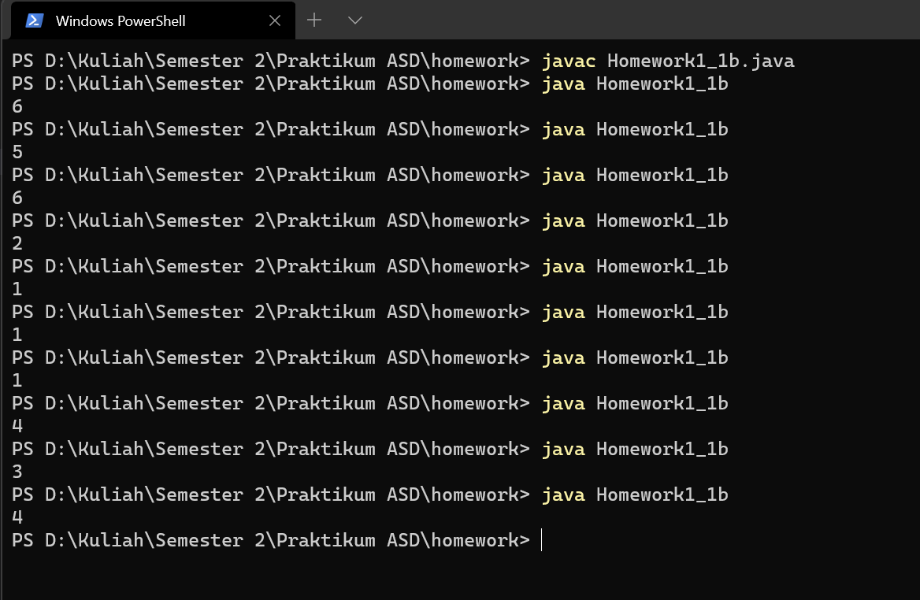

1. 2,4,6,8

Code:

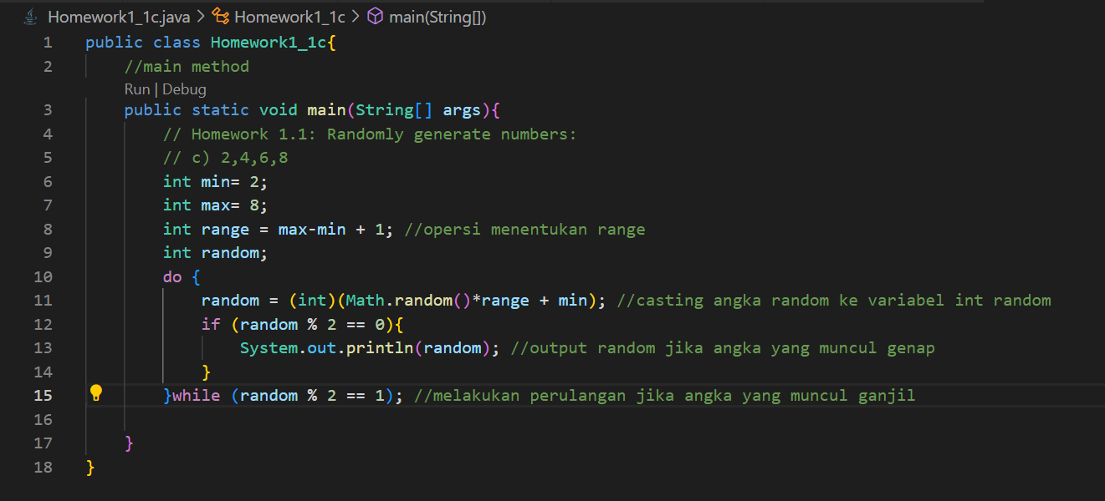

Hasil output:

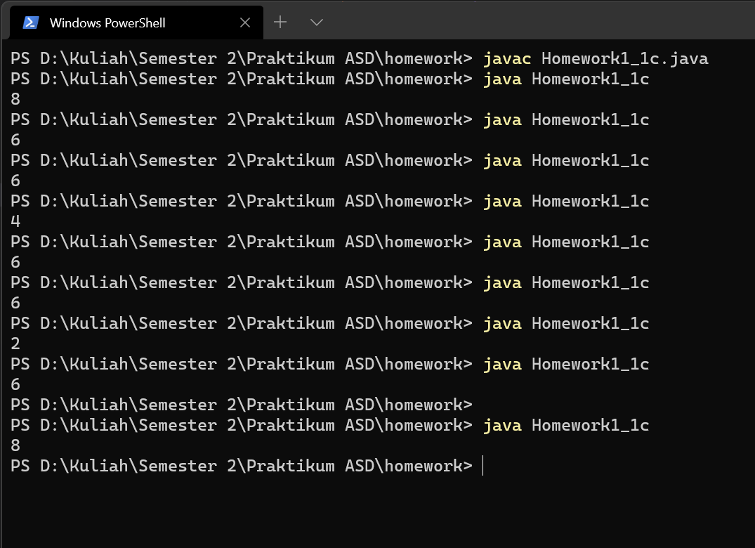

1. -5,-4,...,4,5

Code:

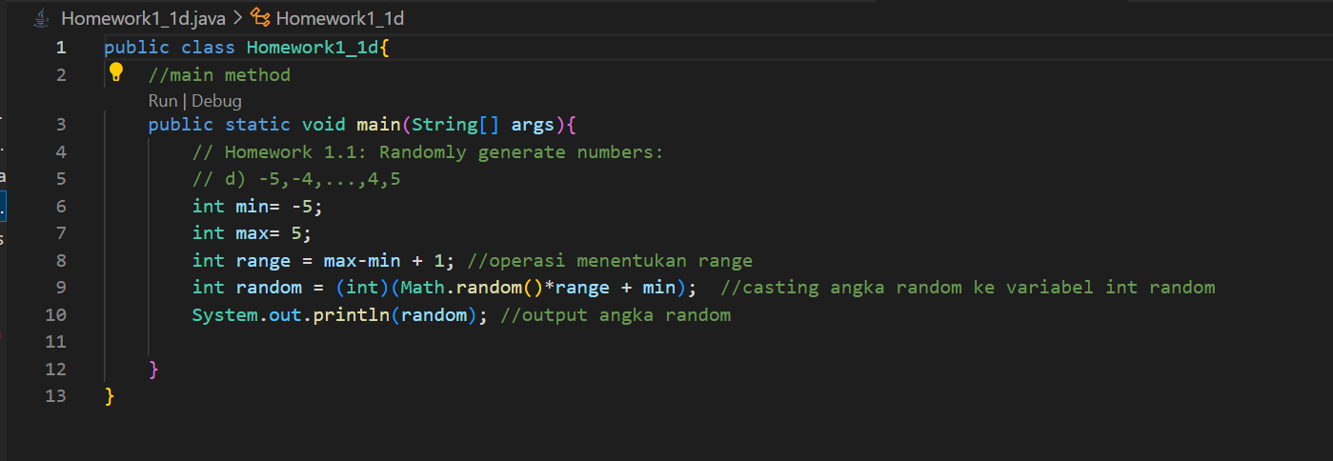

Hasil output:

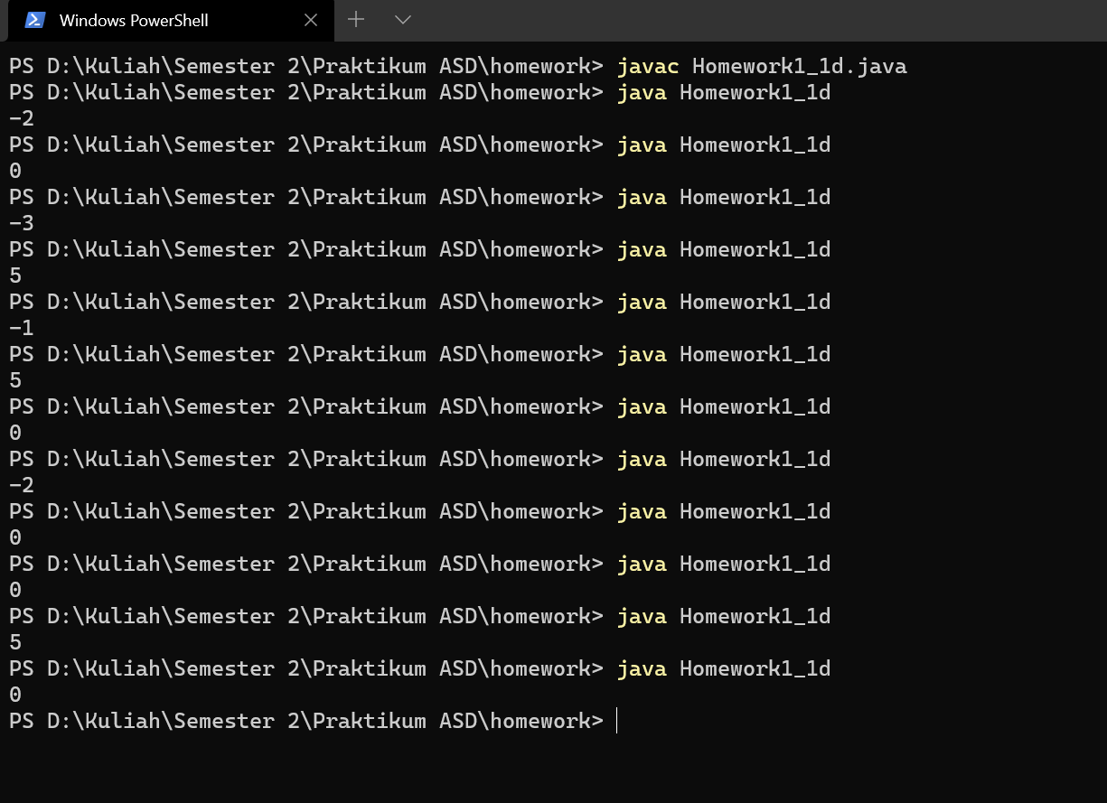

Homework 1.2

Create a program that outputs 9x9 multiplication table

Code:

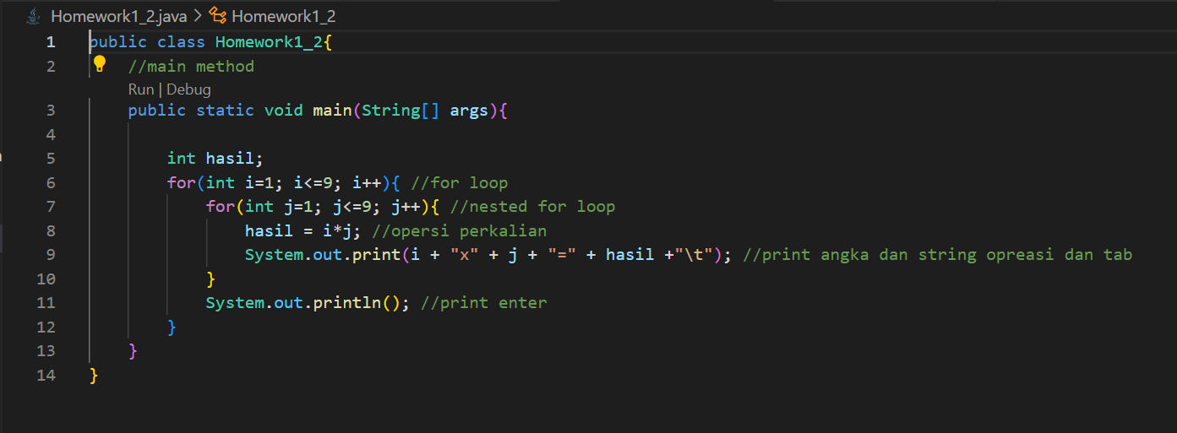

Hasil output:

