

OWL-IMS

Digital Inventory System



Note

If you need training or any kind of expert supports, please feel free to contact us.

Powered By: IMS Team

Pakistan

[mhmmd.nauman@gmail.com](mailto:mhmmd.nauman@gmail.com)

[pakjalihouse@gmail.com](mailto:pakjalihouse@gmail.com)

Table of Content

1. Introduction …………………………………………………………………………

1.1 Purpose

1.2 Services

2.2 User Interface for each Use Case ………………………………………………………..

2.1 Layout

**Use Case 1** : Login Into System

**Use Case 2** : Structure of Dashboard

**Use Case 3** : Category & Items

* + - 3.1 : Category
    - 3.2 : Items

**Use Case 4** : Purchase Order

**Use Case 5** : Order Confirmation

**Use Case 6** : Sale Order

**Use Case 7** : Report

Use Case 1 : Login

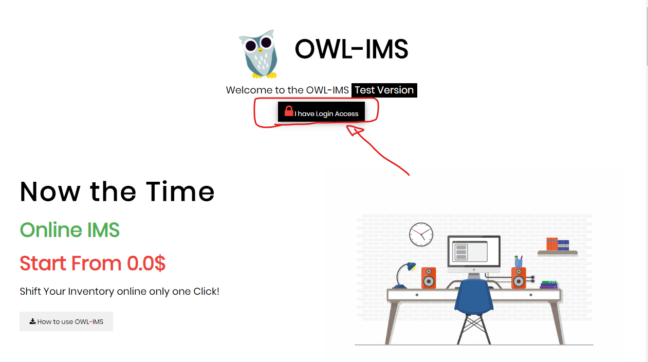

By clicking on  you redirect on this page.

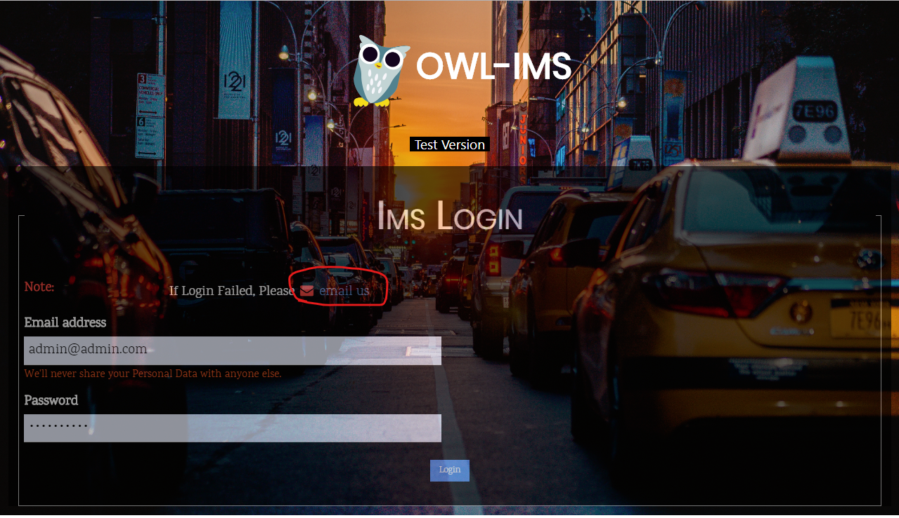

If you don't have login Email address and password. You can email us with some Questions

* Why you need this system?
* How big business you have?
* Which Promo you need?

Our team member contact you soon as possible.

After getting login access and login into system. The system look like this….

Use Case 2 : Structure o

f Dashboard

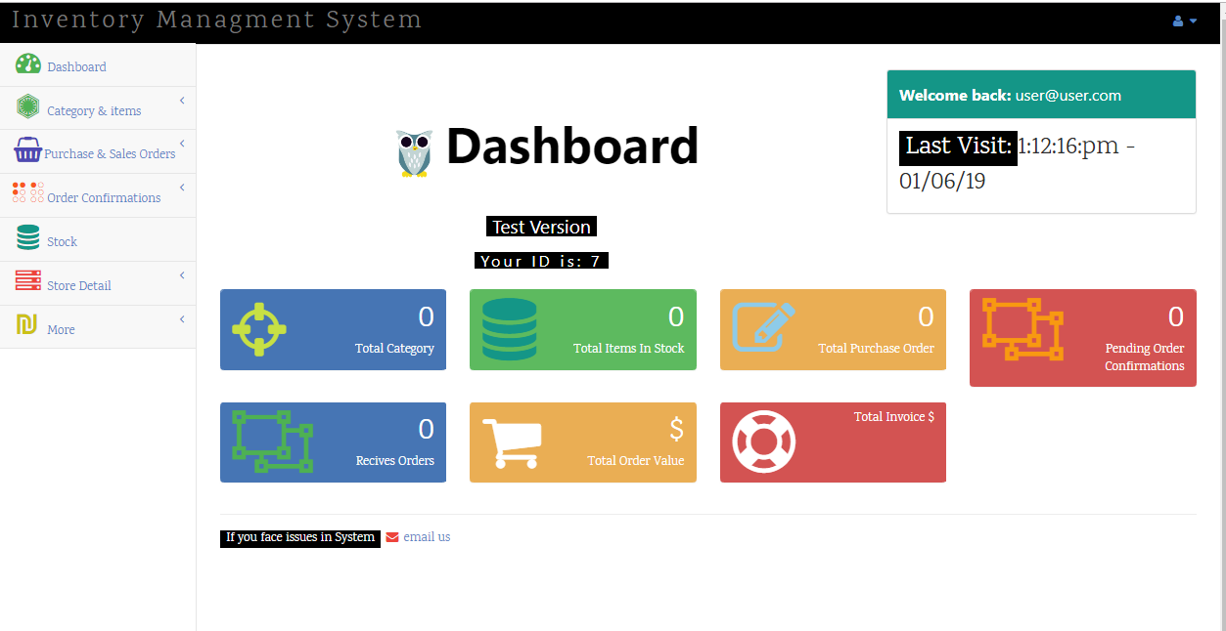

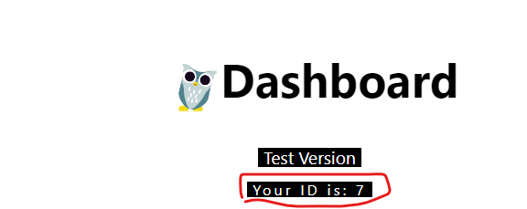

This is your login id.

This is System Version.

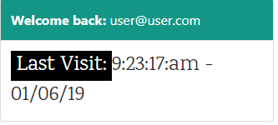 This tell your last login

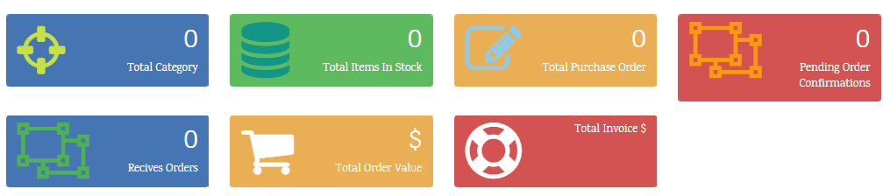

This section tells main function of IMS.

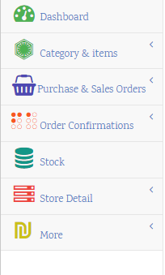

All Basic function of IMS.

* Dashboard
* Category & Items

Category

Items

* + - * Purchase & Sale Orders

Purchase Order

Sale Order

* + - * Order Confirmation

Confirm Po Orders

* + - * Stock
      * Store Detail

Add Store

Store Detail

* + - * More

Report

Buyers

Buyers Purchasing Detail

Vendors

Settings

Use Case 3 : Category & Items

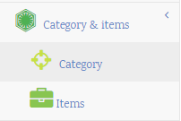

Use Case 3.1 : Category

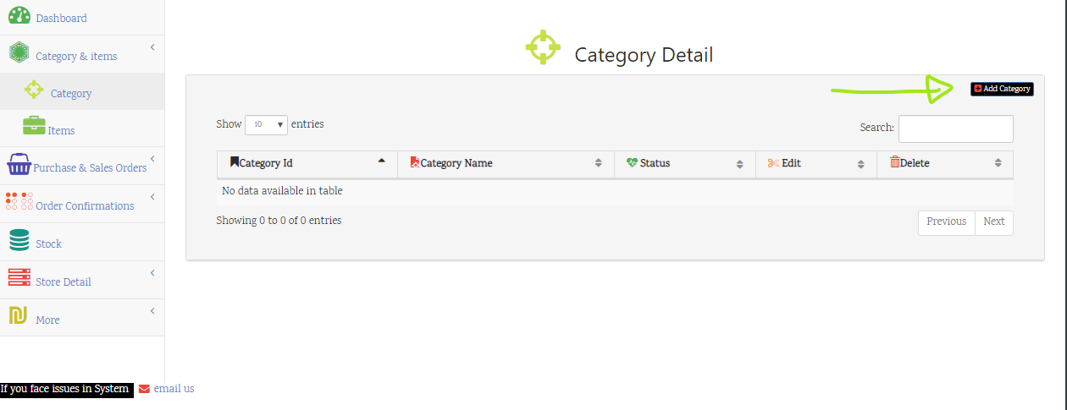

Category Detail

After clicking on this button

**popup will appear like this**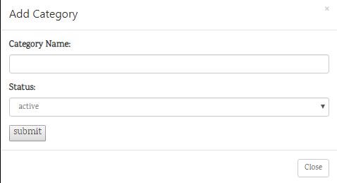

**After adding the Category Name**

it'll look like this

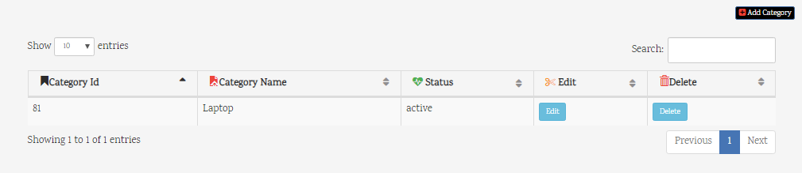

it provide two options

* Edit
* Delete

On Click **Edit**  you can edit Category

On click **Delete** you can delete Category.

By clicking Edit button you can edit category detail 

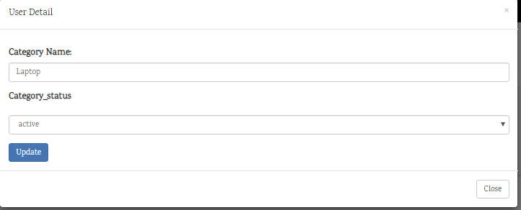

By clicking Delete button you can delete category detail 

Use Case 3.2 : Items

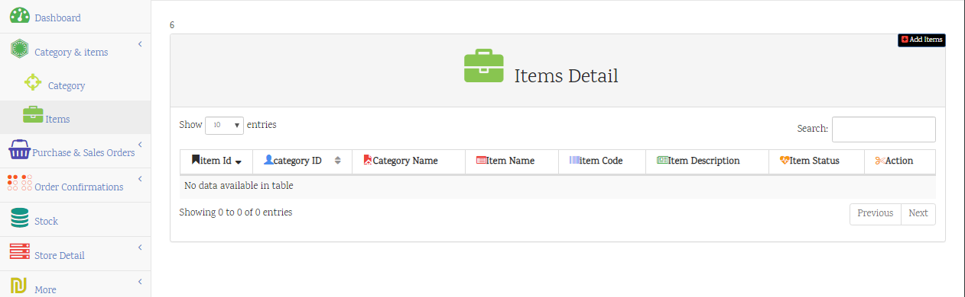

Items Detail

After clicking on this button

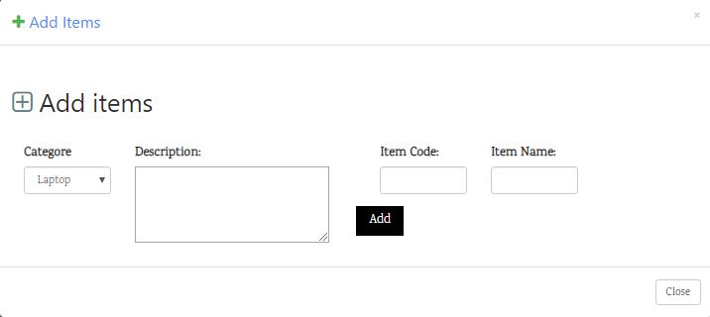Item code of your item

your total added categories. Description of your items

we have one category type "**laptop**" Item name of your item

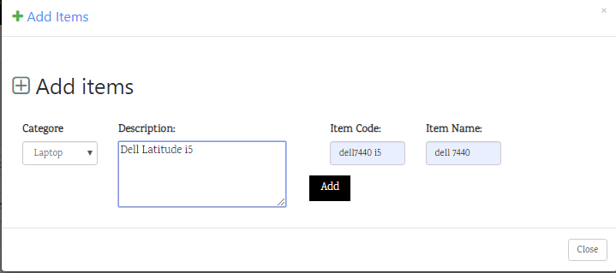

After adding items detail it look like this

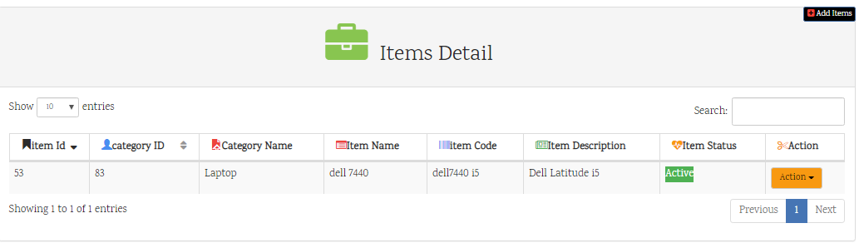

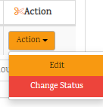

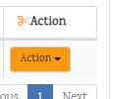

By Expand Action button we have 2 options:

* Edit
* Change Status

After clicking on Edit button you can edit items detail and than update.

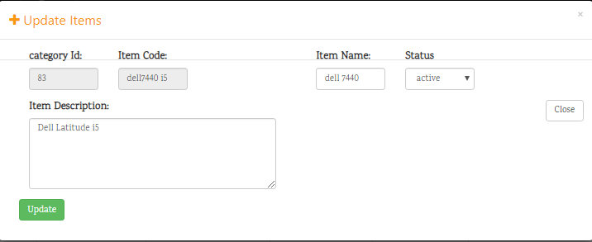

You can only change :

* Items Description
* Item Name
* Status

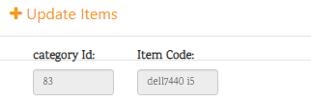

* Category Id & Item Code are Constants you can’t change them.

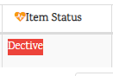

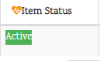On clicking Change Status you can

Activate or Deactivate Items,

Use Case 4 : Purchase Order

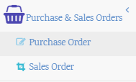

Use Case 4 .1 : Purchase Order

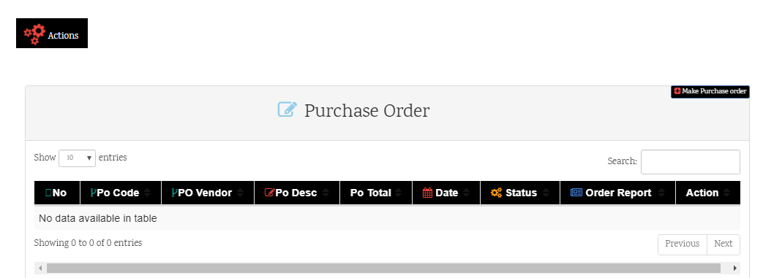

**Purchase Order**

After clicking on this button

The popup will appear where you can make purchase order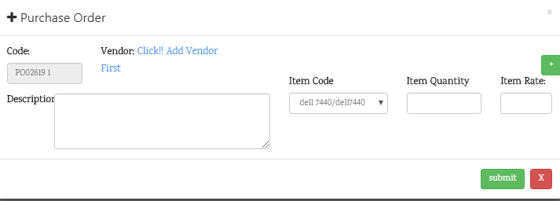

Vendor

Description

PO Code

Item Code

Item QTY

Item Rate

Expand More Fields

How **PO Code** Works?

PO : It Indicate “**Purchase Order**”

02619: It indicate “**Current Date**”

1: It indicate “no of PO`s”

How **Vendor** Works?

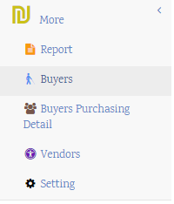Vendor shows, where you purchase your Orders. After clicking on “Click!! Add Vendor First”

It **redirect** you "**Vendor**” Under **More fields.**

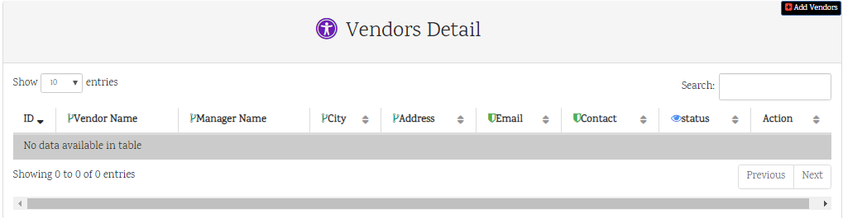

**Vendor Detail**

After clicking on this button

Popup will appear where you can add **Vendor** Details.

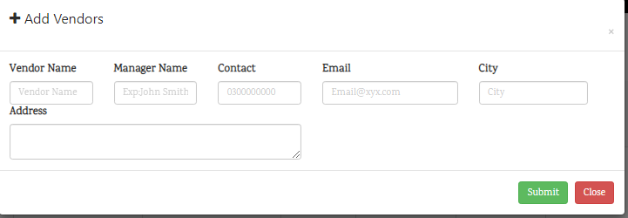

After Adding **Vendors** detail. Now you can see below

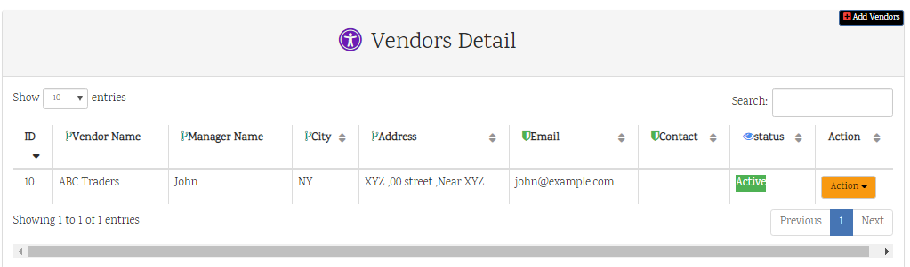

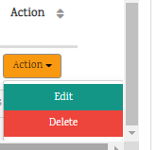 Edit

Delete

After Clicking on **Edit** you can edit and Update Vendors Detail.

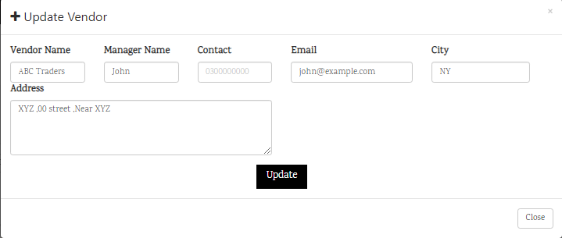



On clicking Change Status you can

Activate or Deactivate Items,

After Adding Vendor Details. Now you can see **Vendors** fields are appear.

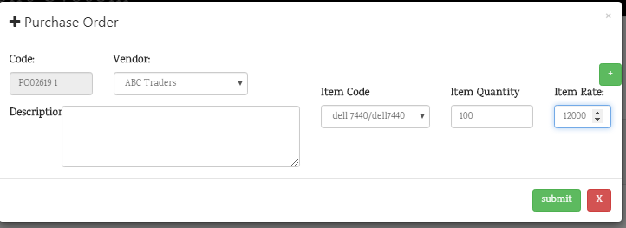

+ Expand More input fields

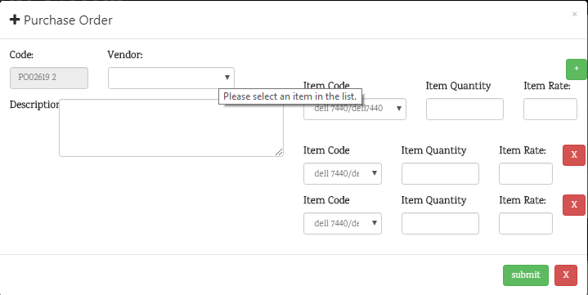

After insert **Purchase Order** it looks like this….

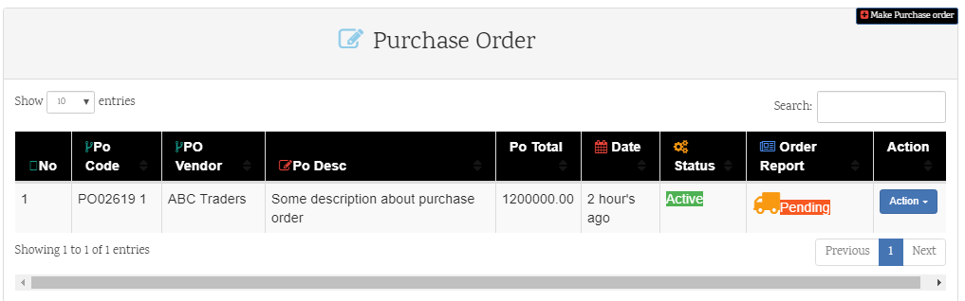

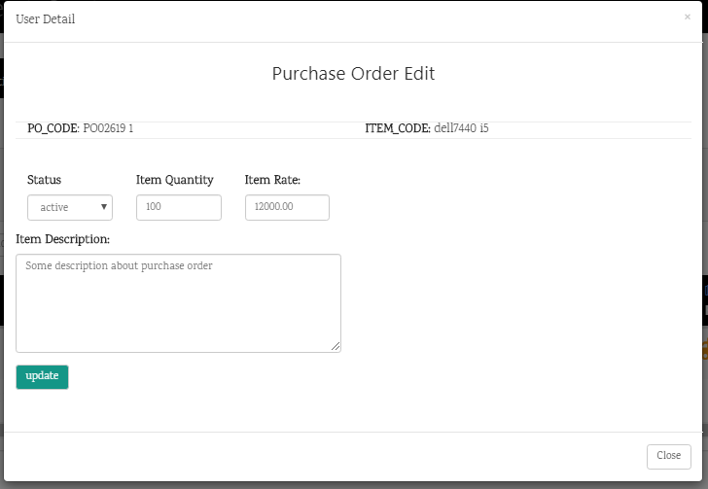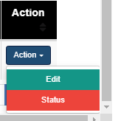

After Click On **Edit**

**Popup appear** where you can edit your **PO** detail.



On clicking Change Status you can

Activate or Deactivate Items,



After Click on **Action Button** it expands some fields. 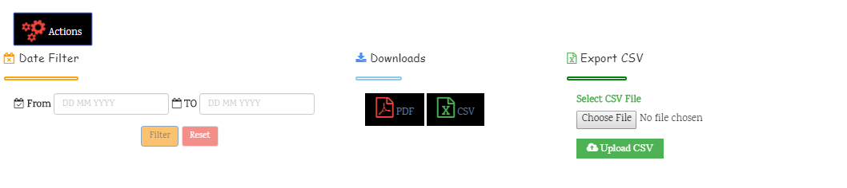

**Export CSV**

You can export csv into after manual changing in Excel.

**Download**

You can download **PDF** or **CSF**

**Date Filter**

You Can filter PO’s with custom date.

Use Case 5 : Order Confirmation

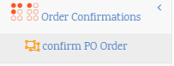

Use Case 5 .1 : Confirm PO Order

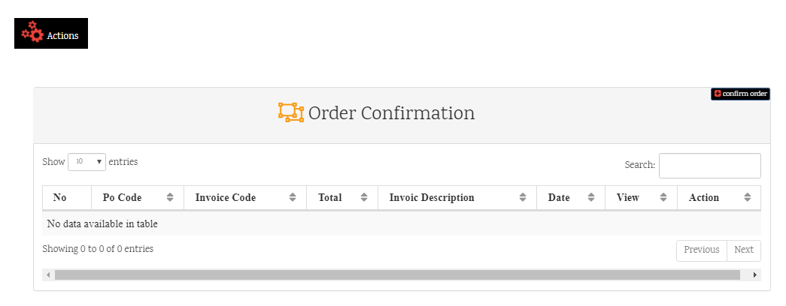

**Order Confirmation**

After clicking on this button

A popup appear where you can confirm your orders…………

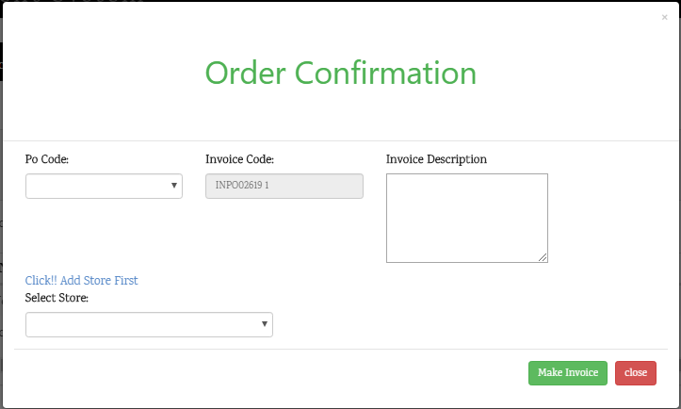

Its means you didn't add store information yet . After clicking on “Click!! Add Store First”.

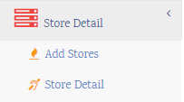It **redirect** you "**Store**” Page Where you can add your store information.

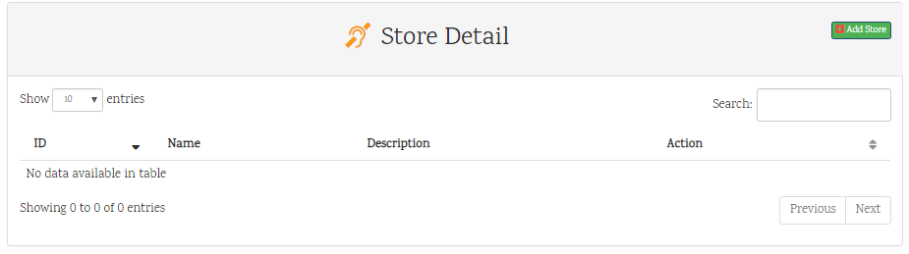

**Store Detail**

After clicking on this button

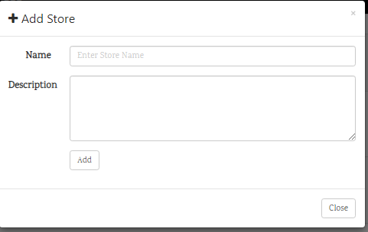Popup will appear where you can add **Store** Details.

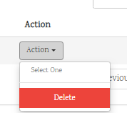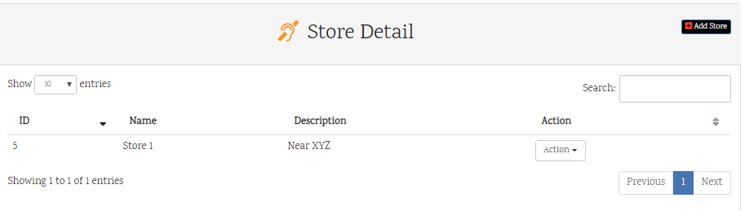

After clicking on **Delete** button, the store will be deleted.



After adding store data you can confirm

your order in **Order Confirmation** Section

You can see **store** are available and you can select **store data**.

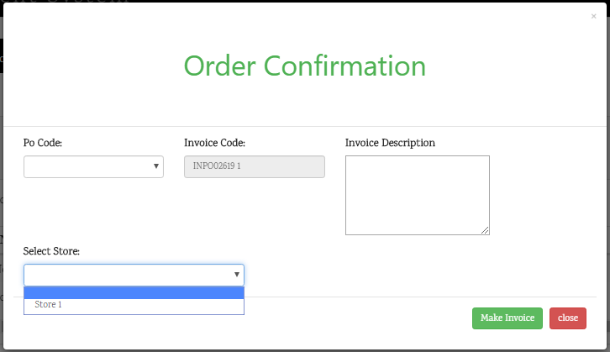

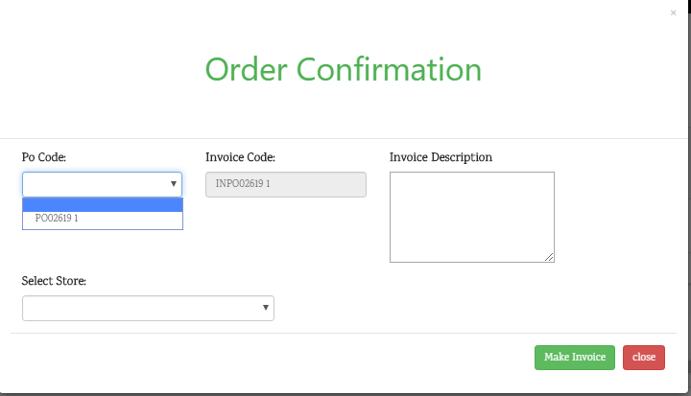

Here you can select "**PO Code**" that you has received

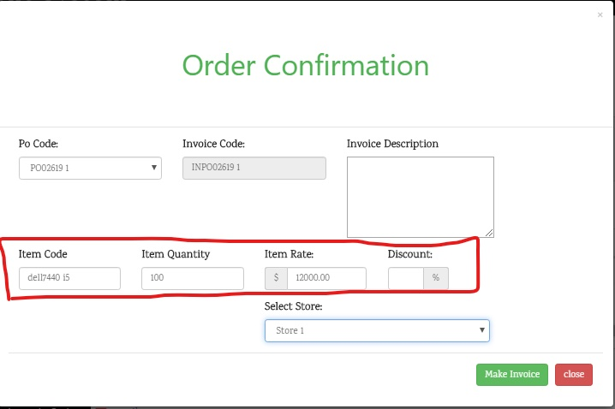

Now you can see the data are available against your "**Po Code**" when you are selected.

All Confirm ORDERS are available in Order Confirmation

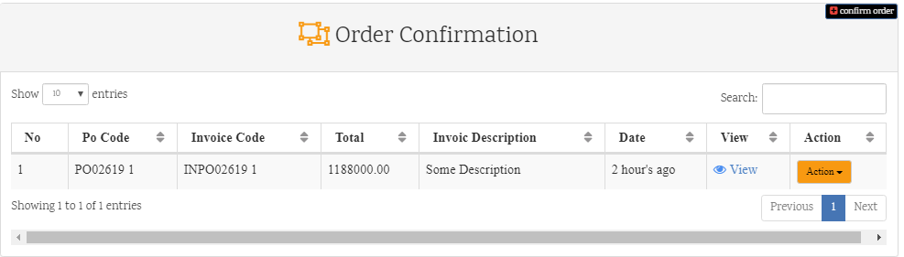

After Click on **View** the detail of Order are shows in popup

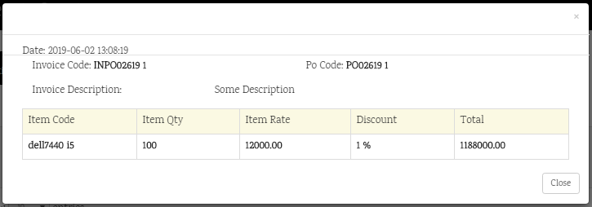

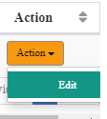

After Clicking on **Edit** button some edit task are performed.

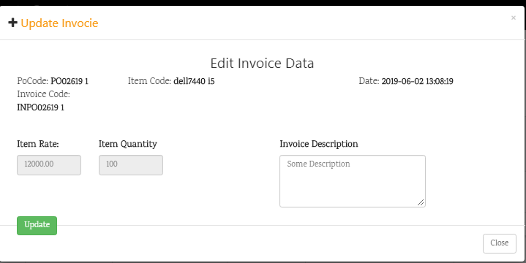

You can **Edit** only Description of Invoice

After Confirmation of **ORDER** different task are performed **Automatically**

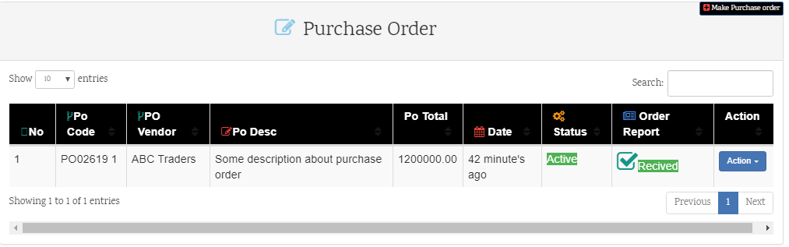

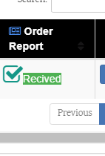

Here you can see in "**Purchase Orde**r " **Order Report** are Received after **Order Confirmation**.

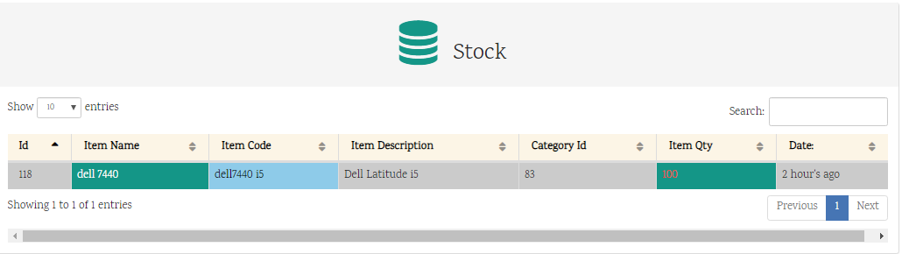After **Confirmation Order** your receiving order are automatically are stored in **Stock**

Note! After click item qty field a popup appears and it shows all detail about specific items

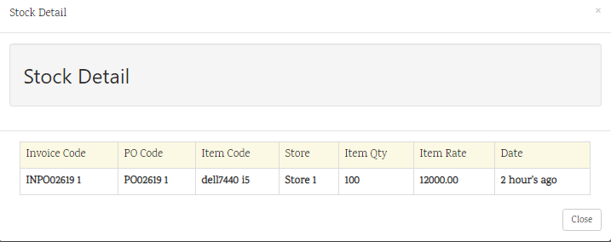

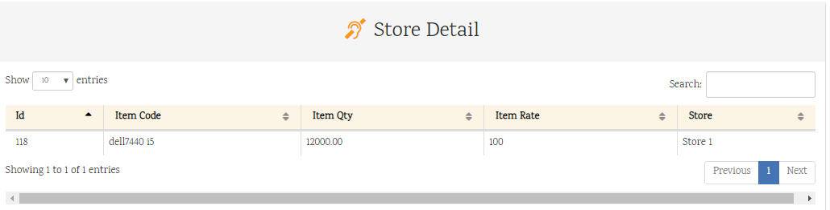

In Store Detail Section you can see which **items** are **stored** in specific stores. And what's their **quantity** and **price**?

Use Case 6 : Sale Order

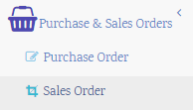

Use Case 6 .1 : Sale Order

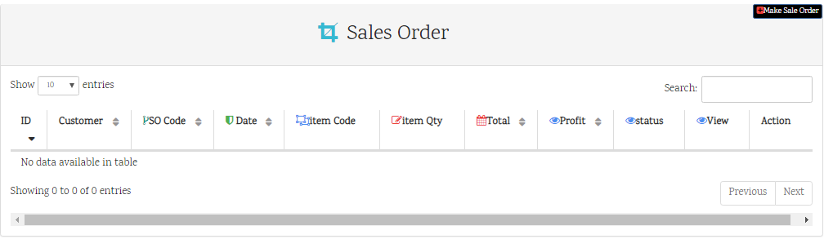

**Make Sale Order**

After clicking on this button

Popup will appear where you can make **Sale Order** Details.

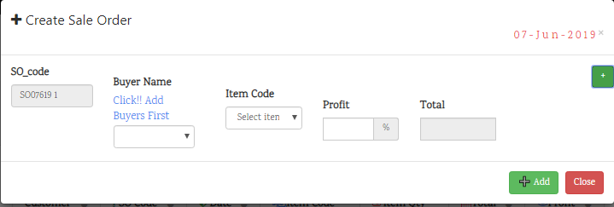

Its means you didn't add store information yet . After clicking on “Click!! Add Buyers First”.

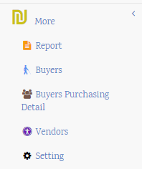It **redirect** you "**Buyers** ” Page Where you can add your store information.

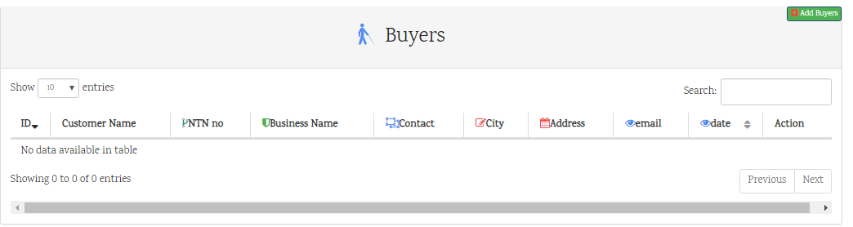

**Add Buyers**

After clicking on this button

Popup will appear where you can **Add Buyers/Customers** Details.

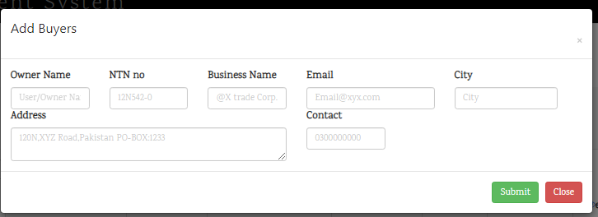

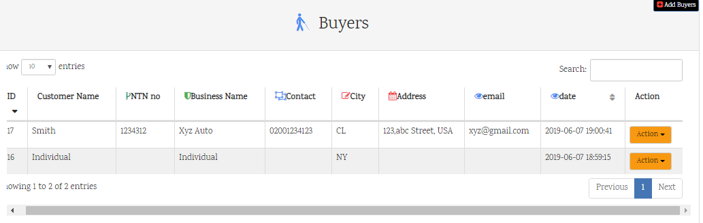**After Adding two records it looks like this**

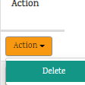

**Here you can Perform Some actions**

After Adding Buyers Detail You can make easily Sale Order.

Now you can see, the message "Add Buyers First" on top of **Buyers Name** are disappears

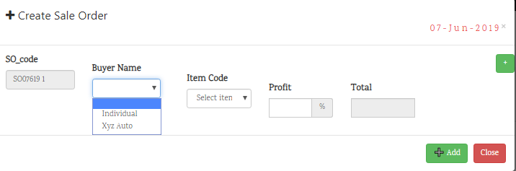

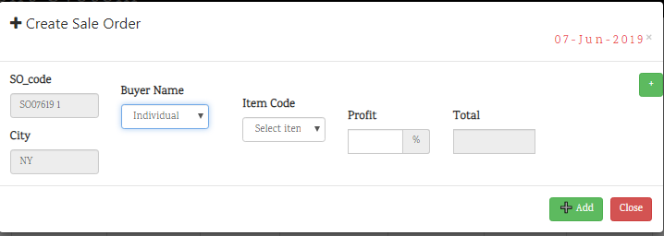After selecting **Buyer** name their city are automatically appears.

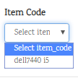After Selecting **Buyers name** you need to select item code….

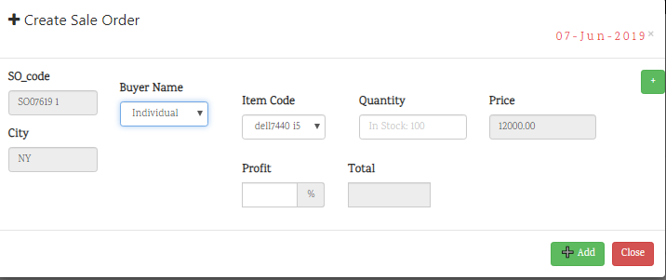



After selecting **Item code** the detail about that item code are comes from stock.

For example, how many **Quantity** are available in Stock.

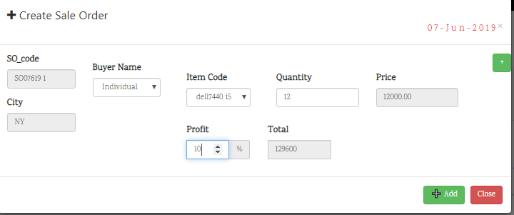

After selecting **Quantity,** you need to select Profit, how much **profit** you want earn on specific item.

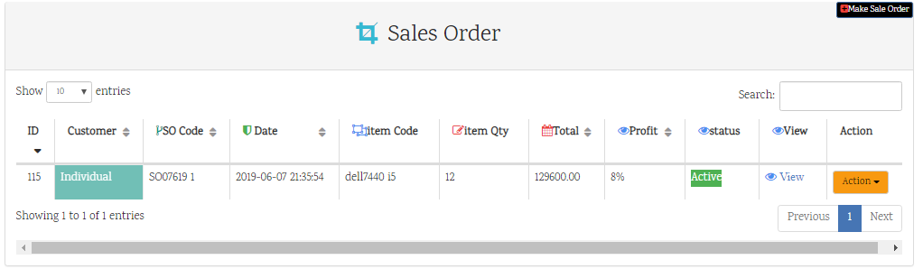

After Selecting detail it looks like this..



Here you can perform some actions on it.

**View**

After clicking on this button

Popup will appear where you can make **View** Details. Where you can see sale order detail.

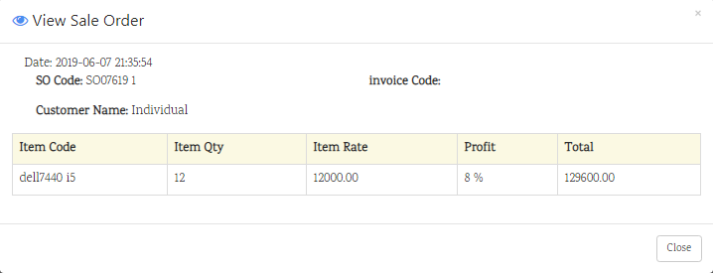

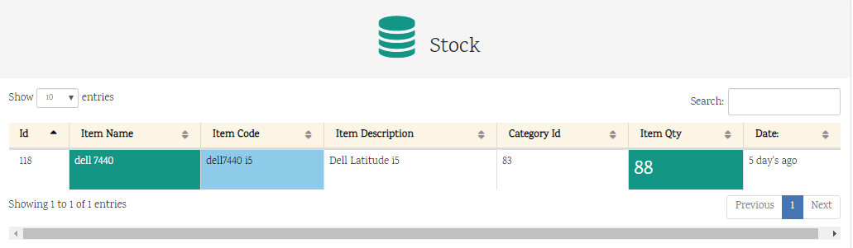

you can see clearly after selling 12 items. **88** items are left from 100.

**Other Interesting features of this IMS is if you wanna track every customer?**

* Customers Purchasing method
* Total purchasing amount of individual customers.
* When individual customers purchased items from you? Its complete tracking.

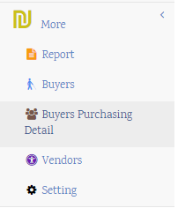

**Let see, where this feature are available**.

This feature is available under **More**

**Buyers Purchasing Detail**

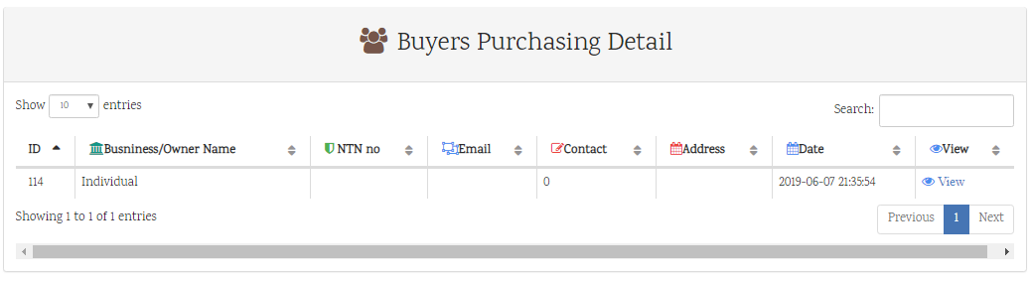

**View**

After clicking on this button

Popup will appear where you can make **View** Details. Where you can see **Buyers Purchasing Detail**.

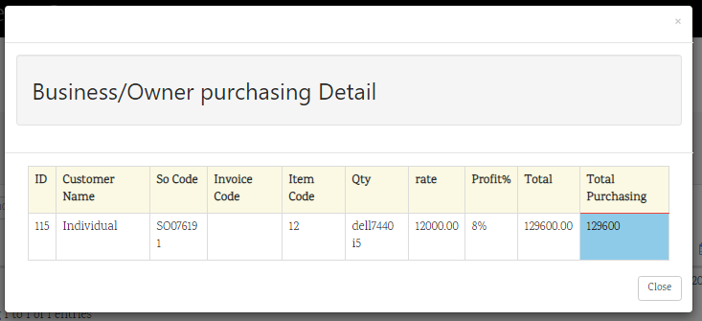

**Total**

It tells the total amount of specific item.

**Total Purchasing**

It tells the total purchasing of that customer or Buyer

Use Case 7 : Report

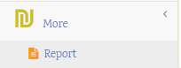

Use Case 7 .1 : 30 Days Report

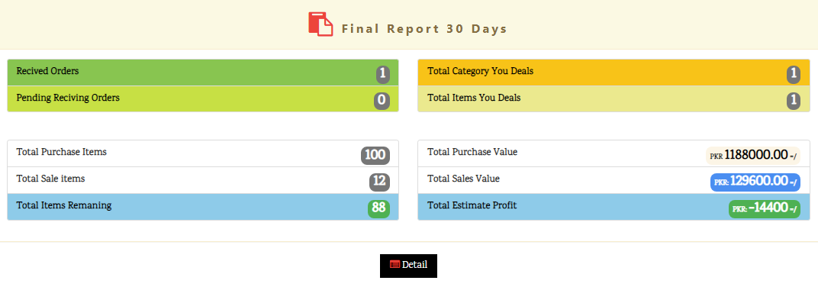

**what include in 30 days report.**

* Received Order
* Total Category
* Pending Receiving Order
* Total Items you deal
* Total Purchase Items
* Total Purchase Value
* Total Sale Items
* Total Sale Value
* Total Items Remaining
* Total Earn Profit



After clicking on this **Quantity**

Popup will appear where it shows all information about that items