Information on Raw Dataset

Basic Info:
Could not read colored images because of the memory issue but tested for the gray scale
Training data:
- 16930 images
- shape
- Labels= [“COVID”, “Lung_opacity”, “normal”, “pneumonia”]
Label: COVID Count: 2892
Label: Lung_Opacity Count: 4809
Label: Normal Count: 8153
Label: pneumonia Count: 1076
Test data:
- 4235 images
- shape: (299,299)
Noisy data:
- 4325 images
- most images have shapes (299,299) except there are 283 images with Shape: (256, 256)

Anomalous Images (Training data):

- White region: (more than one)
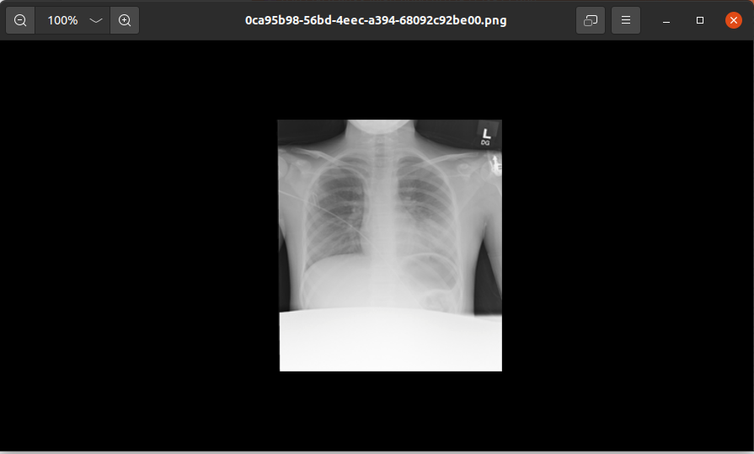

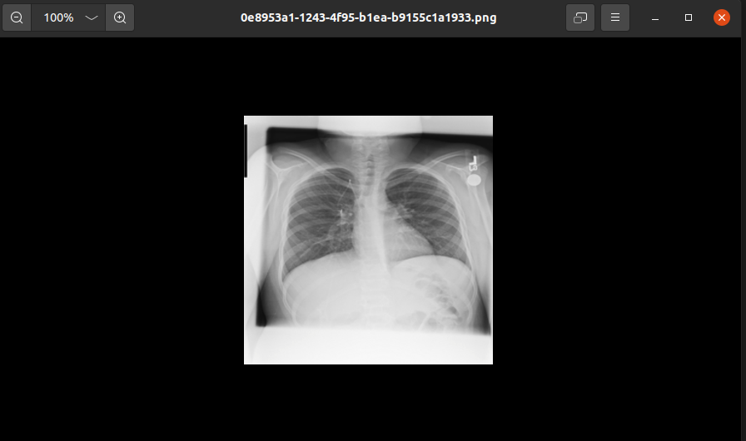

- there are some arrows/marks/letters written at different locations / rectangles (more than one, more than one in an image)
- Some images show medical equipments in the xrays. (this is not the only one)
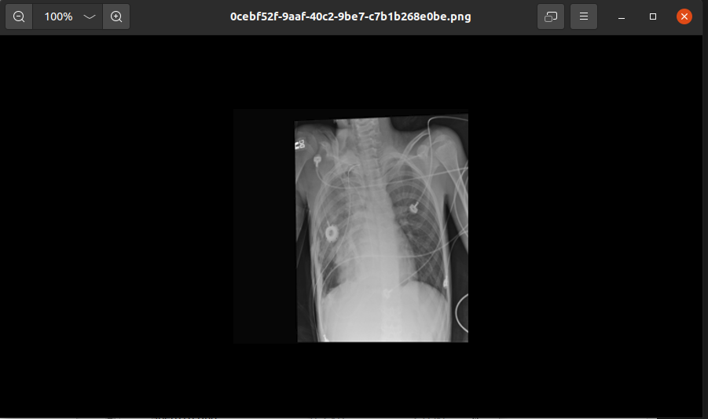

- Some X rays does notseem to be correct in the sense that skin is visible covering the lung region

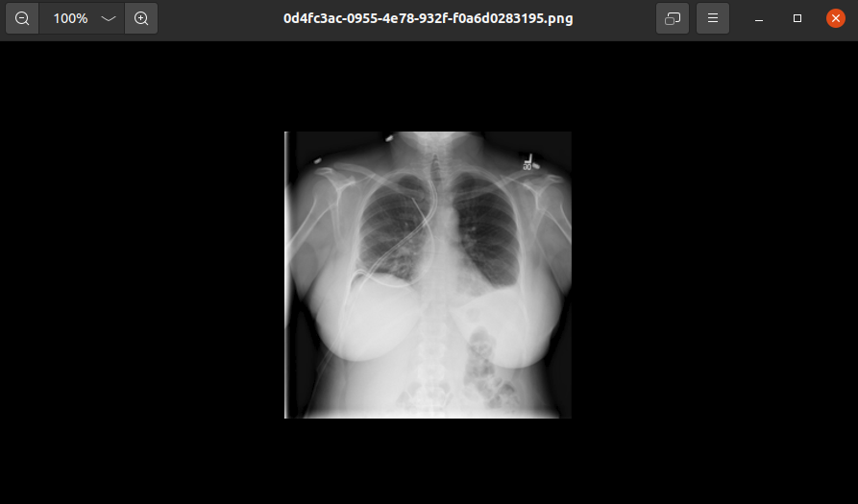

- Nothing visible?(more than one)
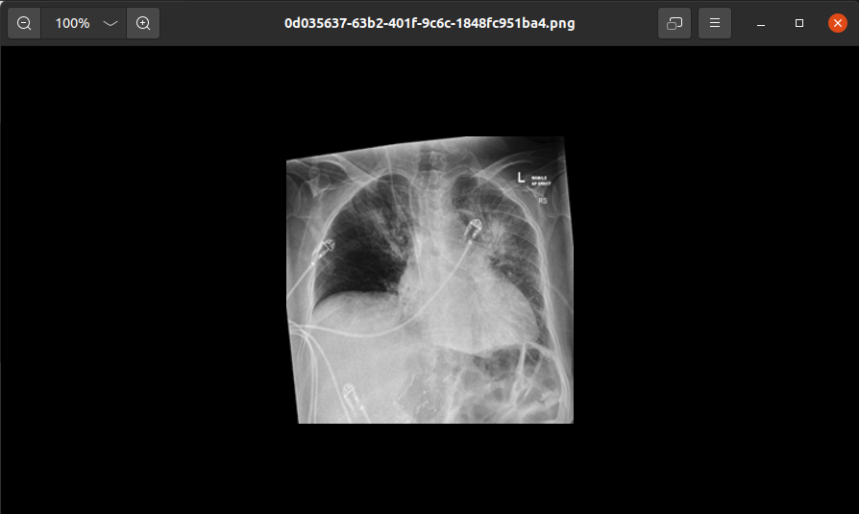

- Black region or squeeze image
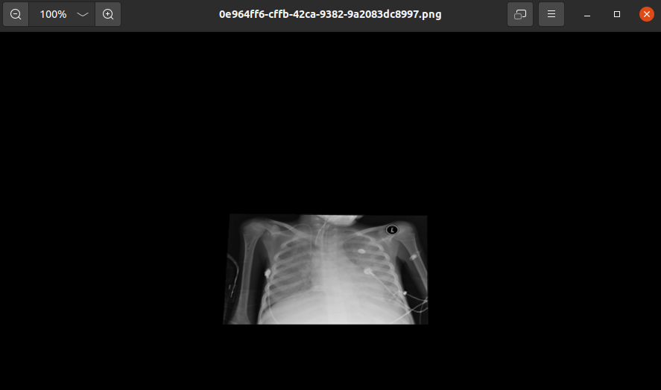
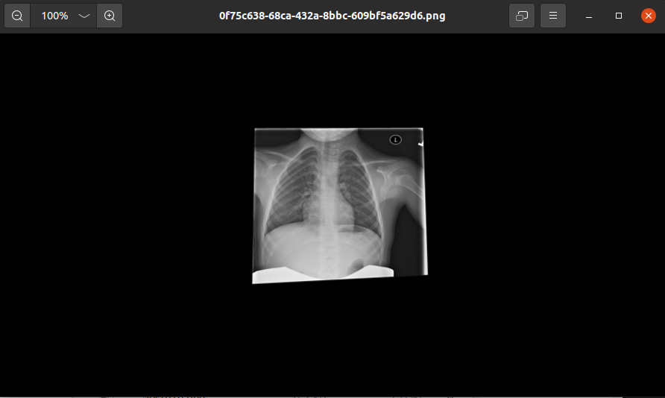

- Shifted

- skewed
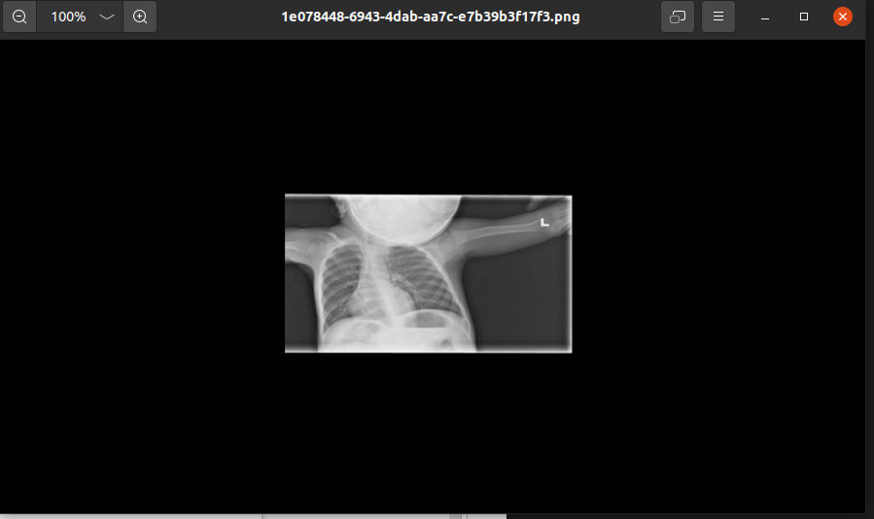

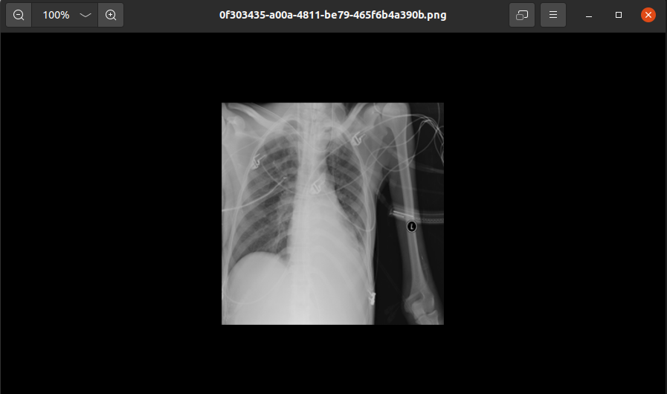

load_data(raw or .npy, return train, test, noisy

kfold, normalization

/ installnig packages
pip freeze > requirements.txt
pip install -r /path/to/requirements.txt

