# Customer & Bank Process - Java Spring Boot Process Engine Integration

## BPMN Model ( created from Camunda Modeler )

**ecom.bpmn**

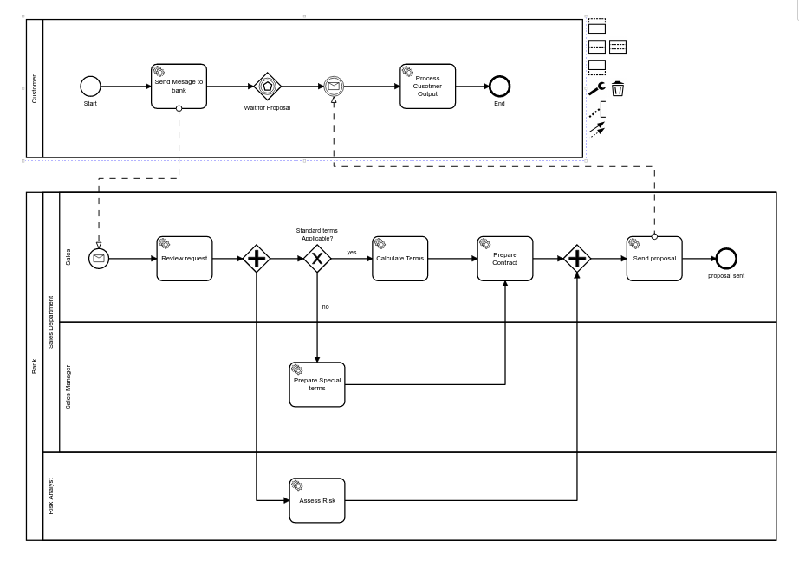

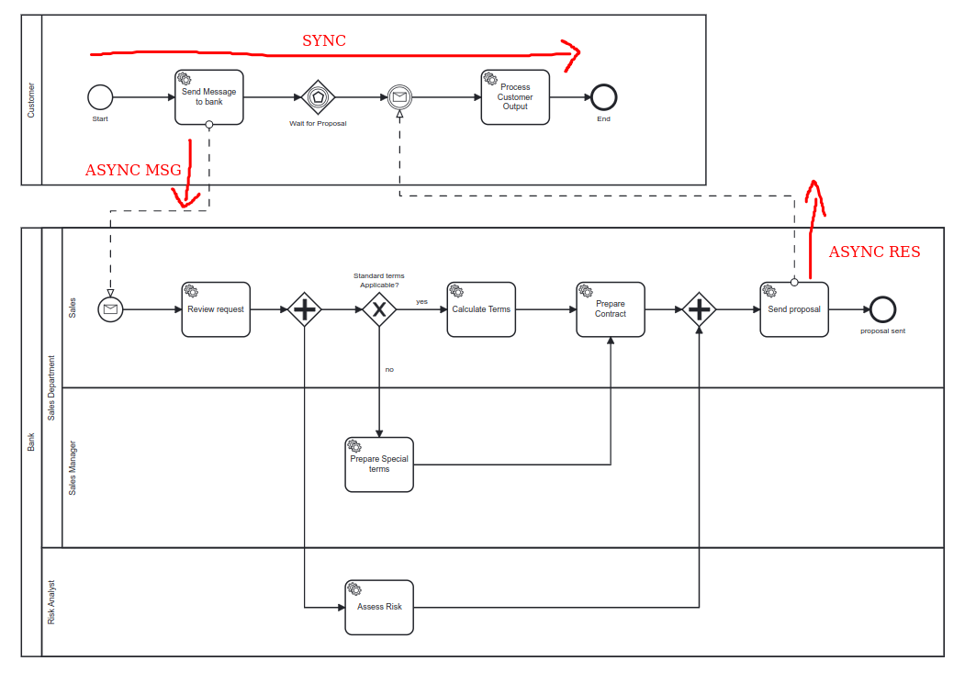

Above model contains 2 main processes

1. Customer
2. Bank

The workflow will be initiated through the below REST call which will trigger the customer process to start, send the message to bank (Sales Department - sales lane) and wait for the bank’s sales department to send the proposal back to the customer process, once the proposal is received, first the bank process will end it’s execution and then the customer process will review the proposal details and end it’s execution with the final results.

**Customer Process - HTTP REST Request**

| POST /api/v1/**customerpool**/start  HTTP/1.1  Host: localhost:8080  Content-Type: application/json  Content-Length: 40  {  "passStandardTermsApplicable": true  } |
| --- |

‘

