

Faculty of Engineering & Technology
Electrical & Computer Engineering Department
ENCS4380, Interfacing Techniques
Homework Assignment: 3D printing Robot
Our Robot “ Saree3 /سريع ”

Prepared by:
StudentOneName : Aya AbuSneineh ID: 1221414
StudentTwoName : Ahamd Sous ID: 1221371
StudentThreeName : Raseel Jafar ID: 1220724
StudentFourName : Basmala AbuHakmeh ID: 1220184
Instructor: Dr. Wasel Ghanem
Submission Date : 28/10/2025

Table of Contents

Table of figures II
1. Introduction 1
2. Design Phase 2
2.1 Overall Shape Selection 2
2.2 Dimensions and Size Constraints 2
2.3 Two-Layer Structure 3
2.4 Wheel Configuration 5
2.5 Sensor Placement and Considerations 6
2.6 Battery and Power System 6
2.7 LEDs and Indicators 7
2.8 PID Control System 7
2.9 Design Software and Reference 7
2.10 Structure of our design 8
3.Creativity and Functionality 10
4. Tools and Methods 11
5. Additional Design Reference 11

Table of figures

Figure 1 : lower layer body 3
Figure 2 : Upper layer body 4
Figure 3 : Standoff Pillar Connecting Upper and Lower Layers 4
Figure 4 : Large Driving Wheel 5
Figure 5 : Small Rear Caster Wheel 5
Figure 6 : Lower Layer of the Robot with Motors, Caster Wheel, and Battery Placement 8
Figure 7 : Upper Layer of the Robot with Arduino, Sensors, LEDs, and Wiring 8
Figure 8 : Assembled Robot Showing Upper and Lower Layers Connected with Standoff Pillars 9

Introduction
In this task, our team designed a small robot intended to navigate mazes, inspired by the Micromouse competition concept. The goal was to develop a compact and efficient robot that could detect and avoid obstacles while following optimal paths inside a maze environment.
Our design is based on a circular two-layer body with a radius of 5 cm, providing both stability and space for internal components.
We aimed to balance creativity with functionality by integrating an ultrasonic sensor for distance detection, LEDs for status indication, and a well-structured chassis suitable for 3D printing. Through this project, we learned how mechanical design and sensor placement directly affect robot movement, balance, and maze-solving capability.

2. Design Phase

2.1 Overall Shape Selection
In the beginning of our design process, we decided that our robot should have a circular shape rather than a square or rectangular one.
The circular design provides better maneuverability inside a maze, since it allows smoother turning and prevents the robot from getting stuck at sharp maze corners. A square-shaped body would make it harder to rotate precisely, especially in narrow maze paths, while a cylindrical body with vertical height could make the robot unstable during fast movements.
By choosing a flat circular structure, the robot achieves a lower center of gravity, better balance, and equal distribution of weight around the center. This makes the motion more stable and efficient for maze-solving tasks.

2.2 Dimensions and Size Constraints
According to the Micromouse competition rules, the robot’s dimensions should be less than 20 × 20 × 20 cm.
Based on this limitation, we decided to design our robot with a radius of 5 cm (diameter ≈ 10 cm), which ensures it fits easily within the allowed size range.
This size also provides enough space to place internal components such as sensors, motors, and the control board, while keeping the robot small and agile for quick navigation through maze cells.

2.3 Two-Layer Structure
Our design consists of two circular layers (upper and lower) to organize components efficiently and maintain balance.
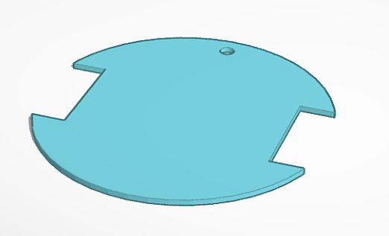
Figure 1 : lower layer body
The lower layer contains the motors, wheels, caster wheel, and battery. We intentionally placed the battery in the lower layer, positioned slightly above the small rear caster wheel, to act as a stabilizing weight.
This placement helps lower the robot’s center of gravity and provides better traction on the driving wheels, preventing the robot from tipping backward during acceleration or when changing direction quickly.
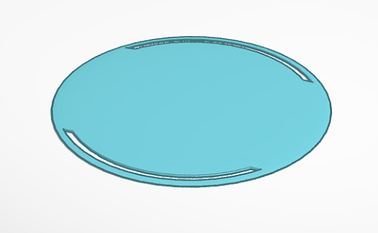
Figure 2 : Upper layer body
The upper layer carries the Arduino microcontroller, sensors, LEDs, and wiring.
The holes on this layer are designed for routing the wires neatly through the body, ensuring a clean layout and preventing tangling or obstruction of other components.
Placing the Arduino above makes it easier to connect the electronic components, upload programs, and maintain the circuit without affecting the mechanical parts below.
Using two separate layers allows for clear separation between the electronic and mechanical systems, minimizing interference and simplifying assembly.
This structure also gives the robot a clean, modular, and 3D-print-friendly design that can be easily upgraded in future versions.
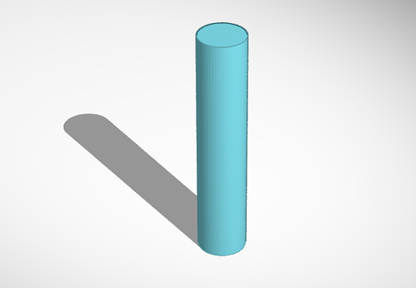
The standoff pillar connects the upper and lower layers and keeps them at a fixed distance. It helps make the structure strong and stable. The space between the layers also gives room for wires and electronic parts, making it easier to assemble and maintain.

Figure 3 : Standoff Pillar Connecting Upper and Lower Layers

2.4 Wheel Configuration
We chose to use three wheels: two large driving wheels on the sides and one small supporting wheel in the front or center.
The two main wheels are connected to the motors and provide the forward and turning motion using a differential drive system.
The small wheel acts as a caster wheel, which stabilizes the robot and supports its weight without restricting direction.
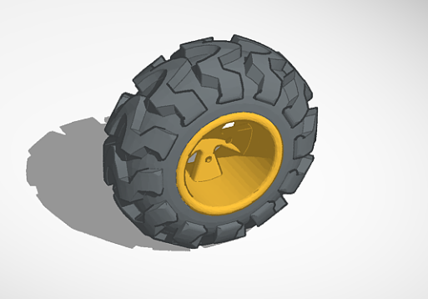
Figure 4 : Large Driving Wheel
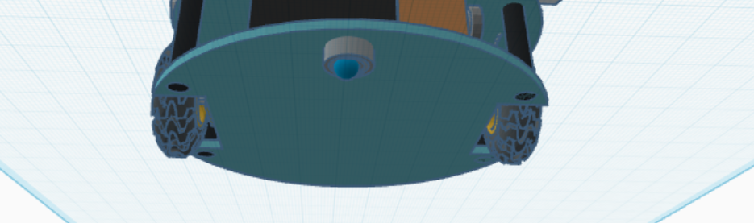
Figure 5 : Small Rear Caster Wheel

This configuration is more efficient than using four wheels because it reduces friction, simplifies movement control, and keeps the design lightweight.
It also ensures smoother turns and easier programming when navigating through maze intersections.

2.5 Sensor Placement and Considerations
During the design, we considered the space and orientation needed for the sensors.
An ultrasonic sensor was positioned at the front of the robot to detect maze walls and obstacles.
The circular shape helps ensure the sensor has a clear, wide field of view, and the front placement allows accurate distance measurement while moving forward.
Additional mounting holes were planned for possible future sensors, such as side sensors, to improve maze-solving accuracy.

2.6 Battery and Power System
In our design, the battery is placed in the lower layer, directly above the small rear caster wheel.
This position was chosen intentionally to serve both mechanical and control purposes. Mechanically, placing the battery low helps stabilize the robot by lowering the center of gravity and distributing weight evenly between the main wheels and the rear caster.
The slight rearward positioning adds a counterbalance effect, preventing the robot from tilting backward or losing traction during sudden acceleration or turning.
From a design perspective, this location also makes wiring shorter and cleaner, since the motors are mounted in the same layer.
We ensured that there’s enough space for safe cable routing between the two layers and that the battery remains secure but removable, allowing easy access for recharging or replacement when needed.

2.7 LEDs and Indicators
We added LED indicators to the design to provide simple visual feedback — for example, showing when the robot is powered on or when it detects an obstacle.
They are positioned on the top layer, visible from any angle, and contribute to the robot’s functional appearance.

2.8 PID Control System
To improve the robot’s movement precision and maze navigation, we planned to implement a PID (Proportional Integral Derivative) controller in the control logic.
The PID controller continuously calculates the error between the desired path and the actual movement of the robot, then adjusts the motor speeds accordingly to minimize this error.
This control approach helps maintain smooth and stable motion, especially when the robot makes turns or tries to correct its direction after detecting walls using the ultrasonic sensor.
By tuning the PID parameters (Kp, Ki, and Kd), the robot can achieve balanced motion, fast enough to navigate efficiently but stable enough to avoid oscillations or overshooting.
Integrating the PID controller makes the design more intelligent and responsive, allowing it to adapt dynamically to maze conditions and maintain consistent speed and direction.

2.9 Design Software and Reference
The entire design was created using TinkerCAD, an easy-to-use and cloud-based 3D modeling tool suitable for quick prototyping.
We were inspired by the visual design ideas from Instructables Micromouse for Beginners we mainly looked at the images to understand component placement and structure.
However, our design was developed independently, adjusted to meet our own goals, and customized for better balance and compactness.

2.10 Structure of our design
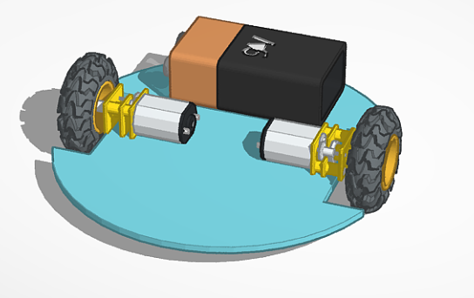
Figure 6 : Lower Layer of the Robot with Motors, Caster Wheel, and Battery Placement
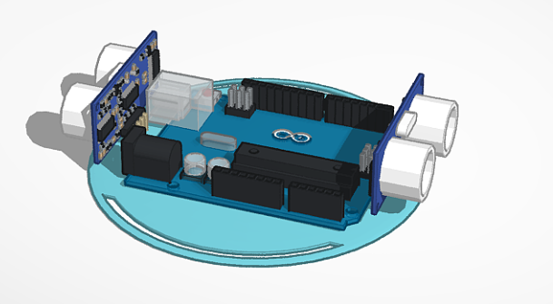
Figure 7 : Upper Layer of the Robot with Arduino, Sensors, LEDs, and Wiring
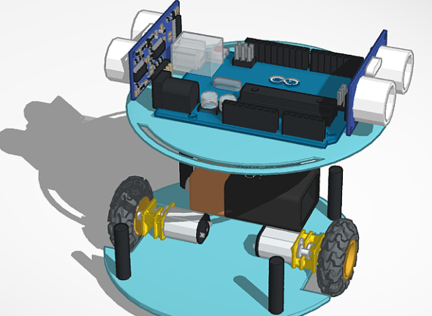 | 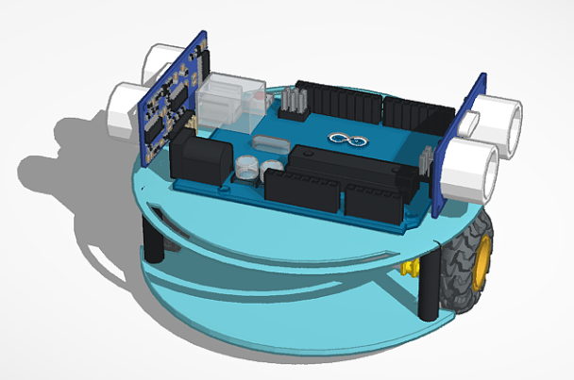

Figure 8 : Assembled Robot Showing Upper and Lower Layers Connected with Standoff Pillars

3.Creativity and Functionality
Our robot design combines both creativity and functionality to achieve a practical yet innovative solution for maze navigation.
The circular double-layer structure is not only visually unique but also functionally efficient it allows a compact design with clear separation between the mechanical and electronic components, reducing interference and simplifying maintenance.
The placement of the battery above the rear caster wheel is an innovative approach that improves balance and traction by lowering the center of gravity and stabilizing the robot during motion. This small but thoughtful adjustment enhances the robot’s control, especially when performing sharp turns inside the maze.
Additionally, the three-wheel configuration provides smooth and efficient movement while minimizing friction and control complexity.
Using LED indicators adds a functional yet creative touch giving the robot a “lively” appearance while also providing feedback on its status (such as power on or obstacle detection).
We also designed the chassis to be modular and easy to upgrade. Future versions can include additional sensors or an enhanced control system without redesigning the entire body.
This forward-thinking design reflects our understanding of both engineering principles and real-world usability, blending creativity with technical precision.

4. Tools and Methods
In this task , we used a combination of software tools, research resources, and personal skills to design and model our 3D-printable robot effectively.
The primary design software we used was TinkerCAD, which allowed us to create a precise 3D model of the robot’s layers, wheels, and internal components. The program’s simple interface enabled quick adjustments, measurements, and visualization of how all components fit together.
To guide our design decisions, we conducted online research using Google to study existing Micromouse robot designs, component placement, and general maze-solving strategies. We also referred to educational videos to understand how each mechanical and electronic component functions within the robot.
Our personal knowledge and skills in physics and mathematics were essential in calculating dimensions, wheel placement, weight distribution, and balance. These calculations ensured the robot could move smoothly and maintain stability while navigating a maze.
By combining these tools, resources, and skills, we were able to produce a functional and aesthetically organized design that is ready for 3D printing and future testing.

Additional Design Reference
For more details and a better view of the complete design of our micromouse robot Saree3, visit the Tinkercad model using the link below:
View Full Design on TinkerCAD

