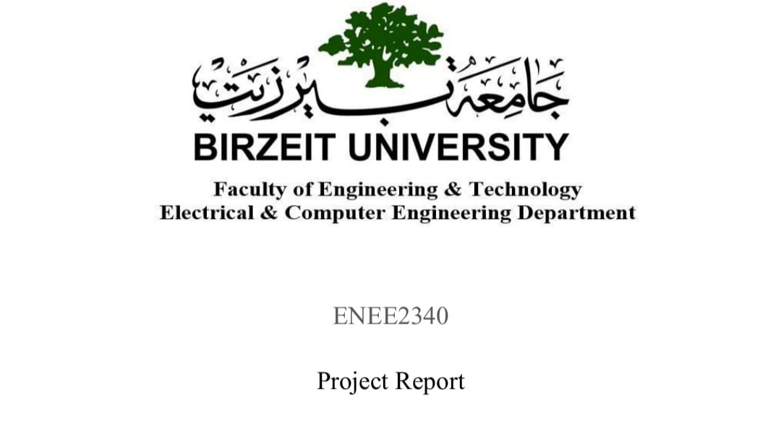

Name : Ahmad Shaher Ahmad Sous

NUM: 1221371

Instructor: Hana bulata

Date:26/ 1/2024

The abstract:-
This project involves the design of 2 logic unite (ALU) using HDL.The logical unite is carrying out logical operations like AND, OR, and as well as arithmetic operations like 4-bit addition and subtraction.

-There are some logical design ,we use them in project:-
Multiplexer:-

A multiplexer, also known as a 'MUX' or 'MPX,' is a combinational logic circuit created to switch
one of several input lines, or 'channels,' to a single common output line using a control signal.
It allows for the time- or speed-varying transmission of one or more analog or digital signals via a
common transmission line. Multiplexers can be analog circuits that use transistors, MOSFETs, or
relays to route voltage or current inputs to a single output, or they can be digital circuits that switch
binary data using high-speed logic gates.

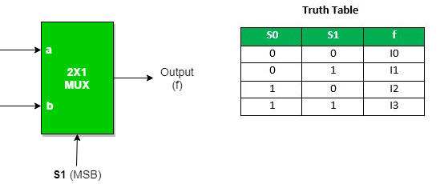

2. Full adder:-

A Full Adder produces two outputs, SUM (S) and CARRY-OUT (C-OUT), by adding three inputs (A, B, and C-IN). When multiple inputs are high, the C-OUT functions as a majority 1's detector by going high. By cascading Full Adders, byte-wide adders can be made, enabling the addition of carry bits between them. When a carry-in bit is present, they are necessary since a 1-bit half-adder cannot handle it and a 1-bit full adder produces 2-bit output.
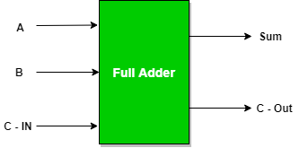

3. AND gate:-

The reason the AND gate has this name is because it behaves much like the logical "and" operator if the values of 0 and 1 are referred to as "false" and "true," respectively. The circuit symbol and logic configurations for an AND gate are shown in the following example and table. The input terminals are on the left in the symbol, while the output terminal is on the right. Both of the inputs must be "true" for the result to be "true." If not, the result is "false." In other words, only when both inputs one AND two are 1, is the output 1.

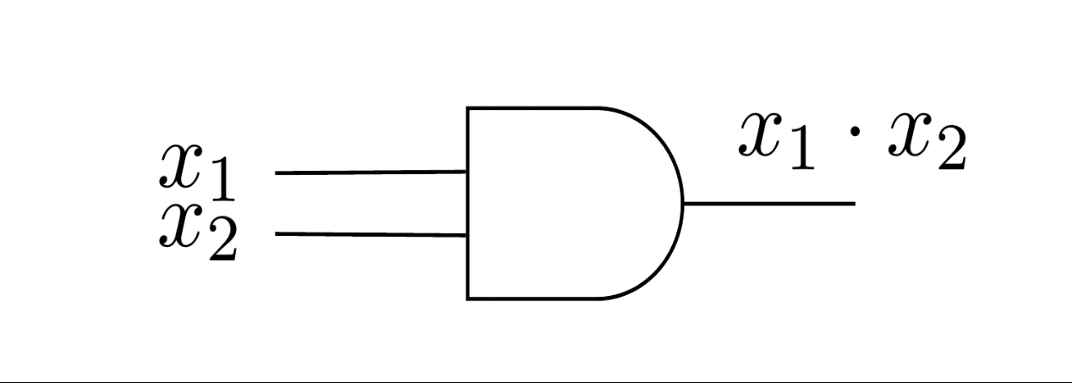

6. The ALU:
A crucial part of a computer's central processing unit (CPU/GPU) is the ALU (Arithmetic Logic Unit). It manipulates binary numbers using arithmetic (addition, subtraction, shifting) and logical (XOR, OR, AND, NOT) operations. The AU (Arithmetic Unit) and LU (Logic Unit) are the two components that make up the ALU. The input data is processed using the specified operands and codes, and the results.

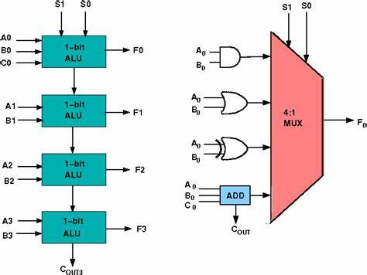

Ful adder module:-
By gate level method:- Verilog code
module Full_Adder(A,B,C,Sum,carry_out);
input A,B,C;
output Sum,carry_out;
wire W0,W1,W2;
xor G_Sum(Sum,A,B,C);
and G_carry_1(W1,A,B);
xor G1(W0,A,B);
and G_carry_2(W2,W0,C);
or G_carry(carry_out,W1,W2);
endmodule

Simulation report:-

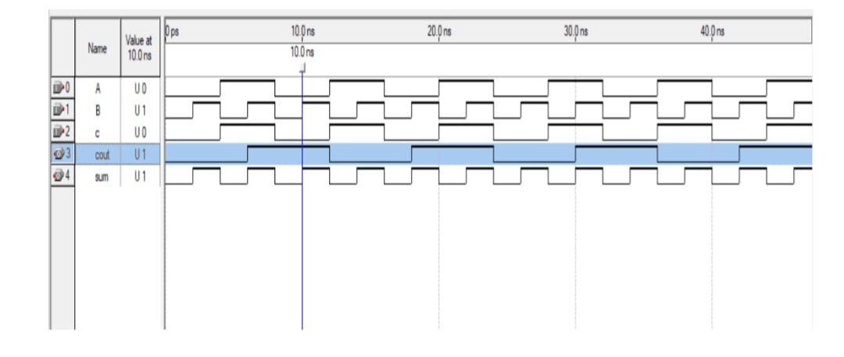

Adder module for two 4bit:
module Addition(A,B,C0,S,cout);
input [3:0]A;
input [3:0]B;
input C0;
output [3:0]S;
output cout;
wire c1,c2,c3;
Full_Adder FA_0(A[0],B[0],C0,S[0],C1);
Full_Adder FA_1(A[1],B[1],C1,S[1],C2);
Full_Adder FA_2(A[2],B[2],C2,S[2],C3);
Full_Adder FA_3(A[3],B[3],C3,S[3],cout);

endmodule
Simulation report:-
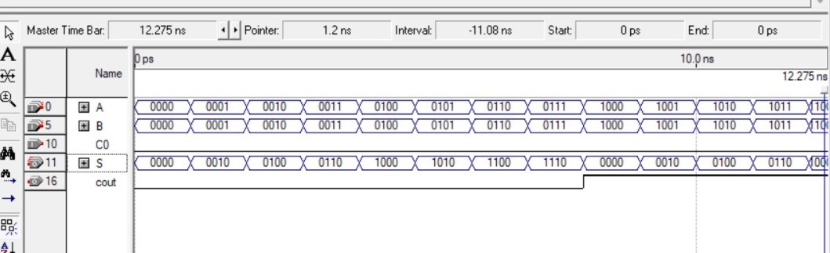

Subtracter:-
module Subtraction(A,B,M,Su,csub_out,over_flow);
input [3:0]A;
input [3:0]B;
input M;
output [3:0]Su;
output csub_out,over_flow;
wire C1,C2,C3;
wire [3:0]not_B;
not B0(not_B[0],B[0]);
not B1(not_B[1],B[1]);
not B2(not_B[2],B[2]);
not B3(not_B[3],B[3]);
Full_Adder FA_0(A[0],not_B[0],M,Su[0],C1);
Full_Adder FA_1(A[1],not_B[1],C1,Su[1],C2);
Full_Adder FA_2(A[2],not_B[2],C2,Su[2],C3);
Full_Adder FA_3(A[3],not_B[3],C3,Su[3],csub_out);
xor G_overflow(over_flow,C3,csub_out);
endmodule

Simulation report:-

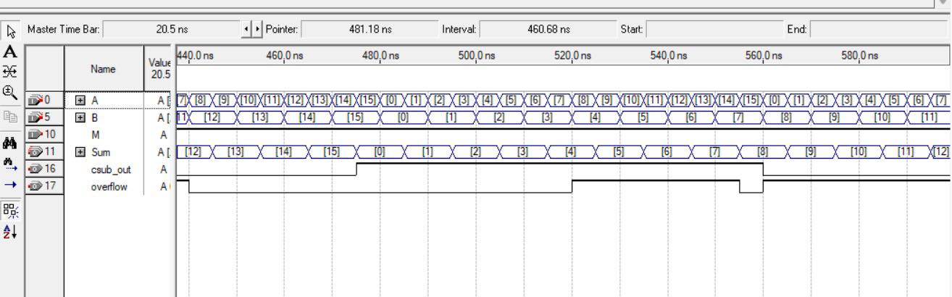

Bit_wise OR:-
module Bitwise_OR(A,B,result);
input [3:0]A;
input [3:0]B;
output [3:0]result;
or G0(result[0],A[0],B[0]);
or G1(result[1],A[1],B[1]);
or G2(result[2],A[2],B[2]);
or G3(result[3],A[3],B[3]);
endmodule

Simulation report:-
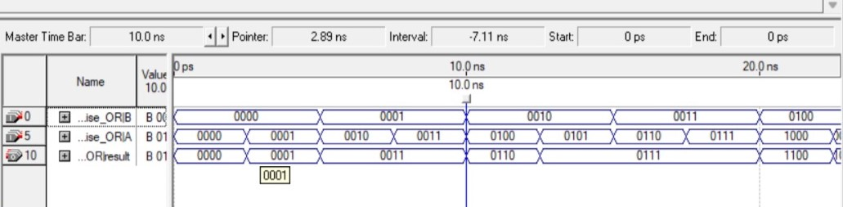

Bit_wise And:-

module Bitwise_AND(A,B,result);
input [3:0]A;
input [3:0]B;
output [3:0]result;
and G0(result[0],A[0],B[0]);
and G1(result[1],A[1],B[1]);
and G2(result[2],A[2],B[2]);
and G3(result[3],A[3],B[3]);
endmodule
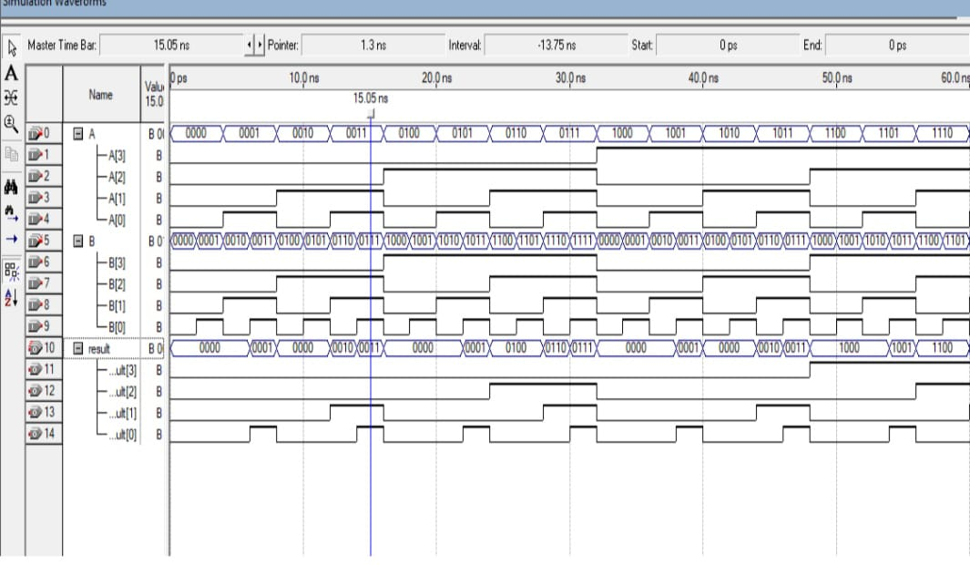

Implement the one-bit ALU using Quartus schematic:
In conclusion, this work entails using Quartus, a flexible digital logic circuit design tool, to create a one-bit Arithmetic Logic Unit (ALU). The term "Quartus" is frequently used in relation to FPGAs and ASICs. Creating the one-bit ALU logic in Quartus by defining connections between logic gates and parts for one-bit binary data operations is referred to as "implementing" in this context. The functionality of the one-bit ALU in Quartus is mostly visualized.
Digital System project:-
Block data flow
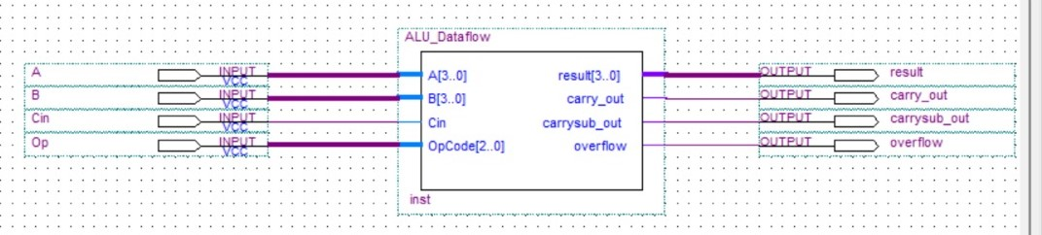

ALU_module for_dataflow:-

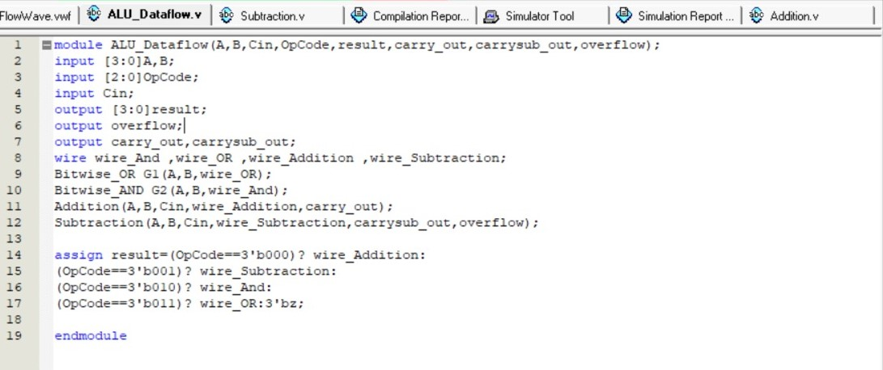
Simulation report:-

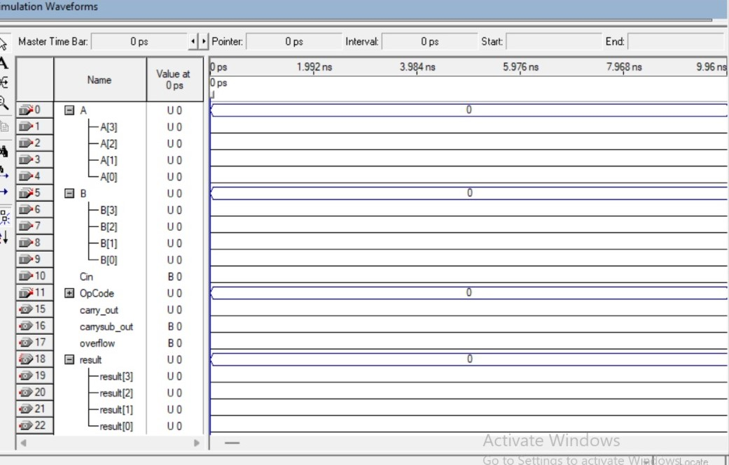

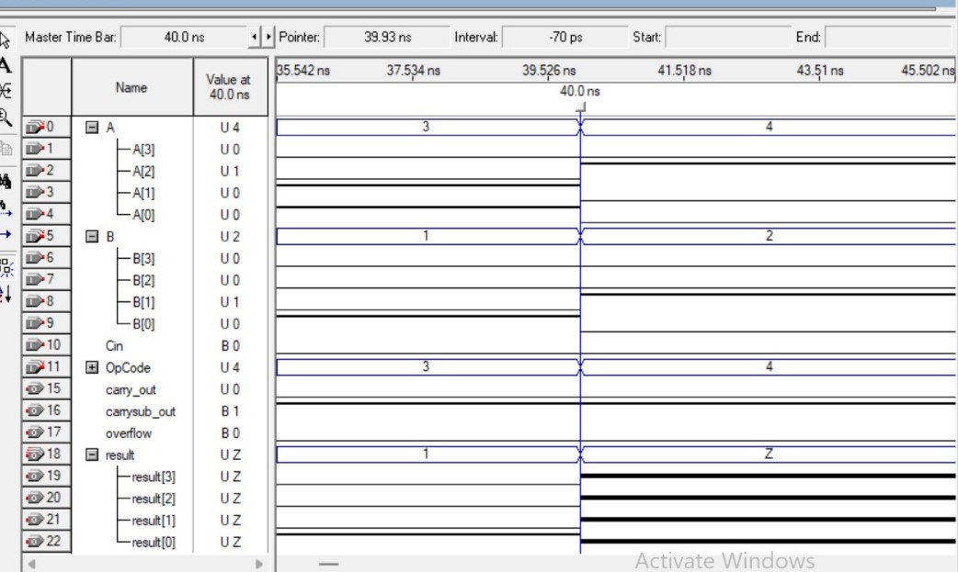

ALU_module for_behaviuoral:-
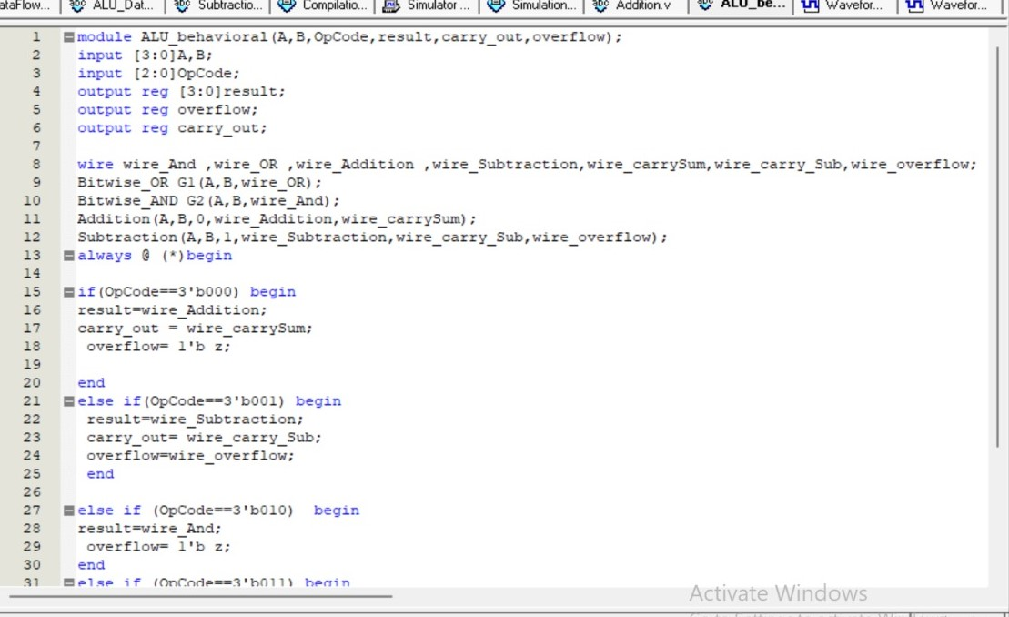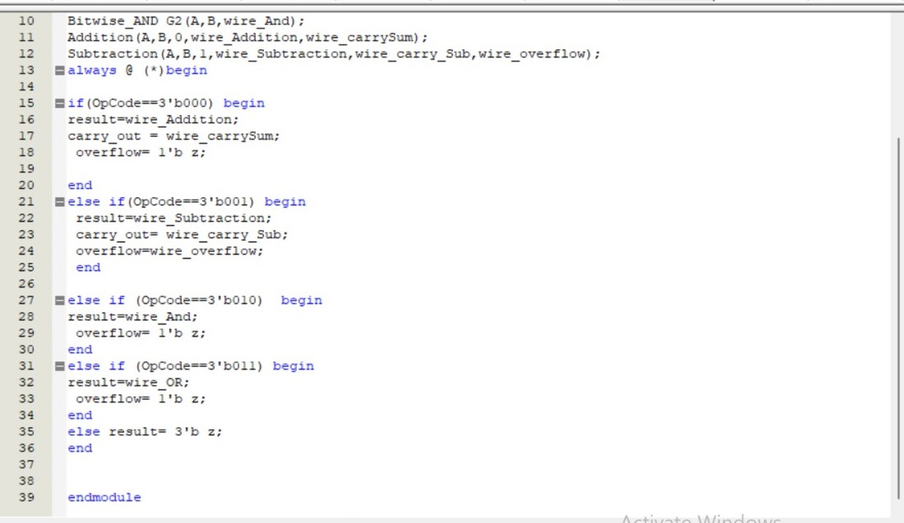

Simulation report:-
