

**Ain Shams University**

**Faculty of Engineering**

**Computer and Systems Engineering Department**

**CSE 321: Software Engineering – 3rd Year CSE – 1st Semester 2016/2017**

**PROJECT DOCUMENT**

**Project Name: Alternative drugs**

**Abstract**: An application to search for alternatives to a drug. User enters the name of the drug to search for its alternatives from the database. Also user can add a drug and its active ingredients to the database.

**1. Introduction**

|  |  |
| --- | --- |
| **1.1 Purpose** | This document is to illustrate the project for the teacher and teacher assistant. |
| **1.2 List of Definitions** | Drugs: medicines.  Active ingredient (AI): It is the ingredient in a pharmaceutical drug that is biologically active. |
| **1.3 Scope** | The alternative drugs system is used to search for alternatives to an unfounded drug in a pharmacy by the active ingredients. Also it allows users to add new drugs and its active ingredients. |
| **1.4 Overview** | Short description of the rest of the document and how it is organized.  The rest of the document will present the needed requirements, diagrams and designs. |

**2. General Description**

|  |  |
| --- | --- |
| **2.1 Product Perspective** | This system is Separated from any other systems that may be used by the client. |
| **2.2 General Capabilities** | The main capabilities of  The system can search and update its database. |
| **2.3 General Constraints** | The general constraint is entering the right name in the search and right name and active ingredients in updating. |
| **2.4 User Characteristics** | Any user can search for alternatives or updating the database |
| **2.5 Environment Description** | The system can be operated on any PC that runs python. |
| **2.6 Assumptions and Dependencies** | We assume that machines have python and its libraries. |
| **2.7 Other resources needed** | We need a SQLite database and tkinter libraries. |

**3. System Requirements**

|  |  |
| --- | --- |
| **3.1 Functional Requirements** | 1. Add new drugs to the database with its active ingredients.  2. Search for alternatives of a drug recorded in the database with its active ingredients.  3. Make a suitable responses to errors |
| **3.2 Non-functional Requirements** | 1. Be developed with python and SQLite database.  2. Works on Windows, Linux and Mac.  3. Finished in 1 month.  4. Short response time.  5. Follow pharmacies standards.  6. Be reliable. |

**4. Use-Case Diagram**

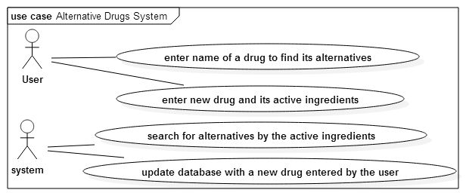

**5.** Narrative Description

5.1. User opens the program to search for alternatives of a drug.

5.2. User enter the drug's name in the search text-box then presses "search" button.

5.3. The system shows the user the alternatives in a message box.

5.4. The user decides to add a new drug to the database.

5.5. The user click "Add new drug" button.

5.6. The user enter the drug's name in the "Drug's name" text-box and its active ingredients separated with commas in the "active ingredients" text-box. Then presses "OK" button.

**6.** Data Model Design

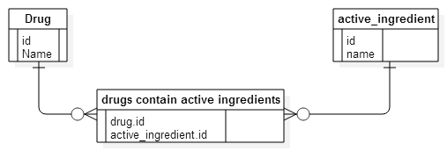

7. Requirements Validation

|  |  |  |  |
| --- | --- | --- | --- |
| Req.ID | 1 | 2 | 3 |
| 1 |  |  |  |
| 2 | **✔** |  |  |
| 3 | **✔** | **✔** |  |

8. Detailed Class Diagram (by using CRC card method as we have domain knowledge)

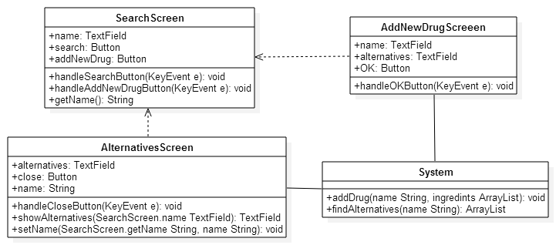

9. State Diagram

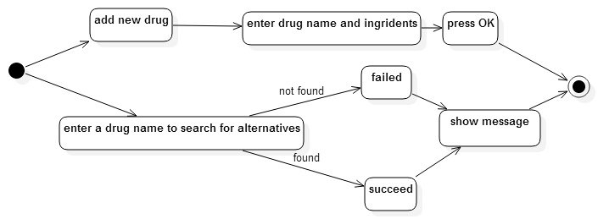

10. Interaction Diagram (Sequence Diagram)

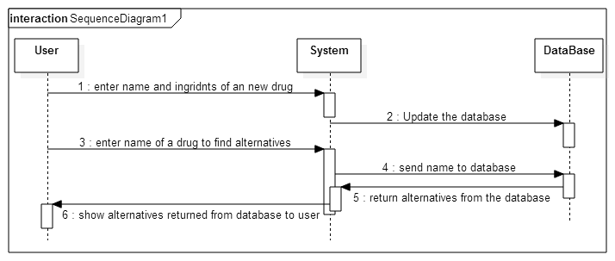

11. User Interface Design

When user runs the program the search screen appeared with "drug's name" text-box, "search" button and "add new drug" button.

The "search" button opens a new screen with the alternatives in a list form and "close" button to close this screen.

The "add new drug" button opens another screen that has "name" text-box, "active ingredients" text-box and "OK" button that update the database with the entries and close this screen.

12. Client-Object Relation Diagram

