Methodology

Cataract

1.1Overview

Cataract is an eye disease. It forms a clouding on the lens in the eye. The proposed system uses the techniques of image processing and classification algorithms for the detection of diseases. For the detection of cataract we first need to isolate the lens of the eye for further processing. To isolate the lens, a localization algorithm is applied. This helps to separate the iris and the pupil of the eye. Simple cropping operation is then applied to obtain the Region of Interest (ROI) to extract desired features from the image. The processing involves the texture analysis by extracting features from the isolated image obtained. These features are then analyzed and a model is obtained which helps in deciding whether any given image of a lens has cataract or not.

Further details of the processes are explained below

1.2 Image Acquisition:

The proposed system requires the user to take an image through the camera of his/her mobile phone. A standard smart phone camera is required for the image acquisition. The image should be taken in good light conditions. Precautions should be taken so that the image does not have reflection in the lens which hinders in the application’s accuracy to classify the image.

1.3 Preprocessing:

The image is then preprocessed to remove noise using filters. The images obtained are usually of higher quality which slows down the processing speeds. The image is scaled down so that its resolution becomes 640x480 pixels.

1.4 Iris/Pupil Localization

We are using a modified method of Camus & Wildes algorithm for iris detection to find the possible centers coordinates of iris and pupil along with their radii. The method involves thresholding to determine the possible coordinates that would correspond for the iris center in the local pixels (i.e. in a 3x3 window). Using the Daugman’s method for iris boundary detection we then search for the pupil boundary within the 10x10 neighborhood of the iris center.

1.4 Daugman’s Integro Differential Operator

The daugman’s integro differential operator is given as

max(r,y0,x0)

(1) (How Iris Recognition Works by John Daugman IEEE Trancations on circuit and systems for video technology, VOL. 14, NO. 1, January 2004)

This operator forms the bases for the iris and pupil localization. The above operator searches for maximum blurred partial derivative in the given x and y coordinates and iterates by increasing radius of the contour (i.e. r) with center coordinates x0 and y0 of the line integral present in the operator. The operator also includes the convolution with a Gaussian filter. Overall the operator looks for the circular boundary of the iris and pupil with its circular contour with increasing radius and returns the radius of the best possible radius and coordinates of the iris and pupil.

Our approach implements the daugman’s operator with a few additional operations to isolate the iris and pupil for ROI extraction. Below is the detailed explanation of the steps followed in the path of isolating the required elements from the image

1.4.1 Thersholding

The input image is scaled to a constant size to speed up the process. Morphological operations are applied to remove the reflections from the image. The image produced by the morphological operations is sharp; filter is applied to blur the sharpness of the image. Using thresholding, possible pixel coordinates are chosen for the center of iris. Then the neighborhood of those coordinates is scanned to see if it is the local minimum or not. We have an array of possible coordinates for the center of the iris. The blur of each coordinate is then calculated by applying the daugman’s operator. The search function then searches the maximum value of blur by scanning all the center coordinates.

1.4.3 Line Integral

The normalized line integral is calculated around a circular contour. The polygon with large number of sides is used to make out a circle from the image and hence used to calculate line integral using summation. The line integral iterates form the minimum given value of radius to the maximum and taking in view all the possible center coordinates for iris and pupil. The line integral finds the circular boundary with the help of the contour with radius r and center points x0 and y0. The best possible value of radius of pupil and iris is obtained.

1.4.4 Partial Derivative

When the line integral finds the boundary that best fits the contour, which means a circle has been taken out of the image as the boundary of iris. Once the circle is taken out, the iteration stops and no more computations for calculating the line integral of the radius for that particular center are performed. Differential is calculated for the obtained line integral. A 1-D Gaussian filter of 5x5 structural elements with appropriate value of sigma is applied. The blur image is obtained. The partial derivative of blur is calculated.

1.4.5 Searching

The maximum value of blur is found by scanning all the possible center coordinates for iris. Once the iris boundary has been found, the algorithm then searches for the pupil boundary by searching only some part of the image. The part is in the neighborhood of the iris. As per Daugman (2) (How Iris Recognition Works by John Daugman IEEE Transactions on circuit and systems for video technology, VOL. 14, NO. 1, January 2004) the pupil radius can range from 0.1 to 0.8 of the iris radius. A 10x10 window around the iris center searches for the pupil boundary using the daugman’s operator. Once the iris and pupil are extracted from the rest of the image of the eye, we can now extract the ROI from it.

1.4.6 ROI Extraction

The Region Of Interest is the area outside the pupil but inside the iris boundary. So we take a simple square cropping window and crop out the area of interest that is within the boundary of the iris but includes the pupil region. This are obtained is the ROI required to perform further analysis for the detection of cataract.

1.5 Classification

After the iris and pupil have been localized, ROI extracted, we now extract information in terms of different properties of the image. These properties can be common in all cataract affected eye images therefore making a range of values that, when obtained in the run time, can help to identify cataract. These properties are called features and a group of them becomes a feature set matrix. This matrix helps us to model or train a classifier a Support Vector Machine (SVM) in this case. This classifier is trained with features of some training dataset including a few normal and a few abnormal images. More images we include in the training of the classifier, more accurate results can be expected.

1.5.1 Feature Extraction

Further information from the ROIs is obtained in the classification process. Each ROI of an image gives off 6 features. These features are considered similar for cataract and non-cataract images.

1. Contrast

Contrast can be defined simply as the difference between the maximum and minimum pixel intensity values in an image. Contrast of each ROI is calculated and treated as a separate feature. Contrasts of all images are stored corresponding to their images. (Brightness and Contrast, Tutorialspoint, <http://www.tutorialspoint.com/dip/Brightness_and_Contrast.htm> Last Access 23-06-15)

2. Homogeneity

Measure of closeness of the distribution of the elements in the image. (Analyzing Texture of an Image, Matlab help, Mathworks Inc. )

3. Correlation

Measures the probability of occurrence of the specified pixel pairs in images ((Analyzing Texture of an Image, Matlab help, Mathworks Inc. )

4. Energy

It is simply the sum of the square of the pixel intensities in the image

5. Entropy

Entropy can be defined as the amount of disorder present in a system. When a system is disturbed its entropy changes. In an image when it has a normalized histogram, has a higher entropy value as compared to an image which is thresholded. If all the pixels of the image have the same value, its entropy is zero. Entropy of an image is given by the formula

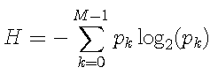

(Entropy by John Loomis, <http://www.johnloomis.org/ece563/notes/basics/entropy/entropy.html>, Last Access 23-06-15

(Rhys Lewis, *Practical Image Processing*, Ellis Horwood Limited, 1990. ISBN 0-13-6383525-0. p 90-91.

William Pratt, *Digital Image Processing, Second Edition*, John Wiley & Sons, Inc., 1991. ISBN 0-471-85766-1. p. 561-563.

Azriel Rosenfeld and Avinash Kak, *Digital Picture Processing, Second Edition, Volume 1*, Academic Press, 1982. ISBN 0-12-597301-2. p. 194-198.

)

6. Standard Deviation

The standard deviation of the image the brightness within a region with some pixels is called sample standard deviation. The standard deviation is the estimate of the mean of underlying brightness of probability distribution. (Fundamentals of Image Processing by Ian T. Young, Jan J. Gerbrands, Lucas J. van Vliet, Delft University of Technology)

1.5.2 SVM classifier

The classifier used for the detection of cataract is Support Vector Machine. It classifies the data into two classes. Either the image has cataract or it doesn’t. The feature set matrix is used to train the classification model. Basically, the SVM classifiers maximize the margin around the separating hyperplane **(An Idiot’s guide to Support vector machines (SVMs) by R.Berwick, Village Idiot)**. The decision is supported by the subset of training samples; supporting vectors. These supporting vectors would change the position the hyperplane if they were removed so they are of high importance in the SVM classification modeling.

2 Results

The dataset comprised of 41 images in total obtained by the courtesy of Dr. Kamran of Al Latif Trust. All the images have premature cataract graded by the doctor.

The results obtained by the developed system are approximately 70% accurate. Out of 36 images that were used as testing about 25 of them are correctly classified. Some of the localization results and ROI feature extraction results are shown below in the figure.

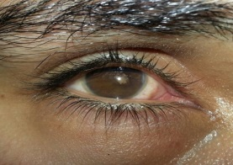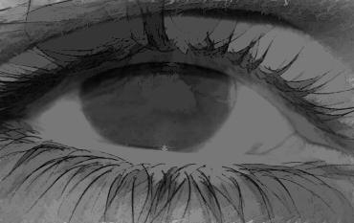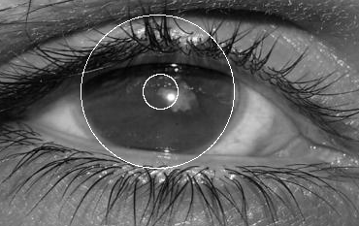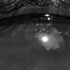

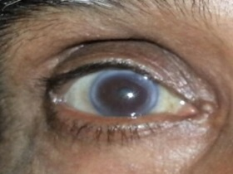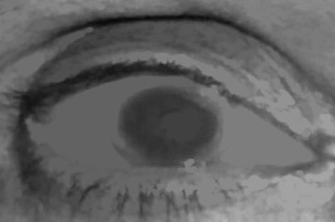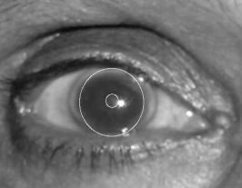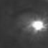

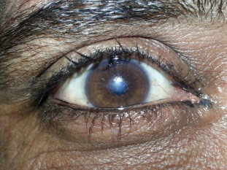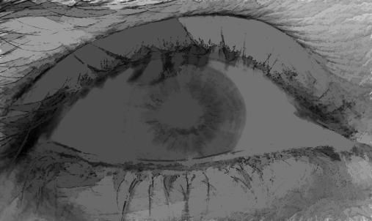­­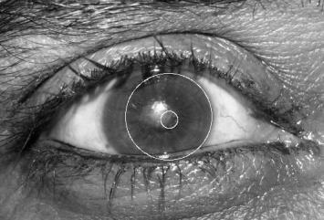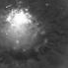

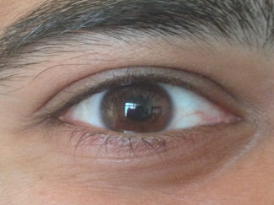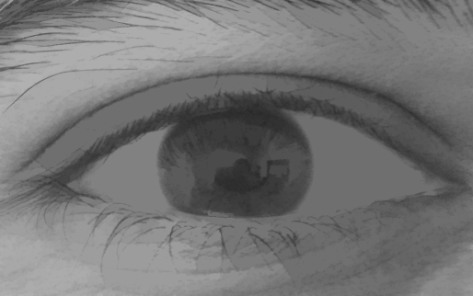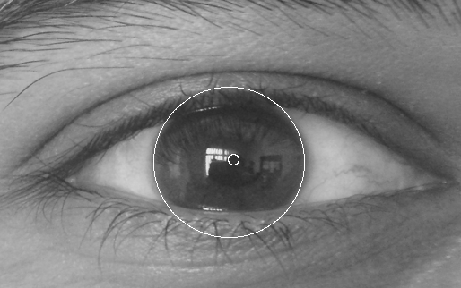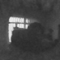

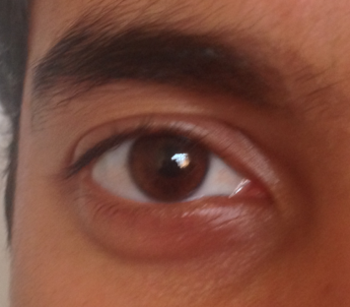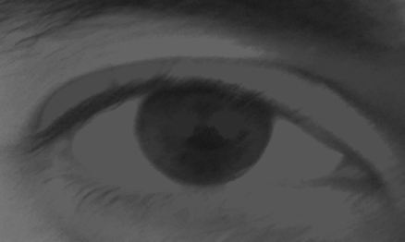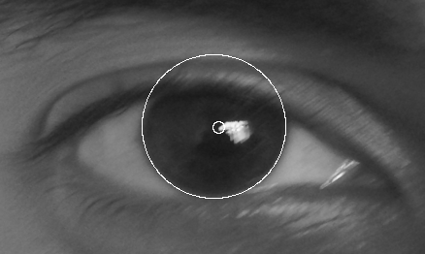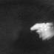

3 Conclusion