# **טכנולוגיות אינטרנט מתקדמות - 61776 (WEB)**

משימת בית מס' 1

Group 13

StudyBuddy

מהנדס המערכת : אחמד טויל

אחמד נבחר לשמש כמהנדס המערכת של הפרויקט, בזכות הידע הטכני הנרחב שלו בפיתוח וניסיונו בעבודה עם ממשקים מורכבים. יכולתו להבין את צורכי המערכת בצורה מקיפה, לצד חשיבה לוגית ומסודרת, תרמו לתכנון הארכיטקטורה וליצירת התאמה בין הרכיבים השונים של המערכת.

בתחילת העבודה, אחמד היה אחראי על חלוקת המשימות בין חברי הצוות, תוך התחשבות בכישורים האישיים של כל אחד, בזמינותו ובתחומי העניין שלו.

כך נוצרה חלוקה מאוזנת והוגנת של העבודה, שאיפשרה לכל אחד מחברי הצוות לתרום בצורה הטובה ביותר.

במהלך כל שלבי הפרויקט התקיימה תקשורת שוטפת בין חברי הצוות, שכללה דיונים משותפים, עדכונים שוטפים וטיפול בבעיות שעלו בזמן אמת, תוך שיתוף פעולה והתגמשות הדדית.

| שם חבר הצוות | משימות שהוקצו | משימו שהושלמו |
| --- | --- | --- |
| אחמד טויל 323065847 | מהנדס מערכת, אחראי על תכנון הארכיטקטורה הכללית של המערכת, חלוקת המשימות בין חברי הצוות, ועבודה על הקוד. | הכל |
| אבראהים אסעד 324835099 | עבודה על תרחישי השימוש (Use Case), השתתפות בכתיבת הקוד ובניית המסכים הראשוניים. | הכל |
| עומר ערמוש 322966326 | השתתפות בכתיבת תרחישי שימוש (Use Case), סיוע בהגדרת הדמויות (Personas). | הכל |
| סירין פאהום 212810071 | ביצוע ראיונות, עזרה בבניית הדמויות (Personas) ומפות האמפתיה (Empathy Maps). | הכל |
| אדם תחאוק 214311912 | השתתפות בדיונים ובקבלת החלטות כלליות, כולל דרישות פונקציונליות ולא פונקציונליות, עיצוב וחשיבה | הכל |
| מרוה עואד 325223451 | ביצוע ראיונות, עזרה בבניית הדמויות (Personas) ומפות האמפתיה (Empathy Maps). | הכל |

git-Link: <https://github.com/AhmadTawil1/studybuddy.git>

Subject: peer-to-peer homework help platform where students can request and provide explanations with AI-assisted moderation

# Design Thinking Stages:

## A. Website Name and Context

Chosen Website Name: StudyBuddy

Context:

**StudyBuddy** is a peer-to-peer academic help platform designed for students to ask homework questions and provide explanations to others.

The goal of the system is to foster a collaborative learning environment where students can support one another, improve academic understanding, and reinforce their own knowledge through teaching.

The platform allows users to post questions, respond to requests, track personal statistics, and earn achievements through active participation.

With a clean and user-friendly interface, students can filter help requests by subject and urgency, view user profiles, and collect points and badges as part of the platform’s gamification system.

*(Future versions will include AI moderation and more advanced features.)*

## B. User Interview and Persona Definition and Empathy Mapping

### Persona Definition:

Persona 1 – Jonathan

| **Characteristics:**   * Interested in technology, gaming, self-learning via YouTube, and electronic music * Prefers learning through: video explanations, summarized notes, and small discussion groups * Curious and introverted at first, but opens up when comfortable   **Challenges:**   * Struggles with time pressure, heavy workloads, and lack of understanding in foundational courses * Finds it hard to ask small questions during lectures due to pace and atmosphere   **Aspirations:**   * Wants to succeed in university * Aims to truly understand the material * Hopes to build academic confidence   **Background Story:**  Jonathan has just started his first year in university and is mainly struggling with math-related courses and independent learning. The transition from high school to academia has been overwhelming – the learning pace is fast, exams are stressful, and he feels lost in large lecture halls. He’s looking for help from someone who already took the same courses and can explain the material clearly, not just give him the solution. Jonathan has heard of solution-sharing websites but prefers to actually **learn** and not just **copy**. | **Personal Details:**   * **Name:** Jonathan * **Age:** 19 * **Gender:** Male * **Location:** Shared apartment in Ashdod * **Education:** First-year Software Engineering student * **Occupation:** Currently unemployed – focusing on studies * **Marital Status:** Single |  |
| --- | --- | --- |

### User Interview – Persona 1: Jonathan

1. Where do you usually look for help when you're stuck with homework or study materials?  
 *“I usually try searching on YouTube or looking for explanations in online forums. Sometimes I ask friends, but only if I really have no choice.”*

2. Have you tried using help platforms (like Campus, Slack groups, WhatsApp groups)? What worked and what didn’t?  
 *“Yes, I joined a few WhatsApp and Slack groups. The problem is that many people don’t answer, or the discussion gets lost in tons of unrelated messages. Sometimes I got help, but it was random.”*

3. How important is it for you to understand the solution and not just get the final answer?  
 *“It’s super important. I don’t want to just pass the assignment; I want to actually understand what I’m doing so I can do it on my own later.”*

4. Have you ever asked someone you don’t know for help? How did that make you feel?  
 *“I tried once or twice in the study group. At first it felt weird, like maybe I’m bothering them. But if they respond nicely, it helps a lot and builds confidence.”*

5. What kind of explanation do you prefer – video, chat, voice, diagrams?  
 *“I prefer short video explanations or diagrams that break things down step by step. If there’s a chat too, that’s helpful when I need clarification.”*

*Empathy Map – Persona 1:* Jonathan

| *Says:*  *“I try asking in the course WhatsApp group when I’m stuck.”*  *“I used Campus and Slack, but sometimes the answers aren’t clear or suitable for my level.”*  *“I just want someone to explain things* ***in a simple way****.”* | *Thinks:*  *“Maybe my question is silly… What if others think I’m not smart?”*  *“Everyone else seems to get it… Am I the only one struggling?”*  *“If only someone could walk me through this step-by-step, it would save me so much time.”* |
| --- | --- |
| *Does:*  *Watches YouTube videos, Googles answers, uses platforms where students share info.*  *Sends questions to WhatsApp groups (sometimes with a screenshot), but doesn’t always explain.*  *Sometimes skips the question completely if he gets no answer.*  *Keeps learning alone even with many tools available – often feeling* ***alone*** *in the process.* | *Feels:*  *Feels* ***frustrated*** *when he can’t understand on his own.*  *Feels* ***uncertain*** *when responses aren’t clear – it hurts his confidence.*  *Feels* ***relieved and motivated*** *when someone helps and he finally understands.*  *Gets* ***energized*** *when he feels in control and really understands the material.* |

Persona 2 – Alex

| **Traits and Characteristics**  * Passionate about teaching and helping others learn * Loves explaining complex topics in simple terms * Enjoys solving problems and guiding peers through challenging coursework * Confident, patient, and empathetic communicator * Sees helping others as both fulfilling and a way to sharpen his own understanding  **Learning Style**  * Prefers interactive learning (discussions, Q&A sessions, tutoring) * Uses visual aids like diagrams or code examples when explaining concepts * Believes teaching is one of the best ways to internalize knowledge  **Challenges**  * Sometimes feels his help goes unnoticed or unappreciated * Struggles to balance tutoring time with his own study schedule * Wants better tools to organize and track student progress  **Aspirations**  * Become a teaching assistant or mentor in university * Gain recognition as a helpful and reliable knowledge resource * Possibly build an online platform to teach and share explanations * Make a meaningful impact by helping others succeed academically | **Personal Details**  * **Name:** Elix * **Age:** 25 * **Gender:** Male * **Location:** Lives in a student dorm in Haifa * **Education:** Third-year Computer Science student * **Occupation:** Works part-time as a private tutor in math and programming * **Relationship Status:** Single |  |
| --- | --- | --- |

User Interview – Persona 2: Alex

**1. What’s most important for you to know when deciding whether to help a student?** *“The clarity of the question is key — if the student gives enough context or explains where they got stuck, it’s much easier to help. I also look at the topic; if it's something I know well, I’m more likely to help quickly.”*

**2. What’s your preferred method for providing help?** *“I prefer short, written explanations or recorded video tutorials. I also like using annotated screenshots or diagrams. I’m fine with chat too, but only if it’s focused and respectful.”*

**3. What would make it easier for you to help students quickly and effectively on a platform?** *“A system that organizes questions by subject and difficulty would be amazing. Also, if there were an AI that could suggest similar past answers or highlight urgent questions, that would save time.”*

**4. What type of reward would you want to receive for helping others?** *“Reputation tags, a leaderboard, or the ability to feature my profile would be great. If there’s also a way to earn symbolic points or payment for top helpers, even better.”*

**5. How would you feel if an AI system gave feedback on the quality of your answers?** *“If it’s constructive, I’d actually appreciate it. I like improving. As long as it’s not intrusive or judgmental, I think it could be very helpful — maybe even give me ideas on how to explain better.”*

*Empathy Map – Persona 2: Alex*

| *Says:*  *“I enjoy helping others – it helps me remember the material too.”*  *“Sometimes it’s hard to know what the student is really asking.”*  *“I wish there was a proper place to organize all help requests.”* | *Thinks:*  *“It’s satisfying when I help someone understand.”*  *“It’s frustrating when I get no reply after I spend time answering.”*  *“There are too many vague questions at once — it becomes overwhelming.”*  *“Still, I’m motivated to share knowledge and improve my explanations.”* |
| --- | --- |
| *Does:*  *Responds to classmates' questions in study groups*  *Tutors others in Zoom or face-to-face sessions*  *Shares self-written materials and guides*  *Active in WhatsApp groups and looks for new ways to contribute* | *Feels:*  *Feels* ***appreciated*** *when others value his help*  *Wishes there was a* ***points or recommendation system***  *Feels frustrated by lack of clarity or question overload*  *Feels motivated when he’s able to make a real difference in someone’s understanding* |

## C. Divergent Thinking – Rapid Ideation for Persona Needs

### **General Features (for both sides)**

* Smart matching system between help seekers and helpers by course, institution, and strengths
* Chat based on questions, with support for continued clarification
* Personal statistics: number of questions asked / answered / understood
* AI suggestions to find an existing answer before posting a new question

### **Help Seekers (Students asking for help)**

* Anonymous mode to reduce social anxiety
* AI guidance to help phrase clear questions
* Rating system: "This answer helped me understand"
* "Explain differently" button for instant feedback loop
* Ability to save great answers and revisit before exams
* Convert received answers into quizzes for review
* "Ask Again Later" Reminder for questions left unresolved
* Question quality tips from helpers (gentle AI-powered prompts like "Try adding more details")

### **Helpers (Students providing help)**

* Rating system for askers to identify clear and respectful users
* Schedule availability via calendar so students can book help when convenient
* AI review of responses before submission (grammar, clarity, etc.)
* Public profile with statistics: subjects helped, average rating, badges
* Tangible rewards: XP system, automated recommendation letters, digital certificate
* Smart chat tools: "Not Clear" button, "Send Summary", question history
* Filter help requests by preferred subject or expertise
* Urgency indicator for questions (Low/Medium/High)
* Voice response option (instead of text)
* Internal helper forum for tips and support
* Multiple help modes: written, chat, or video
* Search filter by response wait time
* AI helper suggestions: "This student suits your strengths!"
* Notification system for new matching questions
* Feedback button from students: "Did it help? Was it clear?"
* AI Time Estimation: shows "Estimated time to answer: 2 min"
* Weekly leaderboard for top contributors (optional visibility)

### **Collaborative Features**

* Group response mode: multiple helpers can co-answer or pass questions between each other
* "Study Rooms": Small group sessions between students with optional observer/helper

### **Ethics and Academic Integrity**

* Academic honesty reminder before posting or answering: "No cheating. Explanations only."

## D. Convergent Thinking – Final Selected Improvements

#### **Features for Both User Types (Shared System Improvements)**

* **Smart Matching System**: Match helpers and seekers based on course, subject, urgency, and academic institution.
* **AI Suggestions Before Submission**: Use AI to suggest existing answers or guide question phrasing before submission.
* **AI-Powered Answer Review**: Provide helpers with AI suggestions to improve clarity or structure of their responses.
* **Multilingual Support**: Include automatic translation for both questions and answers (e.g., Hebrew ↔ English).
* **Conversation Analysis**: Use AI to analyze Q&A interactions and detect whether the student fully understood.

#### **For Help Seekers**

* **Anonymous Question Option**: Reduce anxiety about asking questions publicly.
* **“Explain Differently” Button**: Allows seekers to request alternative phrasing or simplification.
* **Best Answer Voting**: Highlight the most helpful explanation.
* **Personal Answer Archive**: Save helpful answers for quick access during exams.
* **AI Guide for Writing Clear Questions**: Help seekers structure better, clearer questions.

#### **For Helpers**

* **Reputation & Impact Profile**: Visual dashboard showing subjects helped, average rating, and achievements.
* **Availability Scheduler**: Helpers can mark when they’re free to assist, enabling session booking.
* **Urgency Indicators**: Mark questions by priority level (Low, Medium, High).
* **Flexible Help Options**: Choose between text, voice, or video responses.
* **Feedback from Seekers**: “Was this helpful?” button to assess explanation clarity.
* **AI Assistant for Answer Drafting**: Suggests improvements or summarizes answers.

## E. Functional & Non-Functional Requirements

#### **Functional Requirements:**

1. **Help Request Form** A clean and accessible interface to submit help requests by selecting topic, writing a description, attaching files, and choosing help type (chat/text/video).
2. **Open Questions Center for Helpers** A central page that shows all open requests with filters (subject, urgency, availability, response time).
3. **User Profile with Ratings & Points** Each user has a profile showing activity history, feedback, achievements, and subject strengths.
4. **Feedback System After Help** After receiving help, users can rate it (e.g., “Helpful” / “Not Helpful” + optional comment).
5. **Reward Mechanism for Helpers** Points system based on activity, badges by category, and automatic digital certificates.

**Non-Functional Requirements**

1. Easy to Use  
    The platform should feel simple and natural to use. Even someone using it for the first time should be able to ask a question or offer help in just a couple of clicks. No need to waste time figuring things out—it should just make sense.
2. Fast and Smooth  
    Everything should respond quickly. If someone asks a question or gets a suggestion from the AI, it should happen in under 1.5 seconds. No waiting around—just a smooth and efficient experience.
3. Accessible for Everyone  
    The platform should work well for all users, including people with disabilities. That means full keyboard navigation, screen reader support, and good color contrast so it’s readable and usable for everyone.
4. Safe and Respectful Content  
    Any questions or answers that are shared on the platform should be automatically checked. The system should be able to catch rude comments, copied content, or anything that doesn’t belong in a respectful learning environment.
5. Ready to Grow  
    The system should be built to grow easily. Whether we have 100 users or 10,000, it should still work great—fast, stable, and without slowing down.

F. use case diagram:

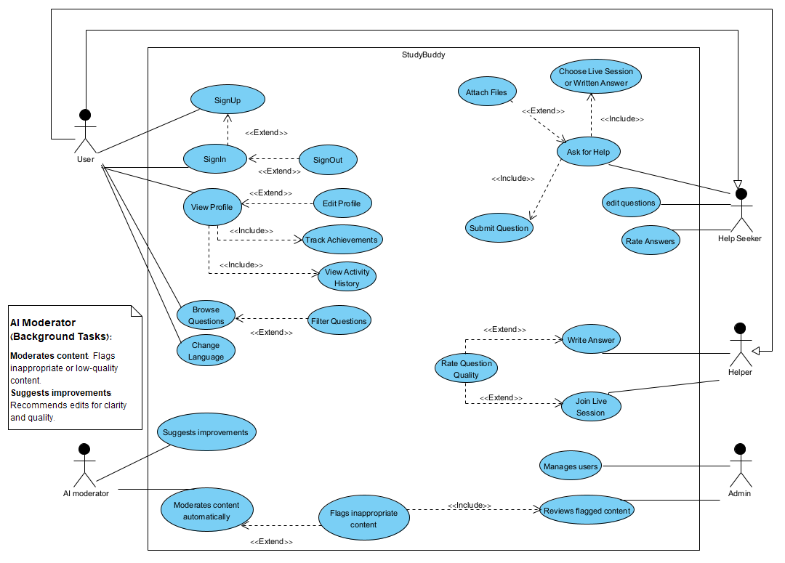

In this use case diagram, the AI Moderator's actions are described in a note rather than using <<include>> or <<extend>> relationships. This decision was made because the AI moderation features (like automatic content flagging and suggesting improvements) operate as **background tasks**, rather than user-driven interactions. Including them as standard use cases would overcomplicate the diagram and distract from the core user functionality, so they were documented separately for clarity.