**Name : Ahmad Yasin**

**Roll No: 233605**

**Mid Lab : Mobile Computing**

**Question# 01:Output:**

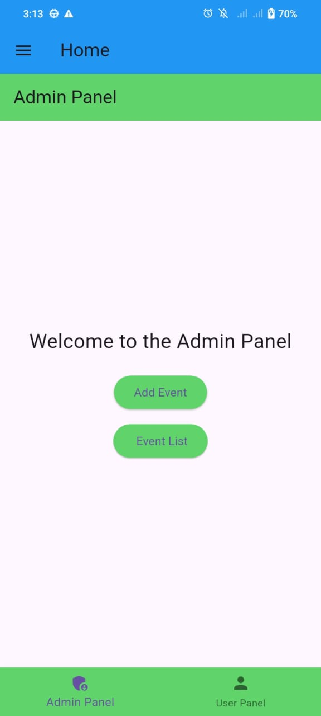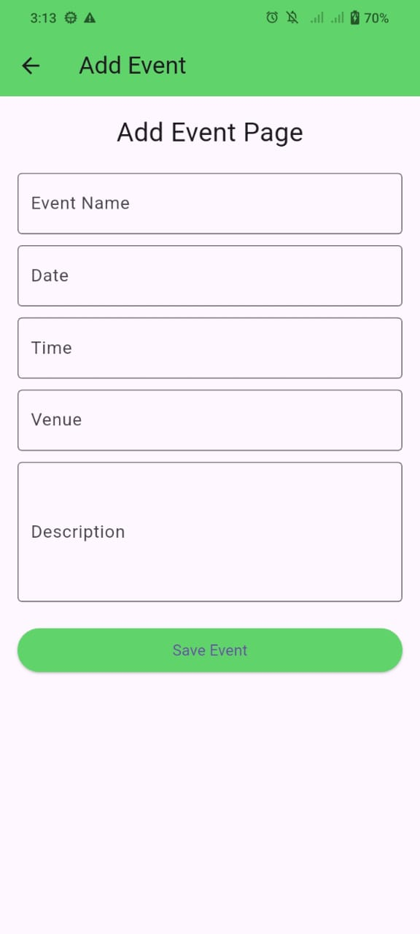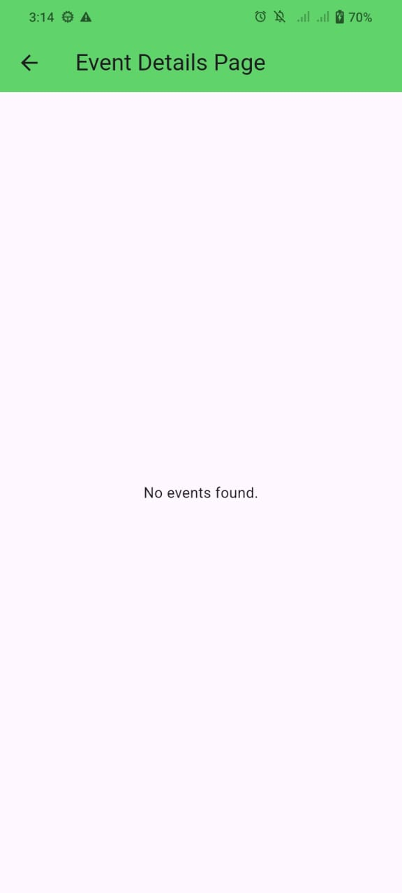

**Question# 02:Output:**