

***Project:***

***Shopping Cart***

***Team Members***

***Leader****: Ahmad Yasin (233605)*

*Hafiz Muhammad Hasnain (233525)*

*Muhammad Talha (233509)*

***About :***

*The Shopping Cart System is a C# console application that simulates basic online shopping functions: adding, removing, updating products, calculating totals, applying discounts, and managing cart expiration. This project demonstrates essential programming skills, including object-oriented design and timer usage.*

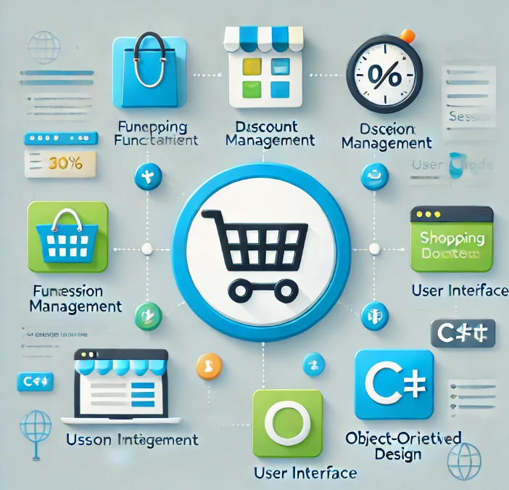

***Objectives:***

* ***User-Friendly Interface****:*
  + - *Create an intuitive console application for easy navigation.*
* ***Product Management****:*
  + - *Enable adding, removing, and updating products in the cart.*
* ***Cart Viewing****:* 
  + - *Display cart contents, including product details and total price.*
* ***Total Calculation****:* 
  + - *Calculate the total cost of products in the cart.*
* ***Discount Application****:* 
  + - *Allow users to apply discounts to their total purchase.*
* ***Checkout Process****:* 
  + - *Provide a summary of the cart and total price during checkout.*
* ***Cart Expiration Management****:* 
  + - *Implement automatic cart expiration after inactivity.*
* ***Product Recommendations****:*
  + - *Suggest products to enhance the shopping experience.*
* ***Error Handling****:*
  + - *Manage invalid inputs gracefully to ensure reliability.*
* ***Documentation and Reporting****:*
  + - *Provide comprehensive documentation for users and developers.*

***Main Menu***

* ***Initialization:***
* *Create ShoppingCart and set up a timer for expiration check.*
* ***Menu Loop:***
* *Displays options until the user chooses to exit.*
* ***User Choices:***
* *Handles inputs for adding, removing, updating, viewing products, calculating totals, applying discounts, checking out, recommending products, or exiting.*
* ***Error Handling:***
* *Alerts users for invalid choices.*
* ***Continuation Prompt:***
* *Asks users to press a key to continue after each action.*



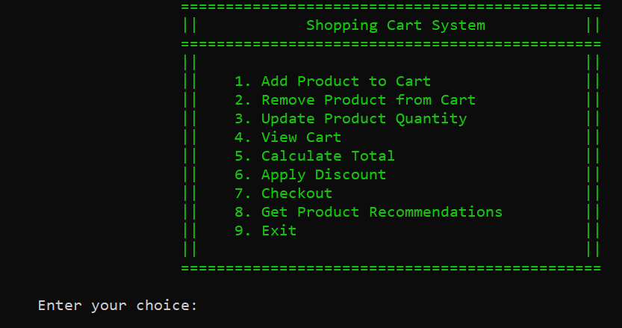

**Classes**

1. **Product Class**

* **Purpose:**

Represents a product that can be added to the shopping cart.

**Attributes:**

* **Id**:

An integer that uniquely identifies the product.

* **Name**:

A string representing the name of the product.

* **Price**:

A decimal value representing the price of the product.

* **Quantity**:

An integer indicating how many units of the product are available or being purchased.

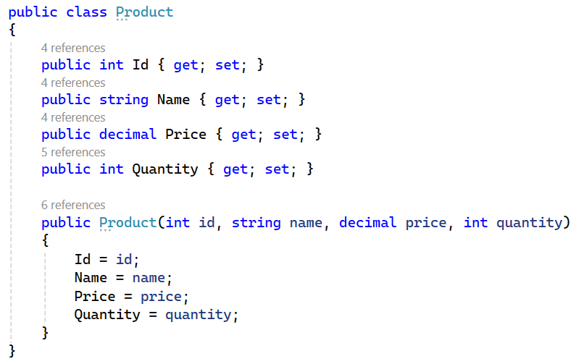

1. ***ShoppingCart Class***

* ***Purpose****: Manages a collection of products that users can add to, remove from, or modify in their shopping cart.*

***Attributes:***

* ***Products****: A list of Product objects that represent the items currently in the cart.*
* ***ExpirationTime:*** *A DateTime object that indicates when the cart will expire.*
* ***EXPIRATION_MINUTES:*** *A constant integer representing the expiration time limit for the cart (set to 5 minutes).*

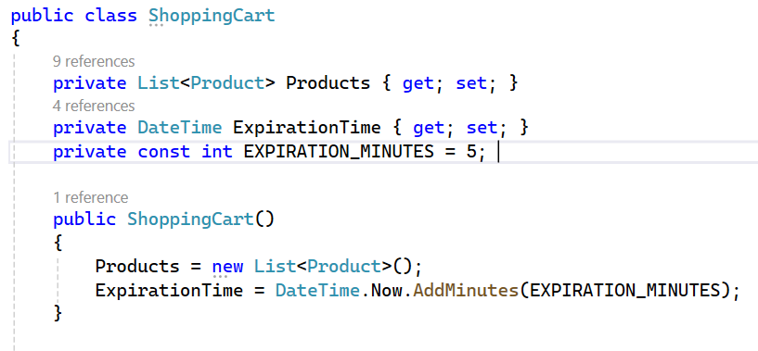

***Functions***

***1.AddProduct():***

* This Function Adds a product to the cart. It also Prompts for product details (ID, name, price, quantity) and calls AddProduct.

**Input :**

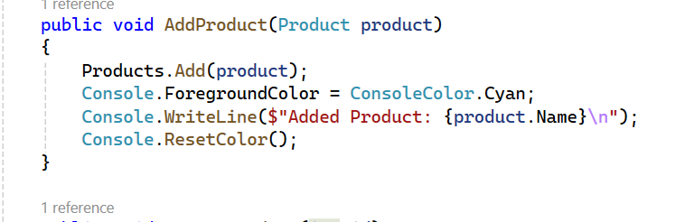

**Output :**

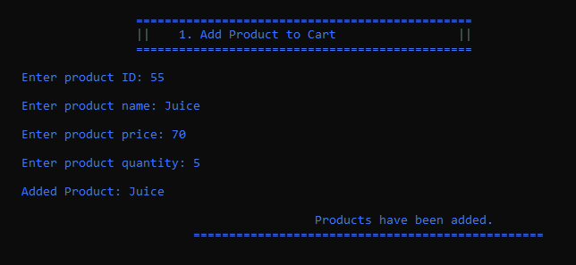

**2.Remove Product from Cart():**

* Prompts for the product ID to remove and calls RemoveProduct.

**Input :**

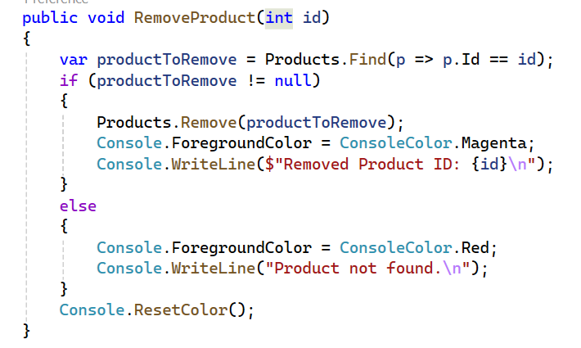

**Output :**

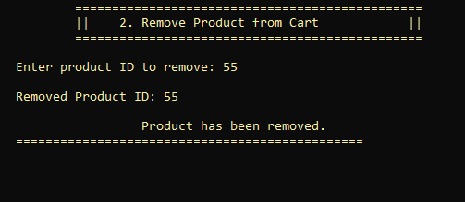

1. **Update Product Quantity():**

* Prompts for the product ID and new quantity, then calls UpdateQuantity.

**Input :**

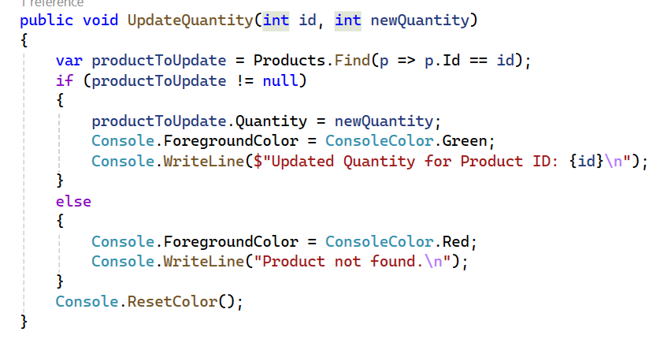

**Output :**

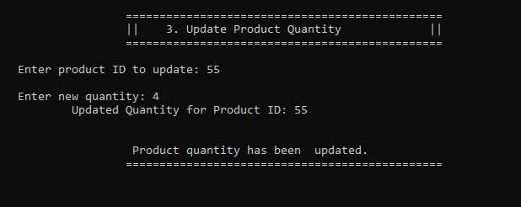

1. **View Cart()**:

* Calls ViewCart to display the contents of the cart.

**Input :**

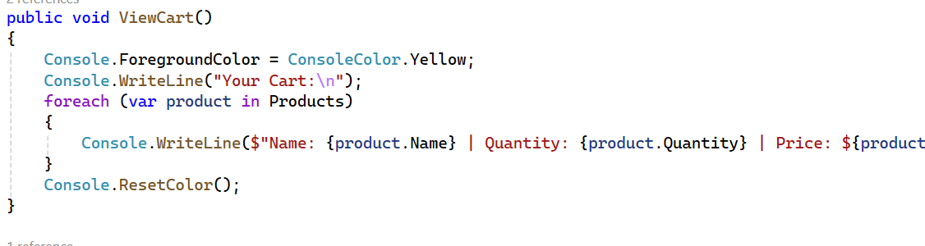

**Output :**

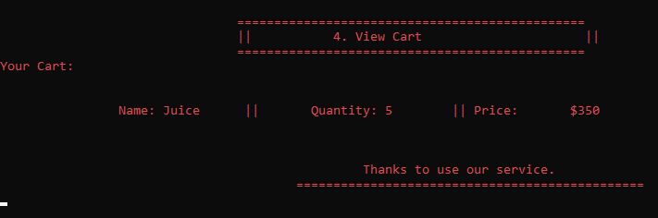

1. **Calculate Total():**

* This Function will Calculate Total and displays the total price.

**Input :**

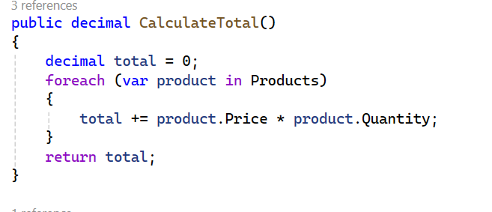

**Output :**

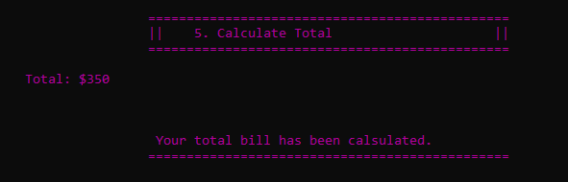

1. **ApplyDiscount()**:

* Applies a discount to the total cost of the cart.

**Input :**

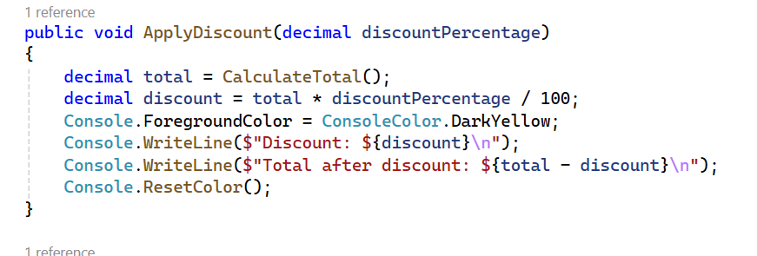

**Output :**

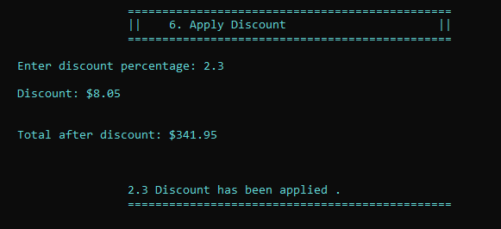

1. **Checkout()**:

* Finalizes the purchase and clears the cart.
* It will also check the expiration of cart if necessary.

**Input:**

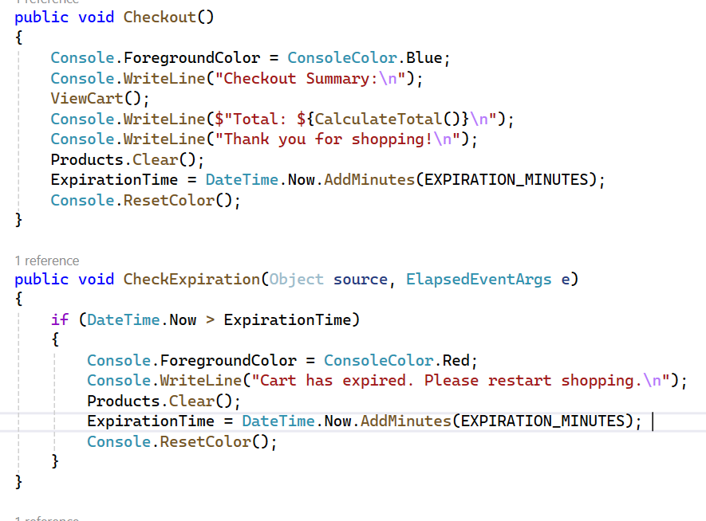

**Output :**

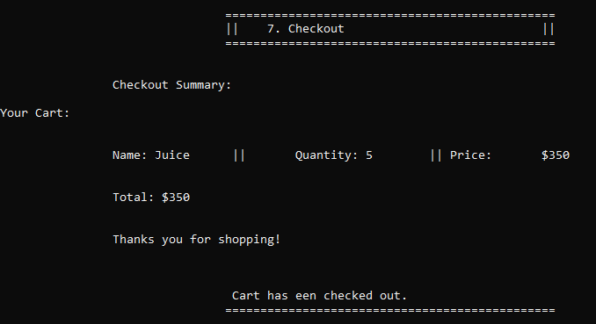

1. **Recommend Products()**:

* Provides a list of recommended products to the user.

**Input :**

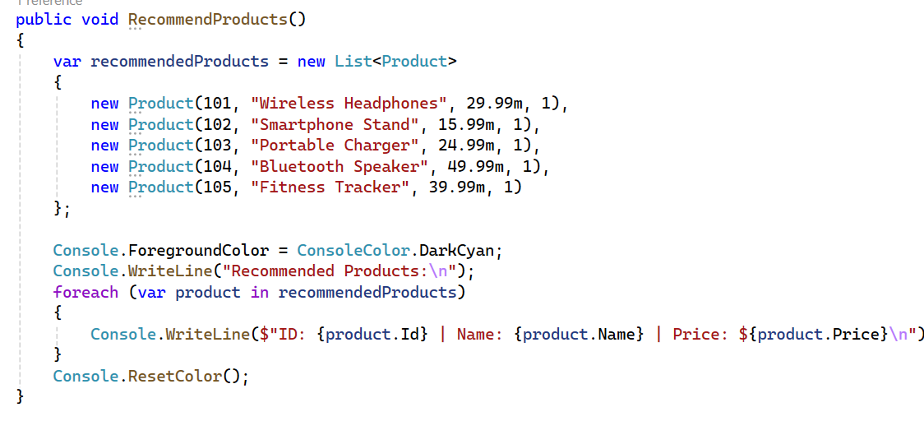

**Output :**

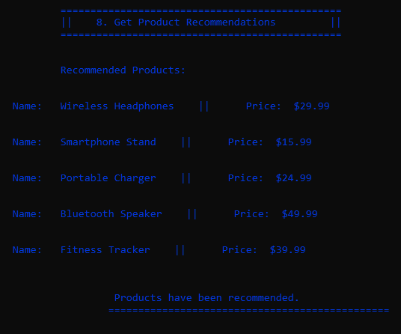

***Shopping Cart Flow Chart***

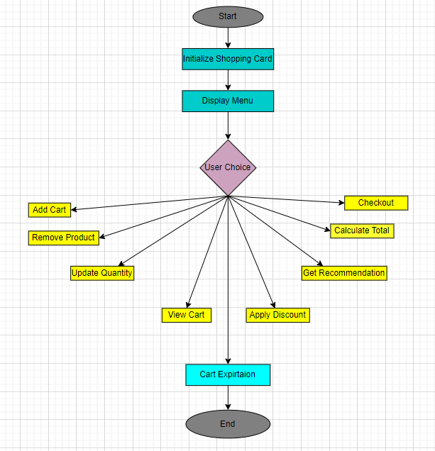

***UML Diagram***

