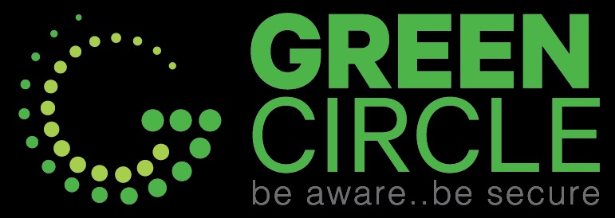
DETAILED TRAINING PROPOSAL
AI-Powered Content Creation, Digital Marketing, Automation & Freelancing
A 96-hour, hands-on training program for young people aged 15–19
Document | Detailed Sessions & Technical Training Proposal
Prepared for | Management, stakeholders and funding partners
Version | 1.0 · October 2026
Status | Proposal for review. No pricing is included at this stage

Contents
1. Executive Summary
2. Program Background
3. Target Audience
4. Program Objectives
5. Learning Outcomes
6. Instructional Methodology
7. Program Duration
8. Training Hours
9. Curriculum Architecture
10. Module Details
11. Session Breakdown
12. Tools & Platforms
13. Hands-on Activities
14. Assessments
15. Pre-Assessment
16. Post-Assessment
17. Capstone Project
18. Student Deliverables
19. Trainer Requirements
20. Technical Requirements
21. Infrastructure Requirements
22. Device and Internet Considerations
23. Age-related Considerations
24. Responsible AI & Safety
25. KPIs
26. Success Measurement
27. Risks & Mitigation
28. Implementation Recommendations
29. References

How to read this document: “Proposed” marks a design choice or target that still needs approval. “TBD” marks information the program team has not yet supplied. Facts about third-party tools were checked against official sources in October 2026 and are listed in Section 29.

1. Executive Summary
This proposal describes a 96-hour practical program that teaches young people aged 15 to 19 how to use AI tools to produce real marketing work: from understanding a client's request, through writing, visuals, characters, voice and short video, to a marketing plan, a simple automation and a published portfolio.
The program runs for 11 weeks, three sessions a week, three hours per session, with a twelfth week held in reserve. About 70% of the time is hands-on. Students work in teams on a single capstone, an AI-Powered Mini Digital Agency project, which they start in week 2 and present on Demo Day.
Two design decisions shape the program. First, every tool is checked against its own age rules: students aged 15–17 follow the full curriculum, but some tools (AI video, AI voice, developer APIs) are shown by the trainer rather than used directly. Second, success is measured by skills and finished work, not by income. Under-18 students cannot contract independently on most freelance platforms, so freelance readiness is measured with a checklist rather than earnings.
Duration  11 weeks + 1 buffer week | Hours  96 (28.5 theory · 67.5 practice)
Format  32 sessions × 3 hours | Audience  Ages 15–19, no technical background
Cohort  20 students (Proposed) | Capstone  AI-Powered Mini Digital Agency

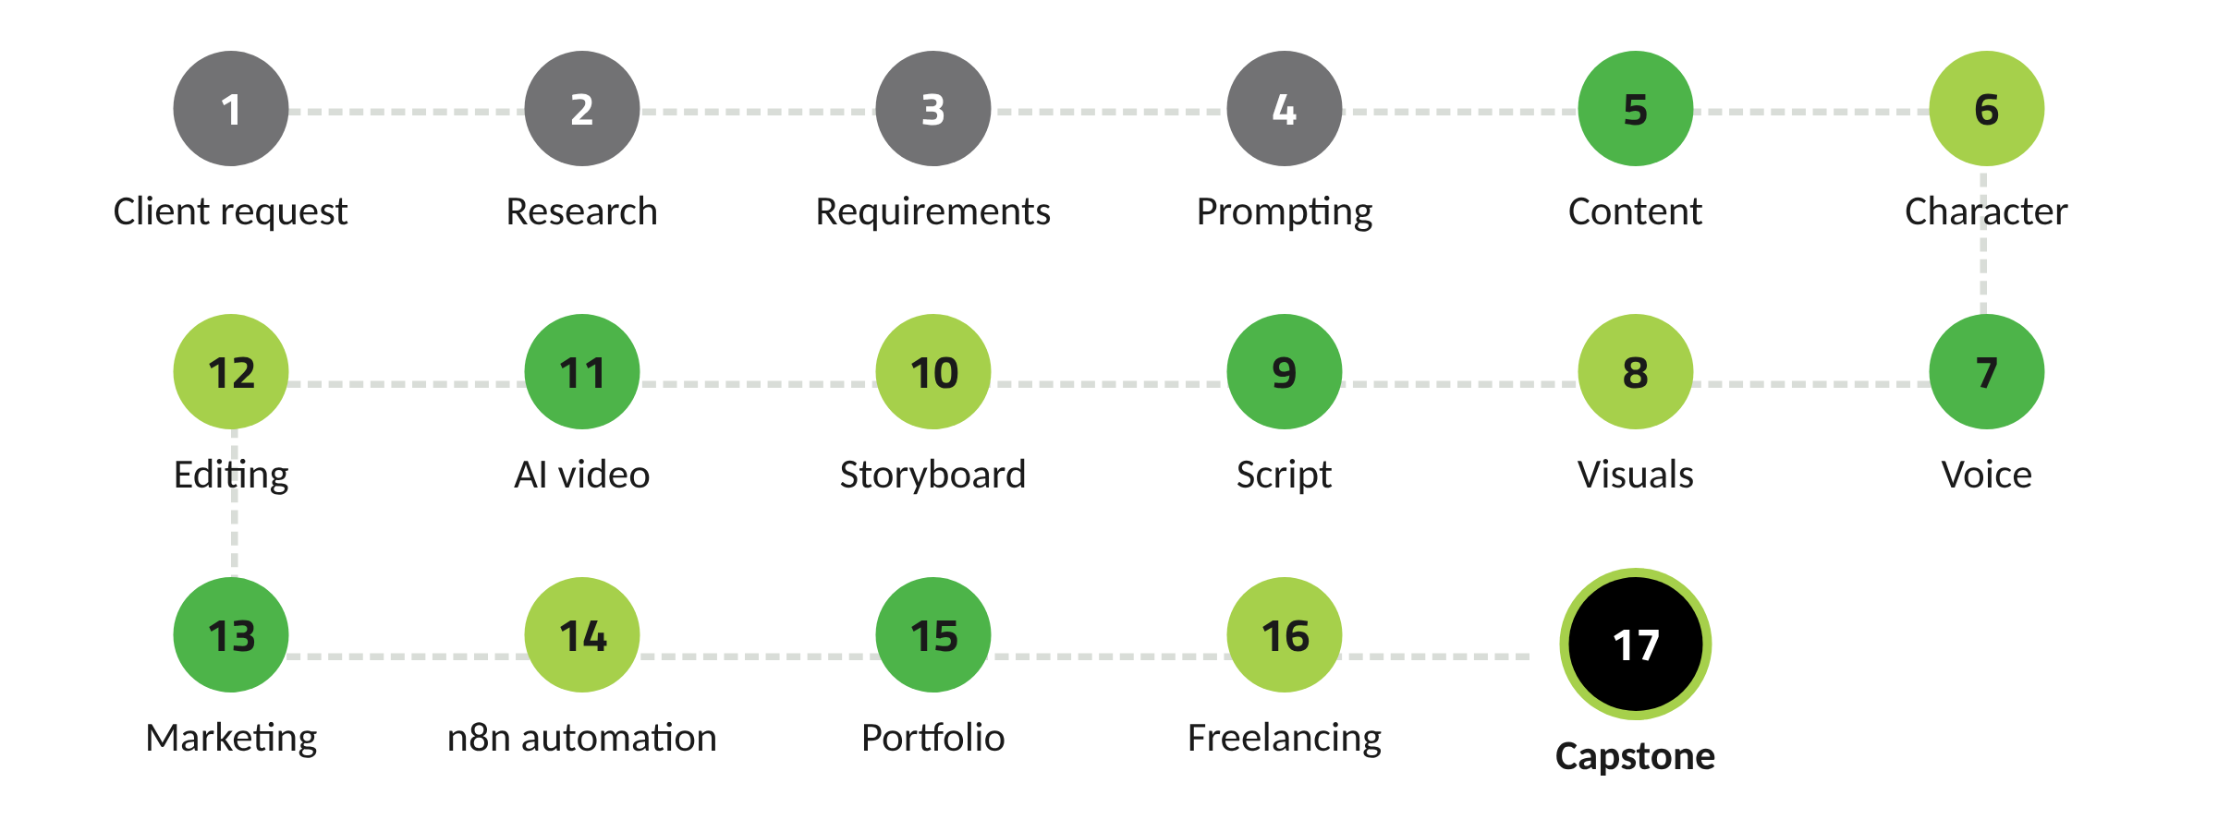
Figure 1. The student journey, from client request to capstone

2. Program Background
Generative AI tools are now part of everyday work in content, marketing and small-business communication. Young people often meet these tools informally, through social media tips and trial and error. What they rarely get is a structured route from “I can make the tool produce something” to “I can deliver work a client can use, and I can explain how I made it.”
This program fills that gap with a client-centred sequence. It deliberately keeps automation and coding at a beginner level: the aim is for students to understand how workflows and simple web pages are built and to produce working examples, not to train engineers.
The program also carries Green Circle's awareness focus, expressed in its line “be aware..be secure”, into the classroom. Account security, credential handling, privacy, consent and honest labelling of AI content are taught as part of every module, not as a separate lecture.

3. Target Audience
The program is open to young people aged 15 to 19. No coding or design experience is required. Students need basic computer skills (typing, file management, using a browser) and the ability to follow instructions in English tool interfaces with Arabic support from the trainer.
 | Ages 15–17 | Ages 18–19
Curriculum and hours | Full curriculum, 96 hours | Full curriculum, 96 hours
Consent | Signed guardian consent required | Own consent
Tool access | Tools that permit their age group; 18+ tools by trainer demo | Same, plus hands-on with 18+ tools where the program provides access
Examples and clients | School, community and family-business scenarios | Same, plus small businesses and personal brands
Freelancing | Portfolio, service packages and practice with program-arranged community partners | Same, plus guidance on opening freelance profiles under each platform's rules

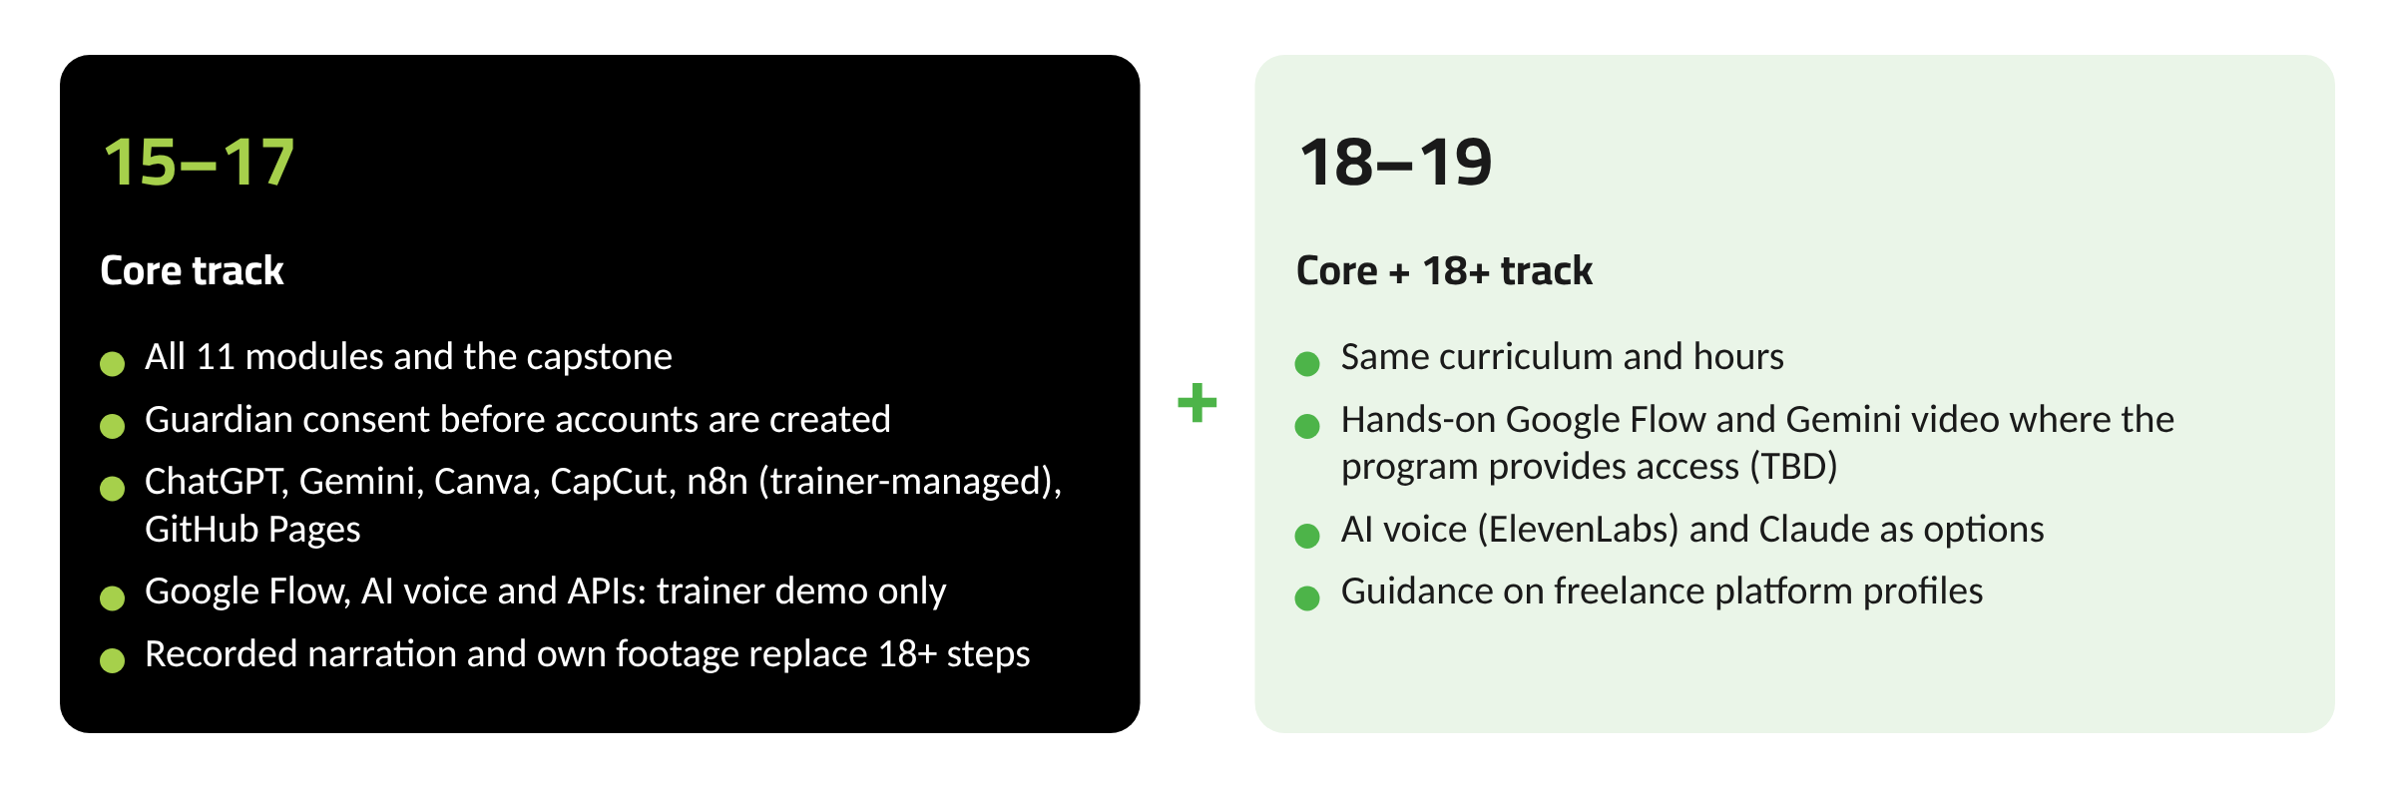
Figure 2. Core track and 18+ track
Selection criteria, recruitment channels and the final cohort size are TBD.

4. Program Objectives
- Build practical AI literacy: how AI assistants work, where they fail, and how to use them safely and honestly.
- Teach a repeatable production process from client request to published content.
- Develop core content skills: copywriting, hooks and CTAs, characters, voice, visuals, scripts, storyboards and short video.
- Introduce digital marketing planning: personas, objectives, content calendars and campaigns.
- Give every student hands-on experience building a simple automation in n8n.
- Prepare students to present their work and approach freelance or entry-level opportunities responsibly.

5. Learning Outcomes
By the end of the program, a student who completes all modules will be able to:
- Turn a vague client request into a one-page creative brief backed by verified research.
- Write structured prompts and reusable context packs that produce usable first drafts.
- Produce a carousel, captions with CTAs and a set of consistent brand visuals.
- Design an AI character with a written character sheet and voice profile.
- Plan a short video with a script and storyboard, then produce and edit a 30–45 second video with captions.
- Build an audience persona, a four-week content calendar and a small campaign plan.
- Build an n8n workflow that collects input through a form, uses an AI step, and saves results to Google Sheets, and explain each step.
- Publish a one-page portfolio and describe three service offers.
- Present a team capstone and explain the decisions behind it.

6. Instructional Methodology
The program follows a 30/70 split between short theory and hands-on practice. Across all modules, theory totals 28.5 hours and practice 67.5 hours.
Each session follows the same four-step loop so students always know what comes next:
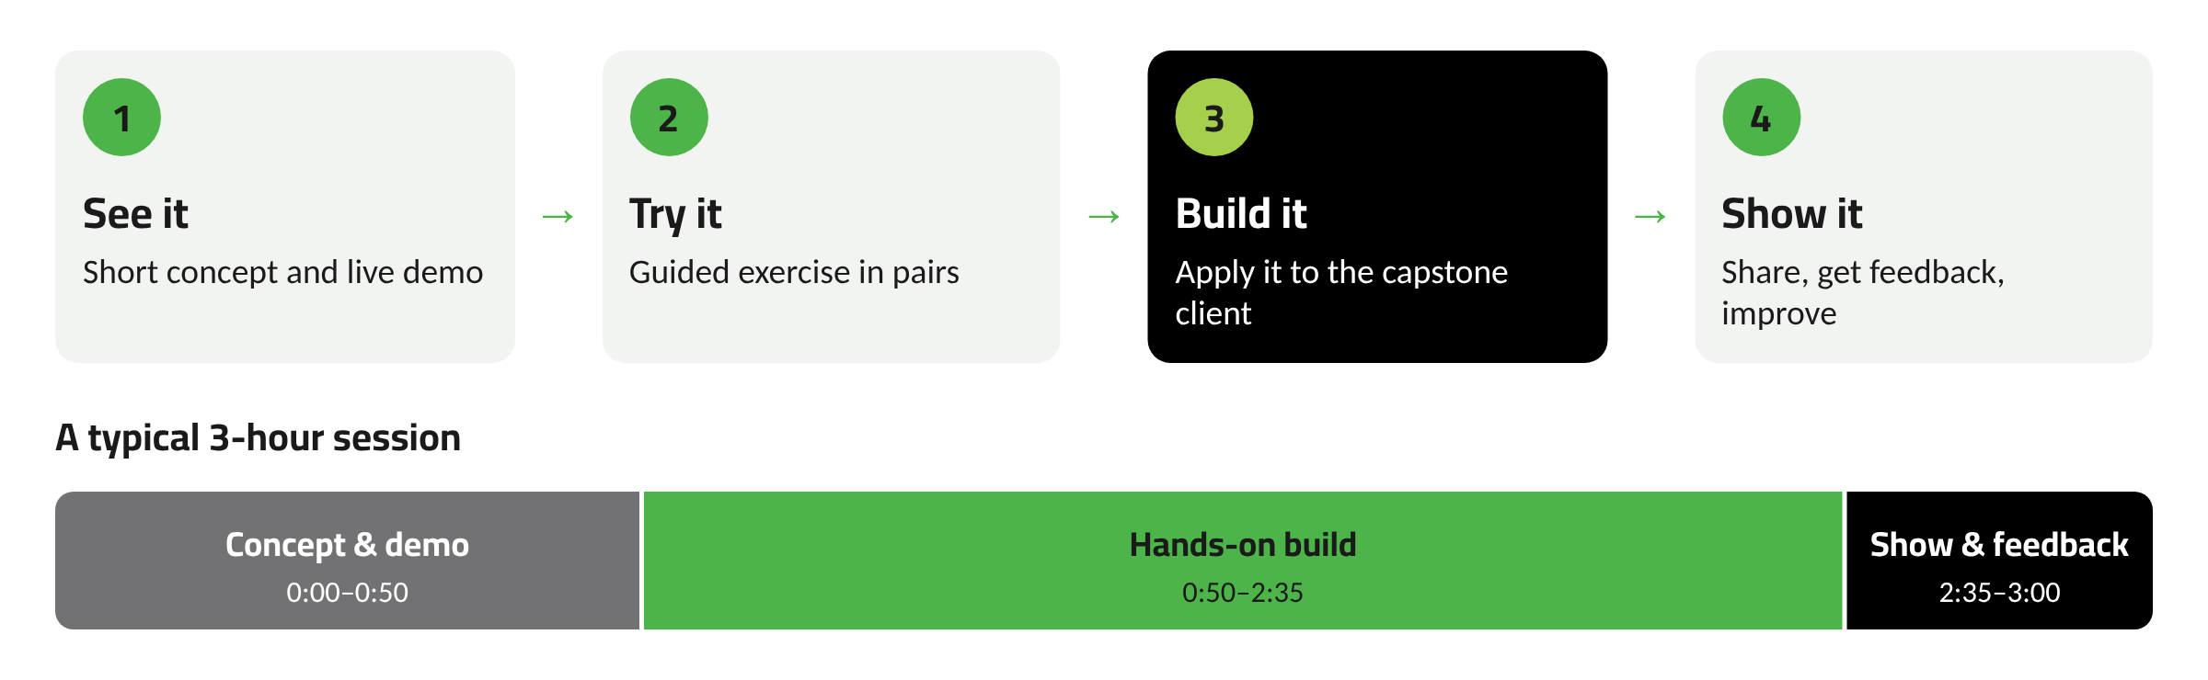
Figure 3. The learning loop and a typical session
Skills are sequenced so that each module uses what the previous one produced: the brief from Module 3 feeds the content in Module 4, the character from Module 5 appears in the video in Module 7, and so on. This keeps motivation high because students see their own project grow.
Teaching choices for this age group: activities are short (15–40 minutes), instructions are written as checklists, examples are drawn from school life, local shops and community causes, and every session ends with something saved to the student's portfolio folder. Trainers model mistakes openly, including AI errors, so students learn to check work rather than trust it.

7. Program Duration
Total duration is 12 weeks: 11 teaching weeks and one buffer week. The buffer absorbs public holidays, exam clashes or make-up sessions without pushing the program past three months.
Proposed rhythm: three sessions a week (for example, two weekday afternoons and one weekend morning), three hours each with a 10-minute break. Exact days and times are TBD and should be set around the school calendar. An intensive summer variant (six sessions a week over six weeks) is possible with the same content and hours.
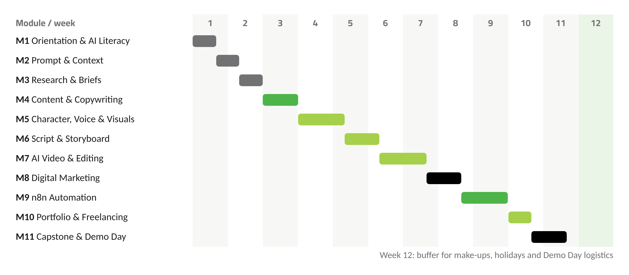
Figure 4. Twelve-week delivery timeline

8. Training Hours
Why 96 hours: each of the 11 modules needs enough hands-on time to produce a real deliverable, and the capstone needs dedicated studio time. Three-hour sessions are long enough for a full See–Try–Build–Show loop but short enough to keep teenagers focused. Thirty-two sessions of three hours give 96 hours, which fits within 11 weeks at three sessions a week.
Module | Sessions | Theory (h) | Practice (h) | Total (h)
M1 Orientation, Pre-Assessment & AI Literacy | 1–2 | 2.5 | 3.5 | 6
M2 Prompt & Context Engineering | 3–4 | 2 | 4 | 6
M3 AI Research, Fact Verification & Client Briefs | 5–6 | 2 | 4 | 6
M4 AI Content Creation & Copywriting | 7–9 | 2.5 | 6.5 | 9
M5 AI Characters, Voice & Visuals | 10–13 | 3.5 | 8.5 | 12
M6 Scriptwriting, Storytelling & Storyboarding | 14–16 | 3 | 6 | 9
M7 AI Video Production, Editing & Publishing | 17–20 | 3 | 9 | 12
M8 Digital Marketing Foundations | 21–23 | 3 | 6 | 9
M9 Automation with n8n | 24–27 | 4 | 8 | 12
M10 Vibe Coding, Portfolio & Freelancing | 28–29 | 2 | 4 | 6
M11 Capstone Studio, Post-Assessment & Demo Day | 30–32 | 1 | 8 | 9
Total | 32 | 28.5 | 67.5 | 96

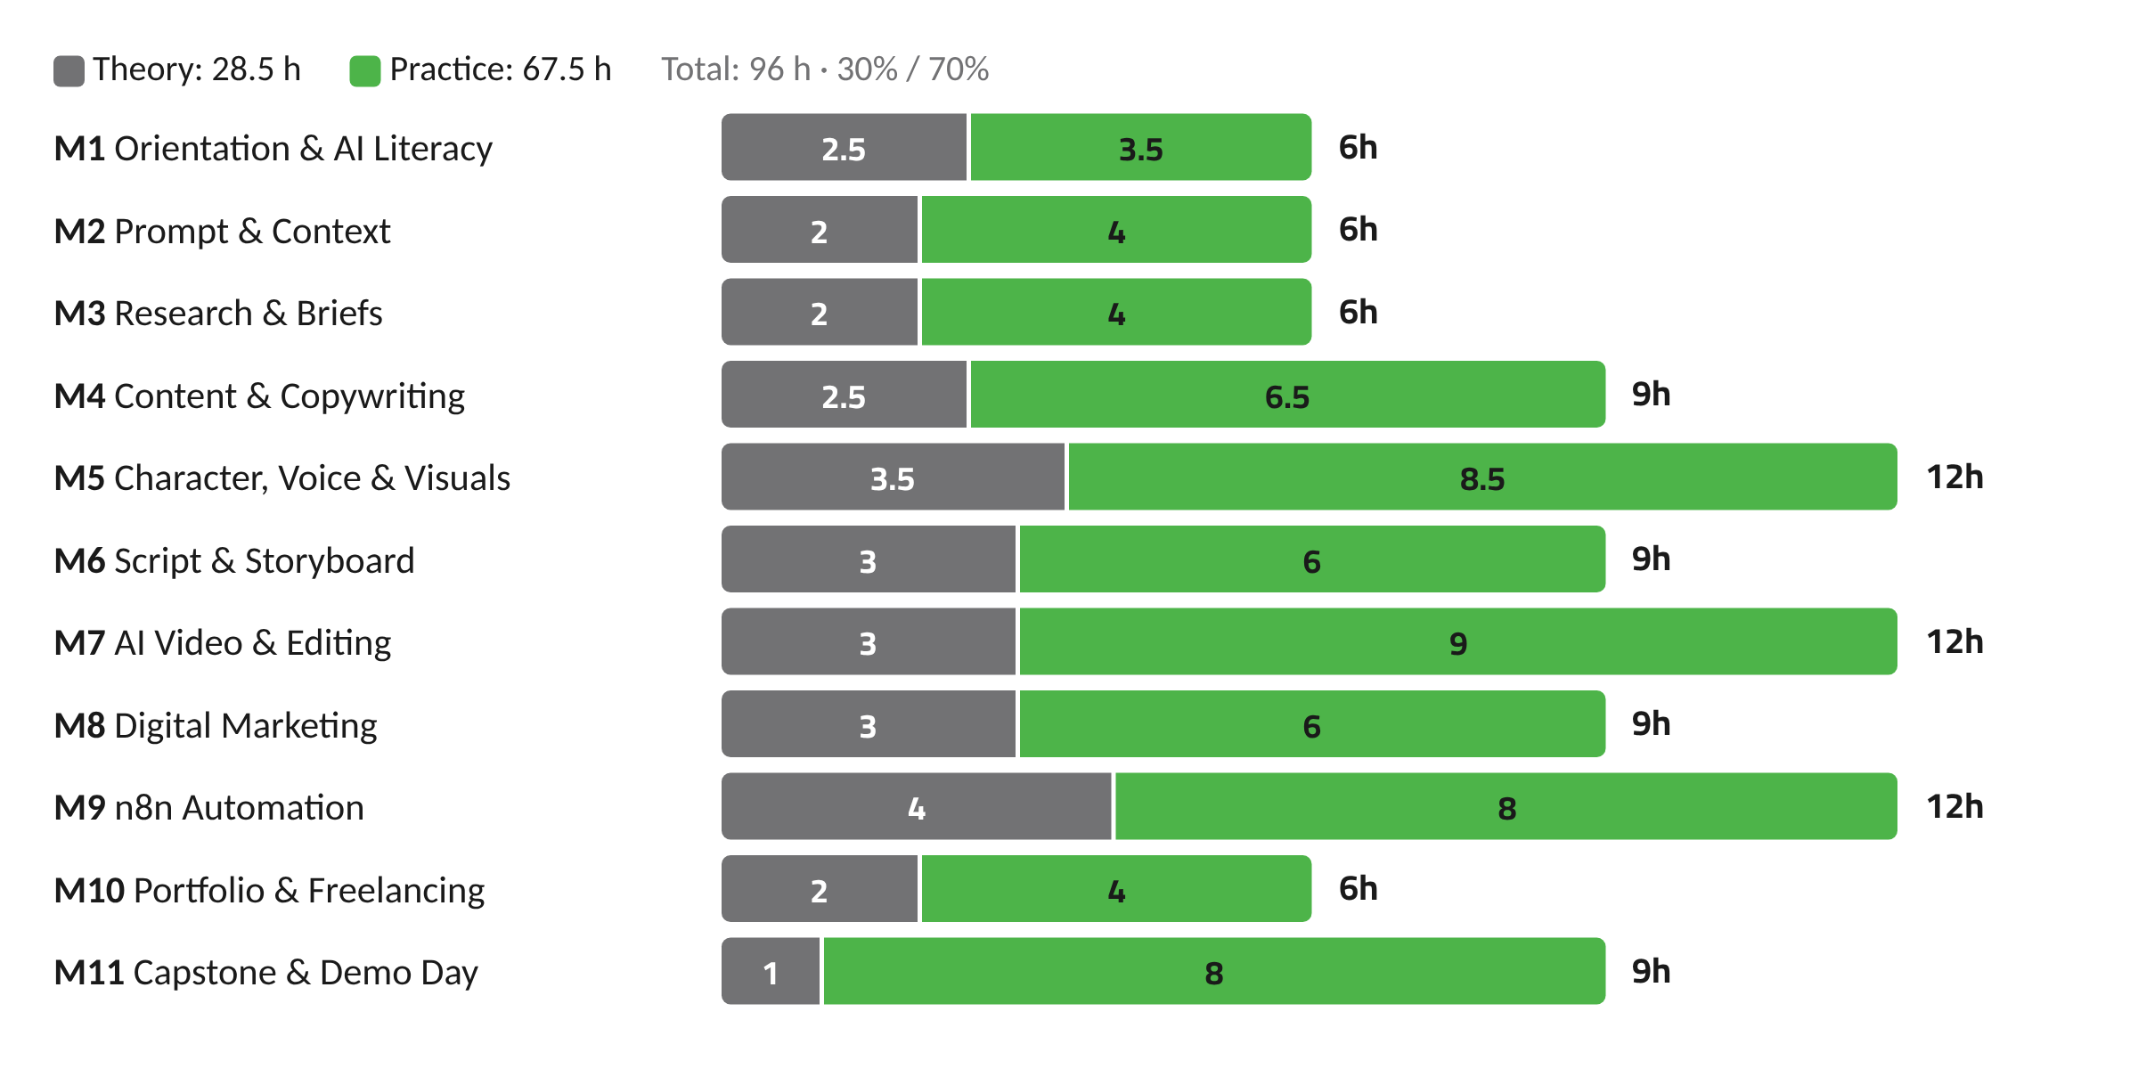
Figure 5. Theory and practice hours per module

9. Curriculum Architecture
The 11 modules are grouped into seven tracks. The Foundation track gives every later module its tools: prompting, research and a clear brief. Production is the largest track because characters, voice and video are the most practice-heavy skills. The capstone runs as a thread through all tracks and is finished in the last three sessions.
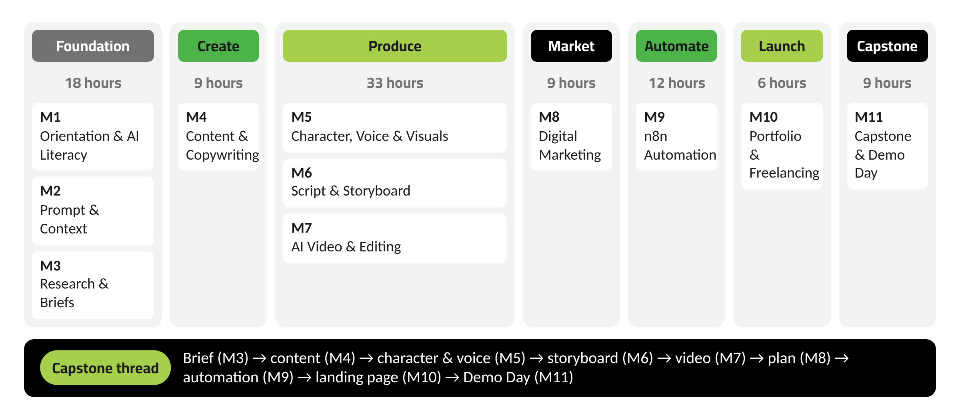
Figure 6. Tracks, modules and the capstone thread
Track | Modules | Hours | Capstone milestone
Foundation | M1–M3 | 18 | Client chosen; brief and research approved
Create | M4 | 9 | Content pillars and first posts
Produce | M5–M7 | 33 | Character, voice, storyboard and edited video
Market | M8 | 9 | Persona, calendar and campaign
Automate | M9 | 12 | Content Idea Generator workflow
Launch | M10 | 6 | Landing page and service packages
Capstone | M11 | 9 | Final package, presentation and post-assessment

10. Module Details
Each module below lists its purpose, outcomes, content, tools, activities, deliverable and assessment. Hours match the session plan in Section 11.

M1 Orientation, Pre-Assessment & AI Literacy
Sessions 1–2 · Hours: 6 · Theory 2.5 / Practice 3.5
Purpose | Set expectations, record each student's starting point, and give an honest picture of what AI assistants do well, where they fail, and how to use them responsibly.
Learning outcomes | - Explain in plain words how an AI assistant produces an answer and why that answer can be wrong  - Spot privacy, consent and copyright risks before using an AI tool  - Compare ChatGPT and Gemini on the same task and justify a choice  - Commit to the program's Responsible AI code
Key topics | Program journey and capstone preview; Pre-assessment; What generative AI is, and what it is not; Hallucinations, bias and privacy; Account security and strong passwords; Labelling AI-made content; ChatGPT and Gemini: interface tour; Age rules for the tools used in this program
Tools | ChatGPT, Gemini, Google Forms
Trainer activity | Runs a live “AI gets it wrong” demo and walks the group through the tool-access plan and the code of conduct.
Student activity | Takes the pre-assessment, then runs the same three prompts in two assistants and logs the differences.
Practical exercise | Spot the error: students receive five AI answers, find the factual mistakes, and correct one with a source.
Expected deliverable | Pre-assessment, signed Responsible AI pledge, assistant comparison log
Assessment method | Baseline score (not graded); completion check

M2 Prompt & Context Engineering
Sessions 3–4 · Hours: 6 · Theory 2 / Practice 4
Purpose | Teach students to get usable results on the first or second try by structuring prompts and giving the AI the right background.
Learning outcomes | - Write prompts that state role, task, context, format and constraints  - Improve a weak prompt through at least three rounds of iteration  - Build a reusable context pack (brand, audience, tone) and apply it across tasks  - Keep a personal prompt library
Key topics | Anatomy of a prompt; Examples and few-shot prompting; Asking for structured output (tables, lists, checklists); Iterating on results; Context engineering: what to give the model and what to leave out; Context packs; Saved instructions and project spaces (concept); Building a prompt library
Tools | ChatGPT, Gemini, Google Docs
Trainer activity | Rewrites a weak prompt live and puts the before and after outputs side by side.
Student activity | Takes on a prompt-upgrade challenge and builds a context pack for a fictional café.
Practical exercise | One task, three prompts: bare, structured, and structured plus context pack. Students score the three outputs with a rubric.
Expected deliverable | Prompt library (10+ prompts) and one context pack
Assessment method | Prompt rubric: clarity, context, constraints, fit of output

M3 AI Research, Fact Verification & Client Briefs
Sessions 5–6 · Hours: 6 · Theory 2 / Practice 4
Purpose | Move from a loose idea to a checked, written brief. This is the step that separates professional work from guesswork.
Learning outcomes | - Use AI to speed up research, then check claims against original sources  - Run a short client interview from a prepared question list  - Turn interview notes into a one-page creative brief  - Keep a clear record of sources
Key topics | AI-assisted research; Lateral reading and source checking; Primary versus secondary sources; A five-step verification checklist; Requirement-gathering questions; Agreeing scope; Creative brief: objective, audience, message, deliverables, tone, deadline
Tools | Gemini, ChatGPT, Google Docs
Trainer activity | Plays a client with a vague request (“I just want more followers”) so students practise asking the right questions.
Student activity | Interviews the “client” in pairs and drafts the brief.
Practical exercise | Fact-check race: verify six claims about a local business sector and label each one Verified, Unverified or False, with a source.
Expected deliverable | Verified research sheet and a one-page creative brief (Capstone milestone 1)
Assessment method | Brief checklist; quality of sources

M4 AI Content Creation & Copywriting
Sessions 7–9 · Hours: 9 · Theory 2.5 / Practice 6.5
Purpose | Write short-form content that people stop for and act on, with AI as a drafting partner rather than the author.
Learning outcomes | - Write hooks, captions and calls to action (CTAs) for a defined audience  - Define three to five content pillars for a brand  - Edit AI drafts until they sound human and on-brand  - Adapt one idea to three formats
Key topics | Content formats: post, carousel, reel, story; Copywriting frameworks: AIDA and PAS; Hooks; CTAs; Tone of voice; Content pillars; Editing AI drafts; Writing for Arabic and English audiences
Tools | ChatGPT, Gemini, Canva
Trainer activity | Runs a “hook clinic”, reviewing student hooks live and explaining why some work and others don't.
Student activity | Writes ten hooks, shortlists three by peer vote, and builds a carousel in Canva.
Practical exercise | One idea, three outputs: a reel hook, a carousel, and a caption with a CTA.
Expected deliverable | Content pillars sheet, one carousel, five captions with CTAs
Assessment method | Copy rubric: clarity, audience fit, hook strength, CTA

M5 AI Characters, Voice & Visuals
Sessions 10–13 · Hours: 12 · Theory 3.5 / Practice 8.5
Purpose | Create a brand character or presenter, give it a consistent look and voice, and produce the visual assets a campaign needs.
Learning outcomes | - Write a character sheet that others could follow  - Keep a character consistent across images using reference images and fixed descriptors  - Produce narration that matches a written voice profile  - Generate and edit images that follow a brief  - Apply clear rules on likeness, consent and disclosure
Key topics | Character design sheet; Consistency techniques: reference image, fixed descriptors, wardrobe and palette; Voice profile: tone, pace, accent; AI narration versus recorded narration; Image prompts: subject, style, composition, lighting; Editing and layout in Canva; Ethics: no real person's face or voice without consent; no copying classmates
Tools | ChatGPT / Gemini image generation*, Canva, Recorded narration (phone or USB mic), ElevenLabs (18+ track)
Trainer activity | Demonstrates a consistency workflow from character sheet to final image; runs the AI-voice demo for under-18 groups.
Student activity | Builds a character sheet, generates six consistent images, and records or generates a 30-second narration.
Practical exercise | Same character, four scenes: students keep face, outfit and style stable across four different settings.
Expected deliverable | Character sheet, voice profile, six-image visual set, 30-second narration
Assessment method | Consistency checklist; alignment with the brief
* Image generation inside ChatGPT or Gemini depends on each tool's settings for teen accounts; confirm during the pre-launch tool audit.

M6 Scriptwriting, Storytelling & Storyboarding
Sessions 14–16 · Hours: 9 · Theory 3 / Practice 6
Purpose | Plan a short video properly before generating anything. Planning saves time and credits and produces better results.
Learning outcomes | - Write a 30–60 second script with a hook, a body and a CTA  - Apply a simple story structure  - Build a shot-by-shot storyboard  - Choose shot types and camera movement with a reason
Key topics | Two-column (audio/visual) script format; Story structures: problem–solution, before–after, three acts; Pacing for short video; Storyboarding; Shot types: wide, medium, close-up, over-the-shoulder; Angles and camera movement; Visual direction notes that feed AI video prompts
Tools | ChatGPT, Gemini, Google Sheets, Canva
Trainer activity | Breaks down a professional advert shot by shot and maps it onto a storyboard.
Student activity | Writes the script and builds a storyboard of six to ten frames.
Practical exercise | Cut a 60-second script to 30 seconds without losing the message.
Expected deliverable | Script and storyboard with shot list (Capstone milestone)
Assessment method | Storyboard rubric

M7 AI Video Production, Editing & Publishing
Sessions 17–20 · Hours: 12 · Theory 3 / Practice 9
Purpose | Turn the storyboard into a finished, captioned video that is ready to publish.
Learning outcomes | - Write shot prompts directly from a storyboard  - Keep characters and scenes consistent from shot to shot  - Edit clips with music, narration and captions  - Export in the right format for each platform and label AI content
Key topics | How text-to-video and image-to-video tools work, and their limits; Google Flow overview; Prompting individual shots; Continuity: reference frames, fixed descriptors, lighting; Editing: cuts, pacing, B-roll; Captions and audio mix; Aspect ratios and export settings; Publishing checklist and AI disclosure
Tools | Google Flow (trainer demo; hands-on for eligible 18+), CapCut, Canva
Trainer activity | Generates clips live from students' storyboards and shows how a small prompt change affects continuity.
Student activity | Edits a 30–45 second video with captions and narration.
Practical exercise | Continuity challenge: produce three consecutive shots where the character, outfit and lighting match.
Expected deliverable | Edited 30–45 second video and a completed publishing checklist
Assessment method | Video rubric: story, continuity, edit quality, captions, audio

M8 Digital Marketing Foundations
Sessions 21–23 · Hours: 9 · Theory 3 / Practice 6
Purpose | Place content inside a plan: who it is for, when it goes out, and how success will be judged.
Learning outcomes | - Build an audience persona from research, not guesswork  - Set a SMART marketing objective  - Build a four-week content calendar  - Design a small campaign with clear success measures
Key topics | The marketing funnel in simple terms; Audience personas; SMART objectives; Choosing platforms; Content calendars; Campaign structure: message, offer, channels, timeline; Basic metrics: reach, engagement, clicks, saves; Organic and paid reach (concepts only; no budgeting)
Tools | ChatGPT, Gemini, Google Sheets, Canva
Trainer activity | Reviews a real public campaign and asks students to reverse-engineer its persona and objective.
Student activity | Builds the persona and calendar for the capstone client.
Practical exercise | Campaign sprint: in 60 minutes, teams turn one objective into a two-week campaign outline.
Expected deliverable | Audience persona, four-week content calendar, campaign one-pager
Assessment method | Marketing plan checklist; peer review

M9 Automation with n8n
Sessions 24–27 · Hours: 12 · Theory 4 / Practice 8
Purpose | Show students that repetitive work can run on its own, and have each team build one useful content workflow from start to finish.
Learning outcomes | - Explain trigger, node, input/output and data flow in their own words  - Build workflows using manual, form and schedule triggers  - Map data between nodes with simple expressions and IF conditions  - Explain API keys, OAuth and access tokens at concept level, and keep credentials safe  - Add an AI step that drafts a hook, caption, CTA and reel idea, then saves them to Google Sheets
Key topics | What automation is; Workflows and nodes; Triggers: manual, form, schedule; Webhooks (concept); Input, output and data flow; Credentials; API keys, OAuth and access tokens (concepts); Credential security; Data mapping; Expressions; IF conditions; Google Sheets integration; Adding an AI step; A simple content automation
Tools | n8n (program-hosted), Google Sheets, AI model node (provider TBD)
Trainer activity | Builds the first workflow live node by node, then sets up all credentials on the program's instance. Students never handle real keys.
Student activity | Rebuilds the workflow, then extends it with a form, an IF condition and an AI step.
Practical exercise | Content Idea Generator: Form → business information → n8n → AI → hook + caption + CTA + reel idea → Google Sheets.
Expected deliverable | Working workflow, a hand-drawn or digital flow diagram, and a one-page explanation
Assessment method | Live run of the workflow; short concept check (Trigger → Process → AI → Action)

M10 Vibe Coding, Portfolio & Freelancing
Sessions 28–29 · Hours: 6 · Theory 2 / Practice 4
Purpose | Give students a place to show their work and the basic habits of working with real clients.
Learning outcomes | - Describe a simple web page in plain language and use an AI assistant to build it  - Review, edit and publish a one-page portfolio or landing page  - Package their skills into three clear service offers  - Write professional messages for first contact, scope confirmation and delivery
Key topics | Vibe coding: describing what you want and reviewing what you get; Basic HTML/CSS structure (reading, not memorising); Publishing a static page; What freelancing involves; Client communication; Service packaging (scope and deliverables; no pricing in this program); Writing a portfolio case study; Age rules on freelance platforms
Tools | ChatGPT / Gemini (canvas features), GitHub Pages, Google Docs
Trainer activity | Builds a landing page live from a plain-language description and fixes two deliberate errors in front of the class.
Student activity | Builds and publishes their own page, then drafts three service packages and four client message templates.
Practical exercise | Client inbox: reply to three realistic client messages (vague request, scope change, late feedback).
Expected deliverable | Published portfolio or landing page, three service packages, client message templates
Assessment method | Portfolio checklist; communication rubric

M11 Capstone Studio, Post-Assessment & Demo Day
Sessions 30–32 · Hours: 9 · Theory 1 / Practice 8
Purpose | Bring every skill together in one client project, measure progress against the starting point, and present the work to an audience.
Learning outcomes | - Deliver a complete mini-agency package for a real or realistic client  - Run a quality check on their own work before submission  - Present decisions and results clearly in five to seven minutes  - Show measurable progress against the pre-assessment
Key topics | Studio sessions with trainer coaching; Team QA checklist; Portfolio case study; Post-assessment; Presentation skills; Demo Day
Tools | All program tools
Trainer activity | Coaches teams, runs stand-up check-ins, and chairs Demo Day with invited guests (guest list TBD).
Student activity | Finishes, checks and presents the capstone; takes the post-assessment.
Practical exercise | Dry-run presentation with structured peer feedback before Demo Day.
Expected deliverable | Full capstone package and final presentation
Assessment method | Capstone rubric, presentation rubric, post-assessment

11. Session Breakdown
Thirty-two sessions of three hours. Weeks assume three sessions per week; week 12 is a buffer.
# | Week | Module | Session | Hands-on work and output
1 | 1 | M1 | Welcome, program journey & pre-assessment | Pre-assessment; team icebreaker; tour of the capstone
2 | 1 | M1 | How AI assistants work & using them responsibly | Spot-the-error task; two-assistant comparison; Responsible AI pledge
3 | 1 | M2 | Prompt anatomy & iteration | Prompt-upgrade challenge; start the prompt library
4 | 2 | M2 | Context engineering & context packs | Build a context pack; three-prompt comparison
5 | 2 | M3 | AI research & fact verification | Fact-check race; verified research sheet
6 | 2 | M3 | Client requirements & creative brief | Client role-play interview; one-page brief; capstone teams formed
7 | 3 | M4 | Content formats & content pillars | Define pillars for the capstone client
8 | 3 | M4 | Copywriting, hooks & CTAs | Hook clinic; ten hooks, three shortlisted
9 | 3 | M4 | From draft to post: editing AI copy & Canva layouts | One idea, three formats; carousel in Canva
10 | 4 | M5 | Designing an AI character | Character sheet; first reference image
11 | 4 | M5 | Character consistency | Same character, four scenes
12 | 4 | M5 | Voice & narration | Voice profile; 30-second narration (recorded, or AI voice on the 18+ track)
13 | 5 | M5 | Image generation & visual content | Six-image visual set edited in Canva
14 | 5 | M6 | Scriptwriting for short video | 30–60 second two-column script
15 | 5 | M6 | Storytelling structures | Rewrite the script using two structures; pick one
16 | 6 | M6 | Storyboarding, shots & visual direction | Six-to-ten frame storyboard with shot list
17 | 6 | M7 | How AI video works; Google Flow walkthrough | Turn storyboard frames into shot prompts
18 | 6 | M7 | Generating shots & scene continuity | Continuity challenge (three matching shots)
19 | 7 | M7 | Video editing in CapCut | Rough cut: pacing, B-roll, music
20 | 7 | M7 | Captions, audio & publishing | Final cut with captions; export; publishing checklist
21 | 7 | M8 | Marketing basics & audience persona | Persona for the capstone client
22 | 8 | M8 | Objectives & content calendar | SMART objective; four-week calendar
23 | 8 | M8 | Building a campaign | Campaign sprint; campaign one-pager
24 | 8 | M9 | Automation thinking & your first workflow | Manual trigger → Edit Fields → Google Sheets
25 | 9 | M9 | Form triggers, data mapping & expressions | Form trigger collecting business information; map fields
26 | 9 | M9 | IF conditions, schedules, webhooks & credentials | Add an IF branch and a schedule; credential-safety drill
27 | 9 | M9 | AI + n8n: Content Idea Generator | Form → AI → hook, caption, CTA, reel idea → Google Sheets
28 | 10 | M10 | Vibe coding a landing page or portfolio | Build and publish a one-page site
29 | 10 | M10 | Freelancing, client communication & service packages | Client inbox exercise; three service packages
30 | 10 | M11 | Capstone studio I | Team production; mid-point review
31 | 11 | M11 | Capstone studio II | QA checklist; portfolio case study; dry-run presentation
32 | 11 | M11 | Post-assessment & Demo Day | Post-assessment; team presentations; certificates (format TBD)

12. Tools & Platforms
Tools were chosen because they are widely used, have free or education access for core tasks, and suit beginners. Each tool's age rule was checked against its official terms or help pages in October 2026. Rules change, so the program team should repeat this check two to four weeks before launch.
Tool | Use in program | Age / access rule (verified) | Access plan | Ref.
ChatGPT | Writing, research, prompting, images, vibe coding | 13+ (or local minimum); under 18 requires parent or guardian permission. Teen protections apply to under-18 accounts. | 15–17 with signed guardian consent; 18–19 own accounts | [1][2]
Gemini (app) | Writing, research, prompting, canvas | 13+ (or applicable local age) with a personal or school Google account; 18+ with a work account. | Both groups; confirm teen feature availability in the pre-launch audit | [3]
Gemini video generation | Short AI clips | 18+; requires Google AI Pro or Ultra for personal accounts. | Trainer demo; hands-on 18+ only if access is provided (TBD) | [4]
Google Flow | AI video production | 18+ with age verification; supported region; eligible Google AI plan. | Trainer demo for all; hands-on for eligible 18+ (TBD) | [5]
Claude | Optional alternative assistant | 18+. | 18+ track only, optional | [6]
ElevenLabs | AI voice and narration | 18+. | 18+ track only; 15–17 record their own narration | [7]
Canva | Design, carousels, storyboards | Under-13s only through Canva Education. | Both groups; AI feature access depends on plan (TBD) | [8]
CapCut | Video editing, captions | 13+ in most countries; some regions set a higher age. | Both groups; confirm local availability | [9]
n8n | Automation workflows | Community Edition can be self-hosted free; some features (e.g. sharing, projects) are excluded. n8n Cloud age terms not verified. | Program-hosted instance; trainer-managed credentials. Hosting model TBD | [10]
Gemini API / Google AI Studio | AI step in n8n (option) | 18+; not for apps directed to or likely used by under-18s. | Not used with 15–17 groups; AI provider for n8n TBD | [11]
Google account (Docs, Sheets, Forms) | Documents, data, forms | 13 is the default minimum; varies by country; Workspace for Education accounts may differ. | Personal or program-managed accounts (TBD) | [12]
GitHub Pages | Publishing the portfolio page | 13+; some countries set a higher age. | Both groups | [13]
Fiverr (reference) | Freelancing discussion | Sellers 18+; 13–17 only through a parent's or guardian's account. | Discussed, not required | [14]

13. Hands-on Activities
Every module has at least one structured exercise with a clear output. The most important ones are listed below; full instructions will be written in the trainer guide (TBD).
Activity | Module | What students do | Output
Spot the error | M1 | Find and correct factual mistakes in five AI answers | Corrected answer with source
Prompt upgrade | M2 | Improve one prompt through three versions and score each | Prompt library entries
Fact-check race | M3 | Verify six claims and label each with a source | Verified research sheet
Client role-play | M3 | Interview a trainer playing a vague client | One-page creative brief
Hook clinic | M4 | Write ten hooks; peers shortlist three | Hooks, carousel, captions
Same character, four scenes | M5 | Keep one character consistent across settings | Six-image visual set
60 to 30 | M6 | Cut a script in half without losing the message | Script and storyboard
Continuity challenge | M7 | Produce three matching consecutive shots | Edited video
Campaign sprint | M8 | Turn one objective into a two-week campaign in 60 minutes | Campaign one-pager
Content Idea Generator | M9 | Build Form → AI → Google Sheets workflow | Working n8n workflow
Client inbox | M10 | Reply to three realistic client messages | Message templates
Demo Day dry run | M11 | Rehearse and give structured peer feedback | Final presentation

14. Assessments
Assessment is continuous and practical. Each module ends with a deliverable checked against a short rubric. The pre- and post-assessments measure progress; the capstone and presentation measure applied skill. Proposed weighting for the final program grade:
Component | Weight (Proposed) | Evidence
Module deliverables (M1–M10) | 40% | Checklists and rubrics per module
Capstone package | 35% | Capstone rubric (team score, individual contribution log)
Demo Day presentation | 15% | Presentation rubric
Participation and reflection | 10% | Attendance, weekly reflection notes

Proposed completion requirement: attendance at 80% or more of sessions and submission of the capstone package. Certificate format and issuing body are TBD.

15. Pre-Assessment
Taken in Session 1, before any teaching. It sets each student's baseline and helps trainers group teams with a mix of strengths. It is not graded.
- Part A · Knowledge check (50 points): 20 short questions on AI basics, prompting, fact-checking, marketing terms and automation concepts.
- Part B · Practical task (50 points): a 30-minute mini-brief. Students produce a social post with any permitted AI tool and explain their choices. Scored with the same rubric used later in the program.
- Part C · Self-rating (not scored): students rate their confidence in ten skills from 1 to 5.

16. Post-Assessment
Taken in Session 32. It uses the same structure and scoring as the pre-assessment, with a parallel set of questions and a different mini-brief of equal difficulty, so scores can be compared fairly. The difference between the two scores (out of 100) is the main measure of learning gain. The self-rating is repeated to track confidence.

17. Capstone Project
AI-Powered Mini Digital Agency. Teams of three to four students choose one client and deliver a complete campaign package. Clients can be a small business, an NGO, a community initiative, a local shop, a restaurant, a personal brand or a social cause. Real clients are arranged through community partners (TBD); otherwise, trainers provide a realistic client profile.
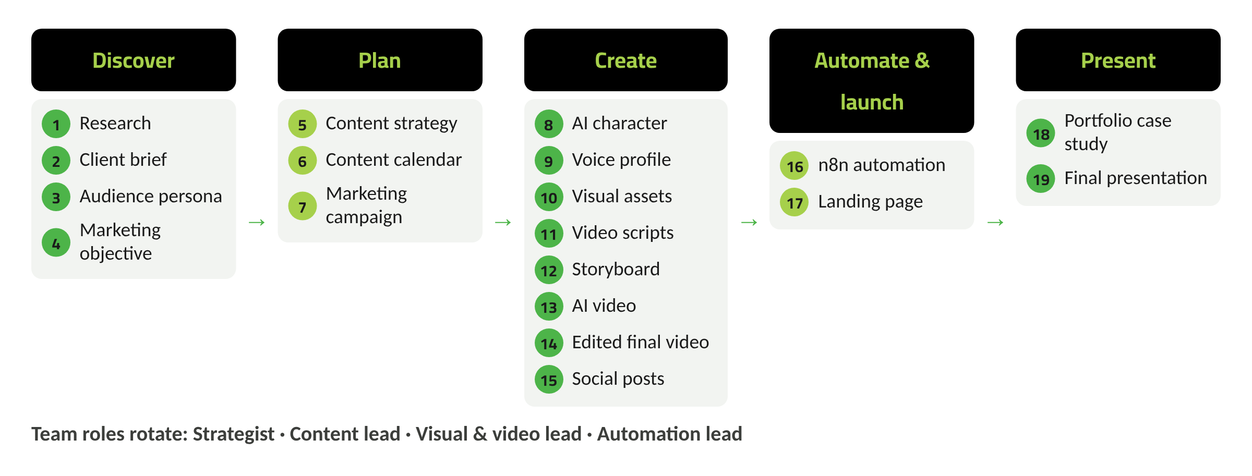
Figure 7. Capstone phases and its 19 deliverables
The capstone is built step by step inside the modules, so the final three sessions are for finishing and polishing. Team roles rotate so every student practises strategy, content, visuals and automation.
# | Deliverable | Built in | Phase
1 | Research | M3 | Discover
2 | Client brief | M3 | Discover
3 | Audience persona | M8 | Discover
4 | Marketing objective | M8 | Discover
5 | Content strategy | M4 | Plan
6 | Content calendar | M8 | Plan
7 | Marketing campaign | M8 | Plan
8 | AI character (if suitable) | M5 | Create
9 | Voice profile | M5 | Create
10 | Visual assets | M5 | Create
11 | Video scripts | M6 | Create
12 | Storyboard | M6 | Create
13 | AI video | M7 | Create
14 | Edited final video | M7 | Create
15 | Social posts | M4 | Create
16 | Basic n8n automation | M9 | Automate & launch
17 | Landing page | M10 | Automate & launch
18 | Portfolio case study | M11 | Present
19 | Final presentation | M11 | Present

Capstone rubric (Proposed)
Criterion | Weight | What “meets standard” looks like (3 of 4)
Brief and research | 15% | Clear objective and audience; claims verified with sources
Content quality | 20% | On-brand, human-sounding copy with strong hooks and CTAs
Visual and video | 20% | Consistent character and visuals; video edited with captions and clean audio
Marketing plan | 15% | Persona, SMART objective and a realistic four-week calendar
Automation | 10% | Workflow runs end to end and the team can explain each step
Responsible AI | 10% | AI content labelled; no personal data or real likeness misused
Presentation | 10% | Clear story of decisions and results within the time limit

18. Student Deliverables
Each student leaves with a portfolio folder and a published page containing the following:
- Prompt library (10+ prompts) and a context pack
- One-page creative brief with verified research
- Carousel and five captions with CTAs
- Character sheet, voice profile and six-image visual set
- Script, storyboard and an edited 30–45 second video
- Audience persona, four-week calendar and campaign one-pager
- Working n8n Content Idea Generator workflow with diagram
- Published portfolio or landing page, three service packages and a capstone case study

19. Trainer Requirements
Proposed staffing per cohort of 20: one lead trainer and one assistant trainer (a ratio of about 1:10 during hands-on work).
- Lead trainer: proven hands-on work in content creation and digital marketing; daily use of AI assistants, image and video tools; working knowledge of n8n at the level taught; experience teaching teenagers.
- Assistant trainer: confident with the tool stack, able to troubleshoot accounts, devices and exports during sessions.
- Both: safeguarding training and background checks as required locally (TBD); agreement to the program's Responsible AI and child-protection code.
- Preparation before launch: complete the tool access audit, run every exercise end to end, set up the n8n instance and credentials, and prepare sample client profiles.
- Optional guest sessions (video production, freelancing) are TBD and would replace, not add to, the planned hours.

20. Technical Requirements
- Accounts: Google accounts (personal or program-managed Workspace, TBD), ChatGPT, Canva, CapCut and GitHub, created under each tool's age rules and with guardian consent where needed.
- n8n: one program-managed instance. Options are n8n Cloud or a self-hosted Community Edition; the choice is TBD. If the Community Edition is used, note that sharing and projects are excluded, so trainers set up credentials per team instance.
- AI provider for n8n: TBD. The provider's API terms must allow use in a program with under-18 learners. If no suitable option is confirmed, 15–17 students build the workflow with a sample AI output step and the trainer demonstrates the live AI connection.
- Google AI plan for trainer demos of Google Flow and Gemini video generation: TBD.
- Shared drive for student portfolios with folder-level access control.
- A password manager or secure sheet held by the lead trainer for program credentials; never shared with students.

21. Infrastructure Requirements
- Computer lab or classroom for 20 students and 2 trainers, with tables arranged for pair and team work.
- Projector or large screen with HDMI, speakers and a microphone for demos.
- A quiet corner or small room for recording narration.
- Headsets with microphones (one per student, Recommended).
- Reliable power with enough sockets for every device.
- Whiteboard or flipchart for storyboarding and workflow sketches.
- Space for Demo Day with seating for guests (number TBD).

22. Device and Internet Considerations
- One laptop per student is Recommended. Video editing runs better on 16 GB RAM; 8 GB is a workable minimum for the rest of the program (Recommended; confirm with IT).
- Current Chrome or Edge browser; CapCut desktop or web version as allowed by local IT policy.
- Internet: AI video generation, uploads and cloud tools are bandwidth-heavy. A dedicated, stable connection for the lab is Recommended; the required speed should be confirmed by the venue's IT team.
- Offline fallback: trainers keep pre-generated sample clips, images and data so a session can continue if a tool or the connection fails.
- Students using their own devices (if allowed) must meet the same minimum and follow the same account rules.

23. Age-related Considerations
The program assumes tool rules will keep changing. The safe default is: if a tool's terms do not clearly allow the student's age group, that tool is shown by the trainer, replaced by an alternative, or reserved for the 18+ track.
Area | Ages 15–17 | Ages 18–19
Consent | Signed guardian consent covering accounts, AI tools and use of student work | Own consent
AI assistants | ChatGPT and Gemini under their teen settings | Same; Claude optional
AI video and voice | Trainer demo; students use recorded narration, images and own footage | Hands-on where access is provided
Developer APIs and keys | Never handled by students | Concept only; keys stay with the program
Likeness and personal data | No real faces or voices of minors in AI generation; no personal data in prompts | Same rules
Freelancing | Practice with community partners; no independent contracts | Guidance on platform rules and first profiles
Publishing | Only with guardian approval; no personal contact details | Student's choice, following privacy rules

24. Responsible AI & Safety
Responsible use is taught and enforced in every module. The rules below are part of the code of conduct each student signs in Session 2.
- Label AI-made content when it is published.
- Check facts against original sources before using them.
- Never generate or clone a real person's face or voice without their consent; never use classmates' likeness.
- Never paste personal data about students, clients or anyone else into AI tools.
- Keep passwords, API keys and tokens private; report any exposure immediately.
- Respect copyright: use licensed or self-made assets and credit sources.
- Do not use AI to deceive, harass or impersonate.

Incidents (for example, misuse of a tool or exposed credentials) are reported to the lead trainer, logged, and handled under the host organisation's safeguarding procedure (TBD).

25. KPIs
Revenue is not used as a headline indicator. Most students are under 18 and cannot contract on their own, and a 12-week program is too short for earnings to reflect learning. The indicators below measure skill, finished work and readiness.
Indicator | How it is measured | Proposed target | Source
Program completion | Attendance at 80%+ of sessions | 85% of students (Proposed) | Attendance register
Pre/post improvement | Same assessment at start and end | +25 points average gain (Proposed) | Pre/post scores
Practical assignments | Module deliverables submitted | 90% submitted (Proposed) | Submission tracker
Video project | Edited video meets rubric | 85% of students (Proposed) | Video rubric
Automation project | Workflow runs end to end | 80% of students (Proposed) | Live run check
Capstone & presentation | Rubric score of 3/4 or higher | 80% of teams (Proposed) | Capstone and presentation rubrics
Portfolio completion | Published page with 3+ pieces | 80% of students (Proposed) | Portfolio check
Freelance readiness | Readiness checklist completed | 75% of students (Proposed) | Readiness checklist

All targets are proposed and should be confirmed with the program team before launch.

26. Success Measurement
Data is collected at four points so that problems can be fixed during the program, not after it.
When | What is measured | Used for
Session 1 | Pre-assessment, self-rating | Baseline; balanced team formation
End of each module | Deliverable checklist, attendance | Spotting students who need support
Week 6 (mid-point) | Short student survey; trainer review | Adjusting pace and support
Session 32 | Post-assessment, rubrics, readiness checklist | Final KPI report
3 months after (Proposed) | Short follow-up survey | Use of skills, portfolio activity, opportunities pursued

A short final report to stakeholders is Proposed, covering KPI results against targets, sample student work (with consent) and recommendations for the next cohort.

Freelance readiness checklist (Proposed)
- Published portfolio page with at least three pieces
- Three written service packages with scope and deliverables
- Creative brief template the student can reuse
- Client message templates (first contact, scope, revisions, delivery)
- Can explain the platform age rules that apply to them
- Has presented work to an audience

27. Risks & Mitigation
Risk | Likelihood | Impact | Mitigation
A tool changes its age rule, pricing or features | Medium | High | Pre-launch tool audit; an alternative tool listed for every activity
Some students cannot use 18+ tools | Certain | Medium | Trainer demos and alternative workflows already designed in
Unstable internet in the lab | Medium | High | Dedicated connection; offline sample assets; generation tasks scheduled early in sessions
Mixed skill levels in one cohort | High | Medium | Pre-assessment-based team mix; stretch tasks for fast students; assistant support
Misuse of AI (deepfakes, impersonation) | Low | High | Signed code of conduct; supervised generation; no real likeness rule; incident procedure
Exposure of credentials or personal data | Low | High | Program-owned credentials; students never handle keys; privacy rule in every module
Over-reliance on AI output | High | Medium | Mandatory editing and fact-check steps; rubrics reward judgment, not volume
Attendance drops during exams or holidays | Medium | Medium | Schedule around school calendar; buffer week; make-up materials
No real clients available | Medium | Low | Realistic client profiles prepared by trainers

28. Implementation Recommendations

Before launch (4–6 weeks)
- Confirm location, dates and cohort size
- Run the tool access audit and finalise the AI provider and n8n hosting model
- Prepare consent forms, code of conduct and trainer guide
- Set up accounts, the n8n instance and shared drive
- Recruit community partners for real-client practice
- Trainer dry run of all 32 sessions' exercises

During delivery (12 weeks)
- Weekly trainer check-in on progress and KPIs
- Mid-point review in week 6
- Keep a log of tool issues and workarounds

After the program
- Demo Day and portfolio showcase
- Final KPI report
- Three-month follow-up survey (Proposed)
- Update the curriculum for the next cohort

Decisions needed (TBD)
- Delivery location, dates, schedule and cohort size
- Selection criteria and recruitment channels
- n8n hosting model and AI provider
- Access plan and accounts for 18+ tools
- Community partners and Demo Day guests
- Certificate format and issuing body
- Delivery language and bilingual materials scope

29. References
Official sources checked in October 2026. Some pages were read through search-engine excerpts of the official page because direct access was blocked in the drafting environment; all should be re-checked before launch.
[1] OpenAI, Terms of Use (age and parental permission). https://openai.com/policies/terms-of-use/
[2] OpenAI Help Center, Parental controls on ChatGPT (teen experience). https://help.openai.com/en/articles/12315553
[3] Google, Gemini Apps Help: What you need to sign in to Gemini Apps. https://support.google.com/gemini/answer/13278668
[4] Google, Gemini Apps Help: Generate videos with Gemini Apps. https://support.google.com/gemini/answer/16126339
[5] Google, Flow Help Center: Flow requirements. https://support.google.com/flow/answer/16353333
[6] Anthropic, Consumer Terms of Service (effective 8 October 2025). https://www.anthropic.com/legal/consumer-terms
[7] ElevenLabs, Terms of Service. https://elevenlabs.io/terms-of-use
[8] Canva, Terms of Use. https://www.canva.com/policies/terms-of-use/
[9] CapCut Help Center, Age requirement of CapCut. https://www.capcut.com/help/age-requirement-of-capcut-app
[10] n8n Docs, Community Edition features; Choose how to use n8n. https://docs.n8n.io/hosting/community-edition-features/
[11] Google, Gemini API Additional Terms of Service (effective 18 December 2025). https://ai.google.dev/gemini-api/terms
[12] Google Account Help, Age requirements on Google Accounts. https://support.google.com/accounts/answer/1350409
[13] GitHub, Terms of Service (age requirement). https://docs.github.com/en/site-policy/github-terms/github-terms-of-service
[14] Fiverr Help Center, Minors policy. https://help.fiverr.com/hc/en-us/articles/32243570935313-Minors-policy

