Culture Swap Wall
Submission answers
Peacebuilding Youth Design Challenge | Yash Abhegoda, Muzamel Tokhi and Arnold Kipletting
How might we question
How might we help young people share their own culture online without having to defend it?
We went through a few versions before we settled on that one. Our first attempt was "how might we use audio to help people connect?", which we dropped because it already contains its answer: it makes audio the solution instead of asking a question. A second version, "how might we help people feel a culture's atmosphere, not just read about it?", was better but still narrowed the field to media formats.
The question we kept puts the person sharing at the centre, and the risk they are taking. It does not name a wall, a comment box, a podcast or a lesson, so several different solutions could answer it. That is what made it useful: it kept us arguing about the real problem, which is not that students have nothing to say, but that saying it online has a cost they cannot control.
Problem Definition
Problem statement: Students talk about their culture constantly in person, but they stop when the audience becomes a screen. A joke can turn into a stereotype in a single comment, and the person who posted it wishes they had said nothing. The problem we set out to solve sits in the two seconds between a story being seen and a reply being written, on platforms built to reward the fastest and sharpest response rather than the most thoughtful one.
Who it affects: Secondary students aged about 12 to 16 who have a story worth sharing and no confidence that it will be treated fairly, plus the classmates who would read it and the teachers responsible for the space between them.
Five barriers came out of our empathy work:
- Fear of judgement. Students are not worried about the technology. They are worried about the audience, and about people they know seeing them fail publicly.
- Stereotyping. A culture gets flattened into a joke, a festival or one family's version, and the person is treated as a representative of everyone with a similar background.
- Bullying and offensive comments. The reason many students never post at all.
- Misunderstanding. Students did not know enough about another culture to reply well, and were embarrassed to ask.
- A skills gap. Some wanted to share but did not know how to describe their culture without it sounding wrong or fake.
Insight that changed the design: several students wanted to share and still did not know what counted as culture. School projects reach for festivals, food and national dress, which makes ordinary life invisible and pushes students to perform. So "Everyday Life" became a category: a family's normal dinner counts, and so does the way a grandmother answers the phone.
Why the obvious options do not solve it: general platforms are built for attention, so their defaults are a public post, an open comment box and a like count. Automated filters catch obvious abuse but are poor at context, dialect, humour and reclaimed language. And a teacher, who does know that the student who left the dismissive comment sits two rows from the student whose celebration was mocked, has no place in the platform where that matters.
Evidence base: our own interviews with students, which were small and not fully documented, plus published Australian data that supports the direction: 21% of 15–19-year-olds reported being bullied in the past year, with 37% of those saying it included cyberbullying; 44% of 12–17-year-olds reported at least one negative online experience in six months; and 31% of teenagers who spoke a language other than English at home reported racial discrimination, compared with 19% overall. We treat these as strong leads rather than proof, and the report says so.
Idea & Prototype
Culture Swap Wall is a small, supervised website where students publish culture as individual stories rather than as posts in a feed. Every story is a tile: a greeting, a recipe, a song, a celebration, or something ordinary. Each tile opens a context card written by the author that explains what the story means to them, what they would like you to understand, and what they would rather you did not assume. The wall is finite and curated, with search and seven categories, and nothing appears until a person has reviewed it.
Our main new idea is the Culture Bridge, a three-step path after every story: Discover, Understand, Connect. A visitor reads the story, then the context, then answers a structured prompt instead of typing into an open comment box: they choose a respectful starting point, write one question ("I noticed... and I wondered..."), reflect, and only then connect. The pause is the entire point. Most online hurt happens in the seconds between seeing something and replying to it, so the interface spends those seconds on understanding.
What we deliberately left out: open comments, public likes, follower counts and direct messages. Each is easy to add and hard to make safe. Likes turn culture into a competition with a number attached, and an open box rewards the fastest reply rather than the most careful one. The only counting the site does is a private moderation record.
Safety is designed in four layers: prevent (visible rules, respectful prompts, no DMs), detect (a keyword pre-check that flags content for a human, reader reports, moderator review), respond (content hidden quickly, author contacted, support for the person affected, escalation to the school), and learn (reports reviewed for patterns, rules rewritten when they fail). The automated check never decides anything on its own; the decision always belongs to a person.
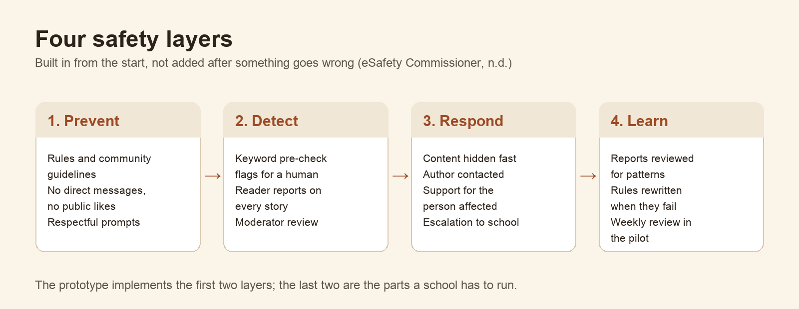
Figure 4. Four safety layers: prevent, detect, respond, learn.
Accessibility: keyboard operation for every control, visible focus, text alternatives, transcripts for audio, strong body-text contrast, resizable text and reduced-motion support, targeting WCAG 2.2 Level AA. We use a regional board instead of a geographic map because precise pins are hard to use with a keyboard or screen reader, and because a political map implies a culture belongs to a state.
What is built: a working prototype of the whole flow, not a mock-up. The discovery wall with search, filters and sorting, eight demonstration stories, the story page with context cards and optional audio, the full Culture Bridge, a submission form with a pre-check, a report control, and a dedicated safety page. It runs in the browser with no accounts, uploads or database, and all eight stories are clearly labelled as fictional so nobody mistakes them for real community voices. The Culture Bridge in particular is a proposed enhancement that we have implemented as a demonstration of the interaction, not a validated intervention.
Live prototype: <https://ahmadmuz.github.io/culture-swap-wall/> Source and full documentation: <https://github.com/Ahmadmuz/culture-swap-wall>
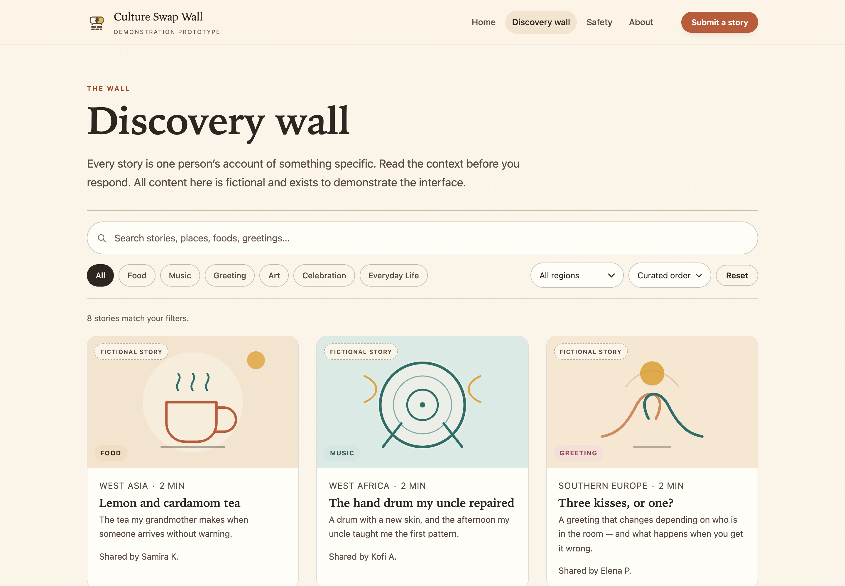
Figure 1. The discovery wall: search, categories and a finite, curated grid of story tiles.
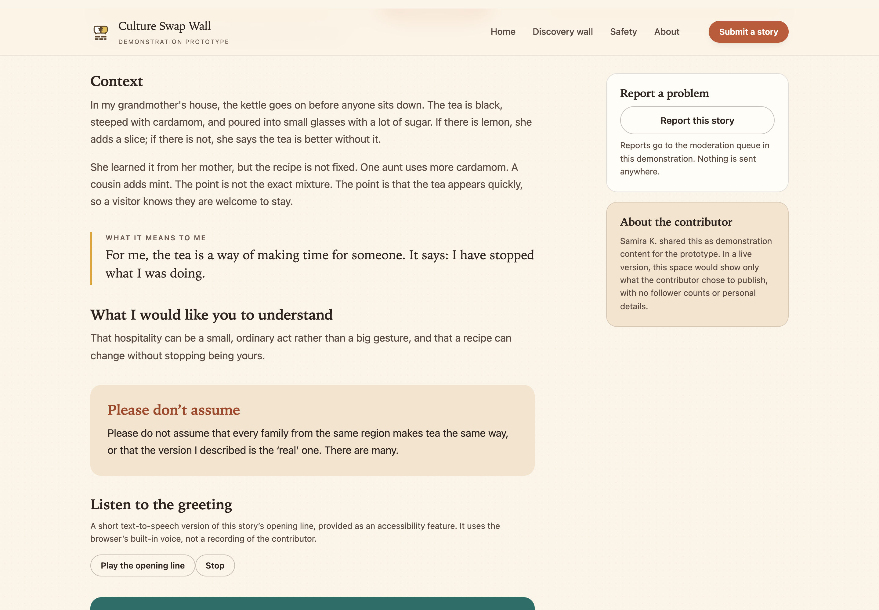
Figure 2. A story page: the context, what the story means to its author, and what they would rather you did not assume.
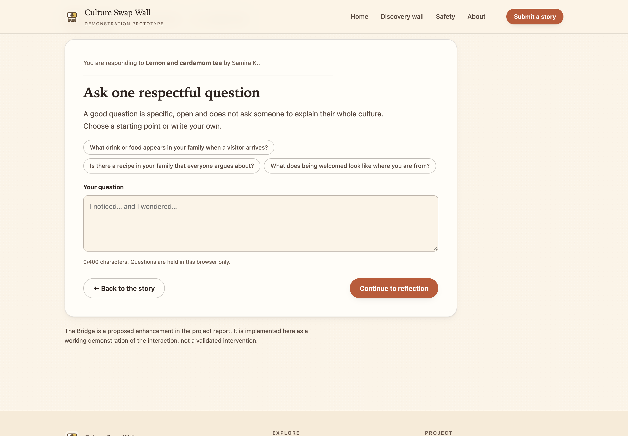
Figure 3. The Culture Bridge: ask one respectful question, reflect, then connect.
Validation
Our first round of feedback was small and informal, and we describe it that way rather than dressing it up. Arnold, a student, used the prototype and gave comments we recorded word for word, and we also collected reactions from other students, teachers and family members. There was no script, no set tasks, no scoring and no second observer, so it was not a usability test. What it could tell us was whether the wall felt warm, whether the idea made sense, and whether anything was obviously broken. It could not tell us whether someone outside a culture would understand the audio greetings, or whether the site works with a screen reader.
It still changed the product in five concrete ways:
What testers said | What we changed
The grid felt dense and the text was small | Larger tiles and larger body text
Text was hard to read on some warm backgrounds | Stronger colour contrast throughout
"There should be a way to flag something horrible" | A report control on every story, with a workflow behind it
The story pop-up felt like a trap | A clear close button, plus Escape support
Six categories felt limiting, and there was no way to find a specific story | Seven categories, search and sorting

Two of those mattered more than the rest. The report button changes the deal between the platform and the user: it says harmful content is not something you have to put up with. The close button looks trivial and is not, because someone who cannot leave a story may feel trapped, which is an accessibility problem and a safety problem at once.
The feedback also did something we did not expect: it validated the deletion. Testers were far more interested in the context card and the question prompt than in the features we had cut, which told us the safety-first version was the version worth building.
What we know we have not done: one friendly tester is a start, not a validation. We have not run a proper usability test with students, we have not compared the Culture Bridge with an open comment box, and we have not tested with a screen reader. Our next round is designed to answer exactly those three questions, with 5–8 students for usability, two small groups for reply quality and safety, and 2–3 people using assistive technology, each with a teacher present, consent, anonymised notes and the right to stop at any point.
Support Required
- A graphic designer or illustrator. The tile artwork is currently geometric placeholders. We want a consistent visual language that can represent many cultures without falling back on flags, national dress or stereotypes.
- Advice on moderation and safeguarding. We need someone with experience running moderated spaces for young people to review our rules, our report workflow and our escalation path before a single real story is published.
- Help finding a school for the pilot. Our next step is a four-week pilot with one class, with a teacher present and a weekly review of reports. We need a school willing to host it and a teacher willing to co-run it.
- Funding for a moderated pilot. Teacher time, moderation cover and hosting are the real costs. Nothing about this project is expensive, but it is not free either.
- An accessibility audit with people who actually use screen readers, keyboards or magnification, so we can test our WCAG 2.2 AA claims instead of asserting them.
- Mentoring in digital peacebuilding or digital citizenship, particularly from anyone who has evaluated whether an intervention like this changes behaviour rather than just measuring whether people enjoyed it.
Website URL
<https://ahmadmuz.github.io/culture-swap-wall/>
Suggested note if the field allows: this is the working prototype of the interface. All eight stories are fictional and written to demonstrate the interaction, there are no accounts and nothing submitted is stored or sent anywhere. It works on phones and desktops, and the Culture Bridge is reachable from any story page.

